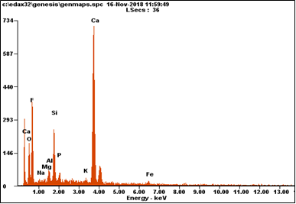
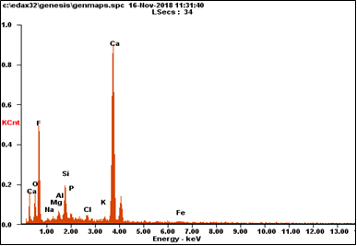
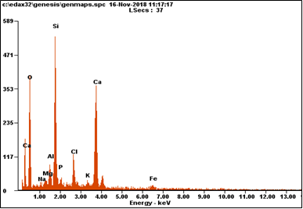
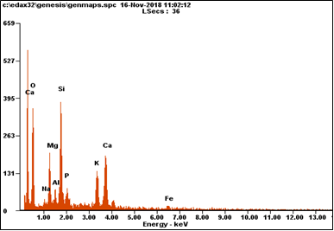
D
CA
B
A
Fig. S4. The EDS analysis of Raw-DM-BC and Ca-DM-BC before and after the adsorption of fluoride from water. Legends: A, original Raw- DM-BC; B, original Ca- DM-BC; C, Ca-DM-BC after the adsorption of fluoride at 5 ppm; and D, Ca-DM-BC after the adsorption of fluoride at 10 ppm.

D
C
A
B
Fig. S5. The SEM image analysis of Raw-DM-BC and Ca-DM-BC before and after the adsorption of fluoride from water. Legends: A, original Raw- DM-BC; B, original Ca- DM-BC; C, Ca-DM-BC after the adsorption of fluoride at 5 ppm; and D, Ca-DM-BC after the adsorption of fluoride at 10 ppm.

