In vitro intestinal toxicity of commercially available spray disinfectant products advertised to contain colloidal silver

Table 1. Consumer product silver concentration Total Claimed, Total Measured and Soluble (Filtrate)
_____________________________________________________________________________
Product Total Ag Claimed Total Ag Measured Filtrate (soluble Ag)
(mg/L) (mg/L) (mg/L)
_____________________________________________________________________________
1 120 18.9 ± 0.9 18.6 ± 0.5
2 500 960.8 ± 28.6 4.9 ± 0.1
3 NR 6.0 ± 1.1 BDL
4 NR 6.1± 0.1 BDL
5 NR 8.7 ± 0.7 0.2 ± 0.1
_____________________________________________________________________________
NR Not Reported
BDL Below Detection Limit

Table 2. Hydrodynamic diameter, primary particle size for selected products
before and after treatment with Synthetic Stomach Fluid (SSF).
_____________________________________________________________________________________
Hydrodynamic Diameter TEM Particle Diameter
_____________________________________________________________________________________
Product NTA Mean (nm) DLS_Z-AVG (nm) PDI P-1 (nm) P-2 (nm)
_____________________________________________________________________________________
1 184 ± 125 166 ± 31 0.43 2.3 30-200
1+ SSF 232 ± 57 180 ± 29 0.33 ND ND
2 77 ± 38 47 ± 0.6 0.48 4.5 20-40
2+ SSF 278 ± 120 715 ± 65 0.23 ND ND
3 199 ± 209 245 ± 11 0.29 15.5 15-30
3 + SSF 132 ± 180 ND ND ND ND
4 222 ± 177 220 ± 5.8 0.34 5.2 15-30
4 + SSF 63 ± 48 ND ND ND ND
5 200 ± 72 421 ± 40 0.43 ND 20-50
5 + SSF 311 ± 130 ND ND ND ND
ND Not Determined

Table 3. Suggested Cause for Cellular Response
_____________________________________________________________________________
Product Soluble Ag Sufficient Particulate Ag Sufficient Unexplained Response
to Cause Cell to Cause Cell Contribution from Product
Response Response Matrix
(mg/L after 1:5) (mg/L after 1:5) (mg/L after 1:5)
_____________________________________________________________________________
1 Yes (3.7) No (1.6) No
2 No (1.0) Yes (191) No
3 No (BDL) No (1.2) Yes
4 No (BDL) No (1.2) Yes
5 No (BDL) No (4.3) Yes
_____________________________________________________________________________
BDL Below Detection Limit
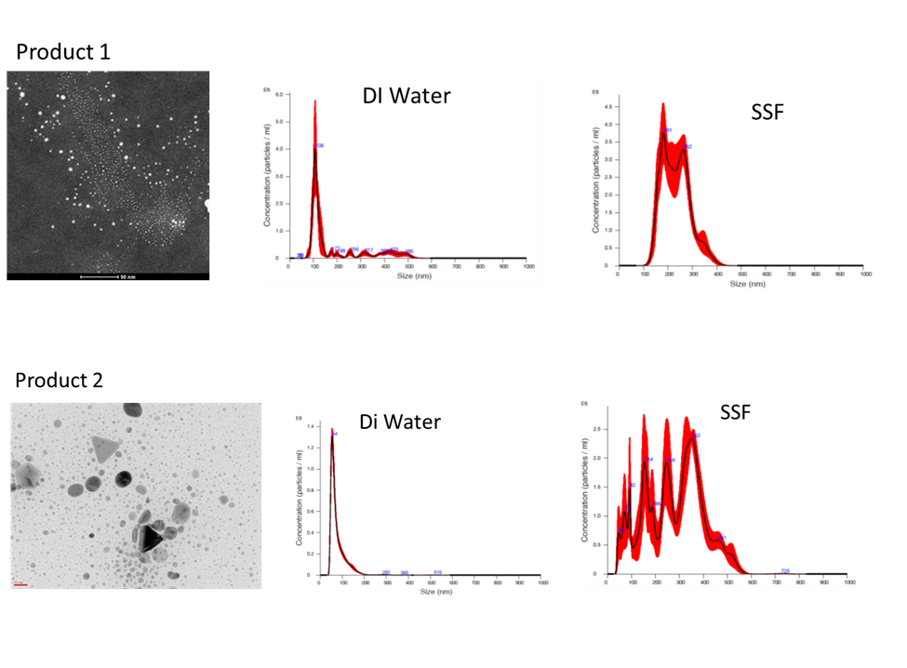
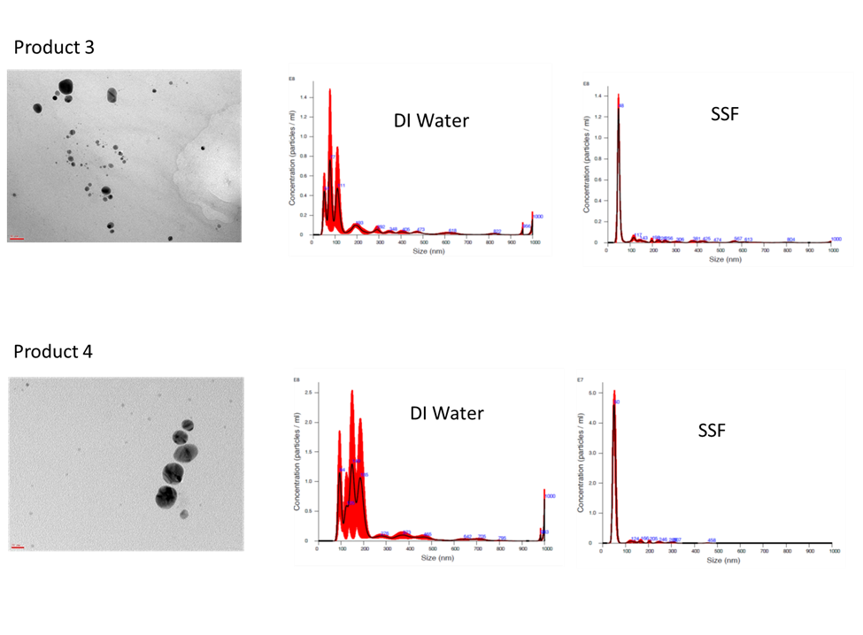

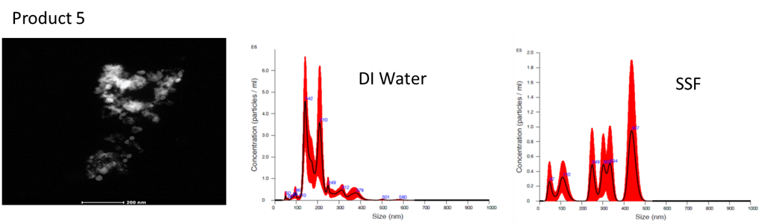
Fig. 1

Table S-1. Characteristics of Colloidal Silver Product Suspensions
____________________________________________________________
Product pH Cl- (ppm) S (ppm)
____________________________________________________________
1 6.6 BDL 27.9
2 7.9 39.8 40.4
3 10.6 25.1 BDL
4 10.0 25.3 BDL
5 2.5 10.6 9.8
____________________________________________________________
BDL Below Detection Limit

Table S-2. Estimated Total Ag Doses from Recommended Product Use

Product Product Application Total Measured Ag Recommended Dose Dose/Day (External, Internal) (mg/L) (mL) (ug Ag)
___________________________________________________________________________________
1 Internal 18.9 0.4 7.6
2 Both 961 1 961
3 External 6.0 Light Spray ND
4 External 6.1 Light Spray ND
5 External 8.7 Hard Surface Spray ND
___________________________________________________________________________________
ND Not Determined

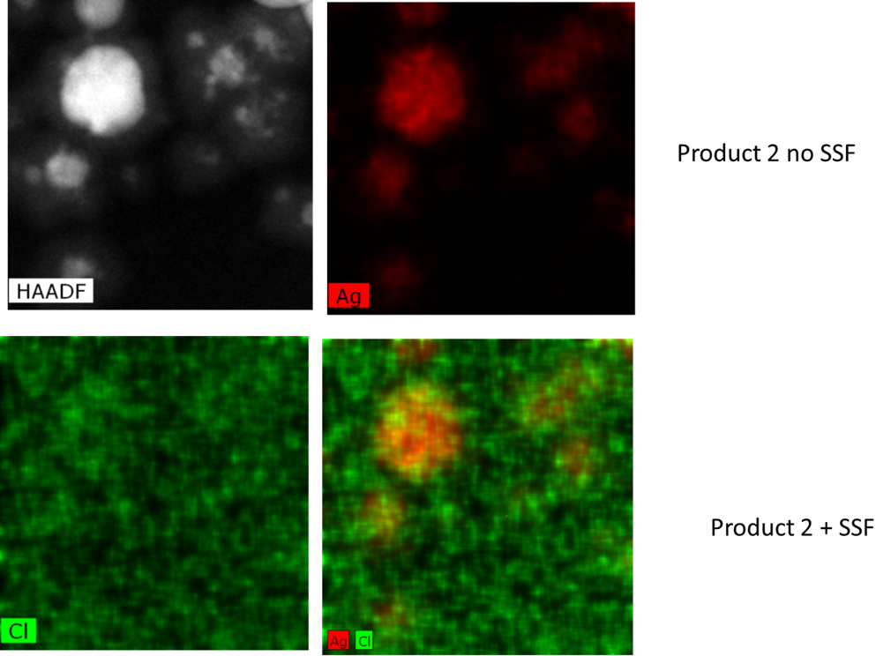

Fig. S-1

