Supplementary Information
Novel Franklinite-like Synthetic Zinc Ferrite Redox Nanomaterial, with Controlled Composition, for Reductive and Oxidative Degradation of Diclofenac

Abdulaziz Al-Anazi¹, Wael H. Abdelraheem¹, Kirk Scheckel², Mallikarjuna N. Nadagouda², Kevin O’Shea³, Dionysios D. Dionysiou^{1,*}
¹Environmental Engineering and Science Program, Department of Chemical and Environmental Engineering (ChEE), University of Cincinnati, Cincinnati, Ohio 45221-0012, United States
² US EPA, National Risk Management Research Laboratory, ORD, NRMRL, WSD, 26 W. Martin Luther King Jr. Drive, Cincinnati, OH 45268, United States
³ Department of Chemistry and Biochemistry, Florida International University, 11200 SW Eighth Street, Miami, FL 33199, United States
*Corresponding author Email: dionysios.d.dionysiou@uc.edu
Fax: +1-513-556-2599; Tel: +1-513-556-0724

Eighteen Figures and one table

Figures
Fig. S1: Collecting the nanomaterial from solution using a magnet
Fig. S2: HR-TEM images of various mixtures of the Zn_{x}Fe_{3-x}O₄ samples show crystallized nanoparticles with an average diameter measuring (A) 41 nm for Zn_{0.1}Fe_{2.7}O₄ (B) 34 nm for Zn_{0.3}Fe_{2.7}O₄ (C) 26 nm for Zn_{0.7}Fe_{2.3}O₄ (D) and 31 nm for Zn_{1.0}Fe_{2.0}O₄.
Fig. S3: Schematic of two subcells of a unit cell of the spinel structure, showing octahedral (A) and tetrahedral (B) sites.
Fig. S4: (A) Survey scans from Zn_{1.0}Fe_{2.0}O₄; (B) Deconvoluted C1s XP core level from Zn_{1.0}Fe_{2.0}O₄; (C) O 1s XP core level from Zn_{1.0}Fe_{2.0}O₄; (D) Fe2p XP core level from Zn_{1.0}Fe_{2.0}O₄; (E) Zn 2p XP core level from Zn_{1.0}Fe_{2.0}O₄.
Fig. S5: (A) Survey scans from Zn_{0.7}Fe_{2.3}O₄; (B) Deconvoluted C1s XP core level from Zn_{0.7}Fe_{2.3}O₄; (C) O 1s XP core level from Zn_{0.7}Fe_{2.3}O₄; (D) Fe2p XP core level from Zn_{0.7}Fe_{2.3}O₄; (E) Zn 2p XP core level from Zn_{0.7}Fe_{2.3}O₄.
Fig. S6: (A) Survey scans from Zn_{0.3}Fe_{2.7}O₄; (B) Deconvoluted C1s XP core level from Zn_{0.3}Fe_{2.7}O₄; (C) O 1s XP core level from Zn_{0.3}Fe_{2.7}O₄; (D) Fe2p XP core level from Zn_{0.3}Fe_{2.7}O₄; (E) Zn 2p XP core level from Zn_{0.3}Fe_{2.7}O₄.
Fig. S7: (A) Survey scans from Zn_{0.1}Fe_{2.9}O₄; (B) Deconvoluted C1s XP core level from Zn_{0.1}Fe_{2.9}O₄; (C) O 1s XP core level from Zn_{0.1}Fe_{2.9}O₄; (D) Fe2p XP core level from Zn_{0.1}Fe_{2.9}O₄; (E) Zn 2p XP core level from Zn_{0.1}Fe_{2.9}O₄.
Fig. S8: (A) Survey scans from Zn_{1.0}Fe_{2.0}O₄ after use; (B) Deconvoluted C1s XP core level from Zn_{1.0}Fe_{2.0}O₄ after use; (C) O 1s XP core level from Zn_{1.0}Fe_{2.0}O₄ after use; (D) Fe2p XP core level from Zn_{1.0}Fe_{2.0}O₄ after use; (E) Zn 2p XP core level from Zn_{1.0}Fe_{2.0}O₄ after use.
Fig. S9: (A) Survey scans from Zn_{1.0}Fe_{2.0}O₄ after use; (B) Deconvoluted C1s XP core level from Zn_{1.0}Fe_{2.0}O₄ after second reuse; (C) O 1s XP core level from Zn_{1.0}Fe_{2.0}O₄ after use; (D) Fe2p XP core level from Zn_{1.0}Fe_{2.0}O₄ after use; (E) Zn 2p XP core level from Zn_{1.0}Fe_{2.0}O₄ after use.
Fig. S10: X-ray absorption near-edge structure (XANES) K-edge spectroscopy of Zn_{1.0}Fe_{2.0}O₄ for Zn (A) and Fe (B). Black curves are the normalized XANES spectra and red curves are derivatives of the normalized XANES spectra.
Fig. S11: K-edge Zn and Fe k³-weighted χ functions for Zn_{1.0}Fe_{2.0}O₄.
Fig. S12: Radial structure functions obtained by Fourier transformation of the K-edge Zn (A) and Fe (B) spectra (black curve) and fitting parameter results (red curve). The fit results are summarized in Table 3.
Fig. S13: The UV/Vis spectrum for reduction of behavior of KMnO₄ using Zn_{1.0}Fe_{2.0}O₄. Experimental conditions are: Zn_{1.0}Fe_{2.0}O₄ = 0.17 g/L, [KMnO₄]₀= 1.0 N.
Fig. S14: (A); KMnO₄ and Zn_{1.0}Fe_{2.0}O₄ at 0 min reaction time, (B); KMnO₄ and Zn_{1.0}Fe_{2.0}O₄ at 80 min reaction time, (C); KMnO₄ and Zn_{1.0}Fe_{2.0}O₄ at 215 min reaction time, (D); KMnO₄ and Zn_{1.0}Fe_{2.0}O₄ at 370 min reaction time, (E) KMnO₄ ONLY at 370 min reaction time. Experimental conditions are: Zn_{1.0}Fe_{2.0}O₄ = 0.17 g/L, [KMnO₄]₀= 1.0 N.
Fig. S15: The effect of different pH on the degradation of DCF using Zn_{1.0}Fe_{2.0}O₄ = 0.17 g/L, [DCF]₀= 10 µM.
Fig. S16 Effect florescence light and dark conditions on overall degradation on DCF at 240 min. Experimental conditions are: Zn1.0Fe2.0O4 = 0.17 g/L, [DCF]0= 50 µM.
Fig. S17 Zn_{1.0}Fe_{2.0}O₄ reusability performance on the degradation on DCF at 60 min. Experimental conditions are: = 0.17 g/L, [DCF]₀= 10 µM.
Fig. S18 Effect of different initial concentration of DCF (1, 5, 10 and 15 µM) on the overall degradation of DCF at 240 min using Zn_{1.0}Fe_{2.0}O₄ = 0.17 g/L.

Tables;
Table S1: LC/Q-TOF-ESI-MS results collected during the degradation of DCF measurement of chromatogram peak area corresponding to each transformation products at each time interval according to their suggested molecular weight (MW), formula, and m/z. Experimental conditions are weight of Zn_{1.0}Fe_{2.0}O₄ = 0.17 g/L, [DCF]₀= 30 µM.

Fig. S1

Fig. S2 (A, B, C and D)
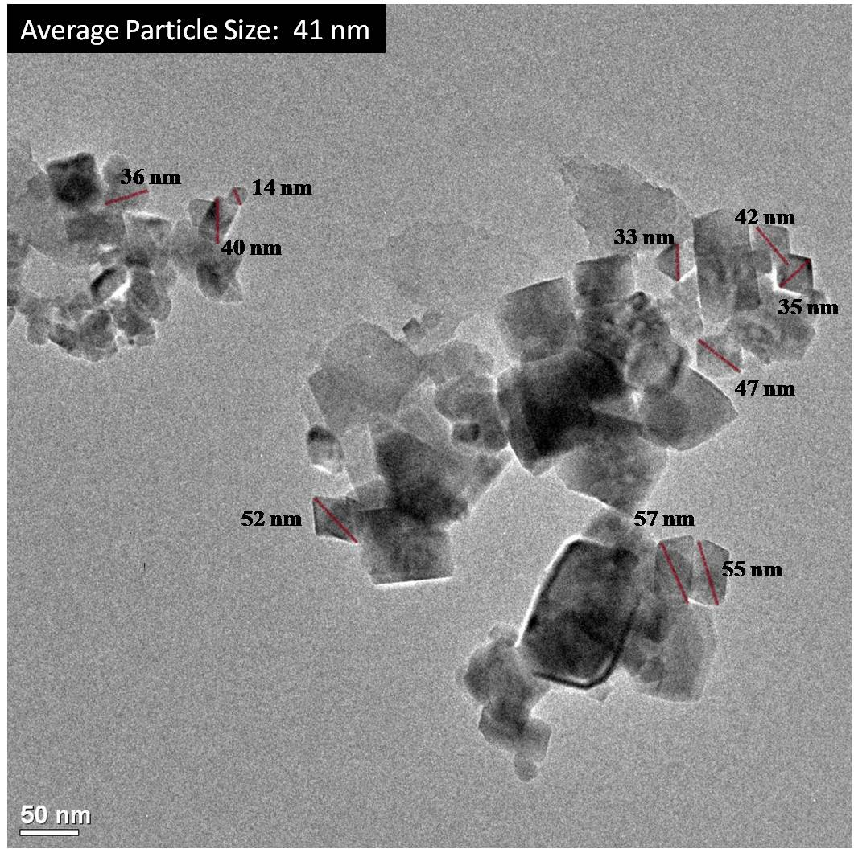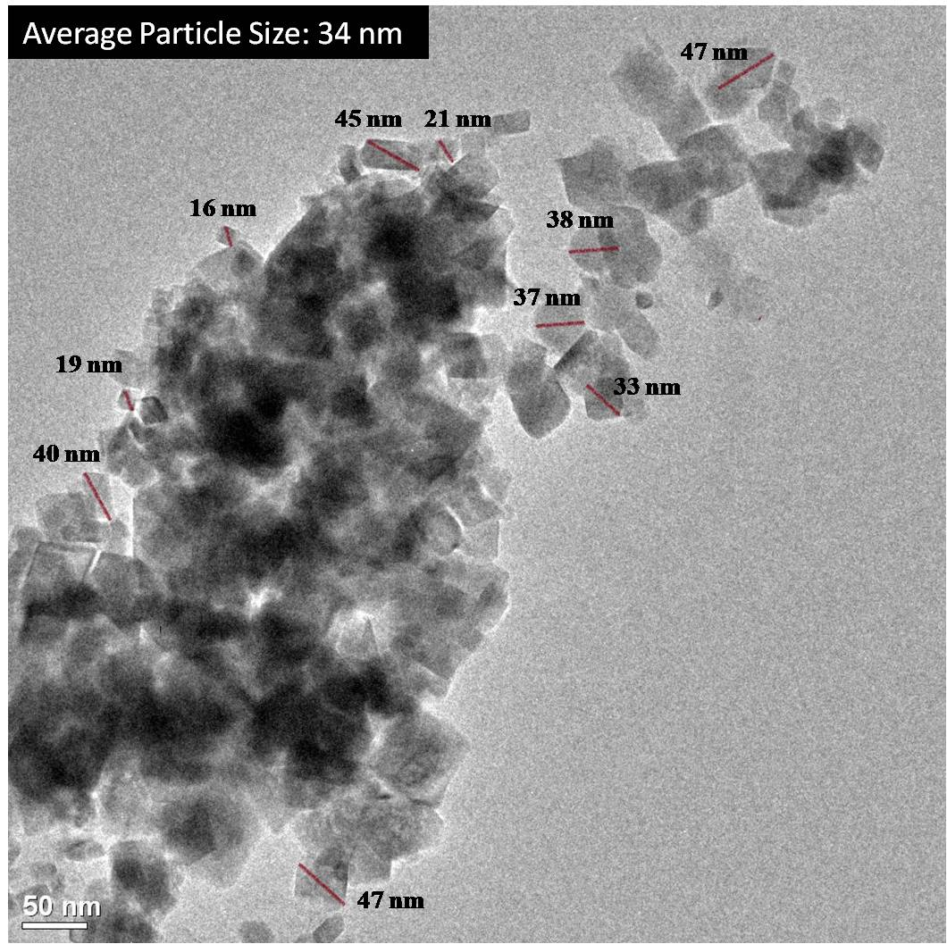
(A)
(B)
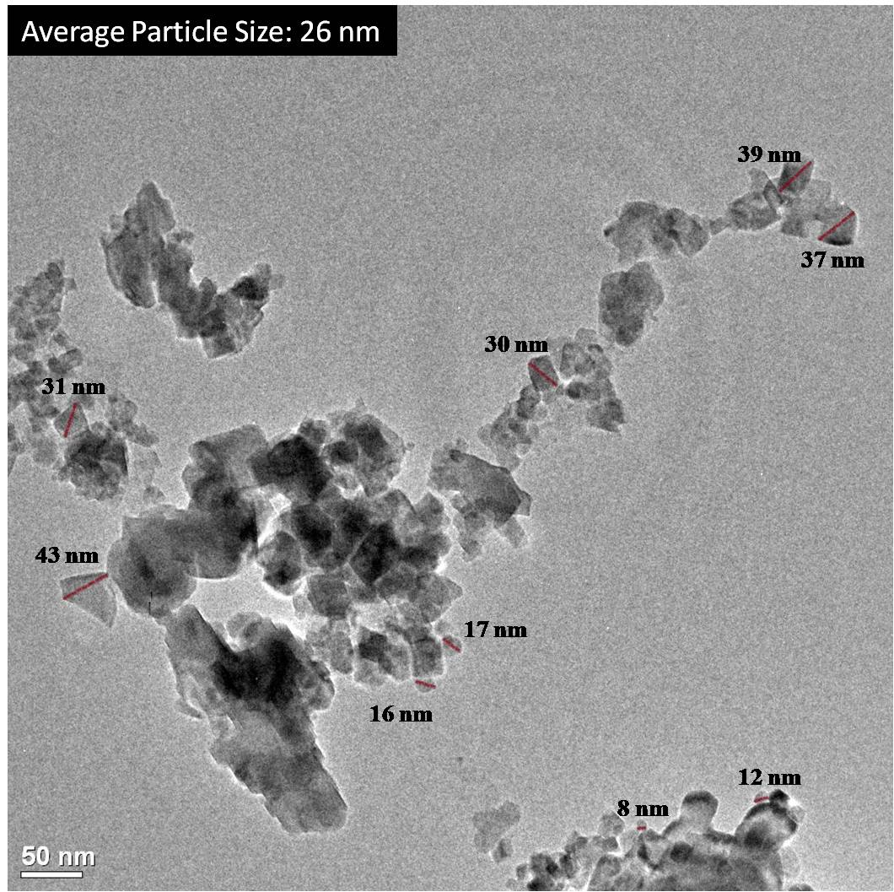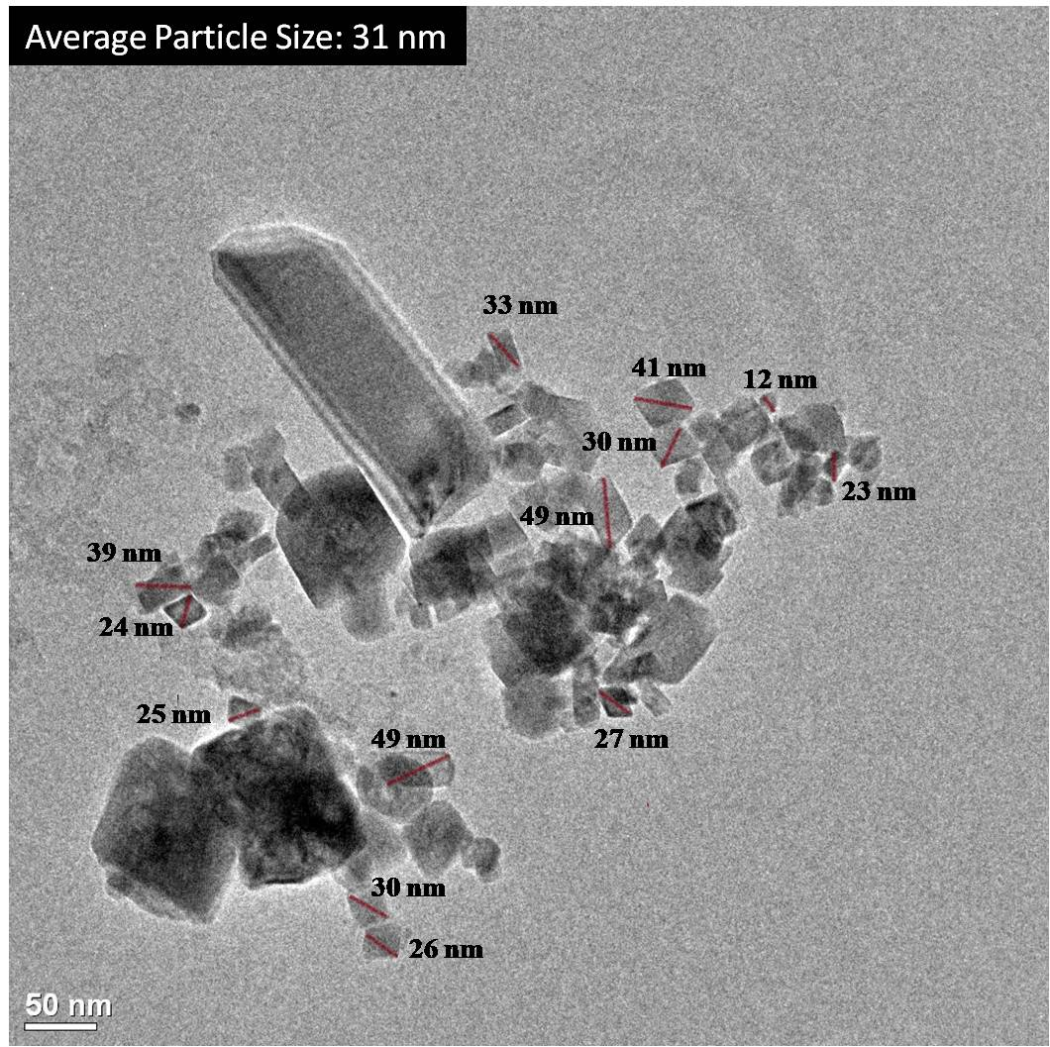
(C)
(D)

Fig. S3
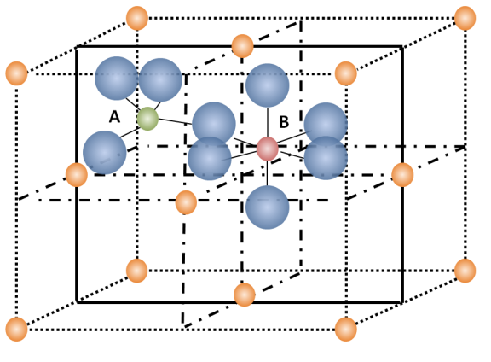

Fig. S4

Fig. S5

Fig. S6

Fig. S7

Fig. S8

Fig. S9

Fig. S10 (A and B)

Fig. S11

Fig. S12 (A and B)

Fig. S13

Fig.S14

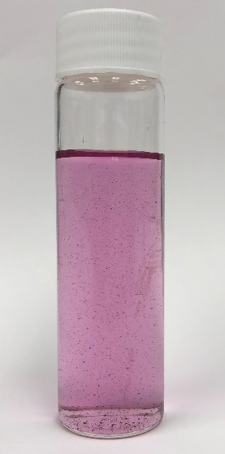
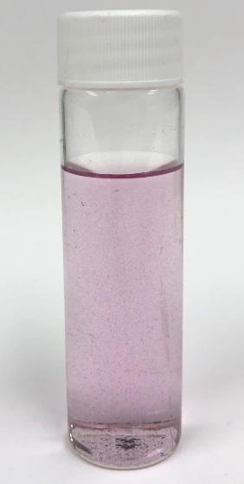
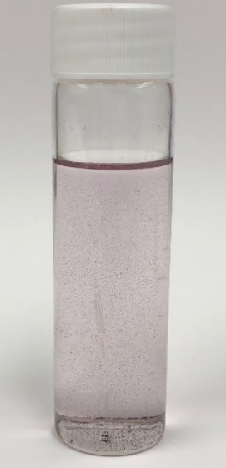
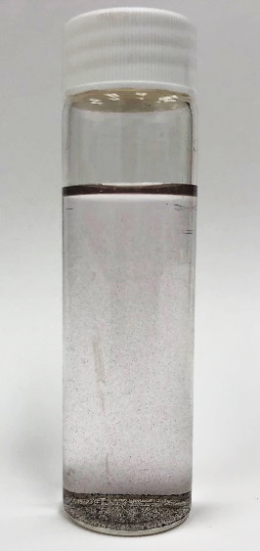
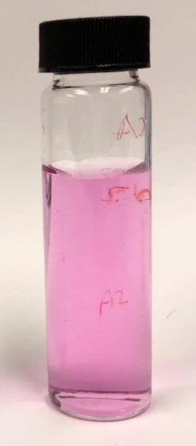
A
B
C
D
E

Fig. S15.

Fig. S16.

Fig. S17

Fig. S18

Table S1
Formula | MW | ID | m/z |  | Reaction Time (min)
 |  |  |  |  | 0 | 1 | 2 | 4 | 8 | 16 | 30 | 60
C₁₄ H₁₁ Cl₂ N O₂ | 295 | DCF | 296.024 |  | 417531 | 141639 | 97038 | 80575 | 95064 | 79231 | 60696 | 57465
C₁₄ H₁₁ N O₂ | 265 | P9 | 266.01 |  | 0 | 53605 | 70341 | 69720 | 74237 | 65906 | 63858 | 62327
C₆ H₄ Cl₂ O₂ | 177.96 | P4 | 178.96 |  | 0 | 30176 | 48327 | 42476 | 45370 | 44370 | 44309 | 43767
C₆ H₄ Cl₂ O₃ | 193.95 | P5 | 194.954 |  | 0 | 58272 | 16472 | 15695 | 15964 | 17804 | 18059 | 13144
C₈ H₈ O₄ | 168 | P3 | 169.042 |  | 0 | 20805 | 34340 | 32991 | 31079 | 29023 | 27789 | 31859
C₁₄ H₁₃ N O₂ | 227.09 | R3 | 228.1019 |  | 0 | 576051 | 2180907 | 180391 | 286452 | 705148 | 961170 | 121560
C₁₄ H₁₁ N O₂ | 225 | R2 | 226.086 |  | 0 | 21523 | 26649 | 26301 | 25808 | 25738 | 26930 | 25311
C₁₄ H₁₂ Cl N O₂ | 261 | R1 | 262.0629 |  | 0 | 66832 | 64743 | 71385 | 81619 | 155016 | 80140 | 62536
C₁₄ H₁₁ Cl₂ N O₃ | 311 | P6 | 310.003 |  | 0 | 23300 | 35401 | 34778 | 34187 | 31919 | 29968 | 33632
C₈ H₉ N O₂ | 151 | P1 | 152.0706 |  | 0 | 69599 | 93789 | 95368 | 82679 | 76214 | 78993 | 81223
C₁₃ H₉ Cl₂ N O₂ | 281 | P8 | 282.008 |  | 0 | 5673 | 8458 | 9600 | 9023 | 9826 | 7202 | 6821
C₁₃ H₁₁ Cl₂ N O | 267 | P7 | 268.029 |  | 0 | 33430 | 43296 | 39342 | 41289 | 43761 | 42030 | 6821
Table S1. LC/Q-TOF-ESI-MS results collected during the degradation of DCF measurement of chromatogram peak area corresponding to each transformation products at each time interval according to their suggested molecular weight (MW), formula, and m/z,. Experimental conditions are weight of Zn_{1.0}Fe_{2.0}O₄ = 0.17 g/L, [DCF]₀= 30 µM

