Novel Franklinite-like Synthetic Zinc Ferrite Redox Nanomaterial, with Controlled Composition, for Reductive and Oxidative Degradation of Diclofenac

Abdulaziz Al-Anazi¹, Wael H. Abdelraheem^{1,2}, Kirk Scheckel³, Mallikarjuna N. Nadagouda³, Kevin O’Shea⁴, Dionysios D. Dionysiou^{1,*}
¹Environmental Engineering and Science Program, Department of Chemical and Environmental Engineering (ChEE), University of Cincinnati, Cincinnati, Ohio 45221-0012, United States, Email: azizalanazi@gmail.com
² Chemistry Department, Faculty of Science, Sohag University, Sohag 82524, Egypt. Email: whafez2008@gmail.com
³US EPA, National Risk Management Research Laboratory, ORD, NRMRL, WSD, 26 W. Martin Luther King Jr. Drive, Cincinnati, OH 45268, United States
⁴Department of Chemistry and Biochemistry, Florida International University, 11200 SW Eighth Street, Miami, FL 33199, United States
*Corresponding author Email: dionysios.d.dionysiou@uc.edu
Fax: +1-513-556-2599; Tel: +1-513-556-0724

Abstract
The current study investigates a novel redox technology based on synthetic franklinite-like zinc-ferrite nanomaterial with magnetic properties and redox nature for potential use in water treatment. Physicochemical characterization revealed the nanoscale size and AB₂O₄ spinel configuration of the zinc-ferrite nanomaterial. The redox activity of nanoparticles was tested for degradation of diclofenac (DCF) pharmaceutical in water, without added external oxidant and under dark experimental conditions. Results revealed ~90% degradation in diclofenac (10 µM) within 2 min of reaction using 0.17 g/L Zn_{1.0}Fe_{2.0}O₄. Degradation of DCF was due to chemical reduction by surface electrons on zinc-ferrite and oxidation by oxygen-based radicals. Three byproducts from reduction route and eight from oxidation pathways were identified in the reaction system. Reaction pathways were suggested based on the identified byproducts. Results demonstrated the magnetic zinc-ferrite is a standalone technology that has a great promise for rapid degradation of organic contaminants, especially DCF in water.

Keywords: Zinc ferrite; Diclofenac (DCF); Advanced oxidation and reduction; Reaction byproducts
Introduction
The development and application of homogeneous heterogeneous metal-based catalysts for treatment of contaminants of emerging concern in aqueous media has received considerable scientific attention [1, 2]. While the solubility of such nanomaterial in the reaction medium is an advantage, problems associated with separation of remaining nanomaterial from reaction medium and difficulties of handling air-sensitive catalysts limited their applications in the field of water treatment [3, 4]. Among the existing numerous materials, transition metals-based catalysts have shown various physical and chemical properties that they have been extensively used in promising applications including energy storage, medical, and air and water treatment [5-9]. Owing to its high magnetic anisotropy, spinel zinc-ferrite has been used in magnetic recording applications [10]. Moreover, water disinfection and degradation of organic pollutants in air and water using iron-based spinel metal oxides [11-13]. Historically, photoactivated zinc-ferrite nanoparticles was used to degrade organic contaminants in water [14, 15]. In some cases, oxidants such as hydrogen peroxide and persulfate are added to zinc-ferrite based photocatalytic system for better performance toward degradation of organic contaminants in water[13, 16]. Herein we demonstrate a novel redox system based on spinel zinc-ferrite nanomaterial for an efficient degradation of a model pharmaceutical diclofenac (DCF) in water in absence of any external energy source, without addition of external oxidants.
DCF is an anti-inflammatory, non-steroidal drug that is mainly used as an analgesic drug to reduce inflammation from arthritis and rheumatic conditions [17]. DCF is one of the frequently detected pharmaceuticals in water sources including influent and effluent wastewater in domestic treatment plants [17, 18]. DCF has found its way to surface water and ultimately to drinking water which might impose negative effects on human health [19]. Municipal wastewater treatment plants typically employ specific treatment technologies such as ozonation, Ultraviolet (UV) radiation, and activated carbon adsorption to remediate organic contaminants including DCF, yet, none of these technologies lead to acceptable removal efficiencies [18]. Therefore, it is critical to find efficient, environmentally compatible removal technology for DCF in water.
In this study, recyclable magnetic spinel Zn_{x}Fe_{3-x}O₄ nanoparticles were synthesized, and characterized using various physical and chemical techniques. The redox activities of synthesized nanoparticles were evaluated for the degradation of DCF in water. Liquid chromatography-mass spectrometry (LC-MS) technique, total organic carbon (TOC), and analysis of inorganic nitrogen-containing products were conducted to evaluate degradation and mineralization of DCF by Zn_{x}Fe_{3-x}O₄. Finally, proposed reaction pathways, based on identified reaction products and reactivity of involved oxidizing and reducing species such as •OH and e⁻ are presented to rationalize the oxidation and the reduction routes.

Experimental

Synthesis of Zn_{x}Fe_{3-x}O₄ magnetic nanoparticles
A combustion method was used to synthesize zinc-ferrite nanomaterial. In this method, a mixture of zinc chloride (98%, Sigma Aldrich) and iron (III) nitrate monohydrate (98%, Sigma Aldrich) was initially prepared at a 1:2 molar ratio of zinc to iron (III). This molar ratio was then varied to produce four different stoichiometries where the adequate number of grams of each chemical was determined by multiplying molar ratios by corresponding molecular weight (i.e., Zn_{1.0}Fe_{2.0}O₄, Zn _{0.7}Fe_{2.3}O₄, Zn _{0.3}Fe_{2.5}O₄, and Zn_{0.1}Fe_{2.9}O₄). Polyvinyl alcohol (PVA, 88% hydrolyzed, average molecular weight of 22,000 g/mol) was added to the reaction mixture in a 1:1 mass ratio. The mixture was grinded and mixed with 15 mL Milli-Q water, placed in a muffle furnace and calcined at 500 °C for 30 min promoting self-ignition of PVA that ultimately generated magnetic nanoparticles of zinc-ferrite.

Characterization of Zn_{x}Fe_{3-x}O₄ nanoparticles
The morphologies of prepared nanomaterial were investigated by an environmental scanning electron microscopy (ESEM, Philips XL 30 ESEM-FEG). Energy-dispersive X-ray spectroscopy (EDS) installed in the ESEM was used to determine chemical compositions of samples. A JEM-2010F (JEOL) HR-TEM with a field emission gun at 200 kV was used after the samples were subject to ultrasonication (2501R-DH, Bransonic) for 30 min in isopropyl alcohol (99.8%, Pharmco). Each sample was fixed on a lacey/carbon 300 mesh copper grid (LC325-Cu, EMS). Selected area electron diffraction (SAED) was obtained with low resolution TEM and analyzed using the open-source program, Diffraction Ring Profiler. Electron diffraction simulations were performed using the commercial software, Desktop Microscopist, with the input of the well-known space group information. Porosimetric analysis was performed using Tristar 300 (Micromeritics) porosimeter analyzer to determine the Brunauer-Emmett-Teller (BET) surface area, pore volume, porosity, Barret- Joyner-Halenda (BJH) pore size and distribution (based on nitrogen adsorption and desorption isotherms). All samples were purged with nitrogen gas for 2 h at 150 °C using Flow prep 060 (Micromeritics) before the porosimetry analysis.
A Cu-Kα wavelength Bruker AXS D8 Discover XRD was used to determine crystal structure of synthesized samples with a receiving slit of 0.3 and 0.2 scan step size from 10 to 70 degrees. Raman spectroscopy measurements were performed with a Renishaw In-Via Reflex dispersive micro-Raman spectrometer with < 2 cm⁻¹ resolution. The laser beam (excitation in the NIR at 785 nm with total laser power below 0.001 mW/µm²) was focused on a spot of about 6.8 µm in diameter with a 20X magnification lens. Rayleigh scattering was rejected with a 200 cm⁻¹ cut-off dielectric edge filter, and analysis of the scattered beam was performed on a 250 mm focal length spectrometer along with suitable diffraction gratings (1200 lines/mm for NIR) and a high-sensitivity charge-coupled device (CCD). All room temperature (RT) Raman spectroscopy measurements were performed in air and at different laser powers to assure that the intensities used did not induce changes in the spectra. The surface analysis studies were performed in a UHV chamber (P<10-9 mbar), equipped with a SPECS LHS-10 hemispherical electron analyzer.
XPS measurements were carried out at room temperature using Kratos Axis Ultra XPS equipped with monochromated (Al) X-Ray source with 12 kV and 10 mA. XPS analysis was performed in spectrum analyzer mode and slot aperture setting with a hybrid lens mode. The XPS core level spectra were analyzed using a fitting routine, which allows the division of each spectrum into individual mixed Gaussian-Lorentzian components after a Shirley and linear background subtraction. The samples were pressed on a ~ 1 cm² carbon tape and then taped on a metal samples holder. Wide survey scans were recorded for all samples, while the core level peaks that were recorded in detail were: O1s, Fe2p, Zn2p and C1s.
XAFS measurements for Zn and Fe (in Zn_{x}Fe_{3-x}O₄) were conducted at the Materials Research Collaborative Access Team (MRCAT) beamline Sector 10-ID, at the Advanced Photon Source of Argonne National Laboratory (USA) [20]. The storage ring operated at 7 GeV in top-up mode. A liquid N₂ cooled double crystal Si (111) monochromator was used to select the incident photon energies and a platinum-coated mirror was used for harmonic rejection. Calibration was performed by assigning the first derivative inflection point of K edge of zinc (9659 eV) or iron (7112 eV) metal foils with simultaneous collection of the foils for each sample scan for calibration of spectra. Five Zn or Fe K edge X-ray absorption spectroscopy spectra were collected in transmission mode. The collected spectra were analyzed using the Athena software program in the computer package IFEFFIT for data reduction and WinXAS 3.0 for data fitting [21, 22]. The individual spectra for each sample were averaged followed by subtraction of the background through the pre-edge region using the Autobk algorithm and normalized to the atomic absorption of one [23]. The data were converted from energy to photoelectron momentum (k-space) and weighted by k³ using WinXAS. X-ray absorption fine structure spectra were calculated over a typical k-space range with a Bessel window. Fourier transforms were performed to obtain the radial distribution function in R-space. Plotted R-space (Å) data are not phase shift corrected so that the true distances are between 0.3 and 0.5 Å longer than the distances shown. Structural parameters were extracted with fits to the standard XAFS equation. Using the FEFF8 and ATOMS codes, ab initio amplitude and phase functions for single shells were calculated for the mineral franklinite ((Zn,Fe^{II})Fe^{III}₂O₄) [24, 25]. Structural parameters for Zn and Fe interactions were obtained by least-squares refinements of the theoretical model function χ (k), allowing R, σ², and ΔE₀ to float, to the k³-weighted EXAFS oscillation over the k-range of 2.3–13.5 Å⁻¹ (Zn) and 2.5–14 Å⁻¹ (Fe), after Fourier-filtering in the range of 0.9–6.1 Å. The S₀² value was held constant at 0.85 to allow refinements of the coordination number. The accuracy of the mean bond distance R is estimated to be within ±0.02 Å and the coordination number N is estimated to be accurate to ±20%, based on the results of theoretical fits to spectra of reference compounds of known structure.

Catalytic activity of Zn_{x}Fe_{3-x}O₄ nanoparticles
To evaluate the zinc-ferrite nanomaterial activities of various Zn_{x}Fe_{3-x}O₄ (Zn_{0.1}Fe_{2.9}O₄, Zn_{0.3}Fe_{2.7}O₄, Zn_{0.7}Fe_{2.3}O₄ and Zn_{1.0}Fe_{2.0}O₄), 5.0 mg of nanoparticle was added to 24 mL Milli-Q water in individual 40 mL glass vials. Sonication for 15 min at 40 kHz (input energy 19 W) was applied to further disperse the zinc-ferrite nanomaterial in water. Then, 6 mL of 50 mM DCF was added to water containing the zinc-ferrite nanomaterial (i.e., final concentration of DCF =10.0 µM). A final volume of 30 mL was achieved in each vial by addition of appropriate amount of Milli-Q water. The vials were placed in a rotating (50 rpm) vial holder to ensure uniform mixing of the solution during the degradation process. The vials were wrapped with aluminum foil to eliminate any light penetrating to solution. Prior to sampling, the nanoparticles were collected at the inner wall of vial using a magnetic bar to maximize retention of nanomaterial during the consecutive sampling process s, Fig. S1. Samples of 300 µL each were drawn at different time intervals (i.e., 0, 1, 2, 4, 8, 16, 30 and 60 min) and were subsequently filtered using a Whatman 0.2 µm syringeless PTFE membrane filter to remove residual nanoparticles. The same degradation experiments were repeated at 30 μM initial DCF concentration to monitor degradation byproducts as well as for quantification of mineralization species (i.e., NO₂‒, NO₃‒, NH₄⁺) and TOC reduction during the degradation process.
In order to check the zinc-ferrite nanoparticles reusability, nanoparticles collection and regeneration strategies were employed. The suspended nanoparticles were collected at the end of each experiment by placing a magnetic bar near to the vial’s wall for 1 min, Fig. S1. After removing the solution, the collected nanoparticles were regenerated by washing with Milli-Q water and then with ethanol. Finally, the nanomaterial was dried at 60 ºC and saved in a refrigerator (at ~ 6 ºC) for further reuse.
Among all synthesized zinc-ferrite nanomaterial, primary investigation showed Zn_{1.0}Fe_{2.0}O₄ has superior degradation activity for DCF. Therefore, further investigations of chemical properties of Zn_{1.0}Fe_{2.0}O₄ were performed to better understand its activity. Chemical reduction property of Zn_{1.0}Fe_{2.0}O₄ was investigated by reducing Mn⁷⁺ in KMnO₄ into Mn²⁺ in acidic medium. Upon mixing Zn_{1.0}Fe_{2.0}O₄ with KMnO₄ in acidic medium, permanganate violet color (due to Mn⁷⁺) faded out and ultimately disappeared due to the formation of colorless reagent (Mn²⁺). The color change of reaction mixture was monitored by measuring the solution UV/Vis spectrum using a spectrophotometer. The reaction was performed in a glass vial containing 1.0 eq/L KMnO₄ and 5.0 mg Zn_{1.0}Fe_{2.0}O₄. Moreover, chemical oxidation property Zn_{1.0}Fe_{2.0}O₄ was investigated by investigating the involvement of •OH in DCF degradation. For that purpose, a specific scavenging agent, i.e., tert-butanol (t-BuOH), was added to the degradation system. In this experiment, 10 µM DCF was mixed with 5.0 mg Zn_{1.0}Fe_{2.0}O₄ in the presence of tert-butanol (t-BuOH) at different concentration levels (i.e., 20, 100, 500 and 1000 mM) and change in DCF concentration was monitored. Moreover, due to reaction between Zn_{1.0}Fe_{2.0}O₄ and water in the degradation system, hydrogen peroxide was expected to release in the solution, thus a spectrophotometric determination of hydrogen peroxide was performed by using its reaction with metavanadate in acidic medium [26].
Furthermore, the degradation of DCF was performed in an effluent wastewater collected after microfiltration step (WWE) in the Groundwater Replenishment System (GWRS) located in Orange County, CA, USA. In this experiment, 0.17 g/L of Zn_{1.0}Fe_{2.0}O₄ was added to 30 mL WWE water containing 10 µM DCF. Major characteristics of WWE wastewater as provided by GRWS in their 2017 online report are summarized in Table S1 (Supplementary Information) [27].

Analytical methods
An HPLC (Agilent 1100 Series) with a photodiode array detector (PDA) was used for the quantification of DCF during the degradation experiments. For separation, a Supelco C₁₈ column (150 mm × 4.6 mm, 5.0 µm) was used with a mobile phase consisted of 0.1% (v/v) formic acid in water and 100% acetonitrile at a ratio of 30:70 (v/v), respectively. The flow rate was 0.30 mL min⁻¹, the injection volume of each sample was 10 µL, the column temperature was 25 ºC, and the detection wavelength for DCF was set at 221 nm. Inductively coupled plasma-atomic emission spectrometry (ICP-AES) was used to quantify leached Zn and Fe from the zinc-ferrite during reaction. Quantification of Cl‒ released from DCF during the degradation experiments was performed by using a Dionex Ion Chromatography (model LC20, USA). An IonPac AS18 (2.0 × 250 mm) column was used to elute the ions. NH₄⁺ was measured (as NH₃-N) using Hach instrument model SL 1000 by using Chem Key for total ammonia as NH₃-N. QuickChem low flow method 10-107-04-1-A for Lachat instrument was used to measure nitrite and nitrate. A Shimadzu VCSH-ASI TOC Analyzer was used for measurement of the change in total organic carbon (TOC) during the degradation experiments to investigate mineralization of DCF by the Zn_{x}Fe_{3-x}O₄.
An Agilent 1290 infinity HPLC system equipped with a Zorbax Eclipse XDB-C18 Rapid Resolution column (2.1 × 50 mm, 3.5 μm, Agilent Technologies) was used to separate the reaction byproducts from samples taken during DCF (initial concentration of 30 μM) degradation experiments. The mass analysis of the byproducts was performed by an Agilent 6540 UHD accurate-mass quadrupole time-of-flight tandem mass spectrometer (Q-TOF-MS) which was coupled to the 1290 HPLC with an electrospray ionization source (ESI). DCF and transformation product candidates were identified based on mass to charge ratio (m/z).

Results and Discussions

Characterization of zinc-ferrite redox nanomaterial
The synthesized zinc-ferrite (Zn_{x}Fe_{3-x}O₄) was characterized by HR-TEM analysis and the average particle size is shown in Fig. S2 (A-D). All nanoparticles were in polycrystalline nanostructures, with average particle size, based on TEM, of 41 nm for Zn_{0.1}Fe_{2.9}O₄, 34 nm for Zn_{0.3}Fe_{2.7}O₄, 26 nm for Zn_{0.7}Fe_{2.3}O₄ and 31 nm for Zn_{1.0}Fe_{2.0}O₄. BET surface analysis demonstrated surface of of Zn_{0.1}Fe_{2.9}O₄, Zn_{0.3}Fe_{2.7}O₄, Zn_{0.7}Fe_{2.3}O₄ and Zn_{1.0}Fe_{2.0}O₄ were 48.7, 26.1, 15.0 and 14.4 m²/g, respectively. According to SEM analysis, all synthesized zinc-ferrite (Zn_{x}Fe_{3-x}O₄) possessed octahedral and tetrahedral particle structures as shown in Fig. 1.
XRD analysis of zinc-ferrite nanoparticles revealed diffraction peaks at 18°, 29.9°, 35.2°, 36.8°, 42.8°, 53°, 56.6° and 62.9° which correspond to cubic, spinel crystal planes (111), (220), (311), (222), (400), (422), (511) and (440), respectively (Fig. 2). This result compares favorably with the hkl planes of zinc-ferrite that has matching spectra at (220), (311), (222), (400), (422), (511), and (440) (PDF #04-007-6616). The relatively minor peaks of (331), (531), (620), (533), and (622) planes were not observed within the 2θ sweep from 0 to 75 degrees, but all have low recorded intensities for zinc-ferrite. The percentage of crystal diffraction in proportion to noise floor suggested the nanoparticles were ~79% crystalline using the Rietvald method [28]. The average sizes of the crystallites for each of the various formulations were determined at (311) which was the dominant peak using the Scherrer equation (Eq. 1) [29].
$τ=\frac{Kλ}{βcosθ}$ (1)
where, K = 0.9 (shape factor), $λ$ is the X-ray wavelength 1.5418 Å, $β$ is the line broadening at FWHM after subtracting instrumental broadening in radians [Δ(2θ)], and θ is the Bragg angle of 36.2°. Additionally, peak broadening for the (311) plane was observed when the content of zinc increased for intermediate concentrations, indicating a decreased crystallite size. Using the dominant (311) peak of Zn_{0.3}Fe_{2.7}O₄ and Scherrer equation, average crystallite size of 13 nm was obtained. When zinc concentration increased as in Zn_{0.7}Fe_{2.3}O₄, the dominant (311) diffraction peak decreased and the average crystallite size was10 nm. Zn_{0.1}Fe_{2.5}O₄ produced crystal sizes of 22 nm, while Zn_{1.0}Fe_{2.3}O₄ possessed 26 nm average particle size.
Fig. 3(A-D) depicts SAED patterns of Zn_{x}Fe_{3-x}O₄.The diffraction rings are consistent with spinel zinc-ferrite crystal structure [30]. The rings of Zn_{0.1}Fe_{2.9}O₄ corresponding to (200) and (311) planes (Fig. 3A) match with zinc-ferrite hkl planes (PDF #04-007-6616). The diffraction rings of Zn_{0.3}Fe_{2.5}O₄ from planes (111), (220), (311), (400), and (511) also match with spinel zinc-ferrite (Fig. 3B). Zn_{0.7}Fe_{2.3}O₄ also resembles zinc-ferrite with diffraction from planes (220), (311), (400), (422), (511) and (440) (Fig. 3C). Lastly, Zn_{1.0}Fe_{2.0}O₄ crystal spectra again agree very well to those of zinc-ferrite with diffraction from planes (111), (220), (311), (511), and (440) (Fig. 3D).
Zinc lattice constants of different nanomaterial were calculated from the reciprocal of space rings in Fig. 3 using the equation $d_{hkl}=\frac{a}{\sqrt{h^{2}+k^{2}+l^{2}}}$, where d is the interplanar spacing, α represents the lattice constant, and hkl are Miller indices. Lattice constants of Zn _{0.1}Fe_{2.9}O₄ were 0.1491 nm for [220] and 0.1250 nm for [311], with an average lattice constant of 0.1370 nm. Using the same equation, lattice constants and their average values for all synthesized nanomaterial were calculated and summarized in Table 1. Generally, as the concentration of zinc in Zn_{x}Fe_{3-x}O₄ increased, the average lattice constant of corresponding nanomaterial increased (Table 1).
The results of SAED diffraction rings and XRD lattice plane reflection suggested zinc-ferrite nanomaterial were in cubic crystalline zinc-ferrite structure, with spinel configuration (i.e., AB₂O₄, Fig. S3). In AB₂O₄ structure, [A] and [B] are occupying the tetrahedral and octahedral sites, respectively [31]. The spinel ferrite unit cell is of cubic structure (space group Oh7-F3dm) that forms a cube with eight ZnOFe₂O₄ molecules consisting of 32O²⁻ anions. The oxygen anions construct a face-centered cube packing, consisting of 64 tetrahedral (A) and 32 octahedral (B) empty spaces that are partially populated by Fe³⁺ and Zn²⁺ cations [32]. In all synthesized nanomaterial, cubic spinel ferrites displayed high percentages of Fe at the tetrahedral location of 80% [33], 66% [34], and 84% [35]. The crystal structure was altered correspondingly with the shift in percentage of Fe at the tetrahedral site. This accounted for the alteration in crystal structure with changing stoichiometry.
The vibration modes in the Zn_{x-1}Fe_{3-x}O₄ nanoparticles were investigated by Raman spectroscopy, Fig. 4. The synthesized Zn_{x-1}Fe_{3-x}O₄ material showed Raman active modes at around 212, 272, 390, 493, 603, 1100, 1330 cm⁻¹ with intensities changing according to stoichiometry [36]. Position of these vibration modes varies with the synthesis process [36, 37] and/or with the incorporation of Zn ions in the crystal lattice [38]. In the current study, zinc-ferrite possessed low frequency spectral vibrations (equal or below 490 cm⁻¹) attributed to those of metal cations and oxygen ions at the octahedral sub-lattice (O-side modes) of Zn_{x}Fe_{3-x}O₄. Other vibrational spectra were noticed at higher frequencies (603, 1100, and 1330 cm⁻¹) that were consistent with vibrations of tetrahedral sub-lattice (T-side modes) [36-38]. Apart from zinc-ferrite, isolated zinc oxide and ferrite were also detected, such as the vibrational modes at 212, 272, 390 and 493 cm⁻¹ of hematite (a-Fe₂O₃) found in zinc-ferrite nanoparticle with lowest zinc content (i.e., x= 0.1) [39]. nanomaterial with higher zinc content were found in higher crystallinity, in spinel structure with traces of impurities. These impurities were randomly formed among the different Zn_{x-1}Fe_{3-x}O₄ samples, without showing a specific tendency; the broad bands at 1100 cm⁻¹ (for x equal to 0.7 or 1.0) and 1330 cm⁻¹ (for x equal to 0.5 or 0.7) were assigned to Zn₃O₄ phase [40] and iron oxides [41], respectively.
Surface analysis (from the top 0 to 10 nm deep) of the synthesized Zn_{x}Fe_{3-x}O₄ was performed using X-ray photoelectron spectroscopy (XPS), Fig. S4 -S9. Analysis of the XPS spectra revealed Fe, Zn, O, and C were the major elements composing all zinc-ferrites in the current study. With regard to Zn_{0.1}Fe_{2.9}O₄, deconvolution of C1s core level peak resulted in three components at binding energies 284 eV, 286 eV, ~288.5 eV corresponding to C-C, C-O, and O-C=O bonds, respectively, Fig. S4(B). These peaks were very intense in case of Zn_{1.0}Fe₂O₄, and C1s peak shape was characteristic to iron carbonate, FeCO₃ [42]. On the other hand, less intense C1s deconvolution peaks with similar bond energies were obtained for the remaining zinc-ferrite materials (i.e., Zn_{0.7}Fe_{2.3}O₄, Zn_{0.3}Fe_{2.5}O₄, and Zn_{0.1}Fe_{2.9}O₄). Zn_{0.7}Fe_{2.3}O₄ possessed three C1s deconvolution peaks C-C bond at 284 eV, C-O bond at ~286 eV and C=O bond at 288.5 eV with reduced peak intensities as the Zn to Fe ratio decreases, Fig. S5 (B). The remaining mixtures, Zn_{0.3}Fe_{2.5}O₄, and Zn_{0.1}Fe_{2.9}O₄ also display peaks I, II, and III at the same bonding energies with a reduction in the peak intensity respectively.
The O1s core level XPS peaks of all zinc-ferrites were also deconvoluted and results are shown in Fig. S4-S9. Peaks analysis resulted in three deconvolution peaks centered at 530 eV, 531 eV, and 534 eV for all zinc-ferrites, with the sane peak intensities. The sub-figures (D) in Fig. S4-S9 of zinc-ferrites show the core level spectra of Fe2p doublet. The binding energy centered at 710.2 eV (in Zn_{1.0}Fe₂O₄) assigned to Fe2p3/2 was deconvoluted into two peaks assigned to 63.49% Fe²⁺ (711 eV) and 36.51% Fe³⁺ (713 eV) of the overall envelope peak. As zinc content decreased in zinc-ferrites, binding energy for Fe2p3/2 increased, e.g., 710.6 eV in Zn_{0.7}Fe_{2.3}O₄, to 711.3 eV in Zn_{0.3}Fe_{2.7}O₄, and to 712 eV in Zn_{0.1}Fe_{2.9}O₄. The XPS binding energy at 710.2 eV was previously reported to be characteristic to Zn_{1.0}Fe₂O₄ [43] or iron carbonates FeCO₃ [42]. Moreover, the binding energy at ~713.5 eV featured Fe³⁺ in Fe₂O₃ particles [44], hematite (α-Fe₂O₃) nanoparticles [45] or FeOOH [46]. Accordingly, Fe2p3/2 peaks of different zinc-ferrites in the current study were concluded to be a sum of two contributions: at the low binding energy (zinc ferrite, iron carbonate) and at the high binding energy (Fe₂O₃ or FeOOH). As zinc content decreases, the component at high binding energy was more intense in the whole spectrum, probably due to the absence of zinc-ferrite compounds on the surface. Finally, all zinc-ferrites unveiled two Zn2p XPS spectra at 1022 eV (for Zn2p3/2) and 1044 eV (for Zn2p1/2) which were identical to Zn_{x}Fe_{3-x}O₄ structure. In the Zn_{0.1}Fe_{2.9}O₄ sample, traces of Zn appeared because of a small amount of Zn atoms. Moreover, the binding energy at 780.0 eV confirmed the existence of characteristic bonding between Zn and Fe in all zinc-ferrites [43].
The average percentage (%) relative to atomic concentration of elements in the analyzed regions of the zinc-ferrites were determined using total peak area of Zn2p, Fe2p and O1s peaks after contribution from substrate was subtracted, appropriate sensitivity factors were applied (i.e., based on Wagner’s collection) and adjusted to transmission characteristics of analyser EA10 with applying corresponding equations for the electron transport properties in the matrix [47].
XPS analysis was also performed to the collected used Zn_{1.0}Fe_{2.0}O₄ material from DCF degradation system to monitor changes in elemental composition of the zinc-ferrites. Fig. S8 and S9 depict XPS analysis of Zn_{1.0}Fe_{2.0}O₄ after one-time use and two-times uses, respectively, for degradation of DCF in water. Resulted shoed the same elemental contents in both samples (i.e., O, C, Zn, and Fe), however, with changes happened to the concentrations of iron species in the zinc-ferrites. With respect to the pre-used C1s core level peak, there was no change in its three major components corresponding to binding energies 284 eV, 286 eV, and ~288.5 eV after uses. Deconvolution of O1s peaks of the two used Zn_{1.0}Fe_{2.0}O₄ samples resembled similar binding energy peaks to that of pre-used sample, i.e., at 530 eV, 531 eV, and 532 eV, however, with a reduction of ~ 2 eV in binding energy of the last peak. Deconvolution peaks of core level spectra of Fe2p3/2 were obtained for the used Zn_{1.0}Fe_{2.0}O₄ samples. Yet, the composition (%) of Fe²⁺ and Fe³⁺ species composing the original Fe2p3/2 envelope peak changed significantly from 63% and 36% in pre-used sample into 50% and 50% in the used sample, respectively (fig. 5).
Characterization of the atomic bonding environment for Zn_{1.0}Fe_{2.0}O₄ nanoparticles was conducted by XAFS analysis from both Zn and Fe perspective. Table 3 shows the optimized parameters highlighting the coordination number (CN) and interatomic bond distance (R) for the Zn and Fe K-edge of franklinite and Zn_{1.0}Fe_{2.0}O₄. Natural franklinite has a chemical formula of (Zn,Fe²⁺)Fe³⁺₂O₄ where minor levels of Fe²⁺ can substitute for Zn in the mineral structure. Evident in Table 3, the structural parameters for franklinite are interestingly similar to that of Zn_{1.0}Fe_{2.0}O₄ nanoparticles in the current study. Additional XAFS data can be found in Supporting Information including normalized X-ray absorption near-edge structure (XANES) spectra and derivatives of the normalized XANES spectra (Fig. S10), k³-weighted χ functions (Fig. S11), and radial structure functions (Fig. S12) for Zn and Fe K-edge data for Zn_{1.0}Fe_{2.0}O₄.

Degradation of DCF by Zn_{x}Fe_{3-x}O₄
The redox activities of the synthesized zinc-ferrites nanomaterial were evaluated for the degradation of DCF under dark experimental conditions (Fig. 6). Unlike previous studies established for degradation of organic contaminants using zinc-ferrite as a photocatalyst, the current Zn_{x}Fe_{3-x}O₄ material showed unique enhanced degradation properties for DCF in water, without any added oxidants or external energy. Fig. 6 depicts the degradation profile of 10 µM DCF in Milli-Q water by using different Zn_{x}Fe_{3-x}O₄ at an initial solution pH of 6.45. DCF degradation deemed super-fast that in some cases degradation reached ~ 90 % complete within the first 2 min of the reaction, yet, no appreciable change in DCF concentration was noted beyond 2 min. Results also revealed as Zn:Fe ratio increased in the zinc-ferrite nanomaterials, degradation of DCF increased. For example, respective removals of DCF at 2 min of reaction by Zn_{0.1}Fe_{2.9}O₄, Zn_{0.3}Fe_{2.7}O₄, Zn_{0.7}Fe_{2.3}O₄ and Zn_{1.0}Fe_{2.0}O₄ were 5, 25, 38 and 90 %. Moreover, using pure ZnO pellets only promoted 5 % removal of DCF under the same experimental conditions, which is similar to the zinc-ferrite with the lowest level of Zn, Zn_{0.1}Fe_{2.9}O₄. These findings implied the synergistic role of Zn and Fe in DCF degradation, among the zinc-ferrites tested, zinc-ferrite with Zn:Fe ratio of 1:2 were clearly superior to the materials with lower Zn levels.
For practical assessment of zinc-ferrites, DCF degradation was conducted in a wastewater effluent (WWE) collected after microfiltration process in the groundwater replenishment system GWRS (Orange County, CA, USA), the world's largest water purification system for indirect potable reuse. In this experiment, 10 µM DCF was spiked in WWE and mixed with 0.17 mg/L Zn_{1.0}Fe_{2.0}O₄ in a glass vial. Figure 6 compares removal percentages of DCF at different reaction times in Milli-Q water and WWE samples. With respect to degradation in Milli-Q water, slightly lower DCF removal was observed in WWE sample. Approximately 90% removal of 10 µM initial DCF was achieved in two min reaction time when Milli-Q water was used, compared to only 60 % removal in WWE sample. Longer reaction time did not lead to a notable improvement in DCF degradation in Milli-Q water, yet degradation in WWE sample continued to increase up to ~75% at 60 min reaction time. The decreased removal in DCF in WWE was due to the complex organic and inorganic matrix of the WWE sample (Table 2). Presence of organic and inorganic species (e.g., chloride, bromide, bicarbonate, etc.) has been previously reported to inhibit degradation of organic contaminants by AOPs in water. Natural organic matter and inorganic ions tend to quench/react with active species such as hydroxyl radical generated during AOPs that typically lead a decrease degradation efficiency. Indeed, the synthesized zinc-ferrite nanomaterials showed a promising result for the removal of DCF even in field water matrices such as EWW.

Redox properties of zinc-ferrite and formation of H₂O₂
Zinc-ferrite material was suggested to release electrons upon contact with aqueous solution due to via oxidation of its Fe²⁺ into Fe³⁺ (Eq. 2). This hypothesis was confirmed by XPS analysis of Zn_{1.0}Fe_{2.0}O₄ before and after degradation experiment (Fig. 5). Zn_{1.0}Fe_{2.0}O₄ lattice consisted of 63 % Fe²⁺ (Fe2p 3/2; 710.5) and 37 % Fe³⁺ (Fe2p 3/2; ~ 713.5) for the as-prepared zinc-ferrite nanomaterial before use (Fig. 5). After degradation process, the same zinc-ferrite nsanomaterial exhibited a decrease in its Fe²⁺ content by 13% and increase Fe³⁺ content by the same percentage due to redox process that took place during degradation process [48]. As a result, several chemical processes could take place based on these electrons at the synthesized Zn_{X}Fe_{3-X}O₄ surface [49].
To further confirm the chemical reduction property of zinc-ferrite, reaction with KMnO₄ (a strong oxidizing agent; E= +1.3 V) in acidic medium was investigated. KMnO₄ is characterized with a purple reddish color due to presence of Mn⁷⁺ in its composition. In presence of a reducing agent (i.e., electron donating substrate), Mn⁷⁺ undergoes a chemical reduction process due to five electrons transfer in acidic medium and convert into Mn²⁺ (colorless reagent) [50, 51]. When KMnO₄ was mixed with Zn_{1.0}Fe_{2.0}O₄ in acidic medium the characteristic purple color of the solution faded out slowly until complete disappearance, Eq. 3 and Fig. S14. The change in spectra of reaction solution was collected at different reaction times as shown in Fig. S13. Upon monitoring change in absorbance intensity corresponding to [Mn⁷⁺] (i.e., 450-600 nm), a fast decrease in the light absorbance was noticed in the first 15 min of the reaction, followed by a gradual decrease until 30 min then the absorbance was almost halted at 60 min. These results confirmed the reducing properties of Zn_{1.0}Fe_{2.0}O₄ in aqueous medium due to oxidation reaction in Eq. 2, that resulted in reducing KMnO₄ and changed the color of solution Eq. 3. [50, 51]
${Fe}^{2+}→ {Fe}^{3+}+e^{-}{Fe}^{2+}→ {Fe}^{3+}+e^{-}$ (2)
$MnO_{4}^{-}+8 H^{+}+5{Fe}^{2+}→ {Mn}^{2+}+5{Fe}^{3+}+4 H_{2}O$ (3)
The generated electrons at the Zinc-ferrite nanomaterials surface were suggested to interact with molecular oxygen in water to generate superoxide anion that further led to formation of hydrogen peroxide (Eq. 4). Previous studies also suggested H₂O₂ release during reaction involving zinc ions or zinc-ferrites in aqueous solutions [52-55]. Therefore, formation of H₂O₂ in the degradation medium in the current study was investigated by its reaction with ammonium metavanadate in acidic medium. In this reaction, a red-orange color is produced due to reaction between H₂O₂ and ammonium metavanadate to form peroxovanadium cation. The latter was then monitored spectrophotometrically (at 450 nm) as a response to H₂O₂ formation [26]. Fig. 9 shows time-based evolution profile of H₂O₂ in an aqueous solution containing Zn_{1.0}Fe_{2.0}O₄. Initially, a fast formation of H₂O₂ was observed, i.e., [H₂O₂] increased from 0.14 µM at 4 min to a maximum of 0.23 µM at the 8 min, followed by a sudden decrease with time until it was almost disappeared from the solution at 60 min. The consumption of H₂O₂ could be explained by its reaction with iron (i.e., Fe²⁺ and Fe³⁺) from the zinc-ferrite to ultimately produce hydroperoxyl radicals that were responsible for DCF degradation (Eqs. 5-8) [52-55]. Hydroxyl radicals could also combine to form H₂O₂ in the system (Eq. 5). Due to the rapid evolution of H₂O₂ at the beginning of the reaction, a fast formation hydroxyl radical was observed, and thus a fast degradation in DCF was observed. As the reaction proceeded, H₂O₂ was consumed progressively and ultimately disappeared from the solution at the end of experiment.
$O_{2}+e^{-}→O_{2}^{•-}$ (4)
$O_{2}^{•-}+O_{2}^{•-}+ 2H^{+}→ H_{2}O_{2}+O_{2}^{•-}$ (5)
${Fe}^{3+}+H_{2}O_{2}→Fe-{(OOH)}^{2+}+H^{+}$ (6)
$Fe-{(OOH)}^{2+}→{HO}_{2}^{•}+{Fe}^{2+}$ (7)
${Fe}^{2+}+H_{2}O_{2}→{}_{}^{•}{OH}+OHˉ+{Fe}^{3+}$ (8)
To further investigate the role of •OH in DCF degradation by zinc-ferrite, quenching experiments were conducted in presence of t-BuOH as a common quenching agent, with a known second order rate constant of its reaction with •OH (i.e., 3.8 – 7.6 × 10⁸ M⁻¹ s⁻¹) [56]. Fig. 8A illustrates the degradation profile of 10 µM DCF by Zn_{1.0}Fe_{2.0}O₄ in presence of different t-BuOH at different initial concentrations (i.e., 20, 100, 500 and 1000 mM). At 5 min reaction time, the addition of 20, 100, 500, and 1000 mM t-BuOH resulted in a drop in DCF removal % to 87, 54, 28, and 15%, respectively. This suggested •OH was majorly involved in DCF degradation. A similar observation was reported by Zhang et al. (2017) for the contribution of •OH in the degradation of PBSA by PMS in presence of CuFe₂O₄ as a catalyst and Li et al. (2018) in the degradation of DCF by Fe⁰/H₂O₂[57, 58]. Moreover, 12% reduction in DCF was observed under nitrogen purging and 38% reduction when 15.0 M Dimethyl Sulfoxide (DMSO) was added to the reaction as shown in Fig. 8B. These results also confirmed •OH was primarily involved in the degradation process.

Role of Fe and Zn in DCF degradation
As explained above, the generated electrons from Zn_{x}Fe_{3-x}O₄ were the driving force for DCF direct reductive degradation and also through indirect oxidation by reactive oxygen species (i.e., O₂^{•−}, HOO• and •OH) produced in the system. Fe²⁺ and Fe³⁺ in Zn_{x}Fe_{3-x}O₄ were also suggested to react with the generated H₂O₂ in the system via Fenton and Fenton-like reactions, respectively, and yield •OH that participated in DCF degradation (Eqs. 4-7). It is also possible for Zn²⁺ in the zinc-ferrites to be reduced into Zn⁺ and/or Zn⁰ at the zinc-ferrite surface; these Zn species played an important role in Fe²⁺ regeneration in the zinc-ferrite via reduction of Fe³⁺ which extended the lifetime of the zinc-ferrite nanomaterial during the degradation process (Eq. 9). Possible reductive degradation route of DCF is explained in section 3.3.2.1.
${{Zn}^{o}/Zn}^{2+} \underset{→}{ } {{Zn}^{+}/Zn}^{2+}+e^{-}\underset{→}{{Fe}^{3+}} {Fe}^{2+}$ (9)

Effect of Zn:Fe stoichiometry and pH on DCF degradation
Fig. 6 shows the effect of change in zinc-ferrite composition on DCF degradation process. The removal percentages for DCF (initial concentration of 10 µM) at 10 min reaction using Zn_{1.0}Fe_{2.0}O₄, Zn_{0.7}Fe_{2.3}O₄, Zn_{0.3}Fe_{2.7}O₄ and Zn_{0.1}Fe_{2.9}O₄ were 10, 20, 35, and 90%, respectively (Fig. 6). Degradation of DCF was notably increasing as the Zn content in Zn-ferrite increased, indicating the important role of zinc in regeneration of Fe²⁺ in the zinc-ferrite nanomaterial during the process. With respect to other prepared Zn-ferrite materials, Zn_{1.0}Fe_{2.0}O₄ showed superior reactivity towards DCF degradation and a very fast removal for DCF at the beginning of the reaction. This was explained by the fast chemical reduction of DCF by electrons at the surface of Zn_{1.0}Fe_{2.0}O₄, in addition to the oxidation by reactive radical species, especially •OH, generated in the first 2-5 min of the degradation process [62]. Rapid degradation of DCF was also reported by Moreira et al. by different hydroxyl radical initiated processes [63]. The decomposition percentage of DCF did not significantly change as the reaction proceeded beyond 5 min in all degradation system, that was likely due to surface poisoning of the zinc-ferrite and decreased generation rate of radical species in the systems [64]. Degradation of DCF by Zn_{1.0}Fe_{2.0}O₄ was slightly enhanced to 95 % in moderately acidic medium (i.e., pH 5.0) in the first 4 min of reaction. Increasing the solution pH to 8.0 resulted in a notable decrease in DCF degradation % to 88 and 24%, respectively (Fig.8). Based on the enhanced performance of Zn_{1.0}Fe_{2.0}O₄ for DCF removal, it was used in the further experiments to examine the roles of Zn-ferrite loading and oxidant initial concentration on the degradation process.

Transformation products and pathways of DCF

Degradation products
Identification of DCF transformation products during the degradation by Zn_{1.0}Fe_{2.0}O₄ was accomplished by analyses of peak areas of extracted ion chromatograms, retention time (R_{t}), suggested formula and m/z values given by the analytical software (Agilent Qualitative Analysis B.04.00) [65]. A relatively high initial DCF concentration (i.e. 30 µM) was used in this experiment to maximize the efficiency of detection of transformation products by the currently employed analytical method. Eleven transformation products were detected during a reaction period of 60 min; their corresponding formulas and detection parameters are presented in Table S1. The assigned transformation products comprised eight compounds from the oxidation pathways and three compounds from the reduction pathways. Fig. 10 (A) and (B) depicts the kinetics profile in terms of change in peak area of DCF and its transformation products during the experiments.
Chemical reduction of DCF comprised three transformation products including R1; m/z 262, R2 (m/z 226) and R3 (m/z 228) [66]. Yu et al. has reported R1 and R2 as reduction products from DCF using hydrated electrons ($e_{eq}^{-})$ generated from ⁶⁰Co γ-irradiation to degrade DCF [61]. To the best of authors’ knowledge, R3 was for the first time detected along with R1 and R2 in the current study (scheme1).
Eight transformation products were tentatively identified from the oxidation pathway, including P1 (m/z =152), P2 (m/z =146), P3 (m/z =169), P4 (m/z =194), P5 (m/z =178.9), P6 (m/z =310), P7 (m/z 268), P8 (m/z =282) and P9 (m/z 266), Scheme 2. The formation of DCF transformation products, and their further degradation varied from one to another in terms of their peak areas. Among all identified byproducts, P1 and P4 showed the highest abundance, with respect to their chromatogram peak area. Generally, all recognized transformation products were evolved quickly in the solution in the first 2 - 4 min of the degradation process and then sustained in the solution till the end of the reaction. About 12% reduction in the peak area of P1 was observed at 4 min and then the compound stayed unchanged in the solution. P5 lost nearly 72% of its maximum peak area after only 2 of reaction time while P4 experienced 14% removal at 4 min. Among all byproducts, P3, P6, P8 and P9 showed the lowest peak areas and insignificant decrease in their volumes were observed till the end of reaction. Hofmann et al. [67] have reported the formation of P1 (m/z =152), P2 (m/z =146) and P7 (m/z =268) among other transformation products detected during the degradation of DCF by sonolysis of catalysts in water, yet, P2 was not detected in the current study and only assumed. Moreover, P3 (m/z =169), P4 (m/z =194), P5 (m/z =178), P6 (m/z =310), P8 (m/z =282) and P9 (m/z 266) were reported in other studies conducted on oxidation of DCF by aqueous chlorine dioxide-based AOP [68, 69].

Degradation pathways
Dechlorination of DCF was the main degradation pathway for the reduction route, and cyclization was suggested to occur after dechlorination as shown in Scheme 1.
The potential pathways of DCF oxidation pathways are presented in Scheme 2; cleavage of the C-N bond, hydroxylation of DCF prompted by •OH, and decarboxylation reaction, were recognized as the main degradation pathways for the oxidation route.

Reduction Route
The reduction of DCF was initiated by electronic attack resulting in the dechlorination of the molecule and the formation of R1 (m/z 262). Further reductive dechlorination of intermediate R1 (m/z 226) promoted complete dechlorination and the formation of R3 m/z 228. Formation of R2 (m/z 226) was justified by further dichlorination and intermolecular cyclization of R1. Another possible formation pathway for R2 (m/z 226) was expected via direct dichlorination and cyclization of the parent compound (DCF). Indeed, the formation of dechlorinated-DCF byproducts as well as cyclization process in DCF has confirmed the involvement of chemical reduction by surface electrons in the degradation process. The identification of the transformation products from the reduction route is in agreement with the presented above XPS analysis confirming once more the generation of electrons.

Oxidation Route
Initially, DCF experienced C₆-N bond cleavage to form P1 (m/z =152) and P2 (m/z =146; not detected in the current study). Via further successive hydroxyl radical attack to P1 at C₈ and C₁₁ and deamination (loss of amino group NH₂), P3 (m/z =169) was formed. Moreover, further hydroxylation of compound P2 was explained to produce P4 (m/z =194) that underwent additional hydroxyl radical attack to form P5 (m/z =178, polyhydroxy dichlorobenzene). A second possible DCF degradation pathway was via hydroxylation prompted by •OH attack at C₁₁ position to form P6 (m/z =310; monohydroxylated-DCF). This compound underwent two types of transformations, the first involved decarboxylation to form P7 (m/z 268), and the second pathway comprised C-N bond cleavage to generate P3 (m/z =169). Compound P8 (m/z =282) was possible formed via sequential hydroxylation and oxidation of the terminal methyl group in P7 into aldehyde moiety. Again, the byproducts P4 and P5 were expected to be produced from P8 after a succeeding C-N bond cleavage and hydroxylation processes. The third major degradation pathway for DCF occurred due to sequential decarboxylation/hydroxylation/oxidation of the terminal acetate group (-CH₂-COOH) to form an aldehyde derivative of DCF P9 (m/z 266). Further hydroxylation of P9 (m/z 266) prompted by •OH electrophilic addition led to formation of P8 (m/z =282). P9 was also suggested to experience C-N bond cleavage followed by successive hydroxylation to form P4 and P5. Ultimately, all byproducts were suggested to mineralize under the current reductive/oxidatiove conditions and yield NH₄⁺, NO₂⁻, H₂O₂ and CO₂.

Hydroxylation products of DCF degradation
Due to the high electron density of phenylacetic acid ring of DCF, it is progressively attacked by •OH to generate various hydroxylated products including DCF-OH [70, 71]. Hydroxylation of DCF can take place upon •OH attack to one of its carbon atoms containing α-hydrogen [57, 70, 72, 73]. Mechanism of DCF hydroxylation by •OH is illustrated in scheme 3. A carbon-centered radical is generated upon electrophilic addition of •OH to DCF benzene ring. The carbon-centered radical can react quickly with dissolved O₂ to form the transient peroxyl radical, that ultimately is converted into monohydroxylated DCF product (i.e., P6) with simultaneous release of hydroperoxyl radical (H₂O•) [73]. Further hydroxylation of DCF can also take place via the same pathway to yield more hydroxylated products [57, 70, 71, 73].

Mineralization of DCF into Cl⁻, NH₄⁺ and NO₂⁻, and TOC removal
Mineral residues based on N atoms are expected from the degradation of DCF by Zn_{x}Fe_{3-x}O₄. Moreover, reduction in the total organic carbon (TOC) content of the DCF degradation system was also expected as a result of the complete oxidation of DCF and its transformation products. Fig. 9 reveals the concentration profile of NO₂– and NH₄⁺ released during the degradation process. The formation of NH₄⁺ and NO₂⁻ during DCF degradation was justified as P1 (m/z =152), P6 (m/z =310), P8 (m/z =282) and P9 (m/z 266) compounds lost N-atoms dudegradation process, then this nitrogen was mineralized into NH₄⁺ and NO₂⁻ in the solution Similar release of N-atoms in the form of NH₄⁺ and NO₂⁻ was previously reported during the degradation of DCF by ultrasonic irradiation [74]. Nitrite ions were detected in the current study at considerably low concentrations as compared to NH₄⁺ (fig. 9). There was no noticeable formation of NH₄⁺ at the beginning of the degradation process (till 10 min). Then, a sudden increase in NH₄⁺ concentration was observed in the solution that reached 0.4 mg/L at 16 min, , that was maintained almost unchanged till 30 min before it resume again a rapid formation until it reached 0.6 mg/L at 60 min. NO₂– has rapidly evolved early in the solution and reached 56 µM at the first 1 min of the reaction, then it continued increasing steadily and slowly in the solution and reached 79 µM at 60 min. Overall, formation of NO₂– was marginal during the degradation process as compared to formation of NH₄⁺ in the same system. The nature of NO₂– under the operated experimental conditions was explained via its low release (i.e., 79 µM) in the 60 min of the reaction. In accordance with above mentioned findings, previous studies reported the rapid oxidation of nitrite ions into nitrate species, especially in oxidative systems [75, 76]
Fig. 9 also shows the result of TOC reduction in the degradation system. About 78% of the theoretical total TOC was removed in the first 8 min of the reaction, yet, longer reaction time (>8 min) did not exhibit any further removal of TOC.
The degradation behavior of DCF by recycled Zn_{1.0}Fe_{2.0}O₄ was studied and results are depicted in Fig. S17. DCF degradation decreased with subsequent reuse of the same Zn-ferrite nanomaterial, that was likely due to the decrease in Fe²⁺ content in the Zn-ferrite that was the main factory for electrons’ generation and further formation of radical species responsible of DCF degradation in the system. Upon investigating the amount of metal leached out off the Zn-ferrite nanomaterial, about 0.21 mg/L Zn metal was released in the solution at 60 min of the reaction, while almost no iron species were found in the solution (i.e., concentrations were below detection limit of the instrument), Fig. 6B. Accordingly, another possible factor for the decreased DCF degradation when recycled Zn_{1.0}Fe_{2.0}O₄ was used is the partial release of Zn²⁺ (i.e., as was investigated by ICP-AES) from the Zn-ferrite nanomaterial that inhibited the regeneration of Fe²⁺

Conclusion
The current study work provided an efficient DCF treatment approach based on spinel Zn_{x}Fe_{3-x}O₄ nanoparticles. A combustion method was used for the synthesis of redox nanomaterial. The synthesized magnetic nanoparticles demonstrated novel reductive and oxidative properties when used in the degradation of DCF in water. Studies on the role of various Zn:Fe stoichiometries showed Zn_{1.0}Fe_{2.0}O₄ was the most effective by removing ~90% DCF in 60 min reaction time, under ambient experimental conditions. DCF degradation in wastewater matrix was also achieved and results showed ~76% of initial 10 µM DCF was removed by Zn_{1.0}Fe_{2.0}O₄ in 8 min. Magnetic zinc ferrite resox nanomaterial showed a reasonable efficiency over three consecutive reuse cycles, with only ~8% decrease in its efficiency for DCF degradation after the first use. Both reduction and oxidation properties of zinc ferrite were justified by its reaction with potassium permanganate and using t-BuOH as a scavenging agent for hydroxyl radical, respectively. Mineralization of DCF was majorly in the form of nitrite and ammonium. Furthermore, 78% of the total theoretical TOC was reduced in the first 8 min of the reaction. Eight transformation products from DCF degradation were identified using LC/MS analysis via oxidation route and three transformation products where identified via reduction route. Degradation pathways of DCF were also suggested based on the detected transformation products. Overall, Zn_{x}Fe_{3-x}O₄ was shown to be a promising magnetic nanomaterial for the degradation of organic contaminants, especially DCF, in wastewater matrix.

Acknowledgement
The authors gratefully acknowledge the support from the Kingdom of Saudi Arabia ministry of higher education for providing the King scholarship to Abdulaziz Al Anazi. D. D. Dionysiou also acknowledges support from the University of Cincinnati through a UNESCO co-Chair Professor position on “Water Access and Sustainability” and the Herman Schneider Professorship in the College of Engineering and Applied Sciences. MRCAT operations are supported by the Department of Energy and the MRCAT member institutions. This research used resources of the Advanced Photon Source, a U.S. Department of Energy (DOE) Office of Science User Facility operated for the DOE Office of Science by Argonne National Laboratory under Contract No. DE-AC02-06CH11357. Although EPA contributed to this article, the research presented was not performed by or funded by EPA and was not subject to EPA's quality system requirements. Consequently, the views, interpretations, and conclusions expressed in this article are solely those of the authors and do not necessarily reflect or represent EPA's views or policies.

References
[1] X. Duan, H. Sun, J. Kang, Y. Wang, S. Indrawirawan, S. Wang, Insights into heterogeneous catalysis of persulfate activation on dimensional-structured nanocarbons, ACS Catalysis, 5 (2015) 4629-4636.
[2] S. Shylesh, V. Schünemann, W.R. Thiel, Magnetically separable nanocatalysts: Bridges between homogeneous and heterogeneous catalysis, Angewandte Chemie International Edition, 49 (2010) 3428-3459.
[3] V. Polshettiwar, R.S. Varma, Nanoparticle‐Supported and Magnetically Recoverable Ruthenium Hydroxide Catalyst: Efficient Hydration of Nitriles to Amides in Aqueous Medium, Chemistry-A European Journal, 15 (2009) 1582-1586.
[4] A.H. Lu, E.L. Salabas, F. Schüth, Magnetic nanoparticles: synthesis, protection, functionalization, and application, Angewandte Chemie International Edition, 46 (2007) 1222-1244.
[5] Z. Iatridi, K. Vamvakidis, I. Tsougos, K. Vassiou, C. Dendrinou-Samara, G. Bokias, Multifunctional Polymeric Platform of Magnetic Ferrite Colloidal Superparticles for Luminescence, Imaging, and Hyperthermia Applications, ACS Applied Materials & Interfaces, 8 (2016) 35059-35070.
[6] Q. Dai, K. Patel, G. Donatelli, S. Ren, Magnetic Cobalt Ferrite Nanocrystals For an Energy Storage Concentration Cell, Angewandte Chemie International Edition, 55 (2016) 10439-10443.
[7] N. Sharma, H. Ojha, A. Bharadwaj, D.P. Pathak, R.K. Sharma, Preparation and catalytic applications of nanomaterials: a review, RSC Advances, 5 (2015) 53381-53403.
[8] X. Wu, W. Wang, F. Li, S. Khaimanov, N. Tsidaeva, M. Lahoubi, PEG-assisted hydrothermal synthesis of CoFe₂O₄ nanoparticles with enhanced selective adsorption properties for different dyes, Applied Surface Science, 389 (2016) 1003-1011.
[9] Y. Hou, X. Li, Q. Zhao, G. Chen, ZnFe₂O₄ multi-porous microbricks/graphene hybrid photocatalyst: Facile synthesis, improved activity and photocatalytic mechanism, Applied Catalysis B: Environmental, 2013, pp. 80-88.
[10] C. Chinnasamy, A. Narayanasamy, N. Ponpandian, K. Chattopadhyay, H. Guerault, J. Greneche, Magnetic properties of nanostructured ferrimagnetic zinc ferrite, Journal of Physics: Condensed Matter, 12 (2000) 7795.
[11] D.H.K. Reddy, Y.-S. Yun, Spinel ferrite magnetic adsorbents: Alternative future materials for water purification?, Coordination Chemistry Reviews, 315 (2016) 90-111.
[12] E. Casbeer, V.K. Sharma, X.-Z. Li, Synthesis and photocatalytic activity of ferrites under visible light: a review, Separation and Purification Technology, 87 (2012) 1-14.
[13] M. Su, C. He, V.K. Sharma, M.A. Asi, D. Xia, X.-z. Li, H. Deng, Y. Xiong, Mesoporous zinc ferrite: synthesis, characterization, and photocatalytic activity with H2O2/visible light, Journal of hazardous materials, 211 (2012) 95-103.
[14] X. Li, Y. Hou, Q. Zhao, L. Wang, A general, one-step and template-free synthesis of sphere-like zinc ferrite nanostructures with enhanced photocatalytic activity for dye degradation, Journal of colloid and interface science, 358 (2011) 102-108.
[15] M.A. Shannon, P.W. Bohn, M. Elimelech, J.G. Georgiadis, B.J. Marinas, A.M. Mayes, Science and technology for water purification in the coming decades, Nanoscience And Technology: A Collection of Reviews from Nature Journals, World Scientific2010, pp. 337-346.
[16] C. Cai, J. Liu, Z. Zhang, Y. Zheng, H. Zhang, Visible light enhanced heterogeneous photo-degradation of Orange II by zinc ferrite (ZnFe2O4) catalyst with the assistance of persulfate, Separation and Purification Technology, 165 (2016) 42-52.
[17] F.J. Beltrán, P. Pocostales, P. Alvarez, A. Oropesa, Diclofenac removal from water with ozone and activated carbon, Journal of Hazardous Materials, 163 (2009) 768-776.
[18] C.-m. Dai, S.-U. Geissen, Y.-l. Zhang, Y.-j. Zhang, X.-f. Zhou, Selective removal of diclofenac from contaminated water using molecularly imprinted polymer microspheres, Environmental Pollution, 159 (2011) 1660-1666.
[19] T. Heberer, Tracking persistent pharmaceutical residues from municipal sewage to drinking water, Journal of Hydrology, 266 (2002) 175-189.
[20] C. Segre, N. Leyarovska, L. Chapman, W. Lavender, P. Plag, A. King, A. Kropf, B. Bunker, K. Kemner, P. Dutta, The MRCAT insertion device beamline at the Advanced Photon Source, AIP Conference Proceedings, AIP, 2000, pp. 419-422.
[21] B. Ravel, M. Newville, ATHENA, ARTEMIS, HEPHAESTUS: data analysis for X-ray absorption spectroscopy using IFEFFIT, Journal of synchrotron radiation, 12 (2005) 537-541.
[22] T. Ressler, WinXAS: A program for X‐ray absorption spectroscopy data analysis under MS‐Windows, Journal of synchrotron radiation, 5 (1998) 118-122.
[23] M. Newville, P. Līviņš, s.Y. Yacoby, J. Rehr, E. Stern, Near-edge x-ray-absorption fine structure of Pb: A comparison of theory and experiment, Physical Review B, 47 (1993) 14126.
[24] S. Zabinsky, J. Rehr, A. Ankudinov, R. Albers, M. Eller, Multiple-scattering calculations of X-ray-absorption spectra, Physical Review B, 52 (1995) 2995.
[25] A.L. Ankudinov, J. Rehr, Relativistic calculations of spin-dependent x-ray-absorption spectra, Physical Review B, 56 (1997) R1712.
[26] R.F.P. Nogueira, M.C. Oliveira, W.C. Paterlini, Simple and fast spectrophotometric determination of H2O2 in photo-Fenton reactions using metavanadate, Talanta, 66 (2005) 86-91.
[27] Orange_County_Water_District, Ground Water Replenishment System-annual reports, 2017 GWRS Annual Report, Accessed on Aug 28th, 2018.
[28] T. Itoh, Y. Nishida, A. Tomita, Y. Fujie, Determination of the crystal structure and charge density of (Ba_{0.5}Sr_{0.5})(Co_{0.8}Fe_{0.2})O_{2.33} by Rietveld refinement and maximum entropy method analysis, Solid state communications, 149 (2009) 41-44.
[29] P. Scherrer, Göttinger Nachrichten Gesell., 1918, vol. 2, Search PubMed, 98.
[30] N.D.S. Mohallem, G.L.T. Nascimento, J.B. Silva, V.L. Guimarães, Study of multifunctional nanocomposites formed by cobalt ferrite dispersed in a silica matrix prepared by sol-gel process, INTECH Open Access Publisher2012.
[31] Z. Wang, R. Downs, V. Pischedda, R. Shetty, S. Saxena, C. Zha, Y. Zhao, D. Schiferl, A. Waskowska, High-pressure x-ray diffraction and Raman spectroscopic studies of the tetragonal spinel CoFe₂O₄, Physical Review B, 68 (2003) 094101.
[32] B. Raveau, M. Seikh, Cobalt oxides: from crystal chemistry to physics, John Wiley & Sons2012.
[33] T.J. Inoue, J. Electrochem. soc. Jpn, 1955, pp. 24.
[34] C. Liu, A.J. Rondinone, Z.J. Zhang, Synthesis of magnetic spinel ferrite CoFe₂O₄ nanoparticles from ferric salt and characterization of the size-dependent superparamagnetic properties, Pure and applied chemistry, 72 (2000) 37-45.
[35] R.A. Pattrick, G. Van Der Laan, C.M.B. Henderson, P. Kuiper, E. Dudzik, D.J. Vaughan, Cation site occupancy in spinel ferrites studied by X-ray magnetic circular dichroism developing a method for mineralogists, European Journal of Mineralogy, 14 (2002) 1095-1102.
[36] Y. Qu, H. Yang, N. Yang, Y. Fan, H. Zhu, G. Zou, The effect of reaction temperature on the particle size, structure and magnetic properties of coprecipitated CoFe₂O₄ nanoparticles, Materials Letters, 60 (2006) 3548-3552.
[37] Y. Zhang, Z. Yang, D. Yin, Y. Liu, C. Fei, R. Xiong, J. Shi, G. Yan, Composition and magnetic properties of cobalt ferrite nano-particles prepared by the co-precipitation method, Journal of Magnetism and Magnetic Materials, 322 (2010) 3470-3475.
[38] H. Le Trong, T.M.A. Bui, L. Presmanes, A. Barnabé, I. Pasquet, C. Bonningue, P. Tailhades, Preparation of iron cobaltite thin films by RF magnetron sputtering, Thin Solid Films, 589 (2015) 292-297.
[39] I.S. Molchan, G.E. Thompson, R. Lindsay, P. Skeldon, V. Likodimos, G.E. Romanos, P. Falaras, G. Adamova, B. Iliev, T.J. Schubert, Corrosion behaviour of mild steel in 1-alkyl-3-methylimidazolium tricyanomethanide ionic liquids for CO₂ capture applications, RSC Advances, 4 (2014) 5300-5311.
[40] C.-W. Tang, C.-B. Wang, S.-H. Chien, Characterization of cobalt oxides studied by FT-IR, Raman, TPR and TG-MS, Thermochimica Acta, 473 (2008) 68-73.
[41] G. Dascalu, D. Durneata, O.F. Caltun, Magnetic measurements of RE-doped cobalt ferrite thin films, Magnetics, IEEE Transactions on, 49 (2013) 46-49.
[42] M. Descostes, F. Mercier, N. Thromat, C. Beaucaire, M. Gautier-Soyer, Use of XPS in the determination of chemical environment and oxidation state of iron and sulfur samples: constitution of a data basis in binding energies for Fe and S reference compounds and applications to the evidence of surface species of an oxidized pyrite in a carbonate medium, Applied Surface Science, 165 (2000) 288-302.
[43] S. Diodati, S. Gross, Coprecipitated Transition Metal Ferrites Investigated by XPS, Surface Science Spectra, 20 (2013) 17-34.
[44] T. Yamashita, P. Hayes, Analysis of XPS spectra of Fe²⁺ and Fe³⁺ ions in oxide materials, Applied Surface Science, 254 (2008) 2441-2449.
[45] M.I. Dar, S.A. Shivashankar, Single crystalline magnetite, maghemite, and hematite nanoparticles with rich coercivity, RSC Advances, 4 (2014) 4105-4113.
[46] A.N. Mansour, R.A. Brizzolara, Characterization of the surface of α-FeOOH powder by XPS, Surface Science Spectra, 4 (1996) 357-362.
[47] S. Ladas, L. Sygellou, S. Kennou, M. Wolf, G. Roeder, A. Nutsch, M. Rambach, W. Lerch, An X-ray photoelectron spectroscopy study of ultra-thin oxynitride films, Thin Solid Films, 520 (2011) 871-875.
[48] G.K. Reddy, P. Boolchand, P.G. Smirniotis, Unexpected Behavior of Copper in Modified Ferrites during High Temperature WGS Reaction Aspects of Fe³⁺↔ Fe²⁺ Redox Chemistry from Mössbauer and XPS Studies, The Journal of Physical Chemistry C, 116 (2012) 11019-11031.
[49] Y. Kuang, Q. Wang, Z. Chen, M. Megharaj, R. Naidu, Heterogeneous Fenton-like oxidation of monochlorobenzene using green synthesis of iron nanoparticles, Journal of colloid and interface science, 410 (2013) 67-73.
[50] J.E. Van Benschoten, W. Lin, W.R. Knocke, Kinetic modeling of manganese (II) oxidation by chlorine dioxide and potassium permanganate, Environmental Science & Technology, 26 (1992) 1327-1333.
[51] I.I. Althagafi, A. Fawzy, Kinetics and Mechanistic Study of Permanganate Oxidation of L-Citrulline in Acidic and Basic Media, American Journal of Physical Chemistry, 5 (2016) 99-107.
[52] Y. Ren, L. Lin, J. Ma, J. Yang, J. Feng, Z. Fan, Sulfate radicals induced from peroxymonosulfate by magnetic ferrospinel MFe₂O₄ (M= Co, Cu, Mn, and Zn) as heterogeneous catalysts in the water, Applied Catalysis B: Environmental, 165 (2015) 572-578.
[53] S.-H. Do, J.-H. Jo, Y.-H. Jo, H.-K. Lee, S.-H. Kong, Application of a peroxymonosulfate/cobalt (PMS/Co (II)) system to treat diesel-contaminated soil, Chemosphere, 77 (2009) 1127-1131.
[54] G.P. Anipsitakis, Cobalt-mediated activation of peroxymonosulfate and sulfate radical attack on phenolic compounds. Implications of chloride ions, Environmental science & technology, 40 (2006) 1000-1007.
[55] T. Hirakawa, Y. Nosaka, Properties of O2•-and OH• formed in TiO2 aqueous suspensions by photocatalytic reaction and the influence of H2O2 and some ions, Langmuir, 18 (2002) 3247-3254.
[56] B.-T. Zhang, Y. Zhang, Y. Teng, M. Fan, Sulfate radical and its application in decontamination technologies, Critical Reviews in Environmental Science and Technology, 45 (2014) 1756-1800.
[57] X. Zhang, M. Feng, L. Wang, R. Qu, Z. Wang, Catalytic degradation of 2-phenylbenzimidazole-5-sulfonic acid by peroxymonosulfate activated with nitrogen and sulfur co-doped CNTs-COOH loaded CuFe₂O₄, Chemical Engineering Journal, 307 (2017) 95-104.
[58] X. Li, M. Zhou, Y. Pan, Degradation of diclofenac by H₂O₂ activated with pre-magnetization Fe⁰ : Influencing factors and degradation pathways, Chemosphere, (2018).
[59] J.A. Khan, X. He, H.M. Khan, N.S. Shah, D.D. Dionysiou, Oxidative degradation of atrazine in aqueous solution by UV/H₂O₂/Fe²⁺, UV//Fe²⁺ and UV//Fe²⁺ processes: A comparative study, Chemical Engineering Journal, 218 (2013) 376-383.
[60] X. Pang, Y. Guo, Y. Zhang, B. Xu, F. Qi, LaCoO₃ perovskite oxide activation of peroxymonosulfate for aqueous 2-phenyl-5-sulfobenzimidazole degradation: Effect of synthetic method and the reaction mechanism, Chemical Engineering Journal, 304 (2016) 897-907.
[61] H. Yu, E. Nie, J. Xu, S. Yan, W.J. Cooper, W. Song, Degradation of diclofenac by advanced oxidation and reduction processes: kinetic studies, degradation pathways and toxicity assessments, Water research, 47 (2013) 1909-1918.
[62] J. Monteagudo, A. Durán, R. González, A. Expósito, In situ chemical oxidation of carbamazepine solutions using persulfate simultaneously activated by heat energy, UV light, Fe²⁺ ions, and H₂O₂, Applied Catalysis B: Environmental, 176 (2015) 120-129.
[63] N.F.F. Moreira, C.A. Orge, A.R. Ribeiro, J.L. Faria, O.C. Nunes, M.F.R. Pereira, A.M.T. Silva, Fast mineralization and detoxification of amoxicillin and diclofenac by photocatalytic ozonation and application to an urban wastewater, Water Research, 87 (2015) 87-96.
[64] J. Dona, C. Garriga, J. Arana, J. Pérez, G. Colón, M. Macías, J. Navio, The effect of dosage on the photocatalytic degradation of organic pollutants, Research on Chemical Intermediates, 33 (2007) 351-358.
[65] G. Zhang, E.M. Wurtzler, X. He, M.N. Nadagouda, K. O'Shea, S.M. El-Sheikh, A.A. Ismail, D. Wendell, D.D. Dionysiou, Identification of TiO₂ photocatalytic destruction byproducts and reaction pathway of cylindrospermopsin, Applied Catalysis B: Environmental, 163 (2015) 591-598.
[66] I.K. Konstantinou, D.A. Lambropoulou, T.A. Albanis, Photochemical transformation of pharmaceuticals in the aquatic environment: reaction pathways and intermediates, Xenobiotics in the Urban Water Cycle, Springer2010, pp. 179-194.
[67] J. Hartmann, P. Bartels, U. Mau, M. Witter, W. Tümpling, J. Hofmann, E. Nietzschmann, Degradation of the drug diclofenac in water by sonolysis in presence of catalysts, Chemosphere, 70 (2008) 453-461.
[68] S.A. Cinar, A. Ziylan-Yavaş, S. Catak, N.H. Ince, V. Aviyente, Hydroxyl radical-mediated degradation of diclofenac revisited: a computational approach to assessment of reaction mechanisms and by-products, Environmental Science and Pollution Research, 24 (2017) 18458-18469.
[69] Y. Wang, H. Liu, G. Liu, Y. Xie, Oxidation of diclofenac by aqueous chlorine dioxide: identification of major disinfection byproducts and toxicity evaluation, Science of The Total Environment, 473 (2014) 437-445.
[70] W.H.M. Abdelraheem, X. He, Z.R. Komy, N.M. Ismail, D.D. Dionysiou, Revealing the mechanism, pathways and kinetics of UV254nm/H₂O₂-based degradation of model active sunscreen ingredient PBSA, Chemical Engineering Journal, 288 (2016) 824-833.
[71] Y. Ji, L. Zhou, C. Ferronato, A. Salvador, X. Yang, J.-M. Chovelon, Degradation of sunscreen agent 2-phenylbenzimidazole-5-sulfonic acid by TiO2 photocatalysis: Kinetics, photoproducts and comparison to structurally related compounds, Applied Catalysis B: Environmental, 140–141 (2013) 457-467.
[72] S. Khan, X. He, J.A. Khan, H.M. Khan, D.L. Boccelli, D.D. Dionysiou, Kinetics and mechanism of sulfate radical- and hydroxyl radical-induced degradation of highly chlorinated pesticide lindane in UV/peroxymonosulfate system, Chemical Engineering Journal.
[73] A. Al-Anazi, W.H. Abdelraheem, C. Han, M.N. Nadagouda, L. Sygellou, M.K. Arfanis, P. Falaras, V.K. Sharma, D.D. Dionysiou, Cobalt ferrite nanoparticles with controlled composition-peroxymonosulfate mediated degradation of 2-phenylbenzimidazole-5-sulfonic acid, Applied Catalysis B: Environmental, 221 (2018) 266-279.
[74] E. Nie, M. Yang, D. Wang, X. Yang, X. Luo, Z. Zheng, Degradation of diclofenac by ultrasonic irradiation: kinetic studies and degradation pathways, Chemosphere, 113 (2014) 165-170.
[75] W.H.M. Abdelraheem, X. He, X. Duan, D.D. Dionysiou, Degradation and mineralization of organic UV absorber compound 2-phenylbenzimidazole-5-sulfonic acid (PBSA) using UV-254 nm/H₂O₂, Journal of Hazardous Materials, 282 (2015) 233-240.
[76] K. Tennakone, S. Punchihewa, R. Tantrigoda, Photocatalytic oxidation of nitrite in water to nitrate, Environmental Pollution, 57 (1989) 299-305.

Captions

Figures;

Fig. 1: SEM imaging of (A) Zn_{0.1}Fe_{2.7}O₄ (B) Zn_{0.3}Fe_{2.7}O₄ (C) Zn_{0.7}Fe_{2.3}O₄ and (D) Zn_{1.0}Fe_{2.0}O₄.
Fig. 2: XRD diffraction patterns of various mixtures of zinc ferrite spanning from Zn_{0.1}Fe_{2.7}O₄, Zn_{0.3}Fe_{2.7}O₄, Zn_{0.7}Fe_{2.3}O₄, and Zn_{1.0}Fe_{2.}0O₄.
Fig. 3: SAED images of (A) Zn_{0.1}Fe_{2.7}O₄ (B) Zn_{0.3}Fe_{2.7}O₄ (C) Zn_{0.7}Fe_{2.3}O₄ (D) Zn₁Fe₂O₄.
Fig. 4: Raman spectra of Zn_{x}Fe_{3-x}O₄, for x equal 0.1, 0.3, 0.7 and 1.0, respectively.
Fig. 5: (A) Fe2p XP core level from Zn_{1.0}Fe_{2.0}O₄ before use
(B) Fe2p XP core level from Zn_{1.0}Fe_{2.0}O₄ after use
Fig. 6: (A) Effect of various stoichiometry’s of zinc ferrite in addition to the effect of zinc oxide alone used in to remove DCF from water samples over 240 minutes. Experimental conditions are: Zn_{x}Fe_{3-x}O₄ = 0.17 g/L, [DCF]₀= 10 µM.
(B)The releasing of Zn²⁺ and the generation of H₂O₂ during the degradation of DCF. Experimental conditions are: Zn_{1.0}Fe_{2.0}O₄ = 0.17 g/L, [DCF]₀= 10 µM.

Fig. 7: The effect of different pH on the degradation of DCF using Zn_{1.0}Fe_{2.0}O₄ = 0.17 g/L, [DCF]₀= 10 µM.
Fig. 8: (A) Effect of different concentrations (0, 20, 100, 0, 500 and 1000 mM) of quenching agent t-BuOH on the overall degradation of DCF and DCF removal percentage at 5 min. Experimental conditions are: Zn_{1.0}Fe_{2.0}O₄ = 0.17 g/L, [DCF]₀= 10 µM.
(B) Effect of different quenching agent DMSO (5.0 M and 15 M) on DCF removal and the effect of Nitrogen purging in DCF removal. Experimental conditions are: Zn_{1.0}Fe_{2.0}O₄ = 0.17 g/L, [DCF]₀= 10 µM
Fig. 9: The generation of NH₄⁺, NO₂ˉ, Clˉ, and TOC as a result of DCF degradation by Zn_{1.0}Fe_{2.0}O₄ = 0.17 g/L, [DCF]₀= 10 µM.
Fig. 10: (A) the evolution of transformation products results from DCF degradation (oxidation) by Zn_{1.0}Fe_{2.0}O₄ = 0.17 g/L, [DCF]₀= 10 µM.
(B) the evolution of transformation products results from DCF degradation (reduction) by Zn_{1.0}Fe_{2.0}O₄ = 0.17 g/L, [DCF]₀= 10 µM.

Schemes:
Scheme 1: Suggested reaction pathways for the DCF degradation (reduction) using Zn_{1.0}Fe_{2.0}O₄ = 0.17 g/L, [DCF]₀= 10 µM
Scheme 2: Suggested reaction pathways for the DCF degradation (oxidation) using Zn_{1.0}Fe_{2.0}O₄ = 0.17 g/L, [DCF]₀= 10 µM.
Scheme 3: HO• attack, a carbon-centered radical is produced upon electrophilic addition of HO• to DCF benzene ring.

Tables:
Table 1: Calculated interplanar lattice spacing and the resulting lattice constant for each of the planes for samples consisting of (A) Co_{0.1}Fe_{2.9}O₄ (B) Co_{0.5}Fe_{2.5}O₄ (C) Co_{0.7}Fe_{2.3}O₄ and (D) Co_{1.0}Fe_{2.0}O₄.
Table 2: The water sample parameters from a microfiltration effluent system.
Table 3: Optimized parameters of Zn and Fe K-edge XAFS data of natural franklinite and sample Zn_{1.0}Fe_{2.0}O₄. CN is coordination number, R is radial distance, and σ² is the Debye-Waller factor. CN for franklinite was fixed to calculated values and S₀² was fixed to 0.85.

Fig. 1 (A, B, C and D)
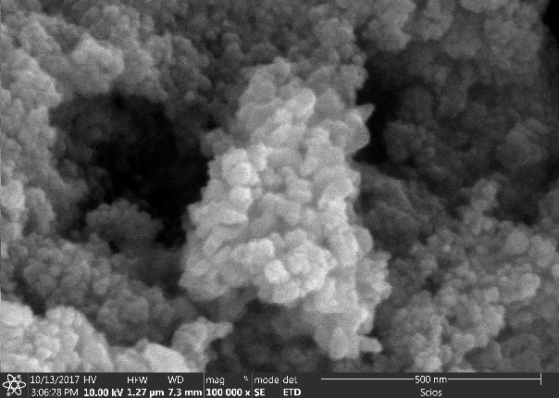  (A) | 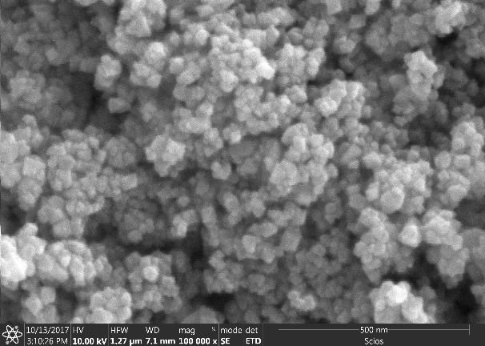  (B)
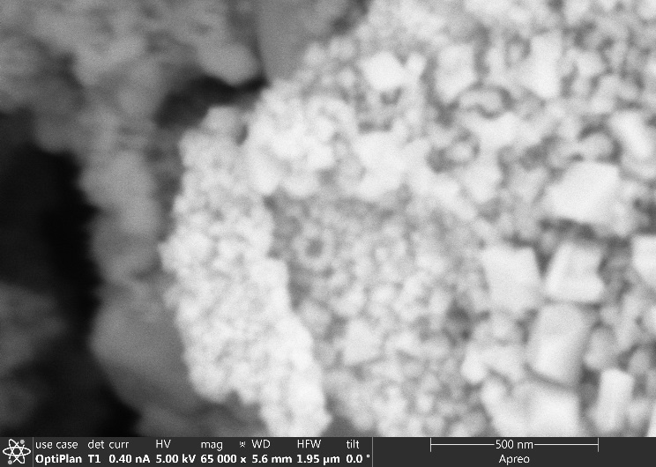  (C) | 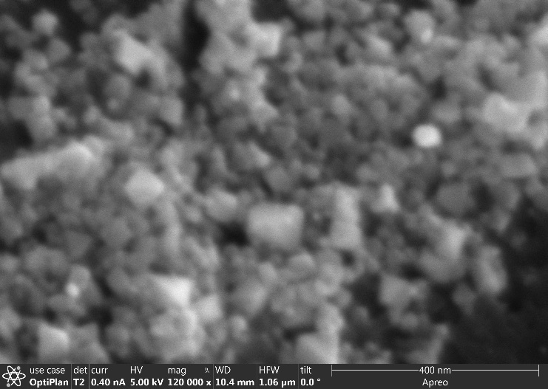  (D)

Fig. 2
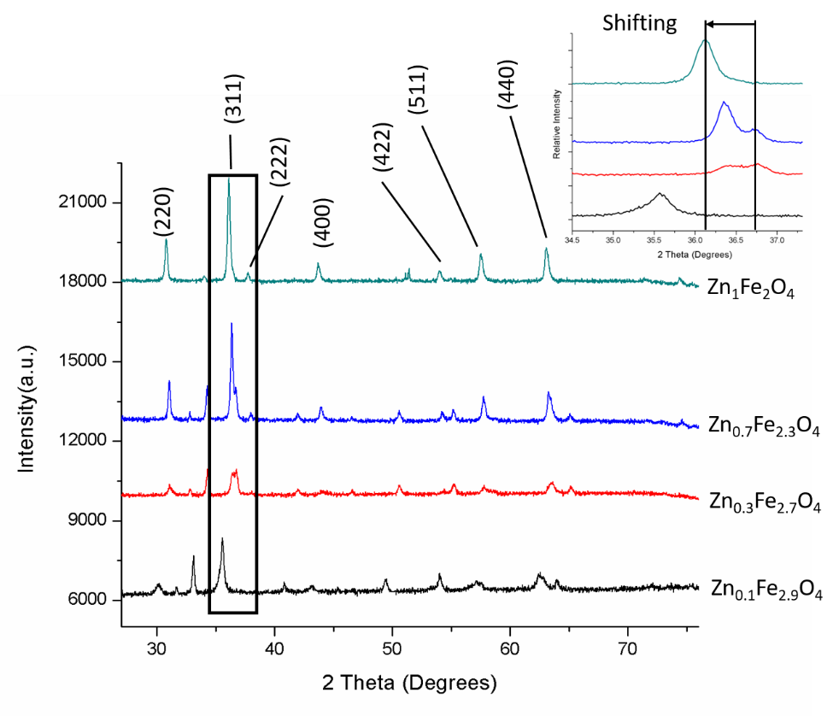

Fig. 3
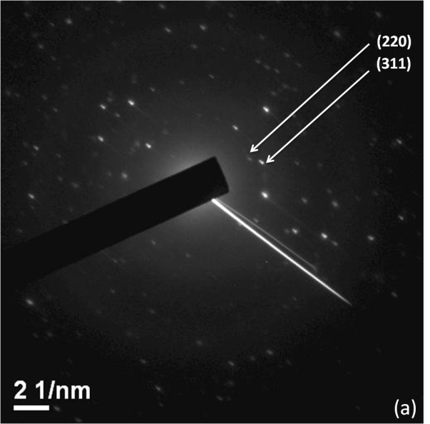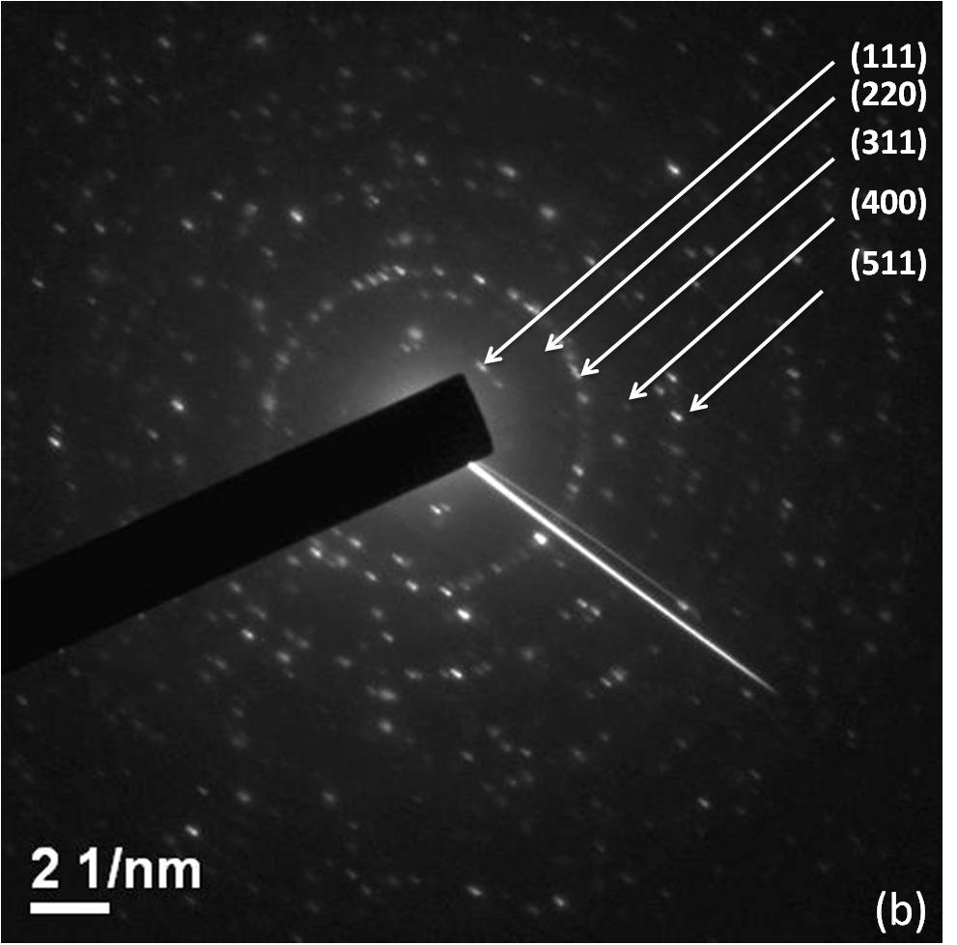
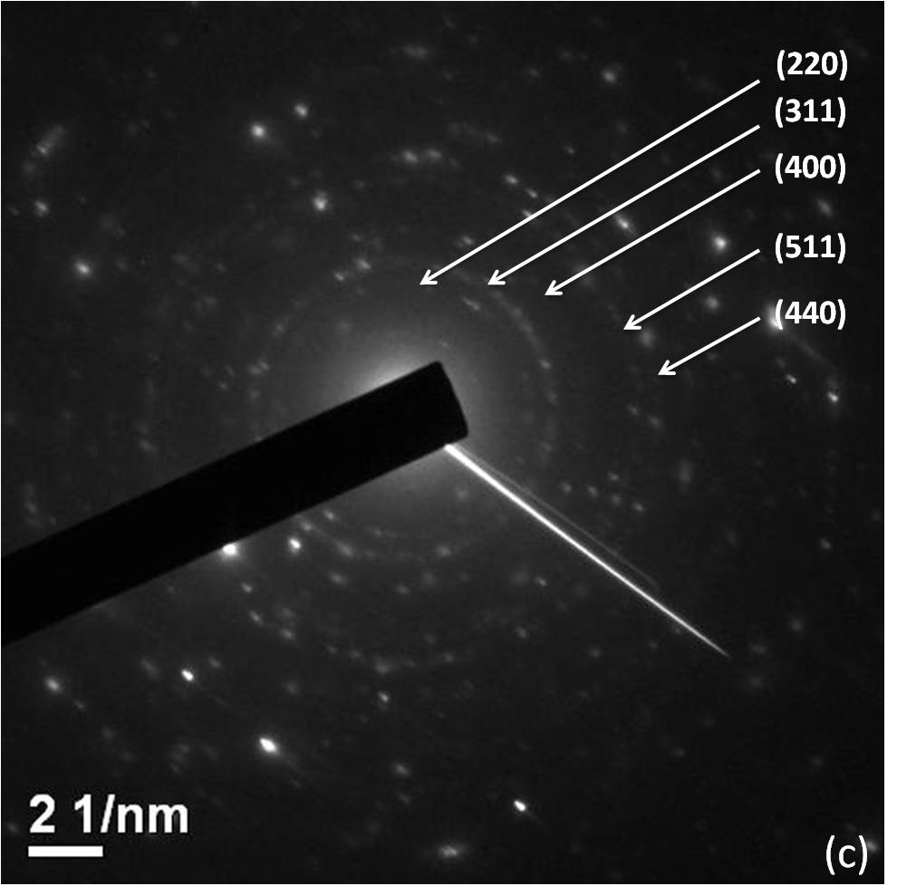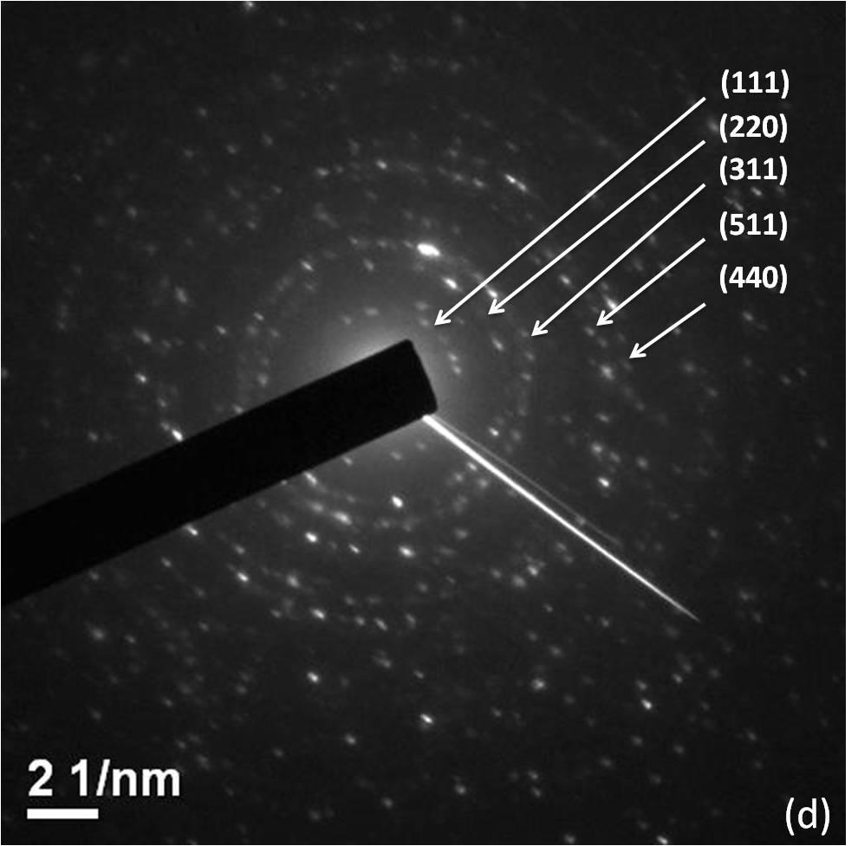

Fig. 4
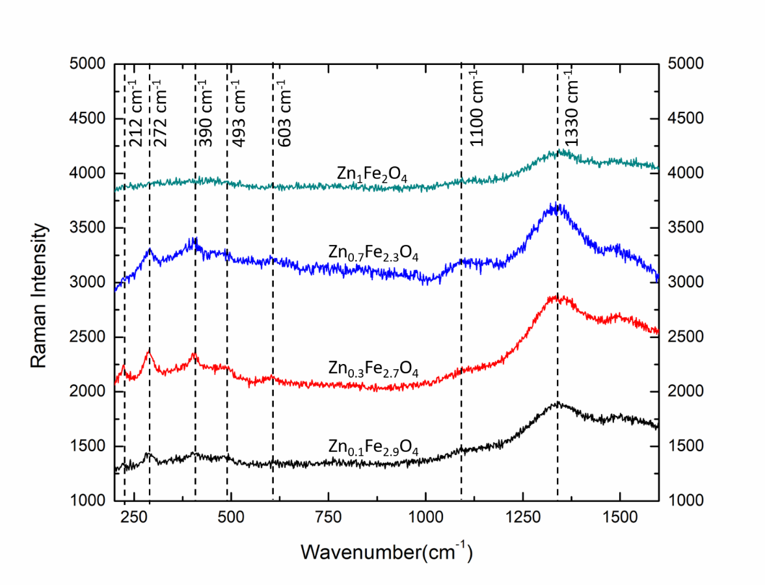

Fig. 5

Fig. 6 (A&B)

Fig. 7

Fig. 8 (A&B)

Fig. 9

Fig. 10 (A&B)

Scheme 1.
Scheme 2.

Scheme 3

Table 1
 |  | a |  | b |  | c |  | d
 |  | Zn_{0.1}Fe_{2.9}O₄ (nm) |  | Zn_{0.3}Fe_{2.5}O₄ (nm) |  | Zn_{0.7}Fe_{2.3}O₄ (nm) |  | Zn_{1.0}Fe_{3.0}O₄ (nm)
[111] |  |  |  | 0.2463 |  |  |  | 0.2410
[220] |  | 0.1491 |  | 0.1445 |  | 0.1434 |  | 0.1450
[311] |  | 0.1250 |  | 0.1239 |  | 0.1214 |  | 0.1209
[400] |  |  |  | 0.1015 |  | 0.1034
[511] |  |  |  | 0.0845 |  | 0.0872 |  | 0.8417
[440] |  |  |  |  |  | 0.0809 |  | 0.0709
Mean(nm) |  | 0.1370 |  | 0.1401 |  | 0.1072 |  | 0.1338

Table 2

Parameter |  | Reading
EC |  | 1499 mS/cm
pH |  | 7.38
Temp. |  | 27.7 °C
ORP |  | +431 mv
TOC |  | 9.68 mg/L

Table 3

 | Zn Edge |  |  |  |  |  |  |  |  | Fe Edge
 | Franklinite |  |  |  | Zn_{1.0}Fe_{2.0}O₄ |  |  |  |  | Franklinite |  |  |  | Zn_{1.0}Fe_{2.0}O₄
 | CN | R (Å) | σ² (Å) |  | CN | R (Å) | σ² (Å) |  |  | CN | R (Å) | σ² (Å) |  | CN | R (Å) | σ² (Å)
Zn-O₁ | 4.00 | 2.00 | 0.003 |  | 4.28 | 2.03 | 0.004 |  | Fe-O₁ | 6.00 | 2.02 | 0.004 |  | 5.97 | 2.02 | 0.007
Zn-Fe₂ | 12.00 | 3.50 | 0.001 |  | 11.92 | 3.51 | 0.004 |  | Fe-Fe₂ | 6.00 | 2.99 | 0.005 |  | 5.97 | 3.00 | 0.006
Zn-O₂ | 12.00 | 3.53 | 0.002 |  | 11.60 | 3.58 | 0.002 |  | Fe-O₂ | 2.00 | 3.49 | 0.002 |  | 2.04 | 3.54 | 0.001
Zn-Zn₂ | 4.00 | 3.66 | 0.002 |  | 4.07 | 3.73 | 0.001 |  | Fe-Zn₂ | 6.00 | 3.50 | 0.004 |  | 6.22 | 3.61 | 0.006
Zn-O₃ | 12.00 | 4.49 | 0.005 |  | 12.61 | 4.51 | 0.006 |  | Fe-O₂ | 6.00 | 3.72 | 0.006 |  | 5.99 | 3.79 | 0.003
Zn-O₄ | 12.00 | 5.35 | 0.006 |  | 12.70 | 5.56 | 0.006 |  | Fe-O₃ | 12.00 | 4.68 | 0.006 |  | 11.84 | 4.70 | 0.004
Zn-Fe₄ | 16.00 | 5.48 | 0.007 |  | 15.59 | 5.49 | 0.007 |  | Fe-O₃ | 12.00 | 4.85 | 0.007 |  | 12.35 | 4.96 | 0.009
Zn-O₄ | 4.00 | 5.65 | 0.002 |  | 4.88 | 5.63 | 0.003 |  | Fe-Fe₃ | 12.00 | 5.17 | 0.003 |  | 12.55 | 5.18 | 0.009
Zn-Zn₄ | 12.00 | 5.97 | 0.005 |  | 12.85 | 5.99 | 0.006 |  | Fe-Zn₃ | 8.00 | 5.48 | 0.007 |  | 8.48 | 5.54 | 0.008
 |  |  |  |  |  |  |  |  | Fe-Fe₄ | 12.00 | 5.97 | 0.006 |  | 11.61 | 5.95 | 0.007
ΔE (eV) | 1.723 |  |  |  | 1.921 |  |  |  | ΔE (eV) | 3.547 |  |  |  | 3.396
S₀² | 0.85 |  |  |  | 0.85 |  |  |  | S₀² | 0.85 |  |  |  | 0.85
R-Factor | 0.009 |  |  |  | 0.013 |  |  |  | R-Factor | 0.007 |  |  |  | 0.012
Table 3. Optimized parameters of Zn and Fe K-edge XAFS data of natural franklinite and sample Zn_{1.0}Fe_{2.0}O₄. CN is coordination number, R is radial distance, and σ² is the Debye-Waller factor. CN for franklinite was fixed to calculated values and S₀² was fixed to 0.85.

