Supporting Information for

Estimates of present and future asthma emergency department visits associated with exposure to oak, birch, and grass pollen in the United States

James E. Neumann¹, Susan Anenberg², Kate R. Weinberger³, Meredith Amend¹, Sahil Gulati¹, Allison Crimmins⁴, Henry Roman¹, Neal Fann⁵, and Patrick L. Kinney⁶

¹Industrial Economics, Inc., Cambridge, Massachusetts, USA, ²George Washington University, Washington, District of Columbia, USA, ³Department of Epidemiology, Brown University School of Public Health, Providence, Rhode Island, USA, ⁴U.S. Environmental Protection Agency, Washington, District of Columbia, USA, ⁵U. . Environmental Protection Agency, Research Triangle Park, North Carolina, USA, ⁶School of Public Health, Boston University, Boston, Massachusetts, USA

Contents of this file

Figures S-1 to S-5
Tables S-1 to S-7
References for Table S-1 to S-3

Introduction

This supporting information includes:

- additional detail on the analytic flow to support the main text methods section (Figure S-1);
- additional detail on studies that support the epidemiology literature review for oak, birch, and grass, including a full reference list (Tables S-1 to S3);
- estimates of pollen season length changes for oak (Figure S-2) – the same figure is provided in the main text but for birch and grass only;
- additional detail on estimated baseline (current climate) asthma emergency department visit incidence by age group, with 95% confidence intervals (Table S-4);
- asthma emergency department visits (all ages) in 2010 associated with 1994–2010 average birch (Figure S-3) and grass (Figure S-4) pollen levels – the same figure for oak was provided in Anenberg (2017);
- asthma emergency department visits (all ages) per 100,000 population in 2010 associated with 1994–2010 average grass pollen levels (Figure S-5, three panels, one for each pollen type);
- annual regional pollen-related asthma ED visits change from baseline for each RCP scenario, averaged across all five General Circulation Models, with detail by age group and region, and 95% confidence intervals (Tables S-5 to S-7).

Figure S-1: Conceptual diagram for analysis of asthma emergency department visits associated with current (Panel A) and future (Panel B) pollen under baseline (1994-2010 average) conditions and two climate scenarios.

Panel A: Current health burden estimate

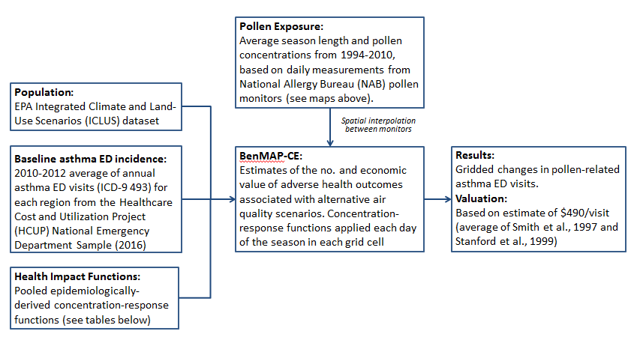

Panel B: Future health burden estimate

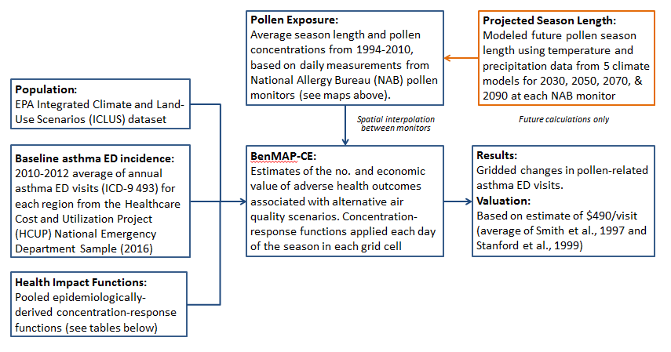
Table S-1: Studies documenting Exposure-response relationships for grass pollen and asthma ED visits

Study | Location | Exposure Definition(s) | Outcome Definition | Unit Increase (grains/m³) | Effect Estimate (Rate Ratio and 95% CI) per Unit Increase in Previous Column¹
Babin et al. 2007 | Washington, DC | Daily concentration | Daily asthma ED visits (age 1-17) | 10 | Age 1-17:  1.026 (1.003, 1.05) at lag 3  Age 5-12 only:  1.043 (1.009, 1.079) at lag 2  1.055 (1.022, 1.09) at lag 3
Darrow et al. 2012 | Atlanta, GA | 3-day average concentration | Daily all-ages (and age-stratified) asthma ED visits | 10 | All ages:  1.022 (1.012, 1.033)  Age 0-4:  1.006 (0.987, 1.026)  Age 5-17:  1.020 (1.001, 1.040)  Age 18+:  1.030 (1.017, 1.043)
Gleason et al. 2014 | New Jersey | Daily concentration, 3-day average concentration, 5-day average concentration | Daily asthma ED visits (age 3-17) | 10 | 1.02 (1.01, 1.03) for 5-day average
Heguy et al. 2008 | Montreal, QC | Daily concentration | Daily asthma ED visits (age 0-8) | 10 | 1.0167 (1.0018, 1.0319) at lag 3
Sun et al. 2016 | Wake County, NC | Daily concentration | Daily all-ages asthma ED visits | 10 | 1.03 (0.98, 1.09), cumulative association at lags 2-4
Zhong et al. 2006 | Cincinnati, OH | Daily concentration | Daily asthma ED visits and outpatient clinic visits (ages 1-18) | 100 | No statistically significant association; association not reported quantitatively
¹ The number of significant digits reported varies across studies.

Table S-2: Studies documenting Exposure-response relationships for birch pollen and asthma ED visits

Study | Location | Exposure Definition(s) | Outcome Definition | Unit Increase (grains/m³) | Effect Estimate (Rate Ratio and 95% CI) per Unit Increase in Previous Column¹
Darrow et al. 2012 | Atlanta, GA | 3-day average concentration | Daily all-ages asthma ED visits | 20 | 1.004 (0.993, 1.016)
Ito et al. 2015 | New York, NY | Daily log-transformed concentration | Cumulative all-ages (and age-stratified) asthma ED visits on the same day as the pollen concentration and up to 7 days afterward | 1680 | All ages:  1.344 (1.196, 1.512)  0-4:  0.935 (0.797, 1.097)  5-17:  2.008 (1.636, 2.464)  18-39:  1.366 (1.145, 1.630)  40-64:  1.223 (1.060, 1.412)  65+:  1.086 (0.869, 1.356)
- The number of significant digits reported varies across studies.

Table S-3: Studies documenting Exposure-response relationships for ragweed pollen and asthma ED visits
Study | Location | Exposure Definition(s) | Outcome Definition | Unit Increase (grains/m³) | Effect Estimate (Rate Ratio and 95% CI) per Unit Increase in Previous Column In Previous Column¹
Darrow et al. 2012 | Atlanta, GA | 3-day average concentration | Daily all-ages asthma ED visits | 15 | 1.001 (0.990, 1.013)
Gleason et al. 2014 | New Jersey | Daily concentration, 3-day average concentration, 5-day average concentration | Daily asthma ED visits (age 3-17) | 10 | Same day:  0.97 (0.96, 0.97)  1-day lag:  0.96 (0.96, 0.97)  3-day lag:  0.97 (0.96, 0.97)  3-day average:  0.95 (0.95, 0.96)  5-day average:  0.94 (0.94, 0.95)
Heguy et al. 2008 | Montreal, QC | Daily concentration | Daily asthma ED visits (age 0-8) | 10 | Same day:  1.0008 (0.9952, 1.0063)  1-day lag:  1.0011 (0.9957, 1.0066)  2-day lag:  0.9959 (0.9904, 1.0014)  3-day lag:  0.9939 (0.9885, 0.9994)  4-day lag:  1.0000 (0.9948, 1.0053)  5-day lag:  0.9954 (0.9921, 1.0006)  6-day lag:  0.9935 (0.9884, 0.9987)
Zhong et al. 2006 | Cincinnati, OH | Daily concentration | Daily asthma ED visits and outpatient clinic visits (ages 1-18) | 100 | 1.54 (1.02, 2.33) at lag 5
¹ The number of significant digits reported varies across studies.

Figure S-2: Estimates of Change in Pollen Season Length by Monitor for Oak

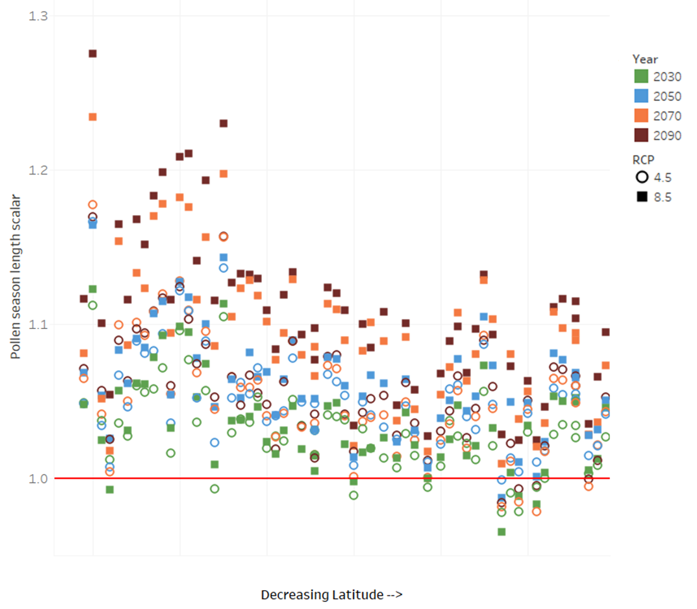

Table S-4: Baseline (1994-2010 pollen season with future population) annual pollen-related asthma emergency department visits by year

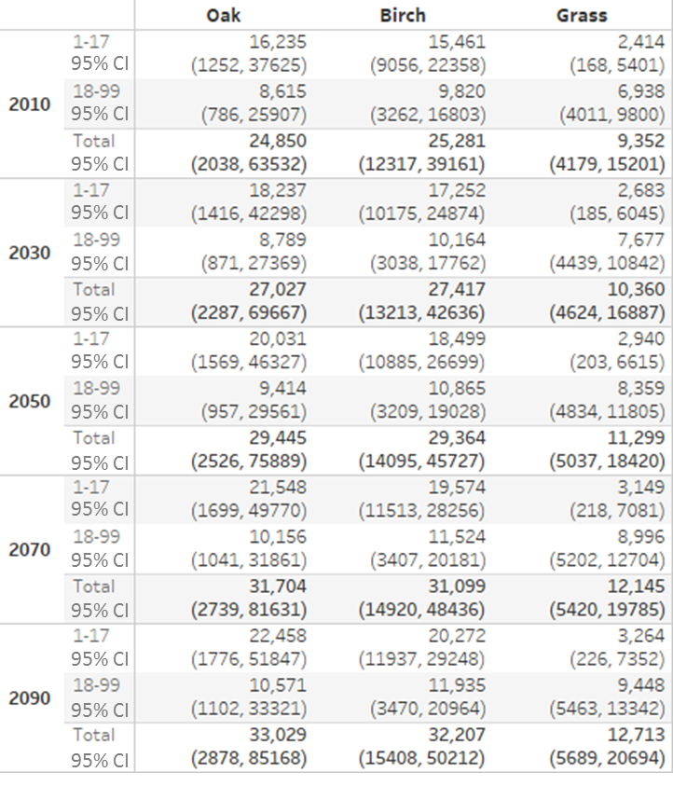

Figure S-3: Asthma emergency department visits (all ages) in 2010 associated with 1994–2010 average birch pollen levels. Black outline indicates the National Climate Assessment (NCA) regions used for this study.

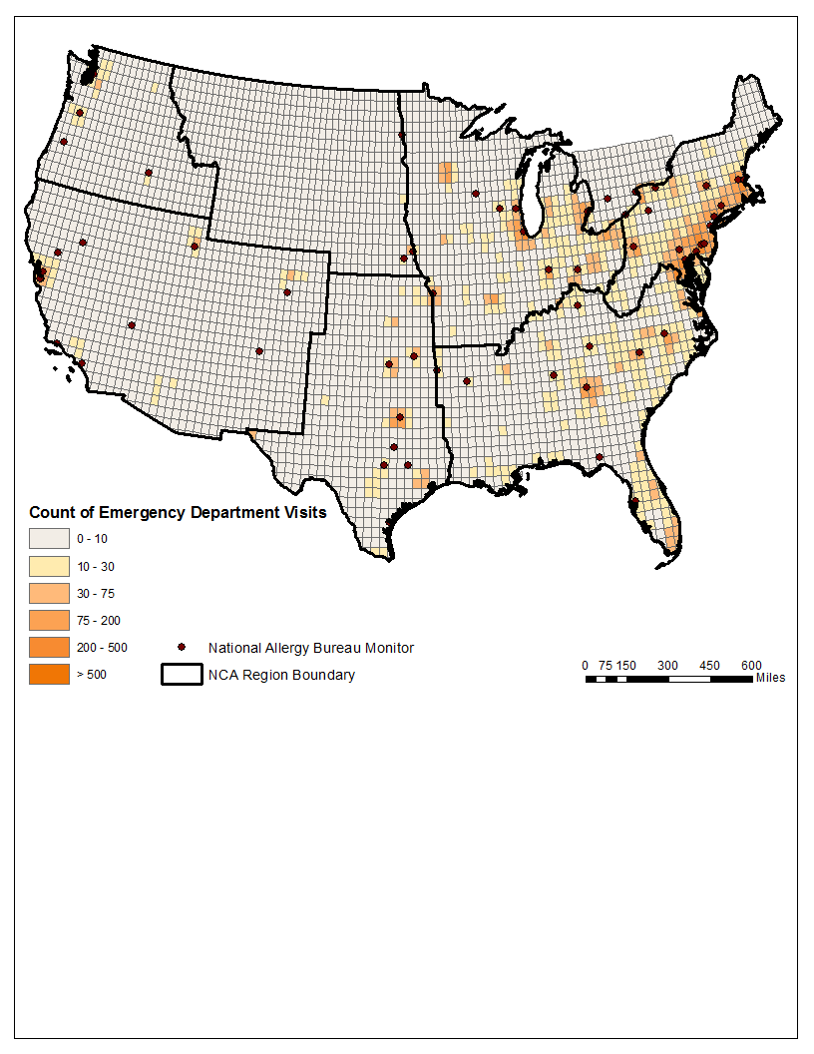
Figure S-4: Asthma emergency department visits (all ages) in 2010 associated with 1994–2010 average grass pollen levels. Black outline indicates the National Climate Assessment (NCA) regions used for this study.

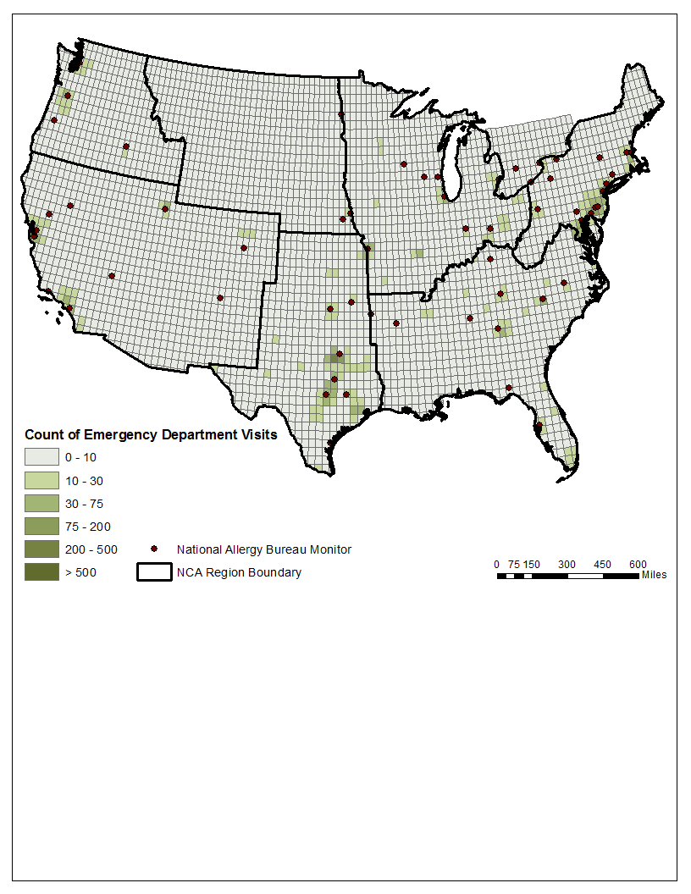

Figure S-5: Asthma emergency department visits (all ages) per 100,000 population in 2010 associated with 1994–2010 average grass pollen levels. Black outline indicates the National Climate Assessment (NCA) regions used for this study.

Panel A: Oak
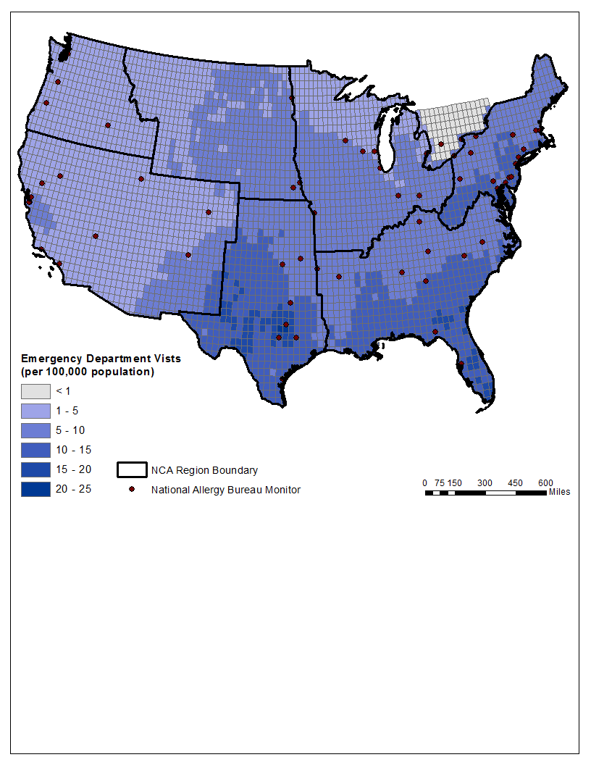

Panel B: Birch
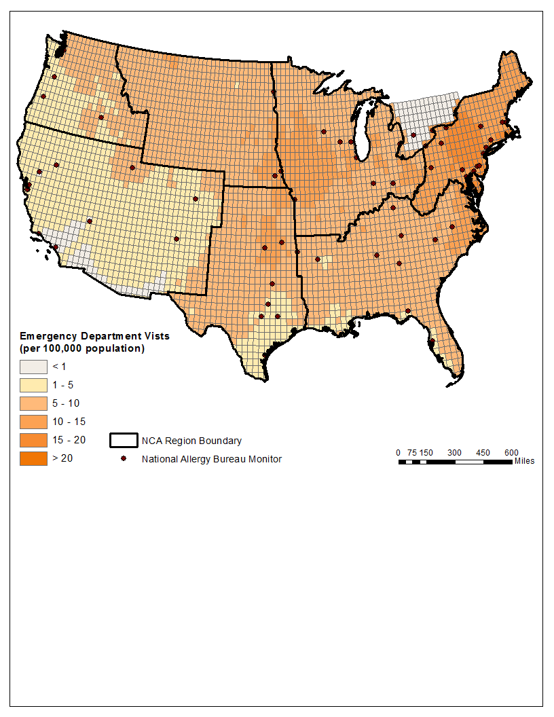

Panel C: Grass
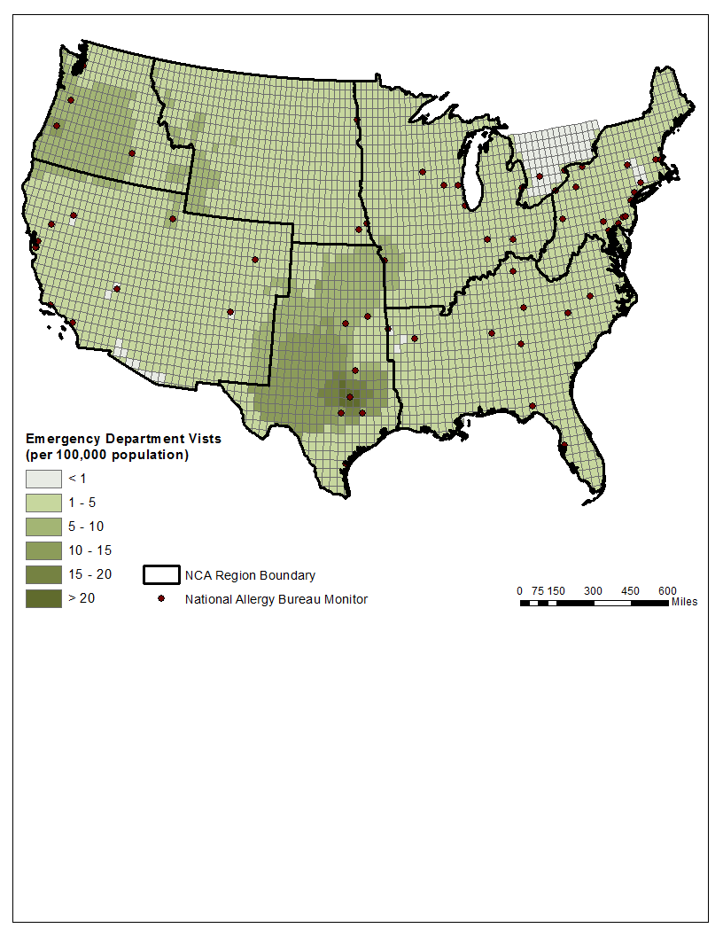
Table S-5: Annual regional oak pollen-related asthma ED visits change from baseline for each RCP scenario, averaged across all five General Circulation Models
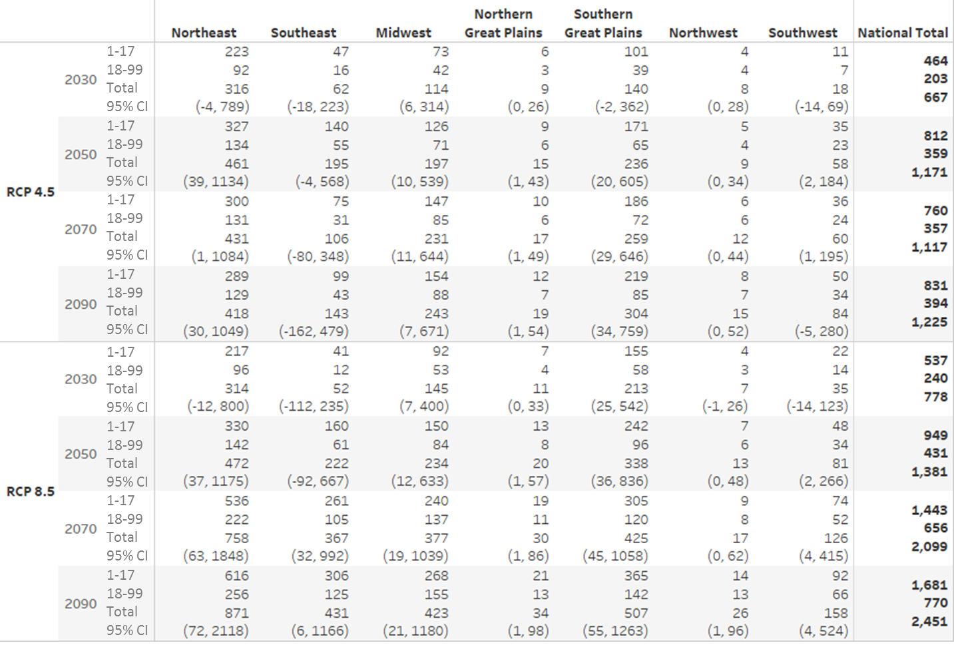
Table S-6: Annual regional birch pollen-related asthma ED visits change from baseline for each RCP scenario, averaged across all five General Circulation Models
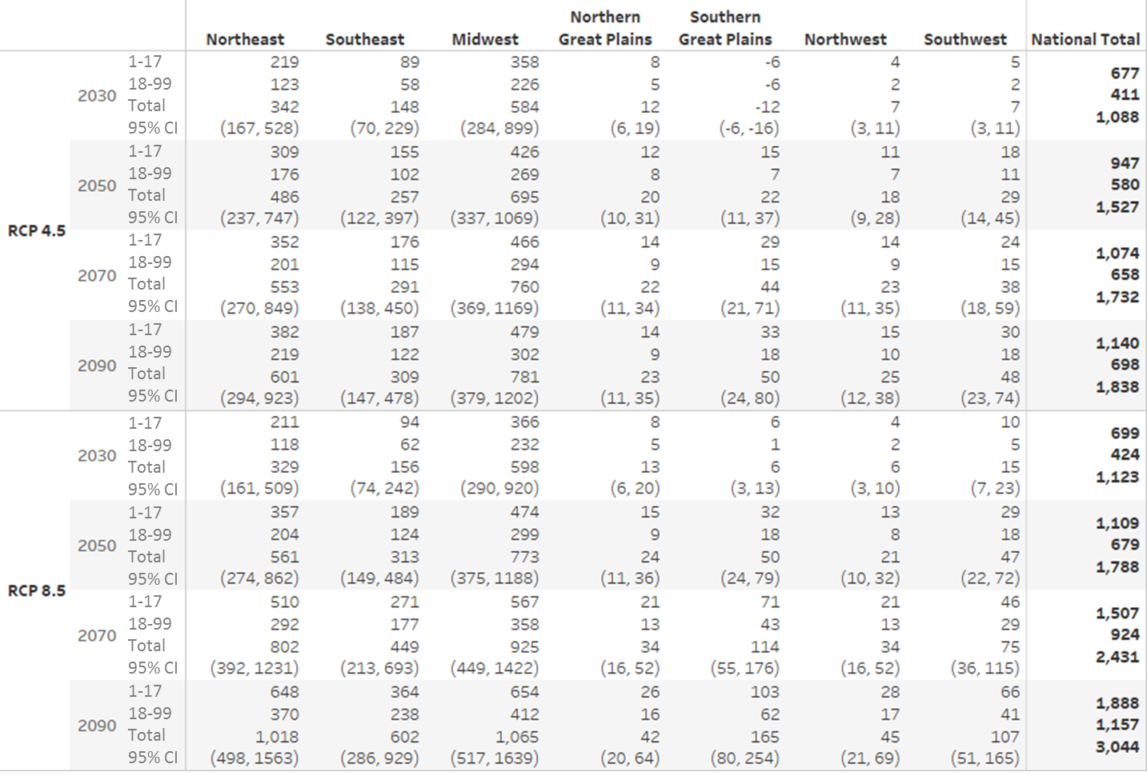
Table S-7: Annual regional grass pollen-related asthma ED visits change from baseline for each RCP scenario, averaged across all five General Circulation Models
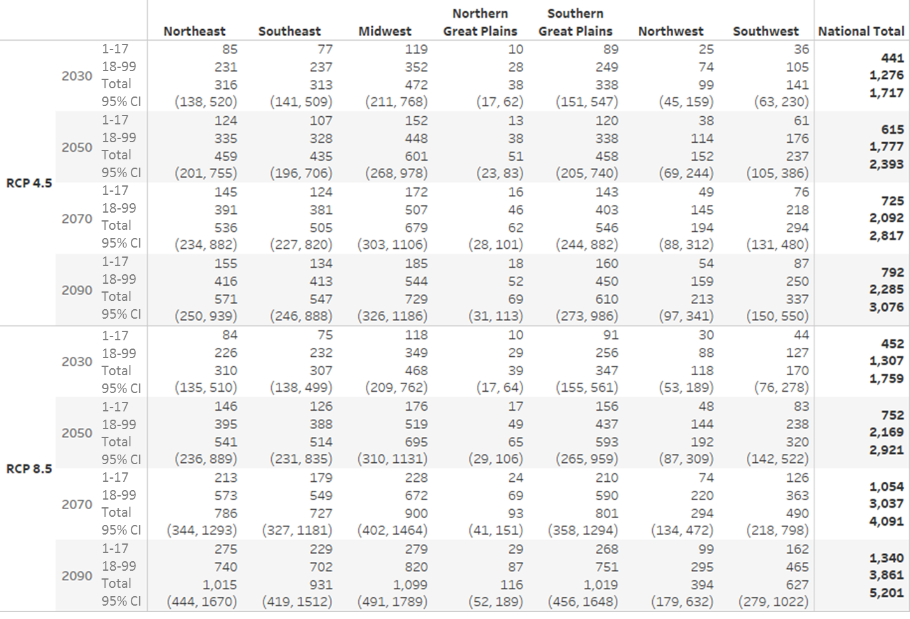

References
Babin SM, Burkom HS, Holtry RS, Tabernero NR, Stokes LD, Davies-Cole JO, DeHaan K, Lee DH. 2007. Pediatric patient asthma-related emergency department visits and admissions in Washington, DC, from 2001-2004, and associations with air quality, socio-economic status and age group. Environmental Health 6:9.
Darrow LA, Hess J, Rogers CA, Tobert PE, Klein M, Sarnat SE. 2012. Ambient pollen concentrations and emergency department visits for asthma and wheeze. Journal of Allergy and Clinical Immunology 130:630-638.
Gleason JA, Bielory L, Fagliano JA. 2014. Associations between ozone, PM2.5, and four pollen types on emergency department pediatric asthma events during the warm season in New Jersey: A case-crossover study. Environ Res 132:421-429.
Heguy L, Garneau M, Goldberg MS, Raphoz M, Guay F, Valois M-F. 2008. Associations between grass and weed pollen and emergency department visits for asthma among children in Montreal. Environmental Research 106(2): 203-211.
Ito K, Weinberger KR, Robinson GS, Sheffield PE, Lall R, Mathes R, et al. 2015. The associations between daily spring pollen counts, over-the-counter allergy medication sales, and asthma emergency department visits syndrome in New York City, 2002-2012.
Sun X, Waller A, Yeatts KB, Thie L. 2016. Pollen concentration and asthma exacerbations in Wake County, North Carolina, 2006-2012. Science of the Total Environment 544:185-191.
Zhong W, Levin L, Reponen T, Hershey GK, Adhikari A, Shukla R, et al. 2006. Analysis of short-term influences of ambient aeroallergens on pediatric asthma hospital visits. Science of the Total Environment 370:330-336.

