Supporting Information

Reactivity of Graphene Oxide with Reactive Oxygen Species (Hydroxyl Radical, Singlet Oxygen, and Superoxide Anion)

*Hsin-Se Hsieh†, Richard Zepp*,††*

*†*National Research Council Associate, National Exposure Research Laboratory, Ecosystem Research Division, U.S. Environmental Protection Agency, Athens, Georgia 30605, United States

*††*National Exposure Research Laboratory, Ecosystem Research Division, U.S. Environmental Protection Agency, Athens, Georgia 30605, United States

*Corresponding author. Phone: (706)355-8117. E-mail: zepp.richard@epa.gov

Pages: 13

Figures: S1-S9

**Chemicals**

Iron(III) perchlorate hydrate (<0.005% Cl-), rose bengal (RB, 92%), furfuryl alcohol (FFA, 98%), 4-chlorobenzoic acid (pCBA, 99%), terephthalic acid (TPA, 98%), 2-hydroxyterephthalic acid (HTA, 97%), potassium hydrogen phthalate (99.95%), *N,N*-diethyl-*p*-phenylenediamine sulfate salt (DPD, 98%), 1,10-Phenanthroline (99%), β-Nicotinamide adenine dinucleotide reduced disodium salt hydrate (NADH, 97%), phenazine methosulfate (PMS, 90%), XTT sodium salt (90%), Nitrotetrazolium blue chloride (NBT2+, 98%), horseradish peroxidase (HRP), superoxide dismutase (SOD) from bovine erythrocytes were obtained from Sigma-Aldrich (St. Louis, MO)**.** Sodium oxalate, hydrogen peroxide (30%), hydroxylamine hydrochloride (96%), Potassium Phosphate Monobasic, and Potassium Phosphate Dibasic were purchased from Thermo Fisher Scientific Inc. (Pittsburgh, PA).

**Competition Kinetics for Superoxide Anion**

At pH 8, the 2 µM PMS-catalyzed oxidation of NADH to $O_{2}^{∙-}$ followed pseudo-first order kinetics with a rate constant $k_{NADH}$ of 0.255 min-1 in the presence of probe (NBT or XTT),

$NADH\underset{→}{PMS, k_{NADH}}O_{2}^{∙-}$ (1)

The time-dependent $O_{2}^{∙-}$ production rate and NADH concentration are expressed as

$P_{O_{2}^{∙-}}=-\frac{d\left[NADH\right]}{dt}=k_{NADH}[NADH]$ (2)

$[NADH]={[NAHD]}_{0}e^{-k_{NADH}t}$ (3)

For the second order reaction of $O_{2}^{∙-}$ with XTT and GO,

$O_{2}^{∙-}+XTT\underset{→}{ k_{XTT}}XTT Formazan$ (4)

$O_{2}^{∙-}+GO\underset{→}{ k_{GO}}Product$ (5)

The total $O_{2}^{∙-}$ scavenging rate and XTT formazan (MF) production rate are written as

$S_{O_{2}^{∙-}}=\left(k_{XTT}\left[XTT\right]+k_{GO}\left[GO\right]\right){[O}_{2}^{∙-}]$ (6)

${P_{MF}=k}_{XTT}\left[XTT\right]{[O}_{2}^{∙-}]$ (7)

$-\frac{d\left[XTT\right]}{dt}=k_{XTT}[XTT]{[O}_{2}^{∙-}]$ (8)

Using quasi-steady-state approximation (QSSA), $P_{O_{2}^{∙-}}=S_{O_{2}^{∙-}}$

${2k}_{NADH}[NADH]=\left({ k}_{XTT}\left[XTT\right]+k_{GO}\left[GO\right]\right){[O}_{2}^{∙-}]$ (9)

${[O}_{2}^{∙-}]=\frac{2k_{NADH}[NADH]}{{ k}_{XTT}\left[XTT\right]+k_{GO}\left[GO\right]}$ (10)

Using ${[O}_{2}^{∙-}]$ in eq 10 to substitute it in eq 7

$P_{MF}=\frac{\left({ k}_{XTT}\left[XTT\right]\right)\left(k_{NADH}[NADH]\right)}{{ k}_{XTT}\left[XTT\right]+k_{GO}\left[GO\right]}$ (11)

The absorbance ratio of MF in the absence and presence of GO equals to the integral of MF production rate, which could be simplified as et 12,

$\frac{∆A_{470,0}}{∆A_{470}}=\frac{\int{P_{MF,0}dt}}{\int{P_{MF}}dt}=\frac{\int{\left(k_{NADH}\left[NADH\right]\right)dt}}{\int{\left(\frac{\left(k_{XTT}\left[XTT\right]\right)\left(k_{NADH}\left[NADH\right]\right)}{{ k}_{XTT}\left[XTT\right]+k_{GO}\left[GO\right]}\right)dt}}=\frac{\int{{(\left[NADH\right]}_{0}e^{-k_{NADH}t}) dt}}{\int{\left(\frac{\left(k_{XTT}\left[XTT\right]\right){(\left[NADH\right]}_{0}e^{-k_{NADH}t})}{{ k}_{XTT}\left[XTT\right]+k_{GO}\left[GO\right]}\right)dt}}$

$\frac{∆A_{470,0}}{∆A_{470}}=\frac{\int{(e^{-k_{NADH}t}) dt}}{\int{\left(\frac{(e^{-k_{NADH}t})}{1+{(k}_{GO}\left[GO\right]/{ k}_{XTT}\left[XTT\right])}\right)dt}}$ (12)

in which ${\left[XTT\right]}_{t+dt}={\left[XTT\right]}_{t}-\left\{\frac{k_{NADH}{(\left[NADH\right]}_{0}e^{-k_{NADH}t})}{1+\left(k_{GO}\left[GO\right]/{ k}_{XTT}{\left[XTT\right]}_{t}\right)}\right\}dt$ by combining eq 8 and 10.

Since there is only one unknown parameter, $k_{GO}$, in each competition experiment for $O_{2}^{∙-}$,

the $k_{GO}$ value could be obtained from least square fitting by minimizing the sum of squared error (SSE) between predicted and measured ΔA470,0/ΔA470.

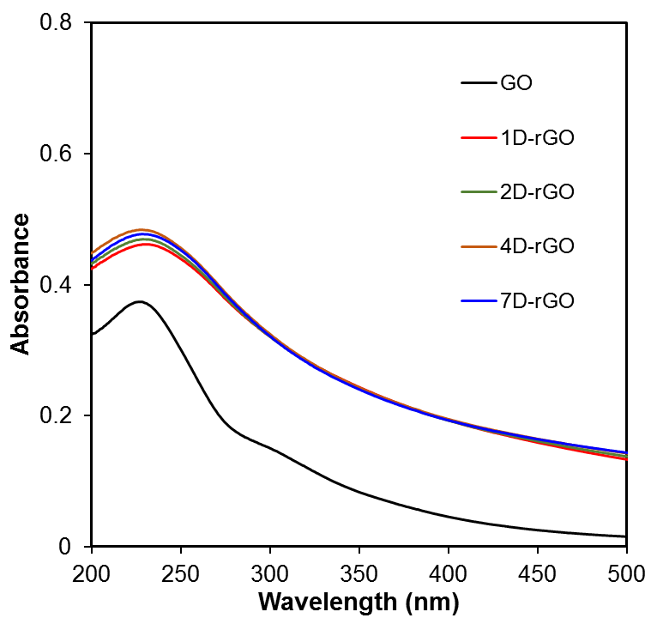

Figure S1. UV-vis absorbance of GO and photoreduced GO (rGO) at constant DOC concentration (4 mg-C/L).

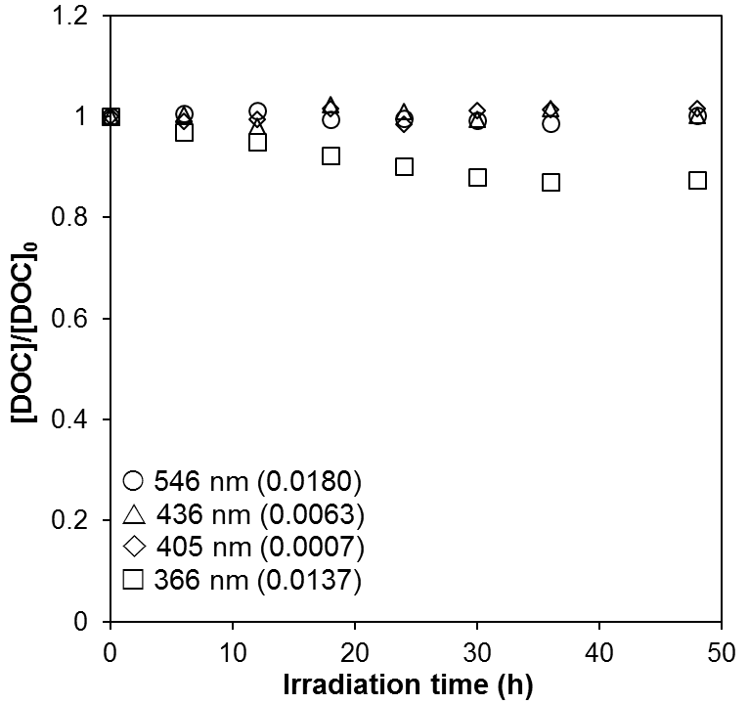

Figure S2. Temporal DOC trend of GO dispersions (15 mg/L) under exposure to light with different wavelength in MGRR. The values in parentheses are the light intensities in mol photons L-1 h-1 in 5 mL solution determined by ferrioxalate actinometry.

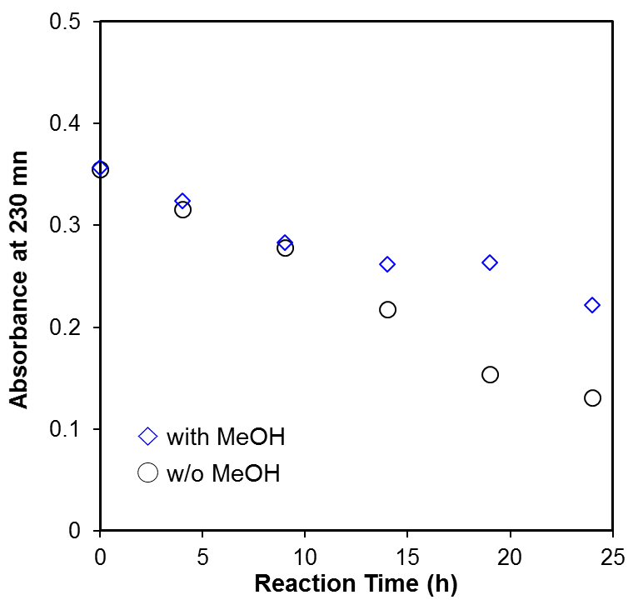

Figure S3. Effect of MeOH (10 mM) on the decrease of GO absorbance at 230 nm in the reaction with HO🞄 produced by photo-Fenton reaction described in Figure 1a.

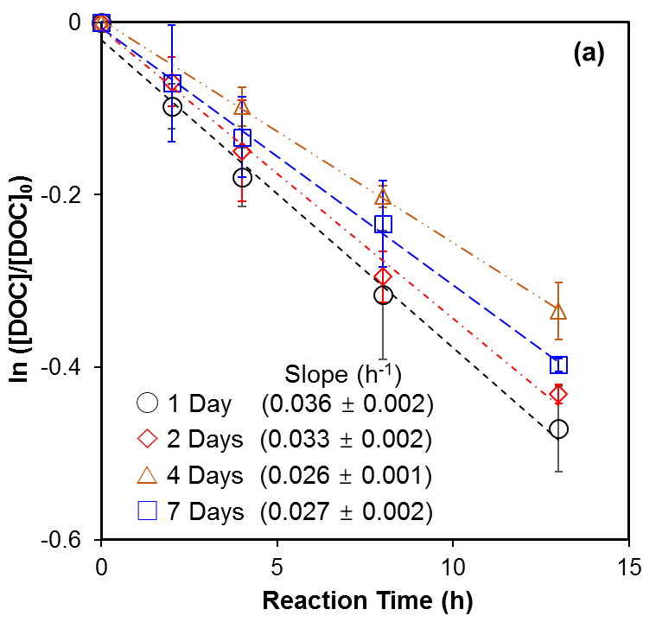

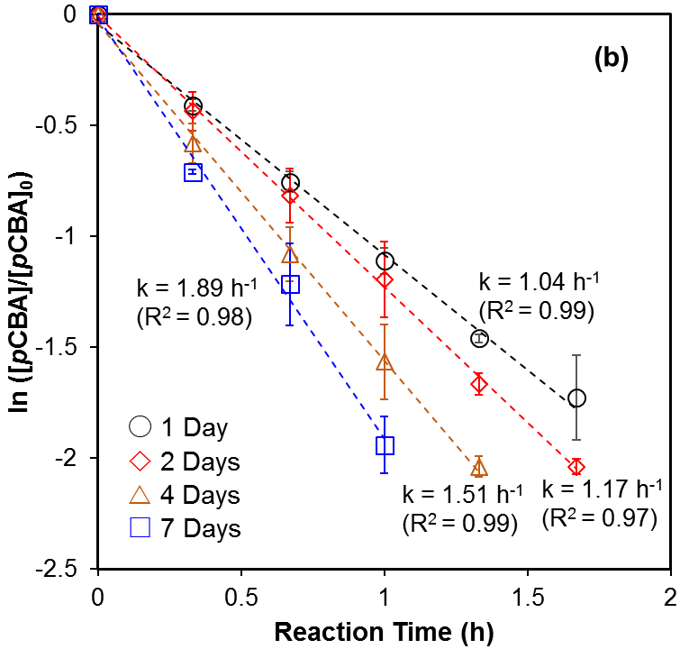

Figure S4. (a) DOC decays of photoreduced GO (rGO, ∼ 4 mg-C/L) in pH 4 dispersions containing 15 μM Fe(ClO4)3 and 10 mM H2O2 under irradiation at 436 nm. (b) Decay of *p*CBA (1.5 μM) added in the samples described in (a) The legends in both figures indicate how long the rGO had previously irradiated in full-spectrum solar simulator (Atlas CPS+).

|  |  |
| --- | --- |
|  | |
|  | |  | |
|  | |  | |

Figure S5. Effect of tert-butanol and rGO on steady state HO🞄 concentrations in the system of sodium oxalate (60 μM), Fe(ClO4)3 (1.5 μM), H2O2 (50 μM), MeOH (50 μM), and *p*CBA (0.5 μM) irradiated at 436 nm. The black dotted lines represent the linear regression fit, and the blue dotted lines are 95% confidence bands.

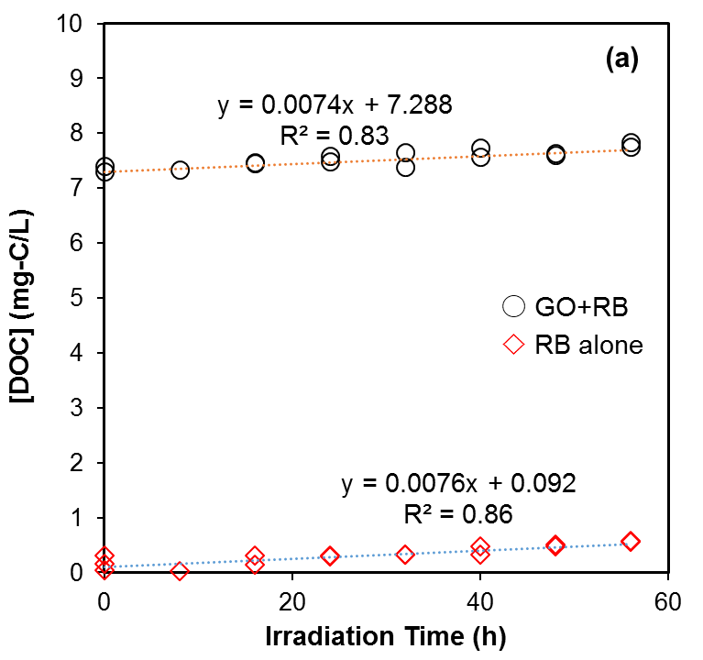

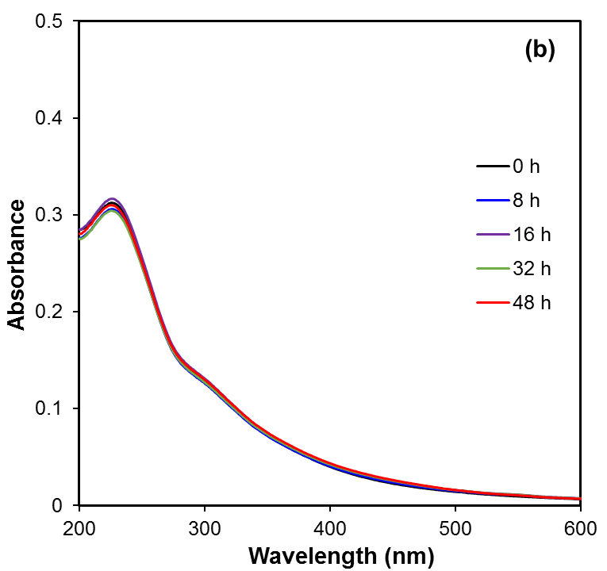

Figure S6. (a) DOC in the RB control samples and mixtures of GO (20 mg/L) and RB under irradiation at 546 nm. The increase of DOC in mixtures was attributed to the step-wise dose of RB (0.5 μM per 8 h). (b) UV-vis spectra of GO (10 mg/L) after continuous exposure to 1O2 ( ~ 6.9 🞨10-13 M) produced by photosensitization of step-wise dosed RB (0.5 μM per 8 h) under irradiation at 546 nm. Before UV-vis measurement, reacted RB was removed by ultrafiltration.

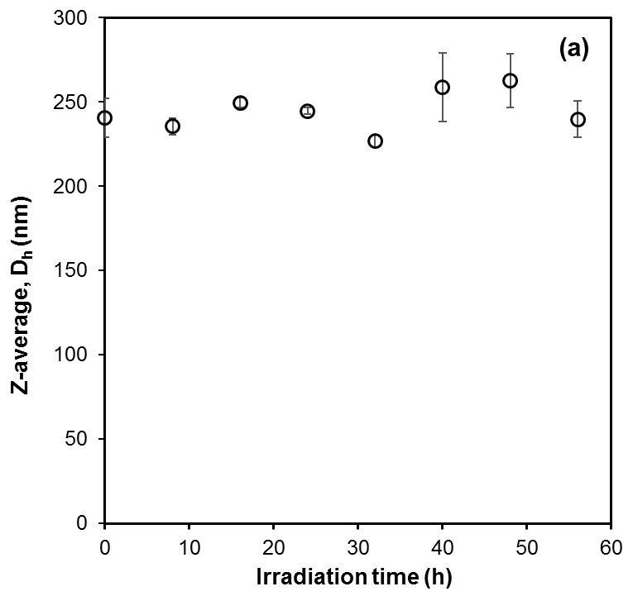

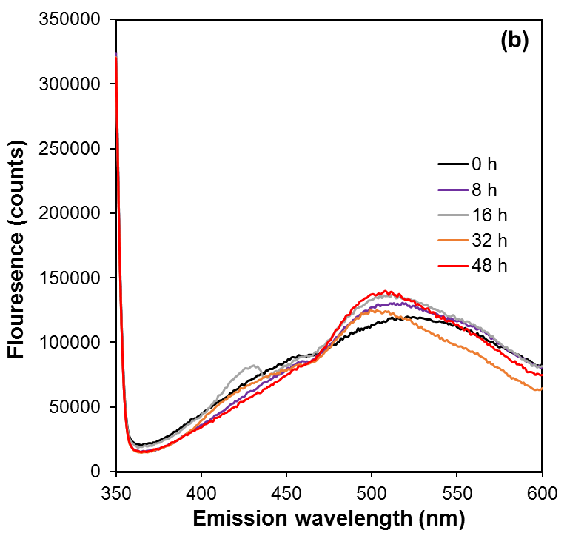

Figure S7. (a) Hydrodynamic diameter of GO after continuous exposure to 1O2 produced by photosensitization of step-wise dosed RB (0.5 μM per 8 h) under irradiation at 546 nm (c) Fluorescence of 1O2 reacted GO with excitation at 310 nm. Before measurement, reacted RB was removed by ultrafiltration.

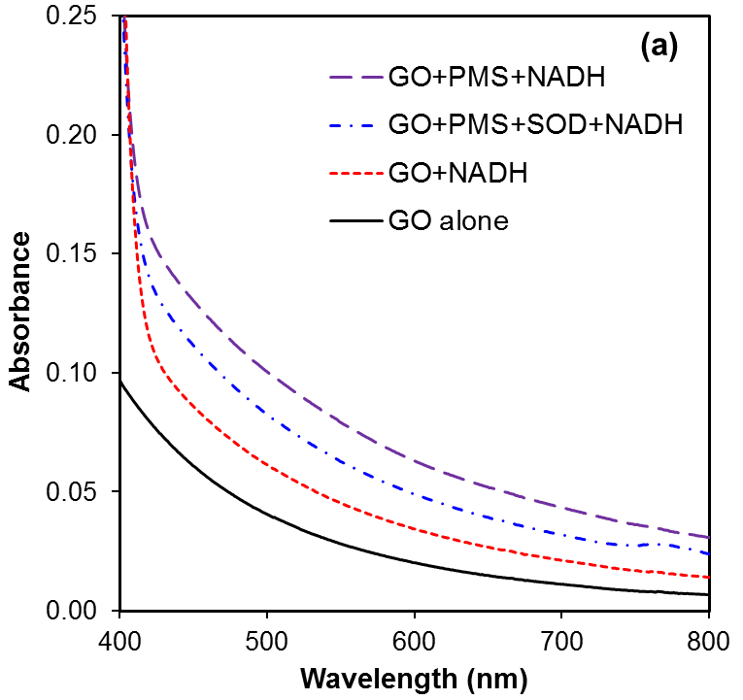

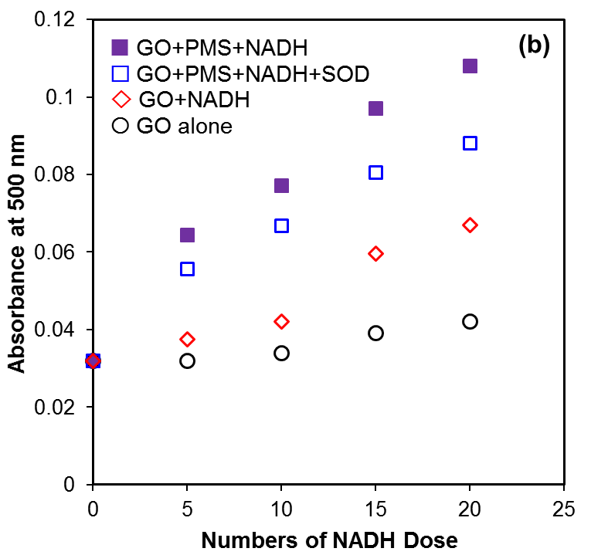

Figure S8. (a) Final absorbances of GO (15 mg/L) in the pH 8 dispersions containing PMS (1µM) and (or) SOD (40 U/mL) after sequentially adding NADH in a stepwise dose increment of 100 µM every 30 min for totally 20 times. (b) Temporal trends of GO absorbance at 500 nm. Note that the absorbance has been normalized to same sample volume (6 mL).

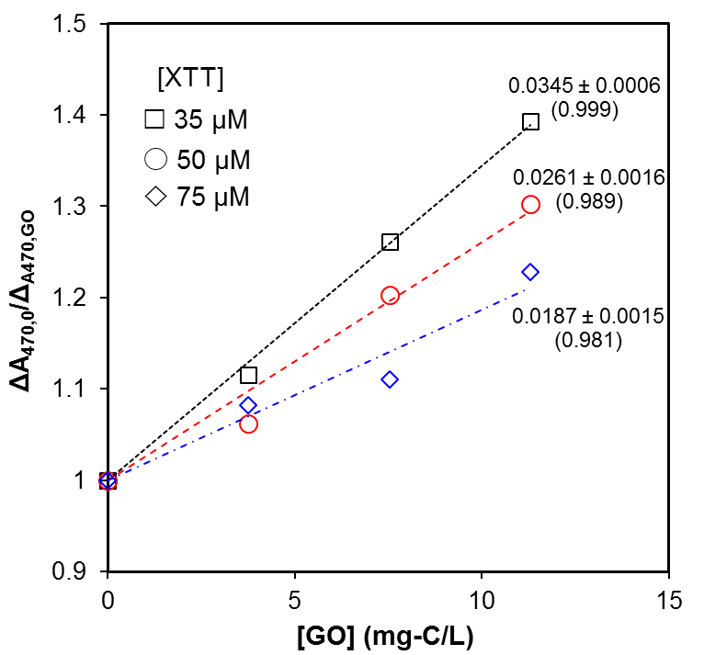

Figure S9. Inhibitory effect of GO on the formation of XTT formazan by superoxide anion in the presence of different initial XTT concentration (NADH = 20 μM; PMS = 2 μM; pH = 8).