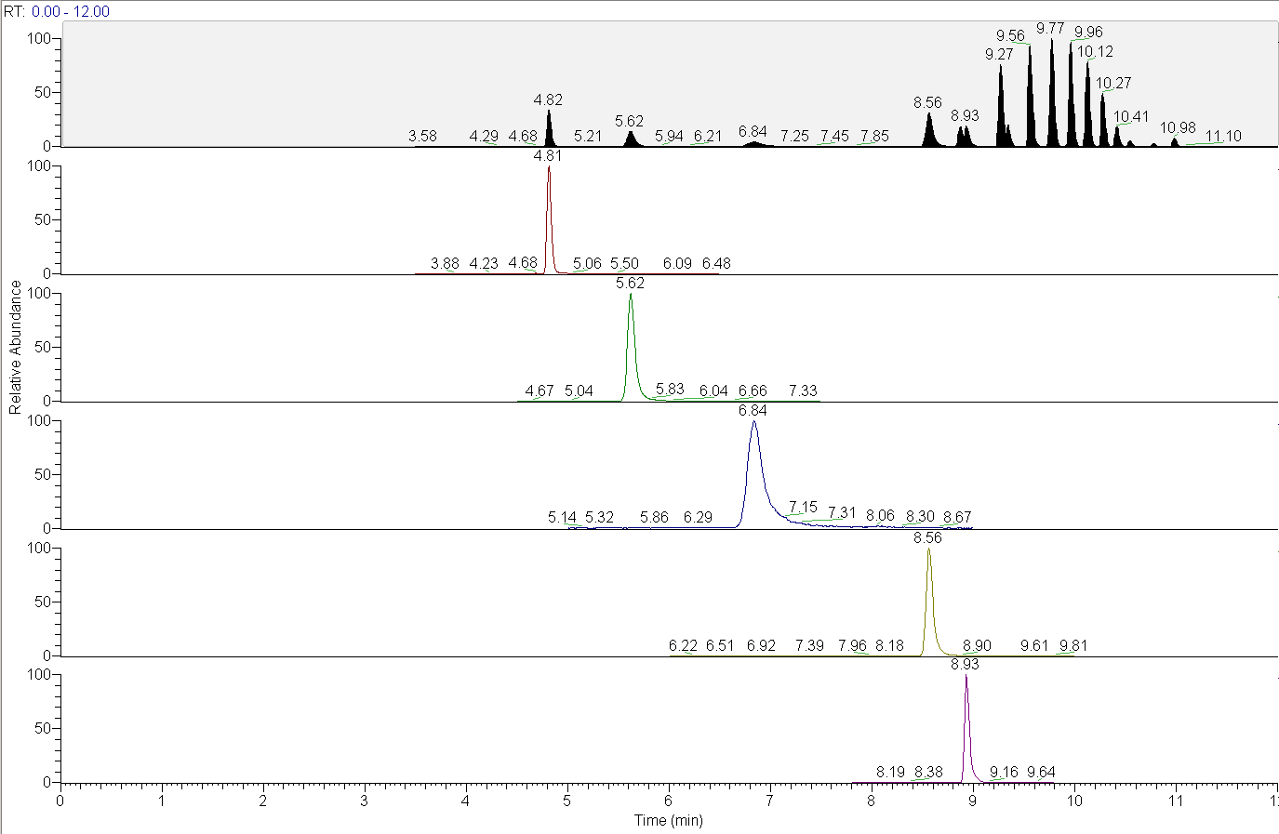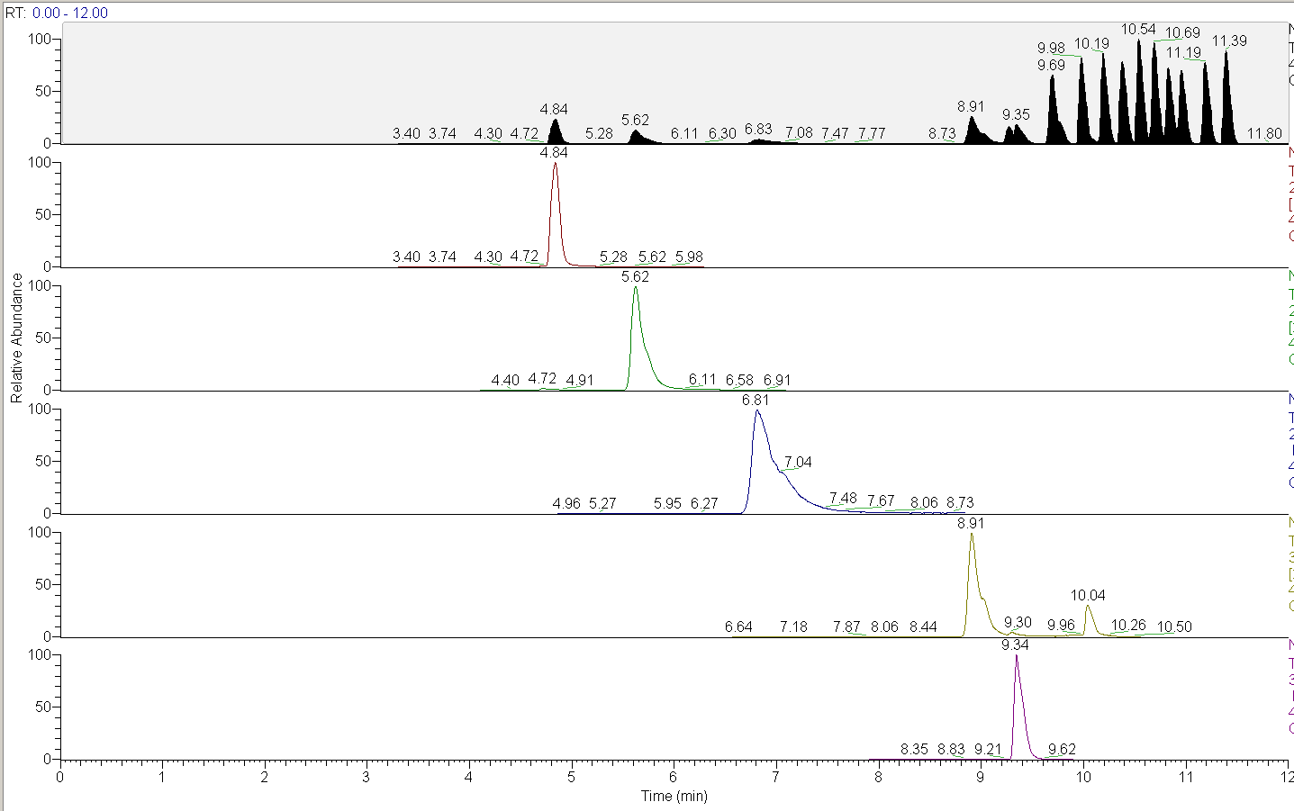
Figure S1. Decrease in column performance using an accucore C-18 2.1 x 50mm column, after 1 week of analysis with pH 10.5 aqueous mobile phase.

Figure S2. PFBA peak area as a function of concentration and injection volume. Some nonlinearity/saturation effects begin to appear with 5000 injection volumes, suggesting a decrease in retention efficiency.

Figure S3. When internal standard peak areas are included this nonlinearity is accounted for through reduced retention of isotopically labeled MPFBA, which behaves identically through the concentration and analysis processes. The result is an increase in low concentration sensitivity without compromising overall method limits.

Figure S4. Method performance for the C4 to C10 carboxylic acids and sulfonates is also consistent across injection volumes and concentrations.

(a)(b)
(c)

Figure S5. Chromatograms for samples prepared with 200 ng/L of all target PFAS and isotopically labeled standards, further spiked with (a): 10 ppb PFBA, PFBS, and b: 100 ppb PFBA. Effects of the high concentration analyte spikes are to broaden the peaks associated with the analyte and associated internal standards due to competition/saturation of the sorbent, and overloading of the analytical column.
(a) (b)
Figure S6. Chromatograms for samples spiked with 100 ug/L (a) and 10 ug/L (b) of Perfluorononanoic acid (PFNA), showing the effects on PFOA (red), MPFOA (green), PFNA (blue), MPFNA (yellow), PFOS (purple), and MPFOS (cyan). While the peaks for PFNA, MPFNA, PFOS, and MPFOS are significantly impacted in the sample fortified at 100 ug/L, the sample spiked at 10 ug/L is not.
Table S1. Absolute internal standard peak areas from PFAS spike recovery study. PFAS analytes were added at concentrations of 200 ng/L, and additional spikes were added of individual or mixes of PFAS compounds. The resulting effects on internal standard areas are shown in the table below, showing suppression of the corresponding internal standards and co-eluting peaks, but NOT other peaks.
Internal Standard Recovery, Avg. of N=3 | MPFBA | MPFBS | MPGenX | MPFHxS | MPFOA | MPFNA | MPFOS | MPFDA
200 ppt PFAS Mix | 222744 | 192801 | 92578 | 196058 | 192415 | 168969 | 254161 | 237258
200 ppt PFAS Mix + 10 ppb PFBA | 115522 | 176758 | 83310 | 190756 | 184631 | 157005 | 231670 | 226281
200 ppt PFAS Mix + 10 ppb PFBS | 204041 | 89218 | 87073 | 190934 | 187753 | 160732 | 231810 | 224592
200 ppt PFAS Mix + 10 ppb PFHxA | 184117 | 172438 | 78398 | 174701 | 172983 | 152060 | 226997 | 214691
200 ppt PFAS Mix + 10 ppb PFHxS | 175715 | 176424 | 83309 | 97797 | 171749 | 159338 | 239221 | 222184
200 ppt PFAS Mix + 10 ppb PFOA | 277911 | 234407 | 103199 | 227464 | 81968 | 178465 | 257730 | 265276
200 ppt PFAS Mix + 10 ppb PFOS | 278078 | 231389 | 102149 | 216983 | 208240 | 98401 | 140740 | 251534
200 ppt PFAS Mix + 10 ppb PFNA | 201382 | 183293 | 86921 | 188954 | 185947 | 65431 | 121655 | 217950
200 ppt PFAS Mix + 10 ppb GenX | 286794 | 241849 | 38970 | 216435 | 208816 | 185164 | 284792 | 267102
200 ppt PFAS Mix + 10 ppb PFBA and PFBS | 111835 | 85956 | 84986 | 177735 | 172293 | 154685 | 235014 | 212605
200 ppt PFAS Mix + 10 ppb PFHxA and PFHxS | 275347 | 230928 | 82561 | 96032 | 189626 | 175765 | 274156 | 252868
200 ppt PFAS Mix + 10 ppb PFOA and PFOS | 286918 | 242838 | 103622 | 222803 | 66205 | 91500 | 128858 | 246300
200 ppt PFAS Mix + 100 ppb PFBA | 43039 | 228700 | 104884 | 221226 | 207555 | 193750 | 289129 | 273959
200 ppt PFAS Mix + 100 ppb PFNA | 254504 | 205541 | 91160 | 204895 | 197312 | 13467 | 45378 | 159973

