**Contribution of regional-scale fire events to ozone and PM2.5 air quality estimated by photochemical modeling approaches**

**Supporting Information**

K. R. Baker1\*,

M. C. Woody2,

G. S. Tonnesen3,

W. Hutzell2,

H.O.T. Pye2,

M. R. Beaver1,

G. Pouliot2,

T. Pierce2

1 U.S. Environmental Protection Agency, Office of Air Quality Planning and Standards

109 TW Alexander Dr., Research Triangle Park, NC 27711

2 U.S. Environmental Protection Agency, Office of Research and Development

109 TW Alexander Dr., Research Triangle Park, NC 27711

3 U.S. Environmental Protection Agency, Region 8, 1595 Wynkoop Street, Denver, CO 80202

Table S-1. CMAQ v5.0.2 aerosol species, density assumption, visual index factor, and optical surrogate. See Table S-2 for refractive index associated with the optical surrogate name.



Table S-2. CMAQ v5.0.2 refractive index table for the sensitivity (top) and baseline (bottom) simulation. The values are dimensionless. The imaginary component indicates how much the medium attenuates light. The real component indicates how the medium affects the wavelength and speed relative to how much the medium refracts or bend light’s path.



Table S-3. Model performance metrics for O3, PM2.5 sulfate ion, PM2.5 nitrate ion, PM2.5 organic carbon, and PM2.5 elemental carbon across all sites in the model domain during the Wallow fire period and Flint Hills fire period. Hourly ozone estimates are matched with CASTNET monitors. Daily average speciated PM2.5 estimates are matched with IMPROVE monitors. This performance evaluation has not been subset in any way to match times and locations impacted by fires. This performance evaluation is intended only to provide context for the surrounding environment of the fires modeled here.



Model performance metrics used to compare observations and model predictions:

|  |  |
| --- | --- |
| Mean Bias | $$\frac{1}{N}*\sum{(Model-Observed)}$$ |
| Mean Error |  |
| Median Bias | Median(model-observed) |
| Median Error | Median(absolute(model-observed)) |

Figure S-1a. Model domain extent and daily centroid location of modeled Wallow and Flint Hills fires included in this model assessment.

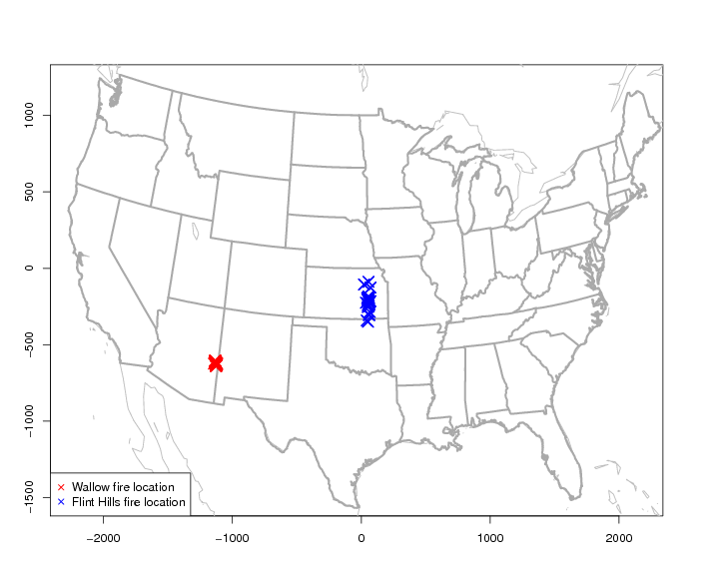

Figure S-1b. Daily centroid location of modeled Wallow and Flint Hills fires included in this model assessment. Routine surface monitors used in the fire impact evaluation are also shown.

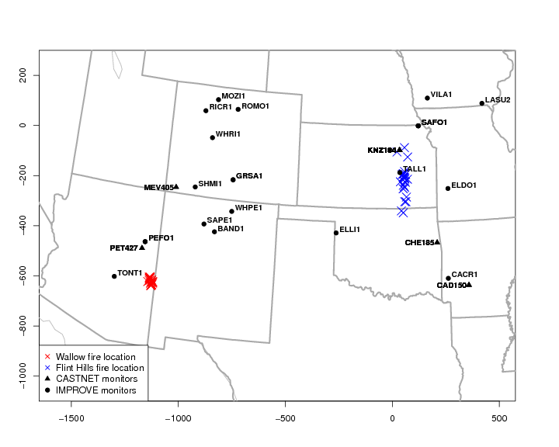

Figure S-2. Temporal profile used for wild and prescribed fire types to allocate daily emissions to hour of the day. These profiles represent the average at each hour of fractional allocation that varies slightly by State.



Figure S-3. HMS plots for the Wallow fire modeling period in June 2011.The HMS product is a column total smoke density and does not provide an estimate of surface layer O3 or PM2.5 impacts.

|  |  |
| --- | --- |
| K:\FILES_20140306\fires\source  contrib project\paper\revised submission\HMS plots\HMS_smoke_20110601.png | K:\FILES_20140306\fires\source  contrib project\paper\revised submission\HMS plots\HMS_smoke_20110602.png |
| K:\FILES_20140306\fires\source  contrib project\paper\revised submission\HMS plots\HMS_smoke_20110603.png | K:\FILES_20140306\fires\source  contrib project\paper\revised submission\HMS plots\HMS_smoke_20110604.png |
| K:\FILES_20140306\fires\source  contrib project\paper\revised submission\HMS plots\HMS_smoke_20110605.png | K:\FILES_20140306\fires\source  contrib project\paper\revised submission\HMS plots\HMS_smoke_20110606.png |

Figure S-4. HMS plots for the Flint Hills fire modeling period in April 2011. The HMS product is a column total smoke density and does not provide an estimate of surface layer O3 or PM2.5.

|  |  |
| --- | --- |
| K:\FILES_20140306\fires\source  contrib project\paper\revised submission\HMS plots\HMS_smoke_20110402.png | K:\FILES_20140306\fires\source  contrib project\paper\revised submission\HMS plots\HMS_smoke_20110403.png |
| K:\FILES_20140306\fires\source  contrib project\paper\revised submission\HMS plots\HMS_smoke_20110404.png | K:\FILES_20140306\fires\source  contrib project\paper\revised submission\HMS plots\HMS_smoke_20110405.png |
| K:\FILES_20140306\fires\source  contrib project\paper\revised submission\HMS plots\HMS_smoke_20110406.png | K:\FILES_20140306\fires\source  contrib project\paper\revised submission\HMS plots\HMS_smoke_20110407.png |

Figure S-4 continued. HMS plots for the Flint Hills fire modeling period in April 2011. The HMS product is a column total smoke density and does not provide an estimate of surface layer O3 or PM2.5.

|  |  |
| --- | --- |
| K:\FILES_20140306\fires\source  contrib project\paper\revised submission\HMS plots\HMS_smoke_20110408.png | K:\FILES_20140306\fires\source  contrib project\paper\revised submission\HMS plots\HMS_smoke_20110409.png |
| K:\FILES_20140306\fires\source  contrib project\paper\revised submission\HMS plots\HMS_smoke_20110410.png | K:\FILES_20140306\fires\source  contrib project\paper\revised submission\HMS plots\HMS_smoke_20110411.png |
| K:\FILES_20140306\fires\source  contrib project\paper\revised submission\HMS plots\HMS_smoke_20110412.png | K:\FILES_20140306\fires\source  contrib project\paper\revised submission\HMS plots\HMS_smoke_20110413.png |

Figure S-5. Maximum hourly contribution using ISAM and brute-force zero out for the Wallow fire event. Contributions shown for CO, precursor gases (NOX, SO2, NH3), primarily emitted PM2.5 species (EC and POA), and secondary pollutants (O3, PM2.5 sulfate ion, PM2.5 nitrate ion).

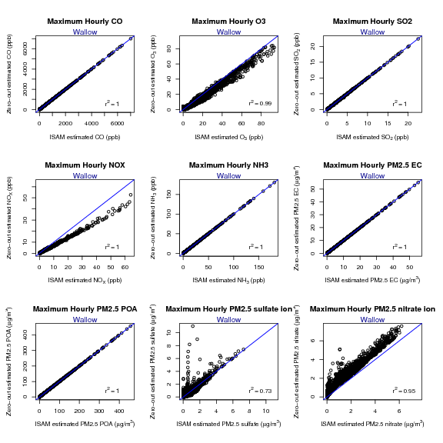

Figure S-6. Maximum hourly contribution using ISAM and brute-force zero out for the Flint Hills fire event. Contributions shown for CO, precursor gases (NOX, SO2, NH3), primarily emitted PM2.5 species (EC and POA), and secondary pollutants (O3, PM2.5 sulfate ion, PM2.5 nitrate ion).

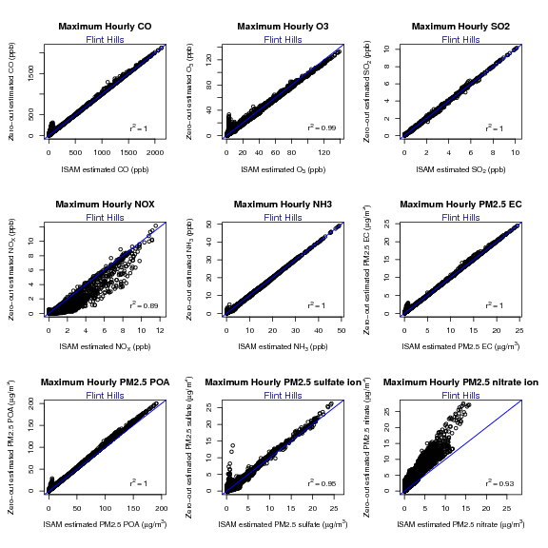

Figure S-7. Maximum hourly contribution using ISAM and brute-force (BF) zero out for the Wallow fire event. Contributions shown for O3, NOX, and PM2.5 nitrate ion for each approach and also the difference between approaches. Warm colors indicate the brute-force approach resulted in higher contribution. Cool colors indicate the source apportionment approach resulted in higher contribution.

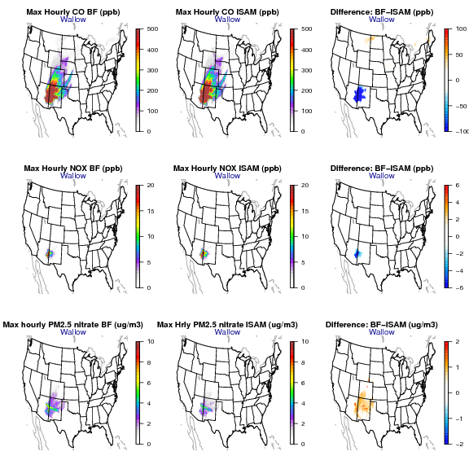

Figure S-8. Maximum hourly contribution using ISAM and brute-force (BF) zero out for the Flint Hills fire event. Contributions shown for O3, NOX, and PM2.5 nitrate ion for each approach and also the difference between approaches. Warm colors indicate the brute-force approach resulted in higher contribution. Cool colors indicate the source apportionment approach resulted in higher contribution.

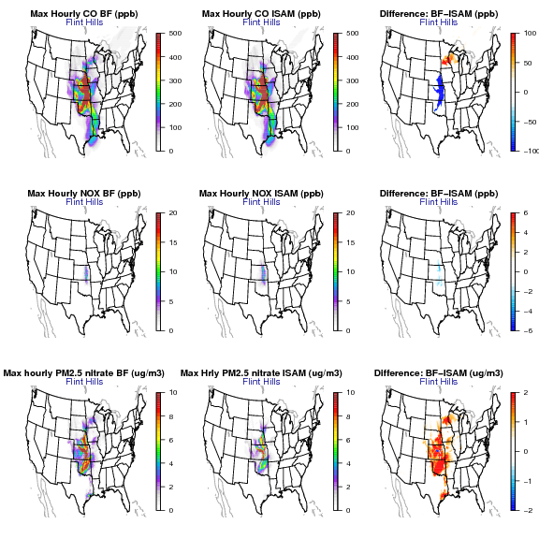

Figure S-9. HCHO production from 11 am to noon for June 4 and 5th for the scenario where Wallow fire emissions are zeroed-out (top row panels). The increase in HCHO and other aldehydes are shown for June 6 at 6 am (middle) and noon (bottom) local time. All results are surface level.

|  |  |
| --- | --- |
| zerowallow_HCHO_prod | zerowallow_HCHO_prod_june5 |
|  |  |
|  |  |

Figure S-10. Maximum hourly impacts from Wallow (top row) and Flint Hills (bottom row) fires to O3. The difference between the baseline simulation and sensitivity with reduced photolysis is also shown. Cool colors indicate less O3 contribution with the sensitivity simulation.

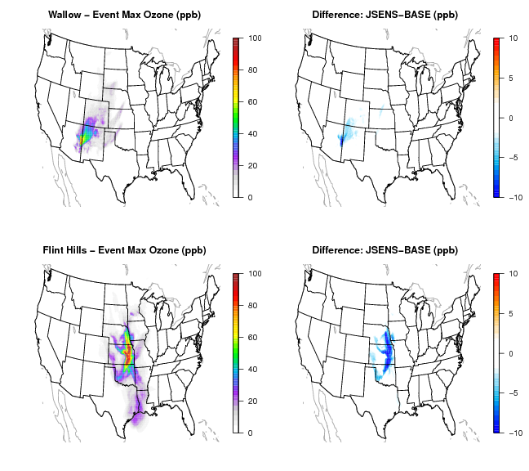

|  |
| --- |
|  |

Figure S-11. Hourly PM2.5 OA enhancement ratios with respect to CO by distance for AE6 and VBS approaches for both fires. The distribution of EC, OA, POA, and SOA are also shown with respect to CO.

