

Water Utility Climate Change Awareness and
Risk Assessment Tool
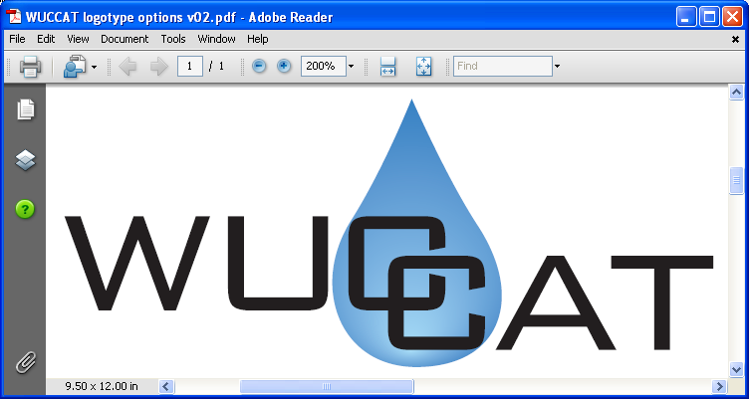

Software Requirements Specification

Draft Version 1.1
March 17, 2010

Prepared for
Water Security Division
Office of Ground Water and Drinking Water
Office of Water
U.S. Environmental Protection Agency

Under
EPA Contract No. EP-C-05-045
Technical, Analytical, and Regulatory Mission Support for the Water Security Division

For Official Use Only—Do Not Cite, Circulate, or Copy

Version History
Version Number | Description of Change | Change  Effective Date
Draft 1.0 | Initial draft | 03/03/2010
Draft 1.1 | Second draft, incorporated client comments | 03/17/2010

Table Of Contents
Section 1.0 Introduction 1
1.1 Identification and References 1
1.2 Document Purpose 1
1.3 Methodology 1
Section 2.0 Overview 2
2.1 Background Information 2
2.2 Application Goals 2
2.3 Operational Policies and Scope 3
2.4 Proposed Process 3
2.5 Assumptions and Constraints 4
2.6 Management Policies and Practices 5
2.7 Support Concept 5
2.8 Stakeholders and Users 5
2.9 Access 5
Section 3.0 Functional Requirements 6
3.1 Overview of Main Functions 6
3.2 Function Level Use Case Diagram 7
3.3 High-Level Function Breakdown 8
Section 4.0 System-Wide Requirements 68
4.1 Requirements 68
Section 5.0 Environment (Non-Functional) Requirements 69
5.1 User Interface Requirements 69
5.2 Integration/Migration Requirements 70
5.3 Software Requirements 70
5.4 Hardware Requirements 70
Section 6.0 Other Non-Functional Requirements 71
6.1 Business Continuity and Recovery Requirements 71
6.2 Performance Requirements 71
6.3 Safety Requirements 71
6.4 Administrative/Backup/Archive Requirements 71
6.5 Expected Life Span/Adaptability Requirements 72
6.6 Training/Tutorial Requirements 72
6.7 Documentation Requirements 72
6.8 Security and Privacy Requirements 72

Tables
Table 2-1. Stakeholders and Users 5
Table 3-1. Overview of Main Functions 6
Table 3-2. Define Criteria Use Case Briefs 8
Table 3-3. Requirements 9
Table 3-4. Interface Requirements 10
Table 3-5. Requirements 16
Table 3-6. Business Rules 17
Table 3-7. Interface Requirements: 17
Table 3-8. Utility Asset Libraries for all Utility Types 19
Table 3-9. Mapping of Fields from VSAT Asset Files to Import as WUCCAT Assets 20
Table 3-10. Requirements 23
Table 3-11. Business Rules 24
Table 3-12. Interface Requirements 24
Table 3-13. Requirements 28
Table 3-14. Business Rules 29
Table 3-15. Interface Requirements 29
Table 3-16. Build Awareness Use Case Brief 34
Table 3-17. Requirements 36
Table 3-18. Business Rules 36
Table 3-19. Interface Requirements 36
Table 3-20. Perform Assessment Use Case Briefs. 40
Table 3-21. Requirements 42
Table 3-22. Business Rules 43
Table 3-23. Interface Requirements 43
Table 3-24. Requirements 50
Table 3-25. Business Rules: 51
Table 3-26. Interface Requirements: 51
Table 3-27. Evaluate Results Use Case Briefs 56
Table 3-28. Requirements. 58
Table 3-29. Business Rules 58
Table 3-30. Requirements 64
Table 3-31. Business Rules 64
Table 5-1. Progress Tracking Requirements 70

Figures
Figure 2-1. Process Flow of the Water Utility Climate Change Awareness and Risk Assessment Tool Analysis 4
Figure 3-1. WUCCAT Use Case Diagram 7
Figure 3-2. Workflow UC001 - Identify Utility 11
Figure 3-3. Workflow UC002 - Identify Assets 18
Figure 3-4. Workflow UC003 - Identify Time Periods 25
Figure 3-5. Workflow UC004 - Identify Threats 30
Figure 3-6. WUCCAT Threat List 31
Figure 3-7. Workflow UC005 - Review Narratives 37
Figure 3-8. Workflow UC006 - Conduct Baseline Assessment 44
Figure 3-9. WUCCAT Risk Matrix. Color in the matrix indicates qualitative risk of low (green), medium (yellow), or high (red). 46
Figure 3-10. Workflow UC007 - Perform Adaptation Analysis 52
Figure 3-11. Workflow UC008 - Evaluate Cost/Risk 60
Figure 3-12. Workflow UC009 - Generate Reports / Assessment Summary 65

Introduction

Identification and References
System name: Water Utility Climate Change Awareness and Risk Assessment Tool
System ID number: TBD
System abbreviation: WUCCAT
Current version number: Draft Version 1.1
Project sponsor: U.S. Environmental Protection Agency, Office of Water
References: Climate Change Risk Assessment and Awareness Tool for Drinking Water and Waste Water Utilities, Proposed Draft Framework, Version 4.0, January 2010

Document Purpose
The purpose of this document is to provide conceptual requirements for WUCCAT. The document details the overall system requirements for the tool including detailed requirements, business rules, and interface requirements. This document should serve as the source for requirements for this tool.

Methodology
WUCCAT development uses an iterative methodology for life-cycle management. This methodology promotes the use of development iterations, open collaboration, and process adaptability throughout the life-cycle of a project. The methodology focuses on developing the requirements for WUCCAT based on subject matter expertise and user community involvement. WUCCAT will be developed in iterations and tested at the end of larger releases to obtain user feedback.

Overview

Background Information
Climate change impacts pose a daunting challenge to the Water Sector’s ability to fulfill its public health and environmental mission. Extreme weather events, sea level rise, shifting precipitation and runoff patterns, temperature changes, and resulting changes in water quality and availability all have potentially significant implications for the sustainability of the nation’s drinking water, wastewater, and storm water utilities (i.e., the Water Sector). Regardless of actions to reduce future levels of greenhouse gases (i.e., mitigation), the Water Sector will still need to develop effective adaptation strategies to address threats posed by climate change.
One aspect of climate change adaptation in the Water Sector is enhancing utility owners’ and operators’ understanding of how climate change may affect their utilities. An obstacle to simply providing access to climate projections to utilities is the lack of precision in forecasting changes in temperature and precipitation with respect to the magnitude and timing of events. Utility owners and operators need both a resource of climate change information and a framework for applying this knowledge to the assessment of risk from climate-related threats to their facilities and water resources.

Application Goals
The U.S. Environmental Protection Agency (EPA) is developing a PC-based Water Utility Climate Change Awareness and Risk Assessment Tool (WUCCAT), using the most current scientific understanding of climate change, to assist drinking water and wastewater utility owners and operators in understanding potential climate change threats and in assessing the related risks at their individual utilities. WUCCAT will endeavor to build awareness of climate change and qualify users to assess likelihood and consequences of climate-related events and select adaptation to reduce the potential risk.
WUCCA will not attempt to model or forecast climate change (e.g., temperature and precipitation changes) or address climate science, but instead will provide a framework for using available climate information as part of utility planning. Climate information and projections are uncertain at local to regional scales; however, as stated in U.S. Global Change Research Program (GCRP) 2009, “the science of making skillful projections at these scales has progressed considerably, allowing useful information to be drawn from regional climate studies.” As planning progresses, utilities still will need to consider climate science and the utilities’ existing climate data when evaluating the plausibility of climate-related threats and how soon they might occur.
WUCCAT is intended to:
- Increase drinking water and wastewater owner and operator awareness of potential climate change impacts on utility operations and missions by assessing climate change threats, threshold levels for asset failures, and the consequences of their failure; and
- Help utilities by supporting planning decisions with (1) analyses of adaptation options that can reduce the identified risks and (2) examinations of the costs of these adaptation options
WUCCAT that is developed shall:
- Enable drinking water and wastewater utility owners and operators to organize information about their utility assets, access the latest scientific information about potential changes in climate specific to their location and the designated time period, understand potential consequences associated with these threats assuming no adaptation measures are undertaken, analyze the potential costs and effectiveness in reducing risks over these time frames assuming certain adaptations are undertaken, and display results in report and other forms.
- Provide an architecture that can be expanded as knowledge of the industry expands.
- Provide a user interface that uses best practices for clarity, simplicity, and ease of navigation.
- Be a stand-alone risk assessment product that allows users to evaluate potential impacts of climate change on their utility and to evaluate adaptation options to address these impacts.
- Provide a structured approach for utilities to assess their risks and identify desired actions to adapt to climate change threats.
- Include a library of drinking water and wastewater utility assets (e.g., water resources, treatment plants, reservoirs, distribution system components, pump stations) that could be impacted by climate change.
- Automatically document the user input information and analysis during each step of the risk assessment process to assist with identification of critical climate change assets and issues.
- Include a library of climate change threats (e.g., sea-level rise, precipitation changes, and reduced snow pack) that covers a broad range of changes in climate anticipated to affect water utilities and reflects regional differences in climate change projections.
- Include customizable strategies that can be implemented to adapt to impacts of climate change.
- Provide a series of risk-reduction cost reports that will allow the user to evaluate various adaptation options.
- Include supporting climate information to assess the likelihood of threat occurrence and potential asset, environmental, community, and economic consequences of this climate-related threat.
- Address how to assess and manage the numerous risks to Water Sector infrastructure from the potential hydrologic variations resulting from climate change on drinking water and wastewater utilities.

Operational Policies and Scope
WUCCAT will be a client-based system that shall be available for individual use on their personal computer. WUCCAT will be available for download from an EPA website. At times, the system may require an update that will be distributed through the download website. WUCCAT may also be distributed by CD upon request. Please refer to the Environment and Other Non-Functional Requirements sections (5 and 6) for policies regarding the system environment.

Proposed Process
WUCCAT will allow drinking water and wastewater utility owners and operators to enter known information about their utility to assist with identifying climate change impacts and threats, assess potential climate change consequences, and evaluate adaptation options. WUCCAT will allow users to assess the thresholds at which climate change impacts could result in threats to assets or mission failure if a major modification of facilities or other adaptive actions are not taken. The steps in WUCCAT analysis will be as follows:
- Enter information that identifies the utility;
- Identify utility assets that may be impacted by climate change;
- Identify time periods for assessment of potential threats;
- Identify climate change threats relevant to the utility and pair to utility assets;
- Assess baseline risk and risk following implementation of adaptation options;
  - Assess likelihood of occurrence of each threat;
  - Assess consequences for each asset-threat pair;
  - Assess risks based on consequences (to asset-threat pair) and likelihood of threat occurrence;
  - Assess adaptation options and determine the change in consequence;
- Review costs and risk reductions based on adaptation options; and
- Output data summaries and reports.

Conceptual Flow
The conceptual flow is depicted in Figure 2-1 Process Flow of the Water Utility Climate Change Awareness and Risk Assessment Tool Analysis (as described in Framework).
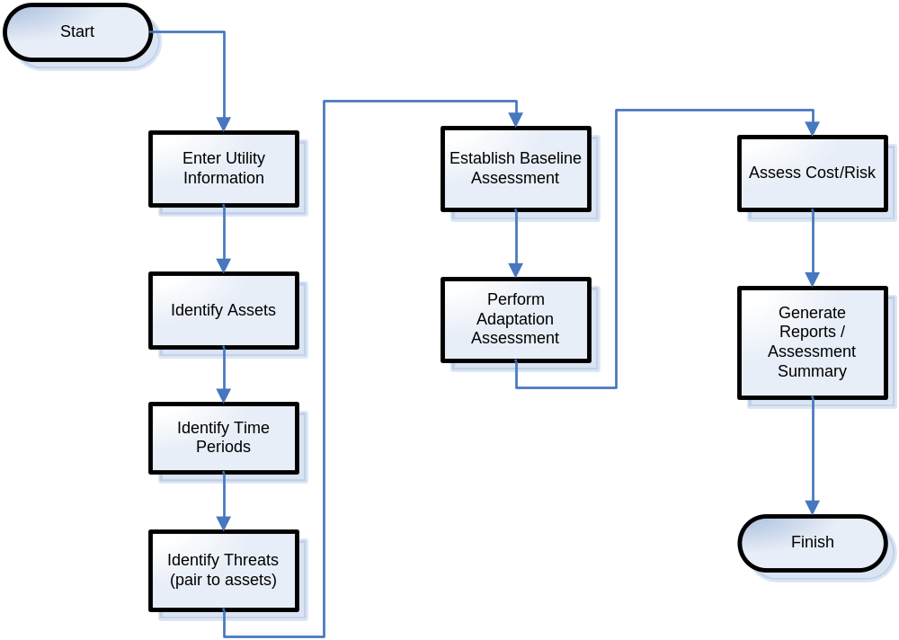
Figure 2-1. Process Flow of the Water Utility Climate Change Awareness and Risk Assessment Tool Analysis

Assumptions and Constraints
Assumptions are suppositions that critically impact the success or validity of the project. Constraints are the project limitations. They are those influences over which none of the participants have control.
Assumption: The climate science, threat descriptions, adaptation starter lists, and model projections being presented to WUCCAT users in narratives represent the best available information to support assessments. Principle sources: U.S. Global Change Research Program (GCRP). 2009. Global Climate Change Impacts in the United States. (Karl, T. R., J. M. Melillo, and T. C. Peterson, Eds.) ISBN 978-0-521-14407-0; World Climate Research Program (WCRP) Coupled Model Intercomparison Project phase 3 (CMIP3) data archive (http://gdo-dcp.ucllnl.org/downscaled_cmip3_projections/); and other peer-reviewed sources produced or cited by these sources.
Assumption: WUCCAT architecture, design, and user interface will use the most recent version of the Vulnerability Self Assessment Tool (VSAT) in order to re-use as much code as possible.

Management Policies and Practices
WUCCAT will be designed and tested by CSC under the guidelines of the EPA Water Security Division (WSD) contract. CSC will work directly with its team member Scientech for the development of the application and any potential maintenance. CSC will designate a project sponsor to work directly with an EPA Work Assignment Manager (WAM) throughout the life cycle of the tool or project. CSC, with the use of Scientech, shall maintain control over the technical aspects of this project, consulting with EPA to ensure decisions made are in compliance with EPA policies and procedures.

Support Concept
WUCCAT will be supported by EPA. It is anticipated that CSC and Scientech will provide this support through the WSD contract. CSC will take steps to ensure the support concept minimizes the number of updates that need to be downloaded for the system by use of sound life-cycle management and maintenance policies.

Stakeholders and Users
The stakeholders and users of WUCCAT software are entities that are responsible for and monitor and review the security and hazards of the Water Sector. Stakeholders and users are listed in Table 2-1.

Table 2-1. Stakeholders and Users
Stakeholder/User | How Software is Used
Water Utilities | Assessment of climate change projections, potential threats to utility and possible adaptations to be pursued.
Wastewater Utilities | Assessment of climate change projections, potential threats to utility and possible adaptations to be pursued.
State Regulatory Agencies | Review assessments from utilities
Federal Organizations | Review assessment from utilities
Water Sector Industry Organizations (including but not limited to AMWA, AWWA, NRWA, WEF, WERF) | Provide recommendations to their members on best practices
EPA | Sponsor for development
Engineering and Water Resource Consultants | Perform assessments on behalf of or in support of a Water Utility and/or Regulatory Agency.

Access
The following information provides a summary of access requirements for WUCCAT:
- System shall be client-based and accessible through an EPA approved website for download, as well as by CD.

Functional Requirements
WUCCAT will be comprised of several functions, each with its own detailed requirements. This section contains an overview of the major functions, including a description of the user stories developed for WUCCAT as well as a brief summary of individual Use Cases (UC) for WUCCAT. It provides information on the intended usage of WUCCAT from an end-user perspective. Detailed requirements are provided in use case format.

Overview of Main Functions
Each of the Main Functions sub-sections is provided below with a mapping to their detailed use case requirements. These processes and use cases are listed below in Table 3-1.
Table 3-1. Overview of Main Functions
Business Process of Main Function | Primary User | Use Case ID/Name of Sub-Section
Define Criteria | Assessor | UC001 Enter Utility Information  UC002 Identify Assets  UC003 Identify Time Periods  UC004 Identify Threats
Build Awareness | Assessor | UC005 Review Narratives
Perform Assessment | Assessor | UC006 Establish Baseline Analysis  UC007 Perform Adaptation Analysis
Evaluate Results | Assessor | UC008 Assess Cost/Risk  UC009 Generate Reports / Assessment Summary

Function Level Use Case Diagram
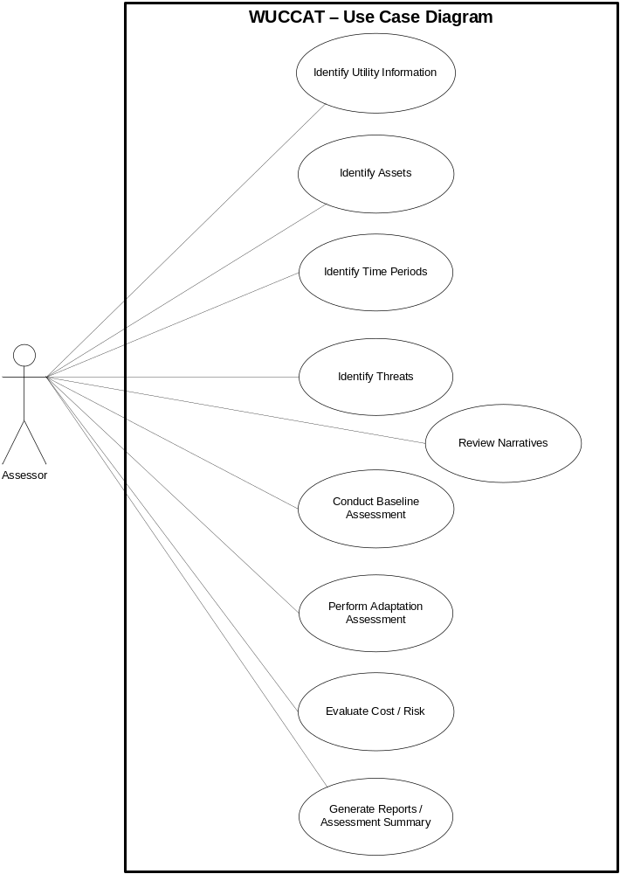
Figure 3-1. WUCCAT Use Case Diagram

High-Level Function Breakdown

Define Criteria
WUCCAT serves as an awareness and risk assessment tool for utilities to consider climate change and adaptation in response to these risks. The first step in performing any assessment is to define the parameters for the assessment. This major function in WUCCAT provides the ability for users to establish assets, threats, view detailed narratives regarding climate change, and pair threats and assets together in order to perform assessments, evaluate results, and generate reports.

Use Case Brief
WUCCAT will allow the user to identify utility information, assets, time periods for consideration, and threats of interest paired to assets for risk assessment.
Table 3-2 provides a brief description of the use cases applicable to this WUCCAT main function.
Table 3-2. Define Criteria Use Case Briefs
Use Case | Goal | Description
UC001 Identify Utility Information | User identifies utility information. | An assessor enters information that identifies the utility.
UC002 Identify Assets | User establishes asset list applicable to utility. | An assessor reviews assets available from a library, defines new assets, changes asset names or properties, or imports assets that were applicable to the utility.
UC003 Identify Time Periods | User has selected the time periods applicable to assessment. | An assessor chooses the time periods for assessment, which represent where events from today until the selected year are considered in assessments.
UC004 Identify Threats | User establishes threat list applicable to assessment. | An assessor reviews descriptive narratives regarding climate change and determines potential threats associated with them. Assessor chooses threats that may be applicable to their utility and shall pair assets to the threat.

Use Cases and Workflows
The following section provides the detailed requirements for each user goal within the system.
        - UC001 Identify Utility Information
Category | Main | Last Updated: | 03/17/2010

Actors:
- Assessor

Description:
An assessor enters information that identifies their utility.

Precondition:
User accessed the WUCCAT from their local computer.

Basic Flow:
- User would like to identify their utility for use in summaries and reports.
- System provides a list of utility types to choose from.
- User chooses a utility type.
- User completes and reviews information fields.
- User indicates their completion status.
- System provides user with next step in the define criteria process.

Alternate Flows:
AF1. Basic Flow 3—User would like to upload information from an external source.
- User chooses an import option (instead of utility type).
- User reviews help file explaining import option.
- User chooses the information file they wish to upload.
- System verifies template format and informs user if file does not meet template requirements.

Exceptions:
E1. Basic Flow 5—User does not wish to save utility information.
- User cancels their edits.
- System displays message, “Changes will not be saved if you continue.”
- User acknowledges error prompt.
- System does not save the change and returns the user to the asset list.

Post Condition:
The user has identified their utility.

Requirements:
Table 3-3 is a list of requirements that apply specifically to this use case. These requirements can be used as a checklist for items to be included in the design and development phases.

Table 3-3. Requirements
High Level Req. ID | Detailed Req. ID | Description
UC001-HR-001 | - | System shall provide a structure for user to define their utility information.
UC001-HR-002 | - | System shall provide the ability to edit utility information.
- | UC001-DR-002.1  UC001-DR-001.1 | System shall provide the fields of information when editing or defining a utility.  - Name—required, text entry  - Type—select from list  - Assessor Name—text entry  - Assessor Title—text entry  - Description—text area  - Latitude—text entry  - Longitude—text entry  - Elevation—text entry  - Age—text entry  - Population Served—text entry (or select from list)  - Address—text entry  - City—text entry  - State—select from list  - Zip Code—text entry  - Contact Name—text entry  - Contact Phone—text entry  - Contact Email—text entry  - Website—text entry
UC001-HR-003 | - | System shall provide a mechanism to upload utility information to the system using a pre-defined upload template. See notes for template details.
- | UC001-DR-003.1 | System shall verify the file being uploaded meets template requirements and inform the user of the specific reason for upload failure.

Business Rules: None

Table 3-4. Interface Requirements
Interface Req. ID | Related Req. ID | Description
UC001-IR-001 | - | User shall be provided with an informational screen as the starting point for entering utility type that explains the process for doing so.

Open Issues: None

Workflow:

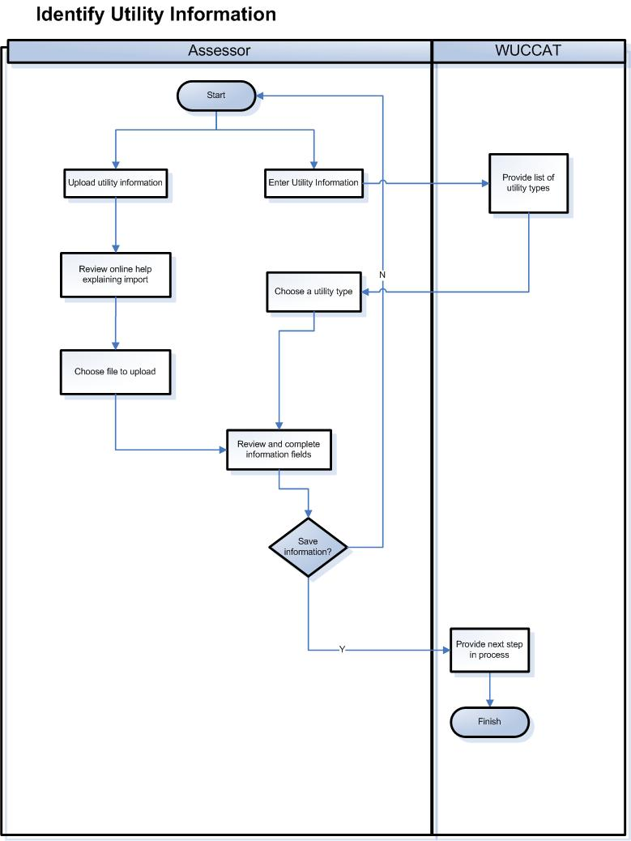
Figure 3-2. Workflow UC001 – Identify Utility

Notes

Notes and Disclaimer to be provided by WUCCAT:
This WUCCAT software was prepared by EPA and its contractor as an informational tool to assist water and wastewater utility owners and operators in identifying climate change risks. It does not purport to be a comprehensive or exhaustive list of all potential climate-related risks.
______________________________________
Disclaimer: The information contained in the WUCCAT software was developed in accordance with best industry practices. WUCCAT should not be exclusively relied on in developing security plans, all hazards analysis or emergency response plans. This information is also not a substitute for the professional advice of an attorney or environmental or security professional. This information is provided without warranty of any kind, and EPA hereby disclaims any liability for damages, arising from the use of the software, including, without limitation, direct, indirect or consequential damages including personal injury, property loss, and loss of revenue, loss of profit, loss of opportunity, or other loss. For assistance locating an attorney or environmental professional, please contact the appropriate licensing authority for your state.

Utility Information Template:
[Name], [Type], [Assessor Name], [Assessor Title], [Description], [Latitude], [Longitude], [Elevation], [Age], [Pop served], [Address], [City], [State], [Zip], [Contact], [Contact phone], [Contact email], [Website]

Sample Interface:
The following represents a sample of what the user interface may represent when complete. This information is not final and may appear different in a release.

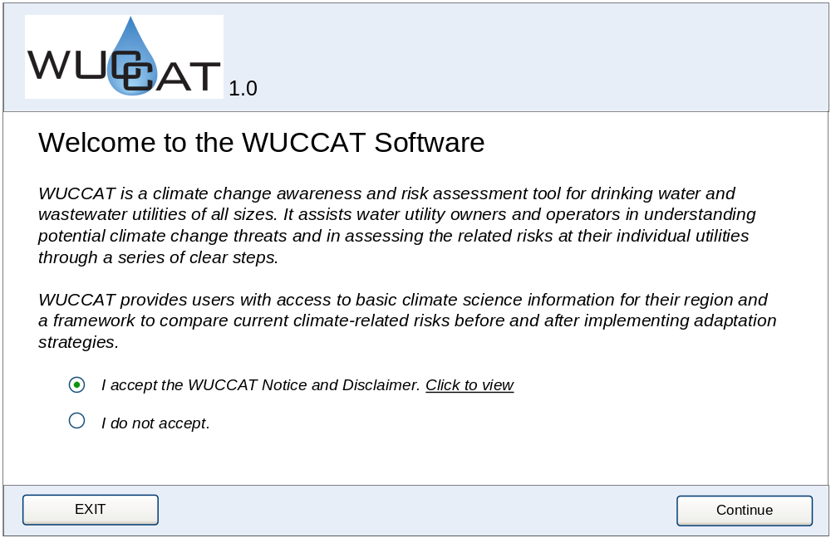
[0-1]. Welcome Screen

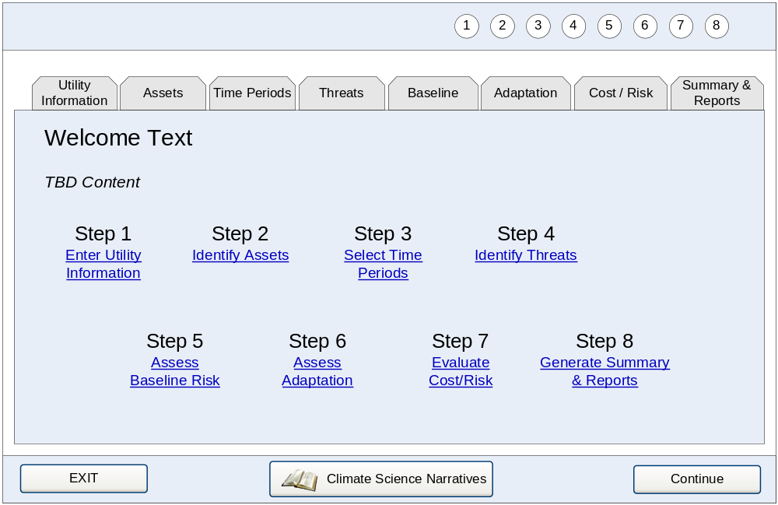
[0-2]. Navigation Screen: TBD Content will be instructions for step selection and overall process.

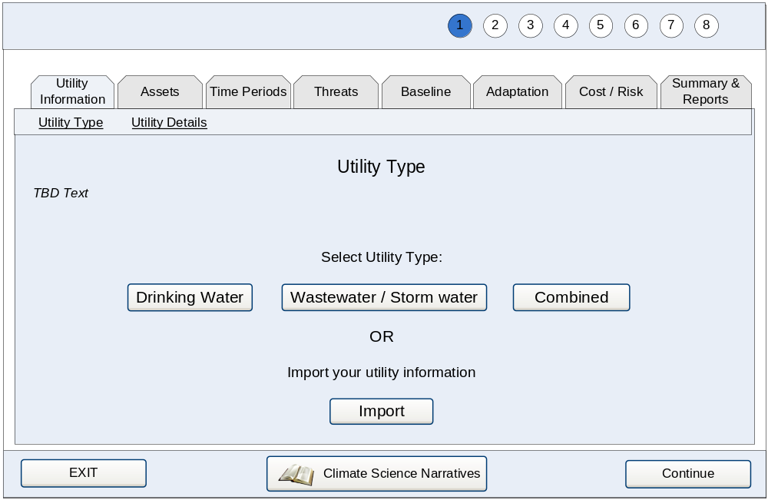
[1-1]. Utility Type Screen: TBD Text will be instructions on selecting utility type or importing.

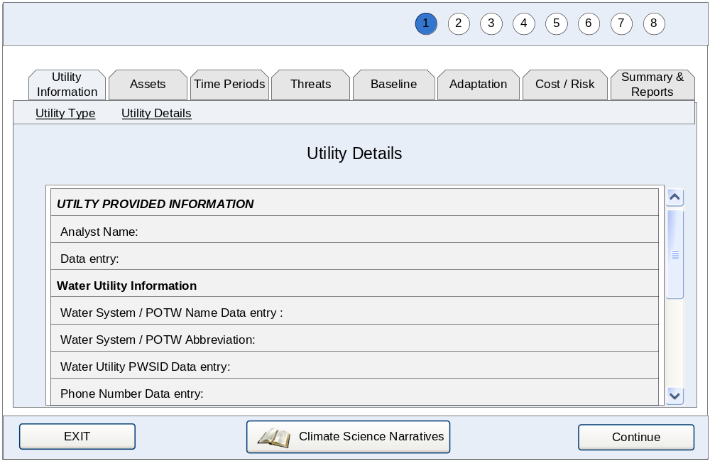
[1-2]. Edit Information Screen.

        - UC002 Identify Assets
Category | Main | Last Updated: | 03/17/2010

Actors:
- Assessor

Description:
Assessor defines assets applicable to their utility by selecting from an asset library, uploading list to system, or defining new assets.

Precondition:
User has entered utility information or chose to access the Identify Assets portion of WUCCAT.

Basic Flow:
- User would like to identify assets applicable to their utility.
- System provides a hierarchy of asset categorizations to select from.
- User selects the asset type from the hierarchy and chooses to add asset.
- User reviews asset information and makes desired modifications.
- System saves asset list.
- User views the updated asset list.
- System prompts user “Have you identified all assets?”
- User indicates their completion status.
- System provides user with next step in the define criteria process.

Alternate Flows:
AF1. Basic Flow 3—User would like to upload assets from an external source.
- System provides an upload page stating the following “The import file needs to be in a particular format. Click here for more information.”
- User reviews help file explaining import option.
- User selects the asset file they wish to upload.
- System verifies template format and informs user if file does not meet template requirements.

AF2. Basic Flow 3—User would like to add an asset not in the library
- User selects “User-defined asset” type in library.
- User enters asset information.

AF3. Basic Flow 3—User would like to add an Asset Subclass and the dependent assets to their asset list.
- User selects asset subclass from library and chooses to add asset.
- System updates and saves “My Assets” list with new assets for each dependent in library.

AF4. Basic Flow 6—User would like to modify/rename/further refine an existing asset.
- User selects asset from list and chooses to edit the asset.
- User modifies asset information.
- System saves the edits and updates the asset list.

AF5. Basic Flow 6—User would like to duplicate an asset.
- User selects an asset from the list and chooses to copy the asset.
- System creates a copy of the asset and sets new asset name to include a prefix of “Copy of.”
- System provides the user with the ability to edit asset information.
- System saves the edits and updates the asset list.

AF6. Basic Flow 6—User would like to delete an asset.
- User selects an asset from the list and chooses to delete the asset.
- System prompts the user “Are you sure you want to delete that asset?”
- User provides confirmation.
- System removes asset, saves the edits, and updates the asset list.

Exceptions:
E1. AF2, AF4, AF5, & AF6—User does not wish to save modification of asset information.
- User cancels their edits.
- System displays message, “Changes will not be saved if you continue.”
- User acknowledges error prompt.
- System does not save the change and returns the user to the asset list.

E2. AF6—System prevents deletion of asset already used in assessments.
- System detects that asset selected for removal has been used in assessment(s).
- System displays message, “Changes will not be saved—asset used in assessment.”
- User acknowledges error prompt.
- System does not save the change and returns the user to the asset list.

Post Condition:
The user has identified the assets applicable to their utility.

Requirements:
Table 3-5 is a list of requirements that apply specifically to this use case. These requirements can be used as a checklist for items to be included in the design and development phases.

Table 3-5. Requirements
High Level Req. ID | Detailed Req. ID | Description
UC002-HR-001 | - | System shall provide an asset library based on their utility type for user to choose from when defining assets. See business rules and notes in this UC for details pertaining to the asset library hierarchy.
UC002-HR-002 | - | System shall provide the ability to add an asset from asset library to the user’s defined asset list, referred to as “My Assets.”
- | UC002-DR-002.1 | System shall provide the ability to add assets to the asset list by Asset Type.
- | UC002-DR-002.2 | System shall provide the ability to add assets to the asset list by Asset Subclass.
UC002-HR-003 |  | System shall provide the ability to edit an existing asset.
 | UC002-DR-002.3  UC002-DR-003.1 | System shall provide the following fields when modifying asset information:  - Utility Type —select from list  - Asset Class—select from list  - Asset Subclass—select from list  - Asset Type—select from list  - Name—required, text entry, default to asset type with an incremented number after it  - Description—text area  - Photograph (filename/link)—file upload  - Latitude—text entry  - Longitude—text entry  - Elevation—text entry  - Material Description—text area  - Replacement Cost—text entry
- | UC002-DR-002.2 | System shall provide a mechanism for user to upload photographs associated with an asset in JPG, GIF, and BMP photo formats.
- | UC002-DR-002.3 | System shall provide the ability to remove a photograph that is associated with an asset.
UC002-HR-004 | - | System shall provide a mechanism for user to define a new asset type.
UC002-HR-005 | - | System shall provide a mechanism to upload assets to the system using a pre-defined upload template. See notes for template details.
- | UC002-DR-004.1 | System shall verify the file being uploaded meets template requirements and inform the user of the specific reason for upload failure.
UC002-HR-006 | - | System shall provide a mechanism to copy existing asset information as one means to create a new asset.
UC002-HR-007 | - | System shall provide the ability for user to delete an asset.
UC002-HR-008 | - | System shall provide the ability for user to upload the VSAT Asset Import template to WUCCAT without any translation tasks from the user. See notes for details on how to translate a VSAT import file to the WUCCAT template.

Table 3-6. Business Rules
Business Rule ID | Related Req. ID | Description
UC002-BR-001 | UC002-HR-006 | When copying assets, system automatically adds the text “Copy of” to the beginning of the asset name to ensure a unique name if it is a duplicate of an existing asset
UC002-BR-002 | UC002-HR-006 | When copying assets at subclass level, system automatically adds the text “Copy of” to the beginning of the asset name and all dependent assets to ensure a unique name if it is a duplicate of an existing asset
UC002-BR-003 | UC002-HR-001 | When adding assets from library, system automatically adds sequential numbers to the end of the asset names to ensure unique names. For example, if the user adds “Sewer” from the library three times, the default names will be “Sewer 1,” “Sewer 2,” and “Sewer 3” (even if user changes asset names in between additions).
UC002-BR-004 | UC002-HR-006 | When copying assets multiple times (more than once), system automatically adds sequential numbers following “Copy” in the new asset name(s) to ensure unique names. For example, if the user copies “Sewer – Elm St” from the library three times, the default names will be “Copy of Sewer—Elm St,” “Copy (2) of Sewer—Elm St,” and “Copy (3) of Sewer—Elm St” (even if user changes asset names in between replications.
UC002-BR-005 | UC002-HR-001 | The asset hierarchy consists of four levels and is defined as Asset Category, Asset Class, Asset Subclass, and Asset Type. The available library is determined by category and consists of the lower three levels. Refer to notes in this UC for details.
UC002-BR-006 | UC002-HR-002 | When adding by subclass, the system shall add all asset types within that subclass to the asset list. System automatically adds sequential numbers at asset type level to the end of the asset names to ensure unique names. Asset names must be unique. Asset name is a term that includes Asset Category, Asset Class, Asset Subclass, and Asset Type.
UC002-BR-007 | UC002-HR-007 | Assets that have an assessment performed on them cannot be deleted.

Table 3-7. Interface Requirements:
Interface Req. ID | Related Req. ID | Description
UC002-IR-001 | - | Assets in both Asset library and “My Asset” list shall be presented in a hierarchal manner so the user can determine asset association with the higher levels.

Open Issues: None
Workflow:
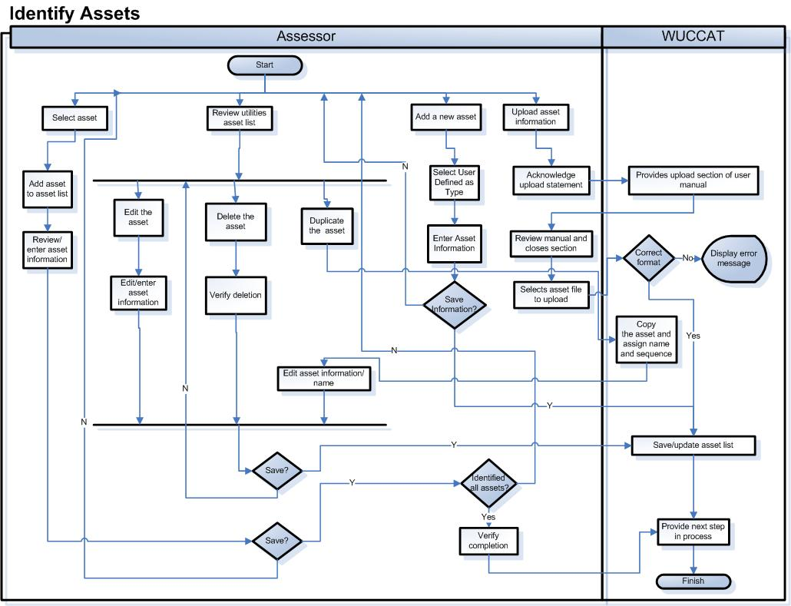
Figure 3-3. Workflow UC002 – Identify Assets
Notes

Table 3-8. Utility Asset Libraries for all Utility Types
Utility Type | Asset Classes | Asset Subclasses | Asset Types
Drinking Water | Natural resources | Water supply | Surface water (streams, rivers, lakes)
Drinking Water | Natural resources | Water supply | Ground water (aquifers)
Drinking Water | Natural resources | Flood protection | Wetlands, flood plain
Drinking Water | Natural resources | User-defined | User-defined assets…
Drinking Water | Infrastructure  (facilities/plants) | Structures | Laboratory
Drinking Water | Infrastructure  (facilities/plants) | Structures | Maintenance
Drinking Water | Infrastructure  (facilities/plants) | Structures | Administrative offices
Drinking Water | Infrastructure  (facilities/plants) | Control and Communications | SCADA
Drinking Water | Infrastructure  (facilities/plants) | Control and Communications | Distributed control systems
Drinking Water | Infrastructure  (facilities/plants) | Control and Communications | Data acquisition systems
Drinking Water | Infrastructure  (facilities/plants) | Control and Communications | Telecommunications / data network
Drinking Water | Infrastructure  (facilities/plants) | Power Supply | Electrical substations
Drinking Water | Infrastructure  (facilities/plants) | Power Supply | Backup generators
Drinking Water | Infrastructure  (facilities/plants) | Raw water conveyance | Intakes / wells
Drinking Water | Infrastructure  (facilities/plants) | Raw water conveyance | Structures (reservoirs, pipes, canals)
Drinking Water | Infrastructure  (facilities/plants) | Raw water conveyance | Pump stations
Drinking Water | Infrastructure  (facilities/plants) | Raw water conveyance | Raw water storage
Drinking Water | Infrastructure  (facilities/plants) | Drinking Water Treatment | Pre-treatment
Drinking Water | Infrastructure  (facilities/plants) | Drinking Water Treatment | Coagulation
Drinking Water | Infrastructure  (facilities/plants) | Drinking Water Treatment | Solids removal
Drinking Water | Infrastructure  (facilities/plants) | Drinking Water Treatment | Desalination
Drinking Water | Infrastructure  (facilities/plants) | Drinking Water Treatment | Filtration
Drinking Water | Infrastructure  (facilities/plants) | Distribution system | Finished water storage
Drinking Water | Infrastructure  (facilities/plants) | Distribution system | Distribution network
Drinking Water | Infrastructure  (facilities/plants) | Distribution system | Meters
Drinking Water | Infrastructure  (facilities/plants) | Distribution system | Pump stations
Drinking Water | Infrastructure  (facilities/plants) | User-defined | User-defined assets…

Utility Type | Asset Classes | Asset Subclasses | Asset Types
Wastewater /  Storm water | Natural resources | Flood protection | Wetlands, flood plain
Wastewater /  Storm water | Natural resources | Receiving water | Surface water (streams, rivers, lakes)
Wastewater /  Storm water | Natural resources | Receiving water | Ground water (underground injection)
Wastewater /  Storm water | Natural resources | User-defined | User-defined assets…
Wastewater /  Storm water | Infrastructure  (facilities/plants) | Structures | Laboratory
Wastewater /  Storm water | Infrastructure  (facilities/plants) | Structures | Maintenance
Wastewater /  Storm water | Infrastructure  (facilities/plants) | Structures | Administrative offices
Wastewater /  Storm water | Infrastructure  (facilities/plants) | Control and Communications | SCADA
Wastewater /  Storm water | Infrastructure  (facilities/plants) | Control and Communications | Distributed control systems
Wastewater /  Storm water | Infrastructure  (facilities/plants) | Control and Communications | Data acquisition systems
Wastewater /  Storm water | Infrastructure  (facilities/plants) | Control and Communications | Telecommunications / data network
Wastewater /  Storm water | Infrastructure  (facilities/plants) | Power Supply | Electrical substations
Wastewater /  Storm water | Infrastructure  (facilities/plants) | Power Supply | Backup generators
Wastewater /  Storm water | Infrastructure  (facilities/plants) | Collection system | Mains
Wastewater /  Storm water | Infrastructure  (facilities/plants) | Collection system | Sewers
Wastewater /  Storm water | Infrastructure  (facilities/plants) | Collection system | Pump stations
Wastewater /  Storm water | Infrastructure  (facilities/plants) | Collection system | Treated/reclaimed water storage
Wastewater /  Storm water | Infrastructure  (facilities/plants) | Wastewater Treatment | Clarification
Wastewater /  Storm water | Infrastructure  (facilities/plants) | Wastewater Treatment | Solids removal
Wastewater /  Storm water | Infrastructure  (facilities/plants) | Wastewater Treatment | Disinfection
Wastewater /  Storm water | Infrastructure  (facilities/plants) | Wastewater Treatment | Biological treatment
Wastewater /  Storm water | Infrastructure  (facilities/plants) | Wastewater Treatment | Biosolids management
Wastewater /  Storm water | Infrastructure  (facilities/plants) | Outfalls | Inland and coastal waters
Wastewater /  Storm water | Infrastructure  (facilities/plants) | User-defined | User-defined assets…

Utility Type | Asset Classes | Asset Subclasses | Asset Types
Combined | Natural resources | Water supply | Surface water (streams, rivers, lakes)
Combined | Natural resources | Water supply | Ground water (aquifers)
Combined | Natural resources | Flood protection | Wetlands, flood plain
Combined | Natural resources | Receiving water | Surface water (streams, rivers, lakes)
Combined | Natural resources | Receiving water | Ground water (underground injection)
Combined | Natural resources | User-defined | User-defined assets…
Combined | Infrastructure  (facilities/plants) | Structures | Laboratory
Combined | Infrastructure  (facilities/plants) | Structures | Maintenance
Combined | Infrastructure  (facilities/plants) | Structures | Administrative offices
Combined | Infrastructure  (facilities/plants) | Control and Communications | SCADA
Combined | Infrastructure  (facilities/plants) | Control and Communications | Distributed control systems
Combined | Infrastructure  (facilities/plants) | Control and Communications | Data acquisition systems
Combined | Infrastructure  (facilities/plants) | Control and Communications | Telecommunications / data network
Combined | Infrastructure  (facilities/plants) | Power Supply | Electrical substations
Combined | Infrastructure  (facilities/plants) | Power Supply | Backup generators
Combined | Infrastructure  (facilities/plants) | Raw water conveyance | Intakes / wells
Combined | Infrastructure  (facilities/plants) | Raw water conveyance | Structures (reservoirs, pipes, canals)
Combined | Infrastructure  (facilities/plants) | Raw water conveyance | Pump stations
Combined | Infrastructure  (facilities/plants) | Raw water conveyance | Raw water storage
Combined | Infrastructure  (facilities/plants) | Drinking Water Treatment | Pre-treatment
Combined | Infrastructure  (facilities/plants) | Drinking Water Treatment | Coagulation
Combined | Infrastructure  (facilities/plants) | Drinking Water Treatment | Solids removal
Combined | Infrastructure  (facilities/plants) | Drinking Water Treatment | Desalination
Combined | Infrastructure  (facilities/plants) | Drinking Water Treatment | Filtration
Combined | Infrastructure  (facilities/plants) | Distribution system | Finished water storage
Combined | Infrastructure  (facilities/plants) | Distribution system | Distribution network
Combined | Infrastructure  (facilities/plants) | Distribution system | Meters
Combined | Infrastructure  (facilities/plants) | Distribution system | Pump stations
Combined | Infrastructure  (facilities/plants) | Collection system | Mains
Combined | Infrastructure  (facilities/plants) | Collection system | Sewers
Combined | Infrastructure  (facilities/plants) | Collection system | Pump stations
Combined | Infrastructure  (facilities/plants) | Collection system | Treated/reclaimed water storage
Combined | Infrastructure  (facilities/plants) | Wastewater Treatment | Clarification
Combined | Infrastructure  (facilities/plants) | Wastewater Treatment | Solids removal
Combined | Infrastructure  (facilities/plants) | Wastewater Treatment | Disinfection
Combined | Infrastructure  (facilities/plants) | Wastewater Treatment | Biological treatment
Combined | Infrastructure  (facilities/plants) | Wastewater Treatment | Biosolids management
Combined | Infrastructure  (facilities/plants) | Outfalls | Inland and coastal waters
Combined | Infrastructure  (facilities/plants) | User-defined | User-defined assets…

Asset Upload Template:
File Format:
Comma Delimited Text files with no header (fields below in Table 3-9). Only assets from Physical category in VSAT will be imported into WUCCAT.
Table 3-9. Mapping of Fields from VSAT Asset Files to Import as WUCCAT Assets
WUCCAT | VSAT
[Utility Type] | [Sector] (must agree with utility type entered earlier)
[Asset Class] | {function of [System Type]}
[Asset Subclass] | [System Type]
[Asset Type] | [Facility]
[Name] | [Name]
[Description] | [Description] & [Component] & [Sub Component]
[Photograph (filename/link)] | [Photograph (filename/link)]
[Latitude] | --
[Longitude] | --
[Elevation] | --
[Age] | --
[Material Description] | --
[Replacement Cost] | --

Sample Interface:
The following represents a sample of what the user interface may represent when complete. This information is not final and may appear different in a release.

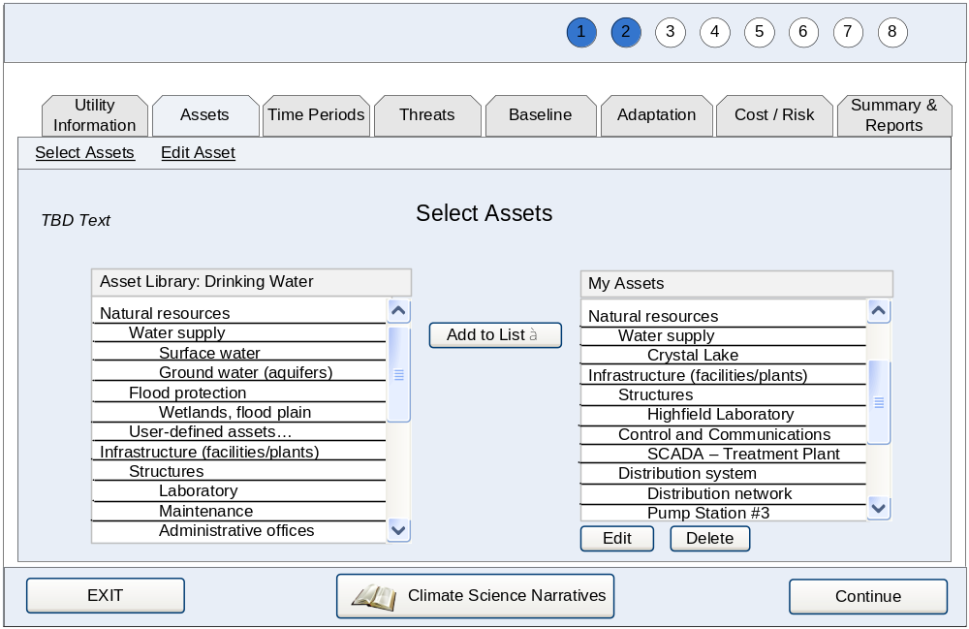
[2-1]. Asset Selection Screen: TBD Text will be instructions on selecting assets.

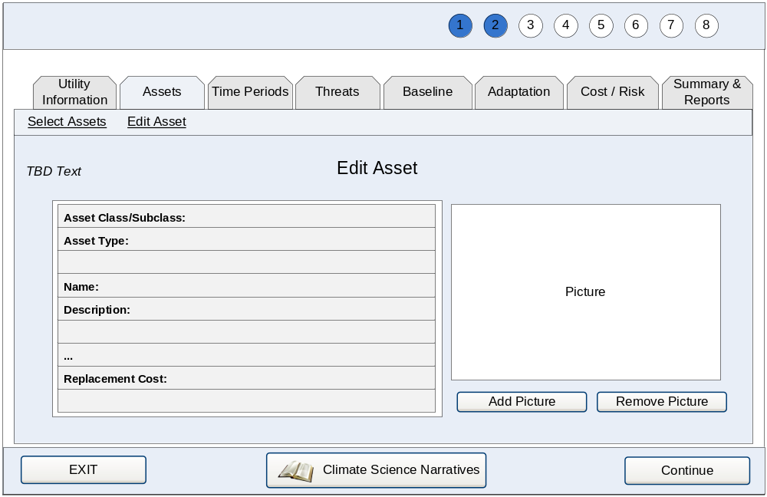
[2-2]. Edit Asset Screen: TBD Text will be instructions on editing assets.

        - UC003 Identify Time Periods
Category | Main | Last Updated: | 03/17/2010

Actors:
- Assessor

Description:
An assessor selects the time periods for the assessment of potential threats.

Precondition:
Assessor has identified their utility or accessed the time period selection portion of WUCCAT.

Basic Flow:
- User enters a year as time period for assessment.
- User adds selection to list of time periods for the assessment.
- User repeats Steps 1 & 2 for additional time periods until all desired periods are entered.
- User indicates completion.
- System saves time period selection.
- User is provided the next step in the define criteria process.

Alternate Flows:
AF1. Basic Flow 1—User would like to remove time period already in their time period list.
- User selects time period they wish to remove.
- System prompts the user “Are you sure you want to delete this time period?”
- User indicates they would like to remove time period.
- System removes the time period from the assessment and updates the time period list.

Exceptions:
E1. AF1—System prevents deletion of time period already used in assessments.
- System detects that time period selected for removal has been used in assessment(s).
- System displays message, “Changes will not be saved—time period used in assessment.”
- User acknowledges error prompt.
- System does not save the change and returns the user to the time period list.

Post Condition:
The user has selected the threats applicable to their utility.

Requirements:
Table 3-10 is a list of requirements that apply specifically to this use case. These requirements can be used as a checklist for items to be included in the design and development phases.

Table 3-10. Requirements
High Level Req. ID | Detailed Req. ID | Description
UC003-HR-001 | - | System shall provide a mechanism for user to add time periods to their assessment, referred to as “My Time Periods.”
 | UC003-DR-001.1 | System shall provide the following fields when adding a time period:  Time Period End Year—numeric entry.
UC003-HR-002 | - | System shall provide a mechanism for user to remove time periods from the “My Time Periods list.

Table 3-11. Business Rules
Business Rule ID | Related Req. ID | Description
UC003-BR-001 | UC003-DR-001.1 | Time periods are designated as years entered by user. They represent a planning horizon where actions and events from today until the selected year are considered in assessments.
UC003-BR-002 | UC003-DR-001.1 | Time periods must be unique and have a minimum of five years between periods. This is based on the likely use of decades by user as minimum time step for periods. This is just the minimum, more than five years between periods selections are likely.
UC003-BR-003 | UC003-HR-001 | User must enter at least one time period and no more than five.

Table 3-12. Interface Requirements
Interface Req. ID | Related Req. ID | Description
UC003-IR-001 | - | Selected time periods entered will be displayed in list for the user to review.

Open Issues: None

Notes

None

Workflow:
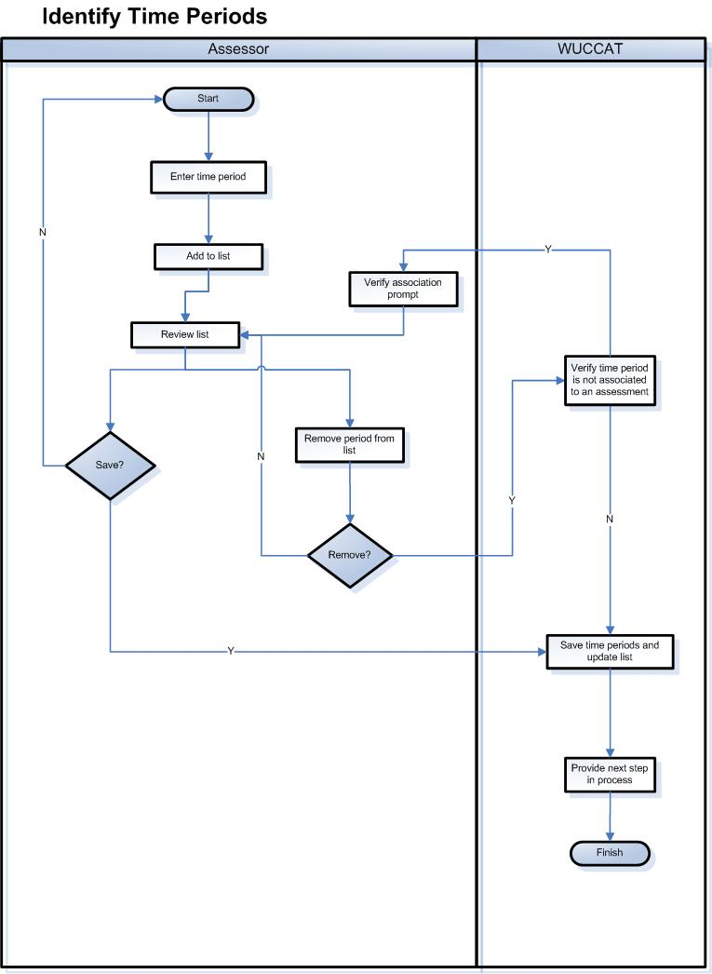
Figure 3-4. Workflow UC003 – Identify Time Periods

Notes

Sample Interface:
The following represents a sample of what the user interface may represent when complete. This information is not final and may appear different in a release.

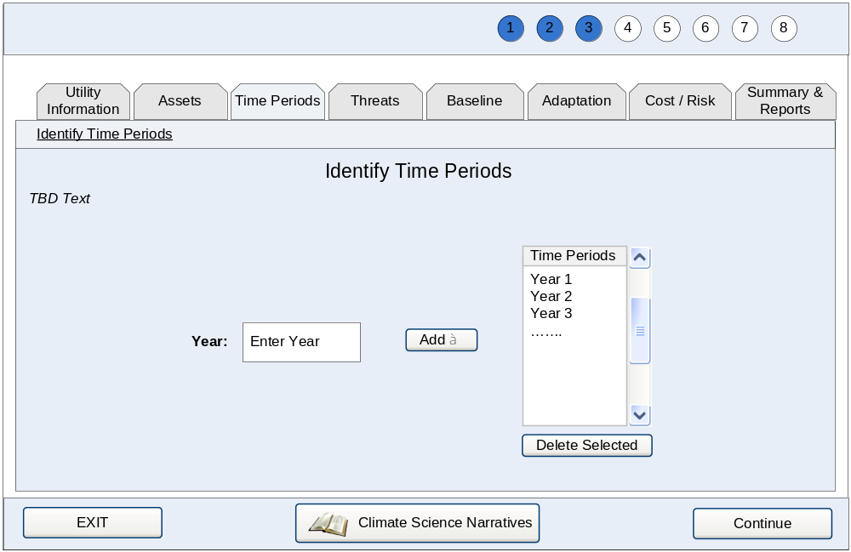
[3-1]. Time period Selection Screen: TBD Text will be instructions on selecting time periods and rationale behind using them (e.g., planning horizons).
        - UC004 Identify Threats
Category | Main | Last Updated: | 03/17/2010

Actors:
- Assessor

Description:
An assessor reviews descriptive narratives regarding climate change impacts and potential threats associated with them (see Section 3.3.2.2.1 UC005). Assessor chooses threats that may be applicable to the assets defined for their utility.

Precondition:
Assessor completed the identify assets section or accessed the threat portion of WUCCAT.

Basic Flow:
- User chooses a region from a map.
- System provides regional narrative separately from the region map (see UC005).
- User reviews narrative and returns to their region selection
- User chooses to continue to threat selection.
- System provides threat selection.
- User adds a threat based on their knowledge/experience to their threat list.
- User reviews threat information and makes desired modifications.
- User pairs assets to the selected threat.
- System saves threat selection.
- User reviews updated threat list.
- System prompts user “Have you identified all threats?”
- User indicates their completion status.
- System provides user with next step in the process.

Alternate Flows:
AF1. Basic Flow 1 or 6—User would like to view additional narratives.
- User accesses the narrative they wish to review.
- System provides narrative.
- User returns to region selection screen.

AF2. Basic Flow 6—User would like to define a new threat.
- User selects “User-defined threat” from threat selection.
- User enters threat name and description.
- System adds the new threat and returns user to an updated threat list.

AF3. Basic Flow 6—User would like to duplicate a selected threat.
- User chooses to duplicate a selected threat.
- System displays definition of duplicated threat with “Copy of” added to name.
- User edits definition and saves their changes to the new threat.
- System adds the new threat and returns user to updated threat list.

AF4. Basic Flow 6—User would like to delete a threat.
- User chooses to delete the threat.
- System prompts the user “Are you sure you want to delete this threat?”
- User provides confirmation.
- System removes threat from the threat list and returns user to updated threat list.

AF5. Basic Flow 6—User would like to modify a threat definition.
- User chooses to modify a selected threat.
- System displays existing threat definition.
- User edits threat information and saves their changes.
- System saves the modifications and returns user to updated threat list.

AF6. Basic Flow 6—User would like to view adaptations associated with a threat group.
- User chooses view adaptations for a threat group.
- System displays the adaptations associated with the selected threat group.
- User reviews adaptations and returns to threat selection.

AF7. Basic Flow 6—User would like to view a summary of threat-asset pairs.
- User chooses to view pair summary.
- System displays the pair summary.
- User chooses to return to threat selection.

Exceptions:
E1. Basic Flow 1 & AF1—User does not wish to view regional or national narrative.
- User chooses to continue without selecting region.
- System displays message, “Continue without reviewing a narrative?”
- User acknowledges prompt and system provides threat list.

E2. AF3, AF4, AF5, & AF6—User does not wish to add a threat or modify a threat definition.
- User cancels their transaction.
- System displays message, “Changes will not be saved if you continue.”
- User acknowledges error prompt.
- System does not save the change and returns the user to the threat list.

E3. AF5—System prevents deletion of threat already used in assessments.
- System detects that threat selected for removal has been used in assessment(s).
- System displays message, “Changes will not be saved—threat used in assessment.”
- User acknowledges error prompt.
- System does not save the change and returns the user to the threat list.

Post Condition:
The user has selected the threats applicable to their utility.

Requirements:
Table 3-13 is a list of requirements that apply specifically to this use case. These requirements can be used as a checklist for items to be included in the design and development phases.

Table 3-13. Requirements
High Level Req. ID | Detailed Req. ID | Description
UC004-HR-001 | - | System shall provide the ability for the user to select the specific region of interest for their assessment.
- | UC004-HR-001.1 | System shall provide indicator of last region selected.
UC004-HR-002 | - | System shall provide the ability for user to choose a threat from a list and add it to their defined threat list, referred to as “My Threats.”
- | UC004-DR-002.1 | System shall provide the ability to locate an individual threat by reviewing climate change categories associated with the region
- | UC004-DR-002.2 | System shall provide the ability to select any threat, regardless of region.
UC004-HR-003 | - | System shall provide a mechanism for user to add a new threat.
- | UC004-DR-003.1  UC004-DR-004.1  UC004-DR-005.1 | System shall provide the following fields for threat definition:  - Threat Group—select from list with “User-defined” option  - Name—required, text entry, default to asset type with an incremented number after it.  - Description / magnitude—text area  - Climate change categories—multiple selection  - Pair Asset to Threat—provide utilities asset list to select from
UC004-HR-004 | - | System shall provide a mechanism for user to modify the definition of an existing threat.
UC004-HR-005 | - | System shall provide a mechanism for user to duplicate an existing threat.
UC004-HR-006 | - | System shall provide the ability to access national, regional, climate change category, and threat group narratives. See UC009 for details.
UC004-HR-007 | - | System shall provide the ability to remove a threat.
UC004-HR-008 | - | System shall provide the ability to view adaptations associated with any threat group when reviewing threats.
UC004-HR-009 | - | System shall provide the ability to copy a threat.
UC004-HR-010 | - | System shall provide a visual summary of pairs that is available at any time.
- | UC004-DR-010.1 | System shall retain pairs as a single asset and a single threat.

Table 3-14. Business Rules
Business Rule ID | Related Req. ID | Description
UC004-BR-001 | UC004-HR-004 | Threats are organized into Threat Groups and Threats. The combination of Threat Group and Threat relates to at least one Climate Change Category. Review notes in this UC for additional information on threat organization.
UC004-BR-002 | UC004-HR-005 | Climate change categories applicable to threats cannot be edited except for user-defined threats.
- | UC004-HR-001 | Regions are defined as Northeast, Southeast, Northwest, Southwest, Great Plains, Midwest, Alaska, Islands, and Coasts.
UC004-BR-003 | - | User cannot remove a threat that has an assessment associated with it.
UC004-BR-004 | - | When selecting threats from library, system automatically adds sequential numbers to the end of the threat name to ensure a unique name. These numbers are sequential for each threat with the same name.
UC004-BR-005 | UC004-HR-009 | When copying threats, system automatically adds the text “Copy of” to the beginning of the threat name to ensure a unique name if it is a duplicate of an existing threat.
UC004-BR-006 | UC004-HR-009 | When copying threats multiple times (more than once), system automatically adds sequential numbers following “Copy” in the new threat name(s) to ensure unique names. For example, if the user copies “Agricultural practices” from the library three times, the default names will be “Copy of Agricultural practices,” “Copy (2) of Agricultural practices,” and “Copy (3) of Agricultural practices” (even if user changes threat names in between replications).

Table 3-15. Interface Requirements
Interface Req. ID | Related Req. ID | Description
UC004-IR-001 | - | Threats shall be presented in a manner in which a user can view narratives for threat groups and climate change categories when selecting which threats to include.
UC004-IR-002 | - | User shall be provided with a map to select their region.

Open Issues: None
Workflow:
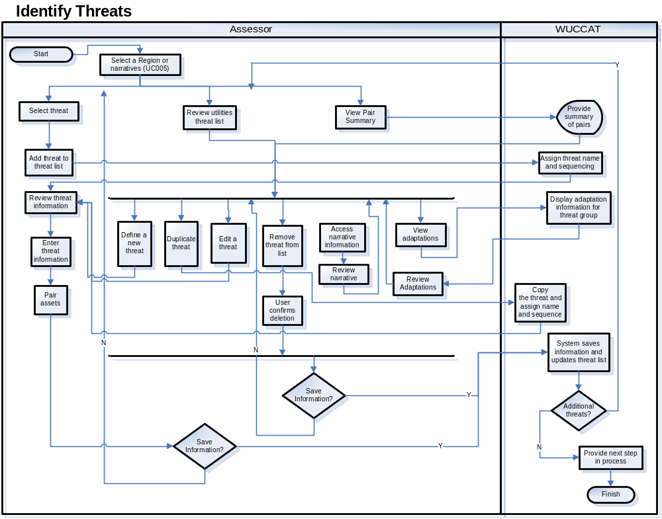
Figure 3-5. Workflow UC004 – Identify Threats
Notes
Content of all narratives are described in UC005.

Threat table (Figure 3-6, below) depicts the connection between projected climate change described in the narratives and the threats they constitute. Note that this table is provided as guidance and does not restrict threat selection for any user. Dots denote connection between climate change and the threat, while open circles denote the ability of users to define new threats and relevant connections.

 |  | Climate Change Categories
Threat Groups | Threats | Increasing Temperature | Rising Sea Level | Changing Evapo-ration | Changing  Winter Hydrology | Changing Storm Frequency & Intensity | Changing Precip-itation
Increased incidence of droughts | Reduced groundwater recharge |  |  | ● | ● |  | ●
Increased incidence of droughts | Lower lake and reservoir levels |  |  | ● | ● |  | ●
Increased incidence of droughts | Reduced snowpack | ● |  |  | ● |  | ●
Increased incidence of droughts | User-defined threat… | ○ | ○ | ○ | ○ | ○ | ○
Degraded water quality | Saline intrusion into aquifers |  | ● | ● | ● |  | ●
Degraded water quality | Altered surface water quality | ● | ● |  |  | ● | ●
Degraded water quality | User-defined threat… | ○ | ○ | ○ | ○ | ○ | ○
Increased flood frequency & extent | High flow events |  |  |  | ● | ● | ●
Increased flood frequency & extent | Coastal storm surges |  | ● |  |  | ●
Increased flood frequency & extent | User-defined threat… | ○ | ○ | ○ | ○ | ○ | ○
Altered or loss of ecosystem services | Loss of coastal landforms |  | ● |  |  | ●
Altered or loss of ecosystem services | Loss of wetlands |  | ● | ● |  | ● | ●
Altered or loss of ecosystem services | Altered vegetation / wildfire risk | ● |  | ● | ● |  | ●
Altered or loss of ecosystem services | User-defined threat… | ○ | ○ | ○ | ○ | ○ | ○
Altered service demand and competing use | Volume & temperature challenges | ● |  |  | ● | ● | ●
Altered service demand and competing use | Agricultural practice changes | ● |  | ● | ● |  | ●
Altered service demand and competing use | Changes in Energy Sector water needs | ● |  |  | ●
Altered service demand and competing use | User-defined threat… | ○ | ○ | ○ | ○ | ○ | ○
User-defined | User-defined threat… | ○ | ○ | ○ | ○ | ○ | ○
Figure 3-6. WUCCAT Threat List

Sample Interface:
The following represents a sample of what the user interface may represent when complete. This information is not final and may appear different in a release.

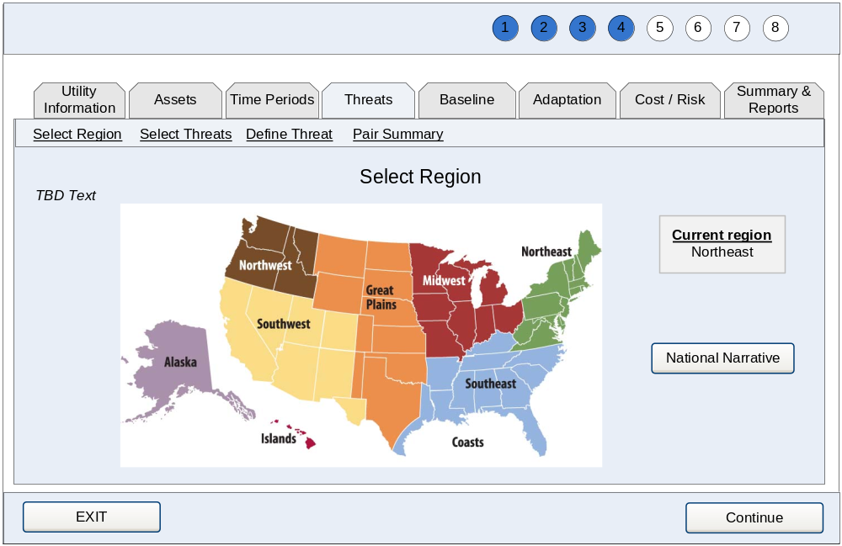
[4-1]. Region Selection (Narratives) Screen: TBD Text will be instructions on selecting regions for regional narratives (or national narrative) and description of links found within narratives.

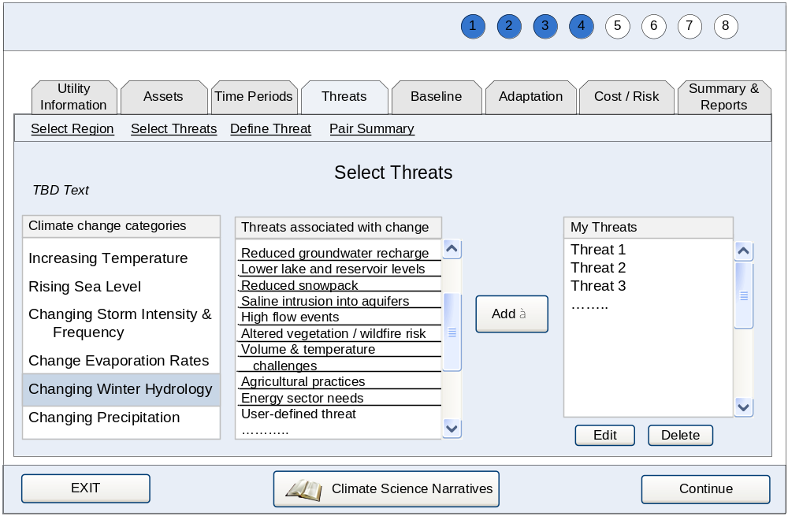
[4-2]. Threat Selection Screen: TBD Text will be definitions of climate change categories and instructions on selecting threats.

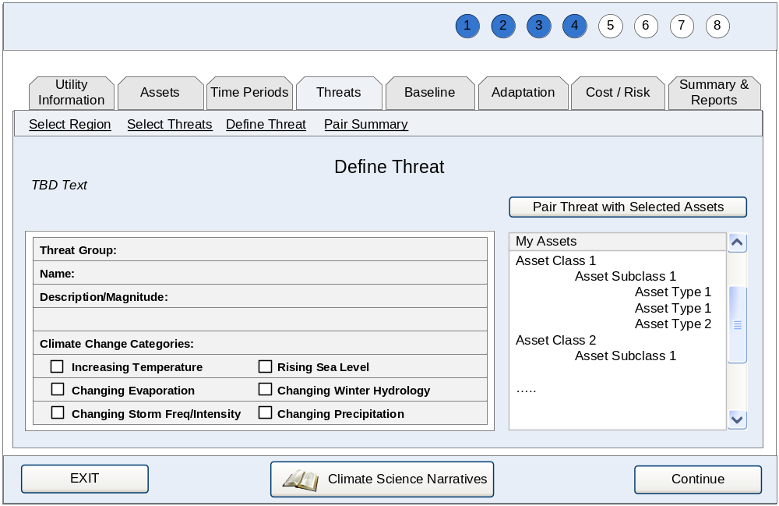
[4-3]. Threat Definition Screen: TBD Text will be instructions on defining threats, with specific guidance on the importance of defining a magnitude related to both asset thresholds and time periods.

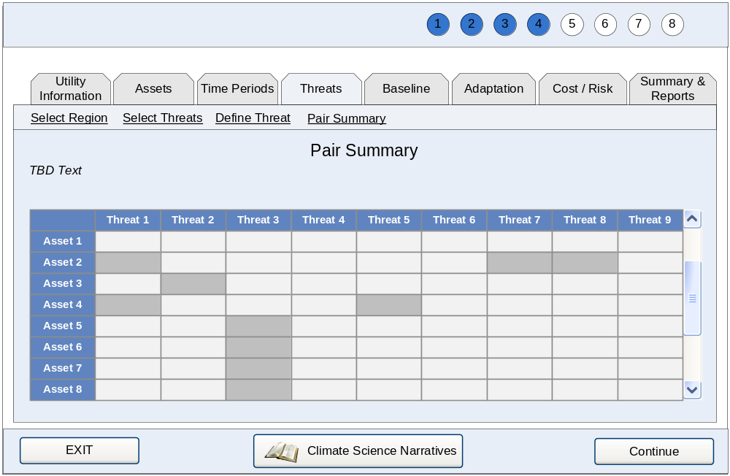
[4-4]. Pair Summary Screen: TBD Text will describe summary presentation.

Build Awareness
WUCCAT will allow the user to review information on climate change, threats, and adaptations in the form of narratives (similar to help screens).

Use Case Brief
Table 3-16 provides a brief description of the use case applicable to this WUCCAT main function.
Table 3-16. Build Awareness Use Case Brief
Use Case | Goal | Description
UC005 Review Narratives | User wishes to review background information to build awareness of climate change, climate-related threats, and adaptations available to mitigate risk. | Assessor reviews narratives of climate change, threat, and adaptation information.

Use Cases and Workflows
The following section provides the detailed requirements for each user goal within the system.

        - UC005 Review Narratives
Category | Main | Last Updated: | 03/17/2010

Actors:
- Assessor

Description:
Assessor reviews narratives of climate change information.

Precondition:
User chose to view a narrative from any portion of the application.

Basic Flow:
- User selects their location on a map and system provides regional narrative.
- User closes narrative and returns to region selection screen.
- User can select another region or choose to continue.
- User chooses to return to the process step last visited.

Alternate Flows:
AF1. Basic Flow 1—User would like to view national narrative.
- User chooses the national narrative instead of a regional one.
- System provides national narrative.
- User closes narrative and returns to region selection screen.

AF2. Basic Flow 2—User would like to view additional narratives in WUCCAT.
- User chooses to view another narrative.
- System provides requested narrative.
- User closes narrative and returns to region selection screen.

AF3. Basic Flow 2—User would like to view projection narrative as an additional narrative.
- User chooses to view the projection narrative.
- System retrieves location from user selection on map for projections to plot.
- User chooses plot type.
- System displays data for the user.
- User closes narrative and returns to region selection screen.

AF4. Basic Flow 2—User would like to print narrative being reviewed.
- User chooses to print narrative.
- System prints narrative.

Exceptions:
None

Post Condition:
The user has reviewed the narratives.

Requirements:
Table 3-17 is a list of requirements that apply specifically to this use case. These requirements can be used as a checklist for items to be included in the design and development phases.

Table 3-17. Requirements
High Level Req. ID | Detailed Req. ID | Description
UC005-HR-001 | - | System shall provide the user with the ability to review narratives on climate change.
- | UC005-DR-001.1 | System shall return user to last process step visited prior to reviewing narratives when they have completed their review of a narrative.
UC005-HR-002 | - | System shall provide a mechanism for user to choose a specific location.
UC005-HR-003 | - | System shall provide access to additional narratives from the narrative under review.
UC005-HR-004 | - | System shall provide the user with the ability to modify plots in projection narratives.
- | UC005-DR-004.1 | System shall provide the ability to select the type of graphs to view within the narrative.
UC005-HR-005 | - | System shall provide a mechanism to update the narratives with limited use of technical resources.
UC005-HR-006 | - | System shall provide the ability to print any narrative in a readable format to a standard 8½ inch width paper in portrait orientation.

Table 3-18. Business Rules
Business Rule ID | Related Req. ID | Description
UC005-BR-001 | UC005-HR-001 | All narratives are read-only.
UC005-BR-002 | UC005-HR-001 | Narrative types include: national, regional, climate change category, data example, threat group, adaptation list, and projection.
UC005-BR-003 | UC005-HR-003 | Data example and climate change category narratives will be accessible (linked from) regional and national narratives.
UC005-BR-004 | UC005-HR-003 | Threat group narratives will be accessible (linked from) climate change category narratives.
UC005-BR-005 | UC005-HR-003 | Data example and adaptation list narratives will be accessible (linked from) threat group narratives.

Table 3-19. Interface Requirements
Interface Req. ID | Related Req. ID | Description
UC005-IR-001 | - | Open links to narratives in a new browser window.
UC005-IR-002 | - | User selected location on map is approximate location of interest for all narratives provided, where location is relevant.
- | UC005-IR-002.1 | Latest location selected by user, resolved to match spatial projection resolution, is used to determine projection information in plots.

Open Issues: None

Workflow:
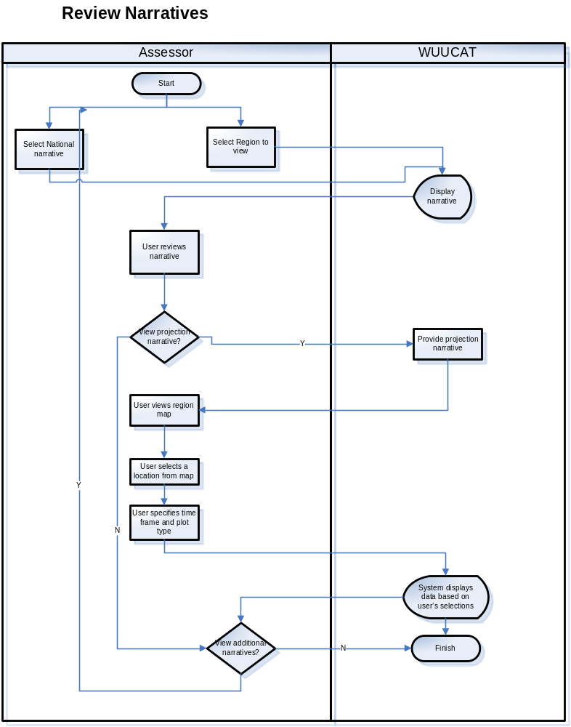
Figure 3-7. Workflow UC005 – Review Narratives

Notes

Data structure for narratives:
National narrative = [title], [text], [temperature], [sea level], [evaporation], [winter], [storms], [precipitation], [image], [citations], [links]

Regional narrative = [title], [text], [temperature], [sea level], [evaporation], [winter], [storms], [precipitation], [image], [citations], [links]

CC narrative = [title], [text], [image], [citations], [links]

Data example narrative = [title], [text], [image], [citations]

Threat group narrative = [title], [text], [image], [citations], [links]

Adaptation list = [title], [text], [list]

Projection narrative = [title], [text], [citations], [time frame(s)], [location], [plot format]

Plot format options:
Box-whisker (in Framework, p33)—up to five time frames in each panel
Line graph (in Framework, Fig 3 p10)—up to five time frames marked on plot in each panel
Seasonal plot (in Framework, Fig B-2 p37)—up to two time frames plotted resulting in four panels

Sample Interface:
The following represents a sample of what the user interface may represent when complete. This information is not final and may appear different in a release.

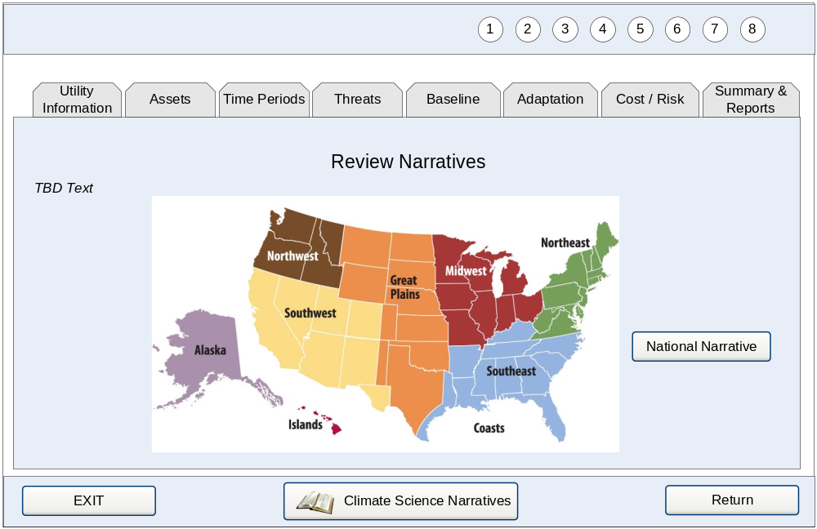
[5-1]. Review Narratives Map: TBD Text will be instructions for beginning the navigation of narratives (similar to [4-1]).
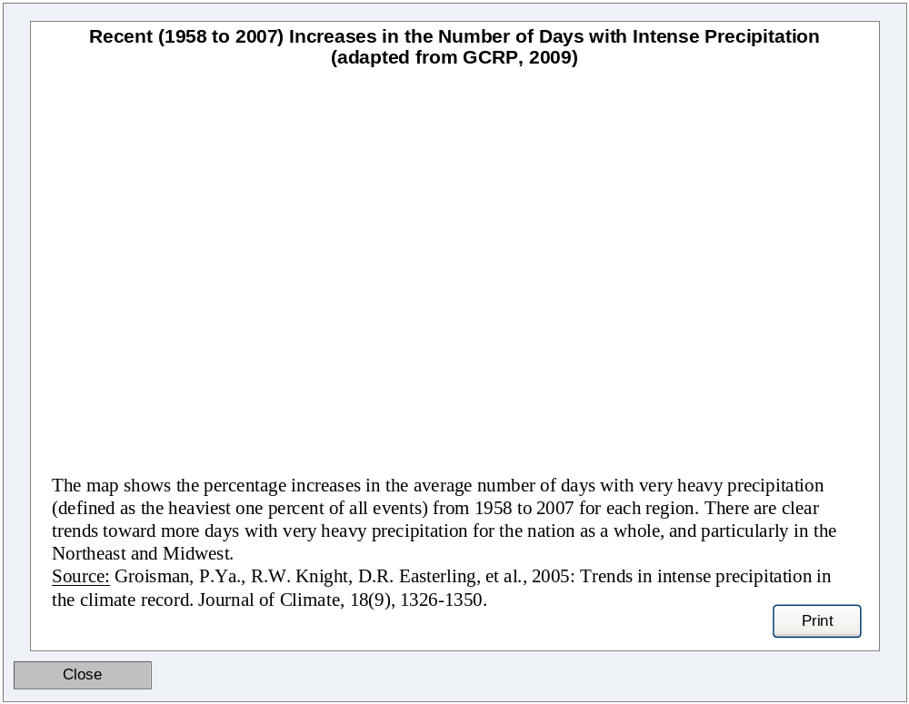
[5-2]. Basic Narrative Example.

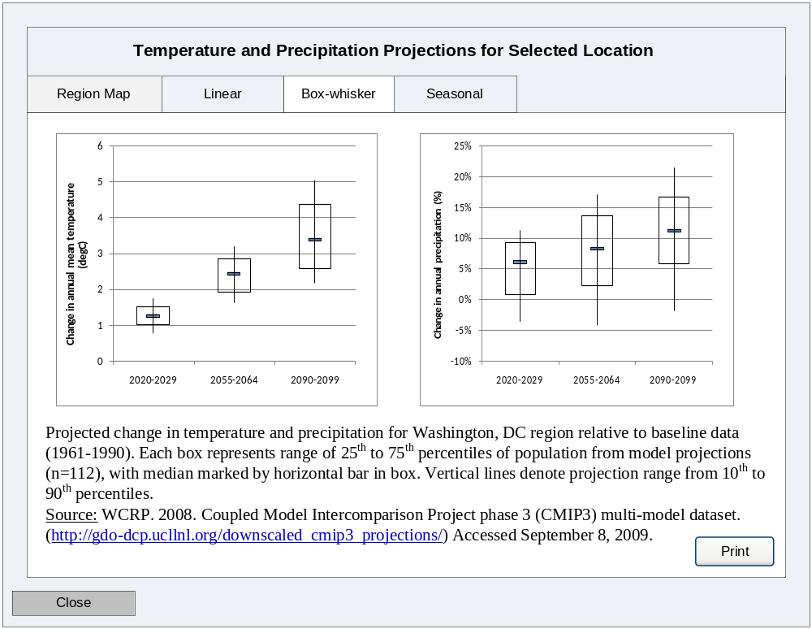
[5-3]. Projection Narrative Example.

Perform Assessment
WUCCAT will allow the user to assess the risk associated with threats by assigning consequences and likelihood of occurrence.

Use Case Briefs
Table 3-20 provides a brief description of the use cases applicable to this WUCCAT main function.
Table 3-20. Perform Assessment Use Case Briefs.
Use Case | Goal | Description
UC007 Establish Baseline Analysis | User wishes to perform an initial risk assessment. | Assessor assigns likelihood for threat and consequences for each asset-threat pair assuming no future adaptation. Assessor reviews narratives and determines consequence weighting for their assessment. Assessor reviews an assessment of risk based on their inputs.
UC008 Perform Adaptation Analysis | User wishes to assign adaptations and assess the resultant risk reduction. | Assessor assigns new consequences for each asset-threat pair following adaptation taken in a specific time period. Assessor reviews an assessment of their current risk based on their inputs. Assessor defines adaptations, including costs.

Use Cases and Workflows
The following section provides the detailed requirements for each user goal within the system.

        - UC006 Conduct Baseline Assessment
Category | Main | Last Updated: | 03/17/2010

Actors:
- Assessor

Description:
Assessor assigns likelihood for threat and consequences for each asset-threat pair. Assessor reviews narratives and determines consequence weighting for their assessment. Assessor reviews an assessment of current risk (baseline).

Precondition:
User has identified time periods for assessment, paired assets and threats, and accessed the baseline assessment portion of WUCCAT.

Basic Flow:
- User defines the likelihood for each threat across all identified time periods.
- System saves selections.
- User chooses an asset-threat pair to assess.
- User defines the levels of consequence attributes for the pair.
- User completes pair definition.
- User chooses to continue and system calculates and saves overall consequence for the pair.
- System displays baseline summary of all pairs assessed so far.
- User repeats steps 3 through 6 until consequences for all desired pairs have been assessed.
- User indicates completion status.
- System provides user with next step in the assessment process.

Alternate Flows:
AF1. Basic Flow 1—User would like to consider threat on a specific time period as a highly likely “scenario.”
- User chooses scenario for time period and threat.
- System sets the likelihood to “very high” and does not allow the user to select the likelihood for the time period.

AF2. Basic Flow 3—User would like to view the baseline summary before completing pair.
- User chooses to view summary.
- System provides baseline summary.
- User chooses to return to pair selection.

AF3. Basic Flow 3—User would like to revisit assessment for a pair.
- User selects a pair which has already been assessed and chooses to revisit assessment.
- System prompts the user “Are you sure you want to revisit assessment for this pair?”
- User provides confirmation and proceeds to assessment.

AF4. Basic Flow 3—User would like to delete assessment for a pair.
- User selects a pair which has already been assessed and chooses to remove assessment.
- System prompts the user “Are you sure you want to remove assessment for this pair?”
- User provides confirmation.
- System returns user to updated pair selection.

AF5. Basic Flow 3—User would like to copy assessment for a pair.
- User selects a pair which has already been assessed and chooses to copy assessment.
- System prompts the user “Select pair with same consequence assessment.”
- System assigns a copy of the assessment to selected pair.
- System returns user to updated pair selection.

AF6. Basic Flow 5—User would like to adjust weighting of consequence attributes.
- User chooses to edit attribute weights.
- System notifies the user “Weights will be applied to consequences for ALL pairs assessed.”
- User acknowledges notice and defines consequence attribute weighting.
- System recalculates all previous consequence assessments.
- System updates weight display.

AF7. Basic Flow 5—User would like to apply highest attribute consequence to pair.
- User chooses to use highest consequence.
- System notifies the user “Choice will be applied to consequences for ALL pairs assessed.”
- User acknowledges notice.
- System recalculates all previous consequence assessments.
- System updates weight display.

AF8. Basic Flow 7—User would like to review all pairs associated with a point in the baseline risk matrix.
- User views a numeric summary of the pairs that were assigned to the same point in the risk matrix.
- User chooses to view the pairs that make up the numeric summary.
- System displays description of each pair sequentially.
- User chooses to view each individual pair, one by one.
- User indicates their completion status with reviewing pairs.
- System returns user to baseline summary.

Exceptions:
E1. AF4 & AF5—User does not wish to delete or modify a pair.
- User cancels their transaction.
- System displays message, “Change will not be saved if you continue.”
- User acknowledges error prompt.
- System does not save the change and returns the user to pair selection.

E2. AF7 & AF8—User does not wish to change how consequence is calculated.
- User cancels their choice following notice.
- System does not save the change and returns the user to the consequence assessment.

E3. Basic Flow 1—User has not identified all of the following: assets, threats, time periods, and pairs.
- System displays the following message “Please identify assets, threats, time periods, and pairs in order to perform Baseline Assessment.”

Post Condition:
The user has populated and reviewed the baseline summary.

Requirements:
Table 3-21 is a list of requirements that apply specifically to this use case. These requirements can be used as a checklist for items to be included in the design and development phases.

Table 3-21. Requirements
High Level Req. ID | Detailed Req. ID | Description
UC006-HR-001 | - | System shall provide a method for assessing baseline risk determined by the consequence of a threat to the paired asset and likelihood of threat occurrence.
UC006-HR-002 | - | System shall provide a summary of the baseline assessment in a graphical matrix of consequence and likelihood of occurrence.
UC006-HR-003 | - | System shall provide a mechanism for user to enter assessment of both likelihood and consequence.
- | UC006-DR-003.1  UC006-DR-007.1 | System shall provide the ability to set the level for each consequence attribute for a pair. See notes in this UC for attribute definitions.
- | UC006-DR-003.2  UC006-DR-007.2 | System shall provide a mechanism to define one or more time periods that are applicable to a threat.
- | UC006-DR-003.3  UC006-DR-007.3 | System shall provide a mechanism to define the likelihood of each threat for each time period.
- | UC006-DR-003.4  UC006-DR-007.4 | System shall provide the ability for user to document assumptions or notes when defining consequences and likelihood.
UC006-HR-007 | - | System shall provide the ability to edit the assessment of a pair.
UC006-HR-004 | - | System shall provide a mechanism to define the consequence attribute weighting for the assessment.
- | UC006-DR-004.1 | System shall provide the ability to define the weighting as either the highest consequence across attributes or by defining a weighted sum
UC006-HR-005 | - | System shall provide the ability to remove the assessment for a pair.
UC006-HR-006 | - | System informs the user of how many pairs have not yet been evaluated.

Table 3-22. Business Rules
Business Rule ID | Related Req. ID | Description
UC006-BR-001 | UC006-HR-004 | System shall provide the ability to define a weighting for each consequence attribute that will apply to all pairs. Default of 0.2 applied by system.
UC006-BR-002 | UC006-HR-003.1 | System will provide the ability to set the consequence level to low, medium, high, or very high for each consequence attribute.
UC006-BR-003 | UC006-HR-003.3 | System will provide the following options for defining likelihood: low, medium, high, or very high. See notes for definitions.
UC006-BR-004 | UC006-HR-001 | System will assign level of risk in a matrix of likelihood and consequence. The aggregation of all assessed pairs in this matrix constitutes the baseline assessment.
UC006-BR-005 | UC006-DR-003.2 | User may choose not to apply a timeframe to a threat by assigning a likelihood of “n/a” to the time period.
UC006-BR-006 | UC006-HR-002 | If multiple pairs are assigned to the same point in the risk matrix, the system will provide a numeric summary of the number of pairs at that point and provide access to the names of the pairings that make up the numeric summary.

Table 3-23. Interface Requirements
Interface Req. ID | Related Req. ID | Description
UC006-IR-001 | - | Likelihood assessment will be conducted on a new screen for each threat.
UC006-IR-002 | - | Likelihood assessment for time periods and threats where “scenario” is chosen will be disabled.
UC006-IR-003 | - | Provide check marks in asset-threat matrix to indicate a pair has been assessed.
UC006-IR-004 | - | Provide consequence levels for attributes in table for the user to select from.

Open Issues: None

Workflow:
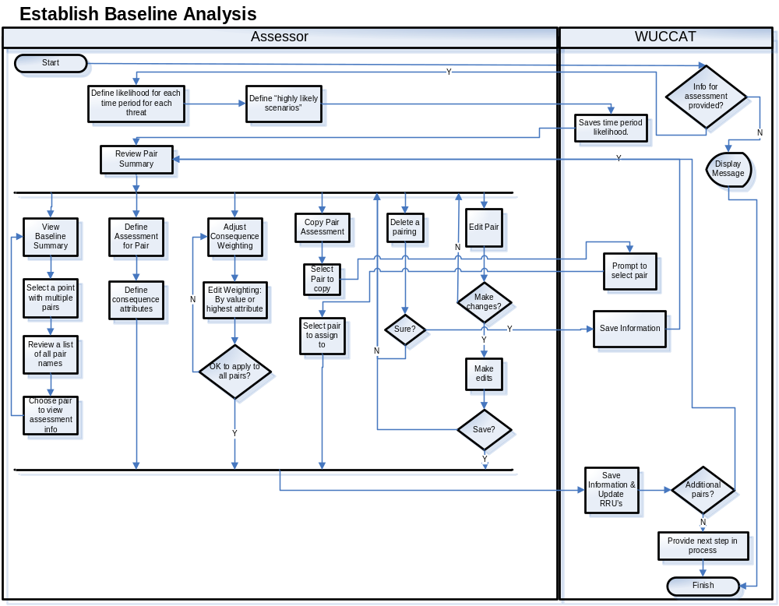
Figure 3-8. Workflow UC006 – Conduct Baseline Assessment

Notes

Likelihood of Occurrence Definitions:
- Low: Possible, but unlikely to occur within the time frame. Threat occurrence is possible, but climate model projections are in general agreement that conditions associated with the threat are unlikely.
- Medium: Occurrence within the time frame is unlikely. While there is no general agreement among climate model projections in the direction and magnitude of changes, some models project conditions associated with the threat. Recurrence within the time frame is also unlikely.
- High: Occurrence within the time frame is likely. A majority of climate models project conditions consistent with the threat, although there may be divergence in model projections. Recurrence within the time frame is also possible. GCRP (2009) defines “likely” as an outcome that has at least a two-thirds chance of occurring.
- Very High: Occurrence within the time frame is probable: not certain, but far more likely to occur than not. Climate model outputs are in general agreement concerning the direction and relative magnitude of projected changes related to the threat. Recurrence is also likely within the time frame. GCRP (2009) defines “very likely” as an outcome that has at least a 90 percent chance of occurring.

Consequence Attributes:
- Business impacts: Revenue or operating income loss evaluated in terms of the magnitude (minor or significant) and recurrence (short-term, seasonal, episodic, long-term) of service interruptions;
- Facility/equipment damage: Costs of replacing the service equivalent provided by a facility or piece of equipment evaluated in terms of the magnitude of damage (minor, significant, complete loss) and financial impacts (flexible cost scale, “$X,” can be customized by each user);
- Water resource water impacts: For water supply utilities, degradation or loss of source water or receiving water quality and/or quantity evaluated in terms of the recurrence (temporary, seasonal, episodic, long-term);
- Environmental impacts: Evaluated in terms of environmental / ecosystem damage or loss (aside from source water resource impacts) and compliance with environmental regulations (permit violations, regulatory enforcement and actions); and
- Community impacts: Public health impacts evaluated in terms of the duration (short or long-term) and extent (minor, localized, widespread).

Consequence Attribute Weighting:
Two approaches will be provided to calculate consequence based on attribute consequences:
- Retain the highest consequence f as the consequence value for the asset-threat pair.
- Aggregate the consequences using a weighted sum to calculate the consequence value for the asset-threat pair. For example, a user may adopt the default equal weighting of 20% for each attribute. The software will assign a numeric value to each consequence level, from low=1 to very high=4. An aggregate score will then be calculated for a given asset-threat pair by multiplying the weighting percentage and value for each attribute and summing the resultant products. This weighted sum will then be translated into a single consequence value: low (1–1.74), medium (1.75–2.24), high (2.25–2.75), and very high (2.76–4).

Risk Matrix (RRUs):
Based on likelihood and consequence assessments, each pair will be assigned a risk metric (Risk Reduction Unit or RRU) based on the following matrix: (will not be editable by user)
Consequence
Very High | High | Medium | Low
100 | 75 | 60 | 50 | Very High | Likelihood of Occurrence
75 | 55 | 45 | 40 | High | Likelihood of Occurrence
60 | 45 | 40 | 37 | Medium | Likelihood of Occurrence
50 | 40 | 37 | 35 | Low | Likelihood of Occurrence
Figure 3-9. WUCCAT Risk Matrix. Color in the matrix indicates qualitative risk of low (green), medium (yellow), or high (red).

Sample Interface:
The following represents a sample of what the user interface may represent when complete. This information is not final and may appear different in a release.

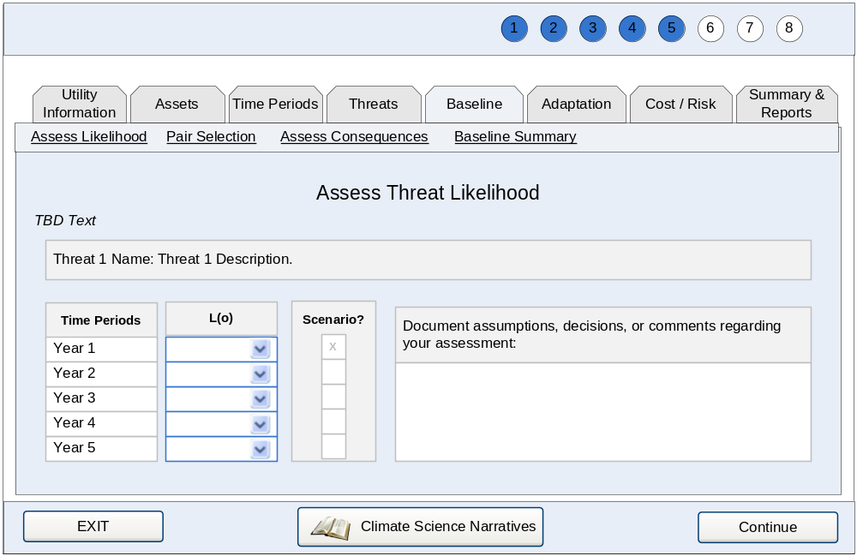
[6-1]. Likelihood Assessment Screen: TBD Text will be instructions on selecting likelihoods for threat, including definition of “scenario” and ability to exempt time periods for this threat.

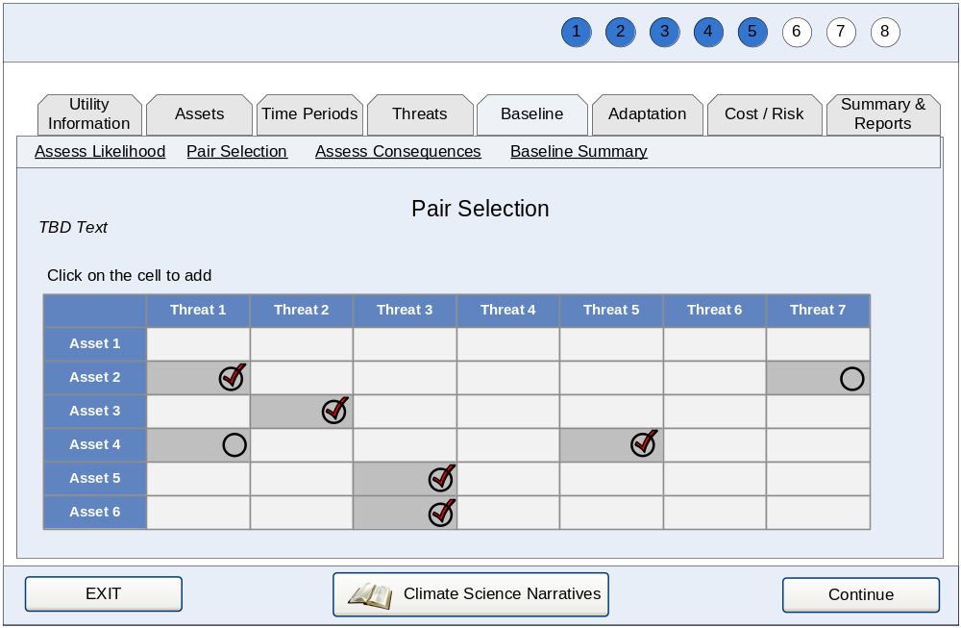
[6-2]. Pair Selection Screen: TBD Text will be instructions on selecting pairs and accounting for pairs already assessed.

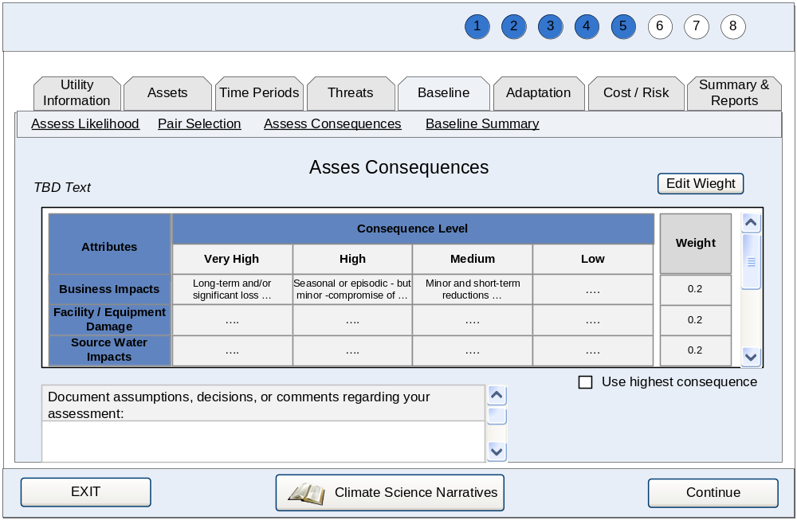
[6-3]. Consequence Selection Screen: TBD Text will be instructions on assessing consequences and adjusting scheme for aggregating consequences (applied to ALL pairs).

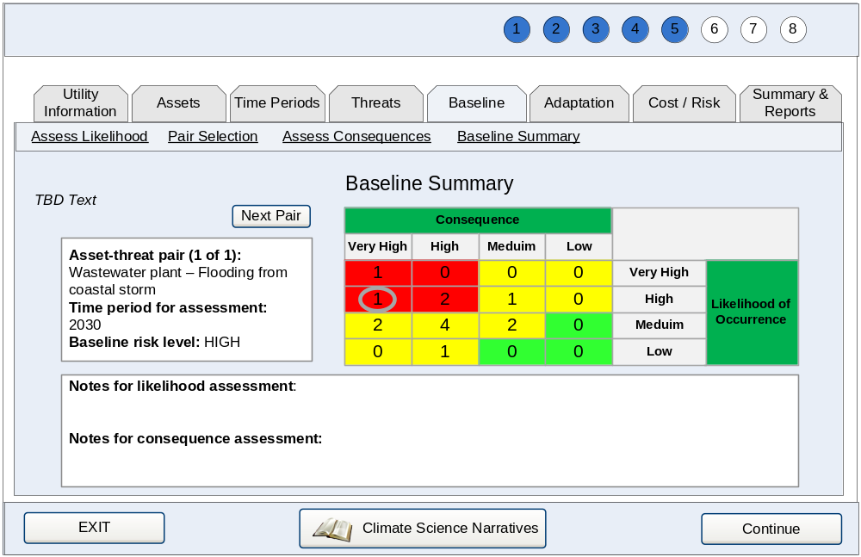
[6-4]. Baseline Summary Screen: TBD Text will describe summary and ability to review pairs using the risk matrix.

        - UC007 Perform Adaptation Assessment
Category | Main | Last Updated: | 03/17/2010

Actors:
- Assessor

Description:
Assessor assigns new consequences for each asset-threat pair following adaptations pursued in a specific time period. Assessor reviews an assessment of their current risk based on their inputs. Assessor obtains reports associated with the assessment.

Precondition:
User has identified time periods for assessment, paired assets and threats already identified, conducted baseline assessment, and accessed the adaptation assessment portion of WUCCAT.

Basic Flow:
- User selects an asset-threat pair and time period to assess.
- System provides adaptations for user to select.
- User defines or revises description and cost of adaptation.
- User re-assesses the levels of consequence attributes for the pair.
- User chooses to complete their modification to a pair.
- System calculates and saves overall consequence for the pair.
- System displays adaptation summary of all pairs selected so far.
- User reviews adaptation summary.
- User repeats steps 1 through 7 until adaptations for and resultant changes in consequences for all desired pairs have been assessed.
- System provides user with next step in the assessment process.

Alternate Flows:
AF1. Basic Flow 1—User would like to view the adaptation summary before completing pair.
- User chooses to view summary.
- System provides adaptation summary.
- User chooses to return to pair selection.

AF2. Basic Flow 1—User would like to revisit assessment for a pair.
- User selects a pair which has already been assessed and chooses to revisit assessment
- System prompts the user “Are you sure you want to revisit assessment for this pair?”
- User provides confirmation and proceeds to assessment.

AF3. Basic Flow 1—User would like to delete assessment for a pair.
- User selects a pair which has already been assessed and chooses to remove assessment.
- System prompts the user “Are you sure you want to remove assessment for this pair?”
- User provides confirmation.
- System returns user to updated pair selection.

AF4. Basic Flow 1—User would like to copy assessment for a pair.
- User selects a pair which has already been assessed and chooses to copy assessment.
- System prompts the user “Select pair with same consequence assessment.”
- User selects pair to copy assessment to.
- System assigns a copy of the assessment to selected pair.
- System returns user to updated pair selection.

AF5. Basic Flow 8—User would like to review all pairs associated to a point in the adaptation risk matrix.
- User views a numeric summary of the pairs that were assigned to the same point in the risk matrix.
- User chooses to view the pairs that make up the numeric summary.
- System displays description of each pair sequentially.
- User chooses to view each individual pair, one by one.
- User indicates their completion status with reviewing pairs.
- System returns user to adaptation summary.

Exceptions:
E1. AF2 & AF3—User does not wish to delete or modify a pair.
- User cancels their transaction.
- System displays message, “Change will not be saved if you continue.”
- User acknowledges error prompt.
- System does not save the change and returns the user to pair selection.

E2. Basic Flow 3—User wishes to revisit adaptation selection while defining it.
- User cancels their transaction.
- System displays message, “Change will not be saved if you continue.”
- User acknowledges error prompt.
- System does not save the change and returns the user to adaptation selection.

E3. Basic Flow 1—User has not identified assets, threats, time periods, and pairs, or has not conducted baseline assessment.
- System displays the following message, “Please identify assets, threats, time periods, and pairs and perform baseline assessment in order to perform an adaptation assessment.”

Post Condition:
The user has reviewed the adaptation assessment.

Requirements:
Table 3-24 is a list of requirements that apply specifically to this use case. These requirements can be used as a checklist for items to be included in the design and development phases.

Table 3-24. Requirements
High Level Req. ID | Detailed Req. ID | Description
UC007-HR-001 | - | System provides a mechanism for user to assign adaptations to a pair based on adaptations that are applicable to a threat group and adaptations that have been applied to the assessment.
- | UC007-DR-001.1 | System shall maintain list of adaptation applied for each time period.
- | UC007-DR-001.2 | System shall provide list of all adaptations for threats in the user-defined threat group.
UC007-HR-002 | - | System provides the ability to revise all adaptations upon selection, including user-defined adaptations.
- | UC007-DR-002.1 | System shall provide the following fields of information when revising an adaptation:  - Adaptation Name—text entry  - Adaptation Description—text area  - Internal Capital Costs  - Qualitative—select from list with options for low/medium/high  - Quantitative—currency entry  - Operation & Maintenance Costs  - Qualitative—select from list with options for low/medium/high  - Quantitative—currency entry  - External Costs  - Qualitative—select from list with options for low/medium/high  - Quantitative—currency entry  - Remarks—text area  - Adaptation Description  - Remarks—text area
UC007-HR-003 | - | System shall provide a summary of risk reduction from adaptations determined by the consequence of a threat on the paired asset and likelihood of threat occurrence.
- | UC007-DR-003.1 | System shall provide the adaptation assessment in a graphical matrix of consequence and likelihood of occurrence before and after adaptation modifications have been applied to the pair.
UC007-HR-004 | - | System shall provide a mechanism to assess consequence changes due attributable to selected adaptation.
- | UC007-DR-004.1 | System shall provide the ability to adjust the levels for consequence attributes based on adaptation.
- | UC007-DR-004.2 | System shall provide the ability for user to document assumptions or notes when defining or editing cost, consequence, and likelihood.
UC007-HR-004 | - | System shall provide a mechanism for user to modify the standard settings the system uses for determining risk reduction units.

Table 3-25. Business Rules:
Business Rule ID | Related Req. ID | Description
UC007-BR-001 | UC007-DR-003.1 | If multiple pairs are assigned to the same point in the risk matrix, the system will provide a numeric summary of the number of pairs at that point and provide access to the names of the pairings that make up the numeric summary.
UC007-BR-002 | UC007-HR-003 | System will record level of risk in a matrix of likelihood and consequence. The aggregation of all assessed pairs in this matrix constitutes the adaptation assessment.

Table 3-26. Interface Requirements:
Interface Req. ID | Related Req. ID | Description
UC007-IR-001 | - | Provide check marks in asset-threat matrix to indicate a pair has been assessed.
UC007-IR-002 | - | Consequence levels for attributes are selected in table and system calculates weighted sum (or highest consequence) after save or save and continue is chosen.
UC007-IR-003 | - | Method for consequence calculation is fixed and based on user choice during baseline assessment.
UC007-IR-004 | - | Consequence levels start at those selected during baseline assessment for the pair being considered.

Open Issues: As shown work flow depicts that the user would select only a single “adaptation strategy” for a selected asset-threat pair. A single “adaptation strategy” can be defined as either a specific adaptation method (e.g. Adopt Emergency Response Plan (ERP)) or a combination of adaptation methods (Adopt ERP + Build a Sea Wall). The potential for allowing multiple “adaptation strategies” to be applied to a single-asset threat pair will be explored during development.
Workflow:
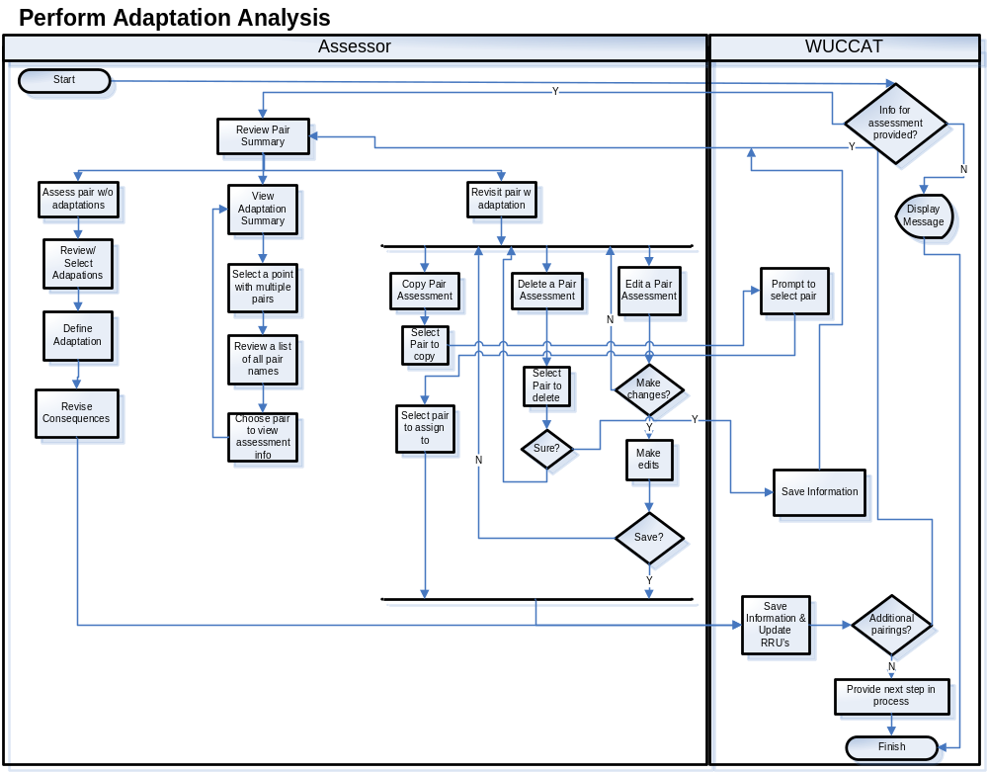
Figure 3-10. Workflow UC007 – Perform Adaptation Analysis
Notes

Adaptation Strategy List: TBD

Selecting Adaptation Strategies:
The user would select only a single “adaptation strategy” for a selected asset-threat pair. A single “adaptation strategy” can be defined as either a specific adaptation method (e.g. Adopt Emergency Response Plan (ERP)) or a combination of adaptation methods (Adopt ERP + Build a Sea Wall). The potential for allowing multiple “adaptation strategies” to be applied to a single-asset threat pair will be explored during development.

Sample Interface:
The following represents a sample of what the user interface may represent when complete. This information is not final and may appear different in a release.

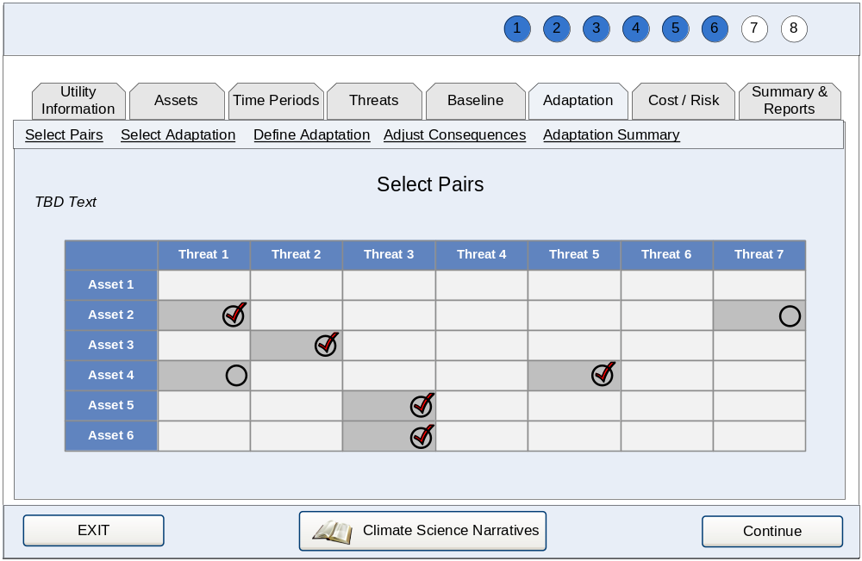
[7-1]. Pair and Time Period Selection Screen: TBD Text will be instructions on selecting pairs.

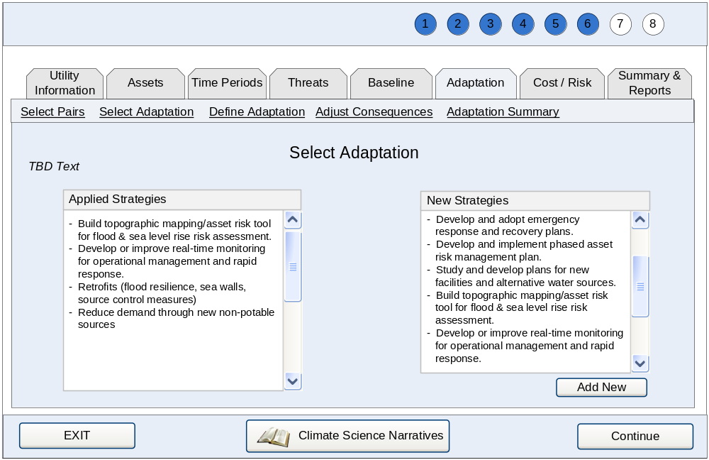
[7-2]. Adaptation Selection Screen: TBD Text will be instructions on selecting adaptations, including pair being assessed and encouragement to select from those already applied for other pairs.

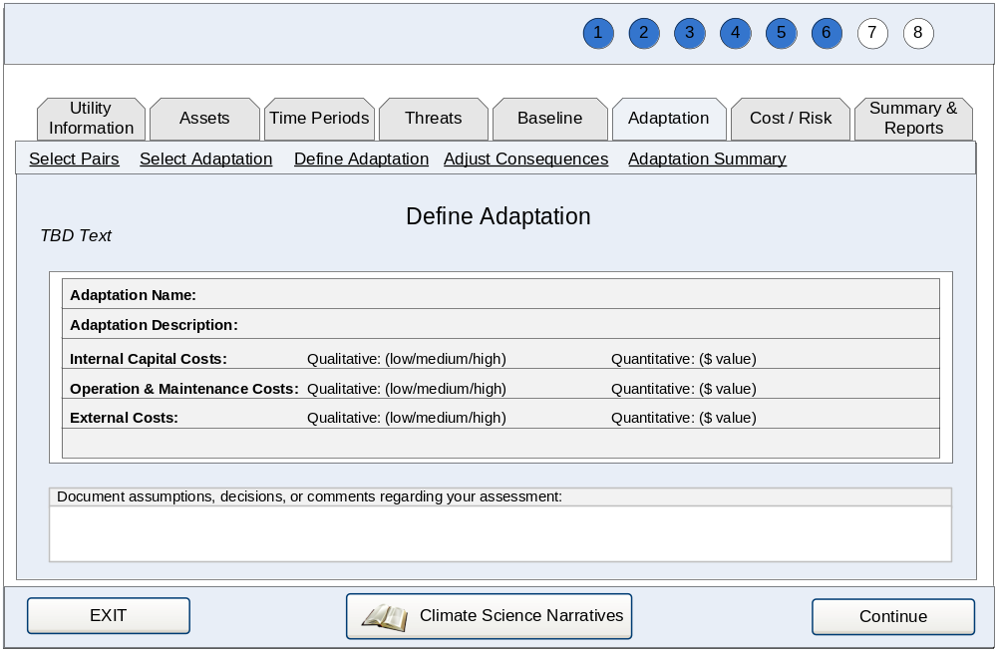
[7-3]. Adaptation Definition Screen: TBD Text will be pair being assessed and instructions on defining adaptations.

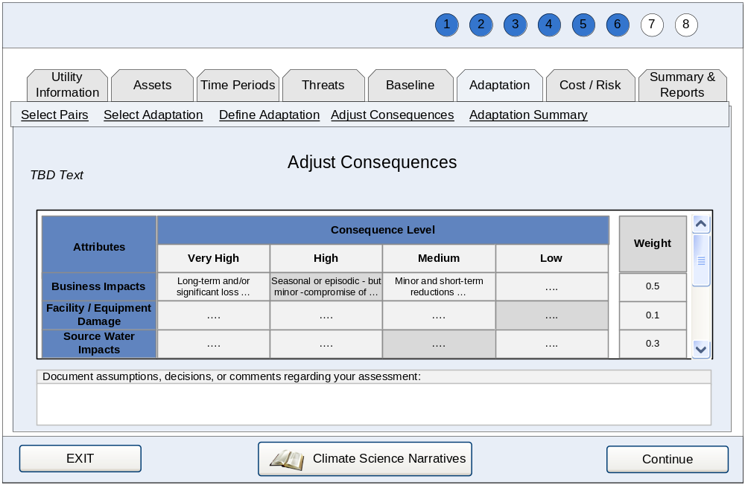
[7-4]. Consequence Adjustment Screen: TBD Text will include pair being assessed and instructions on revising consequences due to the implementation of adaptation.

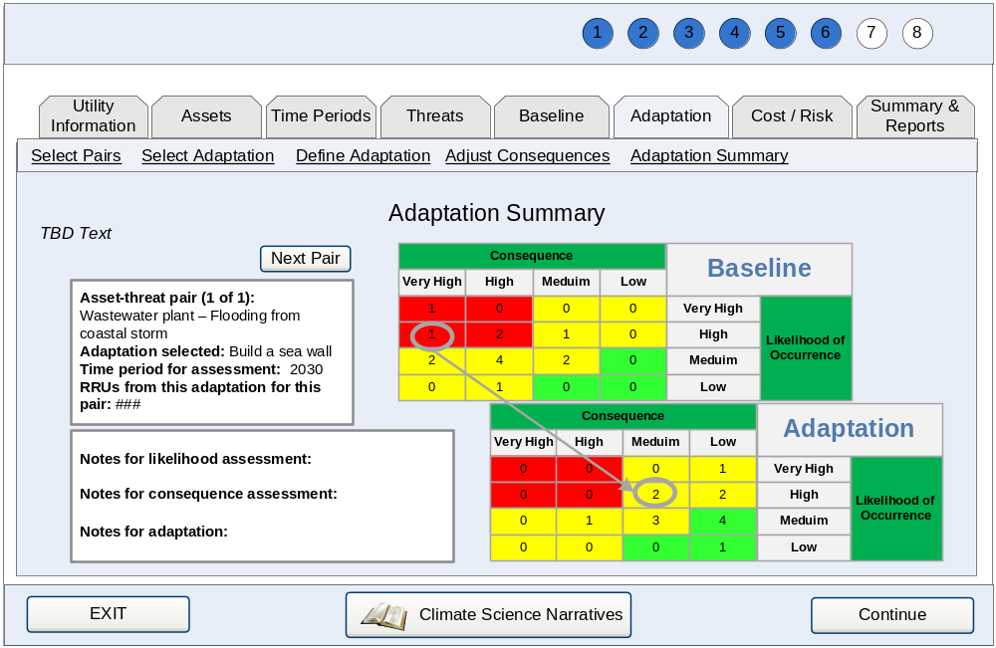
[7-5]. Adaptation Summary Screen: TBD Text will describe summary and capability to review pairs after adaptation using risk matrices.

Evaluate Results
WUCCAT will allow the user to evaluate costs and risk reductions associated with implementation of adaptations and summarize these results in reports.

Use Case Briefs
Table 3-27 provides a brief description of the use cases applicable to this WUCCAT main function.
Table 3-27. Evaluate Results Use Case Briefs
Use Case | Goal | Description
UC009 Evaluate Cost/Risk | User wishes to review costs and risk reductions from adaptations. | Assessor reviews the costs associated with and the risk reductions achieved by implementing adaptations.
UC010 Reports and Summary | User wishes to generate summary report of assessment for their utility. | Assessor selects the adaptations to include and generates a summary report.

Use Cases and Workflows
The following section provides the detailed requirements for each user goal within the system.
        - UC008 Evaluate Cost/Risk
Category | Main | Last Updated: | 03/17/2010

Actors:
- Assessor

Description:
Assessor evaluates the costs associated with and the risk reductions from adaptations.

Precondition:
User has identified time periods for assessment, paired assets and threats already identified, conducted baseline and adaptation assessment, and accessed the Cost/Risk Evaluation portion of WUCCAT.

Basic Flow:
- User reviews assessed adaptations with risk reductions and cost information.
- System saves changes and updates cost information.

Alternate Flows:
AF1. Basic Flow 1—User would like to view and edit the adaptation costs.
- User chooses the name of adaptation to view and revise cost information.
- System provides screen to revise adaptation.
- User revises costs.
- System saves changes and returns the user to cost/risk review.

AF2. Basic Flow 1—User reduces the number of adaptations to review.
- User chooses to review all adaptation(s) of interest.
- User chooses to show selected in displayed list.
- System does not display adaptations that were chosen for exclusion.
- User continues cost/risk review.

AF3. Basic Flow 1—User wishes to see all adaptations after reducing list.
- User chooses to show all adaptations in displayed list.
- System resets all adaptations as selected and user continues cost/risk review.

AF4. Basic Flow 1—User would like to group adaptations together to assess cost for a grouping.
- User selects individual adaptations to include in the group.
- User enters adaptation package name and chooses to create package.
- System saves new adaptation package and returns the user to the cost/risk review.

AF5. Basic Flow 1—User would like to delete an adaptation package.
- User chooses to delete an adaptation package.
- System prompts the user “Are you sure you want to delete adaptation package?”
- User provides confirmation.
- System returns user to cost/risk review.

Exceptions:
E1. AF1—User does not wish to revise adaptation.
- User cancels their transaction.
- System displays message, “Changes will not be saved if you continue.”
- User acknowledges error prompt.
- System does not save changes and returns the user to cost/risk review.

E2. AF5—User does not wish to delete adaptation package.
- User cancels their transaction.
- System displays message, “Change will not be saved if you continue.”
- User acknowledges error prompt.
- System does not save the change and returns the user to cost/risk review.

E3. Basic Flow 1—User has not established assets, threats, time periods, pairings, and conducted a Baseline and Adaptation assessment.
- System displays the following message “Please identify assets, threats, time frames, pairings, and prepare the Baseline and Adaptation assessment in order to perform an Adaptation Assessment.”

Post Condition:
The user has evaluated the costs and risk reductions from adaptations assessed.

Requirements:
Table 3-28 is a list of requirements that apply specifically to this use case. These requirements can be used as a checklist for items to be included in the design and development phases.

Table 3-28. Requirements.
High Level Req. ID | Detailed Req. ID | Description
UC008-HR-001 | - | System shall provide a summary of risk reductions and costs associated with adaptations assessed.
- | UC008-DR-001.1 | System shall provide risk reduction units (RRU) for adaptations summed across all pairs associated with the adaptation and time period. See Business Rules in this UC for details.
UC008-HR-003 | - | System shall provide the ability for user to view and revise costs for any adaptation reviewed.
- | UC008-DR-003.1 | System shall provide the following cost fields for adaptations when viewing or editing an adaptation:  - Internal Capital Costs  - Qualitative – select from list with options for low/medium/high  - Quantitative – currency entry  - Operation & Maintenance Costs  - Qualitative – select from list with options for low/medium/high  - Quantitative—currency entry  - External Costs  - Qualitative- select from list with options for low/medium/high  - Quantitative—currency entry
- | UC008-DR-003.2 | System shall provide the ability for user to document assumptions or notes when editing costs.
UC008-HR-004 | - | System shall provide the ability for user to reduce the list of adaptations to review.
 | UC008-DR-004.1 | System shall provide the ability for user to review list of all adaptations.
UC008-HR-005 |  | System shall provide the ability for user to create new adaptation packages based on selected adaptations.
- | UC008-DR-005.1 | System shall require the user to enter a name for the package when creating a new package.
- | UC008-DR-005.2 | System shall provide the ability for user to delete defined packages.

Table 3-29. Business Rules
Business Rule ID | Related Req. ID | Description
UC008-BR-001 | UC008-HR-001 | Adaptations will be presented in default sort hierarchy of time period (chronological), then RRUs (high to low), then name (alphabetical).
UC008-BR-002 | UC008-DR-001.1 | RRUs aggregated (summed) for an adaptation when several pairs are assigned to the adaptation.
UC008-BR-003 | UC008-DR-001.1 | RRUs are determined by assigning a numeric value based on the consequence and likelihood associated with a pair. The following are the default values for RRUs:
   | Consequence
  Likelihood | Very High | High | Medium | Low
  Very High | 100 | 75 | 60 | 50
  High | 75 | 55 | 45 | 40
  Medium | 60 | 45 | 40 | 37
  Low | 50 | 40 | 37 | 35
UC008-BR-004 | UC008-HR-001 | Both RRUs and costs will be displayed as qualitative and quantitative, with the latter in parentheses, where available.
UC008-BR-005A | UC008-HR-005 | Each adaptation package has a unique name.

Interface Requirements: None

Open Issues: None

Workflow:
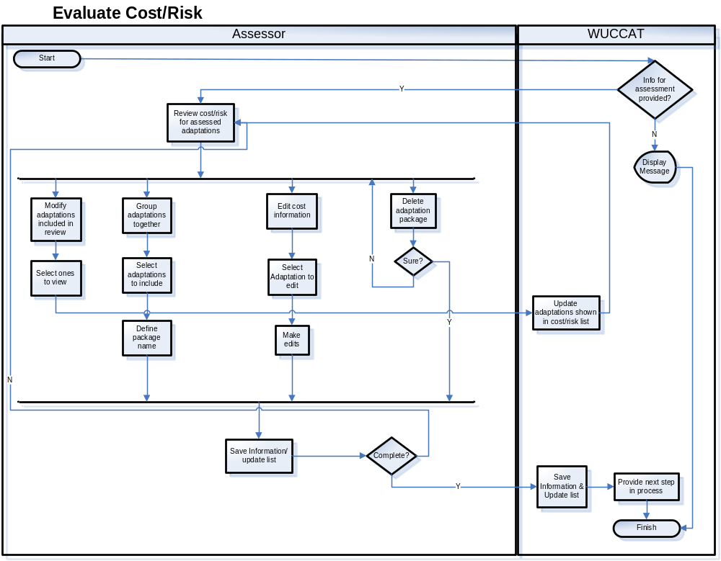
Figure 3-11. Workflow UC008 – Evaluate Cost/Risk

Notes

Sample Interface:
The following represents a sample of what the user interface may represent when complete. This information is not final and may appear different in a release.
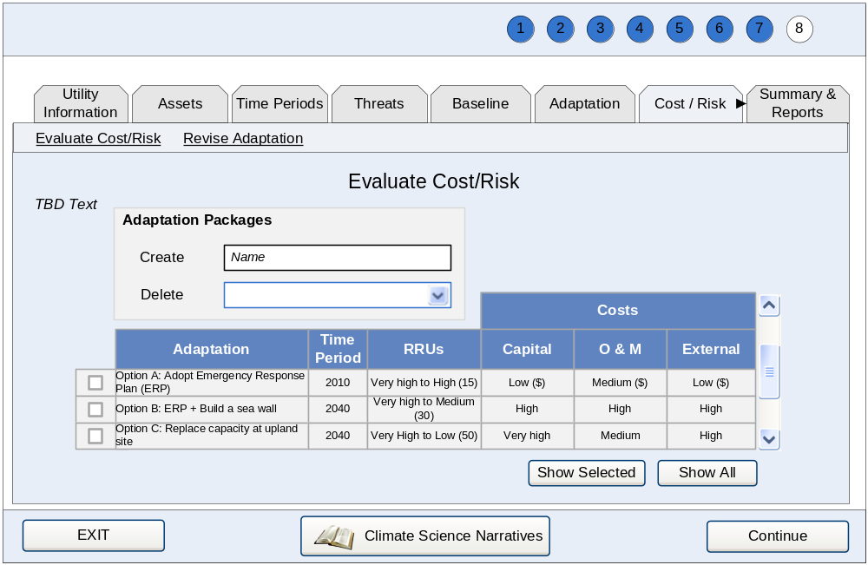
[8-1]. Adaptation Selection Table Screen: TBD Text will be instructions on creation of packages and review of adaptations.

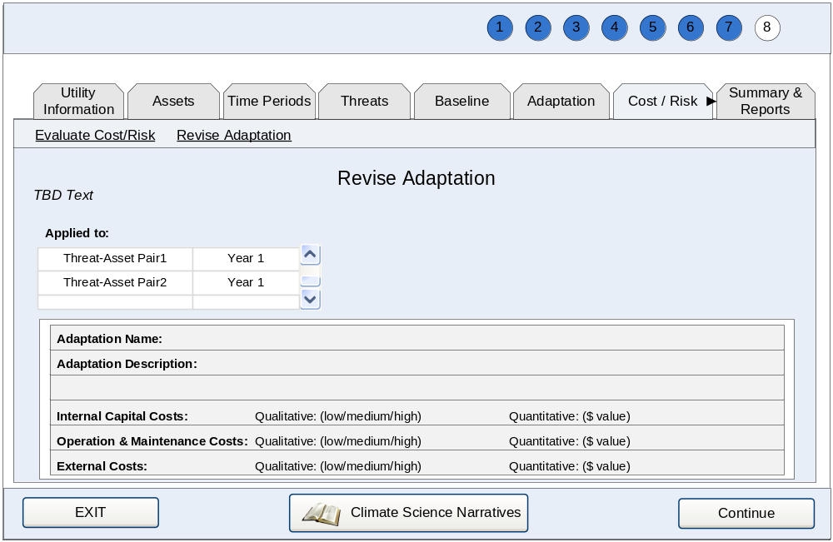 [8-2]. Adaptation Revision Screen: TBD Text will be instructions on revising adaptations and reviewing application of adaptation with respect to pairs and time period.

        - UC009 Generate Reports / Assessment Summary
Category | Main | Last Updated: | 03/17/2010

Actors:
- Assessor

Description:
Assessor selects the adaptations to include in and generates a summary report.

Precondition:
Assessor has identified their utility, assets and threats, assessed associated risks with and without adaptation, and reviewed costs.

Basic Flow:
- User reviews asset-threat-time period-adaptation combinations assessed.
- User chooses combinations to include in summary report.
- User chooses to generate report and system saves selection and generates preview of report.
- User prints summary.
- User returns to preview.

Alternate Flows:
AF1. Basic Flow 1—User would like to sort combinations as part of review.
- User chooses to sort on a particular piece of information.
- System sorts combinations in ascending order.
- User continues review of asset-threat-time period-adaptation combinations assessed.

AF2. Basic Flow 1—User would like to view cost details of any adaptation during review.
- User chooses the adaptation for which they wish to view cost information.
- System displays cost details in details.
- User continues review of asset-threat-time period-adaptation combinations assessed.

AF3. Basic Flow 2—User would like to select all combinations for the report.
- User chooses to select all combinations.
- System includes all combinations in report.

AF4. Basic Flow 2—User would like to include an adaptation package in the report.
- User chooses the adaptation package to include.
- System displays report with selected adaptation package and no others.

AF5. Basic Flow 2—User would like to select combinations for new adaptation package.
- User chooses the combinations to include in adaptation package.
- User enters adaptation package name and chooses to create package.
- System saves new adaptation package and returns user to the updated report.

AF6. Basic Flow 4—User would like to revisit the included combinations before printing.
- User chooses to revisit selections.
- System returns user to selection screen.
- User revises selected combinations to include in summary report.
- User chooses to generate report.
- System saves selection and generates preview of report.

Exceptions:
E1. AF5—User wishes to replace previously created adaptation package.
- User enters existing package name and chooses to create package.
- System displays message, “Existing package will be replaced if you continue.”
- User acknowledges error prompt.
- System saves changes and returns the user to cost/risk review.

Post Condition:
The user obtains report for adaptation schemes for their utility.

Requirements:
Table 3-30 is a list of requirements that apply specifically to this use case. These requirements can be used as a checklist for items to be included in the design and development phases.

Table 3-30. Requirements
High Level Req. ID | Detailed Req. ID | Description
UC009-HR-001 | - | System shall provide a method for generating summary report for adaptations assessed.
UC009-HR-002 | - | System shall provide the ability for user to select specific assessments for each report.
- | UC009-HR-002.1 | System shall provide the ability to report on the assessment criteria including combinations of asset, threat, time period, and adaptation.
- | UC009-HR-002.2 | System provides ability to select all combinations.
- | UC009-HR-002.3 | System provides ability to produce reports on a single adaptation package.
UC009-HR-003 | - | System shall provide the ability for user to sort assessments as part of review and selection for each report.
- | UC009-HR-003.1 | System shall provide the ability to sort by asset, threat, time period, or adaptation.
UC009-HR-004 | - | System shall provide the ability for user to create new adaptation packages based on selected assessments.
- | UC009-DR-004.1 | System shall require the user to enter a name for the package when creating a new package.
UC009-HR-005 | - | System shall provide access to cost details previously provided by user for any adaptation in the list.
UC009-HR-006 | - | System shall provide the ability to produce a report that contains the results and costs of selected combinations.
- | UC009-HR-006.1 | System shall provide the ability to print report in a readable format to a standard 8 ½ inch width paper in portrait orientation.
UC009-HR-007 | - | System shall provide the ability for user to revisit selection of combinations.

Table 3-31. Business Rules
Business Rule ID | Related Req. ID | Description
UC009-BR-001 | UC009-HR-001 | Several asset-threat pairs may be associated with a single adaptation applied for a specific time period.
UC009-BR-002 | UC009-HR-005 | A single set of costs is associated with a single adaptation applied for a specific time period.
UC009-BR-003 | UC009-HR-001 | A single RRU value is associated with each asset-threat pair for a specific time period. RRUs can be aggregated (summed) for an adaptation when several pairs are assigned to the adaptation.
UC009-BR-003 | UC009-HR-002.3  UC009-HR-004 | Adaptation packages include those defined in UC008. Each package has a unique name.

Interface Requirements: None

Open Issues: None
Workflow:
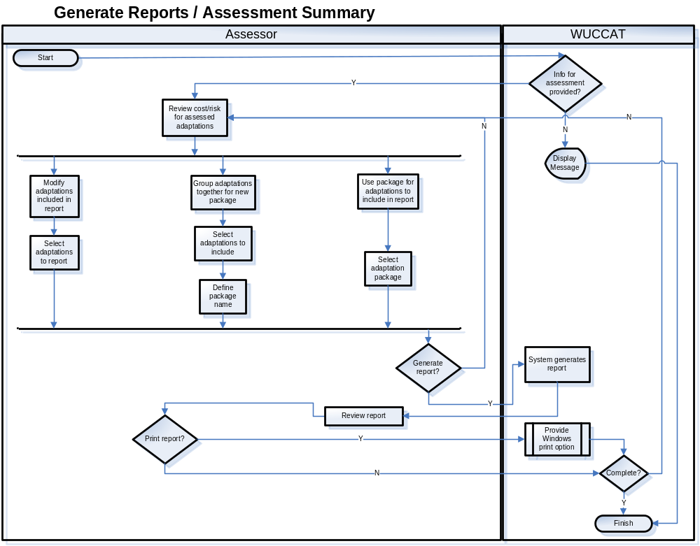
Figure 3-12. Workflow UC009 – Generate Reports / Assessment Summary

Notes

Sample Interface:
The following represents a sample of what the user interface may represent when complete. This information is not final and may appear different in a release.
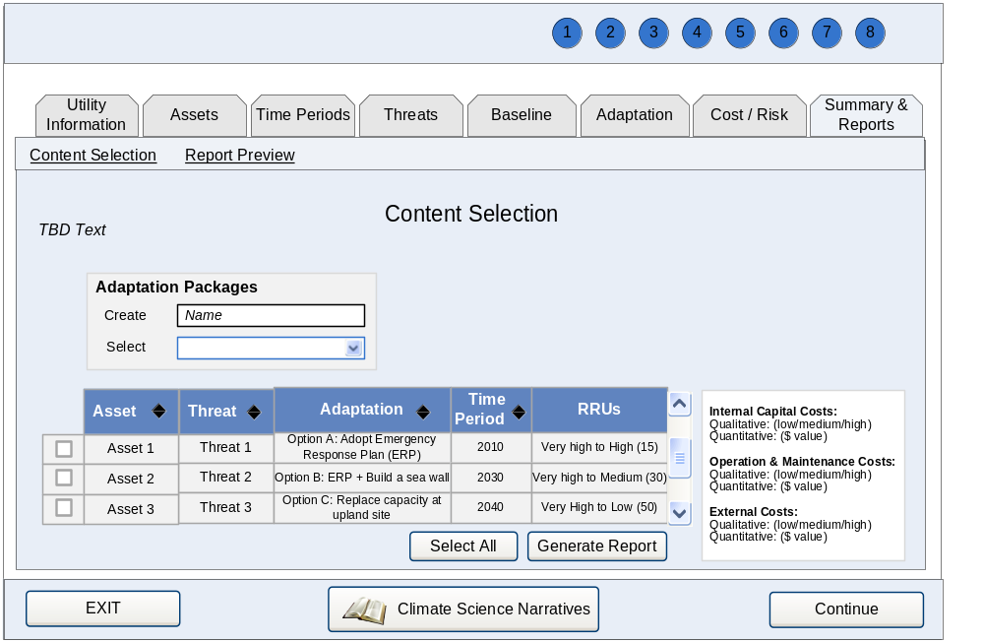
[9-1]. Report Content Selection Screen: TBD Text will be instructions on applying packages and selecting rows for incorporation into reports.

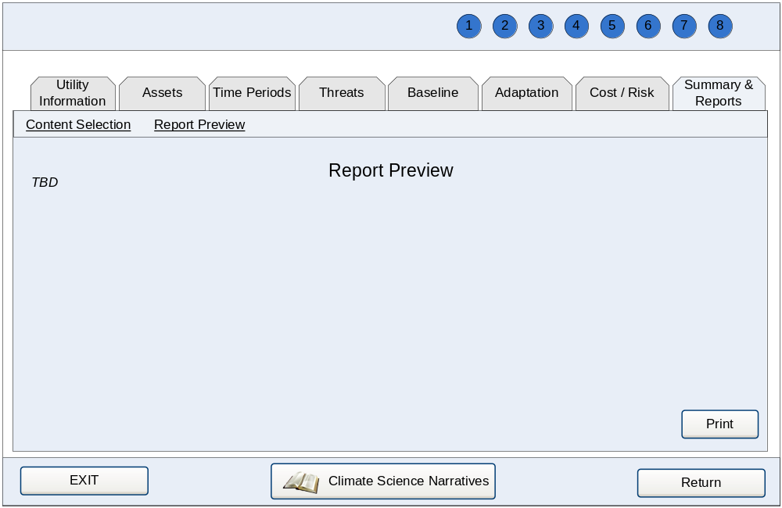
[9-2]. Report Preview and Edit Screen: TBD Content will be based on report template.

System-Wide Requirements

Requirements

The system will provide instructions for printing in the most appropriate page format when the display is best printed in landscape format.

The system will be capable of formatting information to print on standard 8½ inch by 11 inch paper.

The system will validate all data entry fields to ensure data provided are in a format allowed by the database.

System will restrict the ability to enter more information on the screen than what the field is capable of saving to a database.

System will restrict entry information according to the data type of the field.

System will require telephonic number entries to accommodate potential international phone number formatting.

System will validate that e-mail addresses contain domain information.

System will provide the ability to sort data in ascending and descending order for every column of information when data are displayed in tabular format and when applicable.

System will provide the ability to access definitions of fields while on specified screens.

System shall use clear English phrases for screen directions (e.g., “What type of utility assets would you like to work with?”).

System shall provide consistent color-coding throughout the application.

System shall provide consistent color-code for indicating levels of risk.

System shall provide navigation options on process-oriented steps to allow the user to advance logically.

System shall automatically save data when the user advances or returns to portions of the application.

System shall provide the ability to select multiple items from a list without holding the Ctrl key, referred to as “sticky clicks.”

Environment (Non-Functional) Requirements

User Interface Requirements
WUCCAT will be designed using best practices with regard to user interface design for client-based applications. Below is a list of general requirements for the system to follow:

The system will be designed as a client-based application.

The system will be designed to interface with included database containing climate projection information.

All system user interfaces and page elements will have a common look and feel.

The system will endeavor to use best practices to comply with EPA Section 508 standards.

The system will provide forward and backward navigation throughout the system unless it impedes the business flow.

The system will be designed for a minimum screen size of 1024 by 68.

The system will be designed so that descriptive error messages are displayed on screen to the user.

The system shall incorporate several navigation controls, road maps, and work tracking approaches to help users understand where they are in the analysis process and to suggest the next step they need to perform.

System shall organize the primary user navigation into nine major steps. The steps and functions are as follows:

Analysis Setup and Utility Information

Assets—identify, select, update, edit assets

Time periods—identify, select

Threats—identify, select, update, pair with assets, and edit threats

Perform Baseline Risk Assessment

Adaptations—identify, select, update, edit, update risk assessment

Cost/Risk Review—develop and evaluate packages of adaptation measures and evaluate their cost and effectiveness

Results & Reports—review and documentation of analysis in narrative or spreadsheet reports

System shall provide the ability for users to track their progress throughout the assessment process according to the rules outlined in Table 5-1.

Table 5-1. Progress Tracking Requirements
Analysis Step | Work Tracking—Software Checks | Work Tracking—User Experience
Welcome, Utility Information, and Analysis Setup | Check if first time into program  Check if all fields filled out in utility information | Single screen, no work tracking indicator necessary  User prompt if all fields not completed before attempt to move forward
Assets—selection and updating | Check if assets have been visited | Two-step screen with undefined scope, no work tracking indicator necessary
Time periods—selection | Number of time periods included in analysis; must be in range 1 to 5 | Undefined scope in time period inventory creation, no work tracking indicator necessary
Threats—selection and updating | Number of threats included in analysis | Two-step screen with undefined scope, no work tracking indicator necessary
Perform Baseline Analysis | Number of asset threat pairs analyzed out of total number identified | User receives a progress indicator of completion throughout baseline
Adaptations—identify, select, update, edit, update risk assessment | Number of asset threat pairs that have an improvement analysis out of the total that have a baseline analysis performed | Undefined scope in adaptation measure inventory creation
Cost/Risk Review | TBD | No work tracking indicator necessary
Results & Reports | TBD | No work tracking indicator necessary

Integration/Migration Requirements
There are no integration/migration requirements applicable to this system.

Software Requirements
The system will use Microsoft Windows as the operating system for workstations. The system’s user browser will be vendor and version independent to support communications over standard internet protocols. The user must have Windows XP or higher.

Hardware Requirements
No special hardware requirements beyond what is necessary to run Microsoft Windows.

Other Non-Functional Requirements
This section lists the additional requirements of the application.

Business Continuity and Recovery Requirements
WUCCAT is a client-based system; any backup or recovery requirements are the responsibility of the user.

Performance Requirements

Speed
Any interface between a user and the system shall have a maximum response time of 30 seconds. When performing an assessment or compiling data, the result should be displayed within three minutes.

Capacity
There are no capacity requirements applicable to this system.

Ease of Use

The system will be usable by people without training related to WUCCAT.

The system will include navigation that provides a method for accessing the major system goals at anytime as well as suggests a sequential process.

The system will provide online help to provide assistance on using the system. The system will provide a help screen that pertains to the module the user is currently accessing.

Users will be provided with an electronic version of the User’s Manual.

The system will provide simple tutorials for assistance in learning the system.

Safety Requirements
There are no specific safety requirements identified for this system.

Administrative/Backup/Archive Requirements

Administrative
The data used within WUCCAT may need to be updated to ensure an efficient and current dataset and assessment process. The system shall provide the ability for a user to update the data within the application without a new software version unless the dataset requires updates to the software.

Backup
Databases will be backed up on every opening so that the user may recover the file as it was when opened. All other backup protocols shall be defined by the individual user, as this is a client-based system.

Archive
There are no administrative requirements applicable to this system.

Expected Life Span/Adaptability Requirements
WUCCAT is being developed based on the current best available science on climate change, but this is expected to be enhanced over time. WUCCAT shall be designed and architected to address the potential modifications in data as well as limited process modifications. As described above, WUCCAT will provide peer-reviewed climate science information. Should there be modifications in the assessment process; the application will potentially need to be updated. WUCCAT currently anticipates a life cycle for data updates ranging from four to seven years. In addition, WUCCAT will provide links to source web sites for interim news between updates.

Training/Tutorial Requirements
Training is an essential aspect of WUCCAT. The system shall provide adequate online documentation, tutorials, and quick guides to help users achieve an accelerated learning curve when using the system. WUCCAT administrators may elect to have a short demonstration of their administration module, but in general, the application shall be self-explanatory.

Documentation Requirements
The following documentation shall be provided for the system:
- Concept of Operations (Framework)
- Software Requirements Specification (SRS)
- Test Plan
- Test Cases
- User’s Guide
- Online Help
- Quick Reference Guide
- Tutorials

Security and Privacy Requirements
Below is a list of security related requirements for WUCCAT.

Security Requirements

Information received will not be transferred to any other interface.

Data accessed within WUCCAT is to be considered sensitive but unclassified.

The system shall not use scripts with embedded passwords.

Appendix A—List of Acronyms
AMWA | The Association of Metropolitan Water Agencies
AWWA | American Water Works Association
CSC | Computer Sciences Corporation
GCRP | U.S. Global Change Research Program, 2009
NRWA | National Rural Water Association
RRU | Risk Reduction Unit
SRS | Software Requirements Specification
UC | Use Case
VSAT | Vulnerability Self-Assessment Tool
WEF | Water Environment Federation
WERF | Water Environment Research Foundation
WUCCAT | Water Utility Climate Change Awareness and Risk Assessment Tool

The climate science community uses the term “climate change impacts” to describe climatic, hydrologic, geophysical, and geochemical systems, as well as changes in terrestrial and aquatic ecosystems. In this tool, “climate change threats” are the result of how “climate change impacts” alter the operating environment of utility facilities and operations, present risk of mission impairment and/or failure, or undesirable consequences imposed on local communities/economies.

