FIGURE LEGENDS

Fig. 1 Changes in FTIR spectra in regions where hydroxyl and carbonyl functional groups absorb (circled) versus irradiation time demonstrate that pro-oxidant (PO) accelerates photooxidation of LDPE – nanosilica composite under simulated sunlight

Fig. 2 Buildup in absorbance in carbonyl region of LDPE-nanosilica composite on irradiation (5.0 days) by simulated sunlight that passed through cutoff glass filters which blocked wavelengths less than 305 nm, 355 nm, and 385 nm (see Fig. [1](https://link.springer.com/article/10.1007/s10924-023-02864-4#Fig1)). Removal of UV radiation reduces photooxidation of the LDPE-nanosilica composite

Fig. 3 Atomic force microscopic (AFM) image of LDPE/nanosilica composite with added pro-oxidant: irradiated sample (after irradiation for 3.9 days in solar simulator) compared to dark control obtained at ambient conditions with a Digital Instruments Multimode Scanning Probe Microscope. The irradiated surface has less uniformity in the height than the dark control surface

Fig. 4 Effects of irradiation exposure in solar simulator on mechanical properties of LDPE/nanosilica composites with or without added pro-oxidant

Fig. 5 Effects of irradiation on mechanical properties of LDPE/ nanosilica composite. The loss of tensile strength versus irradiation time was quantified as first-order rate constants for composite degradation

Fig. 6 Relative weighting function (blue-green) for sunlight-induced fragmentation of LDPE/nanosilica composite with added pro-oxidant compared to midday July irradiance at latitude 40o N (green) and the weighted irradiance (yellow) for the fragmentation near the surface of a water body. The weighted irradiance, which is the cross-product of the relative weighting function and the irradiance, indicates that the peak action of sunlight is at about 340 nm in the UV spectral region

Fig S1. Conceptual model for autoxidation of polymer matrix. This process leads to

weathering and fragmentation of the matrix and release of nanomaterials from

ENM-polymer composites. Pro-oxidants catalyze autoxidation by accelerating the

decomposition of hydroperoxide intermediates.

Fig S2. Solar simulator used for irradiations

Fig S3. Filtered irradiance used in experiments to define spectral weighting

functions for sunlight-induced weathering of LDPE-nanosilica composites. The

wavelength cutoffs correspond to approximately 50% reduction in irradiance.

Change in title: Add the phrase “with Added Pro-oxidant”

Key Words from Published Paper:

Polyethylene, NanoSilica , Composites, Weathering, Sunlight, Model

Zepp notes: The legends for Fig S1, Fig S2 and Fig S3 are shown here. I am attaching the figures because I could not find them in the material provided here. The figure legends for the the other figures are in the published paper; I added here to have them all in one place.

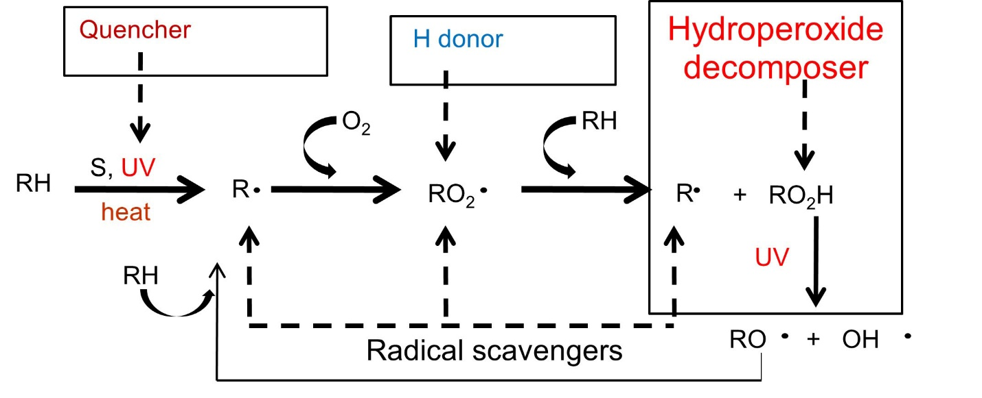

Fig. S1 : . Conceptual model for autoxidation of polymer matrix. This process leads to

weathering and fragmentation of the matrix and release of nanomaterials from

ENM-polymer composites. Pro-oxidants catalyze autoxidation by accelerating the

decomposition of hydroperoxide intermediates.

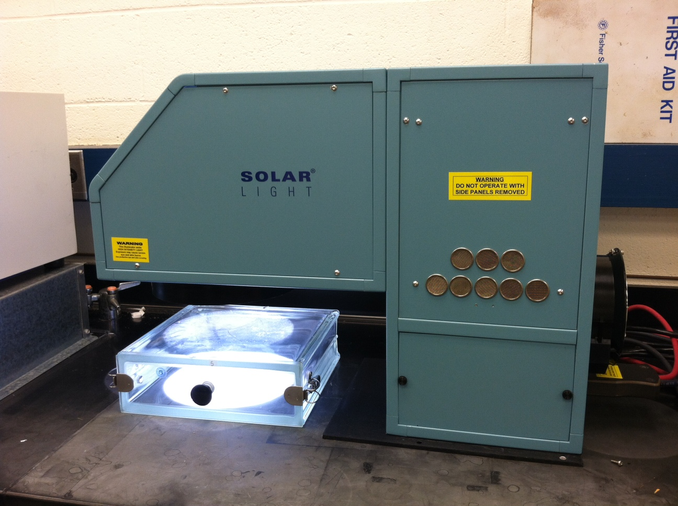

Fig S2. Solar simulator used for irradiations

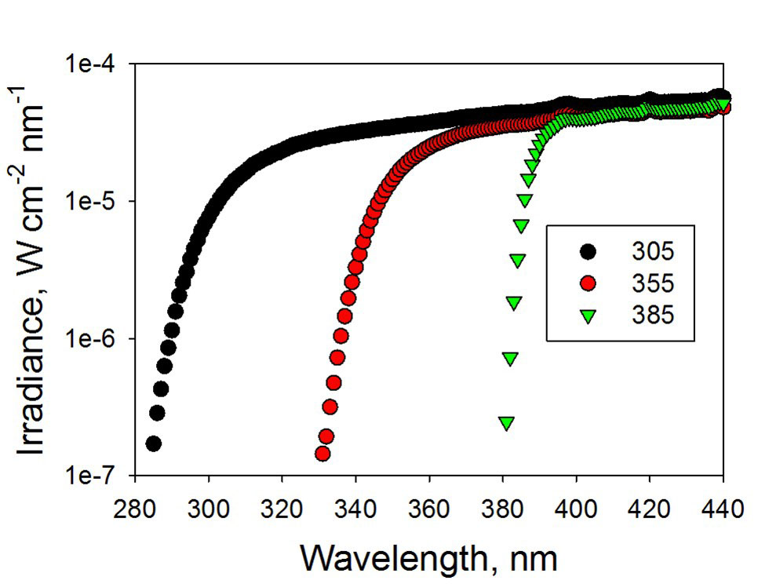\\

Fig S3. Filtered irradiance used in experiments to define spectral weighting

functions for sunlight-induced weathering of LDPE-nanosilica composites. The

wavelength cutoffs correspond to approximately 50% reduction in irradiance.