Polymer w/ Pro-oxidant
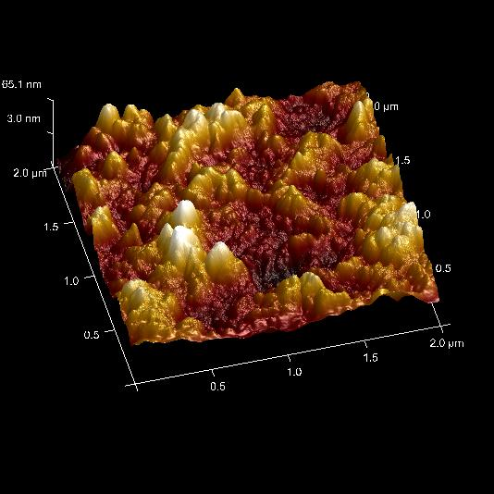
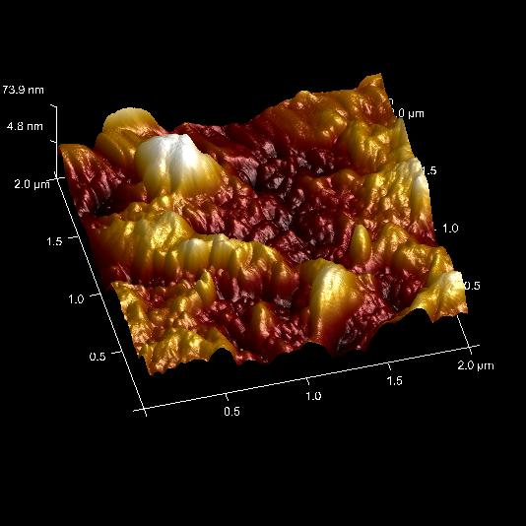
Irradiated Control
Polymer w/o Pro-oxidant
Irradiated Control
Highly Irradiated
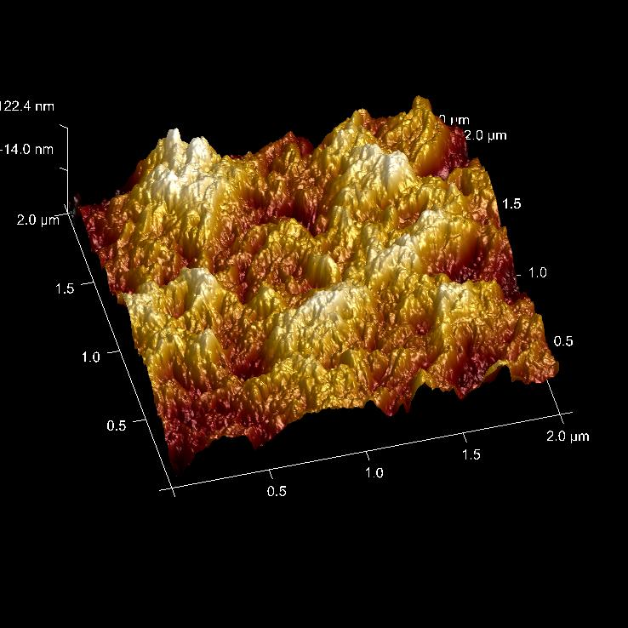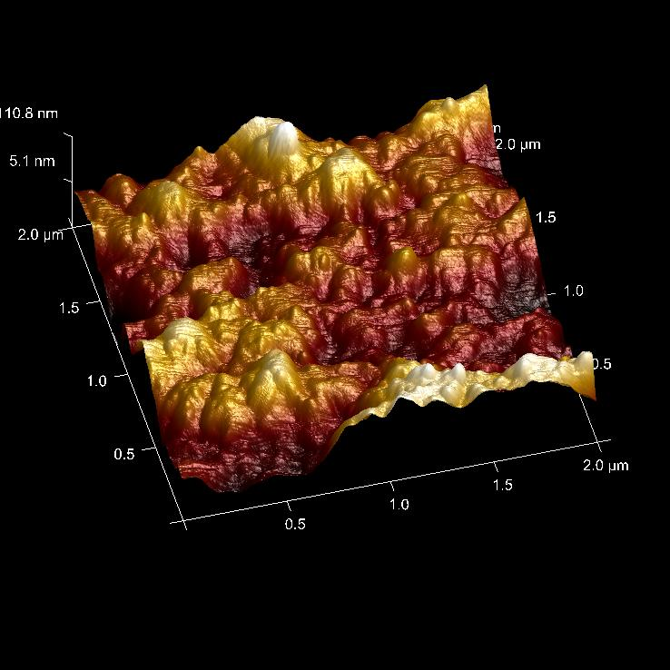
Pro-oxidant No Pro-oxidant

