Fate of Cerium Dioxide Nanoparticles in Soil Monitored by Single Particle ICP-MS
Wenyan Liu¹, Honglan Shi^{1,2}*, Kun Liu²; Xuesong Liu¹, Chady Stephan³, Endalkachew Sahle-Demessie⁴

¹Center of Research in Energy and Environment, Missouri University of Science and Technology, Rolla, MO, USA
²Department of Chemistry, Center for Biomedical Research (CBR), Missouri University of Science and Technology, Rolla, MO, USA
³PerkinElmer, Inc., Woodbridge, On, Canada, L4L 8H1
⁴Office of Research and Development, US Environmental Protection Agency, Cincinnati, OH, USA

Abstract
With the rapid development of nanotechnology and the corresponding growing applications, the possibility of releasing engineered nanoparticles (ENPs) into the environment is increasing. The risk of nanorelease from consumer products prompts the need of investigating of the fate, transportation, transformation, and environmental toxicity of released ENPs. Cerium dioxide nanoparticles (CeO₂ NPs) are one type of widely used ENPs due to their unique oxidative/reductive and catalytic properties. Once the CeO₂ NPs are released into the environment, soils are likely to be their primary repository. However, detection and characterization of CeO₂ NPs in soil is a challenge because of their low predicted environmental concentrations and the high natural background of Ce-containing minerals, leading to the fate of the CeO₂ NPs after released into soils is largely unknown. In this study, we demonstrated the development and validation of a method for the extraction and determination of particle size and concentration of CeO₂ NPs and dissolved Ce in soils. The method is composed of extracting CeO₂ NPs from soils using tetrasodium pyrophosphate (TSPP) aqueous solution and detection of aqueous extracts through single particle ICP-MS. The efficacy of the extraction was assessed by varying the concentration of TSPP solutions. Our results demonstrated that the optimal method employed 5 mM TSPP (1:100 soil-to-reagent ratio), with ultra-sonication to enhance particle dispersion, could efficiently extract CeO₂ particles from both non-aged and aged CeO₂ NP-dosed soil samples with ~100% recovery yield. The aging study showed the size and the particle recovery yield of the dosed CeO₂ NPs in aged soil samples got slightly increased, in comparison with that in the non-aged soil. Overall, the developed method was capable of extracting and accurately measuring the size and concentration of CeO₂ NP in soils.
Keywords: Single particle (SP)- ICP-MS, CeO₂ nanoparticles, Tetrasodium pyrophosphate, Soil, Extraction

Introduction
With the rapid development of nanotechnology and the corresponding growing applications of engineered nanoparticles (ENPs) in various industrial, commercial, and medicinal products [1, 2], more and more ENPs have been released into the environment, triggering concerns on their environmental toxicity, fate, and transport[3]. As a result, the ability to effectively detect and quantify the ENPs in complex environmental matrices is in high demand. Cerium dioxide nanoparticle (CeO₂ NP) is one of these ENPs increasingly widely used in industrial applications such as fuel additives, nanomedicine, coating materials and sunscreens due to their unique oxidative, catalytic, and reductive properties[4, 5]. Consequently, these broad applications inevitably cause their release into the environment. Once the CeO₂ NPs are released into the environment, soils are likely to be their primary repository. Therefore, given the uncertainty of the impacts of CeO₂ NPs on humans and the environment, it is critical to study their fate and transport through soil. However, the detection and characterization of CeO₂ NPs in soils remains a challenge due to their low predicted environmental concentrations and the high natural background of Ce-containing minerals in the complex soil system. To date, some methodologies have been employed to detect and characterize nanoparticles in environment samples, such as field flow fractionation coupled with inductively coupled plasma mass spectrometry (ICP-MS), scanning electron microscopy, transmission electronic microscopy, dynamic light scattering, etc. [6-10]. However, these techniques encountered more or fewer limitations in environmental analysis, such as low sensitivity for environmental-type study and tedious sample preparation. Therefore, a robust, reliable, and sensitive method is highly desired. Most recently, single particle (sp) ICP-MS has been proved to be a promising technique to identify and characterize ENPs, especially at very low concentrations as expected in environmental samples [11-14]. This new emerging technique offers highly sensitive and selective ability to detect and quantify nanoparticles at very low concentration (ng/L), as compared to other methods. It is not only capable of providing information rapidly about particle size (based on the spherical geometry), size distribution and particle number concentration, but able to simultaneously determine the dissolve analyte concentrations in a sample. Hence, the sp-ICP-MS has been utilized characterize and quantify ENMs in various matrices, including the analysis of TiO₂ NPs in sunscreens, gold nanoparticles (AuNPs), silver nanoparticles (AgNPs) and copper NPs in the soil, AuNPs and CeO₂ NPs in Plant tissues, and AgNPs in the aquatic environment[15-22].
To investigate effectively and reliably ENPs in the soil by sp-ICP-MS the development of a method enabling efficient extraction of ENPs from soil while preserving their physical properties is critical. Various extraction reagents have been reported in the literature for use in extracting ENPs from soils [18-20, 23-25]. Among them, alkaline extracting reagents are commonly used owing to their ability of dispersion/dissolution soil organic matters which play a major role in the formation and stability of hetero-aggregates (including metal nanoparticles) in soils [26]. For example, tetrasodium pyrophosphate (TSPP) has been employed to extract AgNPs and Fe(hydr) oxide nanoparticles from soils[19, 20, 23].
The objectives of this work were (1) to investigate a robust method using TSPP as extracting regent to efficiently extract CeO₂ NPs out from soils which dosed with CeO₂ NPs; (2) to develop and optimize the sp-ICP-MS analysis method for the characterization of particle size including size distribution and particle number concentration of CeO₂ NPs in soils; (3) to apply the approach to analyze the impact of aging on the physical properties of the CeO₂ NPs.

Material and methods
1. Chemicals
An aqueous dispersion of CeO₂ NPs (40 wt.%) with a particle diameter range of 30-50 nm was purchased from US Research Nanomaterials (Houston, TX, USA). Ultrapure water (18.2 M.Ω) for preparation/dilution of standards and samples was generated by a Simplicity 185 Millipore water purification system (Billerica, MA, USA). Citrate-coated AuNP standard (40 nm) used in determining the nebulization transport efficiency was purchased from Nanocomposix (San Diego, CA, USA), and the AuNP suspension was sonicated for 15 min prior to use. Dissolved Ce standard solution (1000mg/L in 2% HNO₃) was purchased from High-Purity Standards (Charleston, SC, USA). Tetrasodium pyrophosphate decahydrate (TSPP) serving as extraction reagent was purchased from Fisher Scientific (Pittsburgh, PA, USA).
2. Instrument and Analysis
All sample analysis was carried out on a PerkinElmer NexION 300D ICP-MS (Shelton, CT, USA) running in single particle mode under the conditions listed in Table 1. In this study, ^{139.9}Ce was selected for monitoring all sample measurements because it is the most abundant isotope of Cerium and is interference-free, which endows the highest instrument response. The dwell time, one of the most critical parameters in sp-ICP-MS, was set at 0.1 ms to improve the sizing accuracy and particle concentration dynamic range, and the total sampling time was set to 100 s. At the beginning of each series of analysis, the sample flow rate of the nebulizer was determined by weighing the amount of MQ water aspirated for 3 min, and the transport efficiency of the system was measured in triplicates via particle number concentration method[27], using a well-characterized 40 nm gold nanoparticle standard. Particle sizes and dissolved Ce concentrations were determined based on calibration with dissolved Ce standards, which were prepared in 0.025 mM TSPP solution, with concentrations in the range from 0.1 µg/L to 10 µg/L. All samples were sonicated in an ultrasonic bath for at least 15min before analysis.
The data were acquired and processed by Syngistix Nano Application module. The critical challenge in the sp-ICP-MS data processing is to distinguish particle signals from the dissolved ion signals. Therefore, setting a proper threshold is very important. Here, the threshold was set to the value equal to the intensity of most of highest pulse signals observed from the blank solution (0.025 mM TSPP) to minimize false positives detected from the blanks. Only the signals above the threshold are particle events, while the signals below the threshold are treated as dissolved ions. Considering the fact that soils are complicated systems where Ce-bearing materials exist in various forms (such as CeO₂ NPs, Ce ions adsorbed on undigested soil colloids, or a combination of both), therefore, during the sp-ICP-MS method development, we assumed that Ce-bearing particulates in soil are CeO₂ NPs with a spherical geometry, and the particle mass, and thus size was calculated based on a mass fraction of 81.39% and a density of 7.13 g/cm³. The mean and most frequent particle sizes were derived by fitting particle size distributions with a Gaussian curve. All the measurements were performed in at least two replicates.
Table 1. Settings and parameters for NexION 300D ICP-MS
sp-ICP-MS instrument conditions and settings
Nebulizer | Meinhard Type C, glass
Spray Chamber | Cyclonic, glass
Sample flow rate | 0.28-0.35 mL/min
Transport Efficiency | Particle concentration method, using 40 nm AuNP standard
Nebulizer gas flow | 1.02 L/min
RF power | 1600 W
Cones | Platinum
sp-ICP-MS method parameters
Analyte Monitored | ^{139.9}Ce
CeO₂ Density | 7.13 g/cm³
Ce Mass Fraction in CeO₂NPs | 81.39%
Dwell Time | 0.1 ms
Sample analysis duration | 100 s
Sample Introduction method | Manual

3. Evaluation on detection limits of particle size and particle concentration
The size detection limit of CeO₂ NPs was determined by analyzing 0.025 mM TSPP blank solution which did not contain any CeO₂ NPs. The intensity of the main pulse signals observed from the blank solution was used to establish the particle detection threshold which was used to calculate the NP size detection limit via dissolved Ce calibration curve. Signal intensities above the detection threshold are particle events, while those below the detection threshold are treated as dissolved Ce. The detection limit for the concentration for CeO₂NPs was estimated by analyzing different particle concentrations of CeO₂ NP standards in 0.025 mM TSPP blank solution prepared by a series of dilutions of 0.5 mg/L CeO₂ NPs ranging from 500 to 128000.
4. Effect of dispersant agent tetrasodium pyrophosphate (TSPP) on CeO₂ NPs
TSPP, an alkaline extracting reagent, has been employed to disperse soil during particle analysis due to its ability to disperse and dissolve soil organic matter which is a major agent responsible for formation and stability of hetero-aggregates in soil, including metal nanoparticles [26]. To evaluate whether the TSPP extraction has any impact on the physiochemical properties of the CeO₂ NPs, we prepared two samples of CeO₂ NP using 0.025 mM TSPP solution. One sample underwent the extraction process as described in soil spiking and extraction experiments section, and another did not. The samples were then analyzed using the developed sp-ICP-MS method and the results obtained were compared.
5. Soil samples
The soil used in this research was collected from the upper 5 cm of the campus top-soil Missouri University of Science and Technology, Rolla, MO. Prior to use, the soil was dried in an oven at 100 °C for three days until completely dry, then grounded into fine powder using a porcelain mortar and pestle, and further passed through a 75 µm – aperture sieve to remove larger lumps. Portions of the sample was split for analysis of the mineral and organic fractions, and dispersion of minerals. The powdered soil was stored in a clean ziplock plastic bag.
6. Soil Aging
Two sets of soil samples (150 g each) were prepared. One functioning as a control was mixed with 50 mL of Ultrapure water, and the other was spiked with 50 mL of 100 ppm CeO₂ NP solution in a 250-mL beaker, respectively, and then the soils were homogenized using a spatula. Upon mixing, the soils were left at room temperature and humidity under growing light (light intensity: 4280 Lux) with 16 h light/8 h dark cycles to allow the soils age for 30 days. Soil moisture content was monitored by weighing the containers, and maintained by wetting with ultrapure water every four days, and at the same time, the room temperature and relative humidity were measured.

7. Soil spiking and extraction experiments
The spiked soil samples were prepared by adding 50 µL of 100 mg/L of CeO₂ NP suspensions, which were sonicated for 15 min before use, to 0.15 g of soil, followed by aging for one day at room temperature in 19 mL polypropylene tubes. The soil and CeO₂ NP dosed soil were extracted by following the extraction approach previously reported with slight modifications[19]. Briefly, to evaluate the effect of the concentration of TSPP on the extraction efficiency, 15-mL of various concentrations of TSPP (2.5 mM, 5 mM, and 10 mM) were added into a 19-mL polypropylene tube containing 0.15 g of soil, giving a reagent to soil ratio of 100: 1 (mL: g). The samples were mixed on a vertical rotator for 30 min at 30 rpm, then sonicated for 30 min in an ultrasound bath, followed by another 30 min of mixing on the rotatory mixer at 30 rpm. After that, the mixtures were allowed to settle overnight at room temperature to sediment out micrometer-sized particles. To prevent the introduction of the large particle (e.g., > 1µm) into the sp-ICP-MS system, subsamples were taken from depths of 0.5 cm -1 cm below sample surface. All samples were extracted in triplicate, and during sp-ICP-MS analysis, the samples were diluted to a final TSPP concentration of 0.025 mM.
Results and Discussion
- Effect of TSPP on CeO₂ NPs
Figure 1 shows the comparison of particle concentrations and measured sizes of CeO₂ NPs with and without going through the TSPP extraction process. There was no apparent difference in particle concentration and particle size of CeO₂ NPs observed between samples being carried through the extraction process and without through the extraction process. This indicates the TSPP is suitable for extracting CeO₂ NPs from soil without leading to significant changes in physiochemical behavior (e.g., dissolution and aggregation) of CeO₂ NPs.
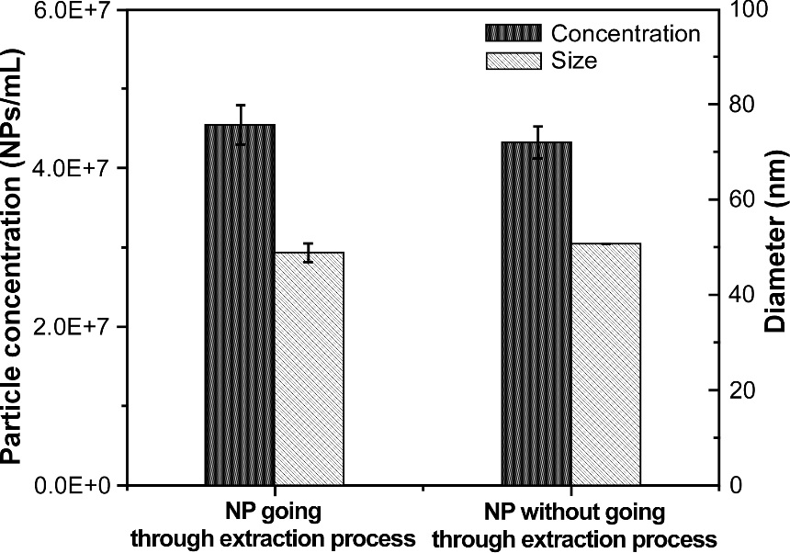
Figure 1. Comparison of particle concentrations and measured size distributions of CeO₂ NPs with and without going through the TSPP extraction process. All samples are analyzed in three replicates.

- Particle size detection limit
It is critical to determine a reasonable threshold to distinguish the particle signals from background noise to obtain reliable results for particle analysis via sp-ICP-MS. The particle size derived from the intensity threshold value based on the calibration curve is the basis for the reported particle size detection limit. In the literature, an iterative approach was employed to determine the intensity threshold. The basic principle of this method lies in repeatedly calculating the intensity threshold is reported on the sample mean (µ) and corresponding standard deviation of the blank (σ) following the relationship µ + (n×σ) (where µ and σ correspond to the average and standard deviation of the blank, and n corresponds to the multiplicator of the standard deviation) until there is no more particle signals higher than µ + (n×σ) can be differentiated. However, this approach is suitable for obtaining the particle size detection limit from continuous signals, but not from pulse (discontinuous) signals generated by particles during the sp-ICP-MS analysis. Figure 3A shows the raw sp-ICP-MS data of 0.025 mM TSPP solution (blank). As can be seen, most pulse signals lie between 1 and 3 counts with the majority of highest pulse signals being 2 counts. Based on this data, the Syngistix software automatically derived an intensity threshold of about 0.2 counts using the iterative method of µ +3σ. However, this threshold is below the smallest intensity (1 count) the sp-ICP-MS can detect, thus, leading to the unpractical particle size detection limit.
Given all sp-ICP-MS analysis, in this work, was performed in the 0.025 mM TSPP solution which in most cases exhibited the highest signals with an intensity of 2 counts, the signal intensity of CeO₂ nanoparticles in the samples equal or below 2 counts cannot be distinguished. Therefore, we chose 3 counts as the intensity threshold, and as a result, this led to a particle size detection limit of about 24 nm, based on the dissolved Ce calibration curve.
- Particle concentration detection limit
Figure 2 shows the results of the particle concentration detection limit of CeO₂ NP standard analyzed in extraction solution (0.025 mM TSPP). Since the particle number concentration of CeO₂ NP standard is unknown, relative concentrations were used for the prepared CeO₂ NP concentrations, where the lowest concentration tested was defined as 1 NPs/mL. As can be seen, in the prepared particle concentration range from 4 NPs/mL to 256 NPs/mL, the measured particle concentrations exhibit a corresponding linear trend. As the prepared particle concentration was further decreased to lower than 4 NPs/mL, however, deviations from linearity was observed (red dots are shown in Figure 2). Moreover, the precision of the particle concentrations dropped significantly (RSD: 20.0% and 12.7 % of the measured particle concentrations of 3179 NPs/mL and 2671 NPs/mL, respectively). This suggests the current sp-ICP-MS method has a particle concentration quantitative detection limit of ~ 3700 NPs/mL for CeO₂ NPs. The result indicate the method is highly sensitive to CeO₂ NPs, and is capable of direct and quantitative detection of the very low concentration of CeO₂ NPs in environmental matrices.
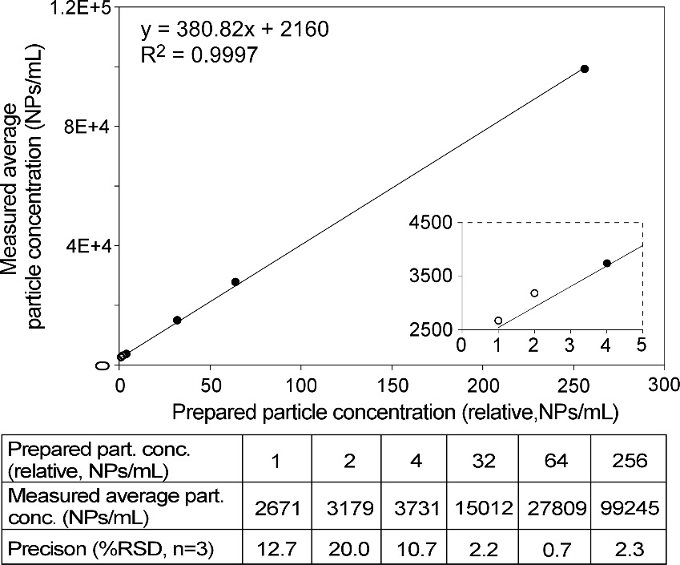
Figure 2. Estimation of the concentration detection limit of sp-ICP-MS for CeO₂ NPs.

- sp-ICP-MS analysis of TSPP extraction of CeO₂ NPs in soil
To determine if CeO₂NPs can be extracted out from the soil, both dosed and un-dosed soil have been extracted with 2.5 mM TSPP and subsequently analyzed by sp-ICP-MS. Figure 3C and 3D display the resulting raw data for the un-dosed soil and the soil dosed with 30-50 nm CeO₂ NPs, respectively. Continuous and pulse signals appear in both cases. Given the continuous signals corresponds to the ionic form of the Ce (include NPs with a size smaller than the size detection limits) and distinct pulse signals represent particulate Ce, this indicates that both dissolved Ce and particulate exist in soil samples. As a comparison to the raw data for the reagent blank (0.025 mM TSPP) shown in Figure 3A, only a few low-intensity pulse signals appeared in the raw sp-ICP-MS data of the un-dosed soil sample (Figure 3C). This indicates the soil is relatively clean of CeO₂NPs, although containing specific types of Ce-bearing particles likely originated from CeO₂NPs, Ce ions adsorbed on undigested soil colloids, or a combination of both. A comparison between Figure 3D and 3C shows the frequency and the intensity of the pulse signals detected in the soil exposed to CeO₂ NPs are higher than those of the undoped soil. This suggests the dosing and extraction procedure are realistic. Figure 4 shows the histogram of the particle size distributions generated from Figure 3B-D. After CeO₂ NPs spike the average particle size observed in dosed soil increased significantly, where the value was between the sizes obtained from the un-dosed soil and the CeO₂ NP standard. This size shift is likely due to the deposition of dissolved Ce on the Ce-bearing NPs or the overlap of the particle size distributions of dosed CeO₂ NPs and Ce-bearing particles initially present in the soil.
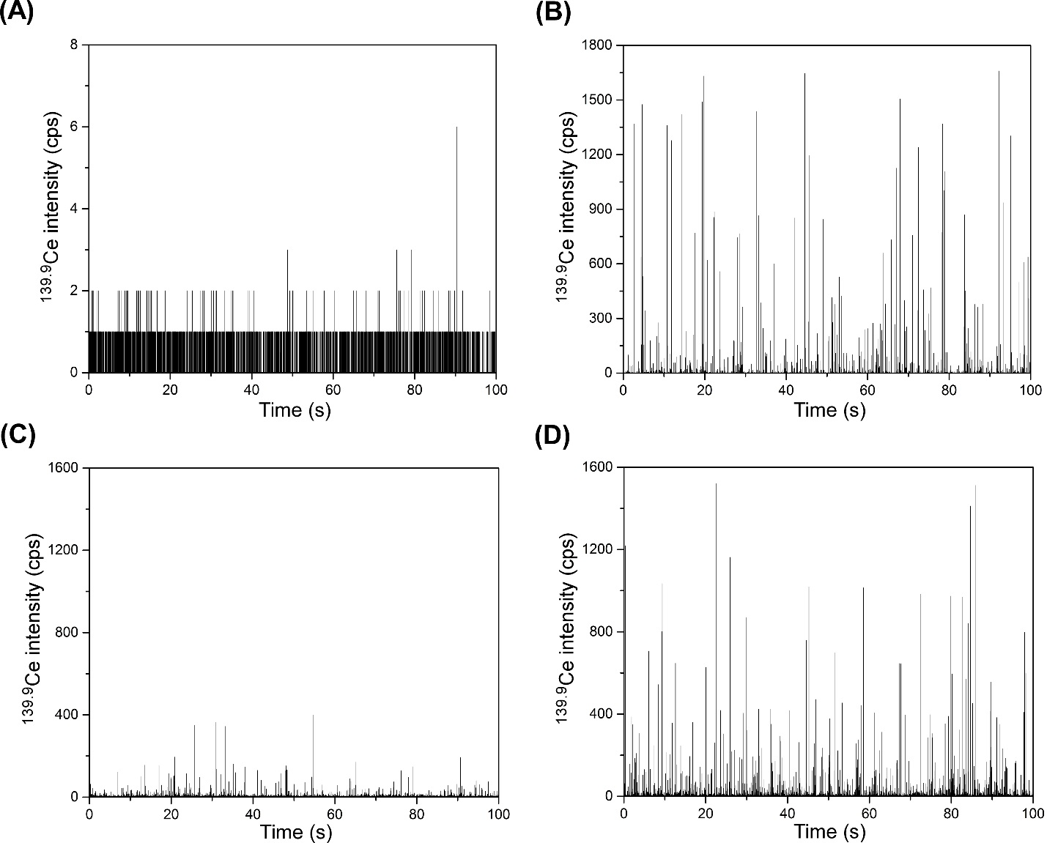
Figure 3. Comparison of raw data obtained from soil without dosing CeO₂ NPs and CeO₂ NP dosed soil. (A) Raw data for reagent blank (0.025 mM TSPP solution). (B) Raw data for CeO₂ NP standard. (C) Raw data for un-dosed soil. (D) Raw data for CeO₂ NP dosed soil.

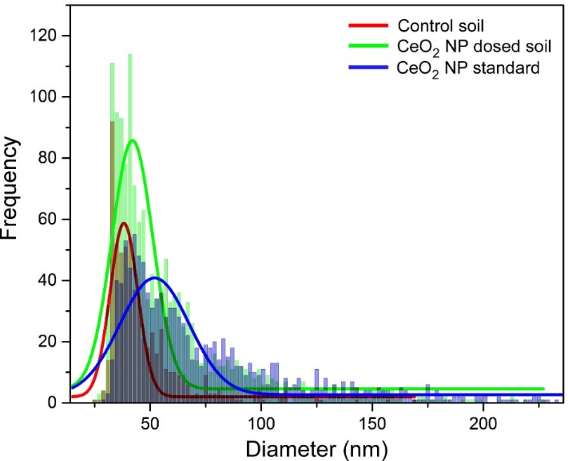
Figure 4. Comparison of particle size distributions of CeO₂ in soil samples. Red: control soil; green: CeO₂ NP dosed soil; and blue: CeO₂ NP standard.

- Effect of the concentration of TSPP on the extraction efficiency
To assess the effect of the TSPP concentration on the extraction efficiency of CeO₂ NPs from soil, the CeO₂ NP-dosed the soil samples were extracted with three different concentrations of TSPP solutions (2.5 mM, 5 mM, and 10 mM), and the extraction efficiency was compared. Table 2 illustrates the sp-ICP-MS results for the corresponding soil extracts. It is evident the extraction yield was similar for 2.5 mM, 5 mM TSPP concentrations with good recovery (close to 100%), and further increasing the TSPP concentration resulted lower extracted particle concentration and high recovery (130%) (see Figure 5). This suggests that the TSPP concentrations tested from 2.5 to 5 mM are appropriate for efficient extraction of CeO₂ NPs from the soil. Therefore, 5 mM TSPP was chose for the soil aging study.

Table 2. Comparison of TSPP extraction efficiency
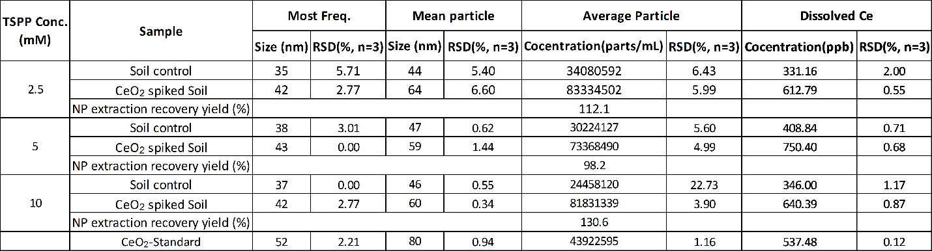

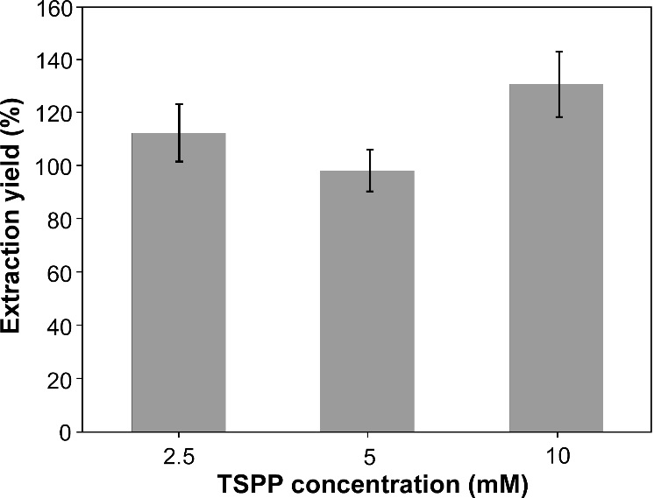
Figure 5. Effect of TSPP concentration on the CeO₂ NP extraction yield. All samples are analyzed in 3 replicates.

- Effect of aging on the fate of CeO₂ NPs in soil
To evaluate the influence of soil aging on the CeO₂ NPs, the CeO₂ NP dosed soil was aged for one month before the TSPP extraction and sp-ICP-MS analysis, as described in the material and methods section, and the results were compared with those obtained from a fresh CeO₂ NP-dosed soil sample. As can be seen in Table 3, the average particle number concentration, the most frequent particle size, and the particle recovery obtained from the aged soil are greater than those from the fresh soil sample, while the dissolved Ce concentration decreased after aging. This phenomenon may suggest that the aging could cause the dissolved Ce to transfer into particulate forms, possibly by the deposition on the surface of clutters in soil.
Table 3. Comparison of the particle size and the particle concentration of CeO₂ NPs extracted from aged and non-aged soils
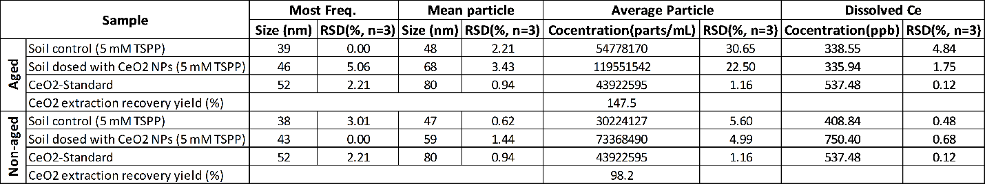
Conclusion
In this study, we have successfully demonstrated the development of an analytical method for the extraction, detection, and characterization of CeO₂ NPs in the soil. The method is composed of the extraction of the CeO₂ NPs from soils using tetrasodium pyrophosphate (TSDP) aqueous solution and the subsequent characterization of aqueous soil extracts via sp-ICP-MS. The results showed that the optimal extraction approach employed 2.5 to 5 mM TSPP at 1:100 soil-to-solvent ratio, with ultra-sonication to enhance particle dispersion. TSPP solution can efficiently extract CeO₂ NPs out from the CeO₂NP-dosed soil samples, without changing the physicochemical properties of the CeO₂NPs; the particle number concentration, particle size as well as size distribution of CeO₂ NPs in soil could be reliably determined via sp-ICP-MS analysis. Moreover, the results showed that the aging process could cause the dissolved Ce to convert into particulate forms. Overall, the developed method provides a promising way to monitor the fate of CeO₂ NPs in the natural soil.
Disclaimer
The US EPA, Office of Research and Development funded and managed this research described herein. It has been subjected to the Agency’s Administrative review and has been approved for external publication. Any opinion expressed in this paper are those of the authors and do not reflect the views of the U.S. EPA.

References
[1] F.M. Christensen, H.J. Johnston, V. Stone, R.J. Aitken, S. Hankin, S. Peters, K. Aschberger, Nano-silver - feasibility and challenges for human health risk assessment based on open literature, Nanotoxicology 4(3) (2010) 284-95.
[2] A. Nel, T. Xia, L. Madler, N. Li, Toxic potential of materials at the nanolevel, Science 311(5761) (2006) 622-7.
[3] B. Nowack, J.F. Ranville, S. Diamond, J.A. Gallego-Urrea, C. Metcalfe, J. Rose, N. Horne, A.A. Koelmans, S.J. Klaine, Potential scenarios for nanomaterial release and subsequent alteration in the environment, Environ Toxicol Chem 31(1) (2012) 50-9.
[4] F.R. Cassee, E.C. van Balen, C. Singh, D. Green, H. Muijser, J. Weinstein, K. Dreher, Exposure, health and ecological effects review of engineered nanoscale cerium and cerium oxide associated with its use as a fuel additive, Crit Rev Toxicol 41(3) (2011) 213-29.
[5] B. Collin, M. Auffan, A.C. Johnson, I. Kaur, A.A. Keller, A. Lazareva, J.R. Lead, X.M. Ma, R.C. Merrifield, C. Svendsen, J.C. White, J.M. Unrine, Environmental release, fate and ecotoxicological effects of manufactured ceria nanomaterials, Environ-Sci Nano 1(6) (2014) 533-548.
[6] M. Baalousha, Y. Ju-Nam, P.A. Cole, B. Gaiser, T.F. Fernandes, J.A. Hriljac, M.A. Jepson, V. Stone, C.R. Tyler, J.R. Lead, Characterization of cerium oxide nanoparticles-part 1: size measurements, Environ Toxicol Chem 31(5) (2012) 983-93.
[7] D. Mitrano, J. Renville, K. Neubauer, R. Thomas, Field-Flow Fractionation Coupled with ICP-MS for the Analysis of Engineered Nanoparticles in Environmental Samples, Lc Gc Eur 25(12) (2012) 652-+.
[8] B. Meisterjahn, E. Neubauer, F. Von der Kammer, D. Hennecke, T. Hofmann, Asymmetrical Flow-Field-Flow Fractionation coupled with inductively coupled plasma mass spectrometry for the analysis of gold nanoparticles in the presence of natural nanoparticles, J Chromatogr A 1372C (2014) 204-211.
[9] G.G. Leppard, Nanoparticles in the environment as revealed by transmission electron microscopy: Detection, characterisation and activities, Curr Nanosci 4(3) (2008) 278-301.
[10] P. Luo, I. Morrison, A. Dudkiewicz, K. Tiede, E. Boyes, P. O'Toole, S. Park, A.B. Boxall, Visualization and characterization of engineered nanoparticles in complex environmental and food matrices using atmospheric scanning electron microscopy, J Microsc 250(1) (2013) 32-41.
[11] C. Degueldre, P.Y. Favarger, Colloid analysis by single particle inductively coupled plasma-mass spectroscopy: a feasibility study, Colloid Surface A 217(1-3) (2003) 137-142.
[12] H.E. Pace, N.J. Rogers, C. Jarolimek, V.A. Coleman, E.P. Gray, C.P. Higgins, J.F. Ranville, Single Particle Inductively Coupled Plasma-Mass Spectrometry: A Performance Evaluation and Method Comparison in the Determination of Nanoparticle Size, Environ Sci Technol 46(22) (2012) 12272-12280.
[13] C. Degueldre, P.Y. Favarger, S. Wold, Gold colloid analysis by inductively coupled plasma-mass spectrometry in a single particle mode, Anal Chim Acta 555(2) (2006) 263-268.
[14] C. Degueldre, P.Y. Favarger, Thorium colloid analysis by single particle inductively coupled plasma-mass spectrometry, Talanta 62(5) (2004) 1051-4.
[15] Y.B. Dan, H.L. Shi, C. Stephan, X.H. Liang, Rapid analysis of titanium dioxide nanoparticles in sunscreens using single particle inductively coupled plasma-mass spectrometry, Microchem J 122 (2015) 119-126.
[16] Y.B. Dan, W.L. Zhang, R.M. Xue, X.M. Ma, C. Stephan, H.L. Shi, Characterization of Gold Nanoparticle Uptake by Tomato Plants Using Enzymatic Extraction Followed by Single-Particle Inductively Coupled Plasma-Mass Spectrometry Analysis, Environ Sci Technol 49(5) (2015) 3007-3014.
[17] J. Tuoriniemi, G. Cornelis, M. Hassellov, Size Discrimination and Detection Capabilities of Single-Particle ICPMS for Environmental Analysis of Silver Nanoparticles, Anal Chem 84(9) (2012) 3965-3972.
[18] E.P. Gray, J.G. Coleman, A.J. Bednar, A.J. Kennedy, J.F. Ranville, C.P. Higgins, Extraction and Analysis of Silver and Gold Nanoparticles from Biological Tissues Using Single Particle Inductively Coupled Plasma Mass Spectrometry, Environ Sci Technol 47(24) (2013) 14315-14323.
[19] D.M. Schwertfeger, J.R. Velicogna, A.H. Jesmer, R.P. Scroggins, J.I. Princz, Single Particle-Inductively Coupled Plasma Mass Spectroscopy Analysis of Metallic Nanoparticles in Environmental Samples with Large Dissolved Analyte Fractions, Anal Chem 88(20) (2016) 9908-9914.
[20] D.M. Schwertfeger, J.R. Velicogna, A.H. Jesmer, S. Saatcioglu, H. McShane, R.P. Scroggins, J.I. Princz, Extracting Metallic Nanoparticles from Soils for Quantitative Analysis: Method Development Using Engineered Silver Nanoparticles and SP-ICP-MS, Anal Chem 89(4) (2017) 2505-2513.
[21] J. Navratilova, A. Praetorius, A. Gondikas, W. Fabienke, F. von der Kammer, T. Hofmann, Detection of Engineered Copper Nanoparticles in Soil Using Single Particle ICP-MS, Int J Env Res Pub He 12(12) (2015) 15756-15768.
[22] Y. Dan, X. Ma, W. Zhang, K. Liu, C. Stephan, H. Shi, Single particle ICP-MS method development for the determination of plant uptake and accumulation of CeO2 nanoparticles, Anal Bioanal Chem 408(19) (2016) 5157-67.
[23] I.C. Regelink, L. Weng, G.F. Koopmans, W.H. Van Riemsdijk, Asymmetric flow field-flow fractionation as a new approach to analyse iron-(hydr)oxide nanoparticles in soil extracts, Geoderma 202 (2013) 134-141.
[24] J.M. Unrine, S.E. Hunyadi, O.V. Tsyusko, W. Rao, W.A. Shoults-Wilson, P.M. Bertsch, Evidence for Bioavailability of Au Nanoparticles from Soil and Biodistribution within Earthworms (Eisenia fetida), Environ Sci Technol 44(21) (2010) 8308-8313.
[25] C. Peyrot, K.J. Wilkinson, M. Desrosiers, S. Sauve, Effects of Silver Nanoparticles on Soil Enzyme Activities with and without Added Organic Matter, Environmental Toxicology and Chemistry 33(1) (2014) 115-125.
[26] G. Cornelis, L. Pang, C. Doolette, J.K. Kirby, M.J. McLaughlin, Transport of silver nanoparticles in saturated columns of natural soils, Sci Total Environ 463-464 (2013) 120-30.
[27] H.E. Pace, N.J. Rogers, C. Jarolimek, V.A. Coleman, C.P. Higgins, J.F. Ranville, Determining transport efficiency for the purpose of counting and sizing nanoparticles via single particle inductively coupled plasma mass spectrometry, Anal Chem 83(24) (2011) 9361-9.

