EXCEL Developer’s Visual Basic
Record Macro and run DEA simulations
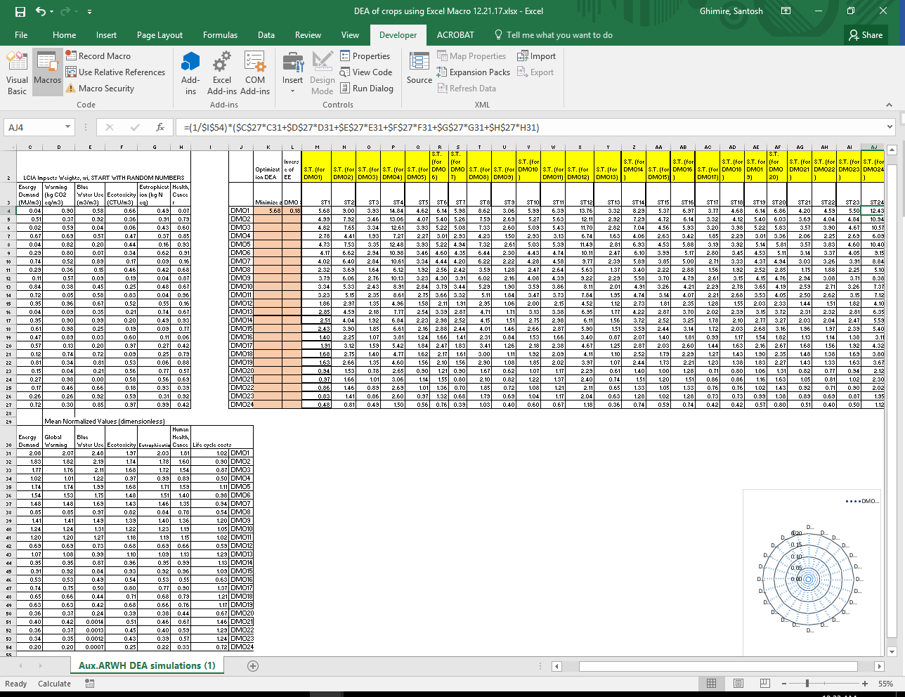

Note that in order to run Macro you must make sure that the Solver is referenced to the Visual Basic Applications Editor: Click ToolReferencesAvailable References (check Solver)
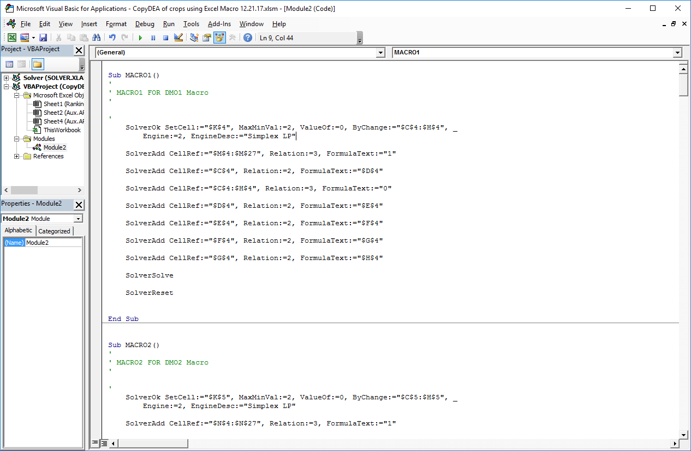
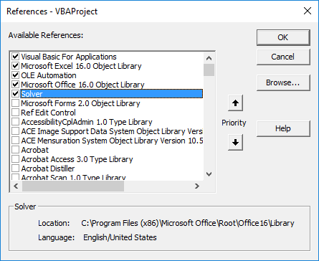
To open the existing Visual Basic (VB) Editor and read the VB Codes: Click DeveloperVisual Basics

