Table1: Operating conditions and performance of TBAB under continuous loading conditions degrading chloroform and ethanol at pH 4

Experimental Conditions and Removal Performance
Phases of Operation | I | II | III | IV | V
Influent CHCl₃ ppm_{v} | 5 | 5 | 5 | 5 | 5
Influent CHCl₃ loading rate, g/m³.h | 0.27 | 0.27 | 0.27 | 0.27 | 0.27
Influent ethanol concentration, ppm_{v} | 25 | 50 | 100 | 150 | 200
Influent ethanol loading rate, g/m³.h | 0.57 | 1.15 | 2.30 | 3.45 | 4.59
Days of operation | 0-30 | 31-59 | 60-181 | 182-211 | 212-244
Average CHCl₃ removal efficiency, % | 69.9 | 71.6 | 75.1 | 78.4 | 80.9
Standard deviation,% | 9.1 | 5.3 | 8.6 | 4.4 | 4.4
Average chloroform elimination capacity, g/m³.h | 0.224 | 0.225 | 0.226 | 0.235 | 0.238
Average ethanol removal efficiency, % | 99.9 | 99.9 | 99.4 | 99.8 | 98.6
Standard deviation,% | 0.0 | 0.0 | 2.2 | 0.5 | 3.7

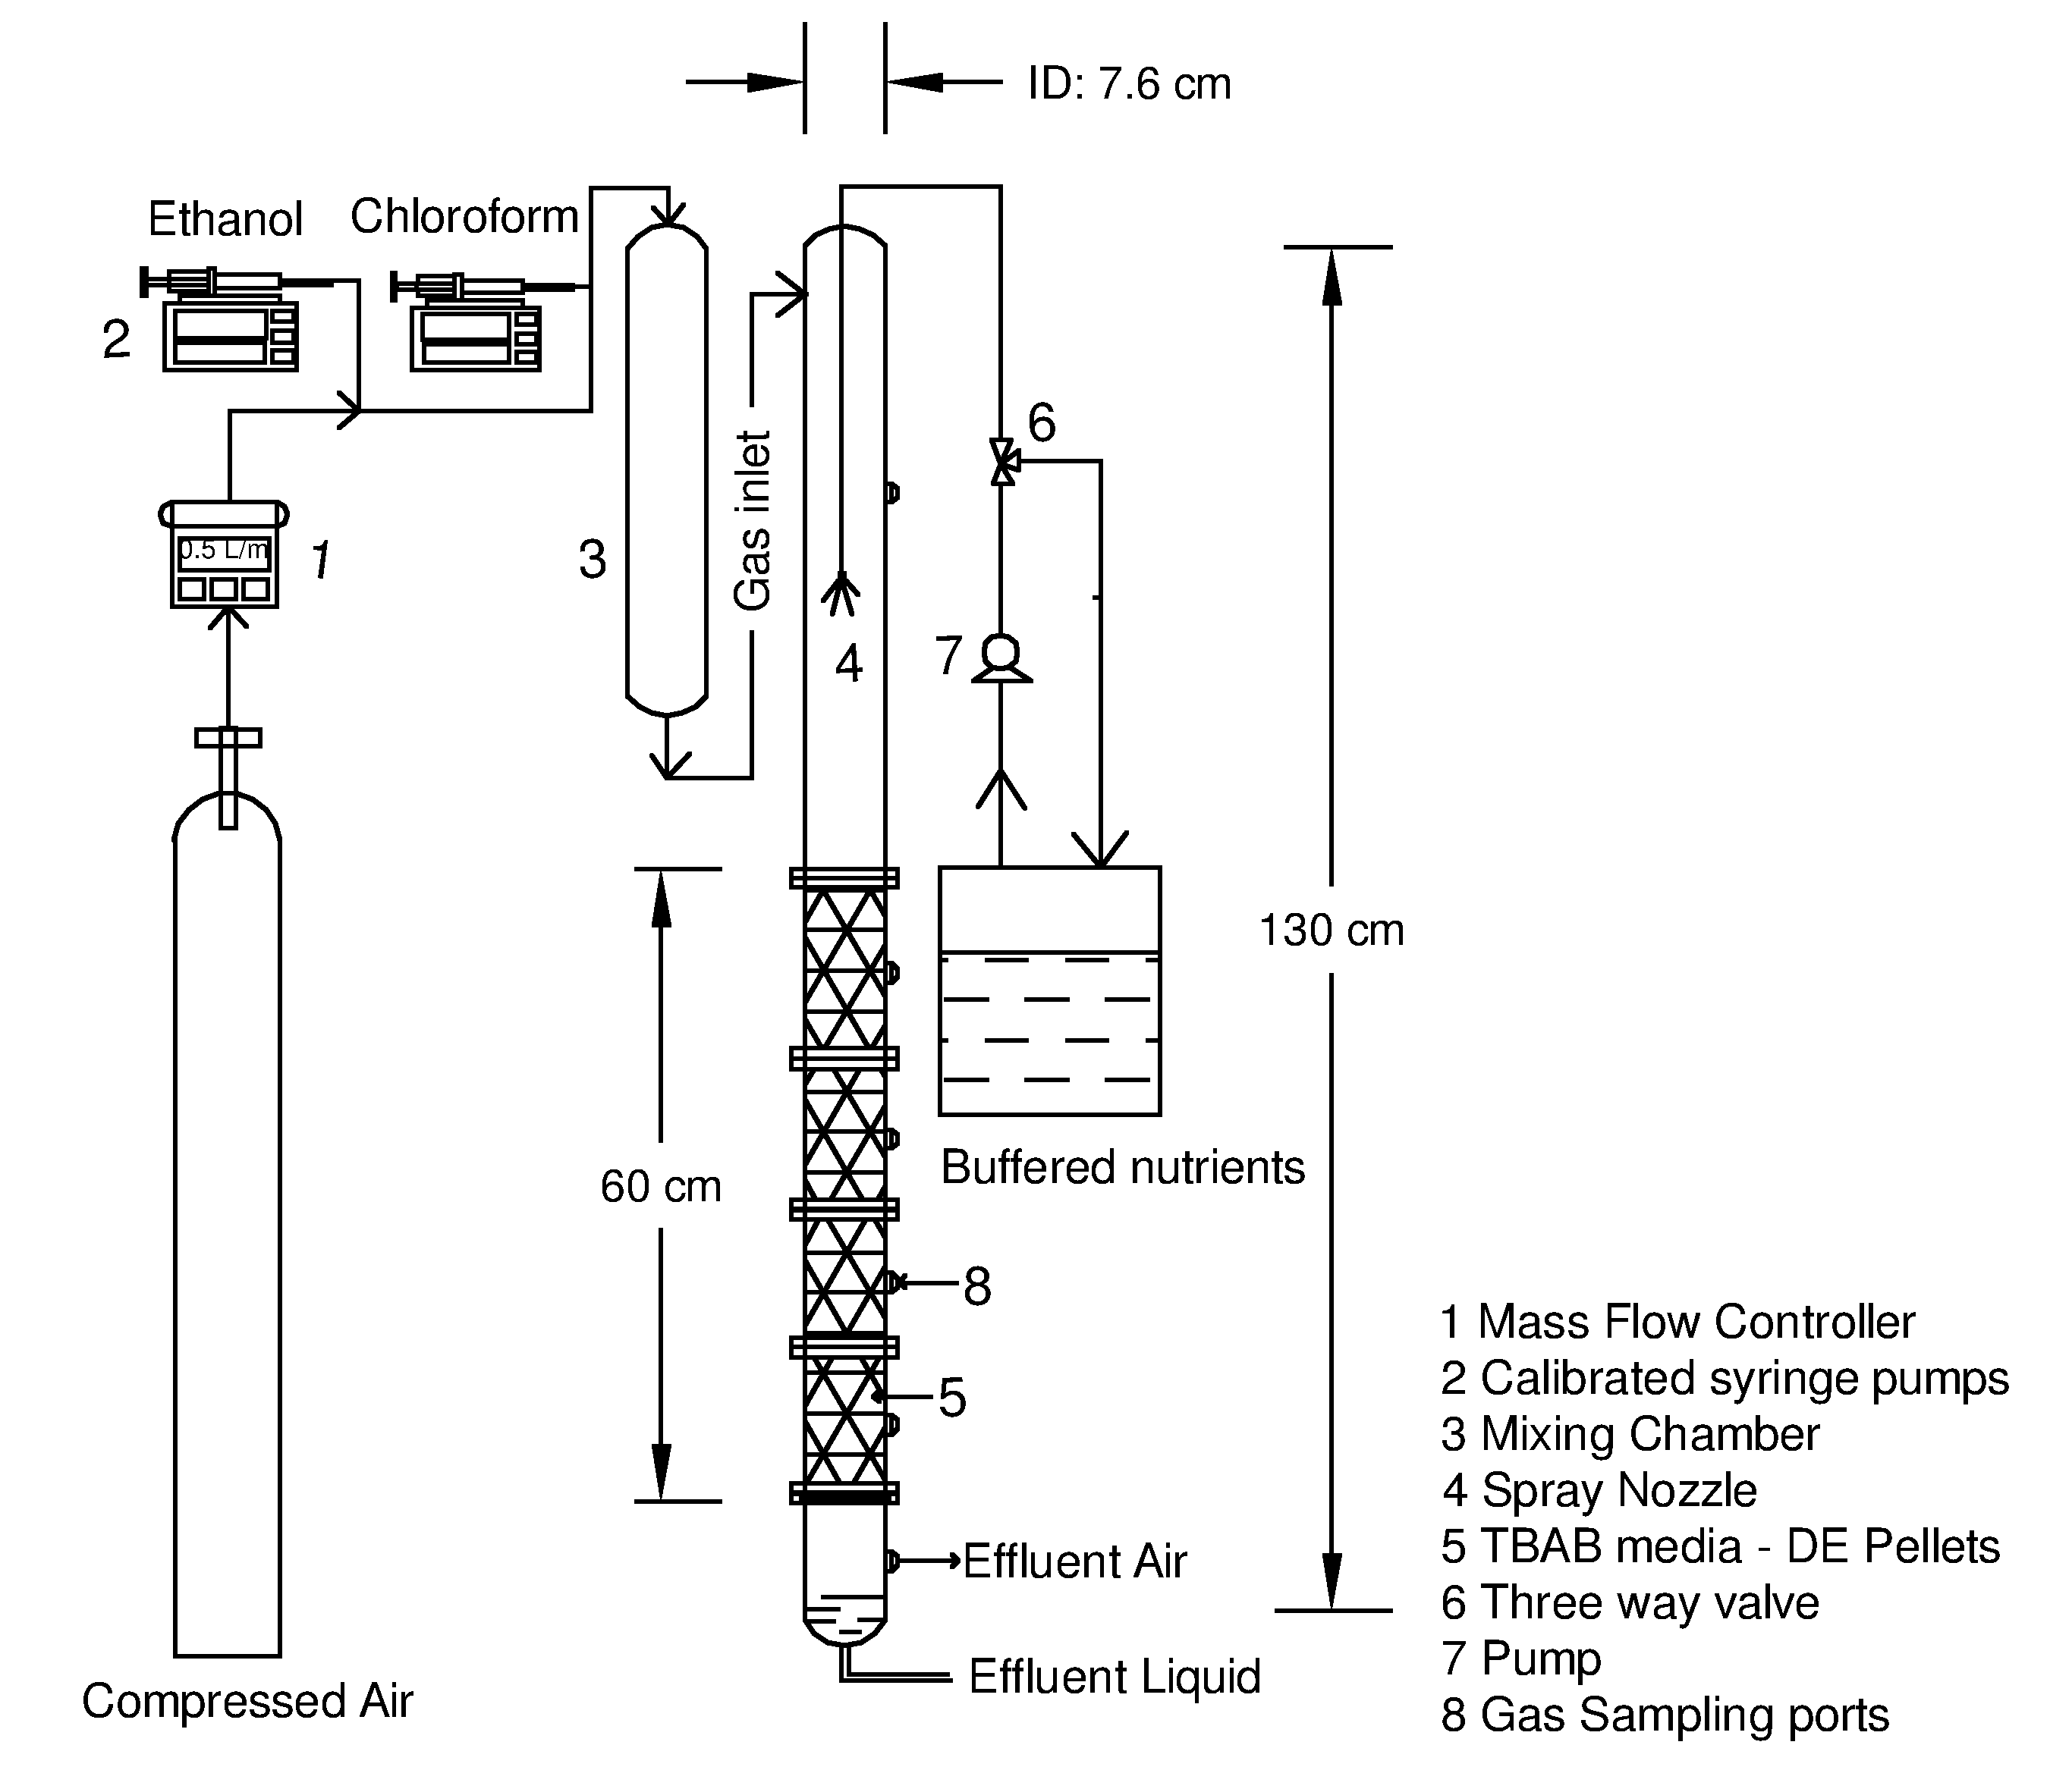

Fig1: Schematic of the trickle bed air biofilter

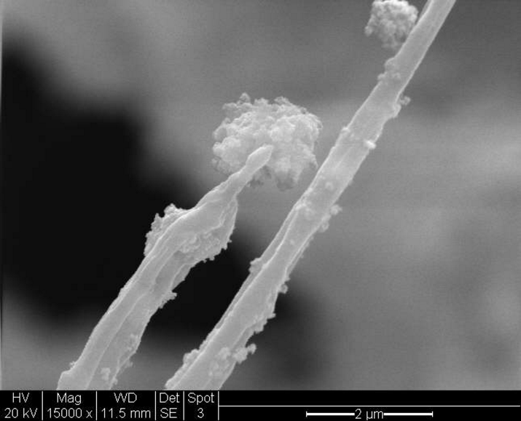
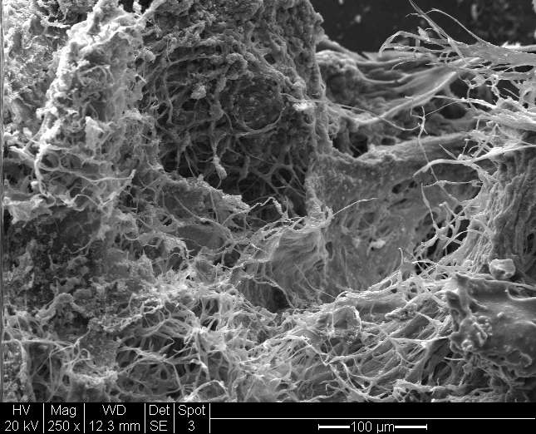
(A)
(B)

Fig 2a and Fig 2b: Surface Imagery of filamentous fungi produced by SEM analysis under 2µm and 100 µm magnification
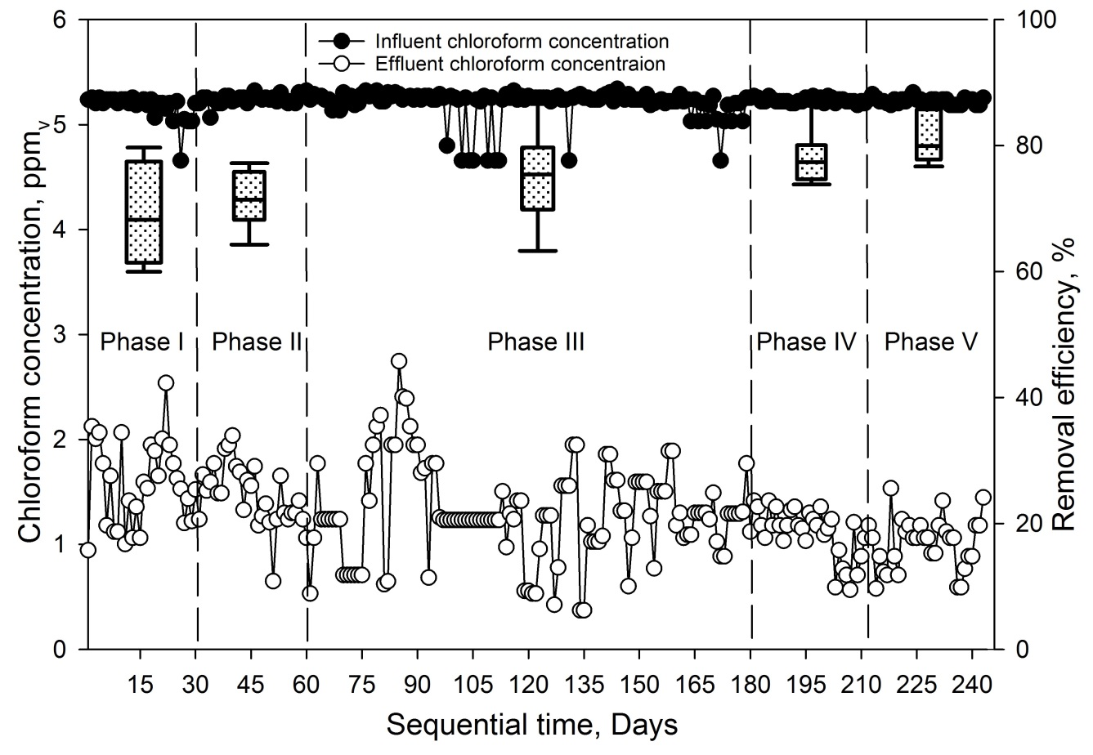
Fig3: Performance of the TBAB with sequential time for the removal of chloroform at pH 4

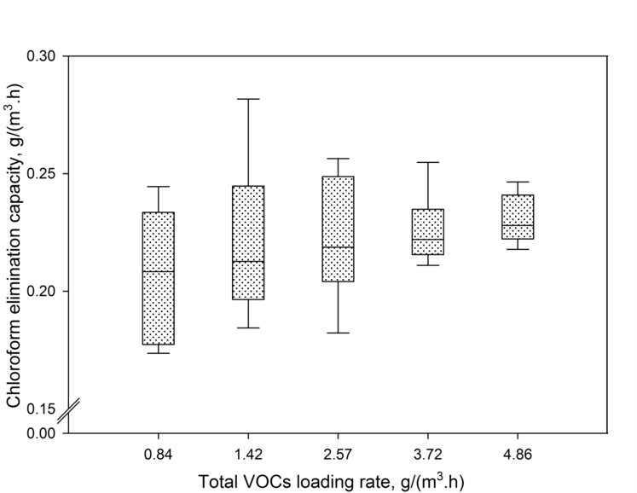
Fig4: Elimination Capacity of chloroform vs. total VOCs loading rates
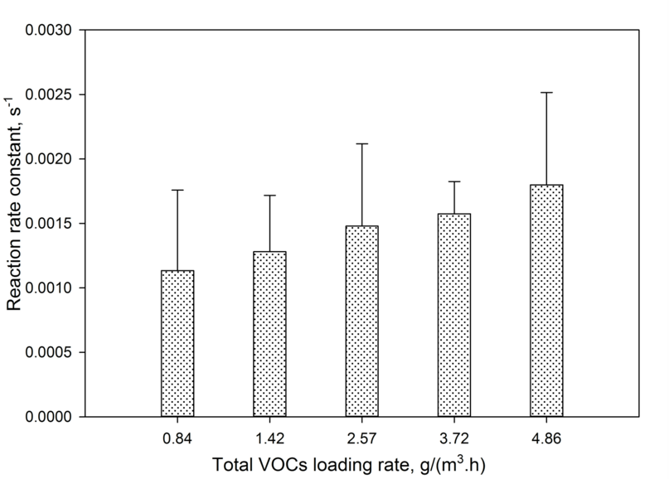
Fig 5: Reaction rate constants for chloroform vs. total VOCs loading rates
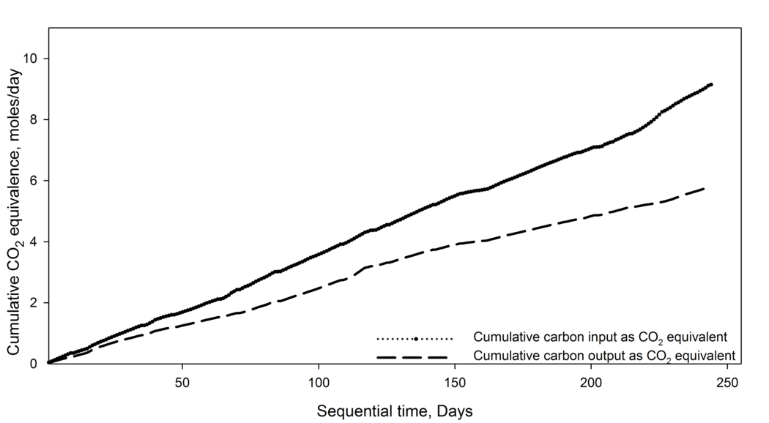
Fig 6: Cumulative carbon input/output as CO₂ equivalent for the TBAB
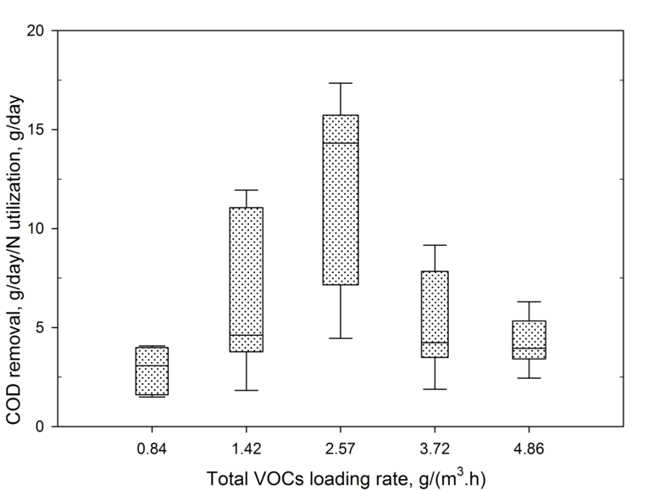
Fig 7: Chemical oxygen demand (COD) removal/nitrogen utilization vs. total VOCs loading rates for TBABs

