Comparative study on the performance of Anaerobic and Aerobic Bio Trickling Filter for the Removal of Chloroform

Figures Captions

Figure 1. Schematic diagram of biotrickling filtration system (BTFs)
Figure 2. Performance of the anaerobic BTF in the four phases with increasing chloroform-to-ethanol, Phase I: (1: 5), Phase II: (1: 10), Phase III: (1: 20), Phase IV: 1: 40. Box-whisker plot show the median and range of removal of chloroform and ethanol for each phase
Figure 3. Reaction rate constants for chloroform for both anaerobic and aerobic BTFs in four corresponding phases ratio of chloroform-to-ethanol (cometabolite). Phase I: (1: 5), Phase II: (1:10), Phase III: (1: 20), Phase IV: (1: 40).
Figure 4. Carbon mass balance of BTF over 160 operation days where cumulative carbon input and output are given as CO₂ equivalent in mole for the anaerobic process.
Figure 5. Bacterial community diversity for the three phases of anaerobic BTF for samples collected at the top port of the biofilter for selected ratio of chloroform-to-ethanol Phase I: (1: 5), Phase II: (1: 10) and Phase III: (1: 20).
Figure 6 Fungi community diversity for the four phases of aerobic BTF for samples collected at the top port of the biofilter for selected chloroform to ethanol. Phase I: (1: 5), Phase II: (1:10), Phase III: (1: 20), Phase IV: (1: 40).
.

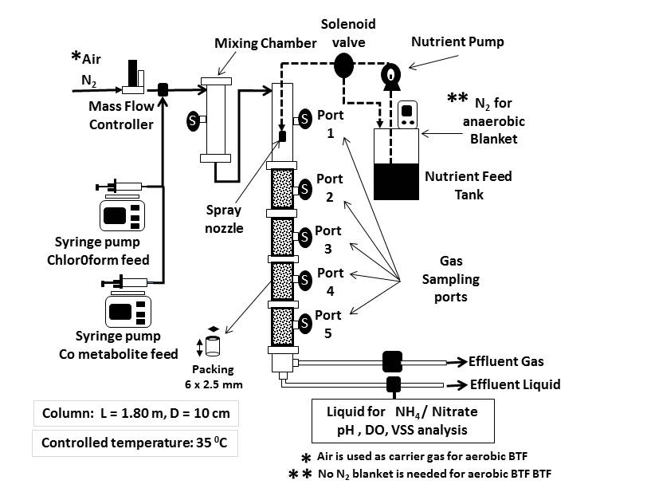
Fig.1
Fig. 2
Fig. 3

Fig. 4

Fig. 5

Fig. 6

