**Supplementary Information for**

**Susceptibility of the Algal Toxin Microcystin-LR to UV/Chlorine Process: Comparison with Chlorination**

Xiaodi Duana, Toby Sananb, Armah de la Cruzb, Xuexiang Hea, Minghao Konga, and Dionysios D. Dionysioua,*

a Environmental Engineering and Science, Department of Chemical and Environmental Engineering (ChEE), University of Cincinnati, Cincinnati, Ohio 45221, United States

b Office of Research and Development, U.S. Environmental Protection Agency, Cincinnati, Ohio 45268, United States

*Corresponding author Email: dionysios.d.dionysiou@uc.edu

Fax: +1-513-556-2599; Tel: +1-513-556-0724

**Texts: 4**

**Figures: 15**

**Tables: 4**

**Schemes: 5**

**Captions**

**Text S1.** Chemicals.

**Text S2.** Analytical Methods.

**Text S3.** Contributions of reactive species in MC-LR degradation during UV/Chlorine by kinetic model.

**Text S4.** Contributions of reactive species in MC-LR degradation during UV/Chlorine by radical scavengers.

**Figure S1.** Structure of MC-LR

**Figure S2.** Chlorine decay kinetics in chlorination and UV/chlorine processes.

**Figure S3.** Role of reactive species for degradation of 1 mg L-1 MC-LR in UV/chlorine process.

**Figure S4.** Effects of radical scavengers in UV/chlorine process.

**Figure S5.** Degradation of MC-LR using chlorine irradiated by UV-LEDs.

**Figure S6.** Molar adsorption coefficients of chlorine at pH 7.4.

**Figure S7.** Effect of chlorine dose on the degradation of MC-LR by UV/chlorine and chlorination.

**Figure S8.** Full scan and SRM chromatograms of products (a) m/z 1011.5 and (b) m/z 1029.5 resulting from UV/chlorine treatment of MC-LR.

**Figure S9.** Time-dependent concentrations of non-chlorinated products.

**Figure S10.** Formation of DBPs resulting from UV/chlorine treatment of MC-LR for the respective time with 24 h subsequent chlorination.

**Figure S11.** HepaRGTM human liver cell toxicity assessed microscopically.

**Figure S12.** Effect of NOM in degradation of MC-LR by UV/chlorine.

**Figure S13.** Degradation of spiked MC-LR by UV/chlorine and chlorination in water samples from Lake Harsha.

**Figure S14.** Degradation of spiked MC-LR by UV/chlorine and chlorination in water samples from Greater Cincinnati Water Works.

**Figure S15.** Formation of DBPs in GAC effluent spiked with 5 µg L-1 MC-LR, treated by UV/chlorine with respective time with 24 h subsequent chlorination.

**Table S1.** Integration of MC-LR degradation by UV, chlorine, HO● and RCS.

**Table S2.** Second-order Rate constants of radicals with scavengers.

**Table S3.** Major MC-LR degradation products generated during UV/chlorine and chlorination.

**Table S4.** Water quality of tested water samples.

**Scheme S1.** Mechanism proposed for hydroxylation of the double bond.

**Scheme S2.** Mechanism proposed for hydroxylation of the aromatic ring.

**Scheme S3.** Mechanism proposed for 2nd hydroxylation of the aromatic ring.

**Scheme S4.** Mechanism proposed for chlorine addition on the aromatic ring

**Scheme S5.** Mechanism proposed for dechlorination-hydroxylation of the aromatic ring.

**Text S1. Chemicals**

Solid MC-LR (> 95%) was obtained from GreenWater Laboratories (FL, USA) and was used without further purification. Sodium hypochlorite solution (available chlorine 10 - 15%) was purchased from Sigma-Aldrich (MO, USA), and 50 wt% hydrogen peroxide was obtained from Fisher Scientific (PA, USA). Suwannee River Natural Organic Matter (NOM) standard (RO isolate) was purchased from the International Humic Substances Society (MN, US). The NOM stock solution was filtered through an Acrodisc® 0.45 µm filter with Supor® membrane (Pall Corporation, NY, USA) and characterized using a TOC-L analyzer (Shimadzu, Japan) and UV-vis absorption by Agilent 8453 spectrophotometer. All other reagents were of ACS analytical grade. The aqueous solutions were prepared with autoclaved deionized (DI) water (resistivity 18.2 MΩ·cm, Millipore, Watford, UK).

**Text S2. Analytical Methods**

The concentrations of MC-LR at high levels (50 – 1000 µg/L) were quantified with an Agilent 1100 liquid chromatography system equipped with a reversed phase C18 column (Discover HS, 2.1 × 150 mm, 5 µm). MC-LR was isolated using an isocratic flow of 0.05% (v/v) trifluoroacetic acid in purified water and acetonitrile at an eluent ratio of 60:40, with a flow rate of 0.2 mL min-1, detection wavelength of 238 nm, injection volume of 20 µL, and column temperature of 40 oC. Analysis of low concentrations of MC-LR (0.025 - 20 µg/L) was performed on a Thermo Scientific TSQ Quantiva triple quadrupole mass spectrometer coupled with an Ultimate 3000 Rapid Separation UPLC system. The samples were analyzed by direct aqueous injection (20 µL) onto a Cortecs C-18+ UPLC column (2.1 × 50 mm, Waters), and separated using a gradient of 20 mM aqueous ammonium formate (pH 3.5) and methanol. MC-LR was monitored at the 995.5 -> 135 selected reaction monitoring (SRM) transition, and calibrated with purified analytical standards. Transformation products were identified by both "full scan" and SRM mode analysis. Products containing an unmodified Adda moiety could be identified by X -> 135 m/z transitions, while full scan analysis was applied for the others due to a lack of identifiable product fragments.

Formation of THMs (including chloroform (CF), bromodichloromethane (BDCM), dibromochloromethane (DBCM), and bromoform (BF)) was evaluated using EPA Method 551A, performed on an Agilent 6900 GC/ECD equipped with a J&W DB-1 column (Agilent, CA, USA). Formation of HAAs (including monochloroacetic acid (MCAA), dichloroacetic acid (DCAA), trichloroacetic acid (TCAA), monobromoacetic acid (MBAA), and dibromoacetic acid (DBAA)) was measured using EPA Method 552.3, and run on a Thermo (Thermo Fisher, PA, USA) Trace-1310 GC/ECD system equipped with a J&W DB-1701 column (Agilent, CA, USA).

**Text S3. Contributions of reactive species in MC-LR degradation during UV/Chlorine by kinetic model**

A comprehensive analysis was conducted by using available kinetic data, including time-dependent degradation of MC-LR as well as the depletion of chlorine and NB, to specify the contributions of different reacting components quantitatively during UV/chlorine process (Table S1). Due to the lack of second order rate constants of Cl•, Cl2•-, and ClO• with MC-LR, the MC-LR degradation contribution formula (S1) was simplified into formula (S2) by integrating Cl•, Cl2•-, and ClO• into RCS as following,

$-\frac{d\left[MC-LR\right]}{dt}={k^{'}}_{UV}\left[MC-LR\right]+k_{chlorine}\left[chlorine\right]\left[MC-LR\right]+k_{OH∙}\left[OH∙\right]\left[MC-LR\right]+k_{Cl∙}\left[Cl∙\right]\left[MC-LR\right]+k_{{Cl}_{2}^{∙-}}\left[{Cl}_{2}^{∙-}\right]\left[MC-LR\right]+k_{ClO∙}[ClO∙][MC-LR]$ Eq.S1

$-\frac{d\left[MC-LR\right]}{dt}={k^{'}}_{UV}\left[MC-LR\right]+k_{chlorine}\left[chlorine\right]\left[MC-LR\right]+k_{OH∙}\left[OH∙\right]\left[MC-LR\right]+{k'}_{RCS}\left[MC-LR\right]$ Eq.S2

where the *k*’UV and *k*’RCS represent the pseudo first-order rate constant of UV photolysis and MC-LR degradation by RCS, respectively. *k*chlorine, *k*OH•,*k*Cl•,*k*Cl2•-, and *k*ClO• represent the second-order rate constants of MC-LR degradation with chlorine, HO•, Cl•, Cl2•-, and ClO•, respectively.

As the concentration of HO• would not be measured directly, 2 µM nitrobenzene (NB) was selected as HO• probe because of its high reactivity toward HO• than other reacting components in UV/chlorine process and limited interference on the MC-LR degradation by UV/chlorine (the decrease of pseudo first-order rate constant of MC-LR with 2 µM NB was less than 10% compared to that without NB).

The removal rate of MC-LR is calculated as

$$R=\frac{\int_{0}^{t}{-d\left[MC-LR\right]}}{{\left[MC-LR\right]}_{0}}=\frac{{\left[MC-LR\right]}_{0}-{\left[MC-LR\right]}_{t}}{{\left[MC-LR\right]}_{0}}=\frac{\int_{0}^{t}{\left[MC-LR\right]\left({k^{'}}_{UV}+k_{chlorine}\left[chlorine\right]+k_{OH∙}\left[OH∙\right]+{k^{'}}_{RCS}\right)dt}}{{\left[MC-LR\right]}_{0}}$$

Eq. S3

Where $\int_{0}^{t}{\left[OH∙\right]dt=k_{OH∙, NB}^{-1}×ln\frac{{[NB]}_{0}}{{[NB]}_{t}}}$.

The specific removal rate by each reacting component is expressed as:

$R_{chlorine}=\frac{\int_{0}^{t}{k_{chlorine}\left[chlorine\right]\left[MC-LR\right]dt}}{{\left[MC-LR\right]}_{0}}$,

$R_{HO·}=\frac{\int_{0}^{t}{k_{OH∙}\left[OH∙\right]\left[MC-LR\right]dt}}{{\left[MC-LR\right]}_{0}}$,

$R_{UV}=\frac{\int_{0}^{t}{{k^{'}}_{UV}\left[MC-LR\right]dt}}{{\left[MC-LR\right]}_{0}}$.

Thus, $R_{RCS}=R-R_{UV}-R_{chlorine}-R_{OH∙}$

The removal rate was calculated as in Table S1 and shown in Fig. S3.

**Text S4. Contributions of reactive species in MC-LR degradation during UV/Chlorine by radical scavengers**

To examine the individual contribution of these radicals to the degradation of MC-LR, radical scavengers, i.e., tert-butanol (TBA), nitrobenzene (NB), and bicarbonate (HCO3–), with known rate constants with the aforementioned radicals (Table S1), were added individually into the reaction solutions. Results of their inhibition effects at different concentrations are shown in Fig. S1a-d. The overall degradation kinetics can be described as Eq.1:

$k_{UV/{Cl}_{2}}^{'}=k_{UV}^{'}+k_{{Cl}_{2}}^{'}+k_{{HO}^{∙}}^{'}+k_{{Cl}^{∙}}^{'}+k_{{ClO}^{∙}}^{'}$ Eq.S4

Where individual *k’* values represent the observed first-order rate constants for UV direct photolysis or the various oxidation processes transforming MC-LR. In the presence of 2 mM TBA (98% of HO• can be scavenged, and the scavenging percentage of RCS cannot be calculated due to the lack of second-order rate constants with MC-LR), the degradation of MC-LR was 0.080 min-1 (0.0137 cm2 mJ-1, Fig. S3a), comparable to the sum of degradation by UV photolysis and chlorination alone (0.081 min-1). Since TBA has limited reactivity toward Cl2•–, the contribution of Cl2•– for MC-LR removal in the UV/chlorine process was determined to be negligible. The partial inhibition by NB (Fig. S3b), which selectively sequesters HO• (50 µM NB can scavenge 89% of HO•), resulted in a *k*obs of 0.0238 cm2 mJ-1, demonstrating that in addition to HO•, certain RCS are playing an important role in oxidation of MC-LR. HCO3– efficiently removes Cl• and Cl2•–, and also removes HO•, albeit at a slower rate than NB (Table S1). It can be estimated that the reaction of HCO3– and ClO• is slow, based on the slow reaction of CO32– with ClO• 1. Because the scavenging of HO• with HCO3– generates CO3•–, and yet the degradation of MC-LR via AOPs is known to be inhibited by HCO3– (Fig. S3c), we can determine that CO3•– does not readily degrade MCs [2](#_ENREF_2" \o "He, 2012 #3). Thus the combination of NB and HCO3– is expected to quench both HO• and Cl• (*k*obs = 0.0192 cm2 mJ-1), leaving only ClO• to oxidize MC-LR (Fig. S3d). Therefore, under the optimized conditions where theconcentrations that are high enough to quench the respective species, but not too high to interfere with other reactions, the *k*obs of MC-LR with different radical species could be estimated as 0.0176, 0.0046, and 0.0055 cm2 mJ-1, respectively, for $k_{{HO}^{∙}}^{'}$, $k_{{Cl}^{∙}}^{'}$, and $k_{{ClO}^{∙}}^{'}$. Subsequently, the contributions of different reacting components were calculated as 8.5%, 25.4%, 42.5%, 11.1%, and 13.3% for UV, Cl2, HO•, Cl•, and ClO•, respectively. HO• is therefore the most important component in this process at neutral pH.

**Figure S1**



**Figure S2**



Figure S2. Chlorine decay in chlorination and UV/chlorine processes. UV254nm fluence rate = 0.1 mW cm-2, [MC-LR]0 = 1 mg L-1, [Cl2]0 = 1.5 mg L-1. pH = 7.4 maintained by 5 mM phosphate buffer.

**Figure S3**



Figure S3. Role of reactive species for degradation of 1 mg L-1 MC-LR in UV/chlorine process. UV254nm fluence rate = 0.1 mW cm-2, [Cl2]0 = 1.5 mg L-1, pH = 7.4 maintained by 5 mM phosphate buffer.

**Figure S4**

1. (b)

 

*k*TBA=0.0137 cm2 mJ-1

*k*NB=0.0238 cm2 mJ-1

(c) (d)

 

*k*NB+HCO3-=0.0192 cm2 mJ-1

(e)



Figure S4. Effects of (a) TBA, (b) NB, (c) HCO3–, and (d) NB+HCO3– in UV/chlorine process. (e) the optimum scavenging conditions. UV254nm fluence rate = 0.1 mW cm-2, [MC-LR]0 = 1 mg L-1, [Cl2]0 = 1.5 mg L-1. pH = 7.4 maintained by 5 mM phosphate buffer in (a) and (b) and 50 mM phosphate buffer in (c) and (d).

**Figure S5**



Figure S5. Degradation of MC-LR using chlorine irradiated by UV-LEDs. [MC-LR]0 = 1 mg L-1, [Cl2]0 = 1.5 mg L-1, pH = 7.4.

**Figure S6**



Figure S6. Molar adsorption coefficients of chlorine at pH = 7.4.

**Figure 7**



Figure S7. Effect of chlorine dose on the degradation of MC-LR by UV/chlorine and chlorination. UV254nm fluence rate = 0.1 mW cm-2, [MC-LR]0 = 1 mg L-1, pH = 7.4.

**Figure S8**

**(a)**

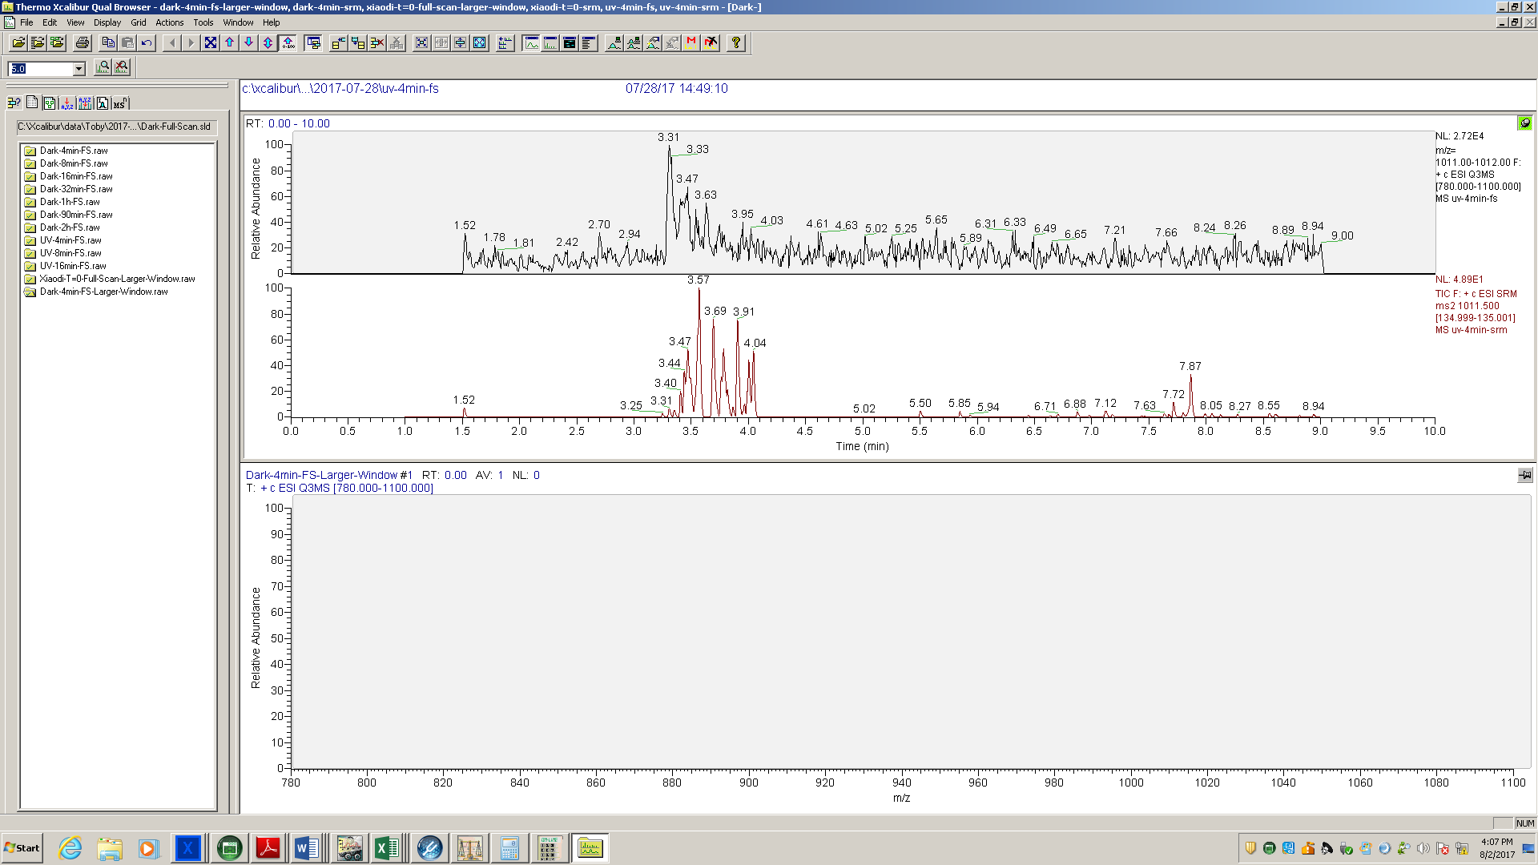

**SRM 135**

**Full-scan**

**(b)**

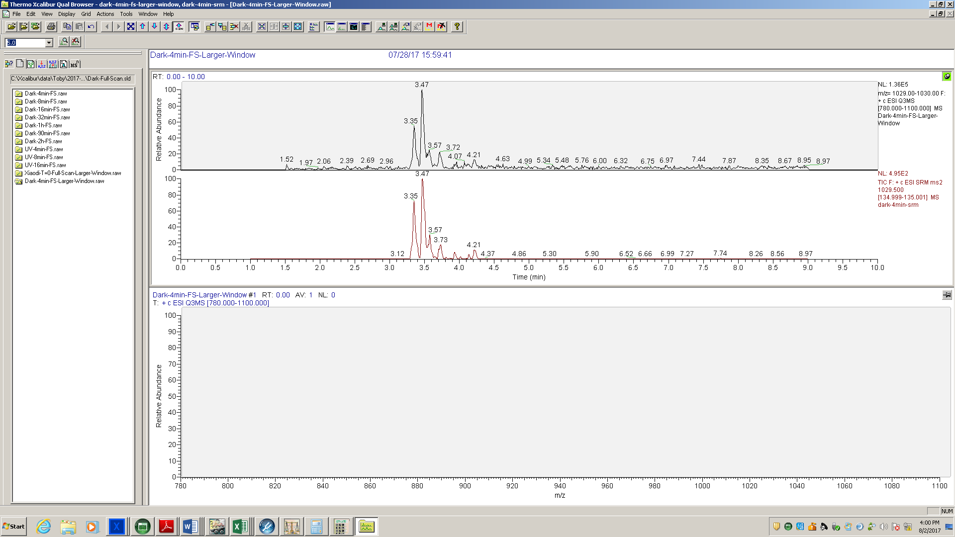

**SRM 135**

**Full-scan**

Figure S8. Full scan (top) and SRM (bottom) chromatograms of products (a) m/z 1011.5 and (b) m/z 1029.5 resulting from UV/chlorine treatment of MC-LR. [MC-LR]0 = 1 mg L-1, [Cl2]0 = 1.5 mg L-1, UV254nm fluence rate = 0.1 mW cm-2, 4 minute reaction time (24 mJ cm-2).

**Figure S9**





**(c)**



Figure S9. Time-dependent concentrations of non-chlorinated products of (a) m/z 1029.5, (b) m/z 1011.5, and (c) m/z 835.4 resulting from UV/chlorine and chlorine treatment of MC-LR. UV254nm fluence rate = 0.1 mW cm-2, [MC-LR]0 = 1 mg L-1, [Cl2]0 = 1.5 mg L-1.

**Figure S10**



Figure S10. Formation of DBPs resulting from UV/chlorine treatment of MC-LR for the respective exposure with 24 h subsequent chlorination. [MC-LR]0 = 1 mg L-1, [Cl2]0 = 1.5 mg L-1.

**Figure S11**

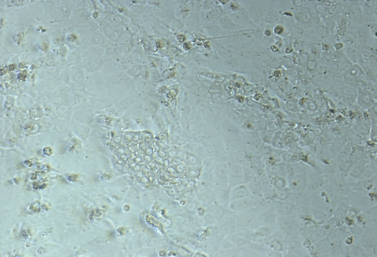 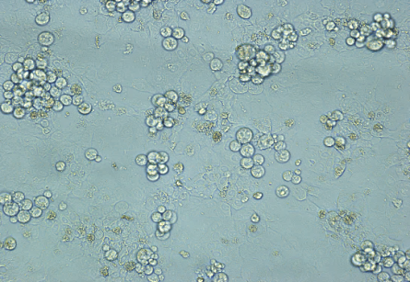

(a) Control untreated (b) MC-LR

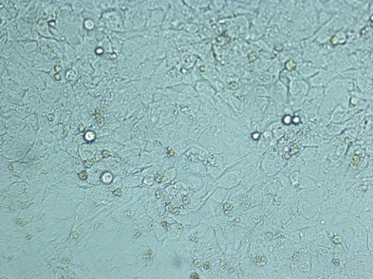 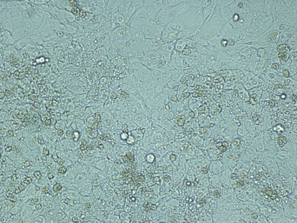

(c) MC-LR + 1.5 mg L-1 Cl2 in dark (d) MC-LR + 0.5 mg L-1 Cl2 + UV

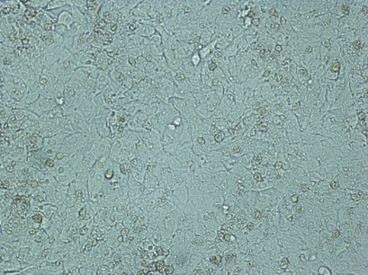

(e) MC-LR + 1.5 mg L-1 Cl2 + UV

Figure S11. HepaRGTM human liver cell toxicity assessed microscopically. Reaction time = 16 min (UV fluence = 96 mJ cm-2), [MC-LR]0 = 1 mg L-1, [AA] = 100 mg L-1, in autoclaved DI water.

**Figure S12**



Figure S12. Effect of NOM in degradation of MC-LR by UV/chlorine. [MC-LR]0 = 1 mg L-1; [Cl2]0 = 1.5 mg L-1, pH = 7.4.

**Figure S13**



Figure S13. Degradation of spiked MC-LR by UV/chlorine and chlorination in water samples from Lake Harsha (Ohio), [MC-LR]0 = 5 µg L-1.

**Figure S14**



Figure S14. Degradation of spiked MC-LR by UV/chlorine and chlorination in water samples from Greater Cincinnati Water Works, [Cl2]0 = 1.5 mg L-1.

**Figure S15**



Figure S15. Formation of DBPs in GAC effluent spiked with 5 µg L-1 MC-LR, treated by UV/chlorine with respective exposure with 24 h subsequent chlorination. [Cl2]0 = 1.5 mg L-1.

Table S1. Integration of MC-LR degradation by UV, chlorine, HO● and RCS.

|  |  |  |  |  |  |  |  |  |
| --- | --- | --- | --- | --- | --- | --- | --- | --- |
| Time (s) | Unit | 0 | 60 | 120 | 240 | 480 | 720 | 960 |
| MC-LR | µM | 1.00 | 0.78 | 0.62 | 0.38 | 0.14 | 0.02 | 0.00 |
| NB | µM | 2.00 | 1.97 | 1.93 | 1.88 | 1.72 | 1.65 | 1.60 |
| Chlorine | µM | 21.00 | 20.37 | 19.95 | 19.19 | 18.56 | 18.21 | 17.51 |
| |  | | --- | |  | | µM | 0.00 | 0.06 | 0.05 | 0.07 | 0.07 | 0.02 | 0.00 |
|  | µM | 0.00 | 0.06 | 0.11 | 0.18 | 0.25 | 0.27 | 0.27 |
| |  | | --- | |  | | µM | 0.00 | 0.07 | 0.08 | 0.08 | 0.13 | 0.02 | 0.00 |
|  | µM | 0.00 | 0.07 | 0.15 | 0.24 | 0.36 | 0.38 | 0.39 |
|  | µM | 0.00 | 0.02 | 0.01 | 0.02 | 0.02 | 0.01 | 0.00 |
|  | µM | 0.00 | 0.02 | 0.03 | 0.05 | 0.07 | 0.08 | 0.08 |
|  | µM | 0.00 | 0.07 | 0.02 | 0.07 | 0.01 | 0.07 | 0.02 |
|  | µM | 0.00 | 0.07 | 0.09 | 0.16 | 0.17 | 0.24 | 0.26 |

Table S2. Second-order Rate constants of radicals with scavengers.

|  |  |  |  |
| --- | --- | --- | --- |
|  | **TBA(M-1 s-1)** | **NB (M-1 s-1)** | **HCO3– (M-1 s-1)** |
| **HO•** | 6.0 × 108 3 | 3.9 × 109  3 | 8.5 × 106 3 |
| **Cl•** | 3.0 × 108 4 | Negligible 5 | 2.2 × 108 6 |
| **ClO•** | 1.3 (±0.1) × 107 7 | Negligible 1 | 600 with CO32– 8 |
| **Cl2•–** | ~ 700 9 | Negligible 10 | 8.0 × 107 11 |

Table S3. Major MC-LR degradation products generated during UV/chlorine and chlorination.

|  |  |  |  |  |  |  |
| --- | --- | --- | --- | --- | --- | --- |
| **m/z** | **Formula** | **Change from MC-LR** | **Isomers in UV/chlorine Chromatogram** | **Possible structures in UV/chlorine** | **Isomers in chlorination Chromatogram** | **Found in other AOPs** |
| 835.4 | C37H58N10O12 | -12C,-16H (Adda) | 1 | h | 1 | Yes12 |
| 995.5 | C49H74N10O12 – MC-LR Isomers | N/A | 2 |  | 0 | UV-AOP13 |
| 1011.5 | C49H74N10O13 | +O | 5+ | a, b, c(c’), d(d’), k | 5+ | Yes14 |
| 1013.5 | C49H76N10O13 | 2H, +O | 1 | j | 2-3 | UV-AOP13 |
| 1029.5 | C49H76N10O14 | +2H, 2O | 7 | e, f, g, l | 7 | Yes14 |
| 1029.5 | C49H73N10O12Cl | -H, +Cl | 3+ | o | 3 |  |
| 1045.5 | C49H76N10O15 | +2H, 3O | 4 | m, n | 1 | Yes14 |
| 1047.5 | C49H75N10O13Cl | +H, O, Cl | 5+ | i, p | 6+ |  |
| 1063.5 | C49H75N10O14Cl | +H, 2O, Cl | 0 |  | 1 |  |

[MC-LR]0 = 1 mg/L, [Cl2]0 = 1.5 mg L-1.

Table S4. Water quality of tested water samples.

|  |  |  |  |  |  |  |  |
| --- | --- | --- | --- | --- | --- | --- | --- |
| Stage | pH | DOC  (mg L-1) | Alkalinity  (mg L-1) | SUVA254  (L mg-1 m-1) | Chloride  (mg L-1) | Bromide  (mg L-1) | Ammonia  (mg L-1) |
| Lake Harsha — Buoy (BUOY) | 8.37 | 8.91 | 212 | 2.91 |  |  |  |
| Lake Harsha — Drinking water treatment plant intake (WTPI) | 8.40 | 7.99 | 212 | 3.25 |  |  |  |
| GCWW — Raw water | 7.89 | 2.93 | 89 | 2.34 | 45 | 0.03 | 0.01 |
| GCWW — After sand filtration | 7.86 | 2.09 | 81 | 1.72 |  | 0.04 |  |
| GCWW — After GAC | 7.78 | 0.43 | 81 | 1.19 | 43 | 0.03 |  |

**Scheme S1.** Mechanism proposed for hydroxylation of the double bond 15.



**Scheme S2.** Mechanism proposed for hydroxylation of the aromatic ring.



**Scheme S3.** Mechanism proposed for 2nd hydroxylation of the aromatic ring (example of hydroxylation on *ortho* position).



**Scheme S4.** Mechanism proposed for chlorine addition on the aromatic ring 16.



**Scheme S5.** Mechanism proposed for dechlorination-hydroxylation of the aromatic ring 17.



**Reference**

1. Wu, Z.; Fang, J.; Xiang, Y.; Shang, C.; Li, X.; Meng, F.; Yang, X., Roles of reactive chlorine species in trimethoprim degradation in the UV/chlorine process: Kinetics and transformation pathways. *Water Research* **2016,** *104*, 272-282.

2. He, X.; Pelaez, M.; Westrick, J. A.; O’Shea, K. E.; Hiskia, A.; Triantis, T.; Kaloudis, T.; Stefan, M. I.; de la Cruz, A. A.; Dionysiou, D. D., Efficient removal of microcystin-LR by UV-C/H2O2 in synthetic and natural water samples. *Water Research* **2012,** *46*, (5), 1501-1510.

3. Buxton, G. V.; Greenstock, C. L.; Helman, W. P.; Ross, A. B., Critical Review of rate constants for reactions of hydrated electrons, hydrogen atoms and hydroxyl radicals (⋅OH/⋅O− in Aqueous Solution. *Journal of Physical and Chemical Reference Data* **1988,** *17*, (2), 513-886.

4. Mertens, R.; von Sonntag, C., Photolysis (λ = 354 nm of tetrachloroethene in aqueous solutions. *Journal of Photochemistry and Photobiology A: Chemistry* **1995,** *85*, (1), 1-9.

5. Watts, M. J.; Linden, K. G., Chlorine photolysis and subsequent OH radical production during UV treatment of chlorinated water. *Water Research* **2007,** *41*, (13), 2871-2878.

6. Fang, J.; Fu, Y.; Shang, C., The Roles of Reactive Species in Micropollutant Degradation in the UV/Free Chlorine System. *Environmental Science & Technology* **2014,** *48*, (3), 1859-1868.

7. Wu, Z.; Guo, K.; Fang, J.; Yang, X.; Xiao, H.; Hou, S.; Kong, X.; Shang, C.; Yang, X.; Meng, F.; Chen, L., Factors affecting the roles of reactive species in the degradation of micropollutants by the UV/chlorine process. *Water Research* **2017,** *126*, 351-360.

8. Huie, R. E.; Clifton, C. L.; Neta, P., Electron transfer reaction rates and equilibria of the carbonate and sulfate radical anions. *International Journal of Radiation Applications and Instrumentation. Part C. Radiation Physics and Chemistry* **1991,** *38*, (5), 477-481.

9. Hasegawa, K.; Neta, P., Rate constants and mechanisms of reaction of chloride (Cl2-) radicals. *The Journal of Physical Chemistry* **1978,** *82*, (8), 854-857.

10. Nowell, L. H.; Hoigné, J., Photolysis of aqueous chlorine at sunlight and ultraviolet wavelengths—II. Hydroxyl radical production. *Water Research* **1992,** *26*, (5), 599-605.

11. Matthew, B. M.; Anastasio, C., A chemical probe technique for the determination of reactive halogen species in aqueous solution: Part 1 &ndash; bromide solutions. *Atmos. Chem. Phys.* **2006,** *6*, (9), 2423-2437.

12. Antoniou, M. G.; Shoemaker, J. A.; Cruz, A. A. d. l.; Dionysiou, D. D., Unveiling New Degradation Intermediates/Pathways from the Photocatalytic Degradation of Microcystin-LR. *Environmental Science & Technology* **2008,** *42*, (23), 8877-8883.

13. He, X.; de la Cruz, A. A.; Hiskia, A.; Kaloudis, T.; O'Shea, K.; Dionysiou, D. D., Destruction of microcystins (cyanotoxins) by UV-254 nm-based direct photolysis and advanced oxidation processes (AOPs): Influence of variable amino acids on the degradation kinetics and reaction mechanisms. *Water Research* **2015,** *74*, 227-238.

14. Antoniou, M. G.; de la Cruz, A. A.; Dionysiou, D. D., Intermediates and Reaction Pathways from the Degradation of Microcystin-LR with Sulfate Radicals. *Environmental Science & Technology* **2010,** *44*, (19), 7238-7244.

15. He, X.; Zhang, G.; de la Cruz, A. A.; O’Shea, K. E.; Dionysiou, D. D., Degradation Mechanism of Cyanobacterial Toxin Cylindrospermopsin by Hydroxyl Radicals in Homogeneous UV/H2O2 Process. *Environmental Science & Technology* **2014,** *48*, (8), 4495-4504.

16. Alegre, M. L.; Geronés, M.; Rosso, J. A.; Bertolotti, S. G.; Braun, A. M.; Mártire, D. O.; Gonzalez, M. C., Kinetic Study of the Reactions of Chlorine Atoms and Cl2•- Radical Anions in Aqueous Solutions. 1. Reaction with Benzene. *The Journal of Physical Chemistry A* **2000,** *104*, (14), 3117-3125.

17. Khan, J. A.; He, X.; Shah, N. S.; Khan, H. M.; Hapeshi, E.; Fatta-Kassinos, D.; Dionysiou, D. D., Kinetic and mechanism investigation on the photochemical degradation of atrazine with activated H2O2, S2O82− and HSO5−. *Chemical Engineering Journal* **2014,** *252*, 393-403.