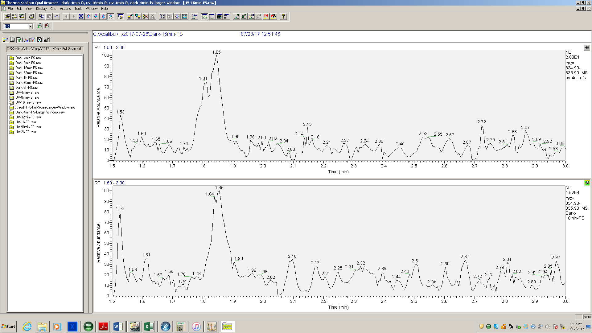

835.4 m/z peak observed in the UV-Cl (top) and Dark-Cl (bottom) experiments.

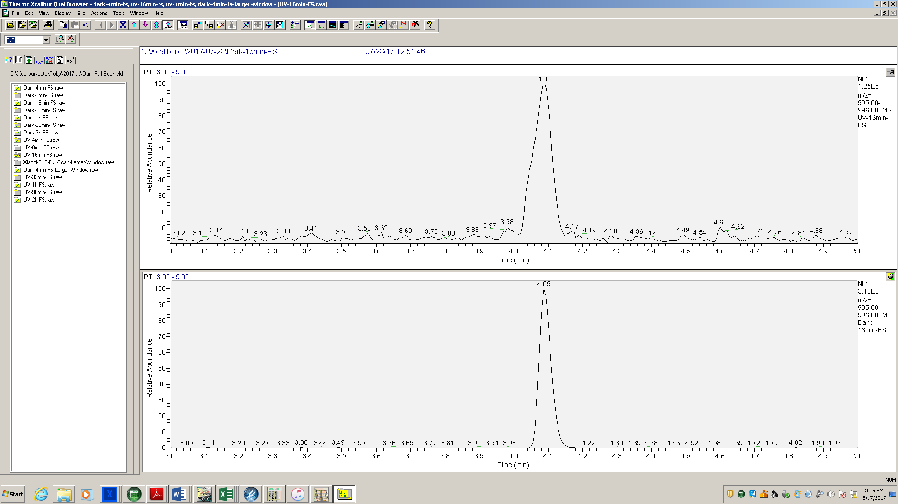

995.5 m/z (MC-LR and isomers) for UV-Cl (top) and Dark-Cl (bottom) at T=16. The UV-Cl peak has a shoulder and second peak at 3.98 minutes representing the result of UV-induced double bond isomerization.

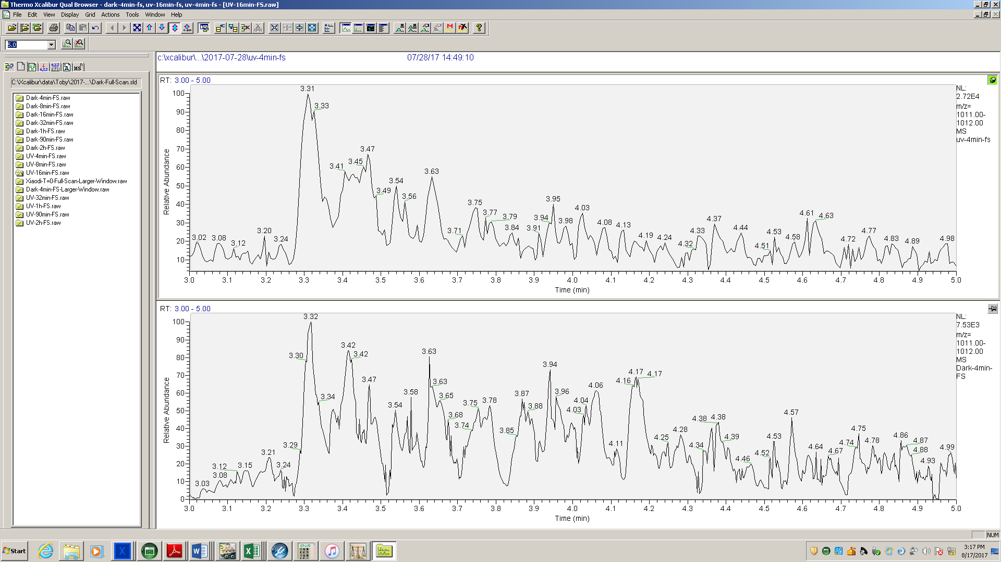

1011.5 m/z chromatography for UV-Cl (top) and Dark-Cl (bottom). Many poorly resolved peaks with a high baseline prevent definitive counting of species.

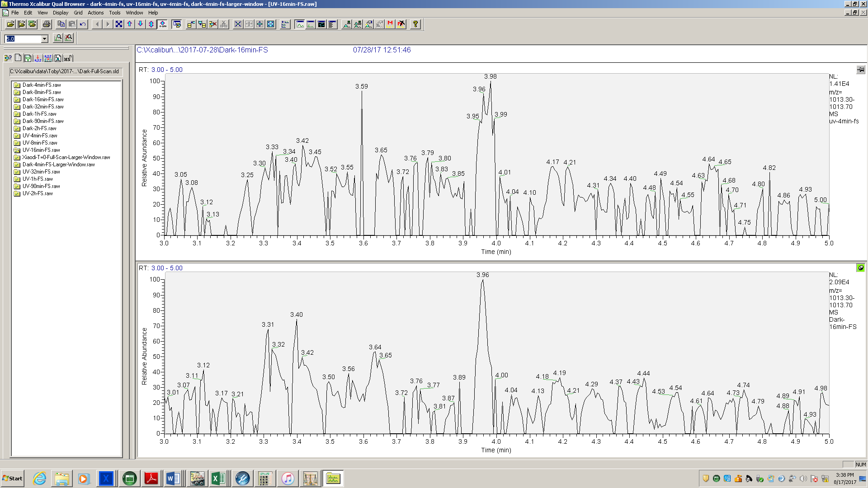

1013.5 m/z chromatogram for the UV-Cl and Dark-Cl, T=4 and 16 minutes, respectively. The peak at 3.95 minutes is the only one clearly identified above baseline.

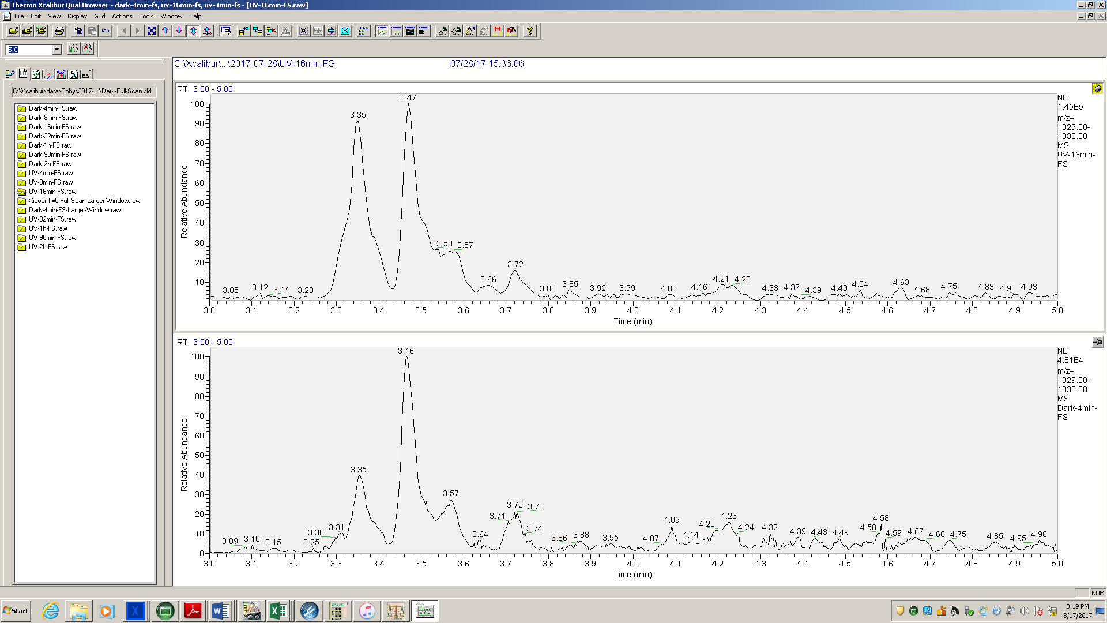

1029.5 m/z peaks for UV-Cl (top) and Dark-Cl (bottom). Peaks from 3.3 to 3.8 minutes are oxygenated (+2O, +2H), the peaks at 4.0 to 4.3 are chlorinated (+Cl, -H).

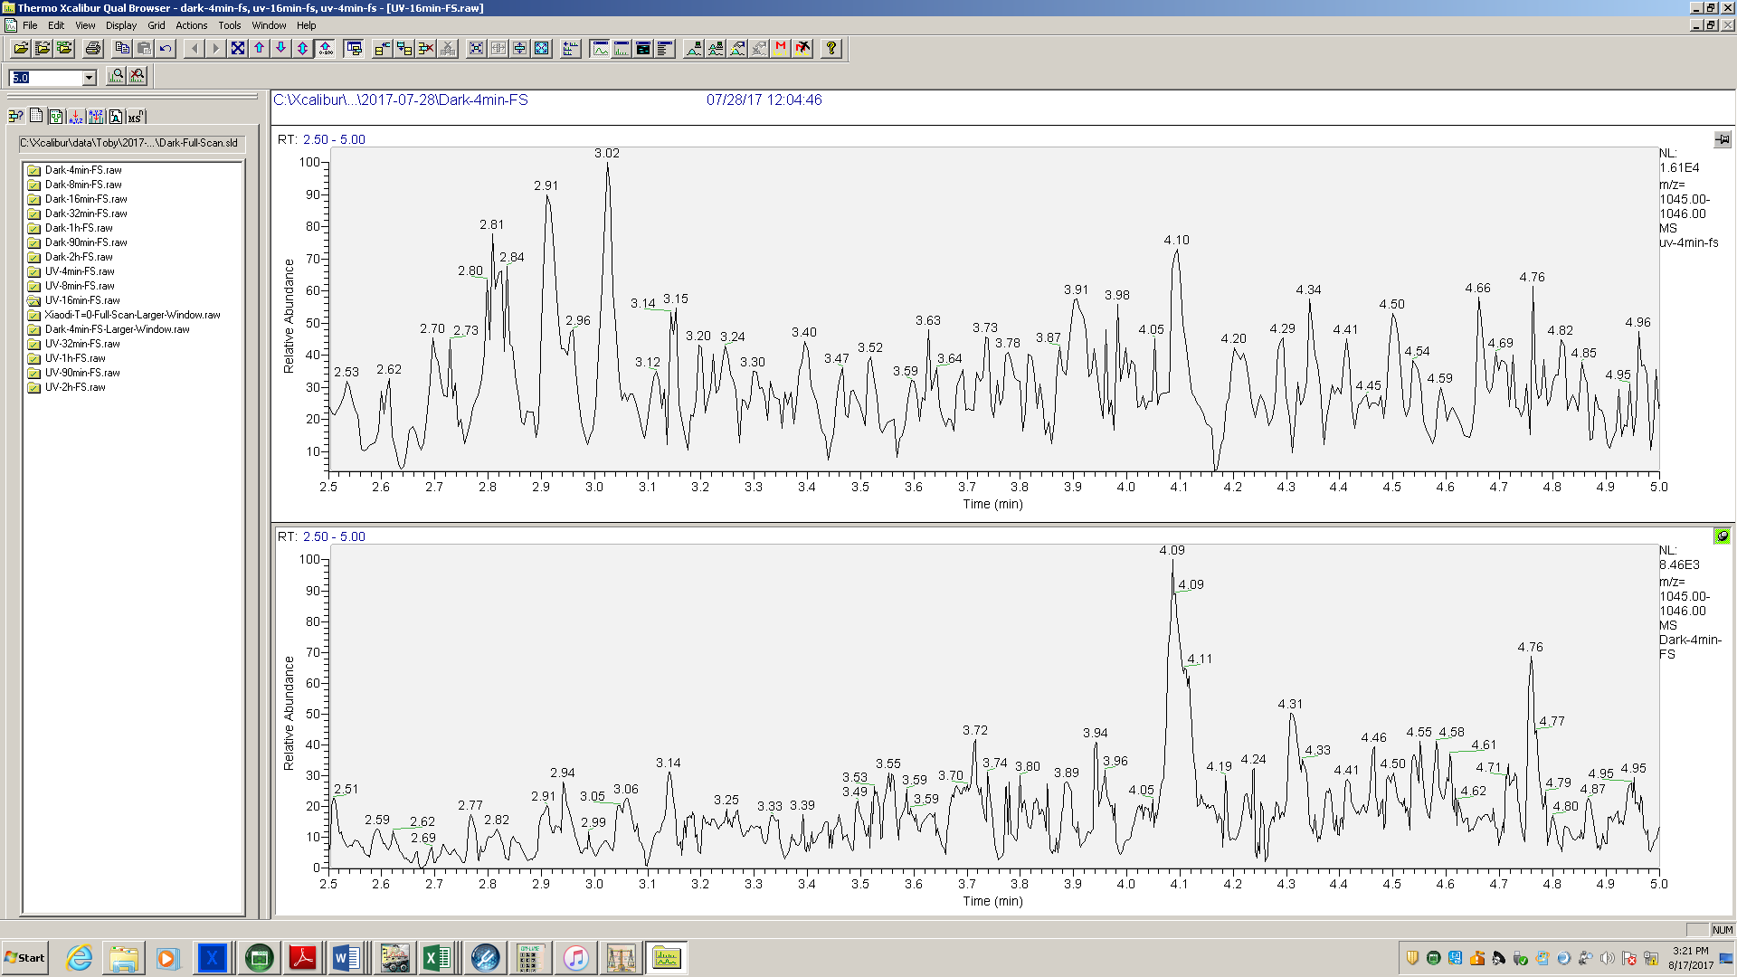

1045.5 m/z peaks for UV-Cl (top) and Dark-Cl (bottom)

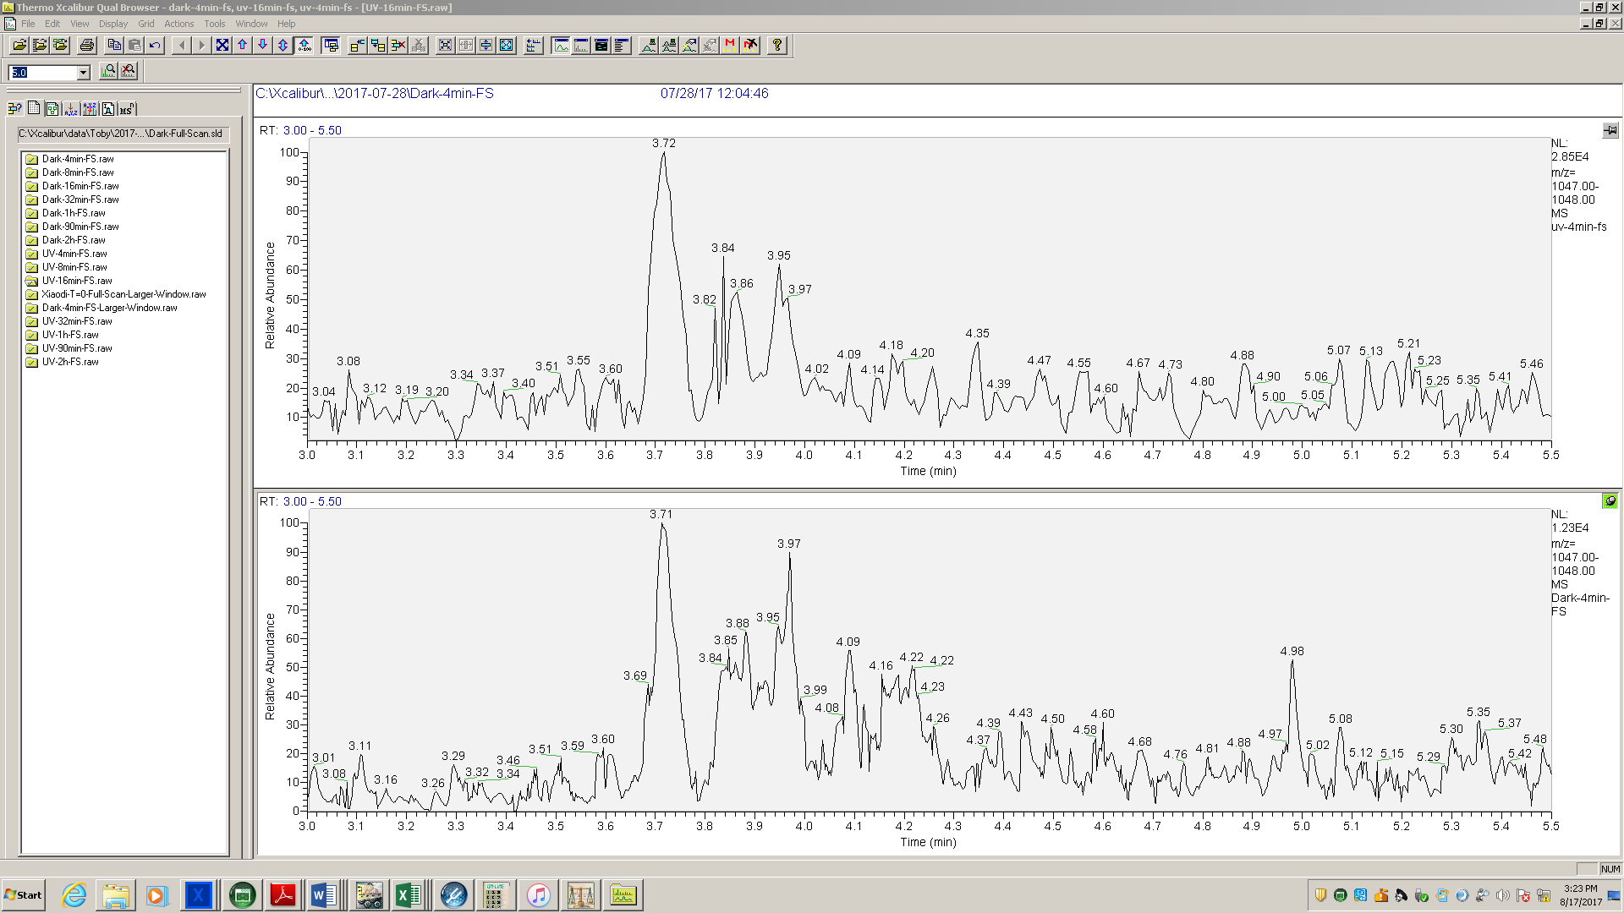

1047.5 m/z peaks for UV-Cl (top) and Dark-Cl (bottom).

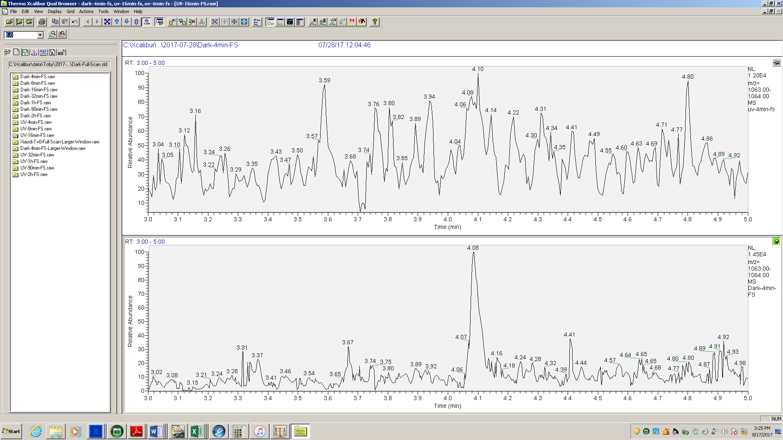

1063.5 m/z peak observed for Dark-Cl (bottom) but not observed above baseline in the UV-Cl experiment (top).