Table 5: Calculations for Fish data
Variable Name | Variable Description | Calculation
Fish_Abun | Total Abundance | Σ fish / unit of interest¹
Fish_Biom | Fish Biomass (individuals) | αL^{β}  L =measured fork length (cm)  α and β = coefficients for length-weight relationships of species²
Fish_Total_Biom | Total Biomass | Σ Fish_Biom / unit of interest¹
Fish_TaxaR | Taxonomic Richness | Σ taxa / unit of interest¹
Fish_Freq | Frequency of taxon occurrence (%) | Proportion of sampled sites in which fish of a given taxon is present / number of sites sampled
¹ units of interest may include site, fish taxon, fish family, and feeding guild
²Menza et al., 2006

Table 11: Calculations using SpGorg Data
Variable Name | Variable Description | Calculation
Spn_n  Gorg_n | Abundance | # colonies in a quadrat
Spn_3DCSA  Gorg_3DCSA | 3D surface area | Refer to SA estimations in Santavy et al. 2012
Spn_Den  Gorg_Den | Density | Σ Spn_n/area of transect  Σ Gorg_n/area of transect
Spn_TSA  Gorg_TSA | Total Surface Area | Σ Spn_CSA in a quadrat or transect area  Σ Gorg_CSA in quadrat or transect area
Spn_CSA_Av  Gorg_CSA_Av | Average Surface Area | Σ Spn_CSA in quadrat or transect area/Spn_n  Σ Gorg_CSA in quadrat or transect area/Gorg_n

Table 13: Common calculations for Stony Coral
Variable Name | Variable Type |  | Variable Description |  | Units |  | Calculation
n | Transect |  | Number (abundance) |  | colonies |  | # colonies in transect area
Den | Transect |  | Density |  | # colonies/sq m |  | Σ n ÷ transect area
Tx | Transect |  | Number of taxa (richness) |  | # taxa/transect |  | # unique taxa in the transect area
Tx_Fr | Region |  | Frequency of occurrence for a taxon |  | % of stations |  | (# sites with a particular taxon ÷ number of sites in region) x 100
CSA | Colony |  | Colony Surface Area |  | m² |  | Mπr² *  r=(colony height + (colony diam/2)/2)  M=1, 2, 3, or 4 depending on morphology (see Morphfactors.xlsx)
CSA_Av | Transect |  | Average Colony Surface Area |  | m² |  | Σ CSA ÷ n
CSA_SD | Transect |  | Standard Deviation of Colony Surface Area |  | -- |  | Standard deviation of CSA_Av
CSA_CV | Transect |  | Coefficient of Variation of Colony Surface Area |  | -- |  | (CSA_SD ÷ CSA_Av) x 100
TSA | Transect |  | Total Surface Area |  | m² |  | Σ CSA for all colonies in transect
3DTC | Transect |  | Total Cover |  | m² / m² |  | TSA ÷ area of transect
LT | Colony |  | Live Tissue (%) |  | Percent |  | Estimated % live tissue on a colony
LT_Av | Transect |  | Average Live Tissue |  | Percent |  | Σ LT ÷ n
LCSA | Colony |  | Live Colony Surface Area |  | m² |  | CSA x (LT ÷ 100)
LCSA_Av | Transect |  | Average Live Colony Surface Area |  | m² |  | Σ LCSA ÷ n
LSA | Transect |  | Total Live Surface Area |  | m² |  | Σ LCSA for all colonies in transect
3DLC | Transect |  | Live Cover |  | m² / m² |  | LSA ÷ area of transect

Supplemental Table 1. Gorgonian morphological shapes and regression models to estimate surface area

Gorgonian Morphology |  | Simulated Model | in situ example | Surface Area Estimations
Sea Fans | Planar  Gorgonia ventalina, Leptogorgia |  | 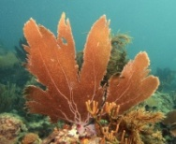 | SA=0.68h²+0.66d²–3.61
 | Three-dimensional  Gorgonia flabellum |  | 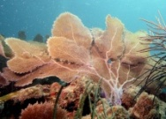 | SA=0.0113h³+106d–1190
Sea Rods  branch and branchlet diameter ≥ 15 - ≤30mm | Unbranched  digitate form,  Briareu | 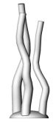 | 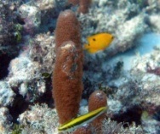 | SA=0.341d³+11.2h–127
 | Branched  Plexaura | 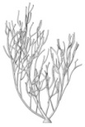 | 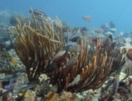 | SA=1.46d²+399
 | Bushy  Eunicea fusca | 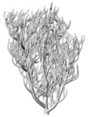 | 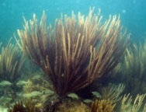 | SA=0.0288h³+ 939
 | Planar  Eunicea tourneforti | 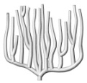 | 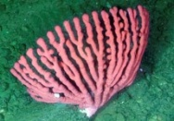 | SA=76.4 d–806
Sea Whips  branch & branchlet diameter ≥5 - ≤15mm | Branched  Pterogorgia | 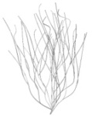 | 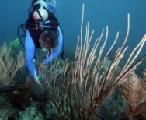 | SA=-0.479h³+3.37h²-1.3h+354
 | Bushy  Pterogorgia guadalupensi | 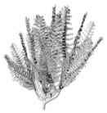 | 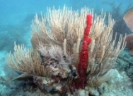 | SA=0.0672d³+1610
Sea Plumes  smallest branch & branchlet diameter usually ≤5mm | Muriceopsis flavida, Pseudopterogorgia | 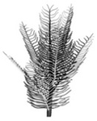 | 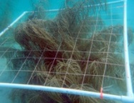 | SA=4.77h²–2990
Encrusting Gorgonians | Briareum,  Erythopodium |  |  | SA=dw

