Supplementary Materials

Adverse Outcome Pathway Networks I: Development and Applications

Dries Knapen^{a,}*, Michelle M. Angrish^{b}, Marie C. Fortin^{c}, Ioanna Katsiadaki^{d}, Marc Leonard^{e}, Luigi Margiotta-Casaluci^{f}, Sharon Munn^{g}, Jason M. O’Brien^{h}, Nathan Pollesch^{i}, L. Cody Smith^{j}, Xiaowei Zhang^{k}, Daniel L. Villeneuve^{i}

ª Zebrafishlab, Veterinary Physiology and Biochemistry, University of Antwerp, Wilrijk, Belgium
^{b} United States Environmental Protection Agency, National Center for Environmental Assessment, Research Triangle Park, NC, USA
^{c} Department of Pharmacology and Toxicology, Ernest Mario School of Pharmacy, Rutgers University, Piscataway, NJ, USA
^{d} Centre for Environment, Fisheries and Aquaculture Science, Weymouth, United Kingdom
^{e} L’Oréal Advanced Research, Aulnay-sous-Bois, France
^{f} Institute of Environment, Health and Societies, Brunel University London, London, United Kingdom
^{g} Joint Research Centre (JRC), European Commission, Ispra, Italy
^{h} Environment and Climate Change Canada, National Wildlife Research Centre, Ottawa, ON, Canada
^{i} United States Environmental Protection Agency, Mid-Continent Ecology Division, Duluth, MN, USA
^{j} Center for Environmental and Human Toxicology, University of Florida, Gainesville, FL, USA
^{k} State Key Laboratory of Pollution Control and Resource Reuse, School of the Environment, Nanjing University, Nanjing, People’s Republic of China

* Address correspondence to: dries.knapen@uantwerpen.be.

Table S1. Description of parameters that could be used to filter a primary AOP network to derive an AOP network tailored to a specific application.

Filter | Description
Taxonomic applicability^{b} | Restricts the network to a given taxonomic space.
Life stage applicabilityª | Restricts the network to specific life stages.
Sex applicabilityª | Restricts the network to pathways relevant to male or female organisms.
Network metrics^{c} | Network metrics are calculated statistics representing how strongly or weakly connected KEs and AOPs are to the network. Networks could be restricted to strongly interconnected AOPs only, or alternatively be expanded to include AOPs that are rather peripheral to the network.
Critical path^{c} | Restricts the network to the AOPs directly linked to the critical path (see section 2.4 for more information on critical paths).
Confidence assessment^{a,b} | Restricts the network to include AOPs with a specified minimum level of confidence, e.g. based on their OECD review status, weight of evidence evaluation, citation index, etc.
ª Filters that could be applied based on structured annotation fields currently captured in the AOP-KB.
^{b} Filters that would require implementation of improved or expanded ontologies in the AOP-KB.
^{c} Filters based on data that would be obtained outside the AOP-KB (e.g., via network analysis software or user-based identification of critical paths).

Table S2. Examples of data layers that could be overlaid over an AOP network (or individual AOPs) to provide additional detail and to facilitate interpretation without overly complicating the underlying framework.

Layer | Description
Feedback and feedforward layer | Displays feedback and feedforward loops that act on specific KERs, as captured in the KER description. Feedback/feedforward loop layers may range from graphically indicating the importance of a loop to a given KER, over implementing predefined loop ontology terms to describe the nature of the loop, to defining loop events (similar to KEs). Such loop events could at some point become KEs of AOPs, if they have been demonstrated to be essential for the progression towards a given AO.
Extrinsic modulating factors layer | Displays modulating factors that are extrinsic to the AOP network. Intrinsic modulating factors are de facto captured in the structure of the network since they arise from a shared KE or KER. Extrinsic modulating factors (e.g., ambient temperature, disease state, diurnal rhythm, …) require separate descriptions and anchoring to the AOP network.
Taxonomic applicability layer | Displays taxonomic applicability domain of KEs and/or KERs.
Life stage applicability layer | Displays life stage applicability domain of KEs and/or KERs.
Sex applicability layer | Displays sex applicability of KEs and/or KERs.
Tissue specificity layer | Displays tissue specificity of KEs and/or KERs.
Temporality layer | Displays time-course data of KERs.
Quantitative data layer | Displays dose-response data of KERs.
Genetic heterogeneity layer | Displays whether the severity of a KE is dependent on genetic background (e.g.., specific alleles).

Case Study 3: Hazard assessment for a complex mixture

Materials and Methods

In September, 2015, a water sample was collected downstream of a major metropolitan waste water treatment plant that discharges to the South Platte River, Colorado, USA. The grab sample, 1L, was collected just below the water surface, directly into a pre-cleaned, organic-free, amber glass bottle. The water sample was extracted by solid phase extraction using an Oasis-HLB glass catridge. Cartidges were conditioned sequentially using 5mL each of ethyl acetate, 50:50 methanol (MeOH):dichloromethane (DCM), MeOH, and water. Prior to SPE, The 1 L whole water sample was filtered using a 47 mm glass-fiber filter (0.7 um pore size). After filtration, 0.5 L of sample was loaded onto a pre-conditioned cartridge. The cartridge was aspirated to near dryness, then eluted using 6 mL of MeOH followed by 6 ml of 50:50 MeOH:DCM. The extract was evaporated to dryness under a gentle stream of nitrogen at 30 degrees C. The sample was then reconstituted in 500 µL dimethyl sulfoxide (DMSO), sonicated for 10 min, then transferred to a clean, amber glass vial. The extract was stored frozen and shipped on ice to Attagene (Attagene, Morrisville, NC, USA) for analysis. The extract in DMSO was tested in the Attagene cis- and trans-FactorialTM assays (http://www.attagene.com/technology.php; Martin and others 2010; Romanov and others 2008). Data were analyzed using an established analysis pipeline for analyzing ToxCast™ high throughput screening data (Filer and others 2017).

Discussion

A widely recognized application for AOP networks is to aid the assessment of complex mixtures. For example, complex mixtures of chemicals have been detected in surface waters across the US (Bradley and others 2017). For many of these compounds, existing apical toxicity data is quite limited, making it difficult to predict what hazards these mixtures might pose. A number of potential approaches that rely on either existing sources of pathway-based data, or direct testing of complex environmental mixtures in pathway-based assays to predict the potential hazards of complex mixtures have been described (e.g., Ekman and others 2014; Schroeder and others 2016). Here we provide an example of how bioactivity profiling of a complex mixture can be used for prediction of apical hazards via construction of an AOP network.

In September 2015, a water sample was collected downstream of a major metropolitan wastewater treatment plant that discharges to the South Platte River (Colorado, USA). The water sample was extracted and the extract was tested using the Attagene cis- and trans-FactorialTM assays (unpublished data), which are part of the ToxCast™ assay library and simultaneously evaluate the ability of a sample to activate 24 different nuclear receptors (trans-Factorial) or 46 different transcription factor promoter-regulated reporter sequences (cis-Factorial). Significant activity was detected for eight different endpoints (Supplementary Table S3), which were mapped to six unique MIEs described in the AOP-Wiki. The global AOP network, representing all AOPs currently described in the AOP-Wiki (accessed: April 5, 2017; Supplementary Figure S1A) was then filtered to focus on KEs, connected to these six MIEs, that were directly relevant to the observed bioactivities (Supplementary Figure S1B). Since the sample was an ambient surface water sample, the assumed focus of the assessment was the potential for direct effects on aquatic life, rather than human health. The resulting collection of AOP networks was therefore further filtered using a critical paths-based approach to exclude AOPs that did not terminate at AOs that would be considered relevant to ecological risk assessment. Focusing on the remaining AOPs, known potential hazards to aquatic vertebrate wildlife associated with this mixture could include impaired reproduction, increased early life stage mortality, and cardiotoxicity (Supplementary Figure S1C and Table S4).

Importantly, observation of pathway-based bioactivities aligned with KEs alone, does not necessarily indicate the perturbation is sufficiently severe to drive the AOP all the way to the adverse outcome. Given that these were in vitro bioactivities, it would first be necessary to confirm that the bioactive compounds would be taken up by aquatic organisms in vivo, and that metabolism and elimination rates were slow enough to allow adequate accumulation of chemical to produce the predicted perturbations. Detailed characterization of ADME would be difficult to generate for a mixture, as there are many components that may contribute to the bioactivity, including unknown constituents. However, given the potential hazards posed by the mixture, one could investigate other KEs within the AOP network to achieve focused, hypothesis-driven in vivo testing. For example, the apical hazard related to embryo lethality is mediated through KEs involving AhR activation, increased Cox2 expression, and altered cardiovascular development (Supplementary Figure S1C). Testing the extract using the fish embryo test (OECD TG 236, OECD 2013), complemented with in vivo measures of CYP1A1 expression (an established indirect indicator of AhR activation), COX2 expression (another KE), and examination of heart morphology would be a suitable follow-up to guide the assessment. In the case of the potential effects on reproduction and sexual differentiation, relatively few KEs linking ER agonism to those apical outcomes have been described to date. A short term test measuring vitellogenin mRNA or protein expression in vivo, an established indirect indicator of ER activation, could at least be used to establish whether the ER-active compounds detected in vitro are available and active in vivo. These examples illustrate that using in vitro screening methods focused on measuring specific KEs of an AOP could be useful for hazard identification and designing follow-up studies. Finally, it is important to realize that AOP networks are limited by the scope of knowledge and relationships currently captured in the AOP-Wiki (Villeneuve and others 2018). While it is well-established that a high level of crosstalk exists between the estrogen receptor and aryl hydrocarbon receptor pathways through a number of different mechanisms (Matthews and Gustafsson 2006), these interactions are currently not yet represented in our AOP network (Supplementary Figure S1C). Further refinement of AOP network-based hazard assessment therefore requires continued efforts to grow the AOP-KB, ultimately fully describing how AOPs and AOP networks might interact with each other.
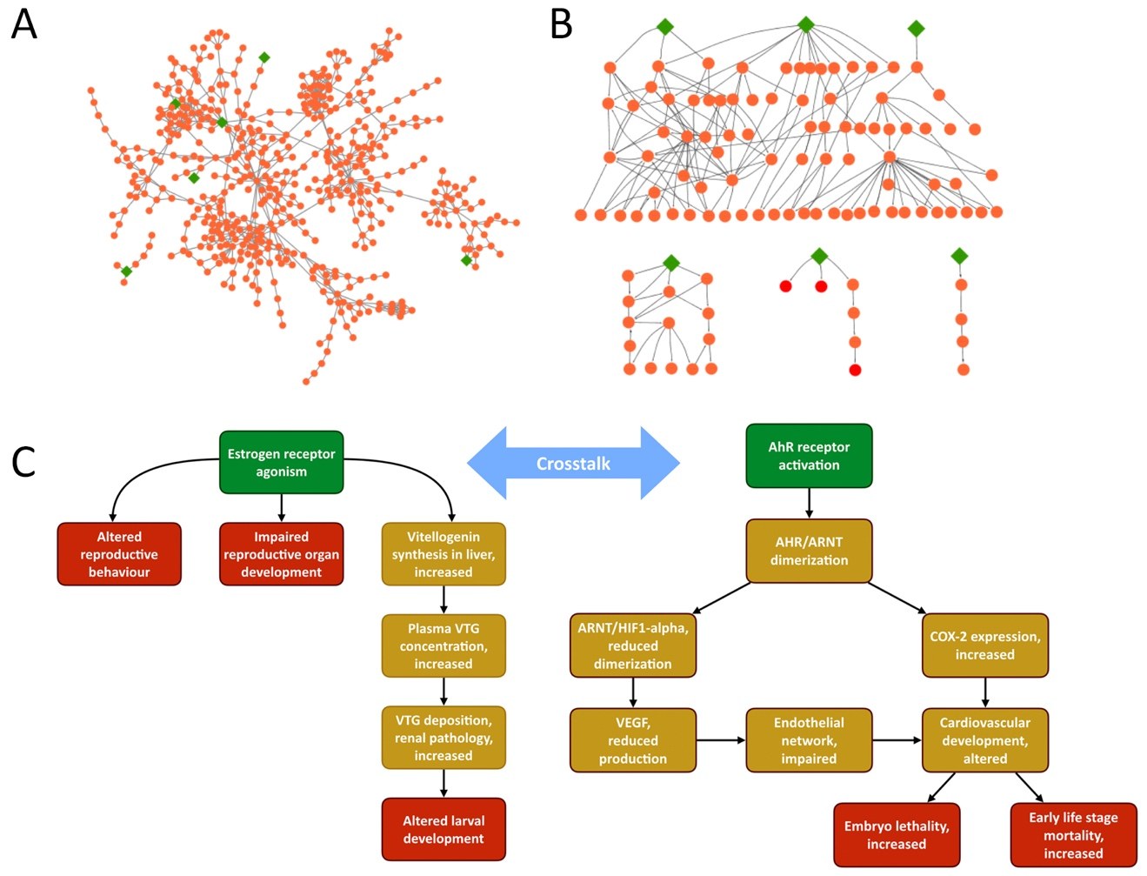
Figure S1. AOP network analysis to support hazard assessment of a complex mixture. (A) Global AOP network representing all AOPs currently described in the AOP-Wiki (accessed: April 5, 2017). The six molecular initiating events directly relevant to the mixture are highlighted as green diamonds. (B) Filtering of the AOP network, selecting only key events that are connected to the six relevant molecular initiating events by no more than 4 subsequent key event relationships. Filtering resulted in one complex AOP network sharing three molecular initiating events and many key events (top), two relatively simple AOP networks sharing a few molecular initiating events and/or key events (bottom left and middle), and one single AOP (bottom right). (C) Further critical paths-based filtering of the network to only include ecologically relevant adverse outcomes helps focus on two AOP networks related to estrogen receptor and aryl hydrocarbon receptor activation. VTG: vitellogenin, AhR: aryl hydrocarbon receptor, ARNT: AhR nuclear translocator, HIF1: hypoxia-inducible factor 1, VEGF: vascular endothelial growth factor, COX-2: cyclooxygenase-2.

Table S3. Screened bioactivity of the water mixture sample.

ANMª | KE^{b} | RM^{c} | AUC^{d} | AC50e | ACC^{f}
ATG_Ahr_CIS_up | Activation, AHR | 1.96 | 15.39 | 0.17 | 0.04
ATG_ERa_TRANS_up | Agonism, Estrogen receptor | 2.14 | 9.20 | 0.32 | 0.33
ATG_ERE_CIS_up | Activation, Estrogen Receptor | 2.86 | 23.78 | -0.18 | -0.82
ATG_GR_TRANS_up | Activation, Glucocorticoid Receptor | 1.49 | 9.53 | 0.24 | 0.27
ATG_NRF2_ARE_CIS_up | Activation, NRF2 | 1.08 | 6.54 | 0.50 | 0.65
ATG_PXR_TRANS_up | Activation, PXR/SXR | 1.41 | 13.12 | 0.09 | 0.96
ATG_PXRE_CIS_up | Activation, PXR/SXR | 2.37 | 5.63 | 0.04 | -0.35
ATG_VDRE_CIS_up | NA | 0.75 | 6.88 | 0.07 | 0.98

ª ANM: assay name assigned by the ToxCast™ program.
^{b} KE: key event title from the AOP-wiki.
^{c} RM: maximum response (log₂) of the sample in that assay.
^{d} AUC: area under the curve.
^{e} AC50: activity concentration at 50% maximal activity (log), where maximal activity is the RM for the sample in that assay.
^{f} ACC: log activity concentration at cut-off (i.e., a response significantly above background/baseline in the assay). See Filer and others (2017) for details on how cut-off was assigned.

Table S4. AOPs selected using a critical paths-based approach in the complex mixture AOP network.

AOP | AOP name | Taxon. Domain | Applicable
Aop:21 | Activation of the aryl hydrocarbon receptor (AhR) leading to early life stage mortality | All teleost and non-teleost fishes; All birds | Yes
Aop:57 | AhR activation leading to hepatic steatosis | Mammals | No
Aop:131 | AhR activation leading to uroporphyria | Mammals, Birds | No
Aop:150 | Aryl hydrocarbon receptor activation leading to embryolethality via cardiotoxicty | Fish, birds, mammals | Yes
Aop:29 | Estrogen receptor agonism leading to reproductive dysfunction | Fish, birds, amphibians | Yes
Aop:52 | ER agonism leading to skewed sex ratios due to altered sexual differentiation in males | NA | NA
Aop:53 | ER agonism leading to reduced survival due to renal failure | NA | NA
Aop:167 | Early-life estrogen receptor activity leading to endometrial carcinoma in the mouse. | Mammals | No
Aop:14 | Glucocorticoid Receptor Activation Leading to Increased Disease Susceptibility | NA | NA
Aop:61 | NFE2L2/FXR activation leading to hepatic steatosis | NA | NA
Aop:11 | Percellome Toxicogenomics Approach for AOP Building: Case study on Pentachlorophenol | NA | NA
Aop:60 | NR1I2 (Pregnane X Receptor, PXR) activation leading to hepatic steatosis | NA | NA

Case Study 4: Polypharmacology

Individual chemicals can interact with multiple protein targets at the same time. In principle, each of those chemical/target interactions can represent the MIE of different AOPs that are triggered simultaneously. In drug discovery and development, the ability of chemicals (i.e., drug candidates) to interact with multiple targets is a well-known phenomenon described as polypharmacology (Reddy and Zhang 2013). Whereas the primary target of pharmaceuticals is generally therapeutically relevant, the interaction with secondary targets (sometimes defined as off-targets) can be related to the manifestation of adverse effects (Lounkine and others 2012). For this reason, drug candidates are screened during drug development using a number of in vitro assays to test whether they interact with molecular targets, or cellular processes, known to be associated with clinically relevant adverse drug reactions (Hamon and others 2009).

Recent high-throughput in vitro screening programs (e.g., ToxCast™, Tox21) have revealed that the concept behind polypharmacology in predictive toxicology may be relevant not only for pharmaceuticals, but to chemicals in general (Thomas and others 2013). However, knowledge about the ability of a given chemical to modulate multiple targets by itself is not informative enough, as some of those chemical/target interactions may occur at very high tissue concentrations that are never reached in real-life exposures. Although cut-off potency values are often applied to prioritize the outcome of the in vitro profiling, interpreting the biological relevance of the results, and the relevance to risk assessment remains challenging. If we consider each chemical/target interaction as the MIE of an AOP, assembling this information in AOP networks can offer a valuable opportunity to facilitate the interpretation of those complex data, and to identify potential nodes of convergence that may be particularly relevant to the safety assessment.

Here we provide an example of how AOP networks can be used to explore the polypharmacological profile of the pharmaceutical beclomethasone dipropionate (BDP), using the fathead minnow as the experimental model. The full details of this work have been described by Margiotta-Casaluci and others (2016). The synthetic glucocorticoid BDP is a widely prescribed pro-drug that is rapidly metabolically activated in the body into the potent beclomethasone 17-monopropionate (17-BMP), driving therapeutic effects. 17-BMP is successively converted into free beclomethasone (BOH) and excreted. Thanks to its ability to modulate the glucocorticoid receptor (GR), BDP is used to treat numerous chronic inflammatory conditions, such as asthma. At the same time, the drug has the ability to modulate two other steroid receptors: the androgen receptor (AR) and the progesterone receptor (PR). Considering the physiological importance of these three receptors as well as their toxicological relevance, existing pharmacological and toxicological data generated during drug development were used to identify the cascades of KEs likely to be triggered by the drug by organizing this information within an AOP network. Some of the KEs (e.g., inhibition of inflammatory cytokines, immunomodulation) are considered therapeutic in humans, but may become adverse in the context of environmental risk assessment. Other KEs, such as skin androgenization and increase of plasma glucose, can be considered adverse in both humans and fish.

Supplementary Figure S2A shows the integration of the AOP network considered by Margiotta-Casauci and others (2016) with two existing AOPs identified in the AOP-Wiki (AOP 14 and AOP 23), which also describe cascades of events triggered in fish by GR and AR activation. The network visualization shows an interesting convergence of the network towards apical effects relevant to risk assessment. Specifically, the network enables us to hypothesize that increased levels of plasma glucose, immunodepression, androgenic effects, and disruption of hormonal feedbacks all contribute to reduce fish reproductive performance. Since 17-BMP acts as a GR, AR, and PR agonist with different potency, it was hypothesized that the different KEs of the network may occur at different drug plasma concentrations. To test this hypothesis, a theoretical network was used to identify a set of KEs that could be validated and quantified experimentally. These KEs, as well as plasma concentrations of BDP, 17-BMP and BOH, were measured in individual fish during and after an in vivo chronic exposure to BDP (Supplementary Figure S2A). These data were used to generate an experimental quantitative AOP network in which each KE is positioned along the axis of drug plasma concentration according to its plasma LOEC (Supplementary Figure S2B, Margiotta-Casaluci and others 2016).

This quantitative AOP network provided evidence that the polypharmacology profile of the BDP was indeed critically important to interpret and predict the toxicological profile of the drug. As expected, different KEs (e.g., decreased fecundity) were observed at higher plasma concentrations, whereas immunomodulation was particularly sensitive to exposure dynamics and, in conditions of chronic sustained exposure, occurred at concentrations lower than those predicted (Margiotta-Casaluci and others 2016). Anchoring each KE to the chronic plasma LOEC provides a valuable tool to guide the future environmental risk assessment of other synthetic glucocorticoids, while minimizing the number of animals used. Finally, this case study illustrates how the development and application of an AOP network enables the design of tailored in vivo studies. In this specific study, all except two of the 12 measured endpoints displayed concentration-dependent responses (Margiotta-Casaluci and others 2016). This high accuracy highlights the great potential of such an approach to inform the development of IATAs.
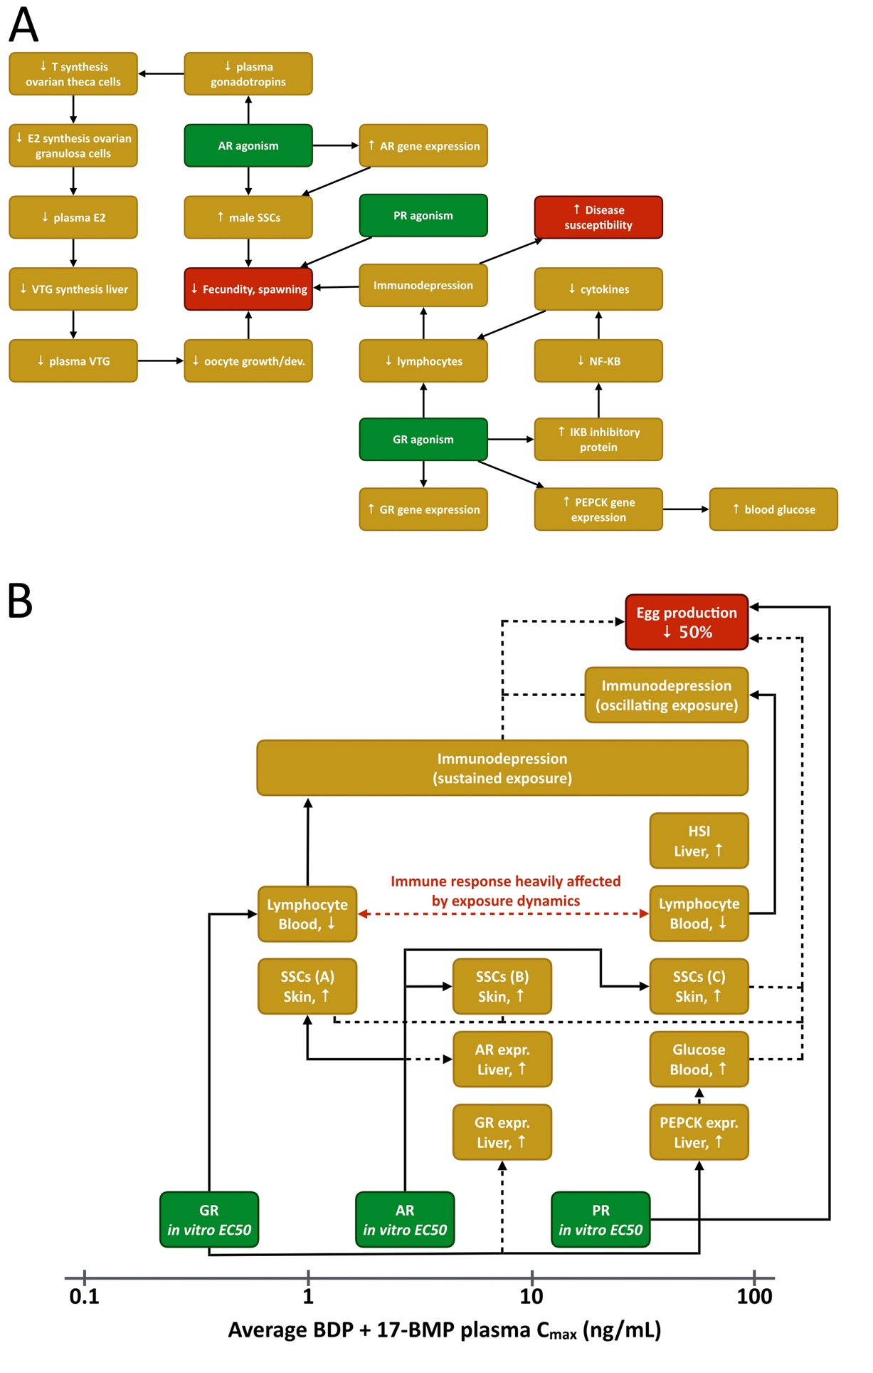
Figure S2. AOP network based on the polypharmacology of the synthetic glucocorticoid beclomethasone dipropionate (BDP, Margiotta-Casaluci and others 2016). (A) Theoretical AOP network displaying the cascade of effects triggered by the simultaneous modulation of three drug targets (GR, AR, PR). Note the convergence towards the AO “Reduced fecundity and spawning”. (B) Experimental validation of the AOP network and establishment of concentration-dependent manifestation of the key events. This network portrays the link between the potency of 17-BMP (the active metabolite of BDP) to modulate GR, AR and PR (expressed as in vitro EC50), and the in vivo mode-of-action related effects observed at different levels of biological organisation. Each box is plotted against the lowest average drug plasma concentration at which the effect was observed. Full lines indicate known cause-effect linkages, whereas dashed lines indicate hypothesised linkages or linkages for which the direction of the response is difficult to predict or generalise. T: testosterone, E2: estradiol, VTG: vitellogenin, AR: androgen receptor, SSCs: secondary sexual characteristics, PR: progesterone receptor, GR: glucocorticoid receptor, NF-KB: nuclear factor kappa-light-chain-enhancer of activated B cells, IKB: inhibitor of kappa B, PEPCK: phosphoenolpyruvate carboxykinase, HSI: hepatosomatic index.

References

Bradley PM, Journey CA, Romanok KM, Barber LB, Buxton HT, Foreman WT, Furlong ET, Glassmeyer ST, Hladik ML, Iwanowicz LR, Jones DK, Kolpin DW, Kuivila KM, Loftin KA, Mills MA, Meyer MT, Orlando JL, Reilly TJ, Smalling KL, Villeneuve DL. 2017. Expanded Target-Chemical Analysis Reveals Extensive Mixed-Organic-Contaminant Exposure in U.S. Streams. Environ Sci Technol 51(9):4792-4802.
Ekman DR, Ankley GT, Blazer VS, Collette TW, Garcia-Reyero N, Iwanowicz LR, Jorgenson ZG, Lee KE, Mazik PM, Miller DH, Perkins EJ, Smith ET, Tietge JE, Villeneuve DL. 2014. Biological Effects–Based Tools for Monitoring Impacted Surface Waters in the Great Lakes: A Multiagency Program in Support of the Great Lakes Restoration Initiative. Environmental Practice 15(4):409-426.
Filer DL, Kothiya P, Setzer RW, Judson RS, Martin MT. 2017. tcpl: the ToxCast pipeline for high-throughput screening data. Bioinformatics 33(4):618-620.
Hamon J, Whitebread S, Techer-Etienne V, Le Coq H, Azzaoui K, Urban L. 2009. In vitro safety pharmacology profiling: what else beyond hERG? Future Med Chem 1(4):645-65.
Lounkine E, Keiser MJ, Whitebread S, Mikhailov D, Hamon J, Jenkins JL, Lavan P, Weber E, Doak AK, Cote S Shoichet BK, Urban L. 2012. Large-scale prediction and testing of drug activity on side-effect targets. Nature 486(7403):361-7.
Margiotta-Casaluci L, Owen SF, Huerta B, Rodriguez-Mozaz S, Kugathas S, Barcelo D, Rand-Weaver M, Sumpter JP. 2016. Internal exposure dynamics drive the Adverse Outcome Pathways of synthetic glucocorticoids in fish. Sci Rep 6: 6:21978.
Martin MT, Dix DJ, Judson RS, Kavlock RJ, Reif DM, Richard AM, Rotroff DM, Romanov S, Medvedev A, Poltoratskaya N, Gambarian M, Moeser M, Makarov SS, Houck KA. 2010. Impact of environmental chemicals on key transcription regulators and correlation to toxicity end points within EPA's ToxCast program. Chem Res Toxicol 23(3):578-90.
Matthews J, Gustafsson J. 2006. Estrogen receptor and aryl hydrocarbon receptor signaling pathways. Nucl Recept Signal 4:e016.
OECD. 2013. OECD guidelines for the testing of chemicals. No. 236: Fish Embryo Acute Toxicity (FET) Test.
Reddy AS, Zhang S. 2013. Polypharmacology: drug discovery for the future. Expert Rev Clin Pharmacol 6(1):10.1586/ecp.12.74.
Romanov S, Medvedev A, Gambarian M, Poltoratskaya N, Moeser M, Medvedeva L, Gambarian M, Diatchenko L, Makarov S. 2008. Homogeneous reporter system enables quantitative functional assessment of multiple transcription factors. Nat Methods 5(3):253-60.
Schroeder AL, Ankley GT, Houck KA, Villeneuve DL. 2016. Environmental surveillance and monitoring--The next frontiers for high-throughput toxicology. Environ Toxicol Chem 35(3):513-25.
Thomas RS, Philbert MA, Auerbach SS, Wetmore BA, Devito MJ, Cote I, Rowlands JC, Whelan MP, Hays SM, Andersen ME, Meek ME, Reiter LW, Lambert JC, Clewell HJ 3rd, Stephens ML, Zhao QJ, Wesselkamper SC, Flowers L, Carney EW, Pastoor TP, Petersen DD, Yauk CL, Nong A. 2013. Incorporating New Technologies Into Toxicity Testing and Risk Assessment: Moving From 21st Century Vision to a Data-Driven Framework. Toxicol Sci 136(1):4-18.
Villeneuve DL, Angrish MM, Fortin MC, Katsiadaki I, Leonard M, Margiotta-Casaluci L, Munn S, O’Brien JM, Pollesch NL, Smith LC, Zhang X, Knapen D. 2018. Adverse Outcome Pathway Networks II: Network Analytics. Environ Toxicol Chem (this issue).

