**Appendix 3**

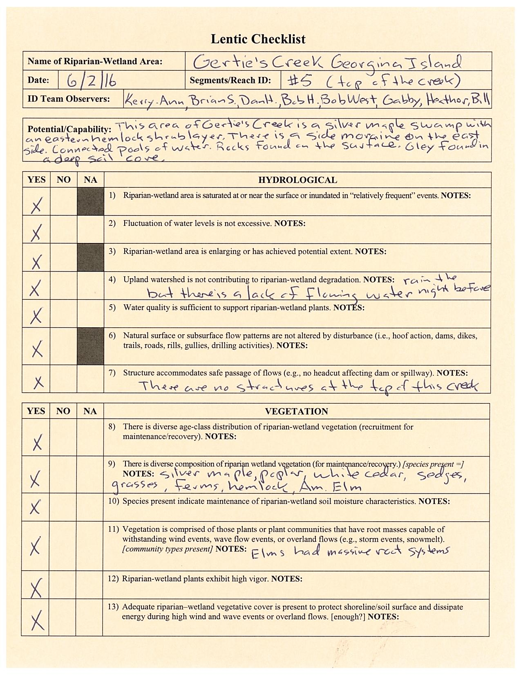**Proper Functioning Condition (PFC) Assessment Forms for Lentic Systems, Reach 5.**

