**Electronic Supplementary Material.**

ESM Figure 1A – 1C. Averages of chemical parameters and SRR in the top 10 cm of sediment.

ESM Figure 2. Sediment chemical and sulfate reduction rate profiles

ESM Figure 3; Results of sediment chemistry ANOVA by depth

ESM Figure 4. Cluster analysis of sediment parameters.

**ESM Figures 1A –1C**

**ESM Figure 1A**. Sediment particulate organic carbon and porewater concentrations of dissolved inorganic carbon and ammonium at each station. Concentrations in individual core fractions were determined and then averaged for the upper 10 cm of sediment. Error bars represent the 95% confidence intervals. Vertical dashed lines separate station transects.

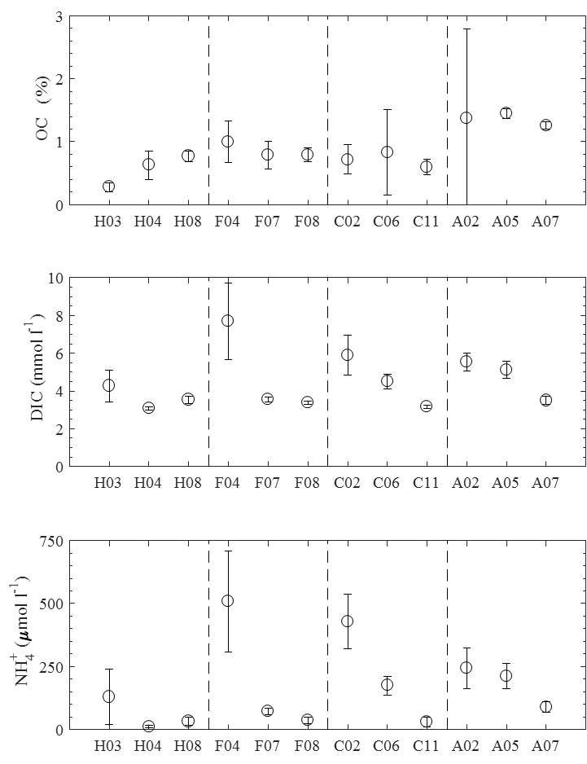

**ESM Figure 1B.** Concentrations of solid phase manganese, Fe(II)HR, Fe(III)HR, and Fe(II)HR:Fe(T)HR ratios for each station. Concentrations in individual core fractions were determined and then averaged for the upper 10 cm of sediment. Error bars represent the 95% confidence intervals. Vertical dashed lines separate station transects.

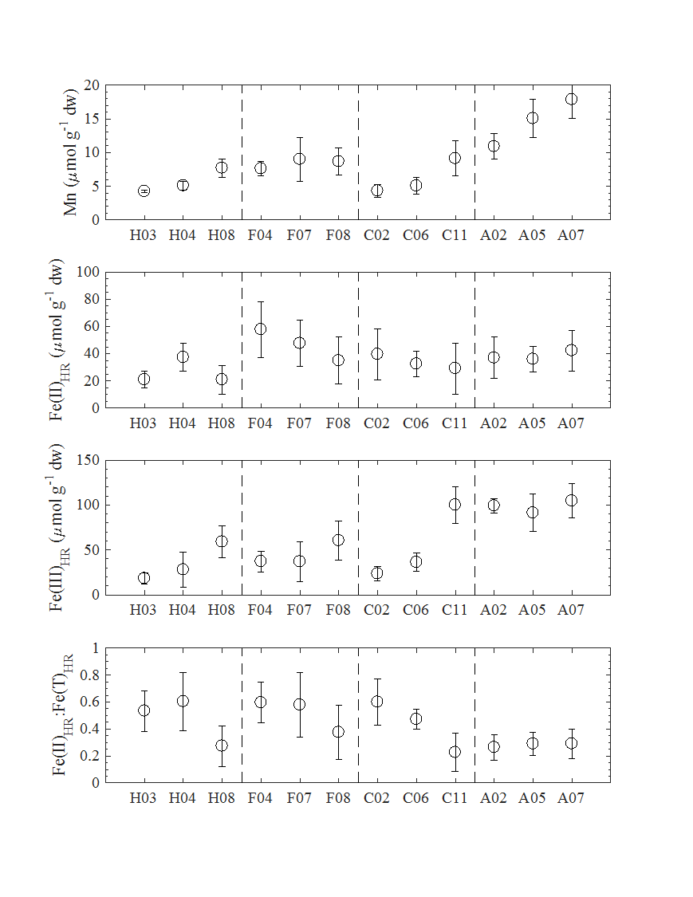

**ESM Figure 1C.** Concentrations of Mn(aq) and Fe2+ and sulfate reduction rates for each station. Concentrations or rates were averaged using values obtained from core fractions in the top 10 cm of sediment at each station. Error bars represent the 95% confidence intervals. Vertical dashed lines separate station transects.

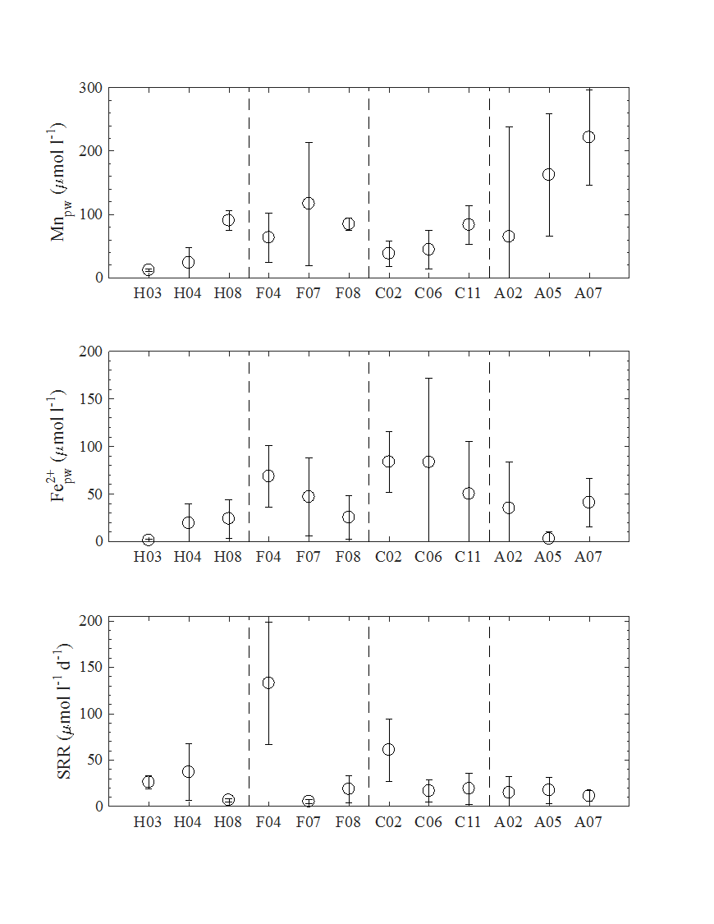

**ESM Figure 2.** Profiles of sediment chemistry and sulfate reduction rates. Profiles of sediment porewater Mn(aq), Fe2+, and DIC concentrations (left column); solid phase Mn(s), Fe(II)HR, and Fe(III)HR concentrations (center column), and sediment % organic carbon and SRR (right column). Stations represented are (top to bottom rows) A02, A05, F04, F07, F08, H03, H04, H08

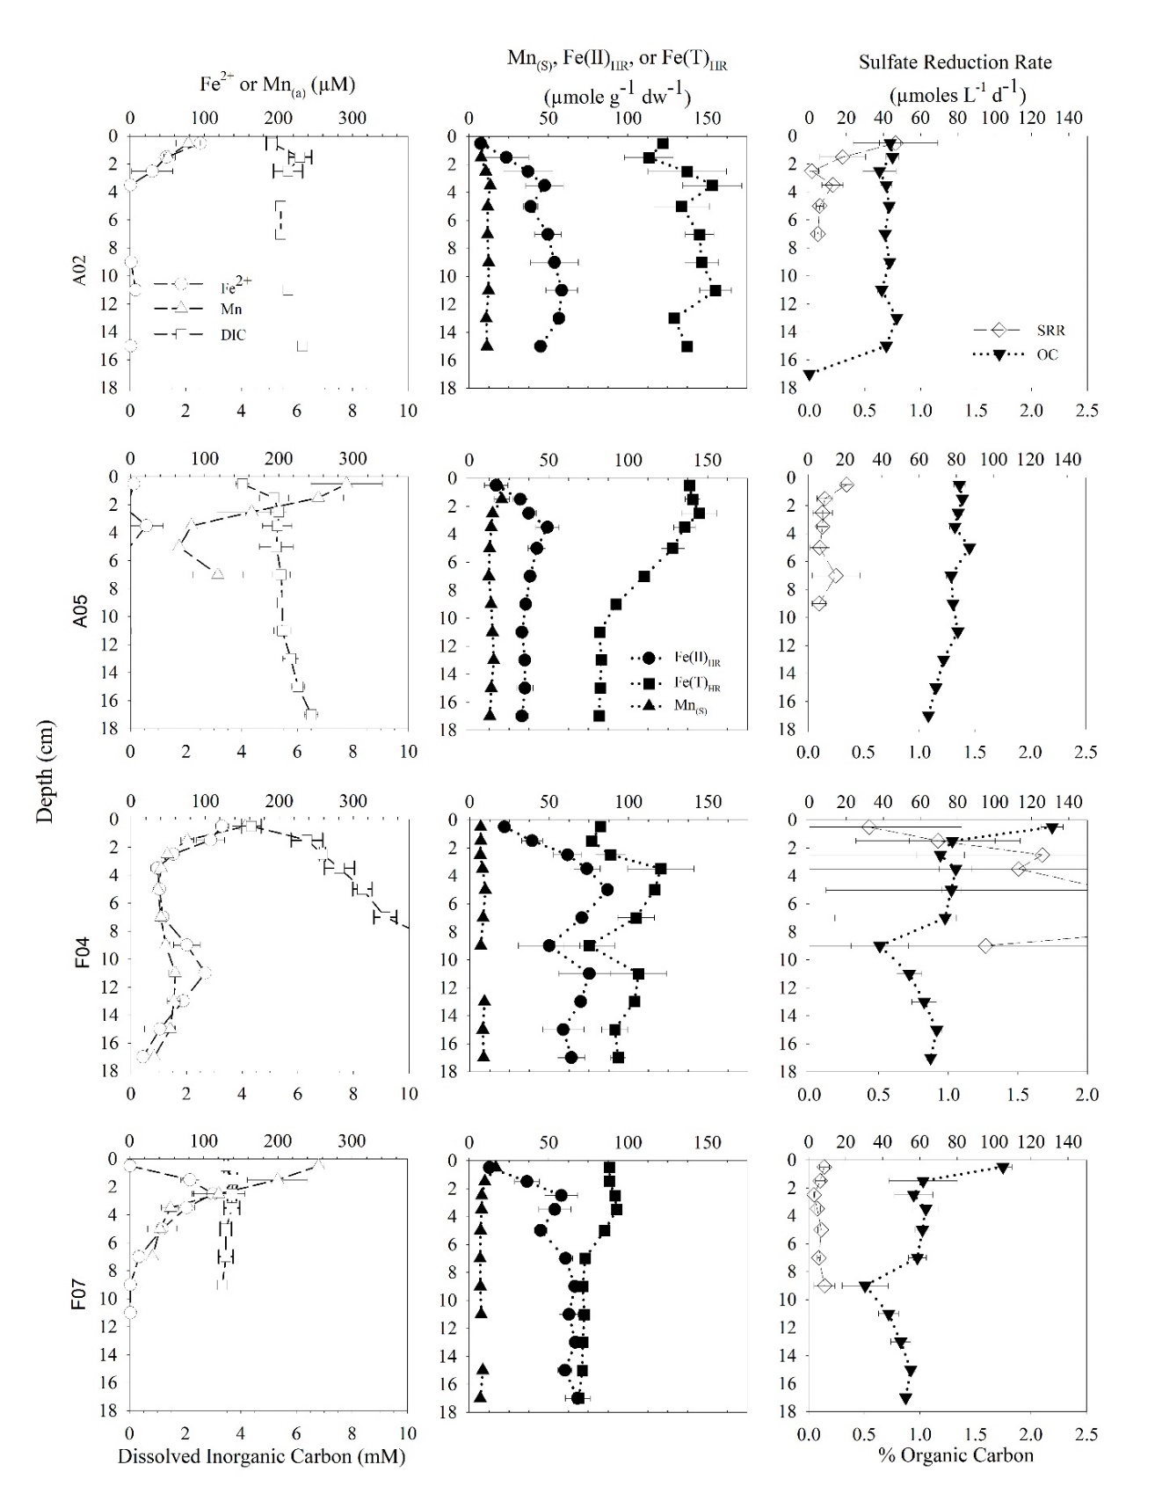

ESM Figure 2 (cont.)

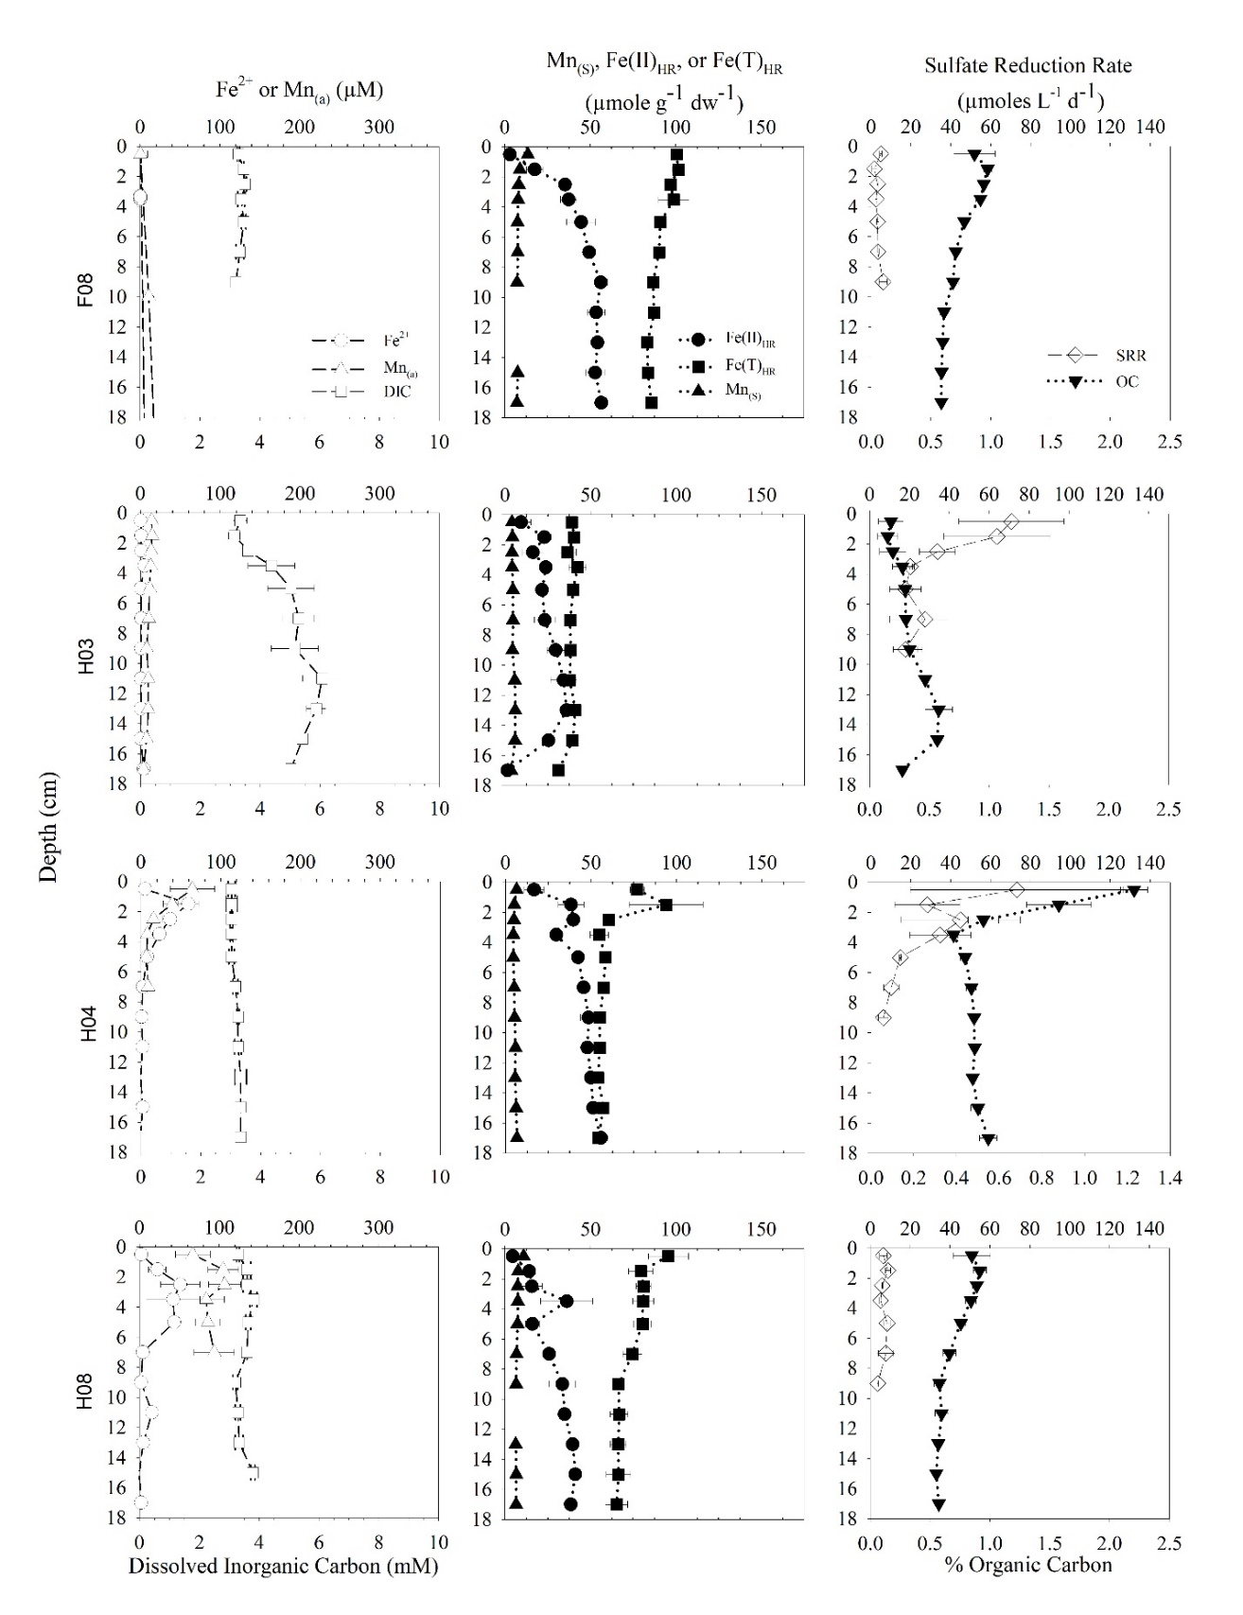

**ESM Figure 3**. Mean (± SE) values for sediment variables grouped by depth regions (Shallow, Middle, and Deep stastions). Different letters denote significant differences in depth region means.

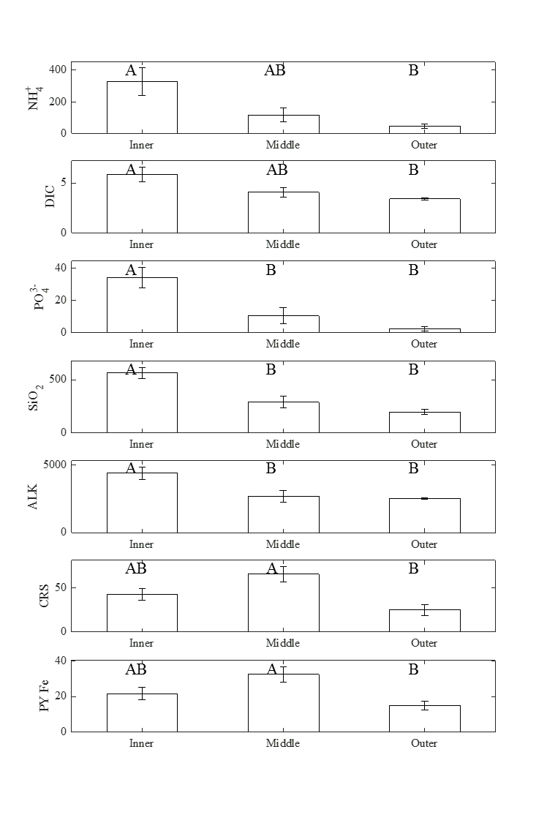

**ESM Figure 4.** Cluster analysis of sediment parameters. Euclidean distances between stations were determined from transformed and normalized 10 cm avarages of sediment parameters. The dendrogram was contructed by the group average method. SIMPROF was used to test for significance (*p* < 0.05) of clusters; red dashed lines indicate no significant difference between stations.

