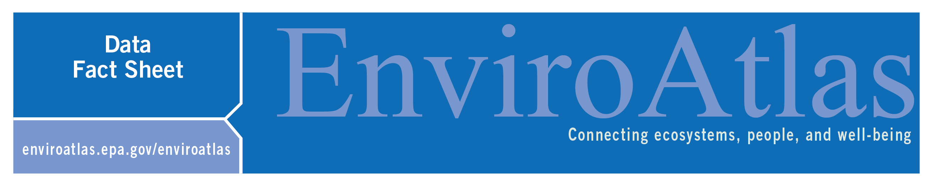
Phosphorus Manure Application
Photo: J. Compton

This EnviroAtlas national map displays the application rate of phosphorus (P) as manure on croplands in the conterminous United States (excluding Hawaii and Alaska) for the year 2012. These data are based on International Plant Nutrition Institute (IPNI) county-level data of P as recoverable manure from concentrated animal feeding operations (CAFOs) and cropland area from U.S. conterminous anthropogenic land use trends 2012 land cover data.

Why is phosphorus in manure important?
Manure is often collected from CAFOSs and used to fertilize crops. The high nutrient (nitrogen and phosphorus) and organic matter content of manure makes it a good organic fertilizer. Use of manure also recycles some of the nutrients that otherwise would be lost to the air or to aquatic ecosystems. This map presents the application rate of phosphorus (P) in livestock manure that is collected from CAFOs and then applied to nearby cropland.
Phosphorus (P) is an essential element for all living organisms, as a component of critical biomolecules for genetic material (DNA, RNA), energy transport (ATP) and membranes (phospholipids) within cells. As such it is necessary for plant growth along with nitrogen and other nutrients. In many ecosystems, including agricultural systems, P can limit plant growth and thus food production. In response to such limitations farmers may apply additional P in the form of inorganic fertilizers, food and green waste composts, animal manures, or biosolids from human waste, which all contain P. However when lost from farms, cities, or industry, P can contribute to aquatic pollution problems.
Although application of P as fertilizers (organic sources like manure and inorganic fertilizer) can increase crop yields, they can also contribute to water quality problems. P in runoff and erosion from agricultural fields, in addition to loses from animal manure on pastures or in CAFOs, cities and homes (from human excreta and detergents), and industries have contributed to algal blooms in lakes and coastal waters. Some of these algal blooms create harmful toxins affecting drinking water, food production (including shellfish), and recreational safety for humans and pets in the lakes, streams, rivers, and coastal waters⁴. Even when the algal blooms are not toxic their formation can cause 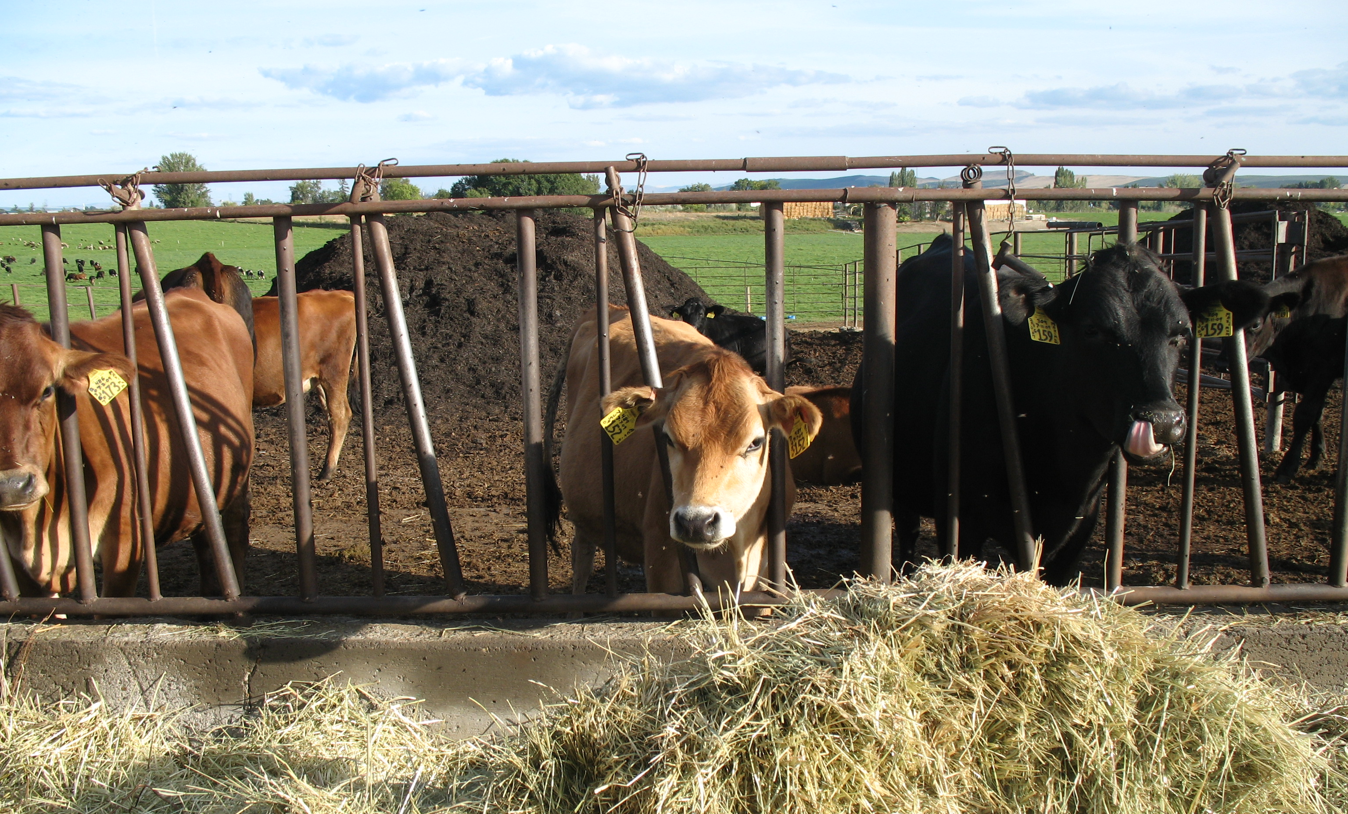
hypoxia (low oxygen zones) which affect plants and animals in aquatic ecosystems and the industries that depend on them, such as fishing in the Gulf of Mexico or Chesapeake Bay.
Manure is an important resource for agriculture, but also has potential as a pollutant. Therefore understanding where and how much P as manure is applied is important to inform management strategies that increase food security and water quality across the U.S. Because livestock have a low P use efficiency (they ingest much more than they can use to make meat, bones, or milk, and thus excrete large amounts of P) CAFOs can be a large source of P that can be lost to waterways, but that can also potentially be recycled on to croplands¹.

How can I use this information?
The map, Phosphorus Manure Application, is one of four EnviroAtlas maps that display P inputs and agricultural crop P demand to the conterminous US. These data could be used either alone or in conjunction with other data layers to help identify areas where P from CAFOs is a significant pollutant source or where there are opportunities for more efficient management and/or recycling. These data could also be used in models that examine the transport and cycling of P across terrestrial and aquatic ecosystems. Information on manure P application is, or will be, needed for the development of nutrient reduction strategies, nutrient credit exchanges, and payments for ecosystem services.
How were the data for this map created?
Phosphorus manure application inputs to cropland in 2012 were estimated using county-level estimates of recoverable manure from confined feeding operations. Recoverable manure is defined as manure that is collected, stored, and available for land application from concentrated animal feeding operations². We acquired county-level data describing total farm-level inputs (kg P yr⁻¹) of P from manure produced by CAFOs at the county level in 2012 from IPNI, which are based on US Census of Agriculture livestock populations³. We used the U.S. National wall-to-wall land use trends (NWALT) for 2012, acquired from the USGS, at the scale of 60 m x 60 m These data were converted to per area rates (kg P km² yr⁻¹) of manure P application by dividing the total P input by the land area (km²) of combined cultivated crop and hay/pasture (agricultural) lands within a county as determined from county-level summarization of the 2012 NWALT layer. We distributed county-specific, per area P inputs rates to agricultural lands (60 m x 60 m pixels) within the corresponding county. In order to correct for some pixels with unrealistically high P application rates (most likely caused a county having little agricultural land), we caped manure P application at 10,000 kg of P per km², which is slightly higher than the maximum reported application rate reported for 2006 by the ARMS Farm Financial and Crop Production Practice survey⁵ For a more detailed description, see the layer’s metadata or the publications below.

What are the limitations of these data?
EnviroAtlas uses the best data available, but there are still limitations associated with these data. Finer scale and crop-specific land use data, including CAFO locations and animal type, could improve our understanding of manure P application rates. The data presented here are based on annual livestock populations and available cropland in a county and not on application rates themselves. As such the application rates are not crop-specific or field-specific but rather a mean across all cropland. Data reporting accuracy and specificity for livestock may not be the same for all states, contributing to potential error and uncertainty. It is also possible that CAFO manure produced in one county in one year is applied in another county or during a later year, introducing additional error. This map does not present data on rangeland used to pasture animals.

How can I access these data?
EnviroAtlas data can be viewed in the interactive map, accessed through web services, or downloaded.

Where can I get more information?
The references below as well as the links throughout this fact sheet contain additional information about P pollution, and sustainability.

Acknowledgements
EnviroAtlas is a collaborative effort led by EPA. The data for Phosphorus Manure Application were compiled by Genevieve Metson of the US National Research Council. The data used to derive Manure phosphorus application came from IPNI and NWALT. The fact sheet was written by Genevieve Metson (NRC), Jana Compton (EPA), and John Harrison (WSU Vancouver).

Selected Publications
¹ Metson, G.S., MacDonald, G.K., Haberman, D., Nesme, T., Bennett, E.M. (2016) Feeding the Corn Belt: Opportunities for phosphorus recycling in U.S. agriculture. Science of The Total Environment 542 Part B.
²Kellogg, R.L., C.H. Lander, D.C. Moffitt, N. Gollehon. 2000. Manure nutrients relative to the capacity of cropland and pastureland to assimilate nutrients: spatial and temporal trends for the United States. US Department of Agriculture: Washington, DC. nps00-0579.

³ IPNI, (2012) A Nutrient Systen (NuGIS) for the U.S., Norcross, GA. Available at www.ipni.net/nugis
⁴ Falcone, J.A. (2015) U.S. conterminous wall-to-wall anthropogenic land use trends (NWALT), 1974–2012: U.S. Geological Survey Data Series 948.

⁵ MacDonald, J.M. et al. (2009) Manure use for fertilizer and for energy: Report to congress. USDA ERM, Washington, DC.

Vaccari, D.A. (2009) Phosphorus: a looming crisis. Scientific American 300, 54-59.

