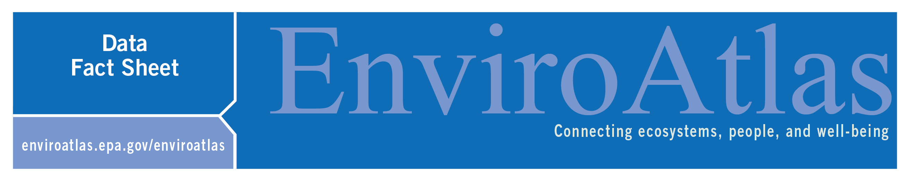
Inorganic Phosphorus Fertilizer Application

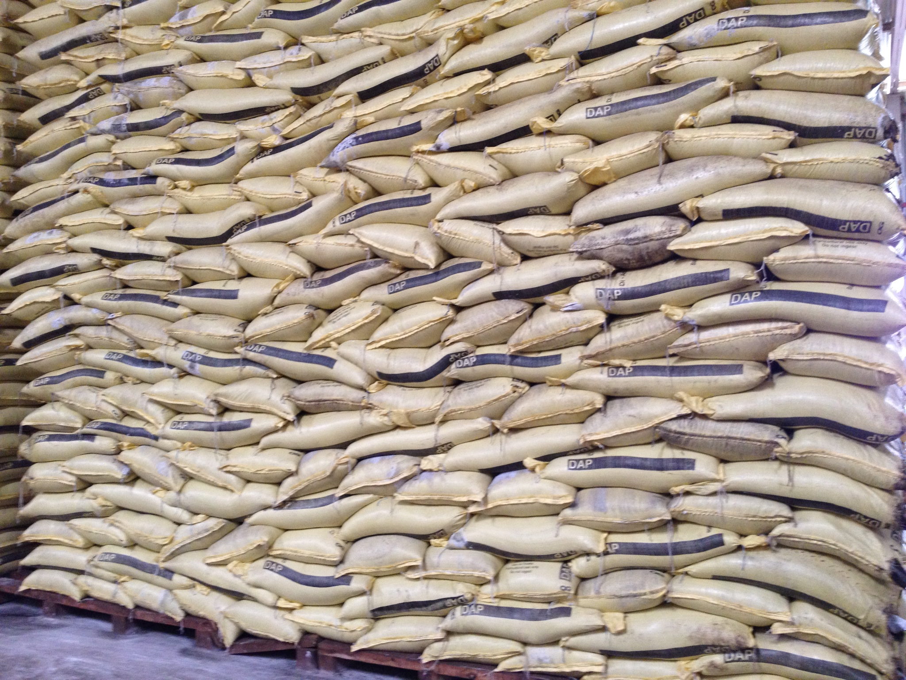
This EnviroAtlas national map displays the application rate of inorganic phosphorus (P) fertilizer on agricultural land in the conterminous United States (excluding Hawaii and Alaska) for the year 2012. These data are based on International Plant Nutrition Institute (IPNI) compilations of county and state fertilizer sales for 2012 and the cropland area from the U.S. conterminous wall-to-wall anthropogenic land use trends 2012 land cover data.

Why is phosphorus fertilizer important?
Phosphorus (P) is an essential element of all living organisms, as a component of critical biomolecules for genetic material (DNA, RNA), energy transport (ATP) and membranes (phospholipids) within cells. As such it is necessary for plant growth along with nitrogen and other nutrients. In many ecosystems, including agricultural systems, P can limit plant growth and thus food production. In response to such limitations farmers may apply additional P in the form of inorganic fertilizers, food and green waste composts, animal manures, or biosolids from human waste, which all contain P. When released from farms, cities, or industry, P can contribute to water pollution problems because algal growth is often limited by P in many freshwater and coastal ecosystems.
Photo: Genevieve Metson, NRC, Fertilizer Plant
Since the domestic discovery of P deposits in the mid 1800’s and following agricultural intensification post World War II, inorganic P fertilizer has become a key agricultural input in the United States¹. This inorganic fertilizer comes from mining concentrated deposits of phosphate rock, which are primarily located in Morocco, China, and the USA (particularly in Florida)². As a mined non-renewable resource, inorganic P fertilizer is subject to potential price fluctuations associated with geopolitical scarcity, in a similar way that oil has been in the past. Increased use of fertilizer has increased crop yields, but also water quality problems associated with the addition of nutrients³. P in runoff and erosion from agricultural fields, in addition to loses from animal manure on pastures or in concentrated animal feeding operations (CAFOs), cities and homes (from human excreta and detergents), and industries have contributed to algal blooms in lakes and coastal waters. Some of these algal blooms create harmful toxins affecting drinking water, food production (including shellfish), and recreational safety for humans and pets in lakes, streams, rivers, and coastal waters⁴. Even when the algal blooms are not toxic their formation can cause hypoxia (low oxygen zones) which harm plants and animals in aquatic ecosystems and the industries that depend on them, such as fishing in the Gulf of Mexico or Chesapeake Bay.
Because of its essential role in agriculture, but potential as a pollutant, understanding where and how much P fertilizer is applied is important to inform management strategies that increase food security and water quality across the U.S. Both up to date information on P fertilizer use (like the 2012 data presented here), and historical information on past use of fertilizers is important because P applied to fields that is not used by crops in the same year can accumulate in soils⁵. These accumulations can be used by plants later, but can also mean that losses to waterways persist even when farmers have stopped applying P fertilizers.

How can I use this information?
The map, Inorganic Phosphorus Fertilizer Application, is one of four EnviroAtlas maps that display P inputs and agricultural crop P demand to the conterminous US. These data could be used either alone or in conjunction with other data layers to help identify areas where P is a significant pollutant source or where there are opportunities for more efficient management. These data could also be used in models that examine the transport and cycling of P across terrestrial and aquatic ecosystems. Information on inorganic P fertilizer application is, or will be, needed for the development of nutrient reduction strategies, nutrient credit exchanges, and payments for ecosystem services.
How were the data for this map created?
Inorganic P fertilizer inputs in 2012 were estimated using county-level estimates of farm P fertilizer inputs. We acquired data describing total agricultural inputs (kg P yr⁻¹) of inorganic P fertilizer to individual counties in 2012 from IPNI⁶. We used the U.S. National wall-to-wall land use trends (NWALT) for 2012⁷, acquired from the USGS, at the scale of 60 m x 60 m. These data were converted to per area rates (kg P km² yr⁻¹) of inorganic P fertilizer application by dividing the total P input by the land area (km²) of combined cultivated crop and hay/pasture (agricultural) lands within a county as determined from county-level summarization of the 2012 NWALT layer. We distributed county-specific per area P inputs rates to agricultural lands (60 m x 60 m pixels) within the corresponding county. In order to correct for some pixels with unrealistically high P application rates (most likely caused by high fertilizer sales in a county with low agricultural land), we caped P application at 6,000 kg of P per km², which corresponds to double the highest application rate reported for corn in 2010 in the ARMS Farm Financial and Crop Production Practice survey⁸. This alternation resulted in less than 1% reduction in total P fertilizer used compared to the reported sales data. For a more detailed description, see the layer’s metadata or the publications below.

What are the limitations of these data?
EnviroAtlas uses the best data available, but there are still limitations associated with these data. In order to match the latest available fertilizer data, we used 60m resolution land use data that are not crop-specific but reflect total cultivated cropland in the county. Finer scale and crop-specific land use could improve our understanding of P fertilizer application rates. The data presented here are based on annual farm fertilizer sales as a proxy for farmer application rates and not on application rates themselves. As such the application rates are not crop-specific but rather a mean over all cropland area within the county. In addition, sales data are not reported with the same level of specificity across all states, creating additional uncertainty. It is also possible that fertilizer sold in one county in one year is applied in another county or during a later year, introducing additional error. IPNI has applied reasonable assumptions to correct for these types of uncertainties when possible (see their detailed methods).

How can I access these data?
EnviroAtlas data can be viewed in the interactive map, accessed through web services, or downloaded.

Where can I get more information?
The references below as well as the links throughout this fact sheet contain additional information about P fertilizers, pollution, and sustainability.

Acknowledgements
EnviroAtlas is a collaborative effort led by EPA. The data for Inorganic Phosphorus Fertilizer were compiled by Genevieve Metson of the US National Research Council. The data used to derive Inorganic phosphorus fertilizer came from IPNI and NWALT. The fact sheet was written by Genevieve Metson (NRC), Jana Compton (EPA), and John Harrison (WSU Vancouver).

Selected Publications
¹ Roberts, T.L., Dibb. , D.W., (2011) Fertilizer Use in North America: Types and Amounts, in: Lal, R. (Ed.), Encyclopedia of Life Support Systems (EOLSS). developed under the Auspices of the UNESCO, Eolss Publishers, Oxford, UK.
² Jasinski, S.M., (2013) Phosphate Rock. USGS Mineral Commodity Summaries 2013. United States Government Printing Office, Washington, D.C.
³ Cordell, D., White, S. (2014) Life’s Bottleneck: Implications of Global Phosphorus Scarcity and Pathways for a Sustainable Food System. Annual review of Environment and Resources 39, 161-188.
⁴ Anderson, D.M., Glibert, P.M., Burkholder, J.M. (2002) Harmful algal blooms and eutrophication: nutrient sources, composition, and consequences. Estuaries 25, 704-726.
⁵ Sharpley, A., Jarvie, H.P., Buda, A., May, L., Spears, B., Kleinman, P. (2013) Phosphorus legacy: Overcoming the effects of past management practices to mitigate future water quality impairment. Journal of Environmental Quality 42, 1308-1326.
⁶ IPNI, (2012) A Nutrient Systen (NuGIS) for the U.S., Norcross, GA. Available at www.ipni.net/nugis
⁷ Falcone, J.A. (2015) U.S. conterminous wall-to-wall anthropogenic land use trends (NWALT), 1974–2012: U.S. Geological Survey Data Series 948.
⁸ USDA ERS, (2015) Agricultural Resource Management Survey on Farm Financial and Crop Production Practices. Washington, DC.

Vaccari, D.A. (2009) Phosphorus: a looming crisis. Scientific American 300, 54-59.

