Crop Phosphorus Removal

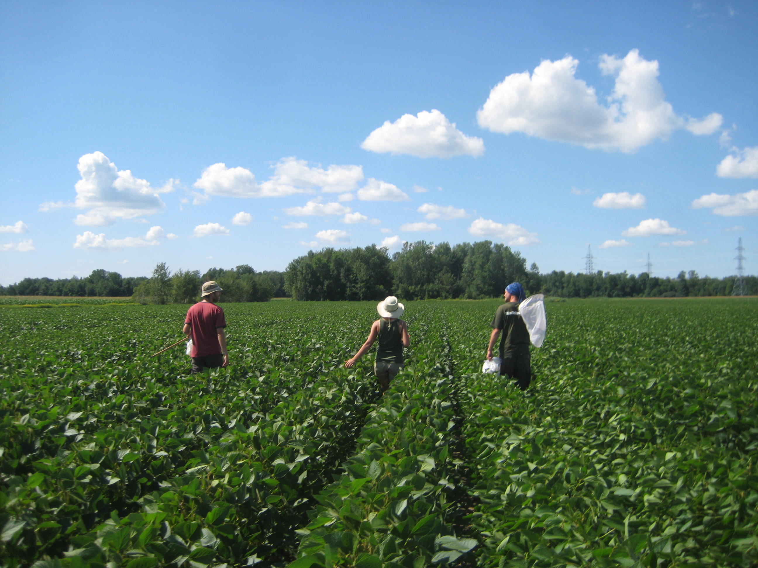
This EnviroAtlas national map displays the mean crop phosphorus (P) removal from croplands in the conterminous United States (excluding Hawaii and Alaska) for the year 2012. These data are based on International Plant Nutrition Institute (IPNI) compilations of county-level major crop harvest and P content of these crops, and cropland area from the U.S. conterminous wall-to-wall anthropogenic land use trends 2012 land cover data.

Why is crop phosphorus removal important?
Phosphorus (P) is an essential element of all living organisms, as a component of critical biomolecules for genetic material (DNA, RNA), energy transport (ATP) and membranes (phospholipids) within cells. As such it is necessary for plant growth along with nitrogen and other nutrients. In many ecosystems, including agricultural systems, P can limit plant growth and thus food production. In response to such limitations farmers may apply additional P in the form of inorganic fertilizers, food and green waste composts, animal manures, or biosolids from human waste, which all contain P. However when lost from farms, cities, or industry, P can contribute to aquatic pollution problems.
Photo: Genevieve Metson, NRC, Soybean field
Since the domestic discovery of P deposits in the mid 1800’s and following agricultural intensification post World War II, inorganic P fertilizer has become a key agricultural input in the United States¹. This inorganic fertilizer comes from mining concentrated deposits of phosphate rock, which are primarily located in Morocco, China, and the USA (particularly in Florida)². As a mined non-renewable resource, inorganic P fertilizer is subject to potential price fluctuations associated with geopolitical scarcity, in a similar way that oil has been in the past. Increased use of fertilizer has increased crop yields, but also water quality problems associated with the addition of nutrients³. P in runoff and erosion from agricultural fields, in addition to loses from animal manure on pastures or in concentrated animal feeding operations (CAFOs), cities and homes (from human excreta and detergents), and industries have contributed to algal blooms in lakes and coastal waters. Some of these algal blooms create harmful toxins affecting drinking water, food production (including shellfish), and recreational safety for humans and pets in the lakes, streams, rivers, and coastal waters⁴. Even when the algal blooms are not toxic their formation can cause hypoxia (low oxygen zones) which affect plants and animals in aquatic ecosystems and the industries that depend on them, such as fishing in the Gulf of Mexico or Chesapeake Bay.

Because of its essential role in agriculture, but potential as a pollutant, understanding where and how much P fertilizer is applied is important to inform management strategies that increase food security and water quality across the U.S. Information on P uptake/removal from crops (like the 2012 data presented here) is important in order to understand if P sources are being over or under applied compared to crop needs.

How can I use this information?
The map, Crop Phosphorus Removal, is one of four EnviroAtlas maps that display P inputs and agricultural crop P demand to the conterminous US. These data could be used either alone or in conjunction with other data layers to help identify areas where P is a significant pollutant source (over application) or where there are opportunities for more efficient management or recycling to meet crop demands. These data could also be used in models that examine the transport and cycling of P across terrestrial and aquatic ecosystems. Information on crop P demand and uptake is, or will be, needed for the development of nutrient reduction strategies, nutrient credit exchanges, and payments for ecosystem services.
How were the data for this map created?
Crop Phosphorus Removal in 2012 was estimated using county-level estimates of crop harvest. We acquired county-level data describing total crop P uptake (kg P yr⁻¹) in 2012 from IPNI, which was compiled using 22 major-crop yields and harvested acres from the USDA National Agricultural Statistics Service summaries and US Census of agriculture (see IPNI detailed methodology for crops considered and removal rates used)⁵. We used the U.S. National wall-to-wall land use trends (NWALT) for 2012⁶, acquired from the USGS, at the scale of 60 m x 60 m. These data were converted to per area rates (kg P km² yr⁻¹) of crop P removal by dividing the total P crop removal by the land area (km²) of combined cultivated crop and hay/pasture (agricultural) lands within a county as determined from county-level summarization of the 2012 NWALT layer. We distributed the county-specific per area P removal rates from IPNI to agricultural lands from NWALT (60 m x 60 m pixels) within the corresponding county. In order to correct for some pixels with unrealistically high P removal rates (most likely caused by low agricultural land), we caped P removal at 9,000 kg of P per km², which is higher than potential removal of high estimates of corn yield⁷ (300 bu/acre) and corn P removal⁸. For a more detailed description, see the layer’s metadata or the publications below.

What are the limitations of these data?
EnviroAtlas uses the best data available, but there are still limitations associated with these data. In order to match the latest available fertilizer data (to create an agricultural balance layer were crop removal is subtracted from fertilizer and manure inputs), we used 60m resolution land use data that are not crop-specific. Finer scale and crop-specific land use could improve our understanding of P removal rates. The data presented here are based on only a subset of the 22 major US crops and are annual in nature. As such the removal rates are neither crop-specific nor farm-specific nor season specific but rather a mean of overall annual cropland within a given county for the year 2012. Some crops that may be particularly important to some areas of the US, but not nationally a major crop, were not considered and thus may represent an underestimate of total P removal in these areas of the country (particularly for diverse western cropland such as California’s Central Valley or Oregon’s Willamette Valley).

How can I access these data?
EnviroAtlas data can be viewed in the interactive map, accessed through web services, or downloaded.

Where can I get more information?
The references below as well as the links throughout this fact sheet contain additional information about P pollution risks, and sustainability.

Acknowledgements
EnviroAtlas is a collaborative effort led by EPA. The data for Crop Phosphorus Removal were compiled by Genevieve Metson of the US National Research Council. The data used to derive Crop Phosphorus Removal came from IPNI and NWALT. The fact sheet was written by Genevieve Metson (NRC), Jana Compton (EPA), and John Harrison (WSU Vancouver).

Selected Publications
¹ Roberts, T.L., Dibb. , D.W., (2011) Fertilizer Use in North America: Types and Amounts, in: Lal, R. (Ed.), Encyclopedia of Life Support Systems (EOLSS). developed under the Auspices of the UNESCO, Eolss Publishers, Oxford, UK.
² Jasinski, S.M., (2013) Phosphate Rock. USGS Mineral Commodity Summaries 2013. United States Government Printing Office, Washington, D.C.
³ Cordell, D., White, S. (2014) Life’s Bottleneck: Implications of Global Phosphorus Scarcity and Pathways for a Sustainable Food System. Annual review of Environment and Resources 39, 161-188.
⁴ Anderson, D.M., Glibert, P.M., Burkholder, J.M. (2002) Harmful algal blooms and eutrophication: nutrient sources, composition, and consequences. Estuaries 25, 704-726.
⁵ IPNI, (2012) A Nutrient Systen (NuGIS) for the U.S., Norcross, GA. Available at www.ipni.net/nugis
⁶ Falcone, J.A. (2015) U.S. conterminous wall-to-wall anthropogenic land use trends (NWALT), 1974–2012: U.S. Geological Survey Data Series 948.
⁷ Murrell, T., Childs, F. (2000) Redefining corn yield potential. Better Crops 84, 33-37.
⁸ Heckman, J. et al. (2001) Phosphorus and potassium removal in corn. Better Crops 85, 4-5.

Vaccari, D.A. (2009) Phosphorus: a looming crisis. Scientific American 300, 54-59.

