A Nitrogen Physical Input-Output Model for Illinois
Shweta Singh, Jana Compton, Troy Hawkins, Daniel Sobota and Ellen Cooter
Supplementary Information

- Flow Diagram for Steps in Development of PIOT for a Region

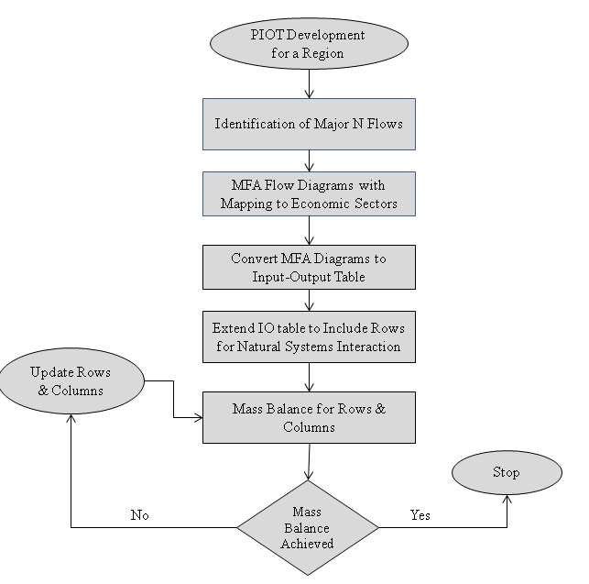

Figure 1 : Steps in Developing the N-PIOT Model

- Material Flow Analysis (MFA) Diagram for Major N flows in Illinois
Step 2 in development of PIOT involves tracking N flows driven by major commodities in the region. This tracking is done by developing material flow diagrams for each commodity separately. Table 1 shows the major crop area in Illinois. The top 3 crop commodities are corn, soybean and wheat. Hence to develop the PIOT for N flows in the Illinois the processing of these 3 commodities are included. To develop the PIOT, MFA for each of these crops are developed and each flows are estimated by using empirical data or calculated. Last, each of the flows are mapped to corresponding economic sectors in the region. To see the process of each flow estimation corresponding to each of these crops refer to specific sections on Soybean, Corn and Wheat below.

Major Crop | Area (Acres)
Corn for Grain | 10,742,787
Corn for Silage | 109,847
Wheat for Grain | 581,084
Soybean for Beans | 10,505,989
Alfalfa (hay) | 416,997
Total of Above | 22,356,704
Total Cropland in Illinois : 24,171,260 Acres
Harvested Cropland in Illinois : 22,562,904 Acres
Major Crops (Corn, Soybean, Wheat & Alfalfa) form 99 % of Harvested Cropland.
Table 1 : Major Crop Areas In Illinois (2002) USDA NASS

The order of description of each flow estimation is: MFA diagram for the crop, Table that shows relevant flows from the MFA diagram with values and method of calculation or estimation and details of all flow estimations along with assumptions.

2.1 Soybean Flow Diagram
Figure 2 : Material Flow Analysis for Soybean in Agro-Based Industries
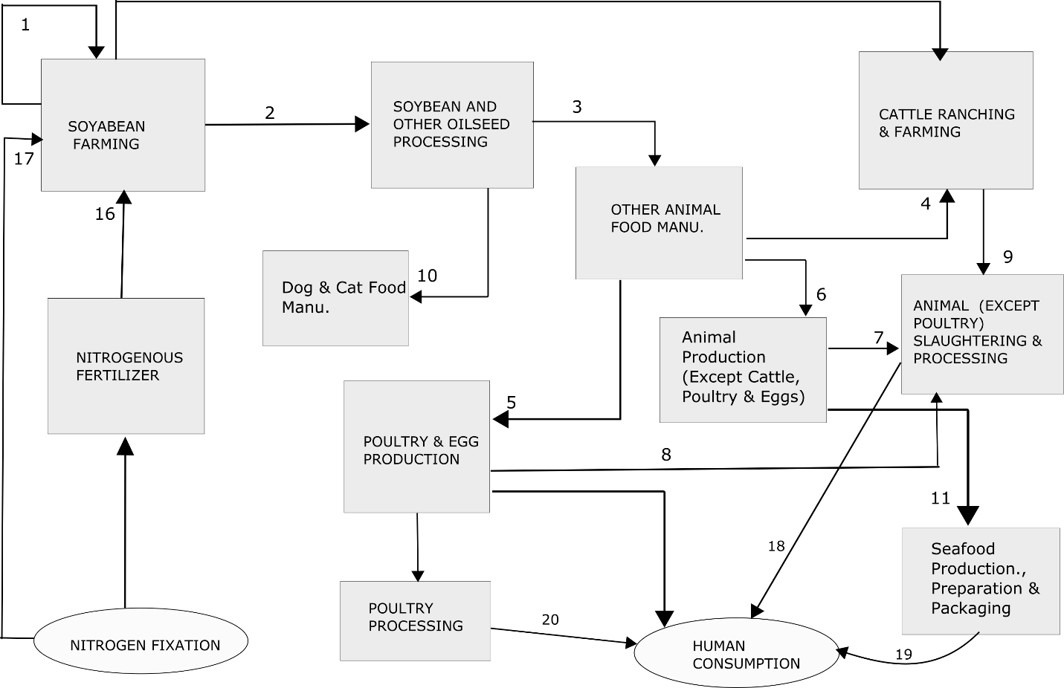

Flow Number | From | To | Description | Data Source | Values (Original Unit) | Values (N) (Metric tons)
1 | Oilseed Farming | Oilseed Farming | Soybean Used for Seed | Calculated | 12.607 million bushels | 1.89E+04
2 | Oilseed Farming | Soybean & Other Oilseed Processing | Soybean Bushels Processed for feed and fuel | Soy-Illinois Report | 273 million bushel | 4.15E+05
3 | Soybean & Other Oilseed Processing | Other Animal Food Manu. | Soymeal for animal food manu. | Calculated based on Soy-Illinois Report | 792 thousand tons | 5.58E+04
4 | Other animal food manu. | Cattle ranching & farming | Manufactured feed for cattle | Calculated | 46.63 (1000 tons) | 3.26E+03
5 | Other animal food manu. | Poultry & Egg Production | Manufactured feed for poultry | Calculated | 40.074 (1000 tons) | 2.82E+03
6 | Other animal food manu | Animal Production except cattle, poultry & eggs | Manufactured feed for hogs etc | Calculated | 624.0072 (1000 tons) | 4.40E+04
7 | Animal production except cattle, poultry & eggs | Animal (except poultry) slaughtering & processing | Processing of hog etc for food | Assumed equal to Flow # 6 | Assumption | 4.40E+04
8 | Poultry & egg production | Poultry processing | Processing of poultry for food | Assumed equal to Flow # 5 | Assumption | 2.82E+03
9 | Cattle ranching & Farming | Animal (except poultry) slaughtering & processing | Processing of cattle for food | Assumed equal to Flow # 4 | Assumption | 3.28E+03
10 | Soybean & other Oilseed processing | Dog & Cat food manu. | Soy processing byproducts for pet food manu. | _ | _ | Not available
11 | Animal production except cattle, poultry & eggs | Seafood product preparation & packaging | Processing of seafood | _ | _ | Not available
12 | Oilseed farming | Exports | Flow going out of state | Soy-Illinois Report | 187 million bushels | 2.81E+05
13 | Oilseed processing | Exports | Flows of soymeal out of state | Soy-Illinois Report | 5736 thousand tons of soymeal | 4.04E+05
14 | Oilseed farming | Beg Stocks | Original stock of soybean bushels | Soy-Illinois Report | 34 million bushels | 5.10E+04
15 | Oilseed farming | End Stocks | Left Over stock of soybean bushels | Soy-Illinois Report | 27 million bushels | 4.05E+04
16 | Nitrogenous fert. Manu. | Oilseed Farming | Nitrogen fertilizer used for soybean farming | Calculated (See 2.1.1) | 2.10E+08 pound of Nr | 9.53E+04
17 | Natural N fixation | Oilseed farming | Nitrogen fixation by soybean | Daniel Sobota (Personal communication) | 3.49E+08 kg-N | 3.49E+05
Table 2 : Flows for Soybean in N- PIOT (Figure 2 shows the Soybean Flows)

Assumptions and Calculations of Soybean Flows: The description for calculation of flows depicted in the material flow diagram for soybean is discussed below. Flow numbers mentioned refer to the number shown on arrows in the material flow diagram, Figure 2.
    - Flow # 16 : Nitrogenous fertilizer input to Soybean farming (Oilseed farming sector)
Rate of Nitrogenous fertilizer use on Soybean in Illinois (2002) = 20 pounds/acre [Source: USDA http://www.ers.usda.gov/data-products/fertilizer-use-and-price.aspx#26744]

Total Area of Land Harvested for Soybean (2002) = 1.05E+07 [Source: NASS, USDA]
Total fertilizer consumed for Soybean in Illinois: 2.10E+08 pounds of Nr

    - Fresh Nr Fixation by Soybean
N fixation data in Soybean for 2002 - Illinois.
Source : Dan Sobota (Personal Communication, manuscript in Prep)
Variable | Value | Unit
Min | 4.32E+06 | Kg-N
1st quartile | 2.04E+08 | Kg-N
Median | 3.49E+08 | Kg-N
Mean | 3.89E+08 | Kg-N
3rd quartile | 5.32E+08 | Kg-N
Max | 1.82E+09 | Kg-N
Table 3 : N Fixation Data in Soybean - Illinois (2002)
2.1.3 Nr Input to Soybean farming sector as Seeds : Calculation of Seed requirement for Soybean Plantation (Flow # 1)
This data was not found. So, communication was established with Soybean expert at USDA NASS, Travis Thorson. (travis_thorson@nass.usda.gov)
It was suggested that Bushels of Soybean for Seed = Acres X 1.16
This data was supported with existing data on use of Soybean bushels for seeds and Acres Harvested. [Data Source: WASDE Report, http://usda.mannlib.cornell.edu/MannUsda/viewDocumentInfo.do?documentID=1194]
From WASDE Report,
Year | Seeds (Million Bushels) | Acres Harvested | Ratio (Seeds in Million Bushels/ Million Acres Harvested )  Unit : Million Bushel/ Million Acres
2000/2001 | 91 | 72.4 | 1.25
2001/2002 | 89 | 73 | 1.21
Table 4 : WASDE Report Data (Estimating Seeds Input for Soybean Farming)
From the table, an approximate ratio of 1.21 was used for the state of Illinois. The ratio from the WASDE report was at national scale.
Soybean used for seeds in Million Bushels = 1.21 x (Area Harvested in Illinois)
= (1.21 x 1.05E+07) bushels
= 12.607 million bushels

    - Flow of Soybean Bushels for Crushing in Soybean & Other Oilseed Processing Sector (Flow # 2)

Use of Soybean in Crushing = 273 million bushels [Source: Soy Illinois Report]
% N in Soybean grain [Source: (Salvagiotti, et al. 2008)] = 6.34 %
Moisture in Soybean Bushel = 13 %
Weight of Soybean bushel = 60 lb

    - Flow of Soybean Bushels Outside State (Flow # 12) = 187 Million Bushels
Conversion to N:
% N in Soybean grain [Source: (Salvagiotti, et al. 2008) ] = 6.34 %
Moisture in Soybean Bushel = 13 %
Weight of Soybean bushel = 60 lb

N flow as exports outside of state = 187 x (10^6) x (1 - 0.13) x 60 x 0.0634 = 6.19E+08 lb of N = 2.81E+05 metric tons of N

    - Beginning Stock of Soybean (Flow # 14) = 34 million bushels = 5.10E+04 metric tons
Conversion to N is done using the same process as in 5
    - End Stock of Soybean (Flow # 15) = 27 million bushels = 4.05E+04 metric tons
    - Soymeal flow out of state (Flow # 13) = 5736 thousand tons
Conversion to N:
% of Protein in Soymeal = 44 – 48 % [Source: Cromwell]
Assumed 44 % in non dehulled soybean meal
% of N in Protein = 16 %
N in Soymeal flowing out of state = 5736 *1000 * 0.44 * 0.16 = 4.04E+05 metric tons
  - 9 Calculation of Soybean meal Consumed Within State
Table 5 : Calculation of Domestic (Illinois) Consumption of Soybean Meal
IL | Production | Total Production Yield |  |  |  | SBM Domestic Use
2002 | Mil lbs | Yield/lb | mil lbs | Protein meal/unit of production | SBM as share of Protein meal | Mil lbs | 1000s s. tons | 1000 tons
Beef | 594.35 | 0.63 | 376.66 | 0.97 | 0.15 | 53.58 | 26.79 | 24.30
Pork | 2495.63 | 0.74 | 1836.02 | 0.99 | 0.76 | 1377.24 | 688.62 | 624.70
Broilers | 0.13 | 0.74 | 0.10 | 0.81 | 0.76 | 0.06 | 0.03 | 0.03
Turkeys | 89.90 | 0.78 | 70.30 | 0.88 | 0.76 | 47.02 | 23.51 | 21.33
Eggs | 112.18 | 1.00 | 112.18 | 0.48 | 0.76 | 41.27 | 20.64 | 18.72
Milk | 2051.00 | 1.00 | 2051.00 | 0.08 | 0.30 | 49.22 | 24.61 | 22.33

The soybean meal consumption within State of Illinois is calculated based on the production data for various cattle, poultry and dairy products. The production data shown in Table 2, is obtained from USDA NASS dataset.
Yield/lb : This is the final yield of product that is obtained for consumption from the original product. This data was assumed to be same for national yield and yield for Illinois. For example, for 1 lb of beef cattle the actual production of beef for consumption is 0.63 lb. The rest of the mass is waste or reused for other filler products.

The yield data is combined with the information on the protein meal required for per unit of production for consumption. For example, 0.97 lb of protein meal is required to generate 1 lb of beef for consumption and out of this protein meal requirement only 15 % comes from soybean meal. These data for meal consumption were obtained from United Soybean Board dataset [] and available here
Source: http://www.unitedsoybean.org/category/topics/animal-ag/#animalAgToolWrap
This was the best information available for calculation of soybean meal consumption within the state. Thus, the soybean meal consumption for producing each of the animal based product (beef, pork, dairy, egg, turkey and broilers) was calculated based on USDA NASS data for these in Illinois in 2002. Each of these flows were then converted into specific inter-sectoral flows based on the mapping of products with sectors.

- N flow in Soybean Meal Consumed by Poultry Within State (Flow # 5): Manufactured feed utilizing Soybean meal for Poultry food. = 40.074 thousand tons. This flow is calculated as sum of soybean meal consumed for production of broilers, turkeys and eggs. These three products are mapped to the sector of “Poultry & Egg Production” which raises poultry (chicken and turkey).

N content = 40.074 x (10^3) x (0.44) x (0.16) = 2.82E+03 metric tons

- N flow in Soybean Meal consumed by other animal such as hogs (Flow # 6) : Manufactured feed Utilizing Soybean meal feed for Hog food = 624.70 thousand tons. This flow is for pork production and mapped as the flow from “Other animal food manufacturing” to “Animal production except cattle, poultry & eggs”.

N content = 624.70 x (10^3) x (0.44) x (0.16) = 4.40E+04 metric tons

- N flow in Soybean meal consumed by cattle such as cattle raised for beef and milk production (Flow # 4) : Manufactured feed Utilizing soybean meal feed for Beef food and milk production = 46.30 thousand tons. This flow is for beef production and mapped as the flow from “Other animal food manufacturing” to “Cattle ranching & farming”.

N content: 46.30 x (10^3) x (0.44) x (0.16) = 3.26E+03 metric tons

2.1.10 Calculation of Soybean Mean Consumed in Animal Food manu. Within State

Total Soybean meal produced = 6528 thousand tons [Soy-Illinois Report]
Export of Soybean meal = 5736 thousand tons [Soy-Illinois Report]

Assumption: The soybean meal produced within state is utilized fully and the amount not exported outside state is sent to animal food manufacturing to be converted into useful product.

Hence, Soybean mean sent to animal food manufacturing (Flow # 3) : Flow from sector “Soybean & Other Oilseed processing” to “Other Animal Food manu” = 6528 – 5736 = 792 thousand tons

N content for Flow # 3 = 792 x (10^3) x (0.44) x (0.16) = 5.58E+04 metric tons
2.2 Corn Flow Calculations
Corn Flow Diagram
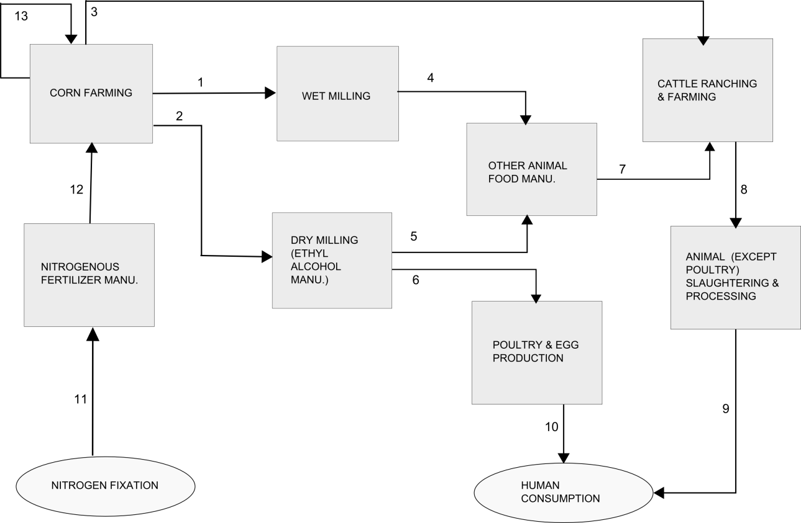
Figure 3 : Material Flow Analysis for Corn in Agro-Based Industries
Table 6 : Flows for Corn PIOT
Flow Number | From | To | Description | Data Source | Values (Original Unit) | Values (N) Metric tons
1 | Corn Farming | Wet Milling | Flow of corn bushels for | Calculated | 80.97 million bushels | 3.03E+04
2 | Corn Farming | Dry Milling | Flow of corn bushels mainly for Ethyl Alcohol Manu. | Calculated | 121.46 million bushels | 4.53E+04
3 | Corn Farming | Cattle ranching & farming | Flow of corn bushels for direct consumption by livestock | Not available | - | -
4 | Wet Milling | Other animal food manu. | Flow of byproducts from wet milling of corn that is used for animal food manu. | Calculated | 1.09E+09 Corn gluten feed and 2.02E+08 lb of Corn gluten mean | 2.42E+04
5 | Dry Milling | Other animal food manu. | Flow of byproducts/co-products from dry milling of corn that is used for animal food manu. | Calculated | 2.13E+09 lbs of DDGS | 4.33E+04
6 | Dry milling | Poultry & Egg production | Flow of byproducts/coproducts from corn dry milling that is directly used as feed for poultry.
7 | Other animal food manu | Cattle ranching & farming | Flow of manufactured animal food to livestock farming industry | Data for consumption of DDGS not available.
8 | Cattle ranching & farming | Animal (except poultry) slaughtering & processing | Flow of N as cattle from livestock farming to animal slaughtering & processing that converts it for human consumption. | Data not available
9 | Animal (Except poultry) slaughtering & processing | Human Consumption | Flow of N final to human consumption within state in form of meat except poultry meat.
10 | Poultry & Egg production | Human Consumption | N flow associated with egg consumption by humans
11 | Nitrogen in Atmospheric pool | Nitrogenous fertilizer manufacturing | Nitrogen fixation by Haber Bosch process from atmosphere by the Nitrogenous fertilizer manu. industry | Assumed to be equal to the N fertilizer consumption in corn farming | 7.73E+05 metric tons of N | 7.73E+05
12 | Nitrogenous Fertilizer manu. | Corn Farming | Flow of N in form of nitrogenous fertilizer to corn farming. | Calculated (See Below) | 7.73E+05  (metric tons of N) | 7.73E+05 metric tons of Nr
13 | Corn farming | Corn farming | Use of seeds produced in the same sector for farming | Calculated | 1.70E+08 gm of Corn Seeds | 16.037 metric tons of Nr

Assumptions and Calculations of Corn Flows:
N Flow from Nitrogenous Fertilizer consumption to Corn Farming (Flow # 12): This flow consists of Nitrogen fertilizer being applied for corn and sweet corn farming.

N fertilizer for Sweet Corn
Sweet corn is used in the economy as fresh sweet corn and processed form.
Fresh sweet corn Farming Data
Source: USDA NASS
Link: http://usda.mannlib.cornell.edu/MannUsda/viewDocumentInfo.do?documentID=1564

Illinois | Source : NASS tables 18,19 in PDF
Sweet Corn : Fresh (2002)
 | Acreage (Acres) |  | Yield per acre
 | Planted | Harvested | Unit : cwt
2001 | 6200 | 5700 | 98
2002 | 6200 | 5600 | 100

Sweet Corn : Processed (Freezing and Canning) (2002)
 | Acreage (Acre) |  | Yield per acre
 | Planted | Harvested | Unit : Short ton
2001 | 18400 | 17500 | 6.66
2002 | 16100 | 13800 | 5.8

Fertilization rate for Sweet Corn Production [Source: John R Teasdale et al, 2008] = 174 KgN/ha or 70.415364 Kg-N/acre
Fertilizer for fresh sweet corn | 436575.2568 | kg-N = (6200*70.415364)
Fertilizer for Processing Sweet Corn | 1133687.36 | kg-N = (16100*70.415364)

N Fertilizer for Corn
Area planted for Corn (Illinois, 2002; Source: USDA NASS): 1.11E+07 Acres
Total N applied to Corn plants = 1.70E+09 lb of N (Source : NASS QuickDataSets)
= 771,103 metric tons of N
Total N Consumption in Corn Plantation for Illinois, 2002 = 771,103 + (436575.2568 x 0.001) + (1133687.36 x 0.001) = 772,673.26 metric tons N = 7.73E+05 metric tons of N
    - Flow of Corn to Wet Milling Plants in Illinois (Flow # 1): This is the flow of corn bushels from corn farming to Wet Milling plants. The data for bushels of corn being milled by wet milling process is not available by each state. So, this flow is calculated based on the average Corn-ethanol being produced per bushel as explained below.

The assumption made is that each state will produce corn-ethanol based on the capacity. So, if capacity of a state is known, then it is assumed that the states are producing corn-ethanol at its full capacity.

Total Corn Ethanol Production in US (2002) = 2130 million gallons
[Source: http://www.ethanolrfa.org/pages/statistics#A ]

Process for Corn-Ethanol Production: Corn-ethanol is produced both in dry milling and wet milling of corn process.

Share of Each process
Dry Milling Process = 60 % of US Ethanol Production
Wet Milling Process = 40 % of US Ethanol Production
Source: US Corn-Ethanol Industry Statistics (Renewable Fuel Association)
http://www.ethanolrfa.org/page/-/objects/pdf/outlook/outlook_2003.pdf?nocdn=1

Assumption 2. Each stats has approximately the same distribution of wet mill and dry mill processes as the National Average (ie 60 % in dry mill and 40 % in Wet Mill)

How much Corn-Ethanol is produced in Illinois for 2002 ?

Total US Ethanol Production Capacity (2002) = 2738 million gallons/year
Ethanol Production Capacity for Illinois in 2002 = 726 million gallons/year
Source: http://www.ethanolrfa.org/page/-/objects/pdf/outlook/outlook_2002.pdf?nocdn=1

% of US Ethanol Produced in Illinois: 26.515 %
Therefore, Ethanol Produced in Illinois (2002)
= .26515 x (2130) million gallons = 564.769 million gallons

Ethanol Produced by Dry Milling vs Wet Milling in Illinois
Wet Milling = 40 % of total production = 0.40 x 564.769 = 225.91 million gallons
Dry Milling = 60 % of total production = 0.60 x 564.769 = 338.86 million gallons

Conversion of Corn-Ethanol Produced to Bushels of Corn
Assumption: 1 bushel = 2.79 gallons of ethanol [Source: RFA]
Corn Bushels Used in Dry Mills = 121.459 million bushels [= 338.86/2.79]

    - Flow # 4: Flow of Byproducts from Wet Milling of Corn to “Other Animal Food Manufacturing”
The wet milling of corn produces by products like “Corn Gluten feed” and “Corn gluten meal” that are used in animal feed manufacturing.
Co-product formation in Wet Milling of Corn per bushel of corn
Co-Product | Value | Unit
Corn Starch | 31.5 | pounds
Corn Gluten Feed | 13.5 | pounds
Corn gluten meal | 2.5 | pounds
Corn Oil | 1.1 | pounds
Source: Corn Milling, Processing and Generation of Co-products (Minnesota Nutrition Conference, Minnesota Corn Growers Association Report)

Co-Product Formation by Wet Milling of Corn in Illinois (2002)
Co-Product | Value (pounds)
Corn Starch | 2.55E+09
Corn Gluten Feed | 1.09E+09
Corn Gluten Meal | 2.02E+08
Corn Oil | 8.91E+07

Calculation of N flowing in Corn Wet Milling Byproducts
To convert the flow of byproducts from corn wet milling to the “Other Animal food manu” in the units of N flows the % of protein in each byproduct was used.

Source: Kelly S. Davis, Corn Milling, Processing and Generation of Co-Products, Minnesota Nutrition Conference, Minnesota Corn Growers Association.
Products of Corn Wet Milling | Protein | Fat | Fibers
Corn Condensed Distillers Solubles (CDS) | 29 % | 9 % | 4 %
Condensed Corn Fermented Extractives (or Corn Steep Liquor) | 25 % on a 50 % solids basis | - | -
Corn Germ Meal | 20 % | 2 % | 9.5 %
Corn Gluten Feed | 21 % (16 % - 23 %) | 2.5 % | 8 %
Corn Gluten Meal | 60 % | 2.5 % | 1 %

For Corn Gluten Feed = 19.5 % (Assumed as average)
For Corn Gluten meal = 60 % (Assumed as reported, max)

Flow # 4
- Flow of Corn Gluten Feed from “Wet Milling to Other Animal Food Manu.” = 1.09E+09 lb = 1.09E+09 x 0.195 x 0.16 = 3.40E+07 lb N = 1.54E+04 metric tons of N
- Flow of Corn Gluten meal from “Wet Milling to Other Animal Food Manu.” = 2.02E+08 lb = 2.02E+08 x 0.60 x 0.16 = 1.94E+07 lb N = 8.80E+03 tons of N
Total Flow # 4 = (1.54 + 0.880) E+04 = 2.42E+04 metric tons of N

    - Flow # 5: Flow of Byproducts from Dry Milling of Corn to “Other Animal Food Manufacturing”

The products of dry milling process of corn involves ethyl alcohol, distillers wet grains, distillers dried grains with solubles and condensate distillers solubles.

Among these, Corn Distillers Dried Grains with Solubles (DDGS) mainly has all the nutrients after extraction of starch in the alcohol. Typical composition of DDGS includes – 27 % protein, 11 % fat and 9 % fiber.

Other report mentioned the protein content of DDGS to be 29 %. So, an average value of 28 % protein content was used for DDGS.

Production of DDGS in Illinois for the year 2002.

Corn Bushels in Dry Milling = 121.459 million bushels

Assumption: 1 bushel corn = 17.5 pounds of DDGS

DDGS produced = 121.459 x (10^6) x 17.5 pounds = 2.125E+09 pounds of DDGS

N in DDGS produced = (2.125E+09) x 0.28 x 0.16 = 9.54E+07 lbs of N = 4.33E+04 metric tons of N

    - Flow # 13: Flow of N from Corn farming to Corn farming in form of “corn seeds” – This flow is calculated by calculating the seed requirement for corn plantations based on acres harvested in Illinois for 2002.

Seeding Rate = Plant population per acre at harvest / (Seed germination x Expected Survival)
Average seed germination rate for corn = 95 %
Expected survival = 85 % - 95 %

[Source: http://corn.osu.edu/newsletters/2010/2010-08-4-13/corn-seeding-rates-vs.-final-stands]

State | Plant population per acre at harvest (bushel/acre) | Seeding Rate (seed/acre) | Acres harvested (Corn for grain) | Total Seeds
Illinois | 135.5 | 158.479 | 10742787 | 1.70E+09

Seeding rate for Illinois = 135.5/ (0.95 x 0.90) = 158.479 seeds/acre
Total Corn Seeds Used in Illinois in 2002 = 10742787 x 158.479 = 1.70E+09
Weight of Seed = 1.70E+09 *(1/10) = 1.70E+08 gm
[Source of Weight: http://www.harvesttotable.com/2011/05/vegetable_seeds_per_ounce_per/]

Protein Content of Corn = 9.42 %
[Source: http://ndb.nal.usda.gov/ndb/foods/show/6432?fgcd=&manu=&lfacet=&format=&count=&max=35&offset=&sort=&qlookup=Corn]
N content in Seed = (9.42/100) x (1.70E+08) = 16.037 metric tons of N
    - Consumption of Sweet Corn directly by Human : Corn farming sector also represents “sweet corn farming” that is directly consumed by humans either as canned, frozen or fresh sweet corn.
- Consumption as Frozen Sweet corn: This flow is represented by the flow of N from “Corn Farming” sector to the “Frozen Food Manu.” Sector.
- Consumption as Canned Sweet Corn : This flow is represented by the flow of N from “Corn Farming” sector to the “Vegetable and Fruit Canning & Drying”
- Consumption as Fresh Sweet Corn: This flow is represented by the direct flow of N from “Corn Farming” to Human Consumption.

US Sweet Corn : Per capita domestic consumption (2002)
Unit : pounds per person
Freezing | Canning | Fresh
9.3 | 7.8 | 9.0

Sweet Corn Domestic Consumption in Illinois (2002)
 | Freezing | Canning | Fresh
Pounds | 1.17E+08 | 9.83E+07 | 1.13E+08
grams | 5.32E+10 | 4.46E+10 | 5.14E+10
gram of proteins | 1.59E+09 | 1.34E+09 | 1.54E+09
Gram of nitrogen | 2.55E+08 | 2.14E+08 | 2.47E+08

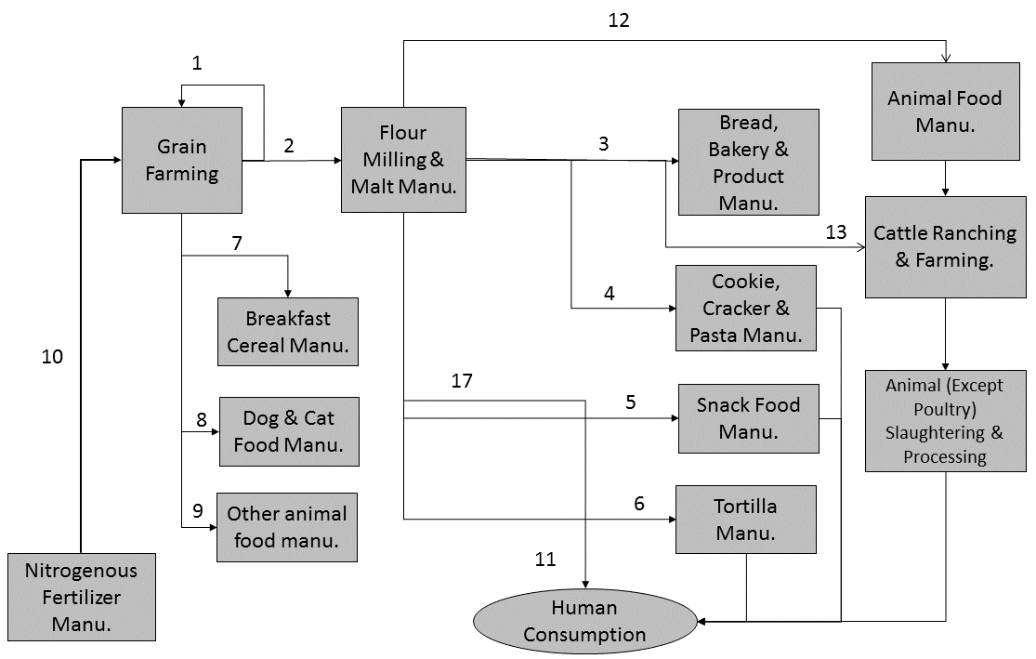
  - Wheat Flow Calculations
Figure 4: Wheat Flow Diagram

Table 7 : Flows for Wheat PIOT
Flow Number | From | To | Description | Data Source | Values (Original Unit) | Values (N) (Metric tons)
1 | Grain farming | Grain farming | Seed for Wheat farming (Produced in Grain farming sector) | Calculated Bases on  Economic Research Service, USDA Dataset (\cite{USDASeedReport}) | 4.82E+07 pound | 4.20E+02
2 | Grain farming | Flour Milling & Malt Manu. | Wheat for Milling | Calculated | 1.49E+07 bushels | 1.01E+04
3 | Flour Milling & Malt Manu. | Bread Bakery & Product Manu. | Wheat Flour for Bread Manu. | Calculated | 2.91E+08 (pounds of floor) | 2.89E+03
4 | Flour Milling & Malt Manu. | Cookie, Cracker & Past Manu. | Wheat for Product Manu. | Calculated | 9.70E+07 (pounds of flour) | 9.64E+02
5 | Flour Milling & Malt Manu. | Snack food manu. | Wheat flour for Snack Manu. | Calculated | 1.48E+08 (pounds of flour) | 1.47E+03
6 | Flour Milling & Malt Manu. | Tortilla Manu. | Wheat flour for Tortilla Manu. | Calculated | 1.83E+07  (pounds of flour) | 1.82E+02
7 | Grain Farming | Breakfast Cereal Manu. | Wheat grains used for breakfast cereal | Calculated | 2.73E+05 (bushels) | 1.86E+02
8 | Grain Farming | Dog & Cat food manu. | Wheat for Dog & Food Manu. | Calculated | 3.24E+05 (bushels) | 2.20E+02
9 | Grain Farming | Other animal food manu. | Wheat for other animal food manu. | Calculated | 8.52E+05 (bushels) | 5.80E+02
10 | Nitrogenous Fertilizer Manu. | Grain Farming | Nitrogen fertilizer applied to wheat farming | ERS USDA | 5.97E+07  (pounds) | 2.71E+04
11 | Flour milling & malt manu. | Human Consumption | Flour being consumed instate |  | 2.72E+04 (grounds of flour) | 2.70E+01
12 | Flour Milling & Malt Manu. | Other Animal Food manu | Byproducts such as Millfeed, Wheat mill run and wheat midlings being used for livestock food manu | This has not been included in the PIOT as the data was not available. | NA
13 | Flour Milling & Malt Manu. | Cattle Ranching & Farming | Wheat milling byproducts used for livestock feed without further processing | This has not been included in the PIOT as the data was not available
14 | Grain farming | Exports | Export of wheat grains out f state |  | 1450.4 (thousand tons) | 2.78E+04
15 | Grain farming | Imports | Import of wheat grain from other regions (cross trading commodity) |  | 1515.8 (thousand tons) | 2.91E+04
16 | Flour milling and manufacturing | Exports | Export of flour from the state |  | 1057.275 (thousand tons) | 2.32E+01
17 | Flour milling and manufacturing | Consumption | Consumption of wheat flour within state |  | 2.72E+04 (pounds of flour) | 2.70E-01
18 | Flour milling and manu. | Imports | Import of flour from other regions |  | 979.402 (thousand tons) | 2.15E+01

Assumptions for Calculation of Flows
    - Wheat Seed Consumption: The rate of seed used in 2002 was assumed same as rate of seed used in 1997 since the yields of these years were not very different and data for 2002 was not available.
Seeding Rate = 73 pounds/acre
Acres planted = 660,000 acres (NASS)
Total Seed Used = 4.82E+07 pounds
    - Wheat Fertilizer Consumption
Pounds/acre of N Fertilizer in 2002 = 90.5 (Source: ERS USDA by interpolation of 2001 and 2003 data)
Acres Planted in 2002 in Illinois = 660,000 (Source: NASS)
Total Fertilizer Used in Illinois for Wheat (2002) = 5.97E+07 pounds of N
    - Total Wheat Consumption in Illinois (2002) : 1.72E+09 pounds
    - Flow from Grain Farming to “Flour Milling & Malt Manu” in Illinois: This flow value was calculated by scaling down the flow of national scale Flour Milling by the share of Illinois.
- Total Wheat Milled in US for Flour (2002): 212,609 of 1000 grain-equivalent bushels (Source : \cite{ERSWheatFlourConsumption}, USDA ERS Datasheet on Wheat Food Use by Component.
- % of Wheat Milling for Flour activity Allocated to Illinois = 7 %
The calculation is based on the total cost of materials that goes to the Flour Miiling sector at the national scale or state of Illinois. The data in the table below is from Manufacturing Industry Survey series.

Economic Data Comparison For NAICS Sector (Flour Milling) for Illinois vs US
2002
Geographic Area Name | 2002 NAICS Code | Meaning of 2002 NAICS Code | Total Cost of materials ($1,000) | Production Workers hourse ($1,000) | Number of employees
Illinois | 311211 | Flour Milling | 377,033 | 1,441 | 912
United States | 311211 | Flour Milling | 4,922,509 | 18,375 | 11,636
 | Ratio |  | 0.076 | 0.078 | 0.078

- Wheat Milled in Illinois = 0.07 * 212,609 = 14882.63 (1000 grain-equivalent bushels) = 1.49E+07 bushels
- Conversion to Pounds of Flour :
- 1 bushel = 43.8 pounds of floor
- Wheat Milled in Illinois = 6.52E+08 pounds of floor being produced

    - Flow from Grain Farming to Sectors other than “Flour Milling and Manufacturing”:
It is assumed that about 90 % of wheat grain bushels used in domestic markets are used in “Flour Milling and Manufacturing” sectors [1]. The rest 10 % are distributed among sectors such as: “Breakfast Cereal Manufacturing”, “Dog & Cat Food Manufacturing” and “Other Animal Food Manufacturing”. The distribution of 10 % of bushels of grain that are consumed within the state to these 3 sectors are based on % used in various industries obtained from report [1]. This was the best data available to calculate the distribution of wheat in other sectors, however this data is a bit old.
- Wheat grains Used in State = 1.49E+07/0.9 = 1.65E+07 bushels of wheat
- Wheat grains used for Breakfast Cereal : (1.65/100) x 1.65E+07 = 2.73E+05 bushels of wheat
- Wheat grains used for Dog & Cat Food Manu. : (1.96/100) x 1.65E+07 = 3.24E+05 bushels of wheat
- Wheat grains used for “Other Animal Food Manu.” : (5.15/100) x 1.65E+07 = 8.52E+05 bushels of wheat

Calculation of Wheat Going to Other Sectors for Illinois
Assumption = 90 % of Wheat grain Used in Domestic Markets is Used in “Flour Milling and Malt Manu.”
Wheat Grains Used in “Breakfast Cereal Manufacturing” | 2.73E+05 bushels
Wheat Grains Used in “Dog & Cat Food Manu.” | 3.24E+05 bushels
Wheat Grains Used in “Other Animal Food Manu.” | 8.52E+05 bushels
    - Flow from “Flour Milling & Malt Manu” to Other sectors:
These flow values are calculated based on distribution of flour being processed for different use. This is described in the report on “The U.S. Milling and Baking Industries” (Harwood, Leath and Heid 2010). About 15 % of the flour being produced in Illinois is sold directly to consumers whereas, 85 % is being used in industries to produce consumer goods such as bakery, tortilla etc.
Flour Sold Directly to Consumers: (15/100) X 6.52E+08 = 9.78E+07 Pounds of flour
Flour Processed in Industries: (85/100) x 6.52E+08 = 5.54E+08 pounds of flour
Further, about 70 % of flour being used in Industries is used by the “Wholesale Bakery” sector ad 30 % is used in “Breakfast Cereal and Other Producers”.
Distribution of Flour Processes to Different Product Categories
Industry Sector Use of Flour | % of Use | Amount Used (Pounds of Flour)
Wholesale Bakery Use | 70 | 3.88E+08
Breakfast Cereal/Other Producers | 30 | 1.66E+08

Distribution of Flour Used in Wholesale Bakery Use
Industrial Use | Pounds of Flour
Bread and Cake Manufacturing | 2.91E+08
Cookie & cracker Manufacturing | 9.70E+07

Distribution of Flour Processed in Breakfast, Cereal etc.
Sector | Total cost of materials ($1,000) | % of total input as materials (assuming same price of flour for both) | Flour Input (pounds of flour)
Tortilla manufacturing | 35,789 | 0.11 | 1.83E+07
Snack food manufacturing | 289,504 | 0.89 | 1.48E+08
Table 8: Wheat Data and Sources
Data | Source | Year | Use in PIOT | Value
Wheat production in Illinois (Bushels) | NASS Census | 2002 | Not directly used | 2.79E+07
Wheat Acres Planted | NASS Census | 2002 | Used for calculation of N fertilizer inputs | 660,000
Per capita Wheat Consumption | Economic Research Service (USDA) – Wheat Supply & Use Data | 2002 | Used for calculation of Wheat consumption in Illinois | 136.9 pounds/person
Illinois State Population in 2002 |  | 2002 | Use for calculation of total wheat consumption in Illinois | 12,586,447
Seeding Rate | USDA-ERS Seed Report | 2002 | Used for calculation of seed used in Illinois | 73 pounds/acre (The seeding rate is for winter wheat since Illinois mainly grows winter wheat)

3 : Import and Export Calculations:
State scale import and export data were not directly reported, however reliable data for national scale export and import of commodities was available. To scale the national scale import to state scale we made an assumption that the share of import are in proportion to disposable income of states. This data is available from Bureau of Economic Analysis (BEA).
FIPS | Area | Description | 2002
00000 | US | Disposable personal income (thousands of dollars) | 8.01E+09
00000 | US | Population | 2.88E+08
00000 | US | Per capita disposable personal income (dollars) | 2.78E+04
17000 | Illinois | Disposable personal income (thousands of dollars) | 3.72E+08
17000 | Illinois | Population | 1.25E+07
17000 | Illinois | Per capita disposable personal income (dollars) | 2.97E+04
Source: BEA , https://www.bea.gov/iTable/
Import of Commodities to Illinois: The import to a state is calculated by using the ratio of disposable income of state population to the disposable income of the whole country.
$${Food Import}_{State} = {Total Import}_{US} × \frac{{Disposable Income}_{State}}{{Disposable Income}_{US}}$$
Commodity | Unit | Value | Year | Source | Scale
Source : http://usda01.library.cornell.edu/usda/waob/wasde//2000s/2002/wasde-12-10-2002.pdf
Beef | million pounds | 3218 | 2002 | WASDE /1 | US
Pork | million pounds | 1070 | 2002 | WASDE /2 | US
Broilers | million pounds | 12 | 2002 | WASDE /3 | US
Turkeys | million pounds | 1 | 2002 | WASDE /4 | US

Commodity | Unit | Value | Year | Source | Scale
Source : http://usda.mannlib.cornell.edu/MannUsda/viewDocumentInfo.do?documentID=1564
Fresh Sweet Corn | pounds | 52,106,295 | 2002 | ERS/USDA | US
Canned Sweet Corn | pounds | 42,014,881 | 2002 | ERS/USDA | US
Frozen Sweet Corn | pounds | 29557470.00 | 2002 | ERS/USDA | US
Sweet corn planting seed | pounds | 614,902 | 2002 | ERS/USDA | US

Import Estimation for State of Illinois: By Calculation
Commodity | Unit | Value | Year | Source | Scale
Beef | million pounds | 1.50E+02 | 2002 | Estimated | Illinois State
Pork | million pounds | 4.98E+01 | 2002 | Estimated | Illinois State
Broilers | million pounds | 1.55E+01 | 2002 | Estimated | Illinois State
Turkeys | million pounds | 4.65E-02 | 2002 | Estimated | Illinois State

Commodity | Unit | Value | Year | Source | Scale
Fresh Sweet Corn | pounds | 2.42E+06 | 2002 | Estimated | Illinois State
Canned Sweet Corn | pounds | 1.95E+06 | 2002 | Estimated | Illinois State
Frozen Sweet Corn | pounds | 1.38E+06 | 2002 | Estimated | Illinois State

4: Emissions Data
The emissions data included in the PIOT are mainly farm scale emissions for corn, soybean and wheat corresponding to the major feedstocks included in development of PIOT. The soybean and wheat emissions data were obtained from EPIC model using FEST-C v1 for Illinois. The variables included in the model output for emissions are YON, Q-NO3 and AVOL with explanations provided in table below.
Variable | Explanation/Interpretations
YON (Kg-N) | Rate of Organic N Sediment loss (Kg/ha). It was processed to get total organic sediment loss for the crops included in PIOT.
Q-NO3 | Amount of NO3-N lost from the soil profile by run-off and leaching (Kg/ha). It was also processed to get total NO3-N lost for each of the crop based on the area planted.
AVOL | Mass of N volatilized (Kg-N). This value was directly provided from the model run by Cooter et al.

Data From EPIC Model (produced using FEST-C v1, Cooter et al, 2012)
Table 9 : Average Annul Emissions Soybean and Winter Wheat Farming in Illinois
Soybean | YON (Kg-N) | Q-NO3 (Kg-N) | AVOL (Kg-N)
Soybean_Irrigated | 6.77E+02 | 5.95E+04 | 3.42E+02
Soybean_RainFed | 1.38E+05 | 8.65E+06 | 1.23E+03
Total (Kg-N) | 1.38E+05 | 8.71E+06 | 1.57E+03
Total (metric tons) | 1.38E+02 | 8.71E+03 | 1.57E+00

Winter-Wheat | YON (Kg-N) | Q-NO3 (Kg-N) | AVOL (Kg-N)
Winter-Wheat_Rainfed | 1.84E+04 | 1.12E+06 | 1.63E+03
Winter_Wheat_Irrigated | 5.02E-01 | 1.28E+02 | 3.94E+01
Total (Kg-N) | 1.84E+04 | 1.1E+06 | 1.7E+03
Total (metric tons) | 1.84E+01 | 1.12E+03 | 1.67E+00

Emissions from Corn Farming : The corn farming emissions were obtained from literature source [ (Ogle, et al. 2008)] and SPARROW model (Alexander, et al. 2008). The nitrous oxide (N2O) emissions from land is directly based on field observations. The water run-off from the applied fertilizer
5 : Miscellaneous Data
Table 10 : Conversion of Flows in PIOT to N (Only Soybean Shown for Example)
Variable | Flow From Sector | Flow to Sector | Original Value | Original Unit | N Flow Value | Unit
Soybean Used for Crushing | Oilseed Farming | Soybean and other oilseed processing | 273 | Million Bushels | 9.03E+08 | Lbs of N
Soybean Used for Seeds | Oilseed Farming | Oilseed farming | 12.607 | Million Bushels | 4.17E+07 | Lbs of N
Soybean export | Oilseed farming |  | 187
Beg Stocks
End Stocks
Soybean Meal Production | Soybean and other oilseed processing sector |  | 12121.2 | Million lbs | 8.53E+08 | Lbs of N
Soybean meal consumption by Beef Production | Other animal food manu. | Cattle Ranching | 24.30172 | 1000 tons | 1.71E+00 | 1000 tons of N
Soybean meal consumption by milk production cattle | Other animal food manu. | Cattle ranching | 22.32751 | 1000 tons | 1.57E+00 | 1000 tons of N
Soybean meal consumption by pork producing hogs | Other animal food manu. | Hog & Pig farming | 624.7002 | 1000 tons | 4.40E+01 | 1000 tons of N
Soybean meal consumption by poultry | Other animal food manu. | Poultry & Egg Production. | 40.07408 | 1000 tons | 2.82E+00 | 1000 tons of N
Export of Soybean meal | Soybean processing |  | 5736 | 1000 tons | 4.04E+02 | 1000 tons of N
Soybean meal sent to animal food manu. Within state | Soybean processing | Other animal food manu. | 792 | 1000 tons | 5.58E+01 | 1000 tons of N
Export of Soymeal from animal food manu. | Other animal food manu. |  | 80.59 |  | 5.67
Nr fertilizer input to soybean farming | Nitrogenous fertilizer manu. | Oilseed farming | 2.10E+08 | Pounds of Nr | 2.10E+08 | Pounds of Nr

Table 11 : Conversion Factors to Convert Flows to Nitrogen
Variable | Value | Unit | Source
N Harvested in Soybean | 1.52 * (# of bushels) | kgN/bushel | (David, Drinkwater and McIsaac 2010)
Protein Concentration of Hybrid Corn in 1985 | 10 %
Protein Concentration of Hybrid Corn in 2006 | 8.50 %
% N Content of Corn Grain | 6.34 % |  | (Salvagiotti, et al. 2008)
Moisture Content of Bushel of Soybean (at weight 60 lb) | 13 % |  | http://ohioline.osu.edu/agf-fact/0502.html
Soybean meal for swine – regular : protein concentration | 44 % |  | Soybeanmeal-thegoldstandard.pdf, by Gary L. Cromwell, Professor, Swine Nutrition (Published in The Farmer’s Pride, KPPA News, Vol.11, No. 20, 1999)
Dehulled Soybean meal : protein concentration | 48 % |  | Soybeanmeal-thegoldstandard.pdf, by Gary L. Cromwell, Professor, Swine Nutrition (Published in The Farmer’s Pride, KPPA News, Vol.11, No. 20, 1999)
Wheat-flour, whole grain | 13.7 | Gm protein/100 gm of wheat | http://en.wikipedia.org/wiki/Wheat_flour
Bushel of Wheat | 1.5 | lbsN/bushel | (Clay and Carlson 2011)
Wheat grain used as seed | 12 | % protein | (Smika and Greb 1973)

Table 12 : N Fertilizer Input to Major Crops (Calculations Shown Earlier)
Crop | N Fertilizer Input
Corn | 7.73E+05
Wheat | 2.71E+04
Soybean | 9.53E+04

Table 13 : Sectors in N-PIOT And Description
Sectors (NAICS) | Description of Sector Activities
Oilseed farming | Soybean farming and other oilseed crop farming. For Illinois, Soybean farming dominates in this sector.
Soybean and Other Oil Seed Processing | Industrial activity involved in processing soybean and other oilseed for conversion into products like soymeal, soyoil, animal feed etc.
Corn Farming | Mostly corn farming.
Wet Corn Milling | Industrial establishments that produce mostly starch, syrup, oil and byproducts such as gluten feed and meal by wet milling of corn and sorghum. In Illinois, it was mainly corn wet milling.
Dry Corn Milling | Dry corn milling is mainly used to produce ethanol.
Wheat Farming | Farming activities growing wheat.
Flour Milling & Malt Manu. | Industries involved in processing wheat for conversion to other products or sale to food manufacturing industry.
Other Animal Food Manu. | Industries involved in food manufacturing for cattle, hogs etc.
Dog & Cat Food Manu. | Industries involved in food manufacturing for pets.
Cattle Ranching & Farming | Livestock farming industry.
Animal Production Except Cattle & Poultry Eggs | Hog, Pig, Sheep, Goat farming industry.
Poultry & Egg Production | Poultry farming industry.
Poultry Processing | Industry engaged in poultry slaughtering and preparing processed poultry and small game meat/meat byproducts.
Animal (Except Poultry) Slaughtering & Processing | Industry engaged in slaughtering and preparing processed meat from hog, pig, cow etc.
Nitrogenous Fertilizer Manu. | Fertilizer manufacturing industry
Bread, bakery and product manu. | Food manufacturing industry of bread etc.
Cookie, cracker and pasta manu. | Food manu.
Snack food manu. | Snack food.
Tortilla manu. | Tortilla manufacturing from wheat flour, corn flour etc.
Breakfast cereal manu. | Cereal manufacturing industry
Frozen food manu. | Industry involved in freezing food such as sweet corn, meat etc.
Vegetable and fruit canning & drying | Industries involved in preparing canned and dried food for distribution.

Table 14: Full Balanced PIOT for N Flows in Illinois (Metric Tons of N)
Note: Grey Cells represent flows in between sectors, i.e. the structural N flows between sectors in Illinois Economy
Red cells represent assumed flow for balancing. Notice that the assumed flows are out of structural flows within the economy
 |  |  |  |  | Oilseed Farming |  | Soybean & Other Oil-Seed Processing |  |  |  | Corn Farming |  |  | Wet Corn Milling |  |  | Dry Corn Milling
 | Soybean Farming & Processing |  | Oilseed Farming |  | 1.89E+04 |  | 4.10E+05
 |  |  | Soybean & Other Oil Seed Processing
 | Corn Farming & Processing |  | Corn Farming |  |  |  |  |  |  |  | 1.60E+01 |  |  | 3.03E+04 |  |  | 4.53E+04
 |  |  | Wet Corn Milling
 |  |  | Dry Corn Milling
 | Wheat Farming & Processing |  | Wheat Farming
 |  |  | Flour Milling & Malt Manu.
 | Animal Food Manu. |  | Other Animal Food Manu.
 |  |  | Dog & Cat Food Manu.
 | Livestock & Poultry Farming |  | Cattle Ranching & Farming
 |  |  | Animal Prod. Except Cattle & Poultry Eggs
 |  |  | Poultry & Egg Production
 | Meat Production (Food Processing) |  | Poultry Processing
 |  |  | Animal (Except Poultry) Slaughtering & Processing
 | Chemical Manu. |  | Nitrogenous Fertilizer Manu. |  | 9.53E+04 |  |  |  |  |  | 7.73E+05
 | Food Manufacturing |  | Bread, Bakery & Product Manu.
 |  |  | Cookie, Cracker & Pasta Manu.
 |  |  | Snack Food Manu.
 |  |  | Tortilla Manu.
 |  |  | Breakfast Cereal Manu.
 |  |  | Frozen food manu.
 |  |  | Vegetable & fruit canning drying
 | Ram Materials  (New N Input) |  | Nr fixation by Soybean |  | 3.49E+05
 |  |  | Industrial Nr fixation
 |  |  | Free Soil Microorganisms Nr fixation
 | Supply of Residuals |  | Plant Residuals
 |  |  | Food Residuals |  |  |  |  |  |  |  |  |  |  | -6.08E+03 |  |  | -1.98E+03
 |  |  | Packaging Residuals
 |  |  | Sewage
 |  |  | Manure
 | Use of Residuals |  | Plant Residuals
 |  |  | Food Residuals
 |  |  | Sewage
 |  |  | Manure |  | 6.56E+04
 | Stock Changes |  | Beg Stocks |  | 5.10E+04 |  | 4.98E+04
 |  |  | End Stocks |  | -4.05E+04
 | Emissions to Nature |  | Air Emissions |  | -1.57E+00 |  | -4.66E+02 |  |  |  | -4.17E+04
 |  |  | Water Emissions |  | -8.71E+03 |  |  |  |  |  | -1.27E+05
 |  |  | Land Emissions |  | -1.38E+02
 |  |  | Total N Inputs to Each Sector |  | 5.30E+05 |  | 4.60E+05 |  |  |  | 6.04E+05 |  |  | 2.42E+04 |  |  | 4.33E+04
Table 2: Full N PIOT Continued….
 |  |  |  |  | Wheat Farming | Flour Milling & Malt Manu. |  |  |  | Other Animal Food Manu. |  |  | Dog & Cat Food Manu. |  | Cattle Ranching & Farming
Soybean Farming & Processing |  |  | Oilseed Farming
 |  |  | Soybean & Other Oil Seed Processing |  |  |  |  |  |  | 5.58E+04
Corn Farming & Processing |  |  | Corn Farming
 |  |  | Wet Corn Milling |  |  |  |  |  |  | 2.42E+04
 |  |  | Dry Corn Milling |  |  |  |  |  |  | 4.33E+04
Wheat Farming & Processing |  |  | Wheat Farming |  | 4.20E+02 | 1.01E+04 |  |  |  | 5.80E+02 |  |  | 2.20E+02
 |  |  | Flour Milling & Malt Manu.
Animal Food Manu. |  |  | Other Animal Food Manu. |  |  |  |  |  |  |  |  |  |  |  | 3.28E+03
 |  |  | Dog & Cat Food Manu.
Livestock & Poultry Farming |  |  | Cattle Ranching & Farming
 |  |  | Animal Prod. Except Cattle & Poultry Eggs
 |  |  | Poultry & Egg Production
Meat Production (Food Processing) |  |  | Poultry Processing
 |  |  | Animal (Except Poultry) Slaughtering & Processing
Chemical Manu. |  |  | Nitrogenous Fertilizer Manu. |  | 2.71E+04
Food Manufacturing |  |  | Bread, Bakery & Product Manu.
 |  |  | Cookie, Cracker & Pasta Manu.
 |  |  | Snack Food Manu.
 |  |  | Tortilla Manu.
 |  |  | Breakfast Cereal Manu.
 |  |  | Frozen food manu.
 |  |  | Vegetable & fruit canning drying
Ram Materials  (New N Input) |  |  | Nr fixation by Soybean
 |  |  | Industrial Nr fixation
 |  |  | Free Soil Microorganisms Nr fixation
Supply of Residuals |  |  | Plant Residuals
 |  |  | Food Residuals
 |  |  | Packaging Residuals
 |  |  | Sewage
 |  |  | Manure
Use of Residuals |  |  | Plant Residuals
 |  |  | Food Residuals
 |  |  | Sewage
 |  |  | Manure
Stock Changes |  |  | Beg Stocks
 |  |  | End Stocks
Emissions to Nature |  |  | Air Emissions |  | -1.67E+00
 |  |  | Water Emissions |  | -1.12E+03
 |  |  | Land Emissions |  | -1.84E+01
 |  |  | Total N Inputs to Each Sector |  | 2.64E+04 | 1.01E+04 |  |  |  | 1.24E+05 |  |  | 2.20E+02 |  | 3.28E+03
Table 2: Full N PIOT Continued….
 |  |  |  | Animal Prod. (Except Cattle & Poultry Eggs) |  |  |  | Poultry & Egg Prod. | Poultry Process. |  |  | Animal (Except Poultry) Slaughtering & Processing |  |  |  | Nitrogenous Fertilizer Manu.
Soybean Farming & Processing |  | Oilseed Farming
 |  | Soybean & Other Oil Seed Processing
Corn Farming & Processing |  | Corn Farming
 |  | Wet Corn Milling
 |  | Dry Corn Milling
Wheat Farming & Processing |  | Wheat Farming
 |  | Flour Milling & Malt Manu.
Animal Food Manu. |  | Other Animal Food Manu. |  | 4.40E+04 |  |  |  | 2.82E+03
 |  | Dog & Cat Food Manu.
Livestock & Poultry Farming |  | Cattle Ranching & Farming |  |  |  |  |  |  |  |  |  | 3.28E+03
 |  | Animal Prod. Except Cattle & Poultry Eggs |  |  |  |  |  |  |  |  |  | 4.40E+04
 |  | Poultry & Egg Production |  |  |  |  |  |  | 2.82E+03
Meat Production (Food Processing) |  | Poultry Processing
 |  | Animal (Except Poultry) Slaughtering & Processing
Chemical Manu. |  | Nitrogenous Fertilizer Manu.
Food Manufacturing |  | Bread, Bakery & Product Manu.
 |  | Cookie, Cracker & Pasta Manu.
 |  | Snack Food Manu.
 |  | Tortilla Manu.
 |  | Breakfast Cereal Manu.
 |  | Frozen food manu.
 |  | Vegetable & fruit canning drying
Ram Materials  (New N Input) |  | Nr fixation by Soybean
 |  | Industrial Nr fixation |  |  |  |  |  |  |  |  |  |  |  |  |  | 8.95E+05
 |  | Free Soil Microorganisms Nr fixation
Supply of Residuals |  | Plant Residuals
 |  | Food Residuals
 |  | Packaging Residuals
 |  | Sewage
 |  | Manure
Use of Residuals |  | Plant Residuals
 |  | Food Residuals
 |  | Sewage
 |  | Manure
Stock Changes |  | Beg Stocks
 |  | End Stocks
Emissions to Nature |  | Air Emissions
 |  | Water Emissions
 |  | Land Emissions
 |  | Total N Inputs to Each Sector |  | 4.40E+04 |  |  |  | 2.82E+03 | 2.82E+03 |  |  | 4.73E+04 |  |  |  | 0

Table 2: Full N PIOT Continued….
 |  | Bread, Bakery & Product Manu. | Cookie, Cracker & Pasta Manu. | Snack Food Manu. | Tortilla Manu. | Breakfast Cereal Manu.
Soybean Farming & Processing | Oilseed Farming
 | Soybean & Other Oil Seed Processing
Corn Farming & Processing | Corn Farming
 | Wet Corn Milling
 | Dry Corn Milling
Wheat Farming & Processing | Wheat Farming |  |  |  |  | 1.86E+02
 | Flour Milling & Malt Manu. | 2.89E+03 | 9.64E+02 | 1.47E+03 | 1.82E+02
Animal Food Manu. | Other Animal Food Manu.
 | Dog & Cat Food Manu.
Livestock & Poultry Farming | Cattle Ranching & Farming
 | Animal Prod. Except Cattle & Poultry Eggs
 | Poultry & Egg Production
Meat Production (Food Processing) | Poultry Processing
 | Animal (Except Poultry) Slaughtering & Processing
Chemical Manu. | Nitrogenous Fertilizer Manu.
Food Manufacturing | Bread, Bakery & Product Manu.
 | Cookie, Cracker & Pasta Manu.
 | Snack Food Manu.
 | Tortilla Manu.
 | Breakfast Cereal Manu.
 | Frozen food manu.
 | Vegetable & fruit canning drying
Ram Materials  (New N Input) | Nr fixation by Soybean
 | Industrial Nr fixation
 | Free Soil Microorganisms Nr fixation
Supply of Residuals | Plant Residuals
 | Food Residuals
 | Packaging Residuals
 | Sewage
 | Manure
Use of Residuals | Plant Residuals
 | Food Residuals
 | Sewage
 | Manure
Stock Changes | Beg Stocks
 | End Stocks
Emissions to Nature | Air Emissions
 | Water Emissions
 | Land Emissions
 | Total N Inputs to Each Sector | 2.89E+03 | 9.64E+02 | 1.47E+03 | 1.82E+02 | 1.86E+02
 | Table 2: Full N PIOT Continued….
 |  | Frozen Food Manu. | Vegetable & Fruit Canning & drying | Exports | Consumption | Imports | Total Outputs
Soybean Farming & Processing | Oilseed Farming |  |  | 2.81E+05 |  | 1.79E+05 | 5.30E+05
 | Soybean & Other Oil Seed Processing |  |  | 4.04E+05 |  |  | 4.60E+05
Corn Farming & Processing | Corn Farming | 2.55E+02 | 2.14E+02 | 5.28E+05 | 2.47E+02 |  | 6.04E+05
 | Wet Corn Milling |  |  |  |  |  | 2.42E+04
 | Dry Corn Milling |  |  |  |  |  | 4.33E+04
Wheat Farming & Processing | Wheat Farming |  |  | 2.78E+04 | 1.61E+04 | 2.91E+04 | 2.64E+04
 | Flour Milling & Malt Manu. |  |  | 4.64E+03 | 2.70E-01 | 2.15E+01 | 1.01E+04
Animal Food Manu. | Other Animal Food Manu. |  |  | 7.38E+04 |  |  | 1.24E+05
 | Dog & Cat Food Manu. |  |  |  | 2.20E+02 |  | 2.20E+02
Livestock & Poultry Farming | Cattle Ranching & Farming |  |  |  |  |  | 3.28E+03
 | Animal Prod. Except Cattle & Poultry Eggs |  |  |  |  |  | 4.40E+04
 | Poultry & Egg Production |  |  |  |  |  | 2.82E+03
Meat Production (Food Processing) | Poultry Processing |  |  |  | 2.82E+03 |  | 2.82E+03
 | Animal (Except Poultry) Slaughtering & Processing |  |  |  | 4.73E+04 |  | 4.73E+04
Chemical Manu. | Nitrogenous Fertilizer Manu. |  |  |  |  |  | 8.95E+05
Food Manufacturing | Bread, Bakery & Product Manu. |  |  |  | 2.89E+03 |  | 2.89E+03
 | Cookie, Cracker & Pasta Manu. |  |  |  | 9.64E+02 |  | 9.64E+02
 | Snack Food Manu. |  |  |  | 1.47E+03 |  | 1.47E+03
 | Tortilla Manu. |  |  |  | 1.82E+02 |  | 1.82E+02
 | Breakfast Cereal Manu. |  |  |  | 1.86E+02 |  | 1.86E+02
 | Frozen food manu. |  |  |  | 2.55E+02 |  | 2.55E+02
 | Vegetable & fruit canning drying |  |  |  | 2.14E+02 |  | 2.14E+02
Ram Materials  (New N Input) | Nr fixation by Soybean
 | Industrial Nr fixation
 | Free Soil Microorganisms Nr fixation
Supply of Residuals | Plant Residuals
 | Food Residuals
 | Packaging Residuals
 | Sewage
 | Manure
Use of Residuals | Plant Residuals
 | Food Residuals
 | Sewage
 | Manure
Stock Changes | Beg Stocks
 | End Stocks
Emissions to Nature | Air Emissions
 | Water Emissions
 | Land Emissions
 | Total N Inputs to Each Sector | 2.55E+02 | 2.14E+02

References
Alexander, Richard B., Richard A. Smith, Gregory E. Schwarz, Elizabeth W. Boyer, Jacqueline V. Nolan, and John W. Brakebill. 2008. "Difference in Phoshphorus and Nitrogen Delivery to The Gulf of Mexico from the Mississippi River Basin." Environmental Science and Technology 42: 822-830.
Clay, D.E., and C.G. Carlson. 2011. "Estimating nutrient removal in wheat grain and straw." In iGrow Wheat : Beast Management Practices for Wheat Production in South Dakota, by D.E. Clay, C.G. Carlson and K. Dalsted. Brookins: South Dakota Cooperative Extension Service.
David, Mark B., Laurie E. Drinkwater, and Gregory F. McIsaac. 2010. "Sources of Nitrate Yields in the Mississippi River Basin." J. Environ. Qual. 39: 1657-1667.
Harwood, Joy L., Mack N. Leath, and Walter G. Heid. 2010. The U.S. Milling and Baking Industries. Agricultural Economic Report Number 611, USDA, Economic Research Service.
Ogle, Stephen M, Stephen J Del Grosso, Paul R Adler, and William J. Parton. 2008. "Soil Nitrous Oxide Emissions with Crop Production for Biofuel: Implications for Greenhouse Gas Mitigation." Edited by Joe L. Outlaw and David P Ernstes. The Life Cycle Carbon Footprint of Biofuels. Florida.
Salvagiotti, F., K.G. Cassman, J.E. Specht, D.T Walters, and A. Weiss. 2008. Nitrogen Update, fixation and response to fertilizer N in soybeans : A review . Faculty Publications, University of Nebraska, Agronomy & Horticulture. http://www.mssoy.org/uploads/files/nebraska-n-review-2008-ok.pdf.
Smika, D.E., and B.W. Greb. 1973. "Protein Content of Winter WHeat Grain as Related to Soil and Climatic Factors in the Semiarid Central Great Plains." Agronomy 65: 433-436.

