Table and Figure Captions

Table 1. Physical, chemical and microbiological water quality guidelines (USEPA) and criteria (CA Title 22, Western Australia) for water reuse
Table 2. Physical, chemical and microbiological water quality of typical wastewater streams and reviewed treatment systems.
Table 3a. GW treatment wetland characteristics and physical/chemical treatment performance
Table 3b. GW treatment wetland pathogen treatment performance¹
Table 4a. GW disinfection technology characteristics and physical/chemical parameters
Table 4b. GW disinfection technology pathogen treatment performance¹

Figure 1. Effluent concentration data as a function of hydraulic retention time (HRT), including any applicable reuse criteria, a) BOD, b) TSS, c) Turbidity
Figure 2. Comparison of GW wetland BOD (a) and TSS (b) performance with NADB datasets
Figure 3. Log(effluent concentration) of total coliform (TC), fecal coliform (FC) and E. coli as a function of HRT (a, b, c) and log(influent concentration) (d, e, f)
Figure 4. Effluent concentrations and log reductions from greywater chlorination studies
Figure 5. Effluent concentrations and log reductions from greywater chlorination studies

Table 1. Physical, chemical and microbiological water quality guidelines (USEPA) and criteria (CA Title 22, Western Australia) for water reuse
Parameter |  | units⁽¹⁾ | US EPA* |  |  | California Title 22** |  | Western Australia***
 |  |  | Unrestricted | Restricted | Environmental | Unrestricted | Restricted | Subsurface Irrigation | Surface Irrigation | Toilet Flushing
Water Quality Parameters
 | pH |  | 6.0-9.0 | 6.0-9.0
 | TSS | mg/L |  | ≤30 | ≤30 |  |  | <30 | <30
 | BOD | mg/L | ≤10⁽²⁾ | ≤30⁽²⁾ | ≤30⁽²⁾ |  |  | <20 | <20 | <10
 | Turbidity | NTU | ≤2⁽³⁾ |  |  | ≤2⁽¹⁰⁾
Pathogen Criteria
 | Total Coliform | MPN/100mL |  |  |  | 2.2⁽¹¹⁾ | 23⁽¹³⁾
 | Fecal Coliform | CFU/100mL | ND^{(4,5)} | ≤200^{(4,8,9)} | ≤200^{(4,8,9)}
 | E. Coli | CFU/100mL |  |  |  |  |  |  | <10 | <1
 | Poliovirus or Surroate |  |  |  |  | 5 log inact.^{(7,12)}
Disinfection Parameters
 | UV Disinfection | mJ/cm² |  |  |  | 100
 | Chlorine Residual | mg/L | 1⁽⁶⁾ | 1⁽⁶⁾ | 1⁽⁶⁾
 | Chlorine CT⁶ | (mg/L) - min) | 90⁽⁶⁾ |  |  | 450^{(7,12)}
* | Source: USEPA, 2012
** | Source: CDPH, 2010
*** | Source: NSW, 2008
¹ | Unless otherwise noted
² | As determined from the 5-day BOD test.
³ | The recommended turbidity should be met prior to disinfection. The average turbidity should be based on a 24-hour time period. The turbidity should not exceed 5 NTU at any time. If SS is used in lieu of turbidity, the average SS should not exceed 5 mg/l. If membranes are used as the filtration process, the turbidity should not exceed 0.2 NTU and the average SS should not exceed 0.5 mg/l.
⁴ | Unless otherwise noted, recommended coliform limits are median values determined from the bacteriological results of the last 7 days for which analyses have been completed. Either the membrane filter or fermentation tube technique may be used.
⁵ | The number of total or fecal coliform organisms (whichever one is recommended for monitoring in the table) should not exceed 14/100 ml in any sample.
⁶ | This recommendation applies only when chlorine is used as the primary disinfectant. The total chlorine residual should be met after a minimum actual modal contact time of at least 90 minutes unless a lesser contact time has been demonstrated to provide indicator organism and pathogen reduction equivalent to those suggested in these guidelines. In no case should the actual contact time be less than 30 minutes.
⁷ | After a minimum contact time of 90 minutes
⁸ | Some stabilization pond systems may be able to meet this coliform limit without disinfection
⁹ | The number of fecal coliform organisms should not exceed 800/100 ml in any sample.
¹⁰ | 10 NTU maximum, standards for media filter, membrane filter standards more stringent
¹¹ | 7 day median, not more than one sample to exceed 23 in 30 days, 240 maximum
¹² | Title 22 requires total coliform limit and either proof of viral removal or chlorine dose as given in table
¹³ | 7 day median, not more than one sample to exceed 200 in 30 days

Table 2. Physical, chemical and microbiological water quality of typical wastewater streams and reviewed treatment systems.
 |  |  | Light Greywater^{1,2} | Mixed Greywater^{1,2} | Mixed Wastewater⁴ | Wetland Influent Ranges | Wetland Effluent Ranges | Disinfection Influent Ranges
Parameter |  | Units
Physical and Chemical |  |  |  | '
 | TSS | mg/L | 29-505 | 19-700 | 22-1690 | 4.9-120 | 0.3-52 | 4.0-32
 | BOD | mg/L | 20-240 | 48-1056 | 112-1101 | 20-435 | 1.0-196 | 1.1-62
 | COD | mg/L | 100-633 | 58-2950 | 1329-1650 | 77-646 | 6.0-363 | 17-130
 | Turbidity | NTU | 12.6-240 | 19-444 |  | 15-254 | 0.3-114 | 0.2-35
 | Total Nitrogen |  | 3.6-19.4 | 1.1-74 | 9.0-240 | 5.2-15 | 1.7-14 | 2.8-4.1
 | Total Phosphorus |  | 0.11-48.8 | 0.062-500 | 0.2-32 | 0.8-9.3 | 0.47-5.2
Bacteria and Bacterial Indicators³
 | Total Coliform | CFU/100mL | 1-7.4 | 3.1-8.8 |  | 5.4-8.7 | 0.7-8.3 | 2.0-5.8
 | Fecal Coliform | CFU/100mL | 0-6.9 | 2.0-8.0 | 4.0-8.2 | 3.7-8.0 | 0.0-6.0 | 1.4-5.1
 | Escherichia coli | CFU/100mL | 2.3-5.7 | 3.6-6.7 | 4.0-7.9 | 2.8-6.7 | 0.0-6.4 | 2.6
 | Enterococci | CFU/100mL | 1.9-3.4 | 2.4-4.6 |  | 2.8-3.8 | 0.5-3.3 | 1.8-3.8
 | Pseudomonas aeruginosa | CFU/100mL | 2.6-3.5 | 2.3-4.3 |  | 3.7-6.8 | 0.2-6.0 | 2.1-3.8
 | Staphylococcus aureus | CFU/100mL | 4.0-5.7 | 3.3-5.7 |  | 3.5 | 1.8 | 1.4-1.9
 | Clostridium perfringens | CFU/100mL | 0.66 |  |  | 2.8-3.1 | 0.8-2.6
 | Legionella | CFU/100mL | 2.2 | 2.2-2.9 |  | 5.1 | 3.8-4.4
 | Salmonella | CFU/100mL |  | 3.7 |  | 0.7-1.3
 | MS2-Coliphage | PFU/mL |  |  |  |  |  | 5.6-8.2
¹ | Boyjoo et al., 1013; Friedler et al, 2011; Ghaitidak and Yadav, 2013; Li et al., 2009
² | Light greywater does not include kitchen or laundry waters, mixed greywater does not
³ | log₁₀concentration
⁴ | Lowe 2007; Metcalf, 2003

Table 3a. GW treatment wetland characteristics and physical/chemical treatment performance
ID | Reference | System¹ | HRT (d) | TSS  (mg/l) |  | Turbidity (NTU) |  | COD  (mg/l) |  | BOD  (mg/l) |  | TN  (mg/l) |  | TP  (mg/l)
 |  |  |  | In | Out | In | Out | In | Out | In | Out | In | Out | In | Out
1 | Jokerst et al., 2012 | FWS | 6.8 | 17 | 12 | 31 | 15 | -- | -- | 86 | 32 | 14 | 5.6 | 4.0 | 1.7
2 | Winward et al., 2008a | Green roof water recycle system | 2.1 | 29 | 3.0 | 20 | 0.8 | 87 | 19 | 20 | 2.0 | -- | -- | -- | --
3 | Winward et al., 2008a | Green roof water recycle system | 2.1 | 93 | 20 | 67 | 29 | 495 | 159 | 164 | 80 | -- | -- | -- | --
4 | Dallas and Ho, 2005 | HSSF, PET | 8.5 | -- | -- | -- | -- | -- | -- | 216 | 4.0 | -- | -- | 9.6 | --
5 | Dallas and Ho, 2005 | HSSF, PET | 4.2 | -- | -- | -- | -- | -- | -- | 155 | 13 | -- | -- | -- | --
6 | Dallas and Ho, 2005 | HSSF, PET | 4.8 | -- | -- | -- | -- | -- | -- | 290 | 10 | -- | -- | -- | --
7 | Dallas and Ho, 2005 | HSSF, PET, no plants | 5.6 | -- | -- | -- | -- | -- | -- | 216 | 16 | -- | -- | 9.6 | --
8 | Dallas and Ho, 2005 | HSSF, PET, no plants | 3.3 | -- | -- | -- | -- | -- | -- | 155 | 18 | -- | -- | -- | --
9 | Dallas and Ho, 2005 | HSSF, PET, no plants | 2.9 | -- | -- | -- | -- | -- | -- | 290 | 14 | -- | -- | -- | --
10 | Dallas and Ho, 2005 | HSSF, crushed rock | 5.1 | -- | -- | -- | -- | -- | -- | 216.0 | 7.0 | -- | -- | 9.6 | --
11 | Dallas and Ho, 2005 | HSSF, crushed rock | 2.5 | -- | -- | -- | -- | -- | -- | 155.0 | 18 | -- | -- | -- | --
12 | Dallas and Ho, 2005 | HSSF, crushed rock | 2.9 | -- | -- | -- | -- | -- | -- | 290 | 18 | -- | -- | -- | --
13 | Dallas and Ho, 2005 | HSSF, crushed rock, no plants | 4.6 | -- | -- | -- | -- | -- | -- | 216 | 9.0 | -- | -- | 9.6 | --
14 | Dallas and Ho, 2005 | HSSF, crushed rock, no plants | 2.7 | -- | -- | -- | -- | -- | -- | 155 | 19 | -- | -- | -- | --
15 | Dallas and Ho, 2005 | HSSF, crushed rock, no plants | 2.4 | -- | -- | -- | -- | -- | -- | 290 | 14 | -- | -- | -- | --
16 | Jokerst et al., 2012 | HSSF, native stone | 13 | 12 | 8.0 | 15 | 9.8 | -- | -- | 32 | 13 | 5.6 | 3.0 | 1.7 | 1.3
17 | Laaffat et al., 2015 | HSSF, gravel | 2.5 | 4.9 | 0.3 | -- | -- | 77 | 11 | 44 | 3.5 | 7.1 | 3.9 | 0.8 | 0.5
18 | Paulo et al., 2009 | HSSF, gravel | 1.5 | 120 | 52 | 254 | 114 | 646 | 362 | 435 | 196 | 8.8 | 5.2 | 5.6 | 5.2
19 | Winward et al., 2008a | HSSF, sand/soil/compost | 2.1 | 29 | 9.0 | 20 | 17 | 87 | 29 | 20 | 2.0 | -- | -- | -- | --
20 | Winward et al., 2008a | HSSF, sand/soil/compost | 2.1 | 93 | 34 | 67 | 12 | 495 | 124 | 164 | 57 | -- | -- | -- | --
21 | Alfiya et al., 2013 | RVF | 4.1 | -- | -- | 72 | 6 | 231 | 25 | 166 | 2 | -- | -- | -- | --
22 | Alfiya et al., 2013 | RVF | 5.8 | -- | -- | 61 | 8 | 224 | 30 | 136 | 5 | -- | -- | -- | --
23 | Alfiya et al., 2013 | RVF | 4.2 | -- | -- | 140 | 5 | 598 | 77 | 229 | 3 | -- | -- | -- | --
24 | Blanky et al., 2015 | RVF | 6.1 | -- | -- | -- | -- | -- | -- | -- | -- | -- | -- | -- | --
25 | Gross et al., 2007a | RVF | 1.3 | 158 | 3 | -- | -- | 839 | 157 | 466 | 1 | -- | -- | -- | --
26 | Gross et al., 2007b | RVF | 3.5 | 46 | 3 | -- | -- | 339 | 47 | -- | -- | -- | -- | 1.9 | 0.5
27 | Yu et al., 2015 | RVF | 3.5 | 24 | 1 | 22 | 0 | 128 | 6 | 40 | 1 | -- | -- | -- | --
28 | Yu et al., 2015 | RVF | 3.5 | 35 | 1 | 30 | 1 | 490 | 17 | 152 | 3 | -- | -- | -- | --
29 | Paulo et al., 2009 | VF, gravel/sand | 1.0 | 52 | 10 | 114 | 26 | 362 | 94 | 196 | 27 | 5.2 | 1.7 | 5.2 | 2.3
30 | Winward et al., 2008a | VF, sand/soil/compost | 2.1 | 29 | 2 | 20 | 8 | 87 | 21 | 20 | 1 | -- | -- | -- | --
31 | Winward et al., 2008a | VF, sand/soil/compost | 2.1 | 93 | 10 | 67 | 2 | 495 | 31 | 164 | 5 | -- | -- | -- | --
32 | Jokerst et al., 2012 | FWS + HSSF, native stone | 20 | 17 | 8.0 | 31 | 9.8 | -- | -- | 86 | 13 | 14 | 3.0 | 4.0 | 1.3
33 | Gerba et al., 1995 | FWS, water hyacinth + SF | 6.0 | 40 | 17 | 64 | 3.9 | -- | -- | 120 | 3.7 | -- | -- | -- | --
34 | Masi et al., 2010 | HSSF, limestone + SF | 0.3 | 43 | 18 | 28 | 2.0 | 120 | 25 | 51 | 10 | 15 | 14 | -- | --
35 | Paulo et al., 2009 | HSSF, gravel + VF, gravel/sand | 2.5 | 120 | 9.8 | 254 | 26 | 646 | 94 | 435 | 27 | 8.8 | 1.7 | 5.6 | 2.3
36 | Masi et al., 2010 | HSSF, limestone + SF + UV | 0.3 | 43 | 18 | 28 | 2.0 | 120 | 25 | 51 | 10 | 15 | 14 | -- | --
37 | Blanky et al., 2015 | RVF + Cl | 6.1 | -- | -- | -- | -- | -- | -- | -- | -- | -- | -- | -- | --
¹FWS = free water surface wetland, HSSF = horizontal subsurface flow wetland, PET = polyethylene, RVF = recycled vertical flow bioreactor (Gross et al., 2007), VF = vertical flow wetland, SF = sand filter, UV = ultraviolet radiation, Cl = chlorination

Table 3b. GW treatment wetland pathogen treatment performance¹
ID | Total coliform (cfu/100 ml) |  | Fecal coliform (cfu/100 ml) |  | E. coli  (cfu/100 ml) |  | Enterococci (cfu/100 ml) |  | Clostridia  (cfu/100 ml) |  | S. aureus  (cfu/100 ml) |  | P. aeruginosa (cfu/100 ml) |  | Legionella  (cfu/100 ml)
 | In | LR | In | LR | In | LR | In | LR | In | LR | In | LR | In | LR | In | LR
1 | -- | -- | -- | -- | 4.0 | 1.1 | -- | -- | -- | -- | -- | -- | -- | -- | -- | --
2 | 5.4 | 3.7 | -- | -- | 2.8 | 2.3 | 2.8 | 2.3 | 3.1 | 1.2 | -- | -- | 4.4 | 3.9 | -- | --
3 | 7.3 | 1.5 | -- | -- | 3.7 | 2.5 | 2.8 | 1.7 | 2.8 | 0.2 | -- | -- | 6.8 | 0.8 | -- | --
4 | -- | -- | 7.9 | 4.6 | -- | -- | -- | -- | -- | -- | -- | -- | -- | -- | -- | --
5 | -- | -- | 6.6 | 3.3 | -- | -- | -- | -- | -- | -- | -- | -- | -- | -- | -- | --
6 | -- | -- | 8.0 | 4.9 | -- | -- | -- | -- | -- | -- | -- | -- | -- | -- | -- | --
7 | -- | -- | 7.9 | 1.9 | -- | -- | -- | -- | -- | -- | -- | -- | -- | -- | -- | --
8 | -- | -- | 6.6 | 0.5 | -- | -- | -- | -- | -- | -- | -- | -- | -- | -- | -- | --
9 | -- | -- | 8.0 | 2.6 | -- | -- | -- | -- | -- | -- | -- | -- | -- | -- | -- | --
10 | -- | -- | 7.9 | 4.5 | -- | -- | -- | -- | -- | -- | -- | -- | -- | -- | -- | --
11 | -- | -- | 6.6 | 1.2 | -- | -- | -- | -- | -- | -- | -- | -- | -- | -- | -- | --
12 | -- | -- | 8.0 | 3.9 | -- | -- | -- | -- | -- | -- | -- | -- | -- | -- | -- | --
13 | -- | -- | 7.9 | 2.5 | -- | -- | -- | -- | -- | -- | -- | -- | -- | -- | -- | --
14 | -- | -- | 6.6 | 1.5 | -- | -- | -- | -- | -- | -- | -- | -- | -- | -- | -- | --
15 | -- | -- | 8.0 | 3.7 | -- | -- | -- | -- | -- | -- | -- | -- | -- | -- | -- | --
16 | -- | -- | -- | -- | 2.9 | 0.8 | -- | -- | -- | -- | -- | -- | -- | -- | -- | --
17 | -- | -- | 3.7 | 2 | -- | -- | -- | -- | -- | -- | -- | -- | -- | -- | -- | --
18 | 8.7 | 0.5 | -- | -- | 6.7 | 0.4 | -- | -- | -- | -- | -- | -- | -- | -- | -- | --
19 | 5.4 | 2.8 | -- | -- | 2.8 | 2 | 2.8 | 1.6 | 3.1 | 1.3 | -- | -- | 4.4 | 2.9 | -- | --
20 | 7.3 | 3 | -- | -- | 3.7 | 2.6 | 2.8 | 1.75 | 2.8 | 1.3 | -- | -- | 6.8 | 3.1 | -- | --
21 | -- | -- | -- | -- | -- | -- | -- | -- | -- | -- | -- | -- | -- | -- | -- | --
22 | -- | -- | -- | -- | -- | -- | -- | -- | -- | -- | -- | -- | -- | -- | -- | --
23 | -- | -- | -- | -- | -- | -- | -- | -- | -- | -- | -- | -- | -- | -- | -- | --
24 | -- | -- | 3.8 | 1.3 | -- | -- | 3.8 | 0.6 | -- | -- | -- | -- | 3.7 | 0.3 | 5.1 | 0.7
25 | -- | -- | 7.699 | 2.3979 | -- | -- | -- | -- | -- | -- | -- | -- | -- | -- | -- | --
26 | -- | -- | -- | -- | 4.7 | 4.6 | -- | -- | -- | -- | 3.5 | 1.7 | 4.3 | -0.4 | -- | --
27 | -- | -- | -- | -- | -- | -- | -- | -- | -- | -- | -- | -- | -- | -- | -- | --
28 | -- | -- | -- | -- | -- | -- | -- | -- | -- | -- | -- | -- | -- | -- | -- | --
29 | 8.3 | 0.7 | -- | -- | 6.4 | 0.9 | -- | -- | -- | -- | -- | -- | -- | -- | -- | --
30 | 5.4 | 4.7 | -- | -- | 2.8 | 2.8 | 2.8 | 2.3 | 3.1 | 2 | -- | -- | 4.4 | 4.2 | -- | --
31 | 7.3 | 3.1 | -- | -- | 3.7 | 2.8 | 2.8 | 2.3 | 2.8 | 2 | -- | -- | 6.8 | 3.8 | -- | --
32 | -- | -- | -- | -- | 4.0 | 1.9 | -- | -- | -- | -- | -- | -- | -- | -- | -- | --
33 | 7.6 | 2.9 | 7 | 3.5 | -- | -- | -- | -- | -- | -- | -- | -- | -- | -- | -- | --
34 | -- | -- | 5.1 | 1.1 | -- | -- | -- | -- | -- | -- | -- | -- | -- | -- | -- | --
35 | 8.7 | 1.1 | -- | -- | 6.7 | 1.2 | -- | -- | -- | -- | -- | -- | -- | -- | -- | --
36 | -- | -- | 5.1 | 4.1 | -- | -- | -- | -- | -- | -- | -- | -- | -- | -- | -- | --
37 | -- | -- | 3.8 | 3.8 | -- | -- | 3.8 | 2.8 | -- | -- | -- | -- | 3.7 | 1.2 | 5.1 | 1.3
LR Range: | (0.5-4.7) |  | (0.5-4.9) |  | (0.4-4.6) |  | (0.6-2.8) |  | (0.2-2.0) |  | (1.7-1.7) |  | (-0.4-4.2) |  | (0.7-1.3)
¹Concentrations given as log₁₀(concentration), LR = log reduction

Figure 1. Effluent concentration data as a function of hydraulic retention time (HRT), including any applicable reuse criteria, a) BOD, b) TSS, c) Turbidity
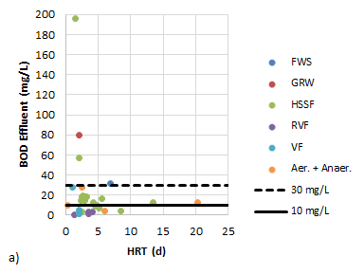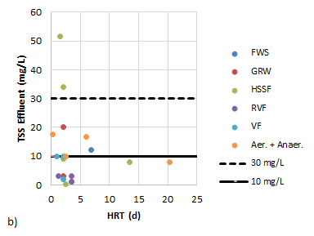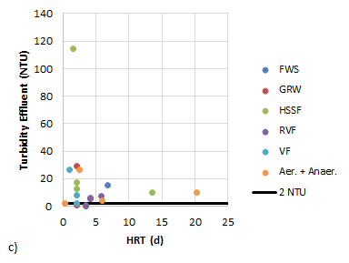
Figure 2. Comparison of GW wetland BOD (a) and TSS (b) performance with NADB datasets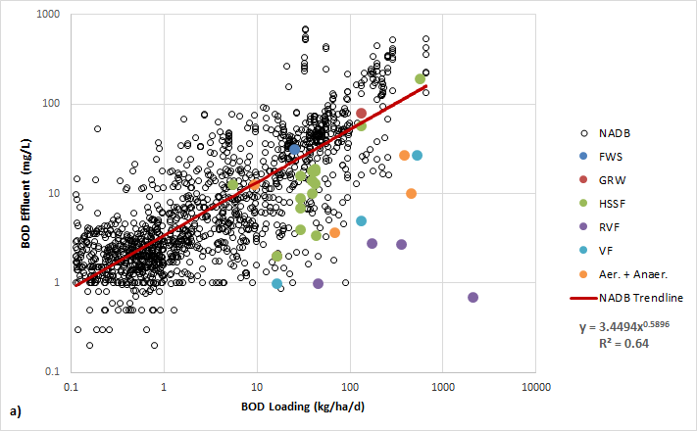 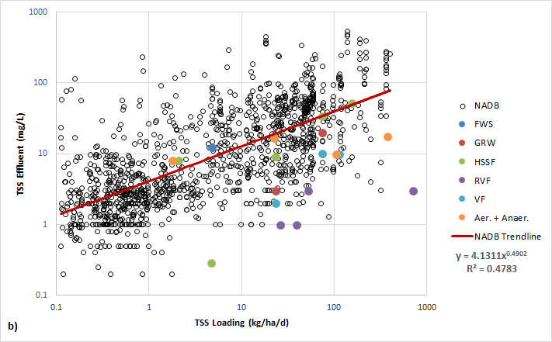

Figure 3. Log(effluent concentration) of total coliform (TC), fecal coliform (FC) and E. coli as a function of HRT (a, b, c) and log(influent concentration) (d, e, f)
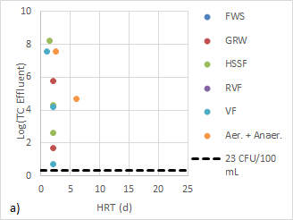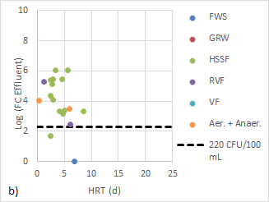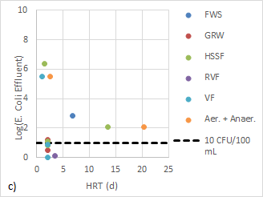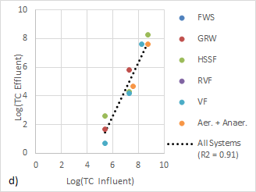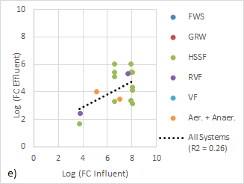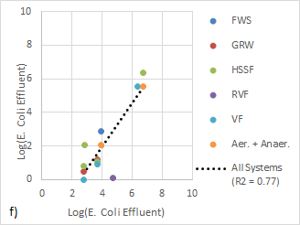

Table 4a. GW disinfection technology characteristics and physical/chemical parameters
ID | Reference | Process | Dosage | Unit | Water Source | Contact Time (h) | TSS (mg/l) | Turbidity (NTU) | UVT (%) | UVA (%) | COD (mg/l) | BOD (mg/l) | TOC (mg/l) | TN (mg/l)
1 | Beck et al., 2013 | NaOCl | 45 | (mg/L) - min | 10 µm filter | -- | -- | 2.2 | 84 | -- | -- | -- | 4.5 | 3.1
2 | Beck et al., 2013 | NaOCl | 45 | (mg/L) - min | 10 µm filter | -- | -- | 1.7 | 87 | -- | -- | -- | 4.4 | 2.84
3 | Beck et al., 2013 | NaOCl | 45 | (mg/L) - min | 10 µm filter | -- | -- | 1.4 | 90 | -- | -- | -- | 4.2 | --
4 | Beck et al., 2013 | NaOCl | 45 | (mg/L) - min | 10 µm filter | -- | -- | 6.0 | 91 | -- | -- | -- | 4.0 | 4.13
5 | Beck et al., 2013 | NaOCl | 68 | (mg/L) - min | 10 µm filter | -- | -- | 2.2 | 84 | -- | -- | -- | 4.5 | 3.1
6 | Beck et al., 2013 | NaOCl | 68 | (mg/L) - min | 10 µm filter | -- | -- | 1.7 | 87 | -- | -- | -- | 4.4 | 2.84
7 | Beck et al., 2013 | NaOCl | 68 | (mg/L) - min | 10 µm filter | -- | -- | 1.4 | 90 | -- | -- | -- | 4.2 | --
8 | Beck et al., 2013 | NaOCl | 68 | (mg/L) - min | 10 µm filter | -- | -- | 6.0 | 91 | -- | -- | -- | 4.0 | 4.1
9 | Beck et al., 2013 | NaOCl | 200 | (mg/L) - min | 10 µm filter | -- | -- | 2.2 | 84 | -- | -- | -- | 4.5 | 3.1
10 | Beck et al., 2013 | NaOCl | 100 | (mg/L) - min | 10 µm filter | -- | -- | 1.7 | 87 | -- | -- | -- | 4.4 | 2.8
11 | Beck et al., 2013 | NaOCl | 280 | (mg/L) - min | 10 µm filter | -- | -- | 1.4 | 90 | -- | -- | -- | 4.2 | --
12 | Beck et al., 2013 | NaOCl | 100 | (mg/L) - min | 10 µm filter | -- | -- | 6.0 | 91 | -- | -- | -- | 4.0 | 4.1
13 | Beck et al., 2013 | NaOCl | 450 | (mg/L) - min | 10 µm filter | -- | -- | 2.2 | 84 | -- | -- | -- | 4.5 | 3.1
14 | Beck et al., 2013 | NaOCl | 450 | (mg/L) - min | 10 µm filter | -- | -- | 1.7 | 87 | -- | -- | -- | 4.4 | 2.8
15 | Beck et al., 2013 | NaOCl | 450 | (mg/L) - min | 10 µm filter | -- | -- | 1.4 | 90 | -- | -- | -- | 4.2 | --
16 | Beck et al., 2013 | NaOCl | 450 | (mg/L) - min | 10 µm filter | -- | -- | 6 | 91 | -- | -- | -- | 4.0 | 4.1
17 | Ekeren et al., 2016 | NaOCl | 297 | (mg/L) - min | light GW, coarse filter | 60 | -- | 28 | -- | -- | -- | -- | 28 | --
18 | Ekeren et al., 2016 | NaOCl | 474 | (mg/L) - min | light GW, SF | 60 | -- | 28 | -- | -- | -- | -- | 28 | --
19 | Ekeren et al., 2016 | NaOCl | 180 | (mg/L) - min | light GW, cartridge | 60 | -- | 28 | -- | -- | -- | -- | 28 | --
20 | Ekeren et al., 2016 | NaOCl | 297 | (mg/L) - min | light GW, coarse filter | 60 | -- | 26 | -- | -- | -- | -- | 45 | --
21 | Ekeren et al., 2016 | NaOCl | 474 | (mg/L) - min | light GW, SF | 60 | -- | 26 | -- | -- | -- | -- | 45 | --
22 | Ekeren et al., 2016 | NaOCl | 180 | (mg/L) - min | light GW, cartridge | 60 | -- | 26 | -- | -- | -- | -- | 45 | --
23 | Ekeren et al., 2016 | NaOCl | 474 | (mg/L) - min | light GW, SF | 60 | -- | 31 | -- | -- | -- | -- | 49 | --
24 | Ekeren et al., 2016 | NaOCl | 474 | (mg/L) - min | light GW, SF | 60 | -- | 37 | -- | -- | -- | -- | 85 | --
25 | Frieder et al., 2011 | NaOCl | 15 | (mg/L) - min | RBC | -- | -- | 1.5 | -- | 0.032 | 47 | 3.7 | -- | --
26 | Frieder et al., 2011 | NaOCl | 30 | (mg/L) - min | RBC | -- | -- | 1.5 | -- | 0.032 | 47 | 3.7 | -- | --
27 | Friedler et al., 2005 | NaOCl | 30 | (mg/L) - min | RBC+SF | -- | 7.9 | 0.61 | -- | -- | 40 | 2.3 | -- | --
28 | Friedler et al., 2006 | NaOCl | 42 | (mg/L) - min | SF | -- | 32 | 35 | -- | -- | 130 | 62 | -- | --
29 | Friedler et al., 2006 | NaOCl | 42 | (mg/L) - min | RBC+SF | -- | 7.5 | 0.6 | -- | -- | 42 | 1.8 | -- | --
30 | Friedler et al., 2006 | NaOCl | 42 | (mg/L) - min | MBR | -- | 12 | 0.2 | -- | -- | 40 | 1.1 | -- | --
31 | Winward et al., 2008 | NaOCl | 60 | (mg/L) - min | light GW | 30 | 29 | 20 | -- | -- | 86 | 20 | 49 | --
32 | Winward et al., 2008 | NaOCl | 90 | (mg/L) - min | light GW | 30 | 29 | 20 | -- | -- | 86 | 20 | 49 | --
33 | Winward et al., 2008 | NaOCl | 150 | (mg/L) - min | light GW | 30 | 29 | 20 | -- | -- | 86 | 20 | 49 | --
34 | Beck et al., 2013 | Ozone | 0.27 | (mg/L) - min | 10 µm filter | -- | -- | 2.2 | 84 | -- | -- | -- | 4.5 | 3.1
35 | Beck et al., 2013 | Ozone | 0.38 | (mg/L) - min | 10 µm filter | -- | -- | 2.2 | 84 | -- | -- | -- | 4.5 | 3.1
36 | Beck et al., 2013 | Ozone | 0.1 | (mg/L) - min | 10 µm filter | -- | -- | 1.7 | 87 | -- | -- | -- | 4.4 | 2.8
37 | Beck et al., 2013 | Ozone | 0.2 | (mg/L) - min | 10 µm filter | -- | -- | 1.7 | 87 | -- | -- | -- | 4.4 | 2.8
38 | Beck et al., 2013 | Ozone | 0.1 | (mg/L) - min | 10 µm filter | -- | -- | 1.4 | 90 | -- | -- | -- | 4.2 | --
39 | Beck et al., 2013 | Ozone | 0.2 | (mg/L) - min | 10 µm filter | -- | -- | 1.4 | 90 | -- | -- | -- | 4.2 | --
40 | Beck et al., 2013 | Ozone | 0.7 | (mg/L) - min | 10 µm filter | -- | -- | 1.4 | 90 | -- | -- | -- | 4.2 | --
41 | Beck et al., 2013 | Ozone | 0.1 | (mg/L) - min | 10 µm filter | -- | -- | 6 | 91 | -- | -- | -- | 4.0 | 4.1
42 | Beck et al., 2013 | Ozone | 0.27 | (mg/L) - min | 10 µm filter | -- | -- | 6 | 91 | -- | -- | -- | 4.0 | 4.1
43 | Beck et al., 2013 | Ozone | 1.2 | (mg/L) - min | 10 µm filter | -- | -- | 2.2 | 84 | -- | -- | -- | 4.5 | 3.1
44 | Beck et al., 2013 | Ozone | 0.38 | (mg/L) - min | 10 µm filter | -- | -- | 1.7 | 87 | -- | -- | -- | 4.4 | 2.8
45 | Beck et al., 2013 | Ozone | 0.3 | (mg/L) - min | 10 µm filter | -- | -- | 1.4 | 90 | -- | -- | -- | 4.2 | --
46 | Beck et al., 2013 | Ozone | 0.5 | (mg/L) - min | 10 µm filter | -- | -- | 6 | 91 | -- | -- | -- | 4.0 | 4.1
47 | Beck et al., 2013 | Ozone | 1.8 | (mg/L) - min | 10 µm filter | -- | -- | 2.2 | 84 | -- | -- | -- | 4.5 | 3.1
48 | Beck et al., 2013 | Ozone | 1.2 | (mg/L) - min | 10 µm filter | -- | -- | 1.7 | 87 | -- | -- | -- | 4.4 | 2.8
49 | Beck et al., 2013 | Ozone | 1.2 | (mg/L) - min | 10 µm filter | -- | -- | 1.4 | 90 | -- | -- | -- | 4.2 | --
50 | Beck et al., 2013 | Ozone | 1.2 | (mg/L) - min | 10 µm filter | -- | -- | 6 | 91 | -- | -- | -- | 4.0 | --
51 | Beck et al., 2013 | Ozone | 2 | (mg/L) - min | 10 µm filter | -- | -- | 6 | 91 | -- | -- | -- | 4.0 | 4.1
52 | Beck et al., 2013 | UV | 10 | mJ/cm² | 10 µm filter | -- | -- | 2.2 | 84 | -- | -- | -- | 4.5 | 3.1
53 | Beck et al., 2013 | UV | 10 | mJ/cm² | 10 µm filter | -- | -- | 1.7 | 87 | -- | -- | -- | 4.4 | 2.8
54 | Beck et al., 2013 | UV | 10 | mJ/cm² | 10 µm filter | -- | -- | 1.4 | 90 | -- | -- | -- | 4.2 | --
55 | Beck et al., 2013 | UV | 10 | mJ/cm² | 10 µm filter | -- | -- | 6 | 91 | -- | -- | -- | 4.0 | 4.1
56 | Beck et al., 2013 | UV | 30 | mJ/cm² | 10 µm filter | -- | -- | 2.2 | 84 | -- | -- | -- | 4.5 | 3.1
57 | Beck et al., 2013 | UV | 30 | mJ/cm² | 10 µm filter | -- | -- | 1.7 | 87 | -- | -- | -- | 4.4 | 2.8
58 | Beck et al., 2013 | UV | 30 | mJ/cm² | 10 µm filter | -- | -- | 1.4 | 90 | -- | -- | -- | 4.2 | --
59 | Beck et al., 2013 | UV | 30 | mJ/cm² | 10 µm filter | -- | -- | 6 | 91 | -- | -- | -- | 4.0 | 4.1
60 | Beck et al., 2013 | UV | 100 | mJ/cm² | 10 µm filter | -- | -- | 2.2 | 84 | -- | -- | -- | 4.5 | 3.1
61 | Beck et al., 2013 | UV | 100 | mJ/cm² | 10 µm filter | -- | -- | 1.7 | 87 | -- | -- | -- | 4.4 | 2.8
62 | Beck et al., 2013 | UV | 100 | mJ/cm² | 10 µm filter | -- | -- | 1.4 | 90 | -- | -- | -- | 4.2 | --
63 | Beck et al., 2013 | UV | 100 | mJ/cm² | 10 µm filter | -- | -- | 6 | 91 | -- | -- | -- | 4.0 | 4.1
64 | El Hamouri et al., 2008 | UV | 400 | mJ/cm² | HSSF | -- | 18 | 2 | -- | -- | 25 | 10 | -- | 14
65 | Ekeren et al., 2016 | UV | 21 | mJ/cm² | light GW, coarse filter | -- | -- | 28 | 38 | -- | -- | -- | 28 | --
66 | Ekeren et al., 2016 | UV | 26 | mJ/cm² | light GW, SF | -- | -- | 28 | 38 | -- | -- | -- | 28 | --
67 | Ekeren et al., 2016 | UV | 28 | mJ/cm² | light GW, cartridge | -- | -- | 28 | 38 | -- | -- | -- | 28 | --
68 | Ekeren et al., 2016 | UV | 21 | mJ/cm² | light GW, coarse filter | -- | -- | 26 | 38 | -- | -- | -- | 45 | --
69 | Ekeren et al., 2016 | UV | 26 | mJ/cm² | light GW, SF | -- | -- | 26 | 38 | -- | -- | -- | 45 | --
70 | Ekeren et al., 2016 | UV | 28 | mJ/cm² | light GW, cartridge | -- | -- | 26 | 38 | -- | -- | -- | 45 | --
71 | Ekeren et al., 2016 | UV | 26 | mJ/cm² | light GW, SF | -- | -- | 31 | 38 | -- | -- | -- | 49 | --
72 | Ekeren et al., 2016 | UV | 26 | mJ/cm² | light GW, SF | -- | -- | 37 | 38 | -- | -- | -- | 85 | --
73 | Frieder et al., 2011 | UV | 19 | mJ/cm² | RBC | -- | -- | 1.5 | -- | 0.032 | 47 | 3.7 | -- | --
74 | Frieder et al., 2011 | UV | 39 | mJ/cm² | RBC | -- | -- | 1.5 | -- | 0.032 | 47 | 3.7 | -- | --
75 | Frieder et al., 2011 | UV | 44 | mJ/cm² | RBC | -- | -- | 1.5 | -- | 0.032 | 47 | 3.7 | -- | --
76 | Frieder et al., 2011 | UV | 69 | mJ/cm² | RBC | -- | -- | 1.5 | -- | 0.032 | 47 | 3.7 | -- | --
77 | Frieder et al., 2011 | UV | 147 | mJ/cm² | RBC | -- | -- | 1.5 | -- | 0.032 | 47 | 3.7 | -- | --
78 | Frieder et al., 2011 | UV | 439 | mJ/cm² | RBC | -- | -- | 1.5 | -- | 0.032 | 47 | 3.7 | -- | --
79 | Friedler and Gilboa, 2010 | UV | 69 | mJ/cm² | RBC | -- | -- | 1.5 | 93 | 0.032 | 47 | 3.7 | -- | --
80 | Winward et al., 2008b | UV | 5.8 | mJ/cm² | light GW | -- | 19 | 18 | 47 | -- | 75 | 20 | -- | --
81 | Winward et al., 2008b | UV | 69 | mJ/cm² | light GW | -- | 19 | 18 | 47 | -- | 75 | 20 | -- | --
82 | Winward et al., 2008b | UV | 277 | mJ/cm² | light GW | -- | 19 | 18 | 47 | -- | 75 | 20 | -- | --
83 | Winward et al., 2008b | UV | 10 | mJ/cm² | HSSF | -- | 4 | 6 | -- | -- | 17 | 2 | -- | --
84 | Winward et al., 2008b | UV | 11 | mJ/cm² | HSSF | -- | 4 | 6 | -- | -- | 17 | 2 | -- | --
85 | Winward et al., 2008b | UV | 277 | mJ/cm² | HSSF | -- | 4 | 6 | -- | -- | 17 | 2 | -- | --

Table 4b. GW disinfection technology pathogen treatment performance¹
ID | Het. Plate Count (cfu) |  | Total coliform (logcfu/100 ml) |  | Fecal coliform (logcfu/100 ml) |  | E. coli (logcfu/100 ml) |  | Enterococci (cfu/100 ml) |  | S. enterica (cfu/100 ml) |  | S. aureus (cfu/100 ml) |  | P. aeruginosa (cfu/100 ml) |  | MS2 Coliphage (logpfu/ml) |  | F-RNA phage (pfu/100 ml)
 | In | LR | In | LR | In | LR | In | LR | In | LR | In | LR | In | LR | In | LR | In | LR | In | LR
1 | -- | -- | -- | -- | -- | -- | -- | -- | 2.9 | 2.9 | -- | -- | -- | -- | -- | -- | 5.6-8.2 | 5.5 | -- | --
2 | -- | -- | -- | -- | -- | -- | -- | -- | 1.8 | 1.8 | -- | -- | -- | -- | -- | -- | 5.6-8.2 | -- | -- | --
3 | -- | -- | -- | -- | -- | -- | -- | -- | 1.9 | 1.9 | -- | -- | -- | -- | -- | -- | 5.6-8.2 | 5.5 | -- | --
4 | -- | -- | -- | -- | -- | -- | -- | -- | 1.9 | 1.9 | -- | -- | -- | -- | -- | -- | 5.6-8.2 | -- | -- | --
5 | -- | -- | 2.0 | 2.0 | -- | -- | -- | -- | 2.9 | 2.9 | -- | -- | -- | -- | -- | -- | 5.6-8.2 | -- | -- | --
6 | -- | -- | 2.6 | 2.6 | -- | -- | -- | -- | 1.8 | 1.8 | -- | -- | -- | -- | -- | -- | 5.6-8.2 | -- | -- | --
7 | -- | -- | 3.5 | 3.5 | -- | -- | -- | -- | 1.9 | 1.9 | -- | -- | -- | -- | -- | -- | 5.6-8.2 | -- | -- | --
8 | -- | -- | 3.3 | 3.3 | -- | -- | -- | -- | 1.9 | 1.9 | -- | -- | -- | -- | -- | -- | 5.6-8.2 | -- | -- | --
9 | -- | -- | -- | -- | -- | -- | -- | -- | -- | -- | -- | 35 | -- | -- | -- | -- | 5.6-8.2 | 5.5 | -- | --
10 | -- | -- | -- | -- | -- | -- | -- | -- | -- | -- | -- | -- | -- | -- | -- | -- | 5.6-8.2 | 6.2 | -- | --
11 | -- | -- | -- | -- | -- | -- | -- | -- | -- | -- | -- | -- | -- | -- | -- | -- | 5.6-8.2 | 5.5 | -- | --
12 | -- | -- | -- | -- | -- | -- | -- | -- | -- | -- | -- | -- | -- | -- | -- | -- | 5.6-8.2 | 4.4 | -- | --
13 | -- | -- | 2.0 | 2.0 | -- | -- | -- | -- | 2.9 | 2.9 | -- | -- | -- | -- | -- | -- | 5.6-8.2 | 5.5 | -- | --
14 | -- | -- | 2.6 | 2.6 | -- | -- | -- | -- | 1.8 | 1.8 | -- | -- | -- | -- | -- | -- | 5.6-8.2 | 5.5 | -- | --
15 | -- | -- | 3.5 | 3.5 | -- | -- | -- | -- | 1.9 | 1.9 | -- | -- | -- | -- | -- | -- | 5.6-8.2 | 6.8 | -- | --
16 | -- | -- | 3.3 | 3.3 | -- | -- | -- | -- | 1.9 | 1.9 | -- | -- | -- | -- | -- | -- | 5.6-8.2 | 6.2 | -- | --
17 | -- | -- | -- | -- | -- | -- | 7.1 | 7.1 | -- | -- | -- | -- | -- | -- | -- | -- | -- | -- | -- | --
18 | -- | -- | -- | -- | -- | -- | 6.5 | 6.5 | -- | -- | -- | -- | -- | -- | -- | -- | -- | -- | -- | --
19 | -- | -- | -- | -- | -- | -- | 5.2 | 5.2 | -- | -- | -- | -- | -- | -- | -- | -- | -- | -- | -- | --
20 | -- | -- | -- | -- | -- | -- | -- | -- | -- | -- | 8.0 | 8.0 | -- | -- | -- | -- | -- | -- | -- | --
21 | -- | -- | -- | -- | -- | -- | -- | -- | -- | -- | 7.8 | 7.8 | -- | -- | -- | -- | -- | -- | -- | --
22 | -- | -- | -- | -- | -- | -- | -- | -- | -- | -- | 7.8 | 7.8 | -- | -- | -- | -- | -- | -- | -- | --
23 | -- | -- | -- | -- | -- | -- | -- | -- | -- | -- | -- | -- | -- | -- | -- | 7.4 | -- | -- | -- | --
24 | -- | -- | -- | -- | -- | -- | -- | -- | -- | -- | -- | -- | -- | -- | -- | -- | -- | 3.8 | -- | --
25 | 6.0 | 3.2 | -- | -- | 2.2 | 1.9 | -- | -- | -- | -- | -- | -- | 1.9 | 1.9 | 2.6 | 1 | -- | -- | -- | --
26 | 6.0 | 3.3 | -- | -- | 2.2 | 1.9 | -- | -- | -- | -- | -- | -- | 1.9 | 1.9 | 2.6 | 1.3 | -- | -- | -- | --
27 | -- | -- | -- | -- | 4.7 | 4.7 | -- | -- | -- | -- | -- | -- | -- | -- | -- | -- | -- | -- | -- | --
28 | 7.4 | 3.4 | -- | -- | 5.1 | 5.1 | -- | -- | -- | -- | -- | -- | -- | -- | -- | -- | -- | -- | -- | --
29 | 5.4 | 2.4 | -- | -- | 4.7 | 4.7 | -- | -- | -- | -- | -- | -- | -- | -- | -- | -- | -- | -- | -- | --
30 | 4.1 | 1.4 | -- | -- | 1.4 | 1.4 | -- | -- | -- | -- | -- | -- | -- | -- | -- | -- | -- | -- | -- | --
31 | -- | -- | 5.3 | 1.6 | -- | -- | -- | -- | -- | -- | -- | -- | -- | -- | -- | -- | -- | -- | -- | --
32 | -- | -- | 5.3 | 2.8 | -- | -- | -- | -- | -- | -- | -- | -- | -- | -- | -- | -- | -- | -- | -- | --
33 | -- | -- | 5.3 | 4.4 | -- | -- | -- | -- | -- | -- | -- | -- | -- | -- | -- | -- | -- | -- | -- | --
34 | -- | -- | -- | -- | -- | -- | -- | -- | -- | -- | -- | -- | -- | -- | -- | -- | 5.6-8.2 | 5.6 | -- | --
35 | -- | -- | 2.0 | 0.8 | -- | -- | -- | -- | 2.9 | 2.9 | -- | -- | -- | -- | -- | -- | 5.6-8.2 | 5.6 | -- | --
36 | -- | -- | 2.6 | 0.8 | -- | -- | -- | -- | 1.8 | 1.8 | -- | -- | -- | -- | -- | -- | 5.6-8.2 | 2.0 | -- | --
37 | -- | -- | -- | -- | -- | -- | -- | -- | -- | -- | -- | -- | -- | -- | -- | -- | 5.6-8.2 | 3.2 | -- | --
38 | -- | -- | 3.5 | 0.3 | -- | -- | -- | -- | 1.9 | 1.9 | -- | -- | -- | -- | -- | -- | 5.6-8.2 | 2.0 | -- | --
39 | -- | -- | -- | -- | -- | -- | -- | -- | -- | -- | -- | -- | -- | -- | -- | -- | 5.6-8.2 | 3.0 | -- | --
40 | -- | -- | -- | -- | -- | -- | -- | -- | -- | -- | -- | -- | -- | -- | -- | -- | 5.6-8.2 | 5.0 | -- | --
41 | -- | -- | 3.3 | 0.5 | -- | -- | -- | -- | 1.9 | 1.9 | -- | -- | -- | -- | -- | -- | 5.6-8.2 | 0.2 | -- | --
42 | -- | -- | -- | -- | -- | -- | -- | -- | -- | -- | -- | -- | -- | -- | -- | -- | 5.6-8.2 | 2.0 | -- | --
43 | -- | -- | 2.0 | 0.8 | -- | -- | -- | -- | 2.9 | 2.9 | -- | -- | -- | -- | -- | -- | 5.6-8.2 | 5.6 | -- | --
44 | -- | -- | 2.6 | 1.6 | -- | -- | -- | -- | 1.8 | 1.8 | -- | -- | -- | -- | -- | -- | 5.6-8.2 | 5.0 | -- | --
45 | -- | -- | 3.5 | 0.8 | -- | -- | -- | -- | 1.9 | 1.9 | -- | -- | -- | -- | -- | -- | -- | -- | -- | --
46 | -- | -- | 3.3 | 1.2 | -- | -- | -- | -- | 1.9 | 1.9 | -- | -- | -- | -- | -- | -- | -- | -- | -- | --
47 | -- | -- | 2.0 | 1.2 | -- | -- | -- | -- | 2.9 | 2.9 | -- | -- | -- | -- | -- | -- | 5.6-8.2 | 5.6 | -- | --
48 | -- | -- | 2.6 | 1.7 | -- | -- | -- | -- | 1.8 | 1.8 | -- | -- | -- | -- | -- | -- | -- | -- | -- | --
49 | -- | -- | 3.5 | 1.8 | -- | -- | -- | -- | 1.9 | 1.9 | -- | -- | -- | -- | -- | -- | -- | -- | -- | --
50 | -- | -- | -- | -- | -- | -- | -- | -- | -- | -- | -- | -- | -- | -- | -- | -- | 5.6-8.2 | 5.6 | -- | --
51 | -- | -- | 3.3 | 1.8 | -- | -- | -- | -- | 1.9 | 1.9 | -- | -- | -- | -- | -- | -- | -- | -- | -- | --
52 | -- | -- | 2.0 | 2.0 | -- | -- | -- | -- | 2.9 | 2.9 | -- | -- | -- | -- | -- | -- | -- | -- | -- | --
53 | -- | -- | 2.6 | 2.6 | -- | -- | -- | -- | 1.8 | 1.8 | -- | -- | -- | -- | -- | -- | -- | -- | -- | --
54 | -- | -- | 3.5 | 3.5 | -- | -- | -- | -- | 1.9 | 1.9 | -- | -- | -- | -- | -- | -- | -- | -- | -- | --
55 | -- | -- | 3.3 | 3.3 | -- | -- | -- | -- | 1.9 | 1.9 | -- | -- | -- | -- | -- | -- | -- | -- | -- | --
56 | -- | -- | 2.0 | 2.0 | -- | -- | -- | -- | 2.9 | 2.9 | -- | -- | -- | -- | -- | -- | -- | 1.5 | -- | --
57 | -- | -- | 2.6 | 2.6 | -- | -- | -- | -- | 1.8 | 1.8 | -- | -- | -- | -- | -- | -- | 5.6-8.2 | 1.2 | -- | --
58 | -- | -- | 3.5 | 3.5 | -- | -- | -- | -- | 1.9 | 1.9 | -- | -- | -- | -- | -- | -- | 5.6-8.2 | 1.8 | -- | --
59 | -- | -- | 3.3 | 3.3 | -- | -- | -- | -- | 1.9 | 1.9 | -- | -- | -- | -- | -- | -- | 5.6-8.2 | 1.2 | -- | --
60 | -- | -- | 2.0 | 2.0 | -- | -- | -- | -- | 2.9 | 2.9 | -- | -- | -- | -- | -- | -- | 5.6-8.2 | 5.9 | -- | --
61 | -- | -- | 2.6 | 2.6 | -- | -- | -- | -- | 1.8 | 1.8 | -- | -- | -- | -- | -- | -- | 5.6-8.2 | 5.8 | -- | --
62 | -- | -- | 3.5 | 3.5 | -- | -- | -- | -- | 1.9 | 1.9 | -- | -- | -- | -- | -- | -- | 5.6-8.2 | 4.1 | -- | --
63 | -- | -- | 3.3 | 3.3 | -- | -- | -- | -- | 1.9 | 1.9 | -- | -- | -- | -- | -- | -- | 5.6-8.2 | 3.9 | -- | --
64 | -- | -- | -- | -- | 4.0 | 4.0 | -- | -- | -- | -- | -- | -- | -- | -- | -- | -- | -- | -- | -- | --
65 | -- | -- | -- | -- | -- | -- | -- | 5.5 | -- | -- | -- | -- | -- | -- | -- | -- | -- | -- | -- | --
66 | -- | -- | -- | -- | -- | -- | -- | 5.5 | -- | -- | -- | -- | -- | -- | -- | -- | -- | -- | -- | --
67 | -- | -- | -- | -- | -- | -- | -- | 5.5 | -- | -- | -- | -- | -- | -- | -- | -- | -- | -- | -- | --
68 | -- | -- | -- | -- | -- | -- | -- | -- | -- | -- | -- | 7.4 | -- | -- | -- | -- | -- | -- | -- | --
69 | -- | -- | -- | -- | -- | -- | -- | -- | -- | -- | -- | 8.3 | -- | -- | -- | -- | -- | -- | -- | --
70 | -- | -- | -- | -- | -- | -- | -- | -- | -- | -- | -- | 8.0 | -- | -- | -- | -- | -- | -- | -- | --
71 | -- | -- | -- | -- | -- | -- | -- | -- | -- | -- | -- | -- | -- | -- | -- | -- | -- | -- | -- | --
72 | -- | -- | -- | -- | -- | -- | -- | -- | -- | -- | -- | -- | -- | -- | -- | -- | -- | 2.7 | -- | --
73 | 5.5 | 1.6 | -- | -- | 2.8 | 0.8 | -- | -- | -- | -- | -- | -- | 1.9 | 1.9 | 2.1 | 1.1 | -- | -- | -- | --
74 | 5.5 | 2.0 | -- | -- | 2.8 | 1.8 | -- | -- | -- | -- | -- | -- | 1.9 | 1.9 | 2.1 | 2.1 | -- | -- | -- | --
75 | 5.5 | 2.3 | -- | -- | 2.8 | 1.7 | -- | -- | -- | -- | -- | -- | 1.9 | 1.9 | 2.1 | 2.1 | -- | -- | -- | --
76 | 5.5 | 3.5 | -- | -- | 2.8 | 2.8 | -- | -- | -- | -- | -- | -- | 1.9 | 1.9 | 2.1 | 2.1 | -- | -- | -- | --
77 | 5.5 | 3.4 | -- | -- | 2.8 | 2.8 | -- | -- | -- | -- | -- | -- | 1.9 | 1.9 | 2.1 | 2.1 | -- | -- | -- | --
78 | 5.5 | 3.2 | -- | -- | 2.8 | 2.8 | -- | -- | -- | -- | -- | -- | 1.9 | 1.9 | 2.1 | 2.1 | -- | -- | -- | --
79 | 5.2 | -0.1 | -- | -- | 2.3 | 0.5 | -- | -- | -- | -- | -- | -- | 1.4 | 1.4 | 3.8 | -0.1 | -- | -- | 4.9 | 4.9
80 | -- | -- | 5.8 | 3.2 | -- | -- | 2.6 | 2.4 | 3.8 | 3 | -- | -- | -- | -- | -- | -- | -- | -- | -- | --
81 | -- | -- | 5.8 | 4.1 | -- | -- | 2.6 | 2.5 | 3.8 | 3.4 | -- | -- | -- | -- | -- | -- | -- | -- | -- | --
82 | -- | -- | 5.8 | 4.8 | -- | -- | 2.6 | 2.6 | 3.8 | 3.8 | -- | -- | -- | -- | -- | -- | -- | -- | -- | --
83 | -- | -- | 2.6 | 2.4 | -- | -- | -- | -- | -- | -- | -- | -- | -- | -- | -- | -- | -- | -- | -- | --
84 | -- | -- | 2.6 | 2.6 | -- | -- | -- | -- | -- | -- | -- | -- | -- | -- | -- | -- | -- | -- | -- | --
85 | -- | -- | 2.6 | -- | -- | -- | -- | -- | -- | -- | -- | -- | -- | -- | -- | -- | -- | -- | -- | --
¹Concentrations given as log₁₀(concentration), LR = log reduction

Figure 4. Effluent concentrations and log reductions from greywater chlorination studies
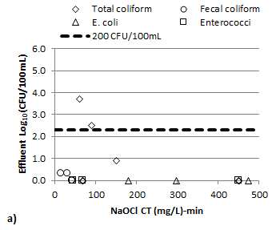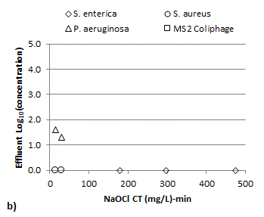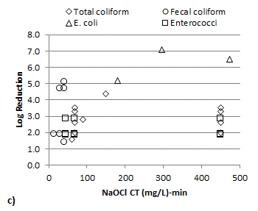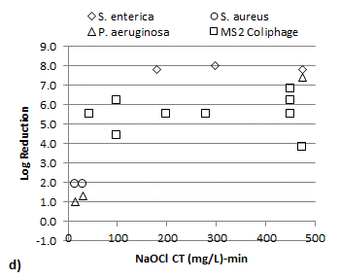
Figure 5. Effluent concentrations and log reductions from greywater UV studies
