Supplementary Material

Effects of Source and Seasonal Variations of Natural Organic Matters on the Fate and Transport of CeO2 Nanoparticles in the Environment

**Zhen Li1, Endalkachew Sahle-Demessie2*, Ashraf Aly Hassan3, Jonathan G. Pressman2, George A. Sorial1, Changseok Han**

1Environmental Engineering Program, Department of Biomedical, Chemical, and Environmental Engineering, University of Cincinnati

P.O. Box 210012, Cincinnati, OH 45221-0012

2U.S. Environmental Protection Agency, Office of Research and Development, NRMRL,

26 W. Martin Luther King Drive (MS 443), Cincinnati, Ohio 45268.

3Department of Civil Engineering, University of Nebraska Lincoln, P.O. Box 886105, Lincoln, NE 68588-6105

1. **Characterization of natural organic matter (NOM)**

The chemical properties and elemental composition of natural organic matter tested are given below.

Table S1. Characterization of NOMs use, total organic carbon (TOC), and UV254 absorbance

|  |  |  |  |
| --- | --- | --- | --- |
| Parameter | OR-NOM-Jan | OR-NOM-July | SRHA |
| Conc. (g/L) | 1.53 ± 0.07 | 1.15 ± 0.09 | 1.05 ± 0.06 |
| TOC (ppm) | 277 ± 12 | 291 ± 16 | 325 ± 28 |
| UV254 | 6.88 | 9.25 | 7.48 |

Table S2. ICP analysis of Ohio River NOM conducted using an iCAP 6000 spectrometer

|  |  |  |  |  |  |  |  |  |
| --- | --- | --- | --- | --- | --- | --- | --- | --- |
| (ppm) | SO4 (IC) | Ca | K | Mg | Na | P | S | Si |
| OR-NOM-JAN | 54.22 | 26.89 | 2.10 | 8.92 | 22.69 | 0.30 | 18.09 | 2.43 |
| OR-NOM-JUL | 86.97 | 44.01 | 2.83 | 14.46 | 25.19 | 0.02 | 29.02 | 1.51 |

Table S3 Elemental analysis of the lyophilized NOM solid. All values corrected for dry conditions and adjusted using

|  |  |  |  |  |  |  |
| --- | --- | --- | --- | --- | --- | --- |
| Sample | C | H | N | O | S | O to C ratio |
| Jan. 2011 | 50 | 5.0 | 2.9 | 38 | 3.5 | 0.76 |
| July 2011 | 55 | 4.1 | 3.1 | 36 | 2.5 | 0.84 |

1. **Nanoparticle characterization**

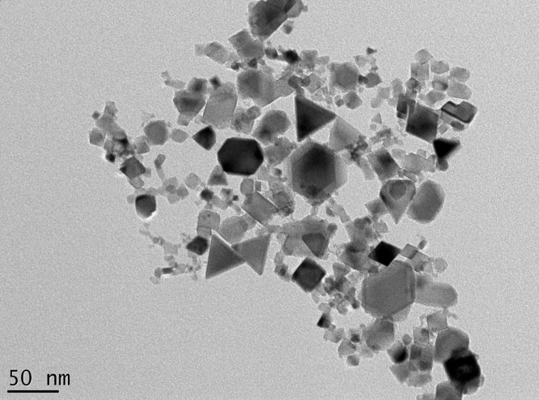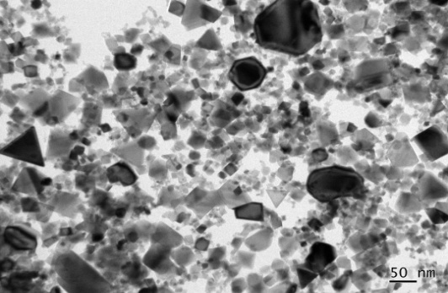

(A)

(C )

(B)

Figure S1, Characterization of CeO2 NPs, (A) Size distribution measured using dynamic light scattering method, (B) X-ray diffraction patterns, and (C) Transmission electron microscope image showing polydispersed NPs

1. **Transport of CeO2 NPs in porous media in the presence of SRHA**

**F:\research transfer\NOM\New folder\FigureS3 .TIFFigure 2S.** Breakthrough of CeO2 nanoparticles in the presence of SRHA (1, 5 and 10ppm) under different ionic concentration: A, 3mM NaCl，B, 5mM NaCl, C, 10mM NaCl



**Figure S3,** Attachment efficiency CeO2 nanoparticles in the presence of SRHA under different ionic concentration

In the presence of SRHA, CeO2 NPs quickly reached full breakthrough (plateau value =1) at an ionic concentration of 3 mM, yielding very small values of Katt (≤ 0.1). At ionic concentration of 5 mM, and SRHA concentration of 5-10 ppm, CeO2 NPs gradually reached full breakthrough at pore volume 10, which is very similar with OR-NOMS but at a faster rate. At 1 ppm SRHA concentration, CeO2 NPs reached partial breakthrough with plateau value of ~0.58, which is higher than in the presence of OR-NOMs (~0.48). At ionic concentration of 10 mM, CeO2 NPs had a partial breakthrough, starting around 1.5 pore volume, and slowly reached the plateau value. The plateau value generally increased with the increase of SRHA concentration. The corresponding attachment efficiency katt is shown in Figure S4, indicating that the facilitating effect of SRHA increases with the increasing SHRA concentration and decreasing ionic strength. The role of SRHA is very similar with OR-NOMs in facilitating the transport of CeO2 NPs but the effect is much stronger.

1. **DLVO calculation for CeO2 nanoparticle**

Particle–collector interaction energy is estimated using classical and modified DLVO theory to account for steric repulsion provided by guar gum. The nanoparticles are assumed to be uniform spheres, small relative to the sand grains, i.e., sphere-to-plate interaction is calculated. Equations of classical DLVO theory for bare particles–bare collector interactions(Healy and White 1978) (Elimelech and O'Melia 1990):

The equation for double layer interaction Vedl:

S (1)

The equation for Van de Wal force Vvdw

S(2)

Where $κ=({\frac{2000e^{2}N_{A}N_{c}I_{c}}{ε_{0}ε_{r}kT})}^{1/2}$ S(3)

And A $=\left(A_{11}^{1/2}-A_{22}^{1/2}\right)\left(A_{33}^{1/2}-A_{22}^{1/2}\right)$ S(4)

$F_{steric}\left(h\right)= 2πa_{p}\left(\frac{Tk_{B}}{s^{3}}\right)\left\{\frac{4l}{5}\left[{\left(\frac{l}{h}\right)}^{\frac{5}{4}}-1\right]+\frac{4l}{7}\left[{\left(\frac{h}{l}\right)}^{\frac{7}{4}}-1\right]\right\}$ S(5)

$ϕ_{steric} \left(D\right)= -\int_{∞}^{D}{F_{steric }(h)dh}$ for h, D ≤ l S(6)

In the equations, h is the separation distance between the particle surface and sand surface, λ is the characteristic wavelength of the interaction (100 nm), k is the Boltzmann constant, κ is the Debye length, R is the particle diameter, T is the absolute temperature (298°K), ∈0 is the permittivity of a vacuum, ∈r is the relative dielectric constant of water , NA is Avogadro's number, Ic is the ionic strength, R is the particle diameter (62.6nm, measured by particle analyzer) and *φ* 1 and *φ* 2 are surface potentials of particles and sand, respectively. Here zeta potentials were used as estimation for surface potentials.

In Eq.4, Hamaker constant A is the overall Hamaker interaction parameter for the deposition of a CeO 2 NP onto sand surface when suspended in water. The Hamaker constants A11, A22, and A33 are for sand surface, water and CeO 2 NP in vacuum, respectively. The values used were: A 11 = 6 .5× 10−20 J, A 22 = 3.7 × 10−20 J, and A 33 = 5.7 × 10−20 J, which were obtained from literature.(Israelachvili 1991).

1. **Measurement Techniques**

Dry powder Analysis and Suspended Particles will be analyzed. The sensitivity and limitation of instruments and method used will be carefully considered.

Table S44. A Quality Assurance Objectives for Precision, Accuracy and Method Detection

|  |  |  |  |  |  |  |
| --- | --- | --- | --- | --- | --- | --- |
| **Critical Meas.** | **Matrix** | **Method** | **Units** | **Precision**  **(RPD)** | **Accuracy** | **QC** |
| Turbidity | Suspension | Turbid meter | NTU | ±10% | Concentration of suspended colloidal particles, particle size and color affects results | Vendor Standard,  Calibration for each NP |
| H | Water | pH probes |  | 0.01 | 0.01 | Daily QC Vendor standards |
| Nano mass |  | Weight per volume | mg | ± 3% | 0.1 |  |
| Size Distribution | Suspended | Dynamic light scattering &  Laser Diffraction Beckman-Coulter-LS230 |  |  | Particle shape affects results  DLS, LS* | 2-4% Reproducibility, Vendor QC |
| Morphology, Image | Solid | SEM, EDX, TEM, XRD, AFM | nm for size |  |  | Au standard for size |
| Zeta potential | Suspended | Zetasizer | mV | ± 10% |  |  |
| Nano particle Composition | Acid digested | ICP | * *g/l | ± 5% |  | Calibration with known standards |
| Particle concentration | Suspended | UV-Vis | Mg/l | ± 5% |  | Calibration with known standard |
| Nano particle Crystallinity | Solid | XRD |  |  |  | Si standard |
| NOM composition | Solid | TOC | mg/l | ± 5% |  | CV1.5% max. (CV2% max. at 1000mg/L or higher) |

DLS–dynamic light scattering, Beckman Coulter LS-230

**F. References**

Healy, T.W. and White, L.R. (1978) Ionizable surface group models of aqueous interfaces. Advances in Colloid and Interface Science 9(4), 303-345.

Elimelech, M. and O'Melia, C.R. (1990) Effect of particle size on collision efficiency in the deposition of Brownian particles with electrostatic energy barriers. Langmuir 6(6), 1153-1163.

Israelachvili, J. (1991) Intermolecular and Surface Forces, Academic Press, London.