Supporting Information
Carbon Nanotube Reinforced Polypropylene Composite
Degradation and Stability During Environmentally Aging

Changseok Han¹, E. Sahle-Demessie^{2,}*, Jun Wang³

Content page

Scheme 1. Preparation of films of polypropylene (PP) and composite of PP-carbon nanotubes. 2
Figure S1. A SEM image of multiwalled carbon nanotubes (NANOCYLTM NC7000) used to prepare polypropylene nanocomposites obtained with a scanning electron microscope (JSM-6490LV, JEOL). 3
Figure S2. PP and PP-MWCNT composite samples placed in an accelerating solar aging system. 3
Figure S3. Theremogravimetric analysis onset weight loss temperature of PP (PP0x) and PP-with 4 wt% CNT (PP4x) composite samples after selected the solar aging times. 4
Figure S4. Differential scanning calorimetric analysis for aged polypropylene (a) PP01, (b) PP02, (c) PP03, and PP-CNT composites (d) PP41, (e) PP42, and (f) PP43 that underwent accelerated weathering for selected periods. 5
Figure S5. DSC data of (a) changes of melting temperatures of different parts of PP43 and (b) changes of crystallization temperatures of different part of PP43 6
Figure S6. Linear plots of $ln β$ vs 1/T for aged PP01 samples with different values of α. 6
Figure S7. Linear plots of $ln β$ vs 1/T for aged PP02 samples with different values of α. 7
Figure S8. Linear plots of $ln β$ vs 1/T for aged PP03 samples with different values of α. 8
Figure S9. Linear plots of $ln β$ vs 1/T for aged PP41 samples with different values of α. 9
Figure S10. Linear plots of $ln β$ vs 1/T for aged PP42 samples with different values of α. 10
Figure S11. Linear plots of $ln β$ vs 1/T for aged PP43 samples with different values of α. 11

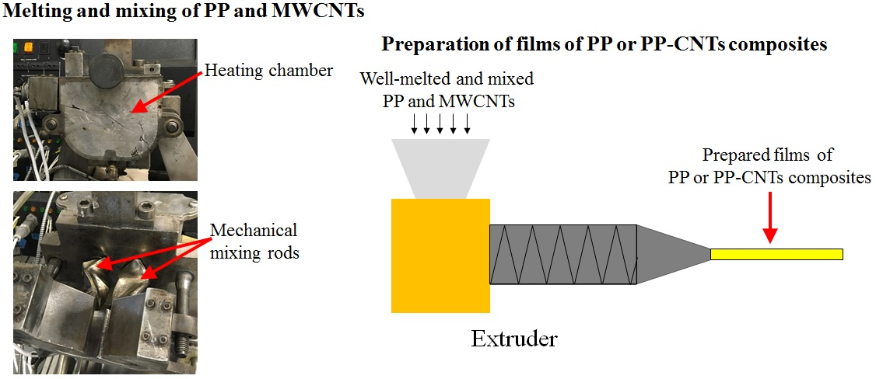
Melt PP + CNT mixture
T > 150 ºC
Extruded Air cooled
L
Melt mix with screw extruder

Scheme 1. Preparation of films of polypropylene (PP) and composite of PP-carbon nanotubes.

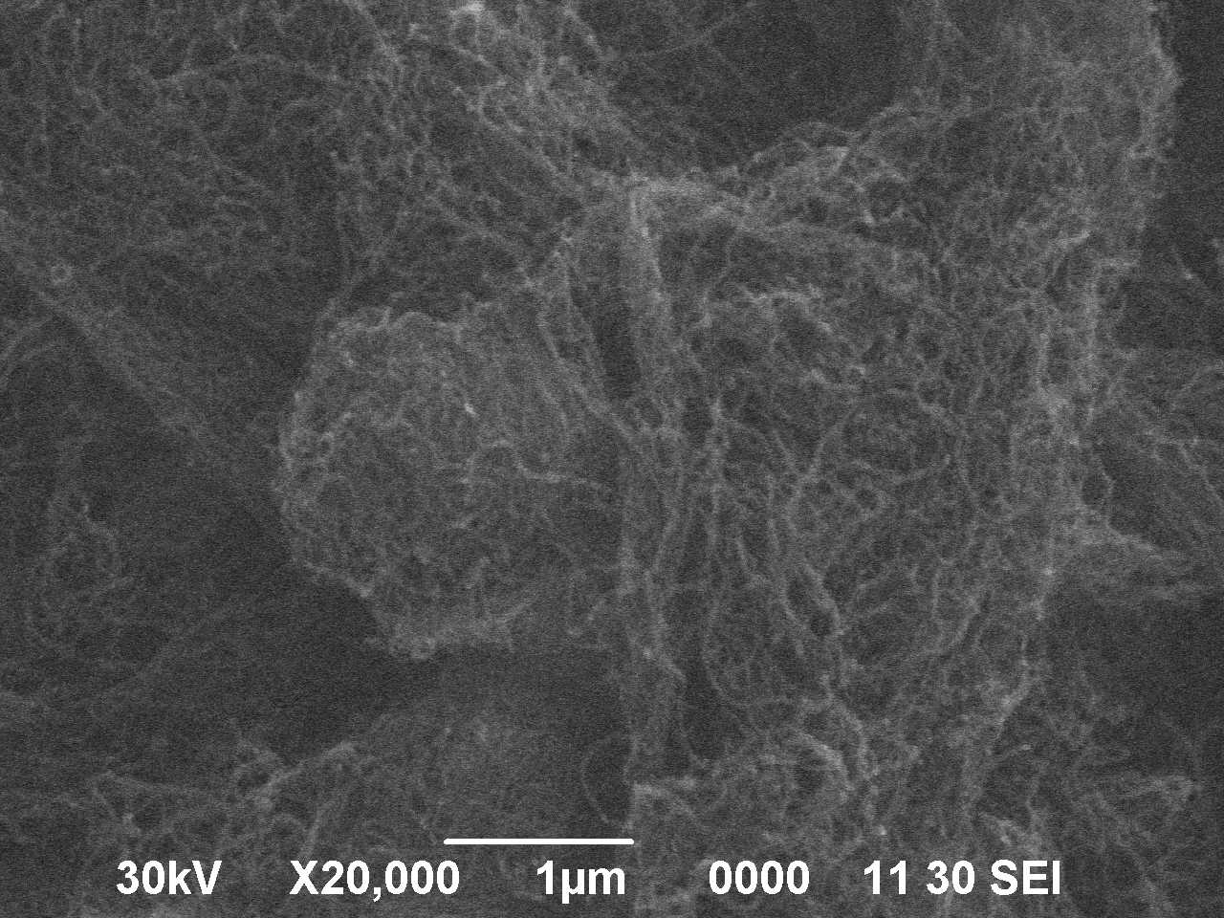

Figure S1. A SEM image of multiwalled carbon nanotubes (NANOCYLTM NC7000) used to prepare polypropylene nanocomposites obtained with a scanning electron microscope (JSM-6490LV, JEOL).

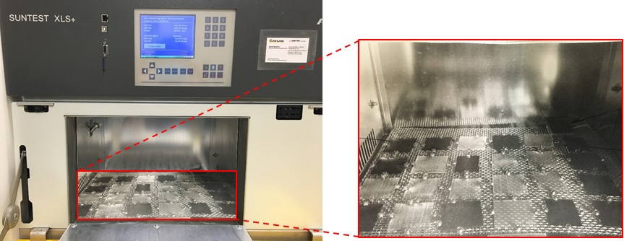

Figure S2. PP and PP-MWCNT composite samples placed in an accelerating solar aging system.

Figure S3. Theremogravimetric analysis onset weight loss temperature of PP (PP0x) and PP-with 4 wt% CNT (PP4x) composite samples after selected the solar aging times.

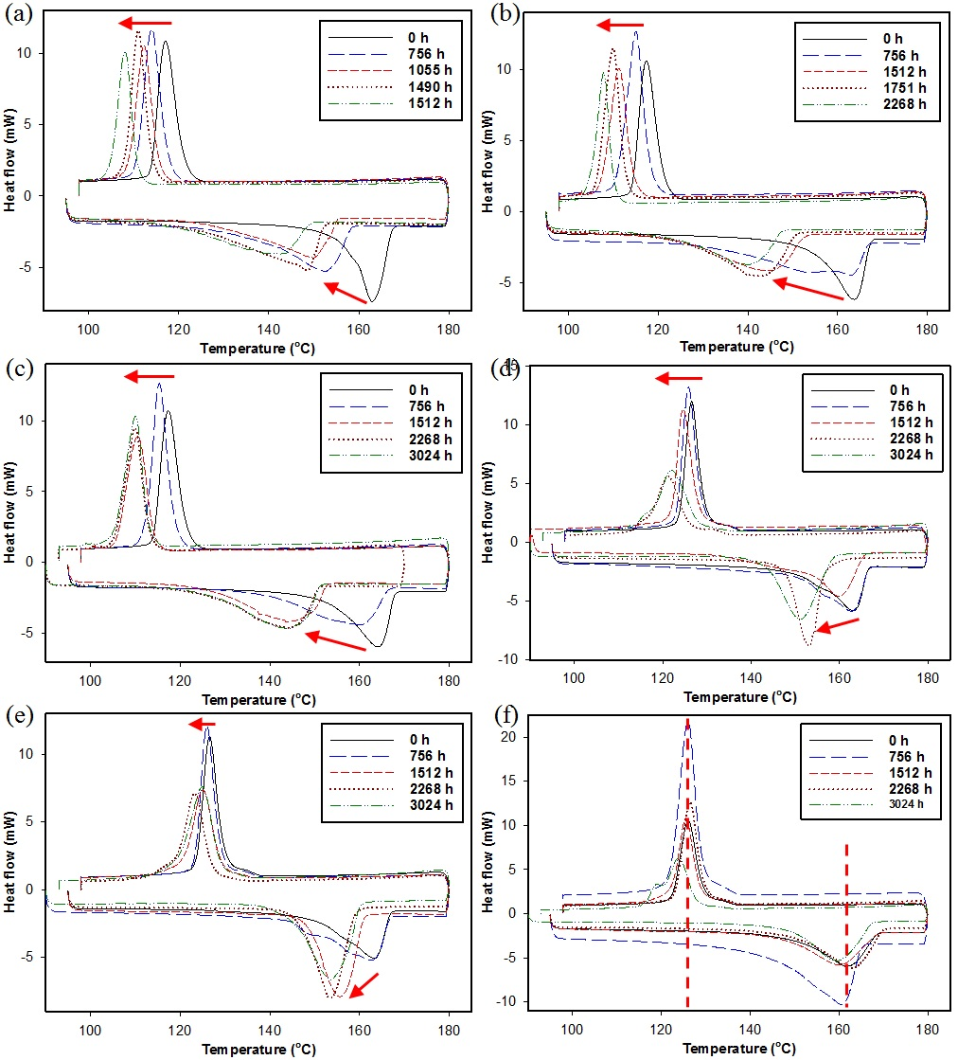

Figure S4. Differential scanning calorimetric analysis for aged polypropylene (a) PP01, (b) PP02, (c) PP03, and PP-CNT composites (d) PP41, (e) PP42, and (f) PP43 that underwent accelerated weathering for selected periods.

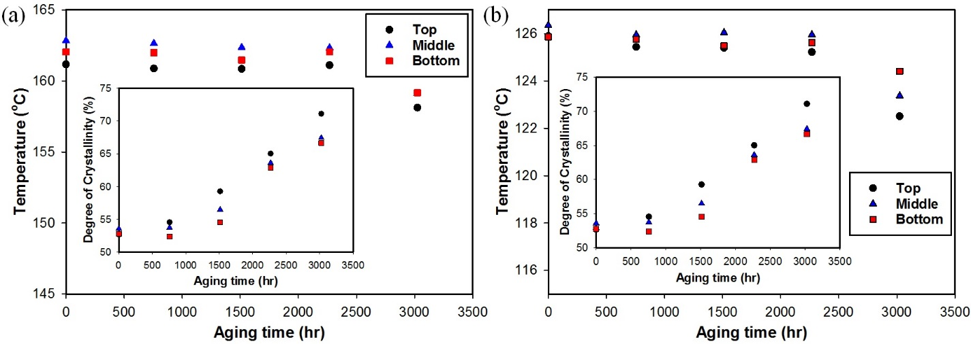
Figure S5. DSC data of (a) changes of melting temperatures of different parts of PP43 and (b) changes of crystallization temperatures of different part of PP43.

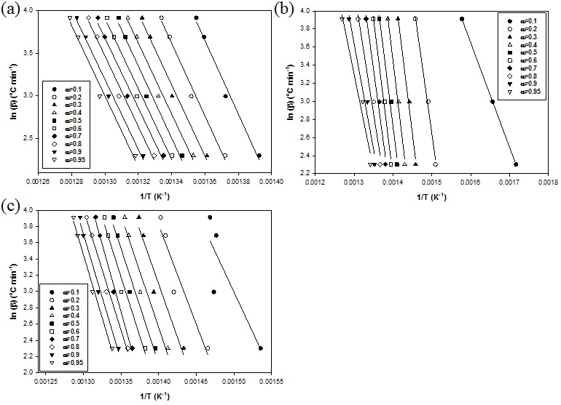

Figure S6. Linear plots of $ln β$ vs 1/T for aged PP01 samples with different values of α.

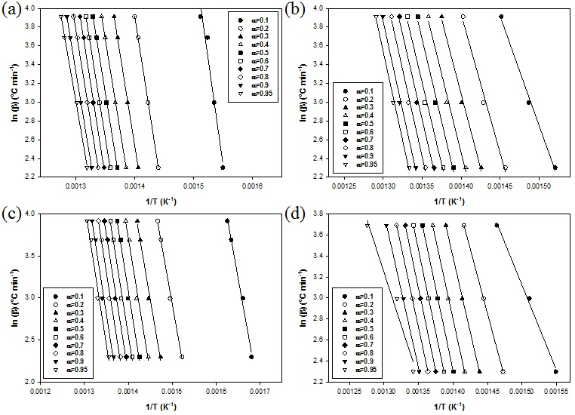

Figure S7. Linear plots of $ln β$ vs 1/T for aged PP02 samples with different values of α.

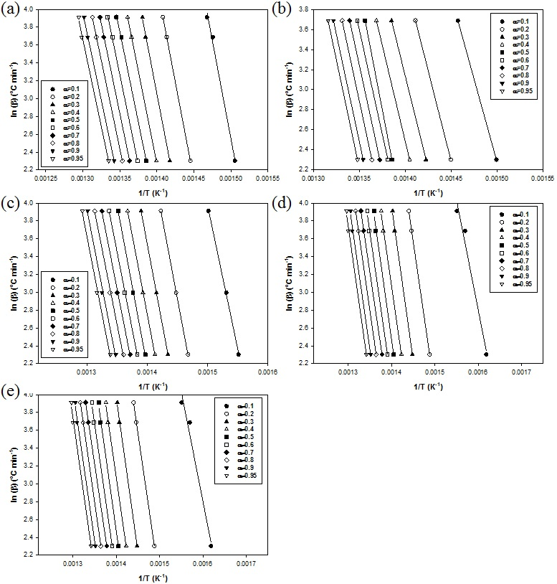

Figure S8. Linear plots of $ln β$ vs 1/T for aged PP03 samples with different values of α.

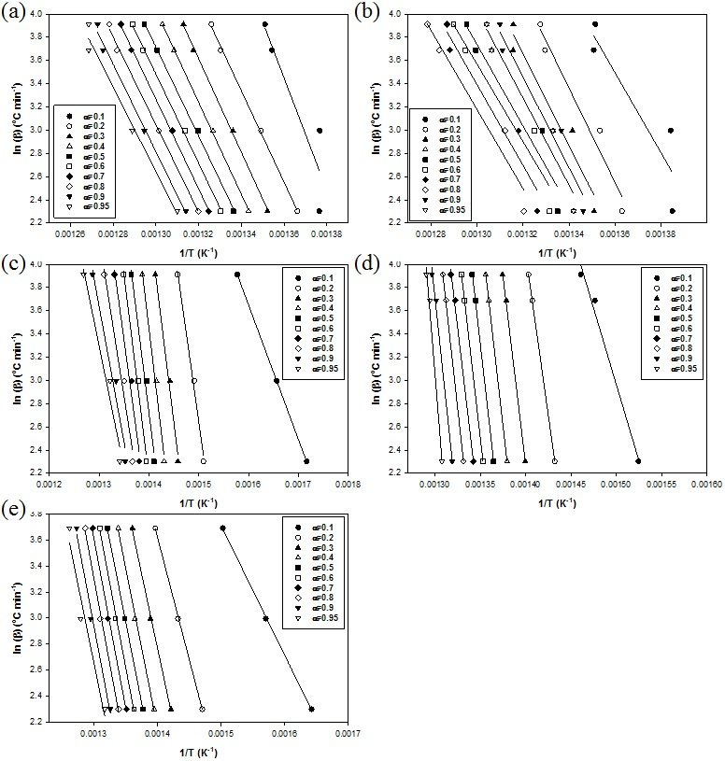

Figure S9. Linear plots of $ln β$ vs 1/T for aged PP41 samples with different values of α.

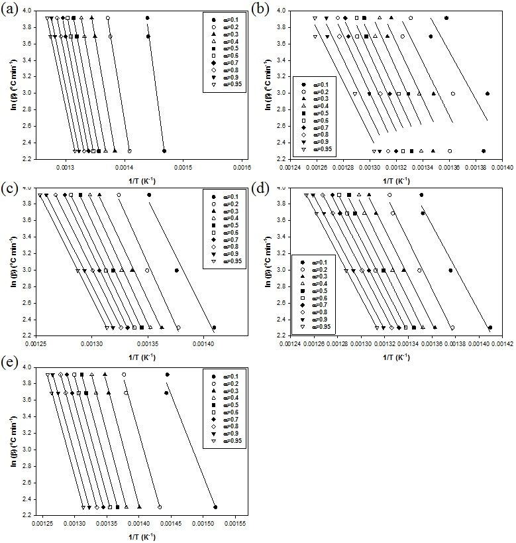

Figure S10. Linear plots of $ln β$ vs 1/T for aged PP42 samples with different values of α.

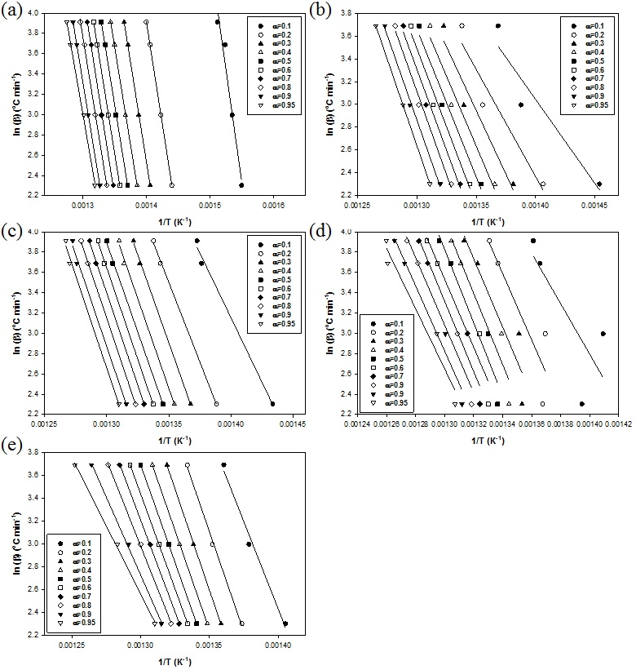

Figure S11. Linear plots of $ln β$ vs 1/T for aged PP43 samples with different values of α.

