Suspect Screening Analysis of Chemicals in Consumer Products
  - Supporting Information
Katherine A. Phillipsª, Alice Yau^{b}, Kristin A. Favela^{b}, Kristin K. Isaacsª, Andrew McEachran^{c,d}, Christopher Grulke^{d}, Ann M. Richard^{d}, Antony J. Williams^{d}, Jon R. Sobusª, Russell S. Thomas^{d}, John F. Wambaugh^{d*}

ªNational Exposure Research Laboratory U.S. Environmental Protection Agency, Office of Research and Development, 109 T. W. Alexander Drive, RTP, NC USA 27711
^{b}Southwest Research Institute, San Antonio, TX
^{c}Oak Ridge Institute for Science and Education (ORISE), Oak Ridge, TN, USA 37830
^{d}National Center for Computational Toxicology U.S. Environmental Protection Agency, Office of Research and Development, 109 T. W. Alexander Drive, RTP, NC USA 27711
*Corresponding Author:
Email: wambaugh.john@epa.gov
Phone: 1-(919)-541-7641

There are 47 pages, 36 figures, and 4 tables in the supporting information.

SI Methods
Reagents and Materials used in Analysis
Product Selection
GC×GC-TOF/MS Analysis
Identification of Flame Retardant Chemicals
Identification of Potential Estrogen Receptor Chemicals
Assignment of Functional Use to Support SSA Identification of Chemicals
SSA Concentration Comparison with Existing Weight Fraction Data
Determination of Retention Time Windows
SI Results
Identification of Label Reported Ingredients in Products
SI Figures
Figure S1 – Confirmed absent rate of chemicals in SSA.
Figure S2 – Estimated concentrations in the 100 tested consumer products.
Figure S3 – Histogram of the number products in which each type of spectral match was identified.
Figure S4 – Box plot of the range of log-estimated concentration values for each type of spectral match.
Figure S5 – Normalized retention time windows used in chemical confirmation analysis.
Figures S6-S36 – Gas chromatographs for each product studied in this analyses at varying levels of solution dilution.
SI Tables
Table S1 – All information collected from the suspect screening of consumer products.
Table S2 – Intrinsic chemical properties of two hundred chemical standards provided for the suspect screening.
Table S3 – List of chemicals that were either confirmed or tentatively identified in 25 or more products
Table S4 – Retention time modulation periods used to calculate the retention time windows used for confirming the presence or absence of a chemical.

SI Methods

Reagents and Materials used in Analysis
Dichloromethane, Optima™ Hexanes (a mixture of hexane isomers where the n-hexane content is greater than or equal to 60%), and diethyl ether were purchased from Thermo Fisher Scientific (Waltham, Massachusetts). Internal standard compounds used in the GC×GC-TOF/MS analysis included acenaphthene-D₁₀ (CASRN: 156067-26-2), chrysene-D₁₂ (CASRN: 1719-03-5), 1,4-dichlorobenzene-D₄ (CASRN: 3855-82-1), naphthalene-D₈ (CASRN: 1146-65-2), perylene-D₁₂ (CASRN: 1520-96-3), and phenanthrene-D₁₀ (CASRN: 1517-22-2). Internal standards were obtained from Restek (State College, Pennsylvania). The following recovery (extraction surrogate) compounds were used: nitrobenzene (CASRN: 4165-60-0), 2-fluorophenol (CASRN: 367-12-4), phenol-D₅ (CASRN: 4165-62-2), p-terphenyl-D₁₄ (CASRN: 1718-51-0), 2-fluorobiphenyl (CASRN: 321-60-8), and 2, 4, 6-tribromophenol (CASRN: 118-79-6).

Product Selection
Five test objects each were selected arbitrarily from among 20 diverse categories of consumer products and articles of commerce including air freshener, baby soap, carpet, carpet padding, cereal, cotton clothing, deodorant, fabric upholstery, glass cleaner, hand soap, indoor house paint, lipstick, plastic children’s toy, shampoo, shaving cream, shower curtain, skin lotion, sunscreen, toothpaste, and vinyl upholstery. All items with the exception of three carpet pads were purchased in retail stores in San Antonio, Texas in a convenience sampling manner. Three carpet pads were obtained from a store in Georgia. Selection of the products was varied based on colors, types of materials, fragrances, or country of origin. For example, different colors of cotton clothing were selected for testing with multiple manufacturing countries, and both regular and organic cotton were included for comparison. Swatches of upholstery fabric (i.e., fabric that is not part of an assembled article), different materials such as cotton, linen, 100% polyester and polyester blends were included. Products selected for the SSA were intended to be methodologically challenging rather than statistically representative of either products or product categories.

GC×GC-TOF/MS Analysis
Two-dimensional gas chromatography time-of-flight/mass spectrometry (GC×GC-TOF/MS) is a form of GC/MS wherein two analytical GC columns are connected in series affording two degrees of separation. Ideally, the two columns have different coating materials rendering the separations on the two columns orthogonal. Between the two columns is a modulator, which regulates the flow of sample between the two columns. The thermal modulator works by applying cryogenically cooled nitrogen gas to trap and focus chemicals eluting from the first column, then injects them into the second column by the application of heated gas. The second column is typically very short with a separation time on the order of the modulator cycle time (4-6 seconds). As chemicals elute from the second column, they are routed into the TOF/MS. The TOF/MS is utilized instead of a quadrupole because the cryogenically-sharpened peaks require a fast mass analyzer for optimum peak definition.

Identification of Flame Retardant Chemicals
As an example of a chemical class relevant to human health, we identified flame retardants. ToxCast chemical annotations provided through EPA’s Distributed Structure-Searchable Toxicity (DSSTox) database and public information were used to identify ToxCast inventory chemicals that have been associated with use as flame retardants ^{1, 2}. Those flame retardant chemicals used as standards for the present analysis are marked as such in Table S2.

Identification of Potential Estrogen Receptor Chemicals
Putative estrogen receptor (ER) agonists were used as a second example of chemicals relevant to human health. Judson et al. (2015) analyzed HTS bioactivity data to identify likely ER-active chemicals among more than 1,800 chemicals tested for estrogenicity by Phase II of the ToxCast project ³. Chemicals were tested in concentration-response format by 18 separate in vitro assays, including a set of Tox21 assays. Each assay-chemical combination was assessed using curve-fitting to identify whether a systematic response as a function of concentration was observed, as characterized either by a Hill function or a gain-loss model in cases where cytotoxicity occurred at high concentrations. A pathway-based model was used to make a consensus determination of whether the behavior of the chemicals in all 18 assays was consistent with ER activation. The pathway-based model can identify both ER agonists and antagonists. Scores related to ER agonist activity were used in this analysis. Most (93.1%) were predicted negative, whereas 111 compounds (6.1%) were predicted to be potent ER agonists. Sixty-four potential ER agonists identified by Judson et al (2015) are examined ³.

Assignment of Functional Use to Support SSA Identification of Chemicals
Chemical functional use data and predictions are employed as a means to support the likelihood that tentative chemical identifications could actually be in products. This is done using a database of functional use information (i.e., FUse) and a suite of validated QSUR models^{4, 5}. FUse contains reported functional use classifications for over 14,000 chemicals. These reported functions were harmonized using a clustering algorithm so that each chemical has only one harmonized function (e.g., many surfactants, cleansers, and emulsifiers could be clustered into a harmonized function “surfactant”). The harmonized function data were used to train the QSUR models using chemical properties (via EPI Suite ⁶) and structural descriptors (via ToxPrint descriptors ⁷) as parameters. These QSURs then return a numerical probability that a chemical can be classified as having a given function based solely on chemicals structure and physicochemical properties ⁵. Only predictions whose probability is greater than or equal 80% are then used as predicted functional uses.

SSA Concentration Comparison with Existing Weight Fraction Data
Sample concentrations for each identified spectral match were estimated using an internal standard as described above; an extraction efficiency of 100% in each sample was assumed. The estimated concentrations (µg/g) were converted to weight fractions (g/g) and compared with existing consumer product weight fraction data. Estimated concentrations for intentionally-added chemicals in the formulated product samples (e.g., baby soap, deodorant) were compared with an EPA database of curated weight fraction data obtained from publically-available material safety data sheets (MSDS) from manufacturer and retailer sources ^{8, 9}. This MSDS database contains data for over 1,900 chemicals (unique chemical abstract registration numbers, CASRNs) in over 16,000 formulated products. Concentrations for article samples (e.g., carpet padding, clothing) were compared with concentrations measured in consumer products via compliance testing performed by the State of Washington Department of Ecology ¹⁰ and reported in the Department’s public database ¹¹.

Determination of Retention Time Windows
Sample products were grouped into one of 6 categories to determine the size of the retention time window. This window indicates the time difference allowed between a measured retention time and the retention time of an internal standard for an identification to be considered a positive confirmation. Table S3 shows the categories and the number of seconds making up the window for each category.
However, samples were analyzed with confirmation standards after the initial suspected screening. As a result, the retention times of tentatively identified chemicals could fall outside of the retention time windows in Table S3 and be classified as confirmed absent chemicals due to noise. To rule out chemicals that are truly confirmed absent a normalized first and second dimension retention time was calculated for each tentative identification, $i$, according to:

 | $${\hat{t}}_{i,d}= \frac{t_{i,d}- t_{i,d,lower}}{t_{i,d,upper}- t_{i,d,lower}}$$ | (1)

where, ${\hat{t}}_{i,d}$ is the normalized retention time in dimension, $d$. A value of ${\hat{t}}_{i,d}=0$ implies the measured retention time is equal to the lower bound of the retention time window in dimension $d$ ($t_{i,d,lower}$), ${\hat{t}}_{i,d}=0.5$implies the measured retention time is equal to the retention time of the chemical reference standard, and a value of ${\hat{t}}_{i,d}=1$ implied that the measured retention time of a tentative identification is equal to the upper bound of the retention time window ($t_{i,d, upper}$). Figure S4 shows the distribution of the normalized first and second dimension retention times for all identified spectral matches whose matched chemical underwent confirmation. Confirmed absent chemicals were taken to be any chemical identifications whose retention times were greater than the first quantile of the distribution of $\left|{\hat{t}}_{i,d}\right|$.
In some instances, there were multiple measurements of a standard’s retention time for the same product category and retention time window category (see Table S3). In these cases, the mean retention time was determined for a chemical across a product category and retention time window category. This mean value was then used in the above assessment to determine if a tentative identification was indeed a confirmed absent hit.

SI Results

Identification of Label Reported Ingredients in Products
For the 100 products tested in the SSA, 931 ingredients were reported on product labeling or on manufacturer websites; ingredients were reported using chemical names. These reported ingredient lists were obtained primarily for personal care (e.g., sunscreen, lipstick) and home care (e.g., glass cleaner, air freshener) product formulations, although some limited ingredients were identified for interior house paint. Of the 931 reported ingredients, 827 were able to be linked to the corresponding chemical abstract registration number (CASRN), which allowed for mapping between reported chemicals in the products and chemicals with identified spectral matches from SSA. Of the 827 ingredients with an assigned CASRN, there were 95 ingredients (32 unique CASRNs) across 36 products (10 product categories) where a reported ingredient was also an identified spectral match of the SSA in that same product category. Ingredients were identified most often in personal care product formulations; sunscreens and skin lotions had the most ingredients mapped to an identified spectral match (each with 19).

Many of the remaining 732 ingredients (307 unique CASRNs) that could be mapped to a CASRN but were not identified in the SSA, were botanical ingredients (e.g., lavender oils, fruit extracts) or mixtures (e.g., iron oxides). Other listed ingredients not found were volatile propellants (butane, propane). Missing ingredients may be compounds for which the SSA methods used here were not appropriate or that were not included in the NIST 08 database. However, some individual reported ingredients (e.g., parabens) that were missed by the SSA in one product were successfully identified in other products.

SI Figures
Figure S1 shows the rate of confirmed negative hits for in all 100 products (that is the number of hits that were confirmed absence for a compound divided by the total number of confirmed present and confirmed absent hits for the same compound). There were only 29 chemicals whose absence in products was confirmed. Figure S2 shows all confirmed chemical identifications, tentative chemical identifications, and tentative chemical class identifications for all products tested in the SSA. Hierarchical clustering was used to sort the order of chemicals (x-axis) by commonly occurring chemicals across all product categories. Figure S3 is a stacked histogram of the number of products in which confirmed and tentative identifications chemicals were detected. Figure S5 shows the ranges of estimated concentrations for chemicals in each product category for confirmed and tentative identifications. Finally, Figures S6 – S36 are all collected 2-D gas chromatograms for the 100 products sampled in the SSA. Each figure is annotated to provide the anonymized name of the product and the dilution factor and solvent corresponding to that chromatogram.

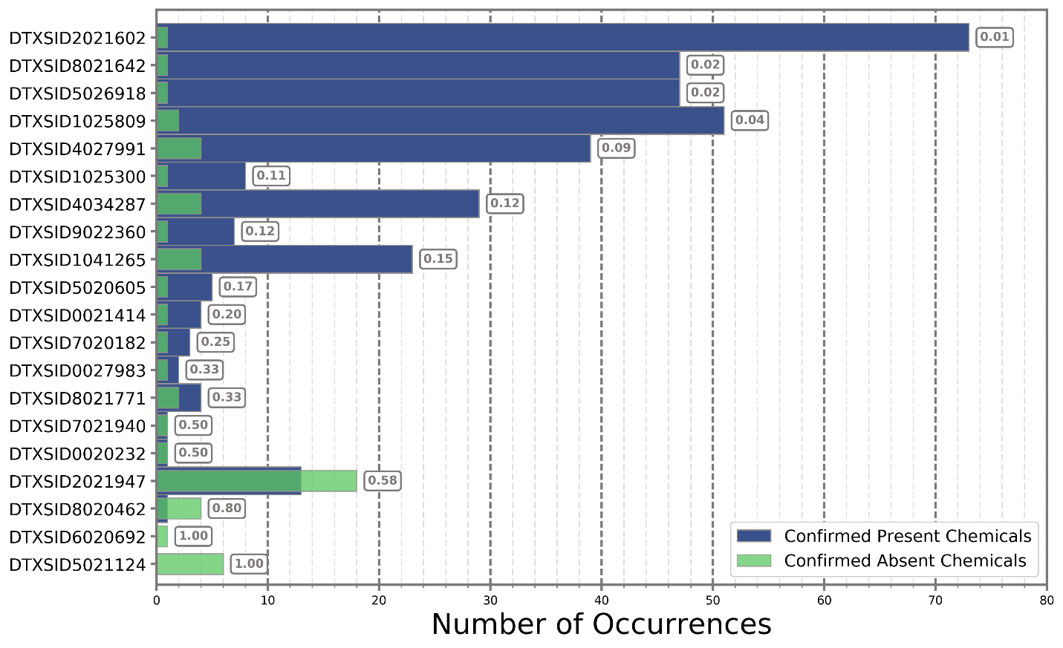
Figure S1. Confirmed absent rate of chemicals in SSA.

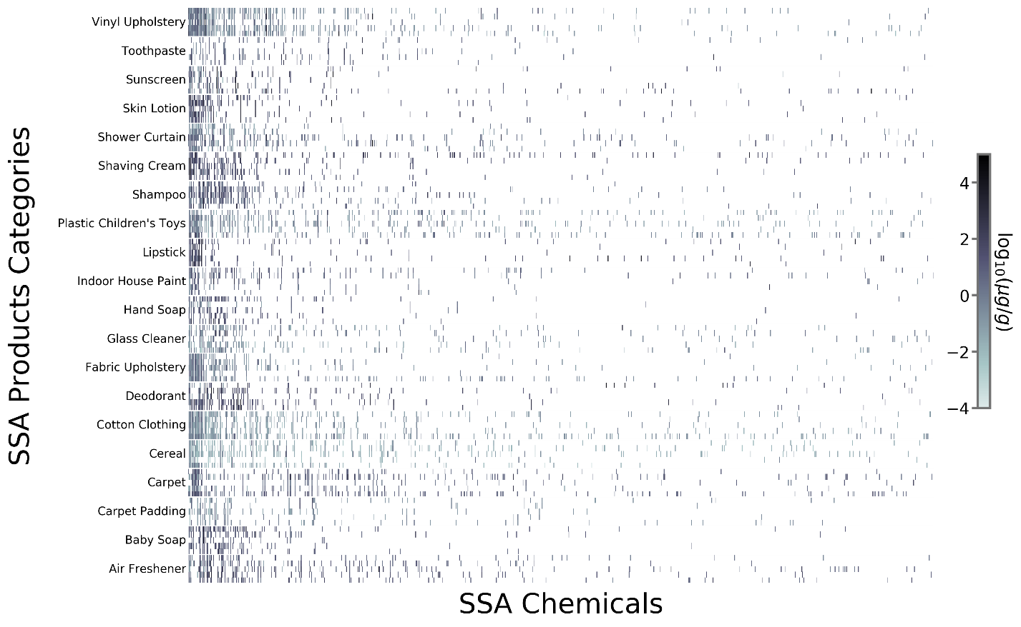
Figure S2. Estimated concentrations of chemicals in the 100 tested consumer products. Each one of the product samples is a row in the heat map, while the columns represent an identified spectral match (i.e., confirmed chemical identification, tentative chemical identification, or tentative chemical class identification) from at least one product in the SSA. Chemicals are sorted using a Hierarchical clustering algorithm such that chemicals occurring across multiple products within a product category appear near each other in the heat map. The log-value of the concentration is shown with darker values representing higher estimated concentration values. White spaces indicate that the chemical was not identified in a particular product.

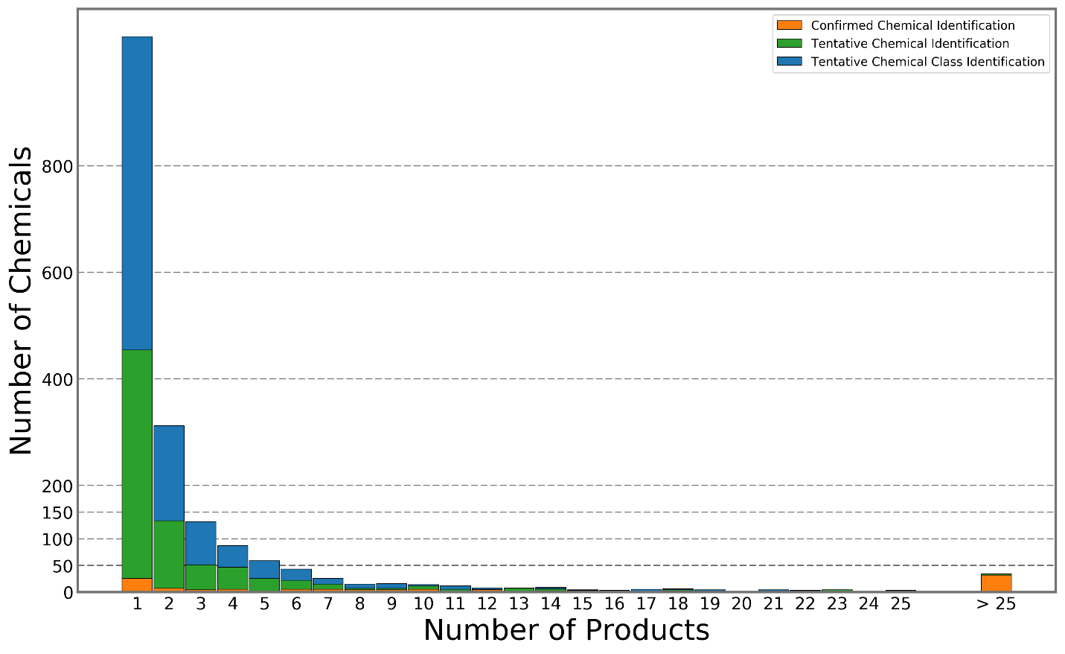
Figure S3. Stacked histogram of the number products in which each type of identified spectral match was found (note: both x- and y-axes are in rectilinear coordinates).

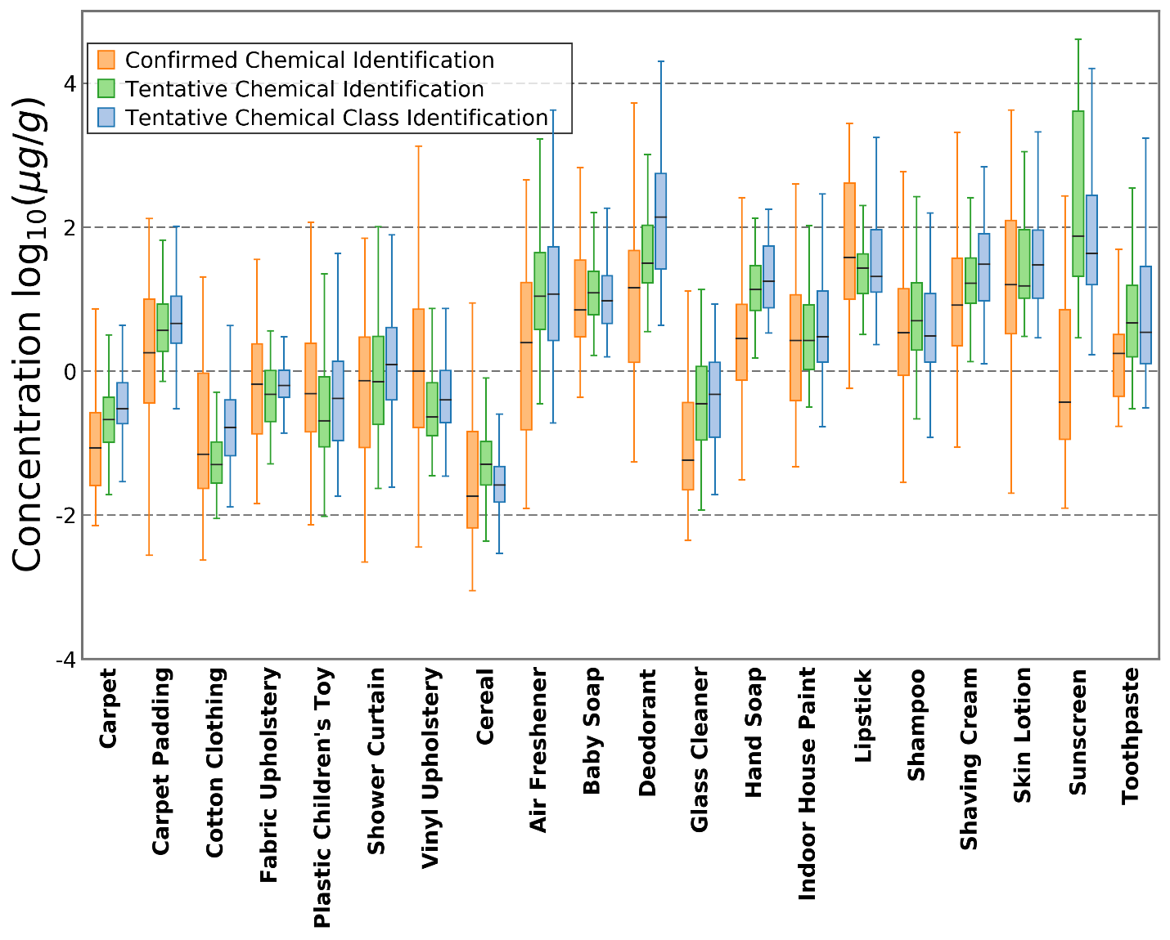
Figure S4. Box plot of the range of log-values for estimated concentration for all identified spectral matches.

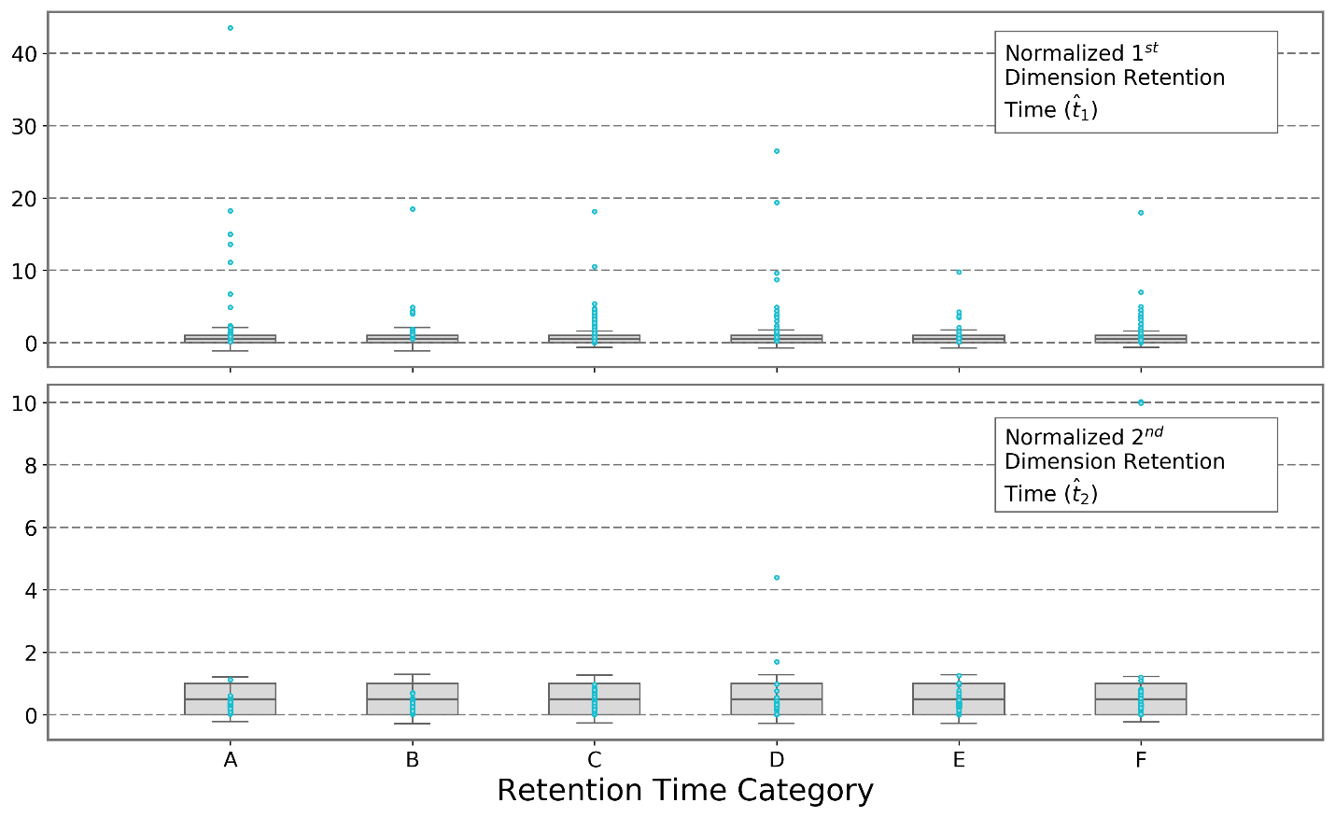
Figure S5. Normalized retention time windows used in chemical confirmation analysis. The box indicates the full retention time window ranging from${\hat{t}}_{d}=0$ to ${\hat{t}}_{d}=1$. The bar inside the box indicates the actual retention time of the standard (i.e., ${\hat{t}}_{d}=0$.5). The whiskers indicate the retention time window cutoffs used to determine if a tentative hit was a confirmed absent. The gray points are actual normalized retention time values of tentatively identified chemicals in the samples of 100 products.

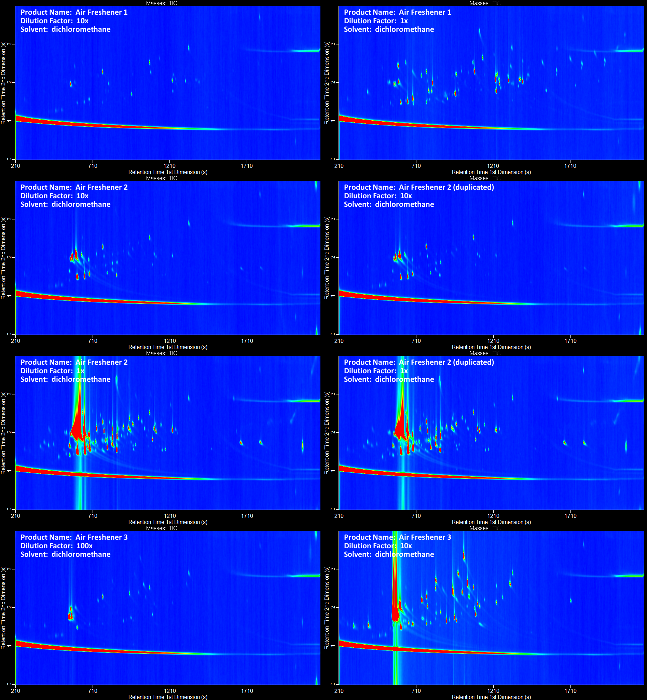
Figure S6. Gas chromatograms of air fresheners.

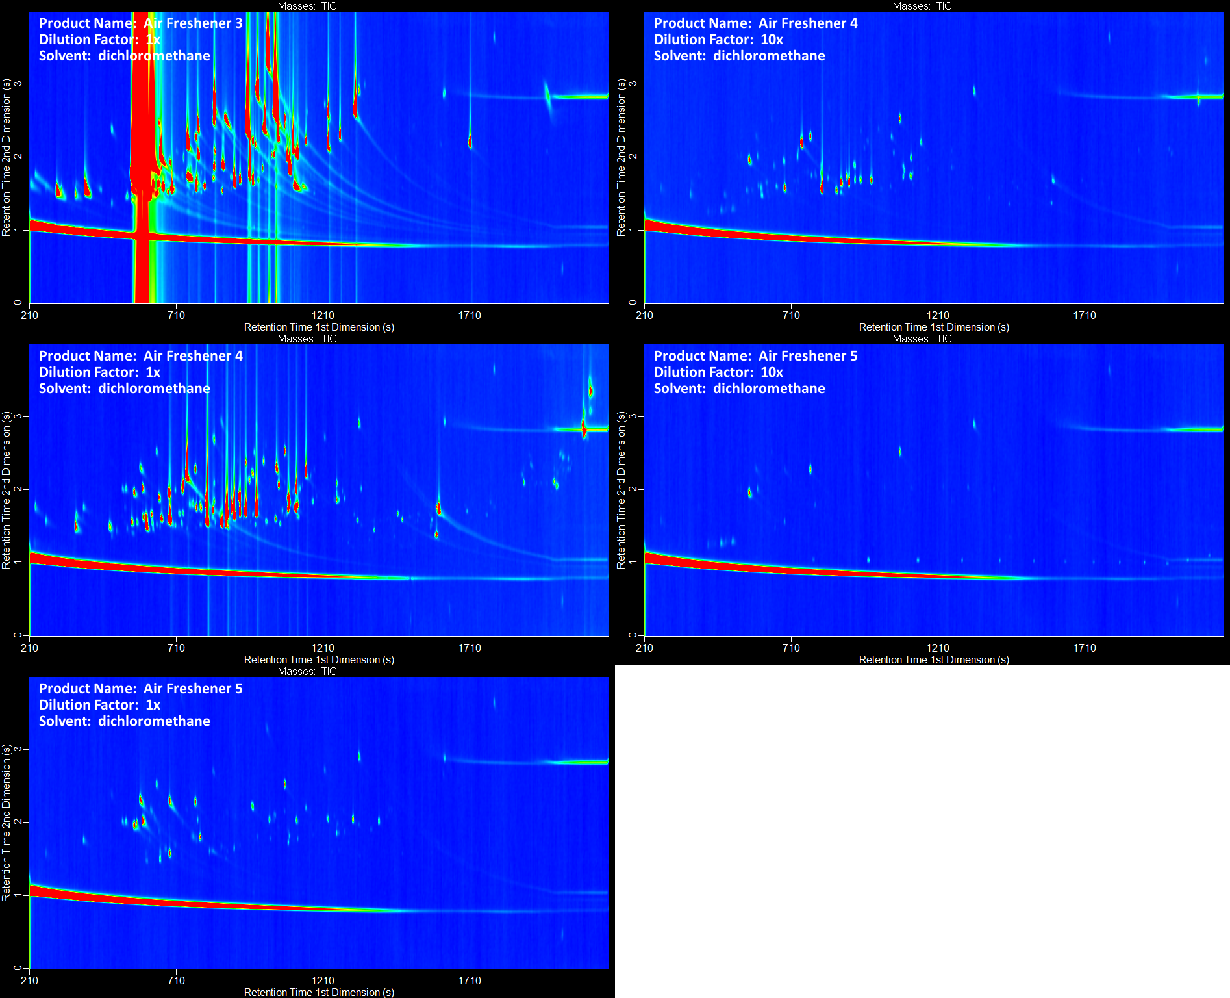
Figure S7. Gas chromatograms of air fresheners (continued).

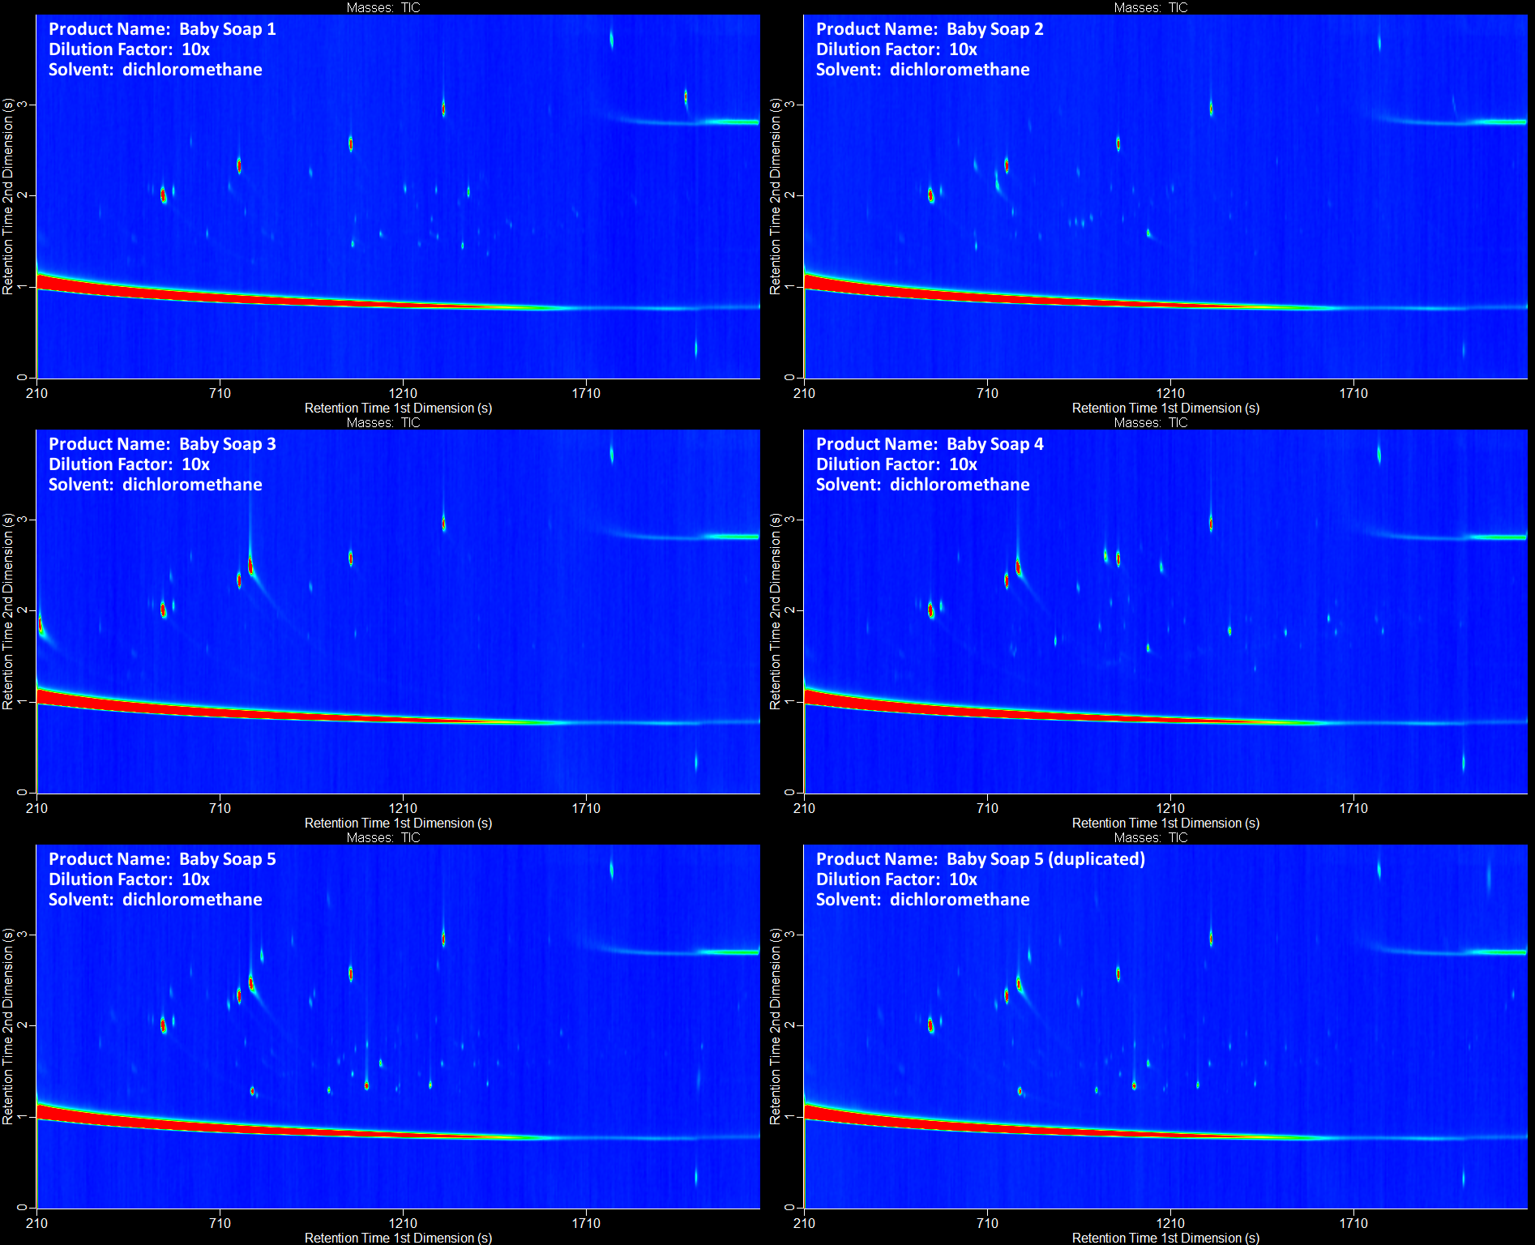
Figure S8. Gas chromatograms of baby soaps.

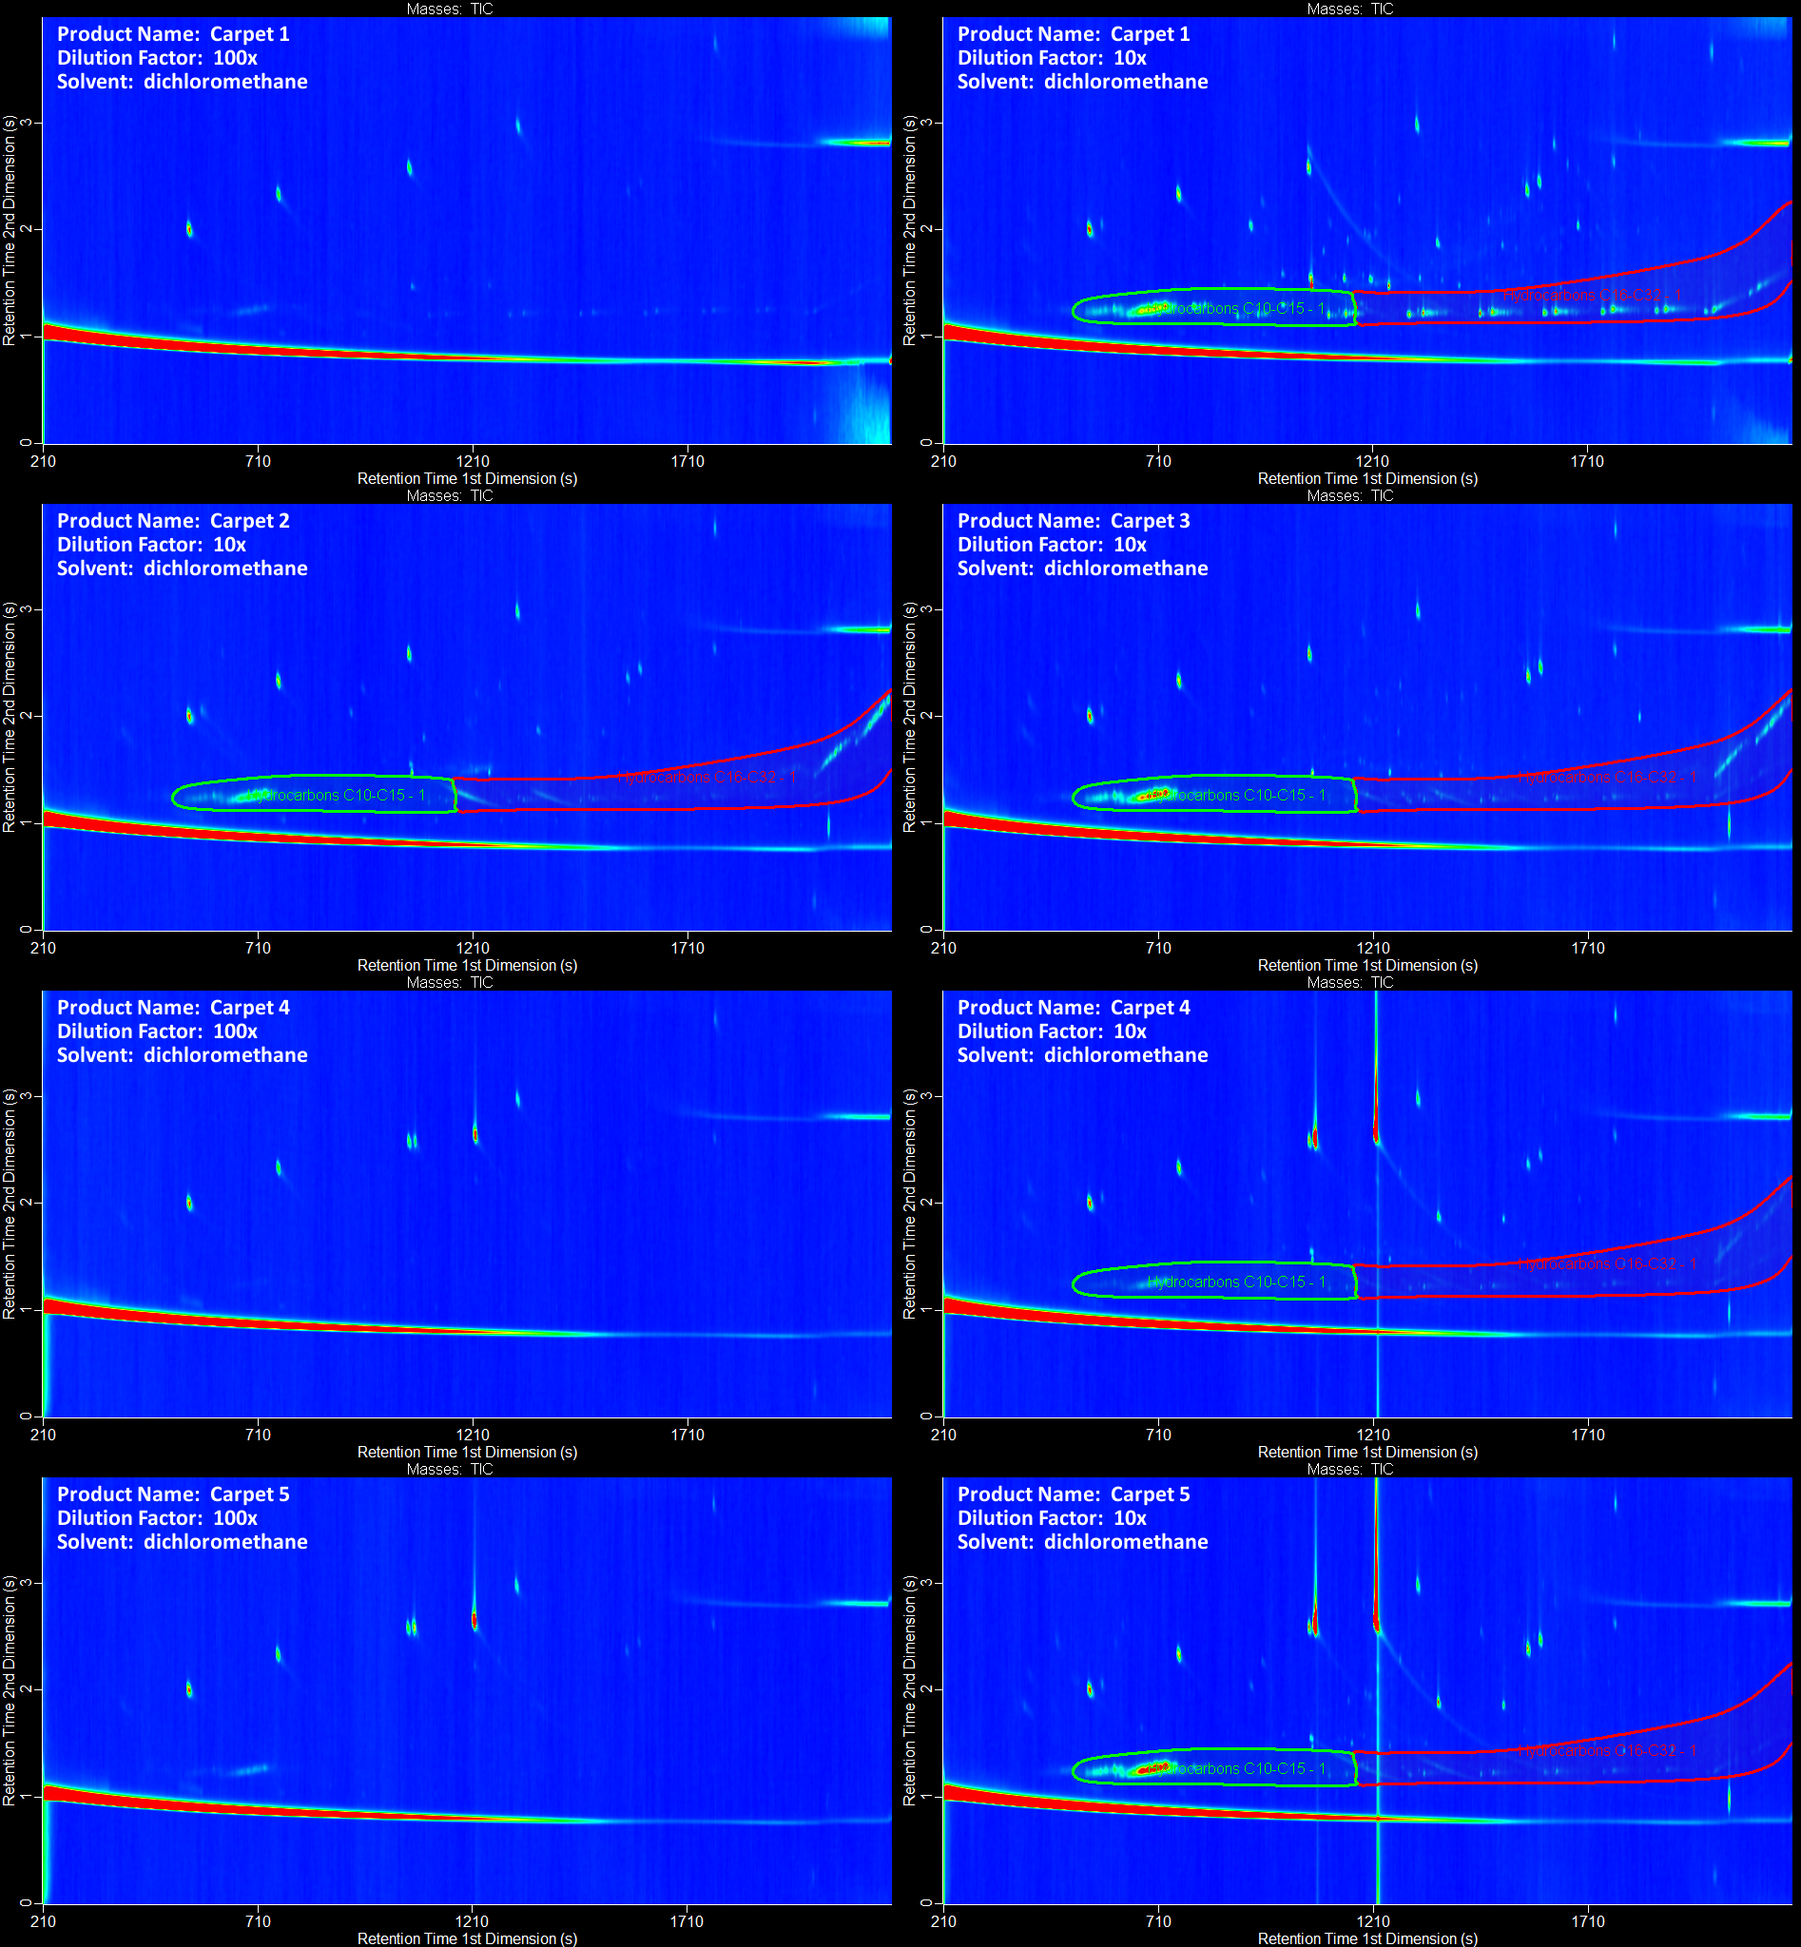
Figure S9. Gas chromatograms of carpets.

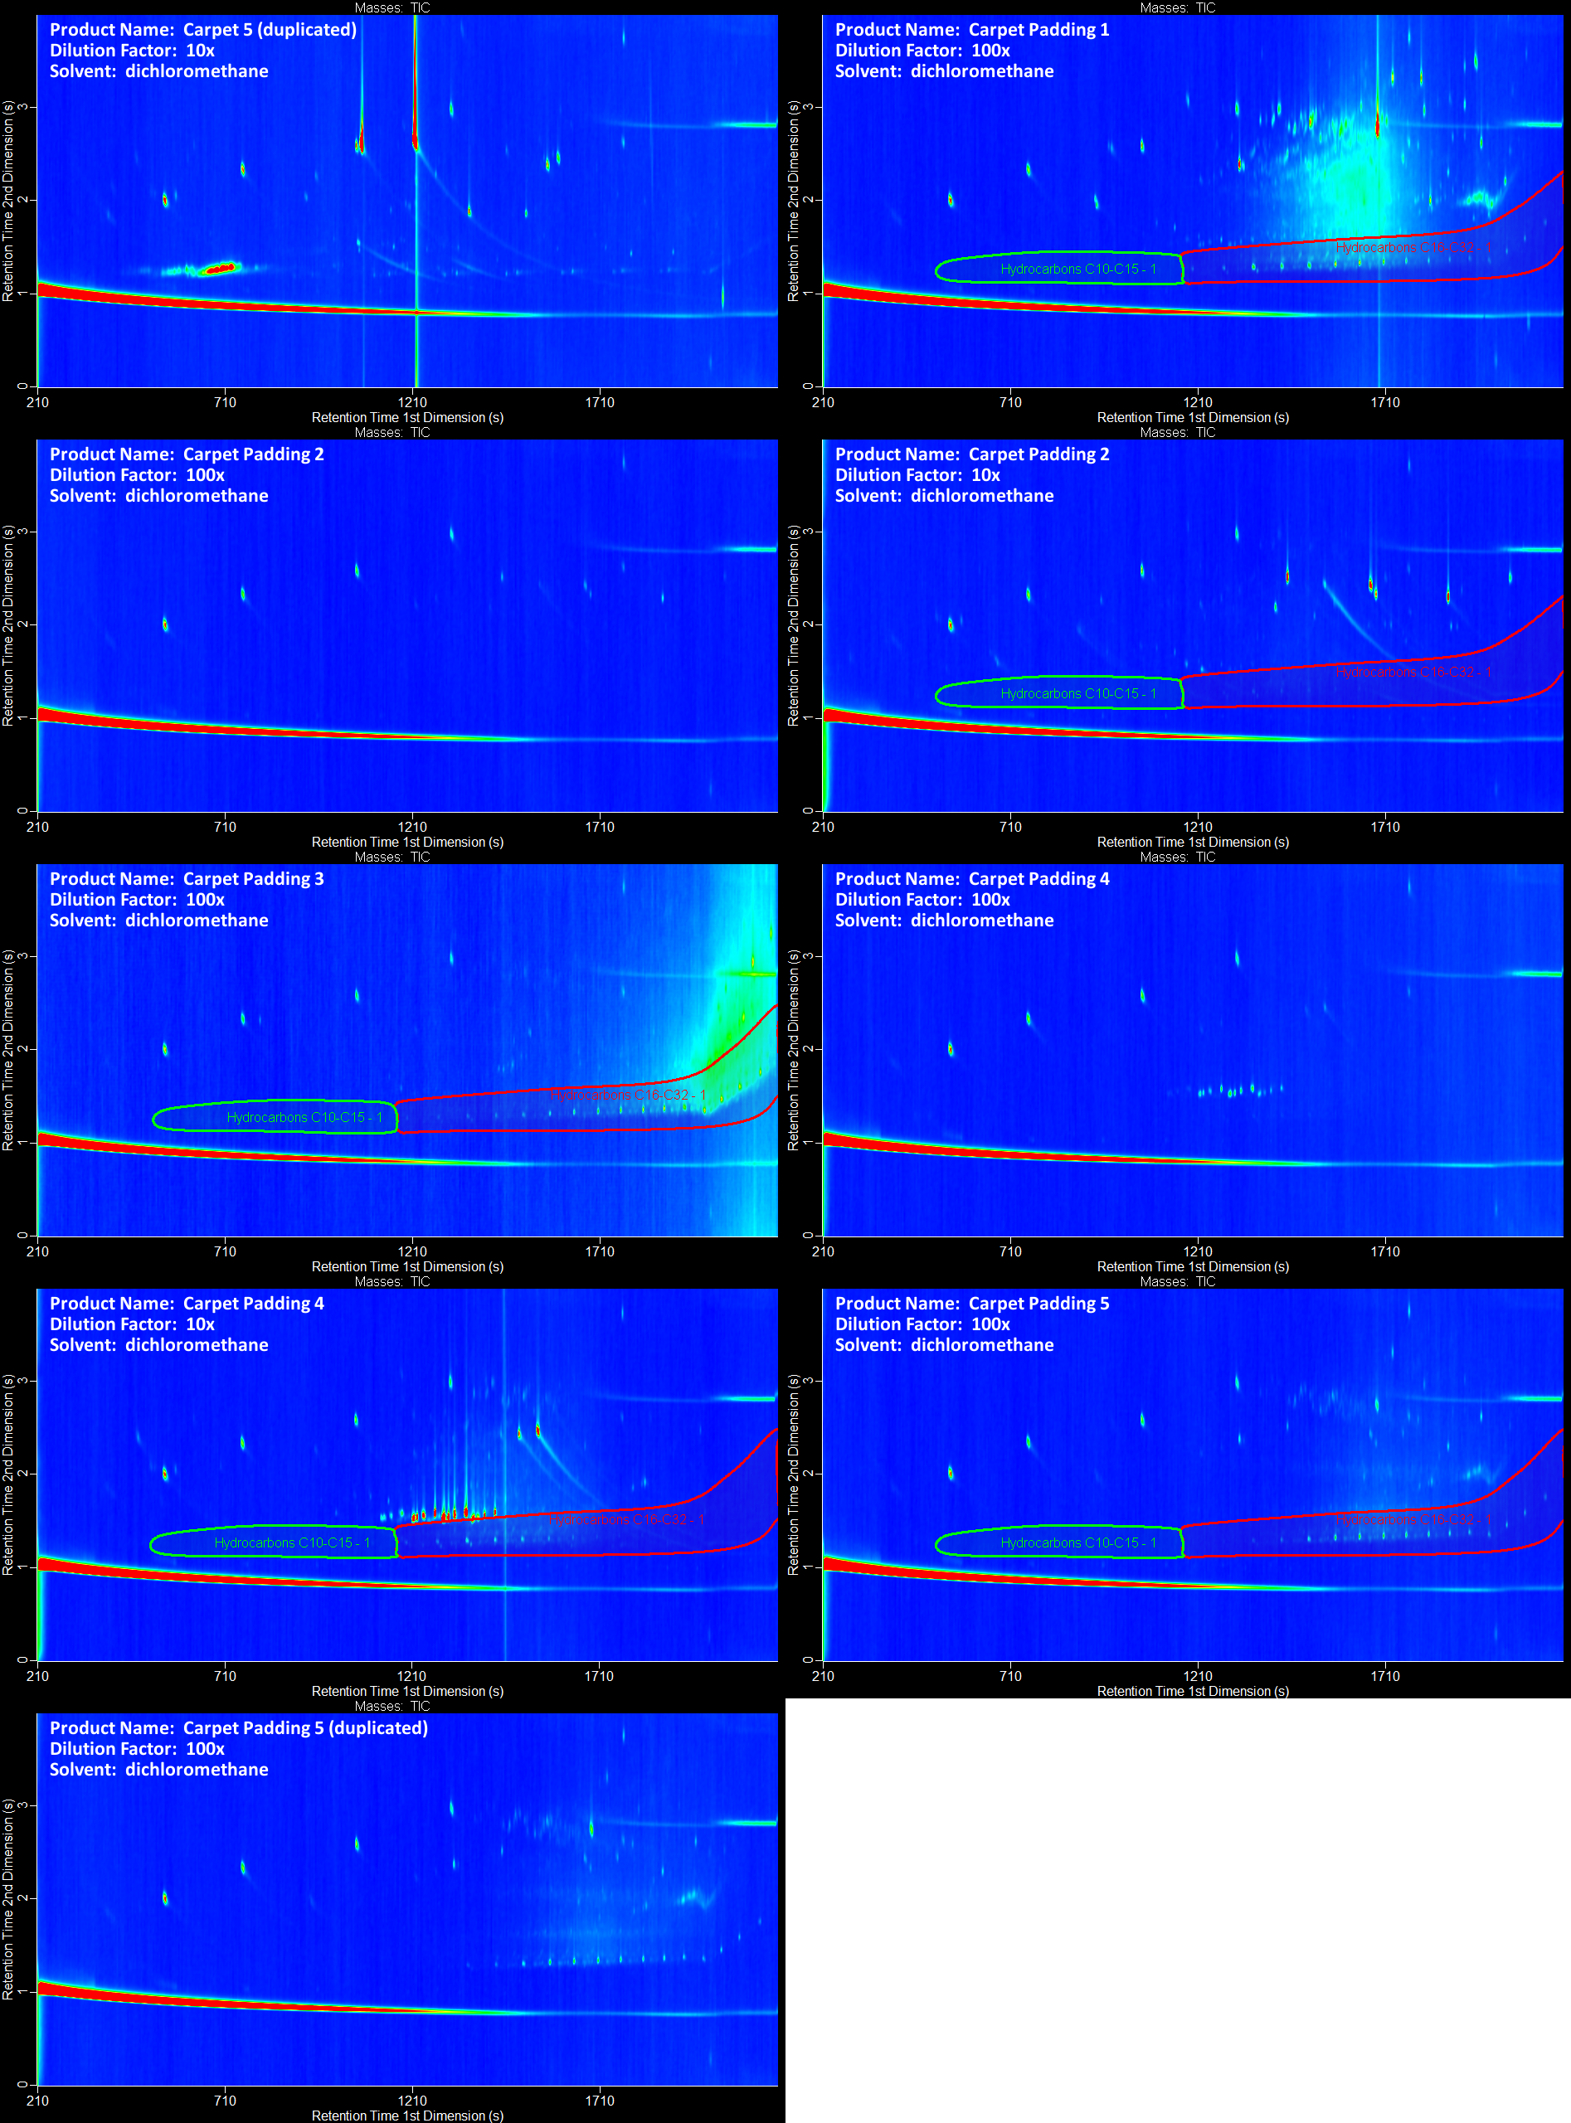
Figure S10. Gas chromatograms of carpets (continued).
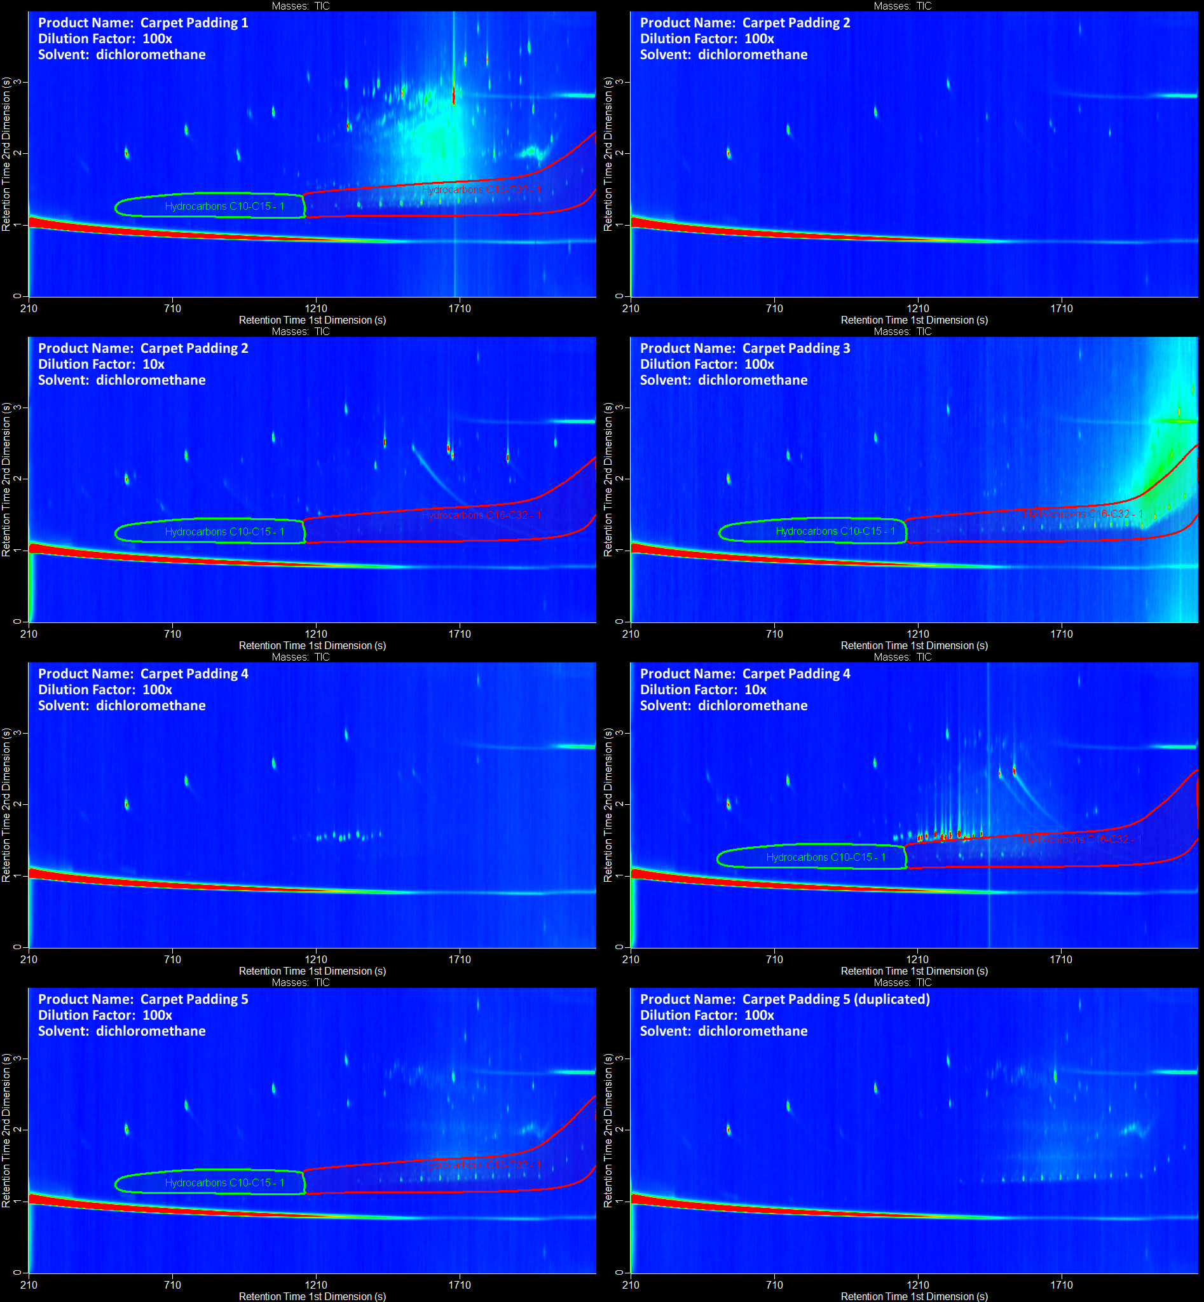
Figure S11. Gas chromatograms of carpet paddings.

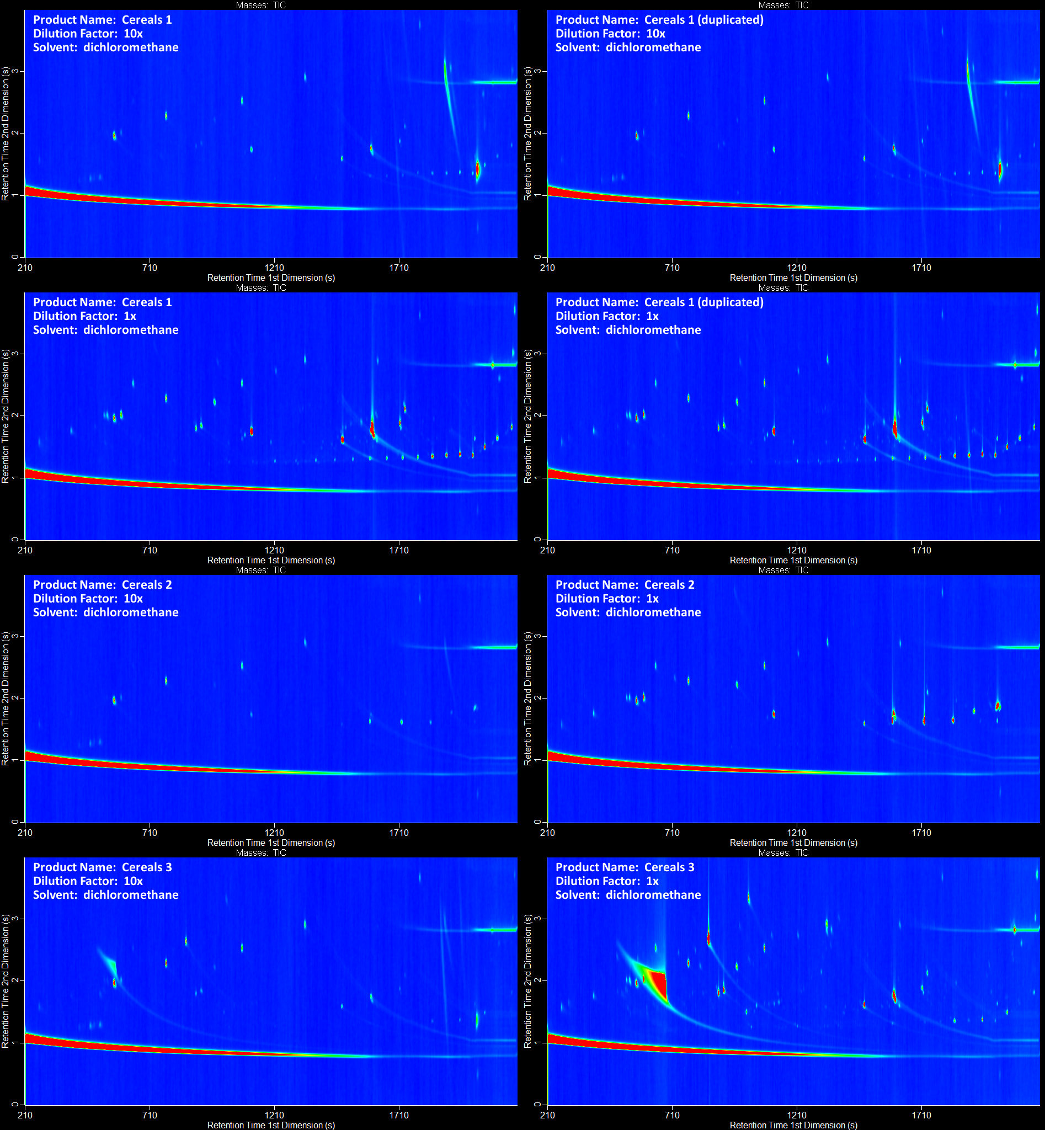
Figure S12. Gas chromatograms of cereals.

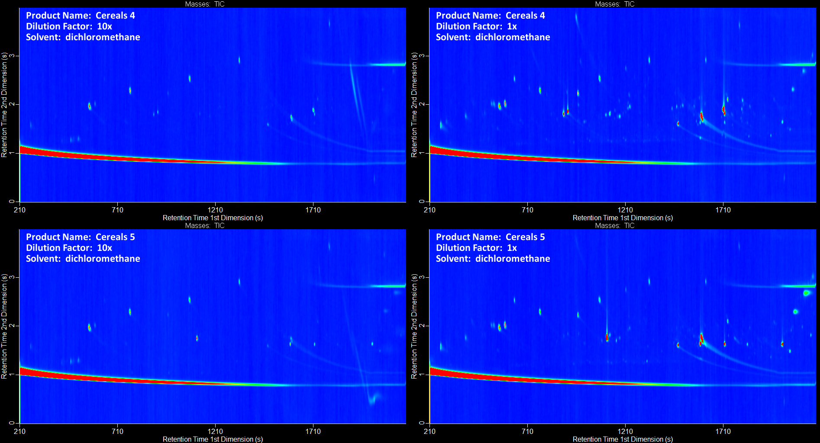
Figure S13. Gas chromatograms of cereals (continued).

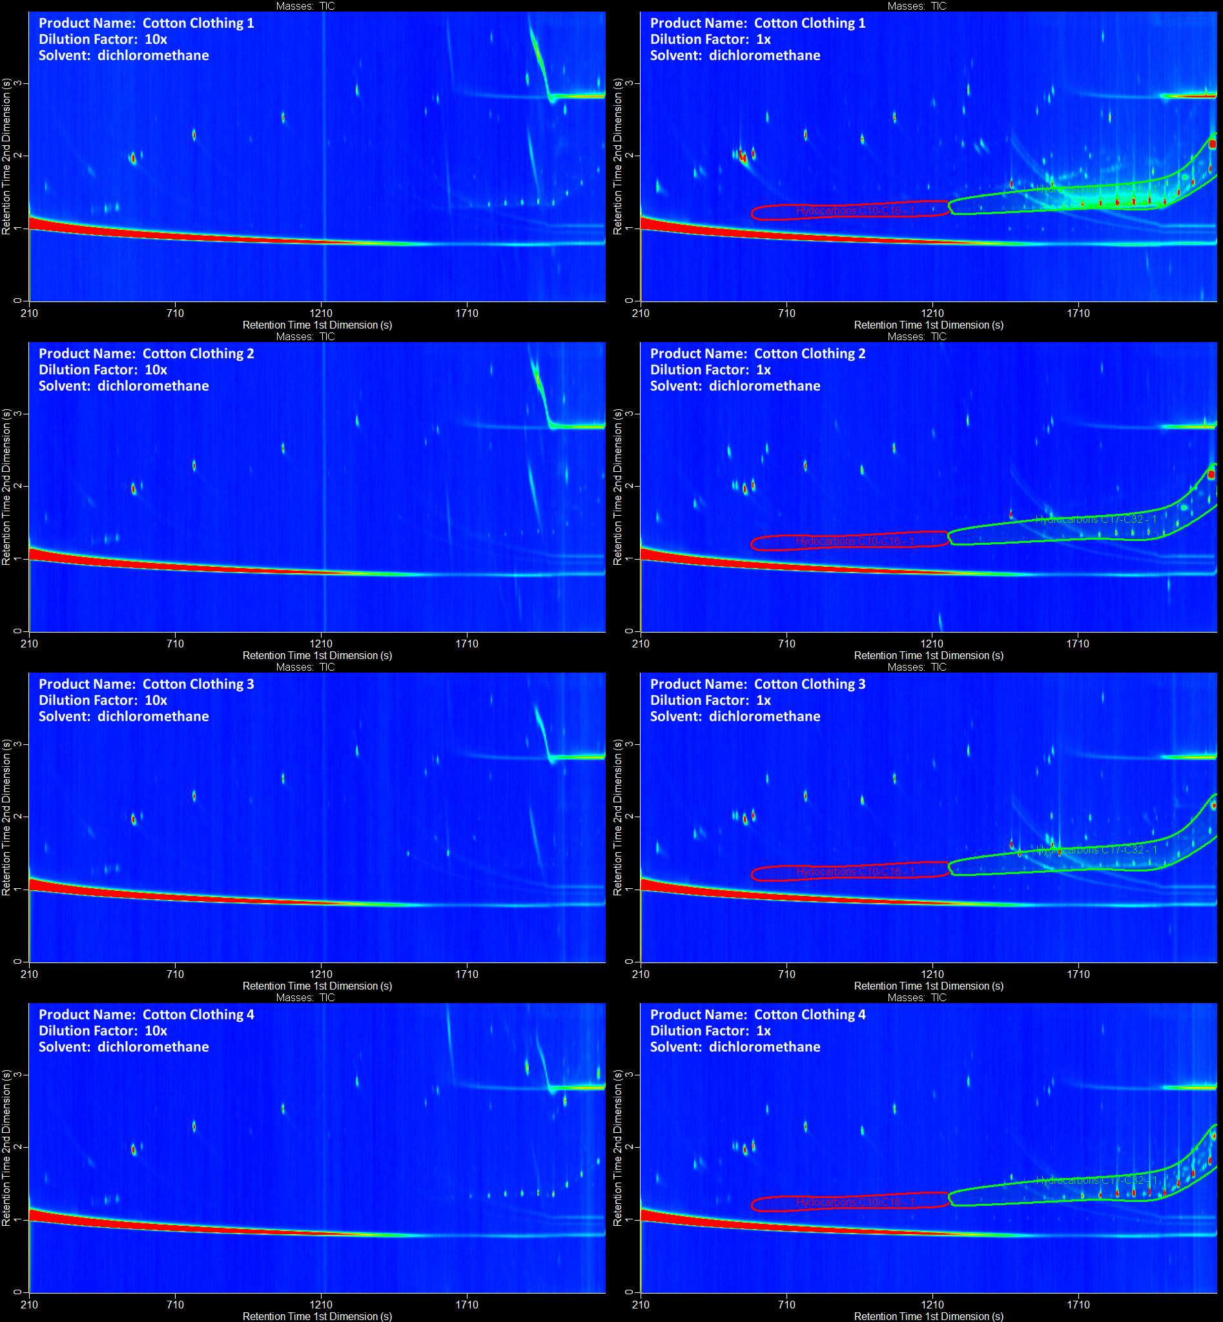
Figure S14. Gas chromatograms of cotton clothing.

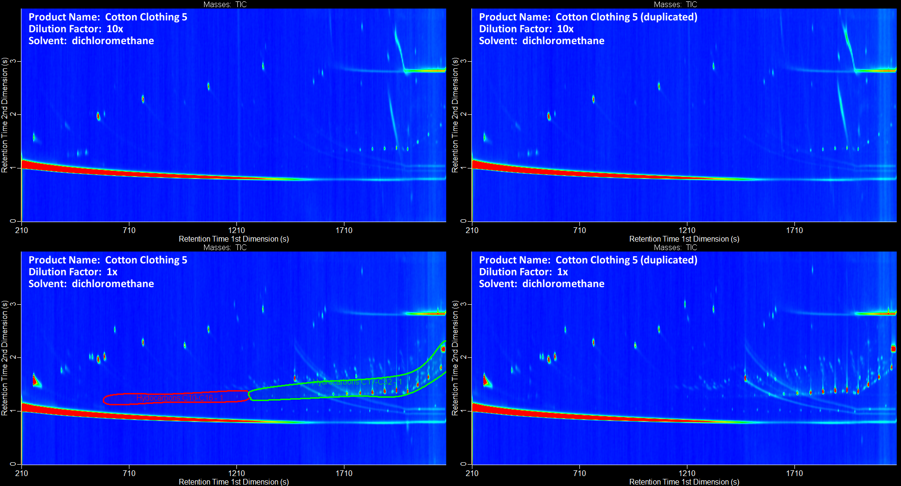
Figure S15. Gas chromatograms of cotton clothing (continued).

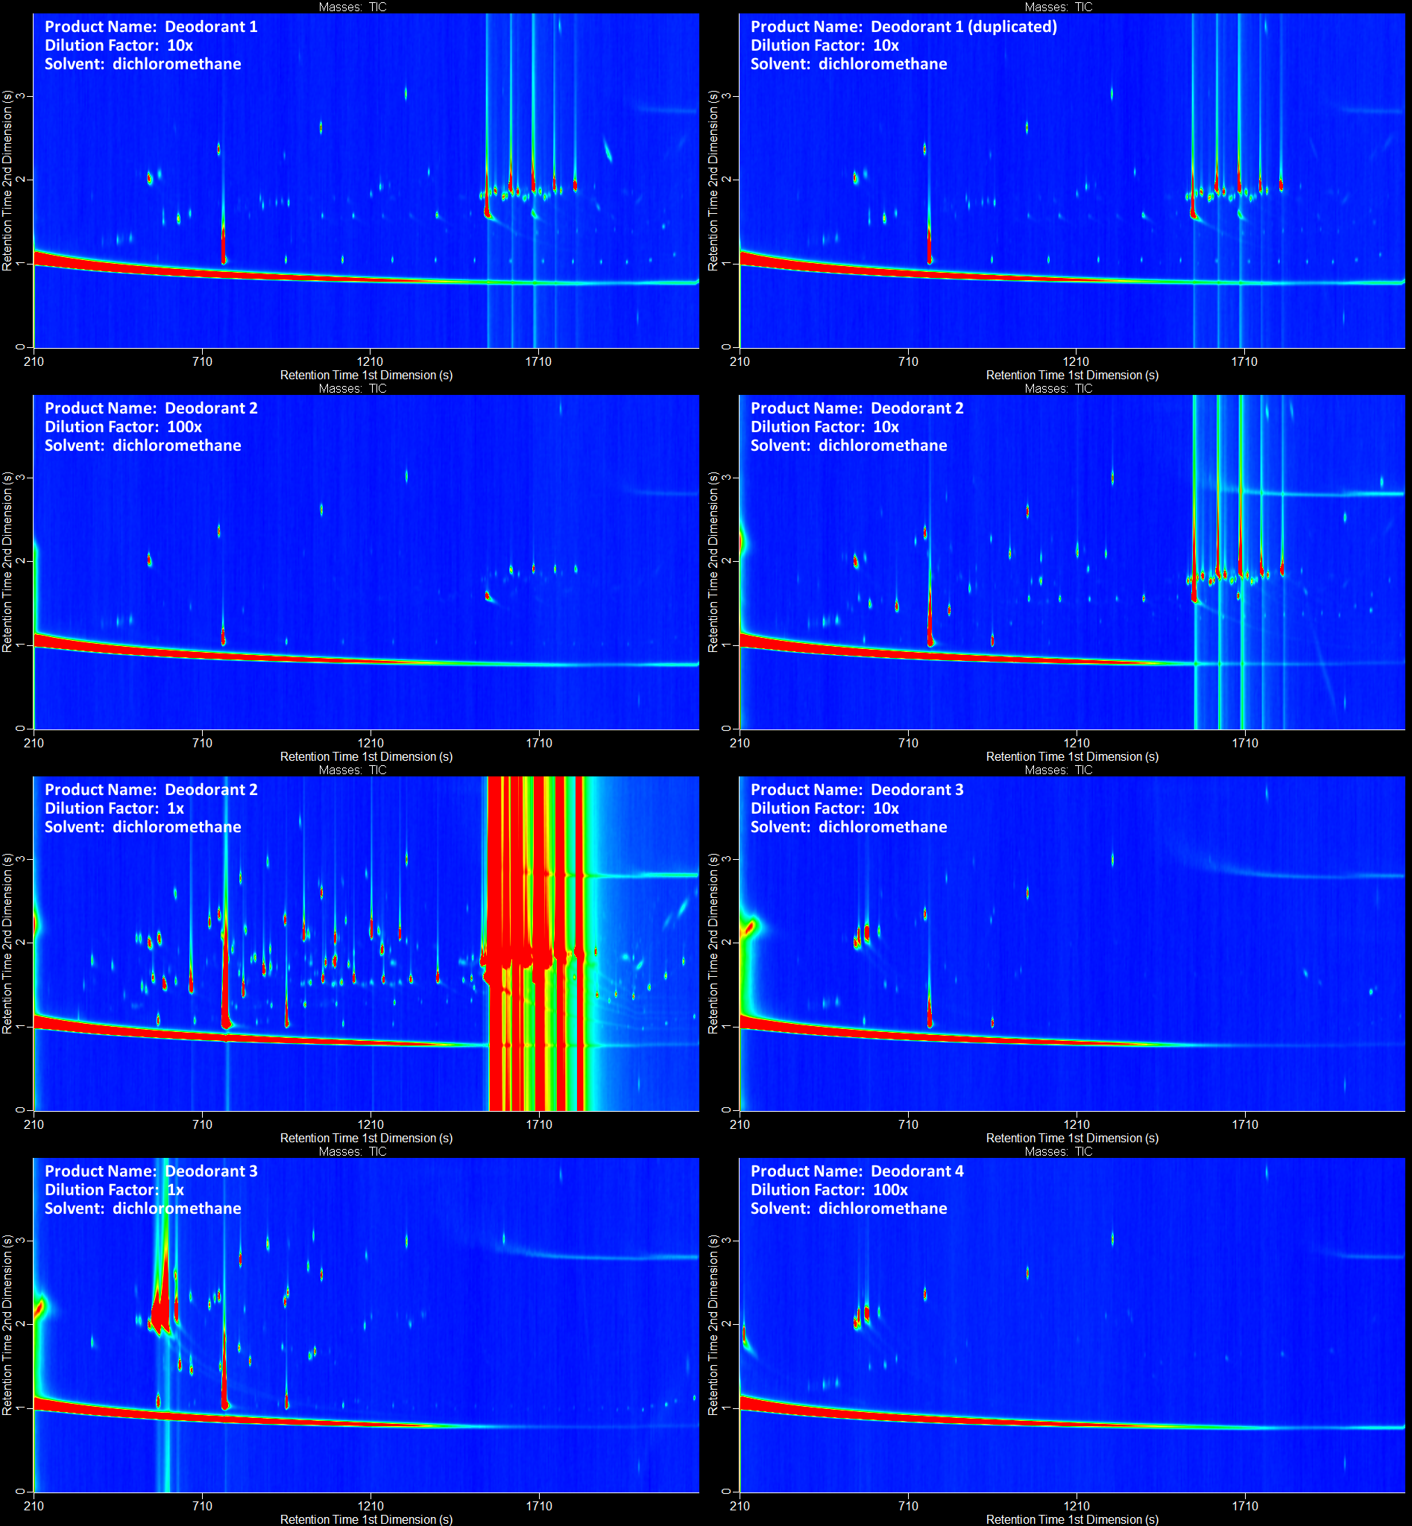
Figure S16. Gas chromatograms of deodorant.

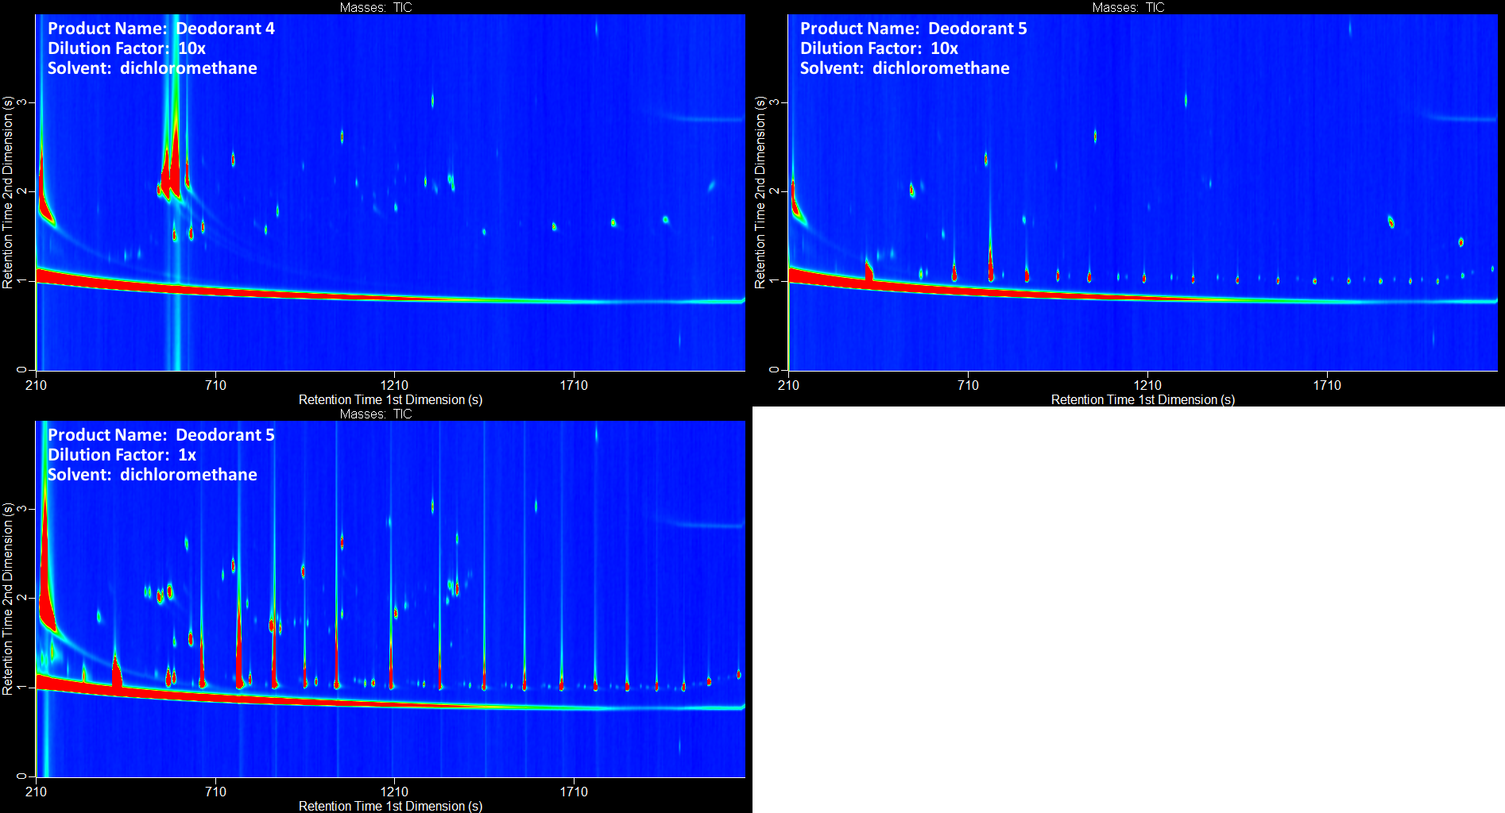
Figure S17. Gas chromatograms of deodorant (continued).

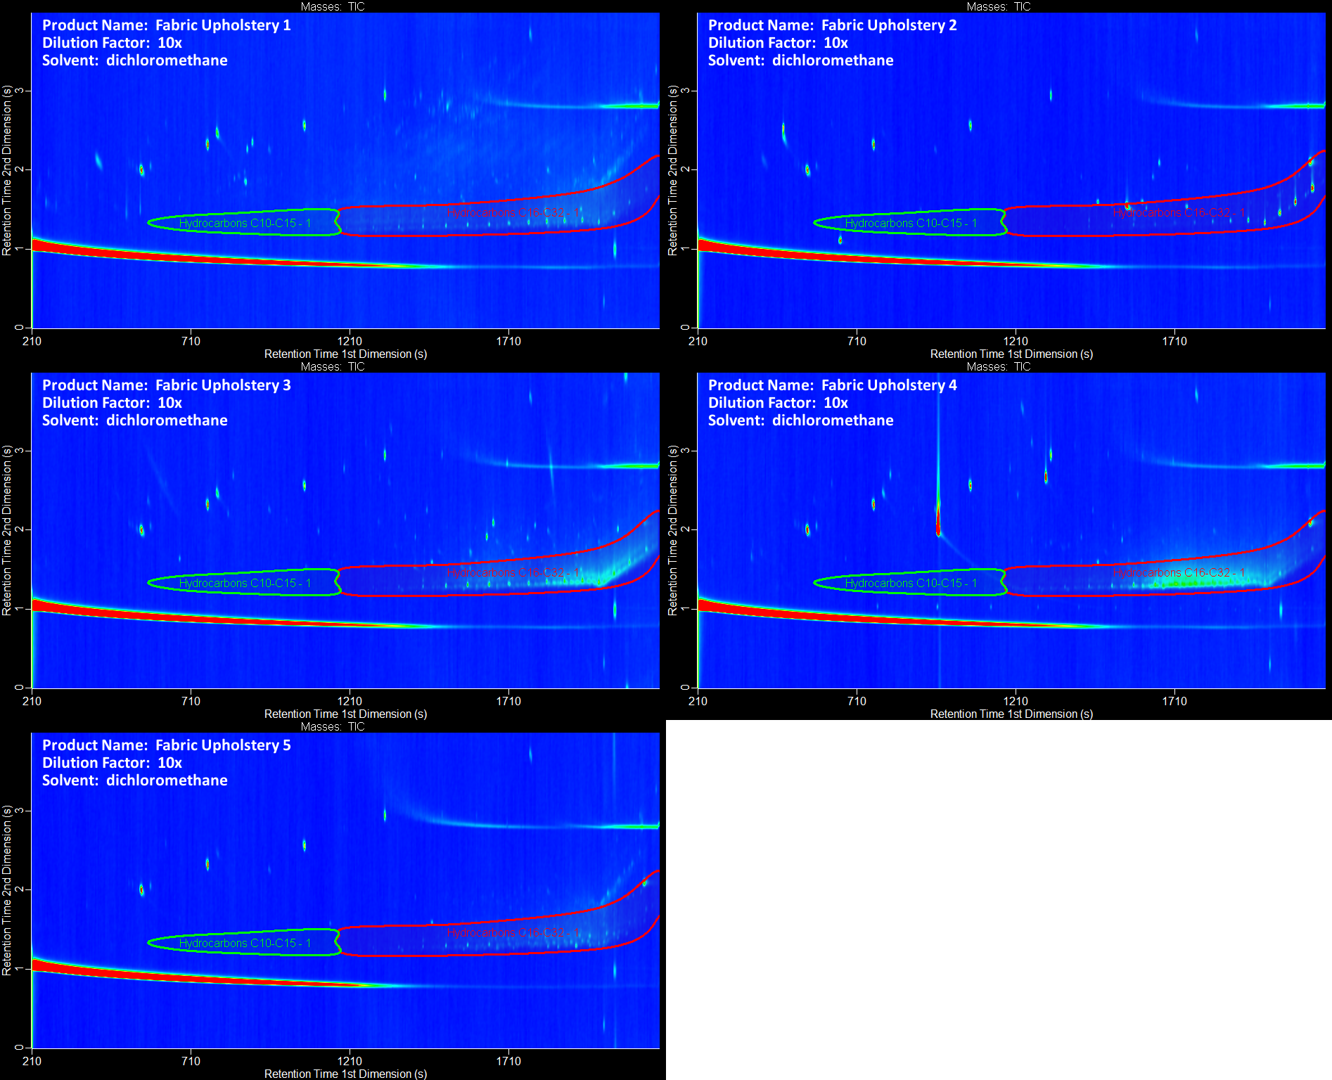
Figure S18. Gas chromatograms of fabric upholstery.

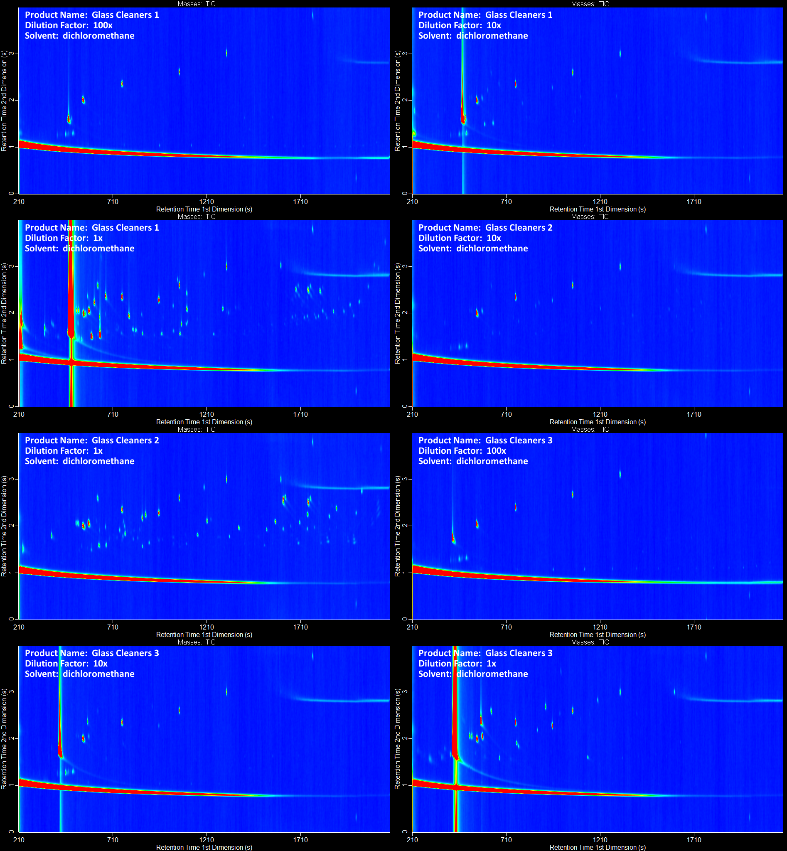
Figure S19. Gas chromatograms of glass cleaners.

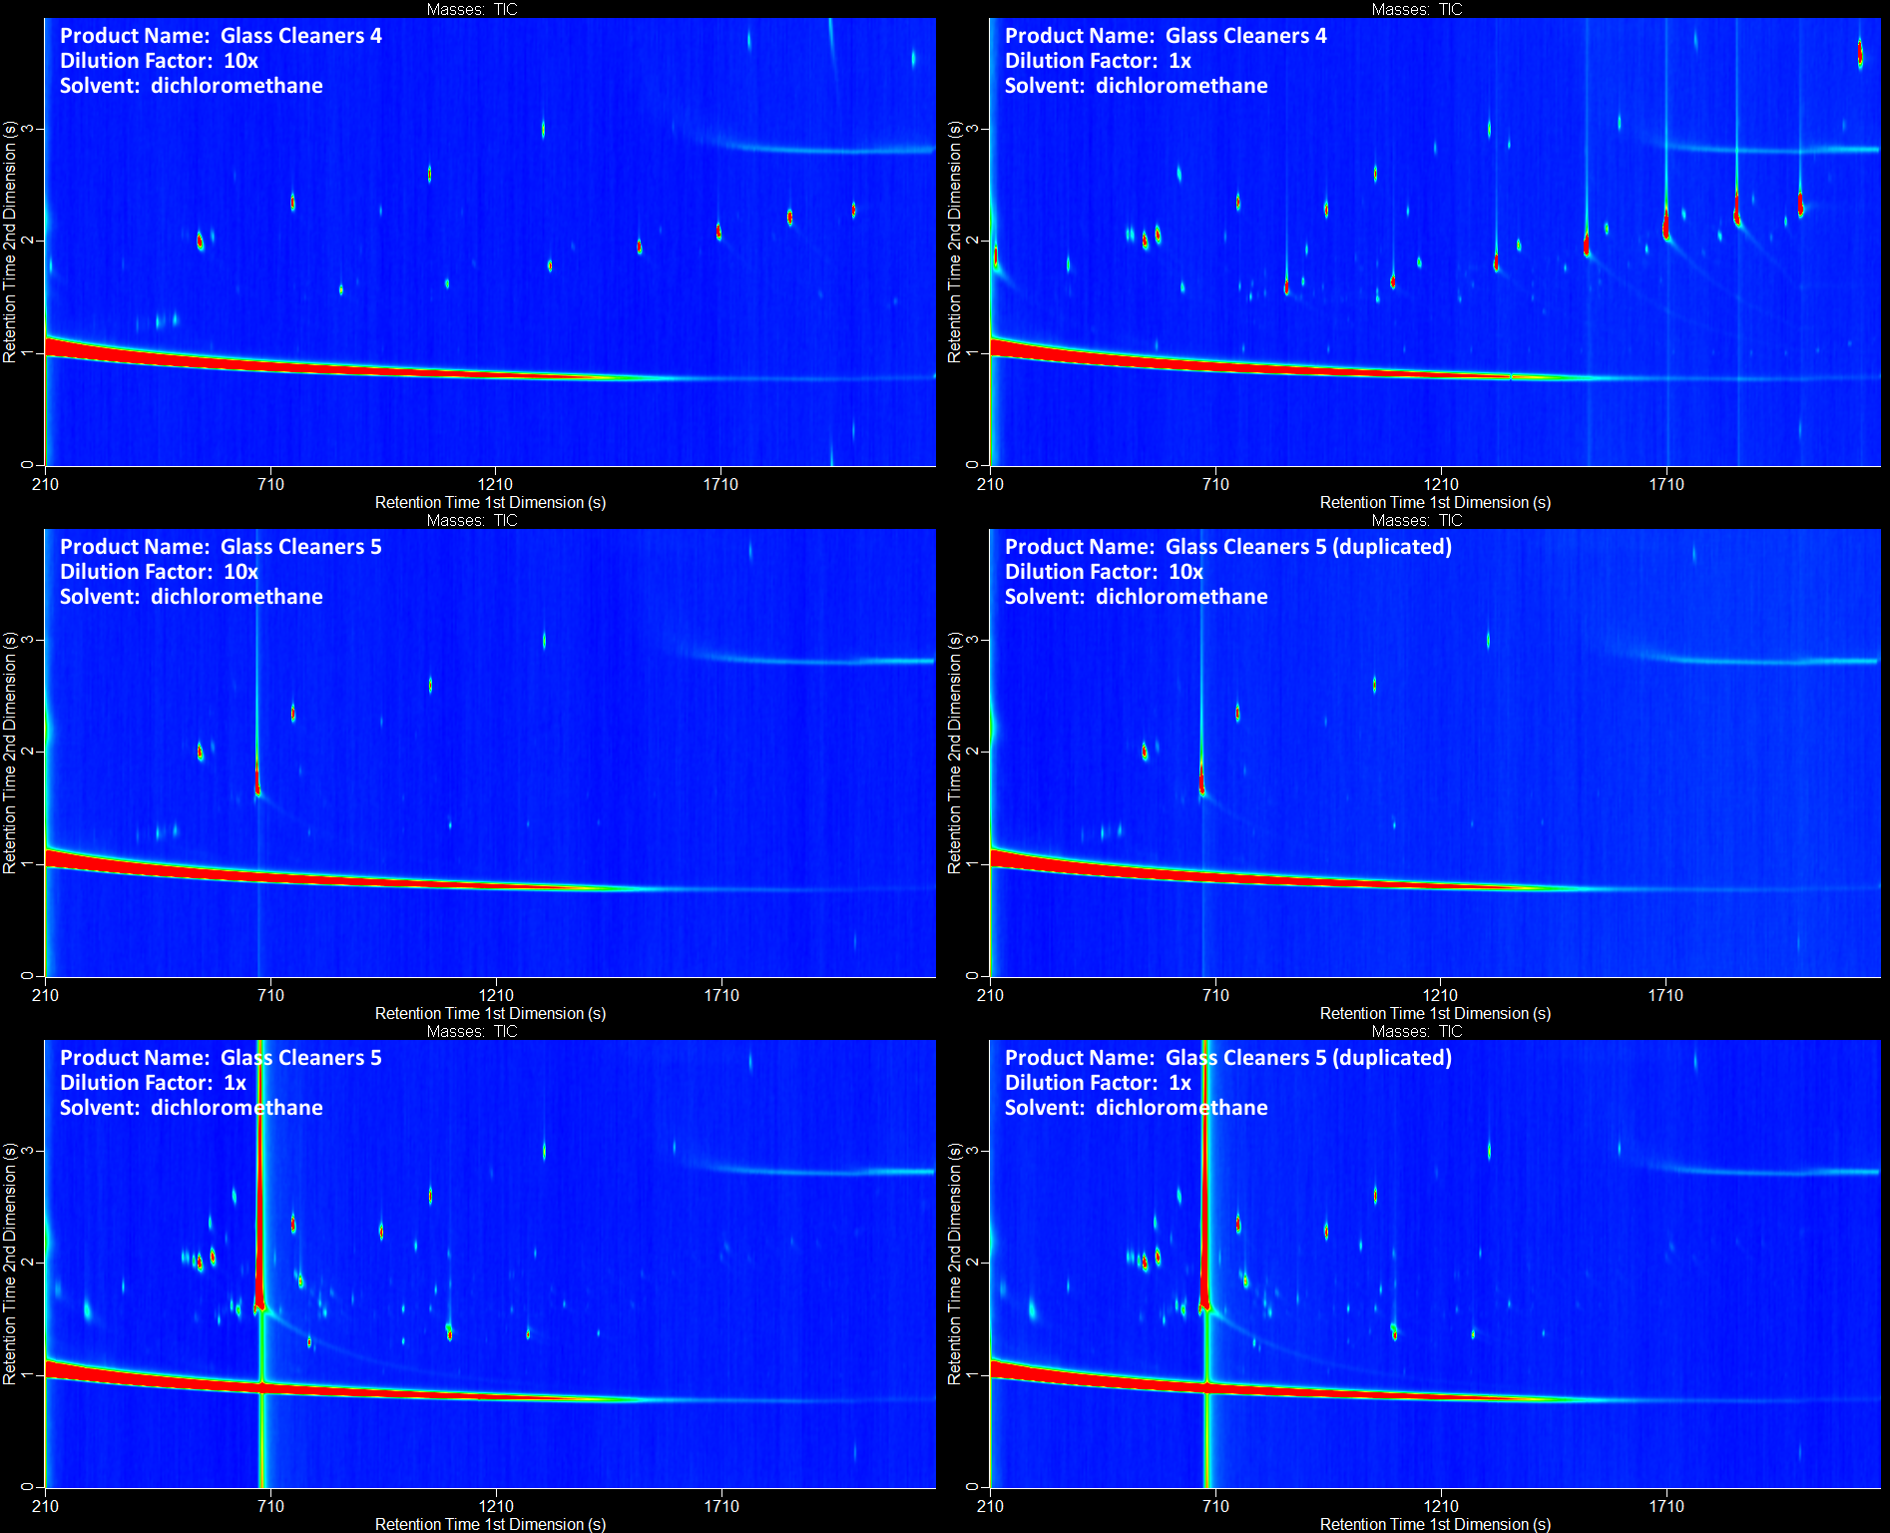
Figure S20. Gas chromatograms of glass cleaners (continued).

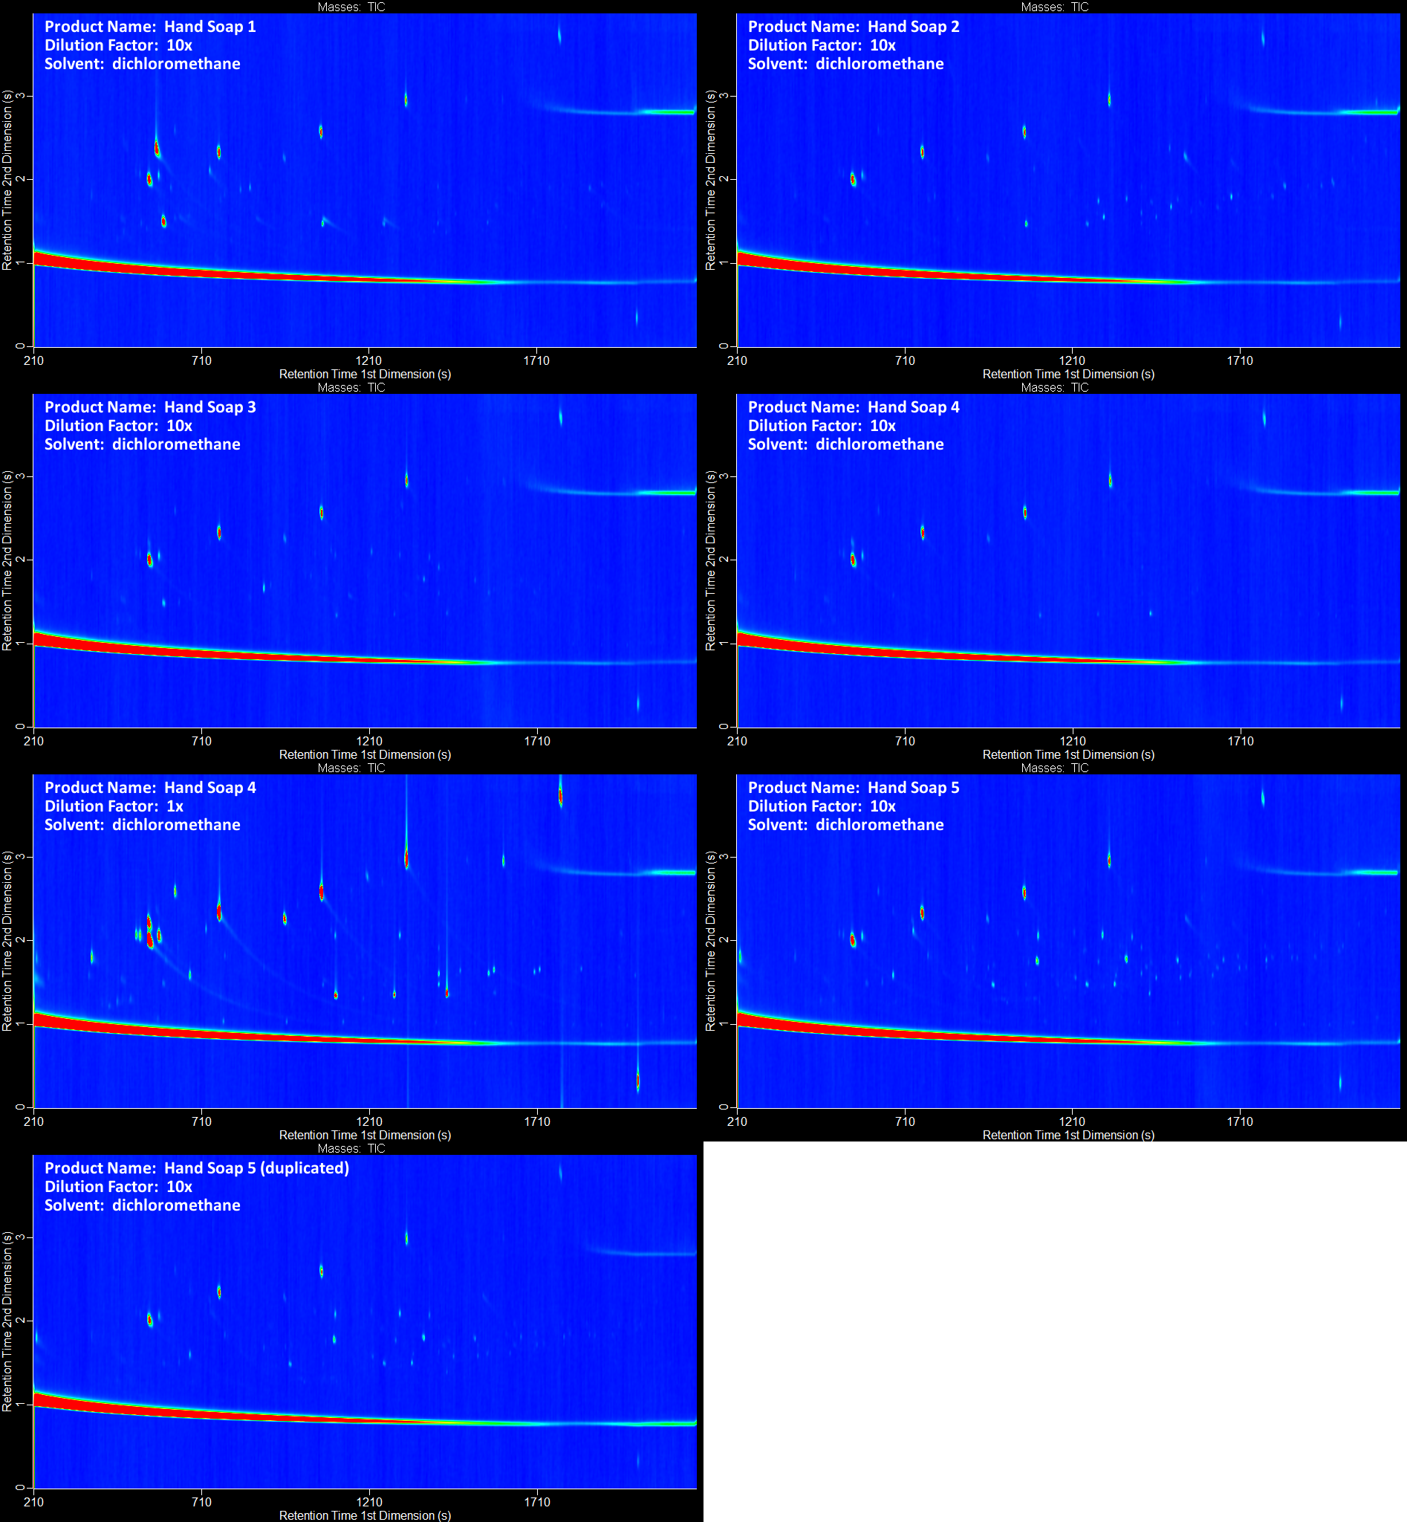
Figure S21. Gas chromatograms of hand soaps.

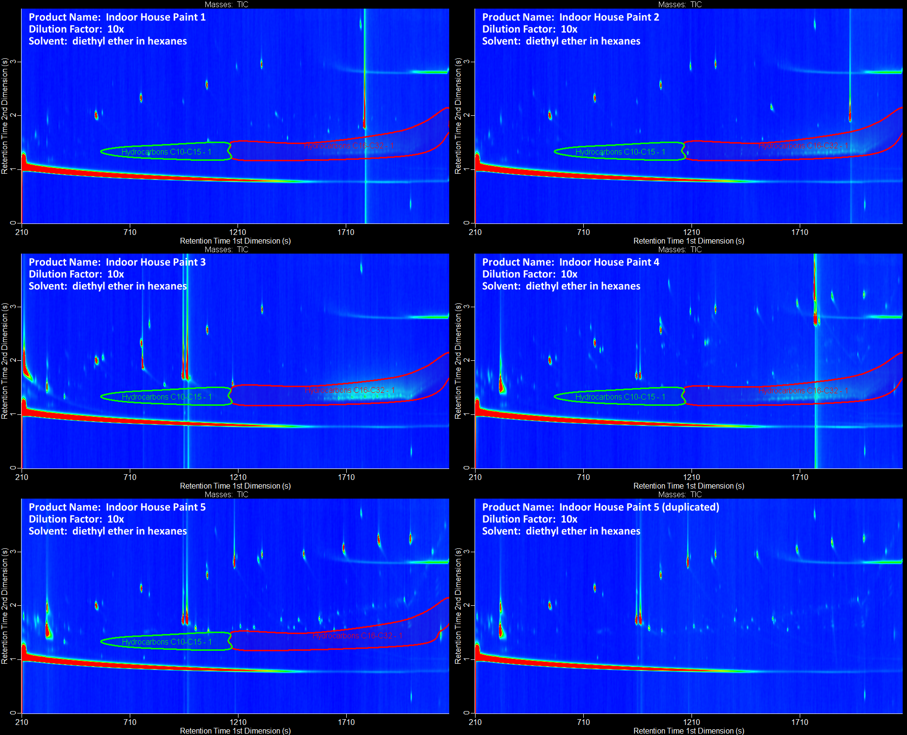
Figure S22. Gas chromatograms of indoor house paints.

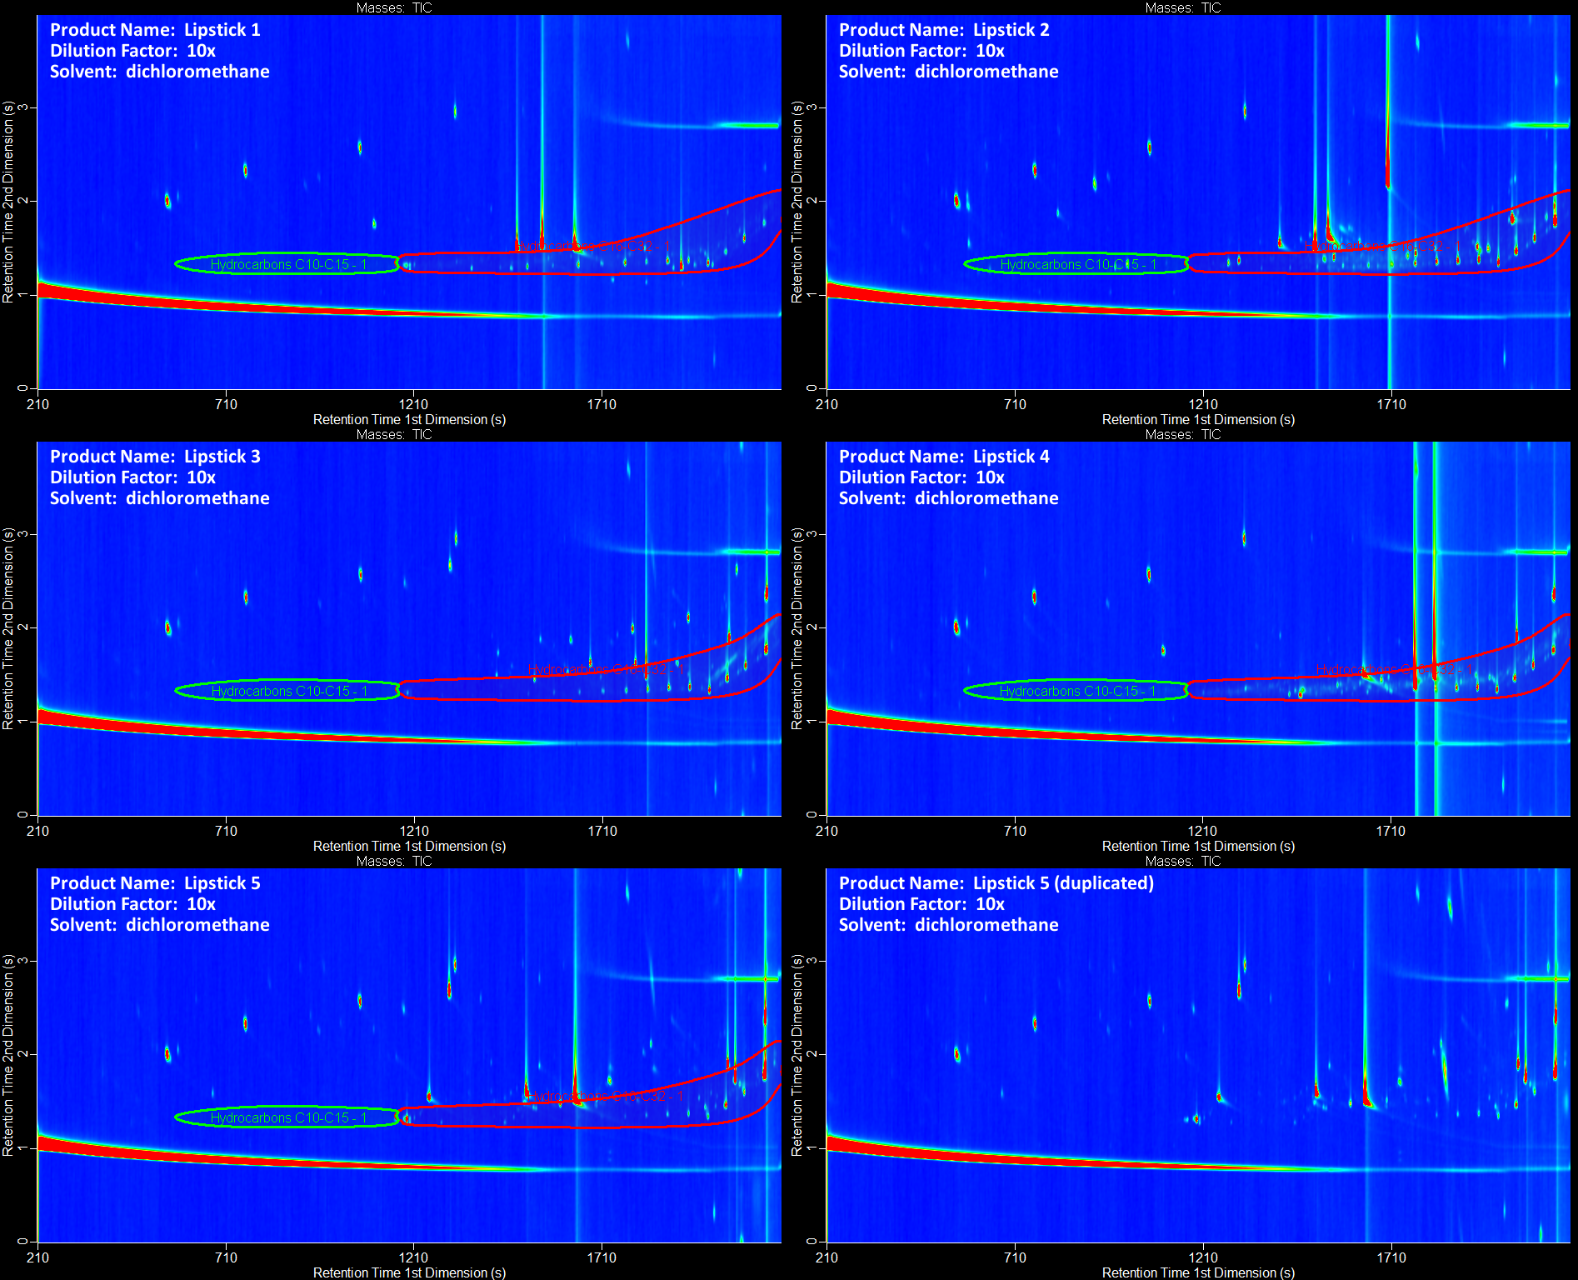
Figure S23. Gas chromatograms of lipsticks.

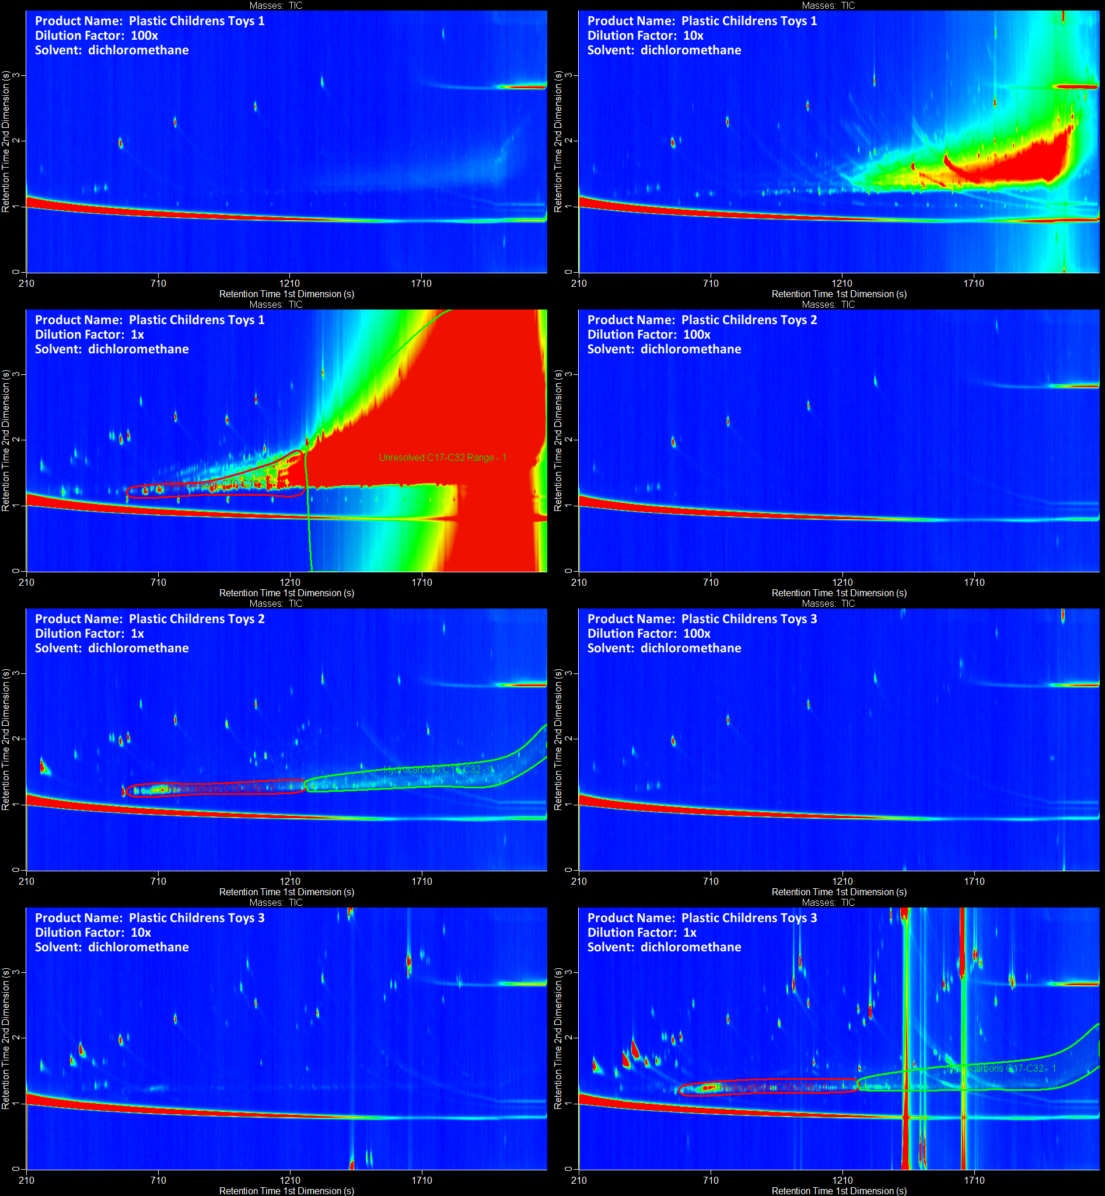
Figure S24. Gas chromatograms of plastic children’s toys.

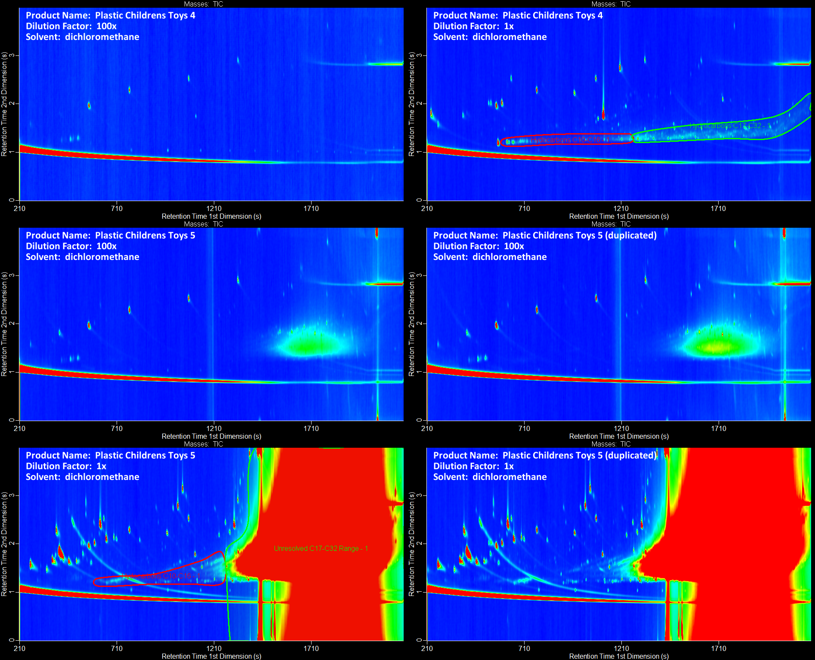
Figure S25. Gas chromatograms of plastic children’s toys (continued).

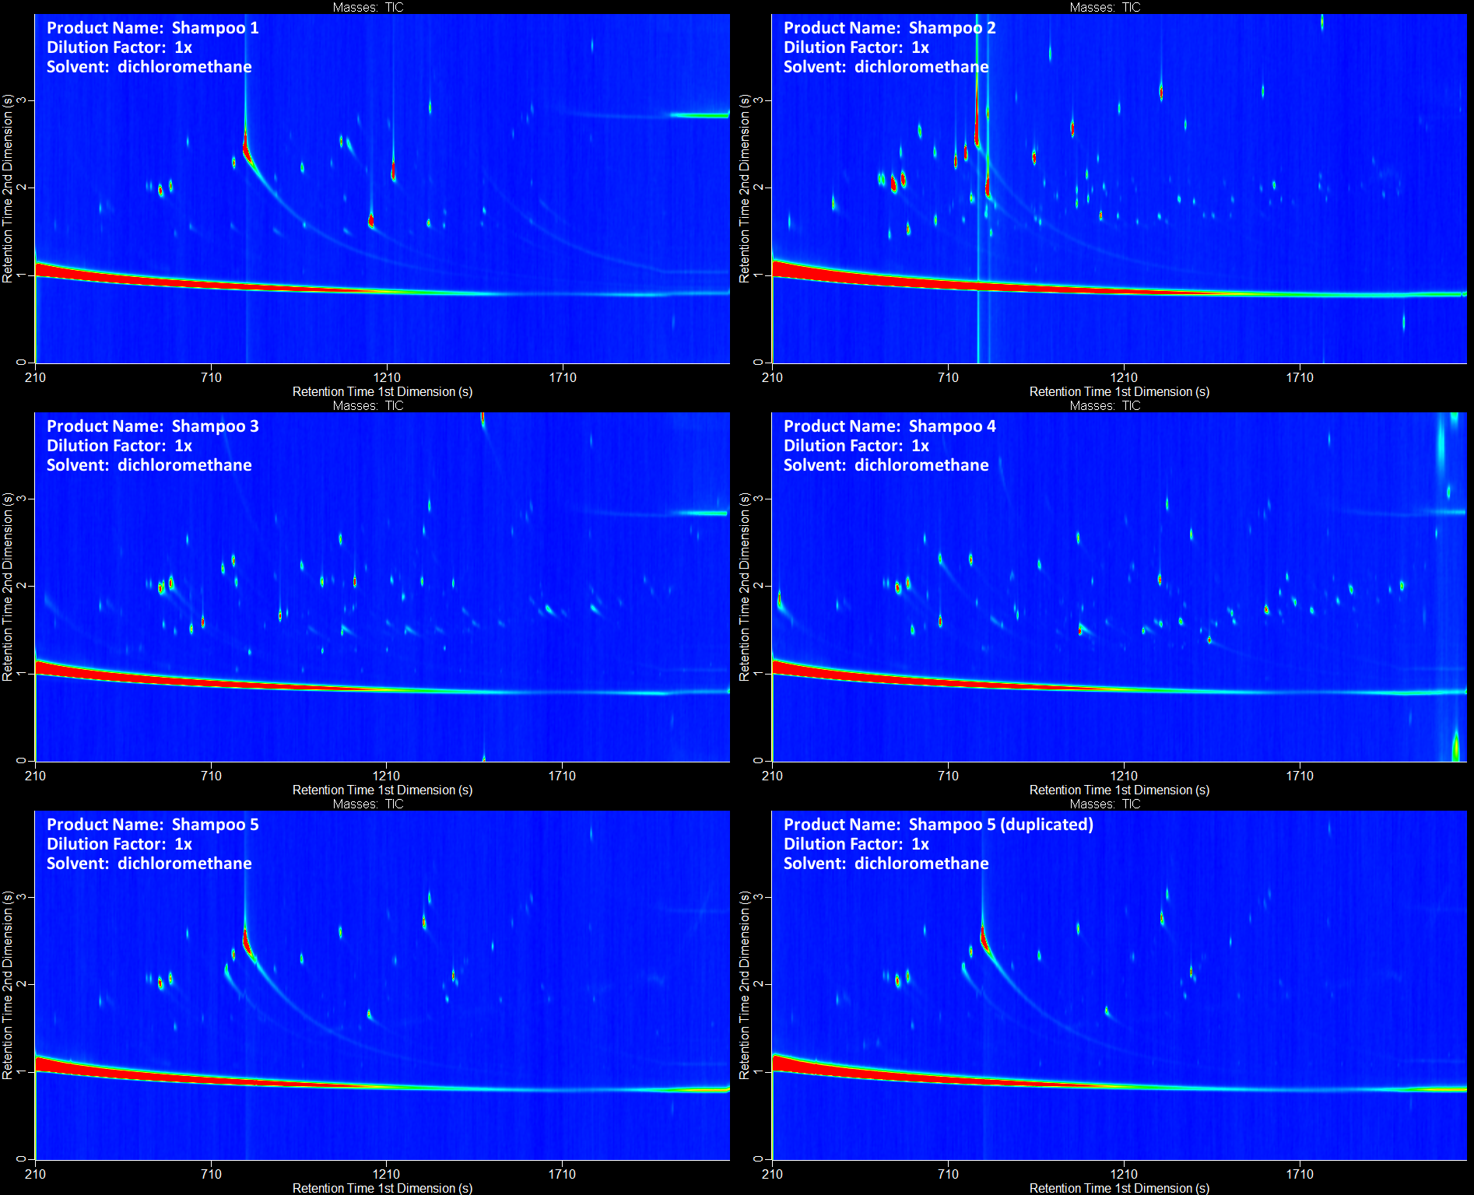
Figure S26. Gas chromatograms of shampoos.

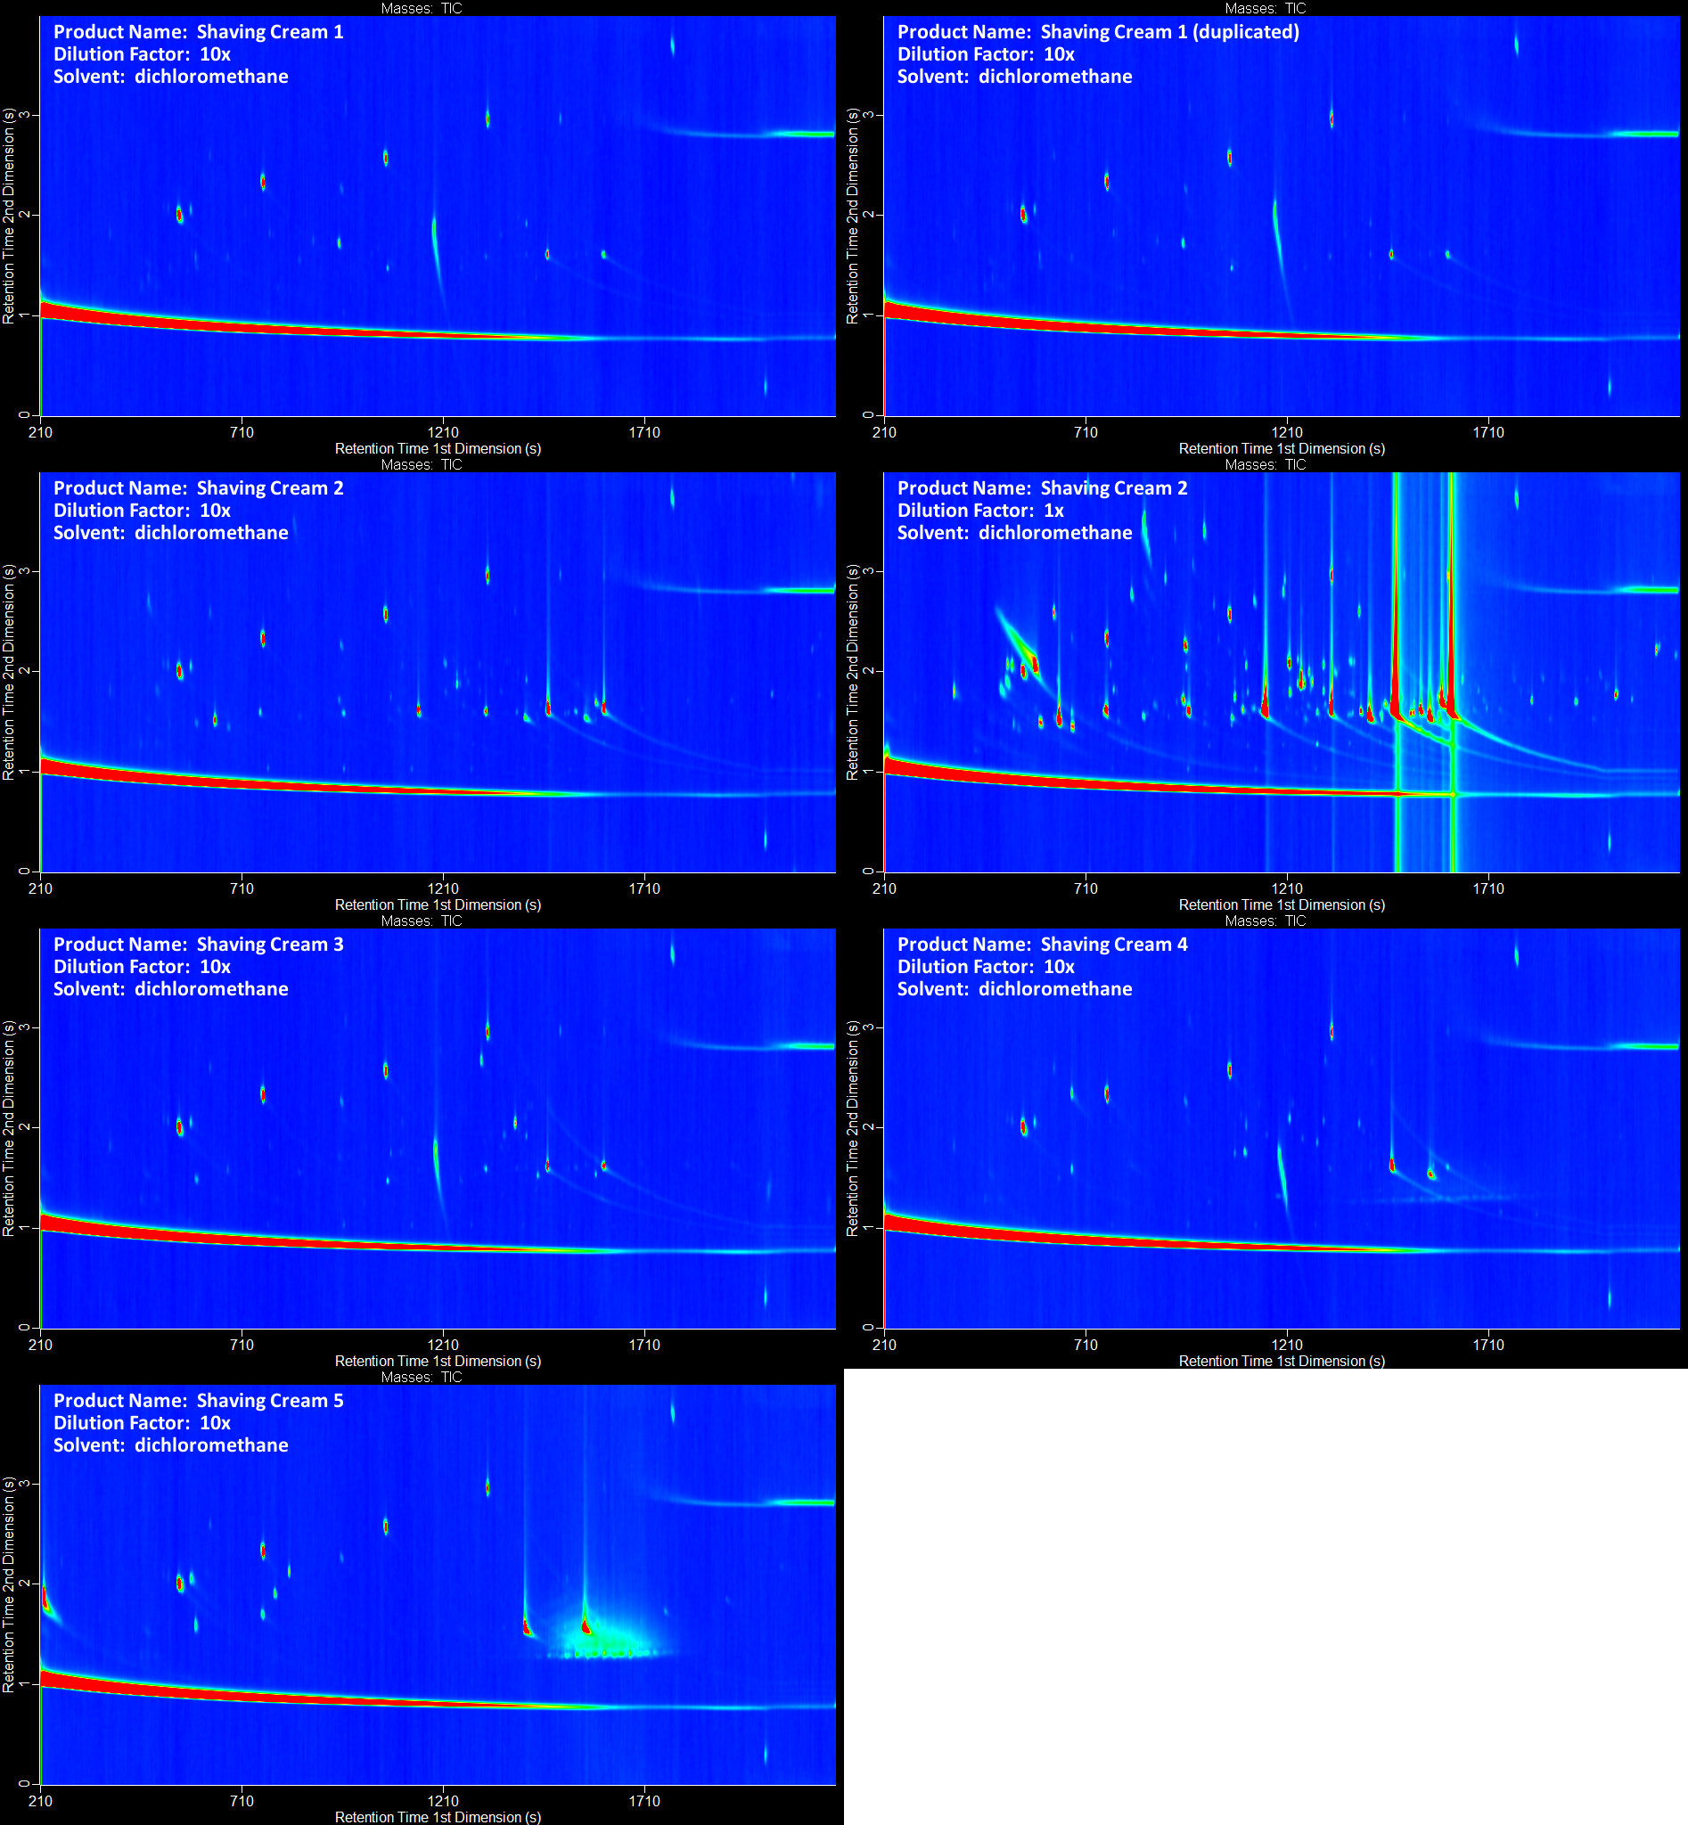
Figure S27. Gas chromatograms of shaving creams.

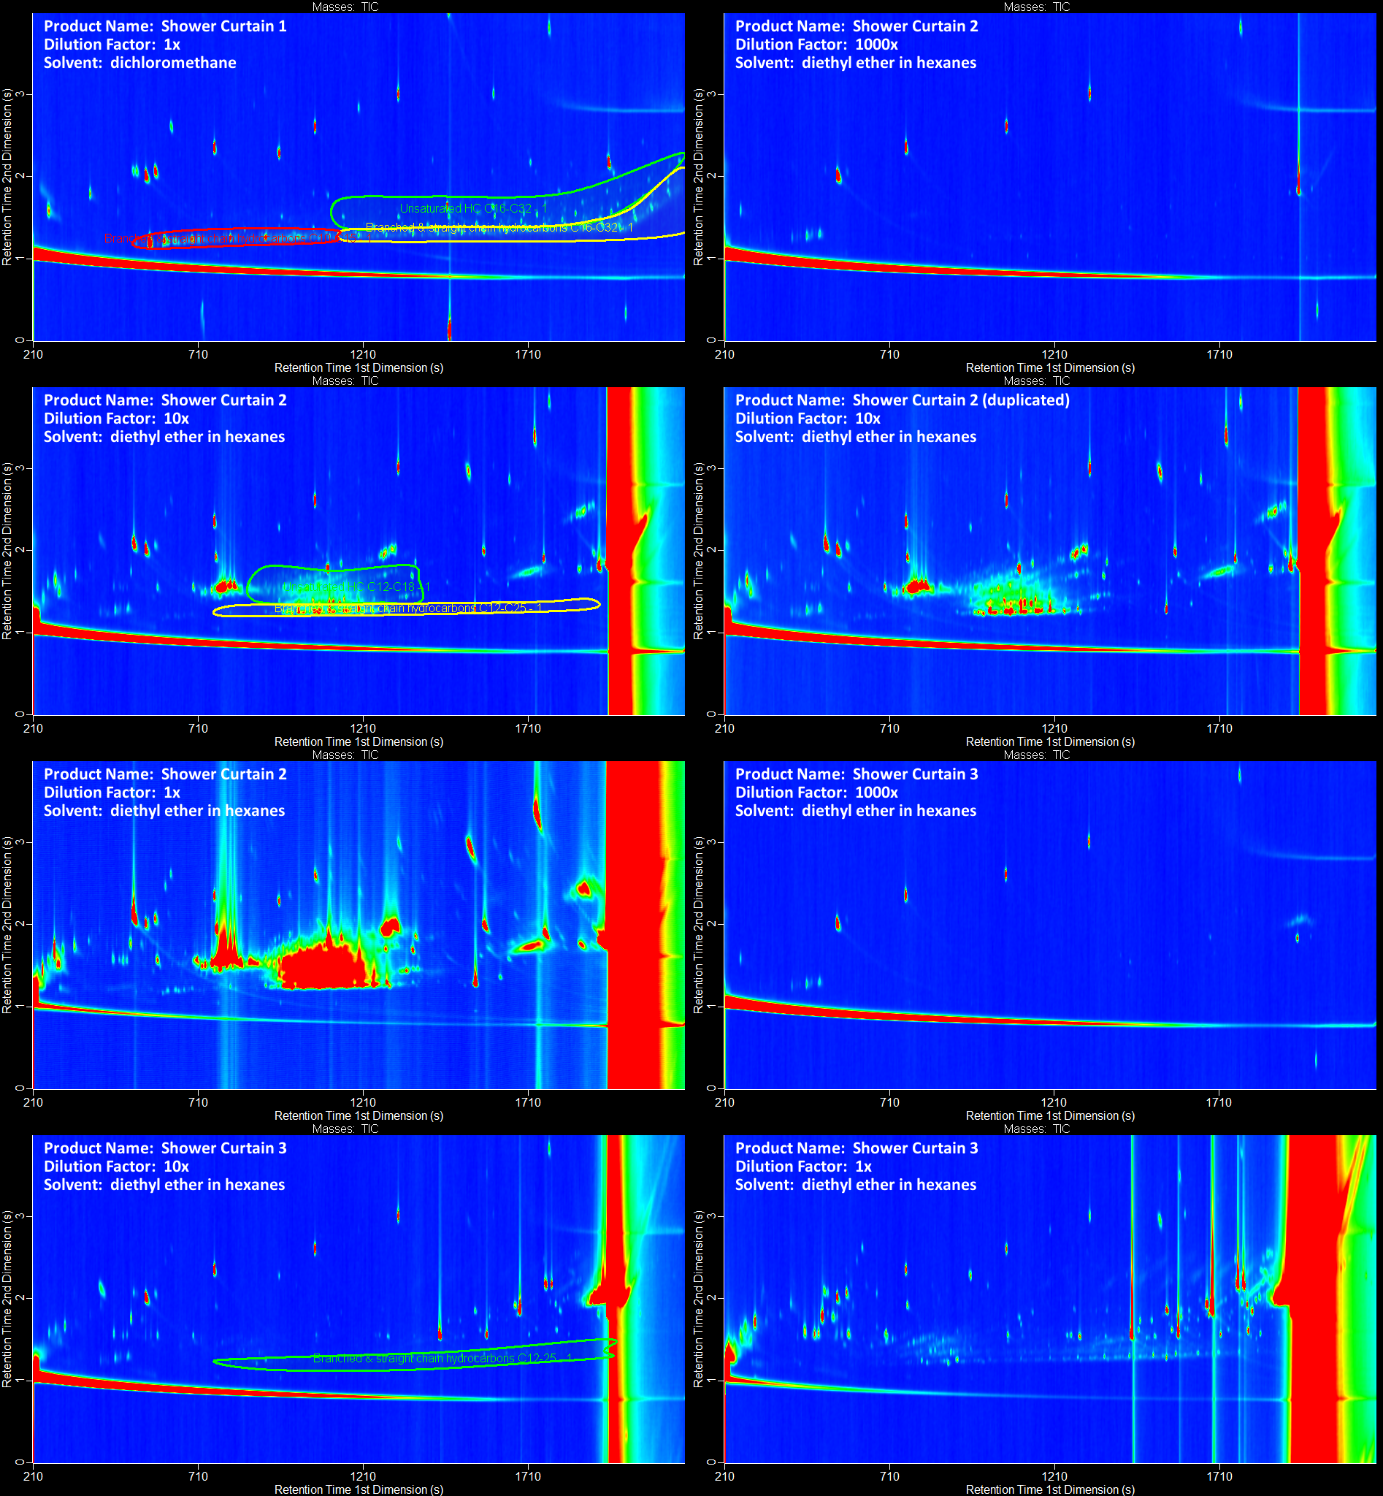
Figure S28. Gas chromatograms of shower curtains.

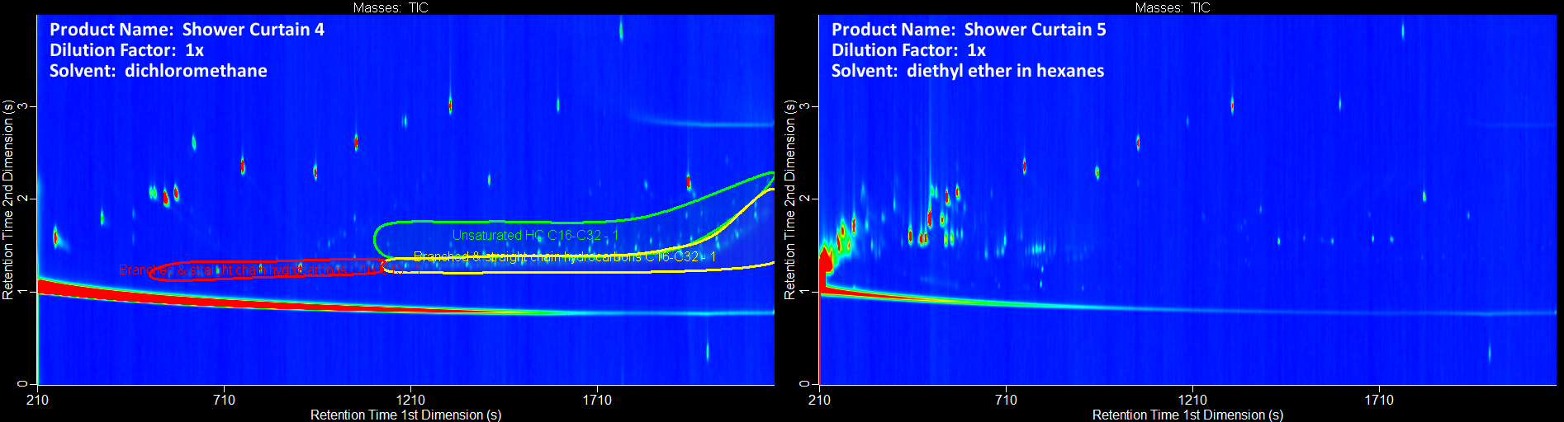
Figure S29. Gas chromatograms of shower curtains (continued).

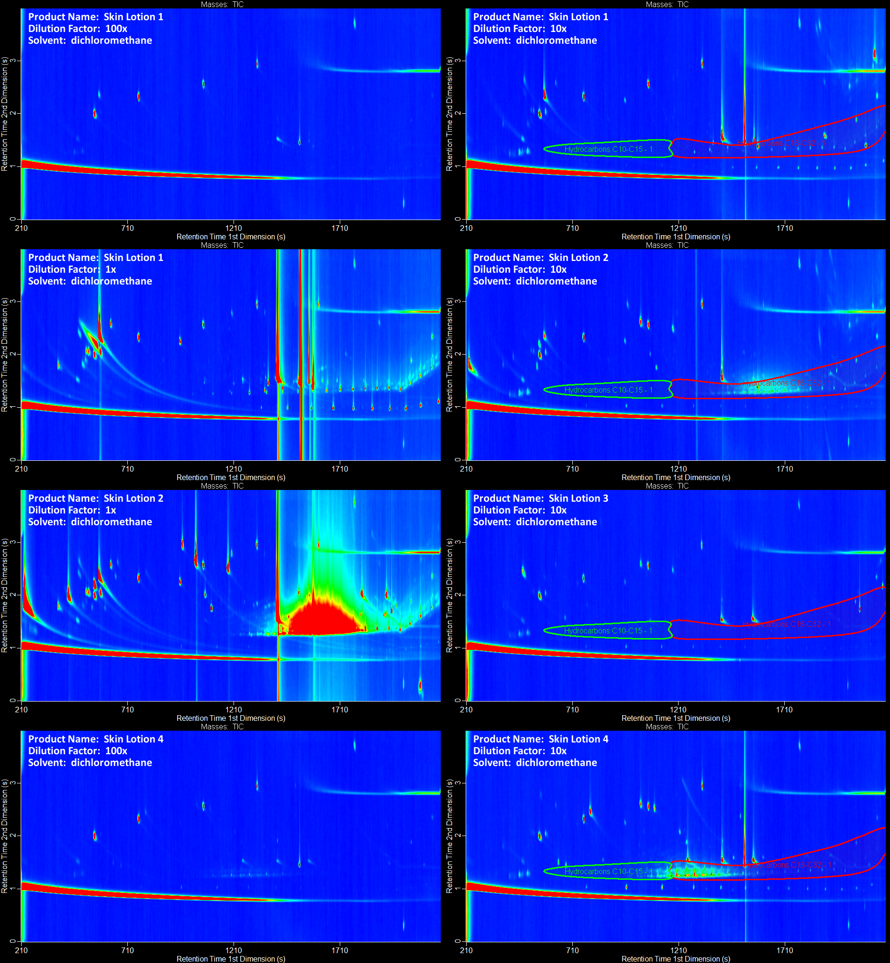
Figure S30. Gas chromatograms of skin lotions.

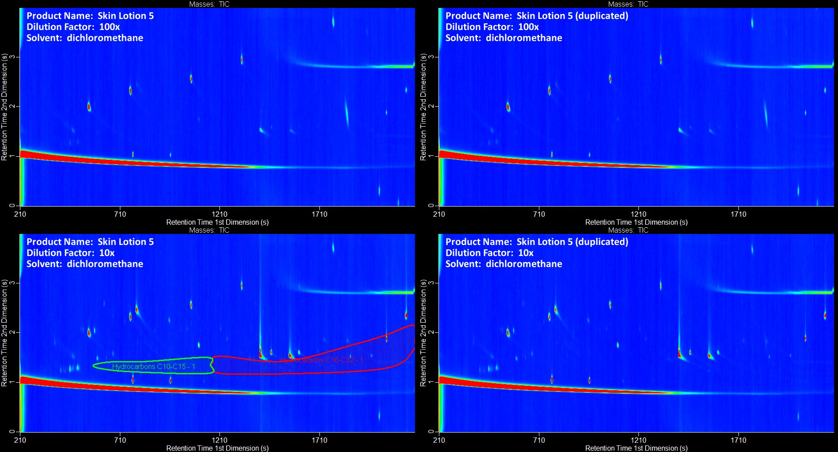
Figure S31. Gas chromatograms of skin lotions (continued).

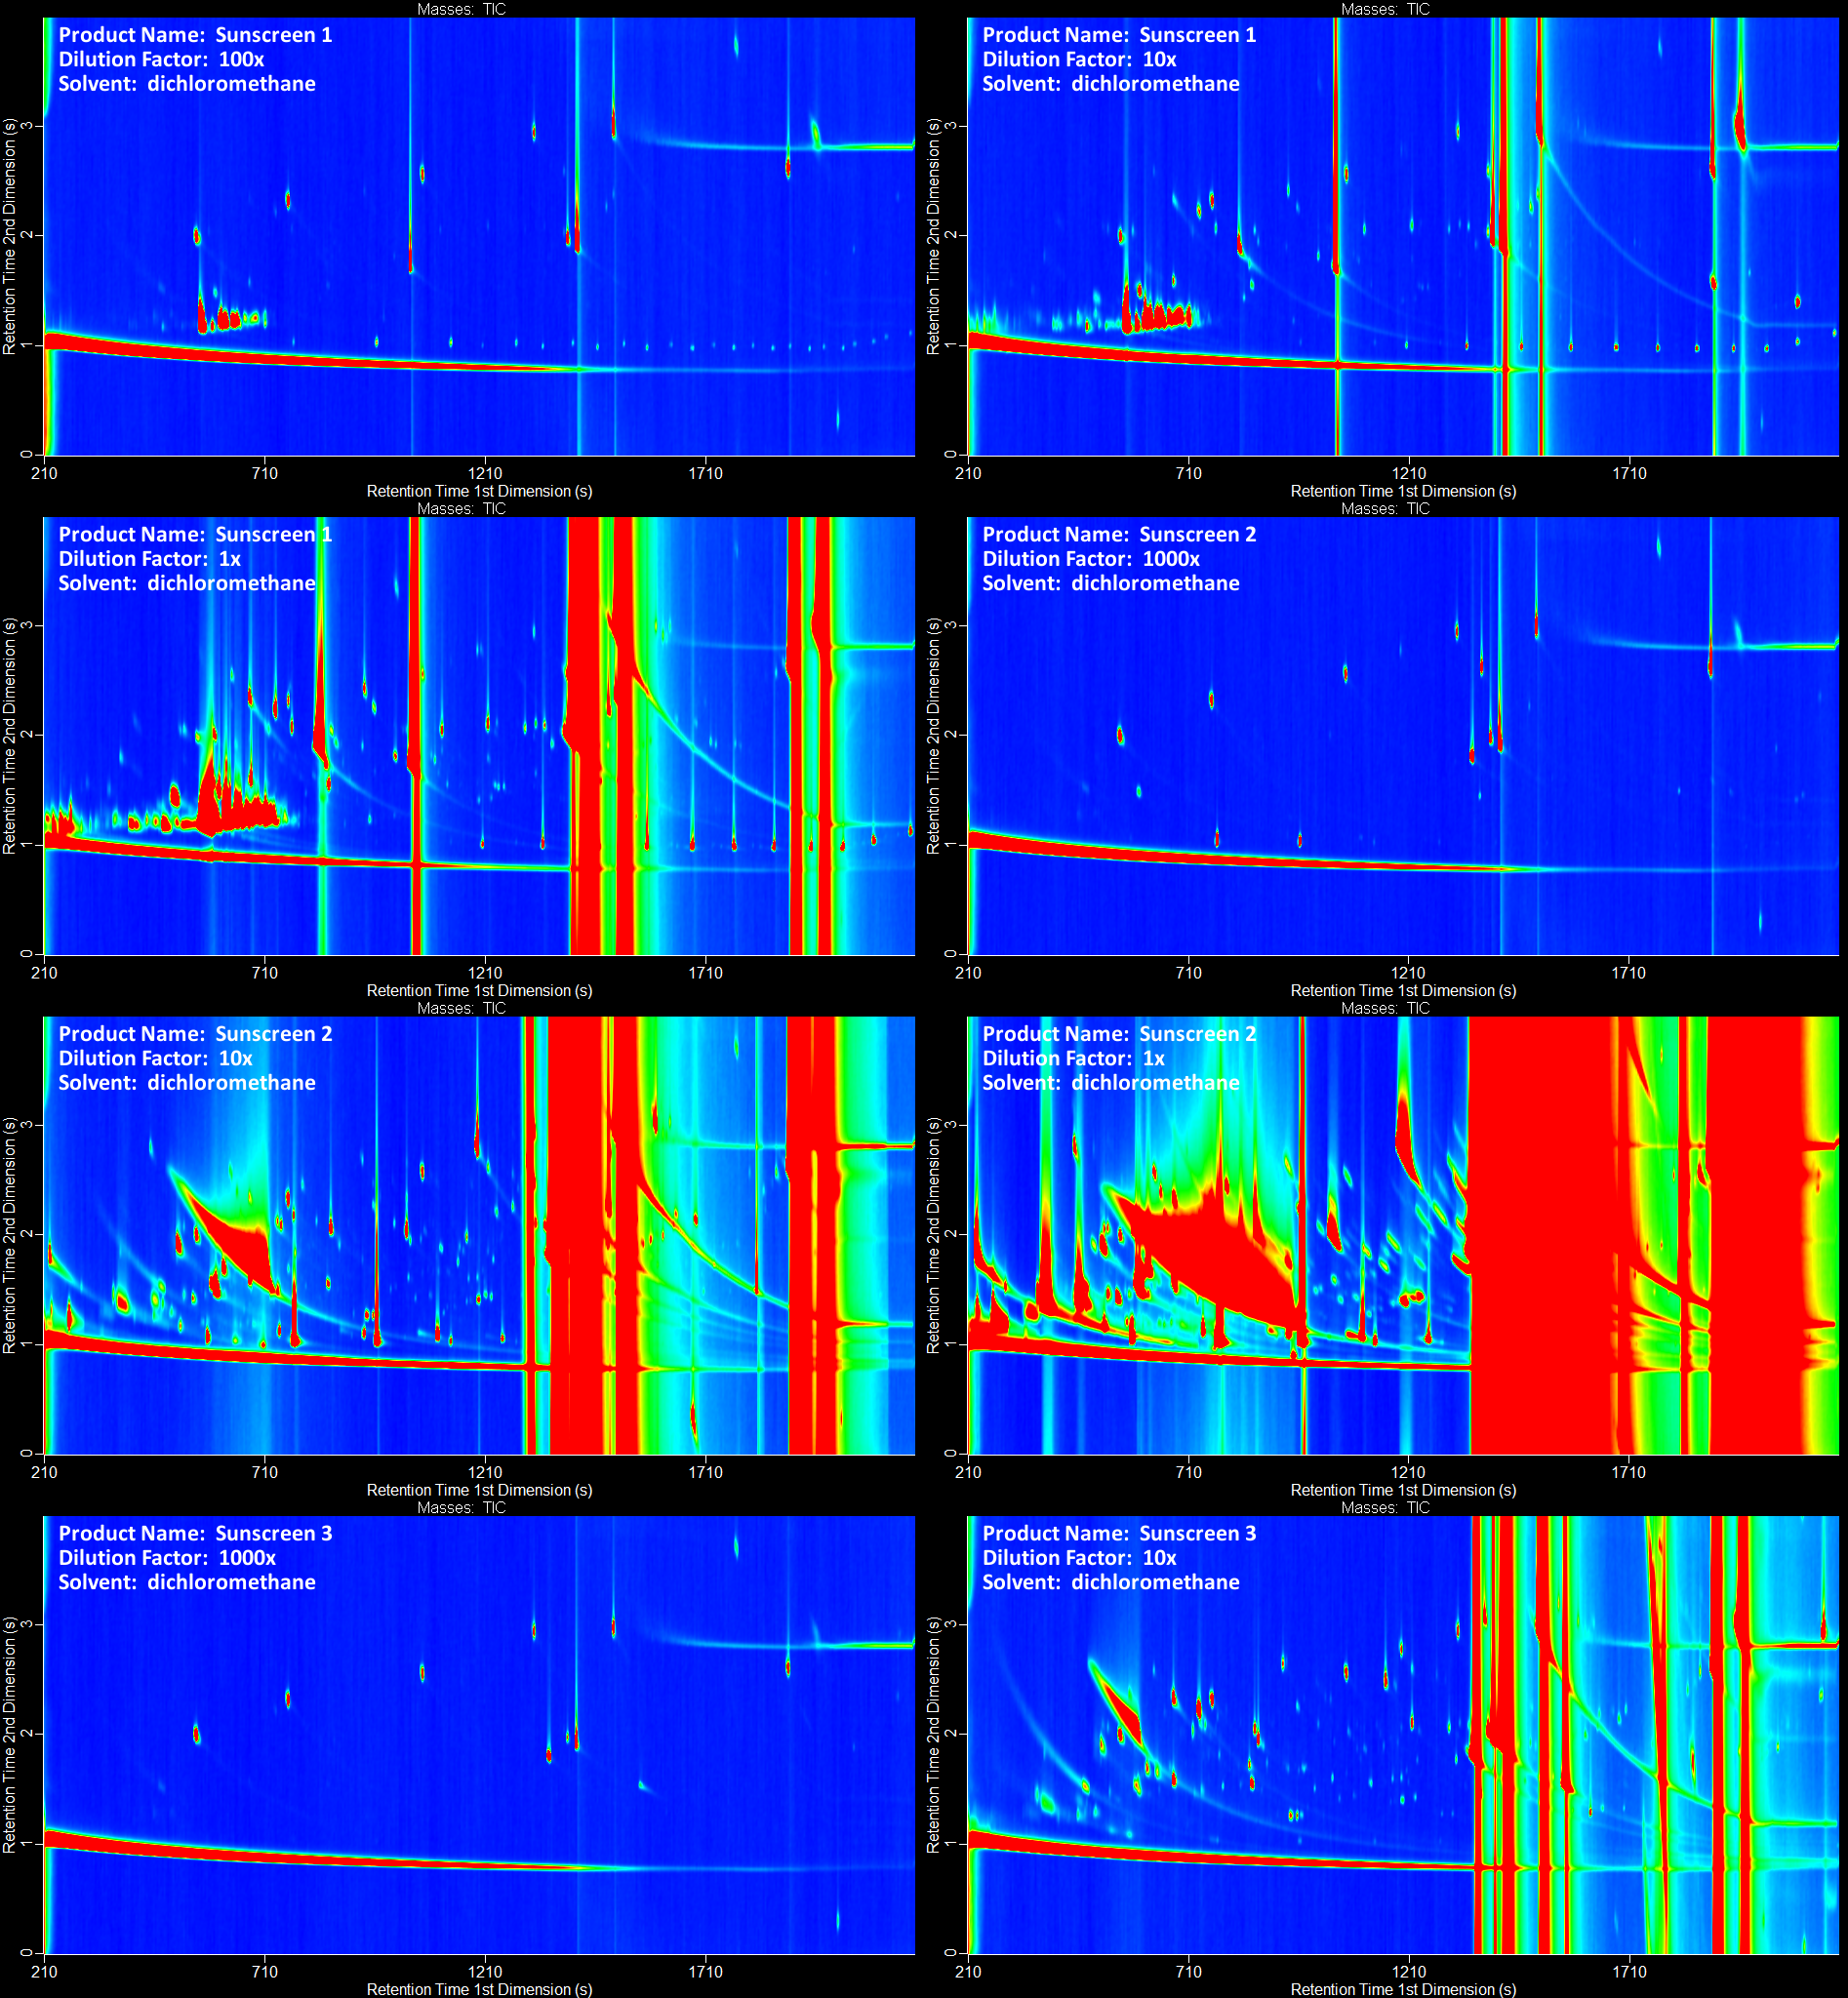
Figure S32. Gas chromatograms of sunscreens.

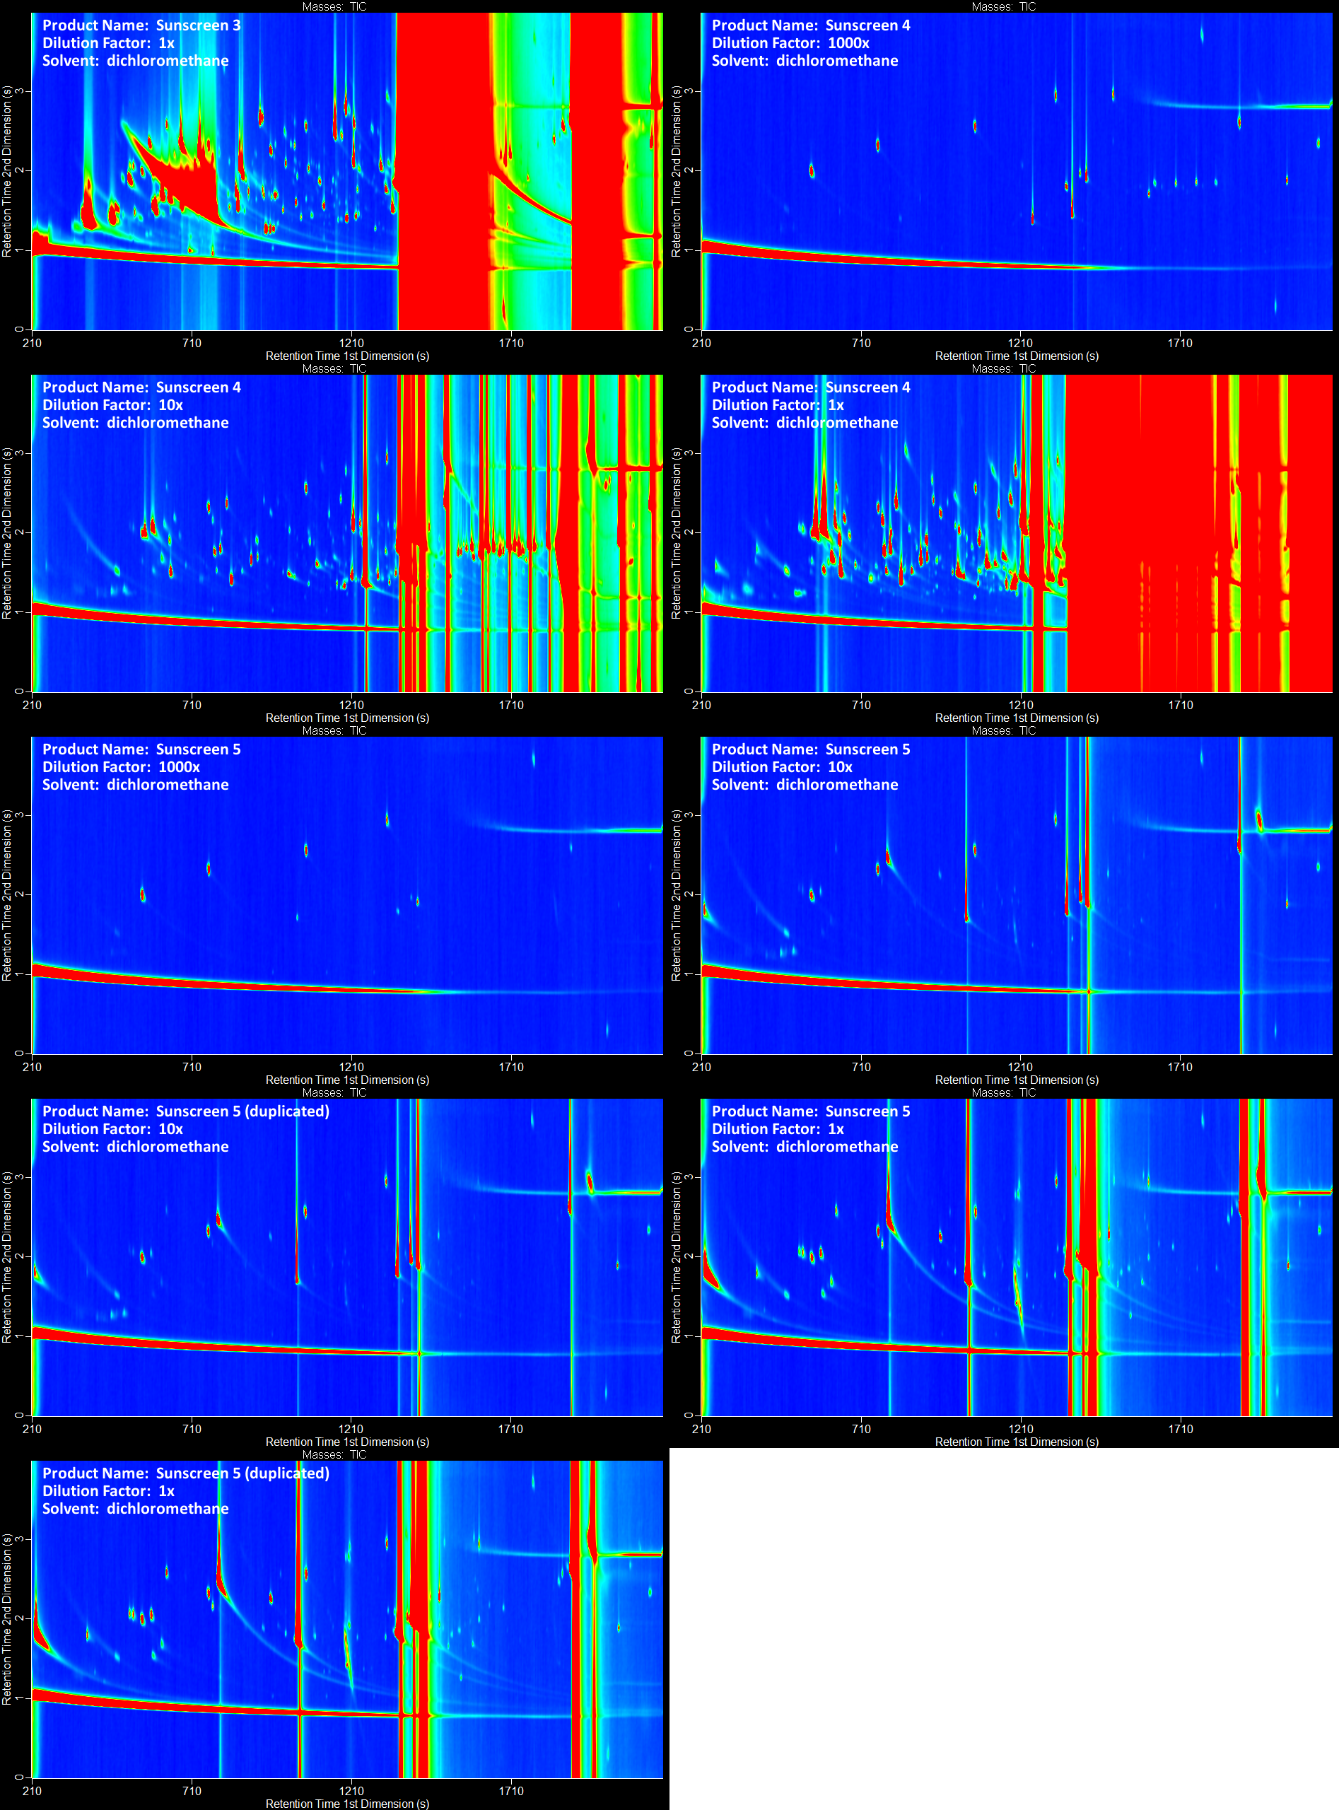
Figure S33. Gas chromatograms of sunscreens (continued).
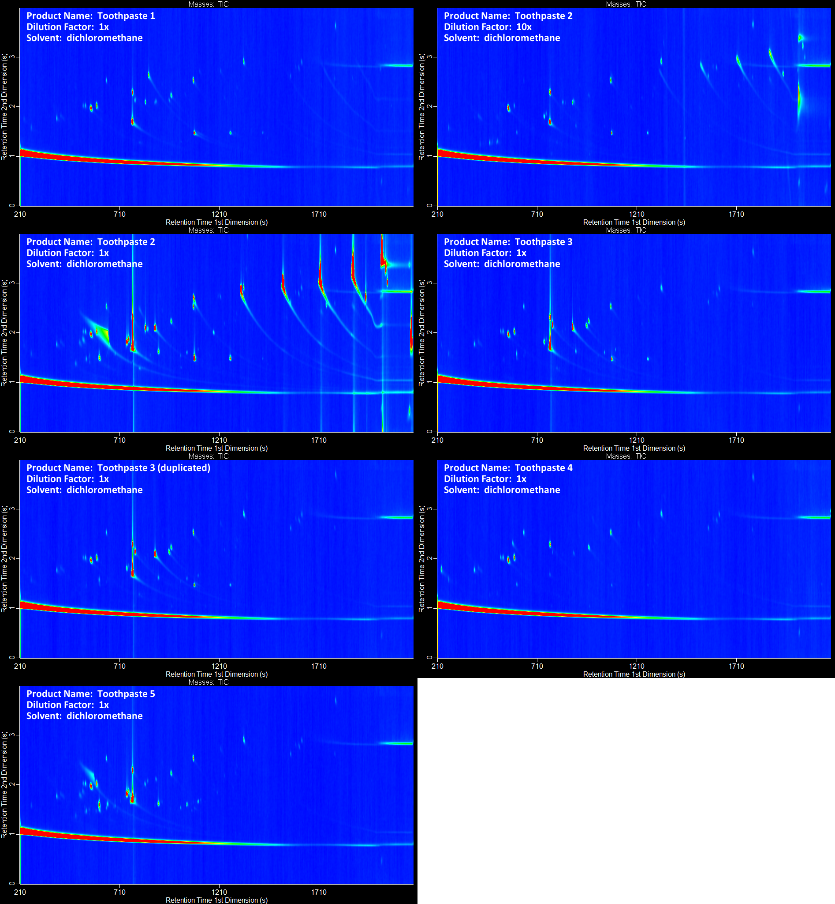
Figure S34. Gas chromatograms of toothpastes.

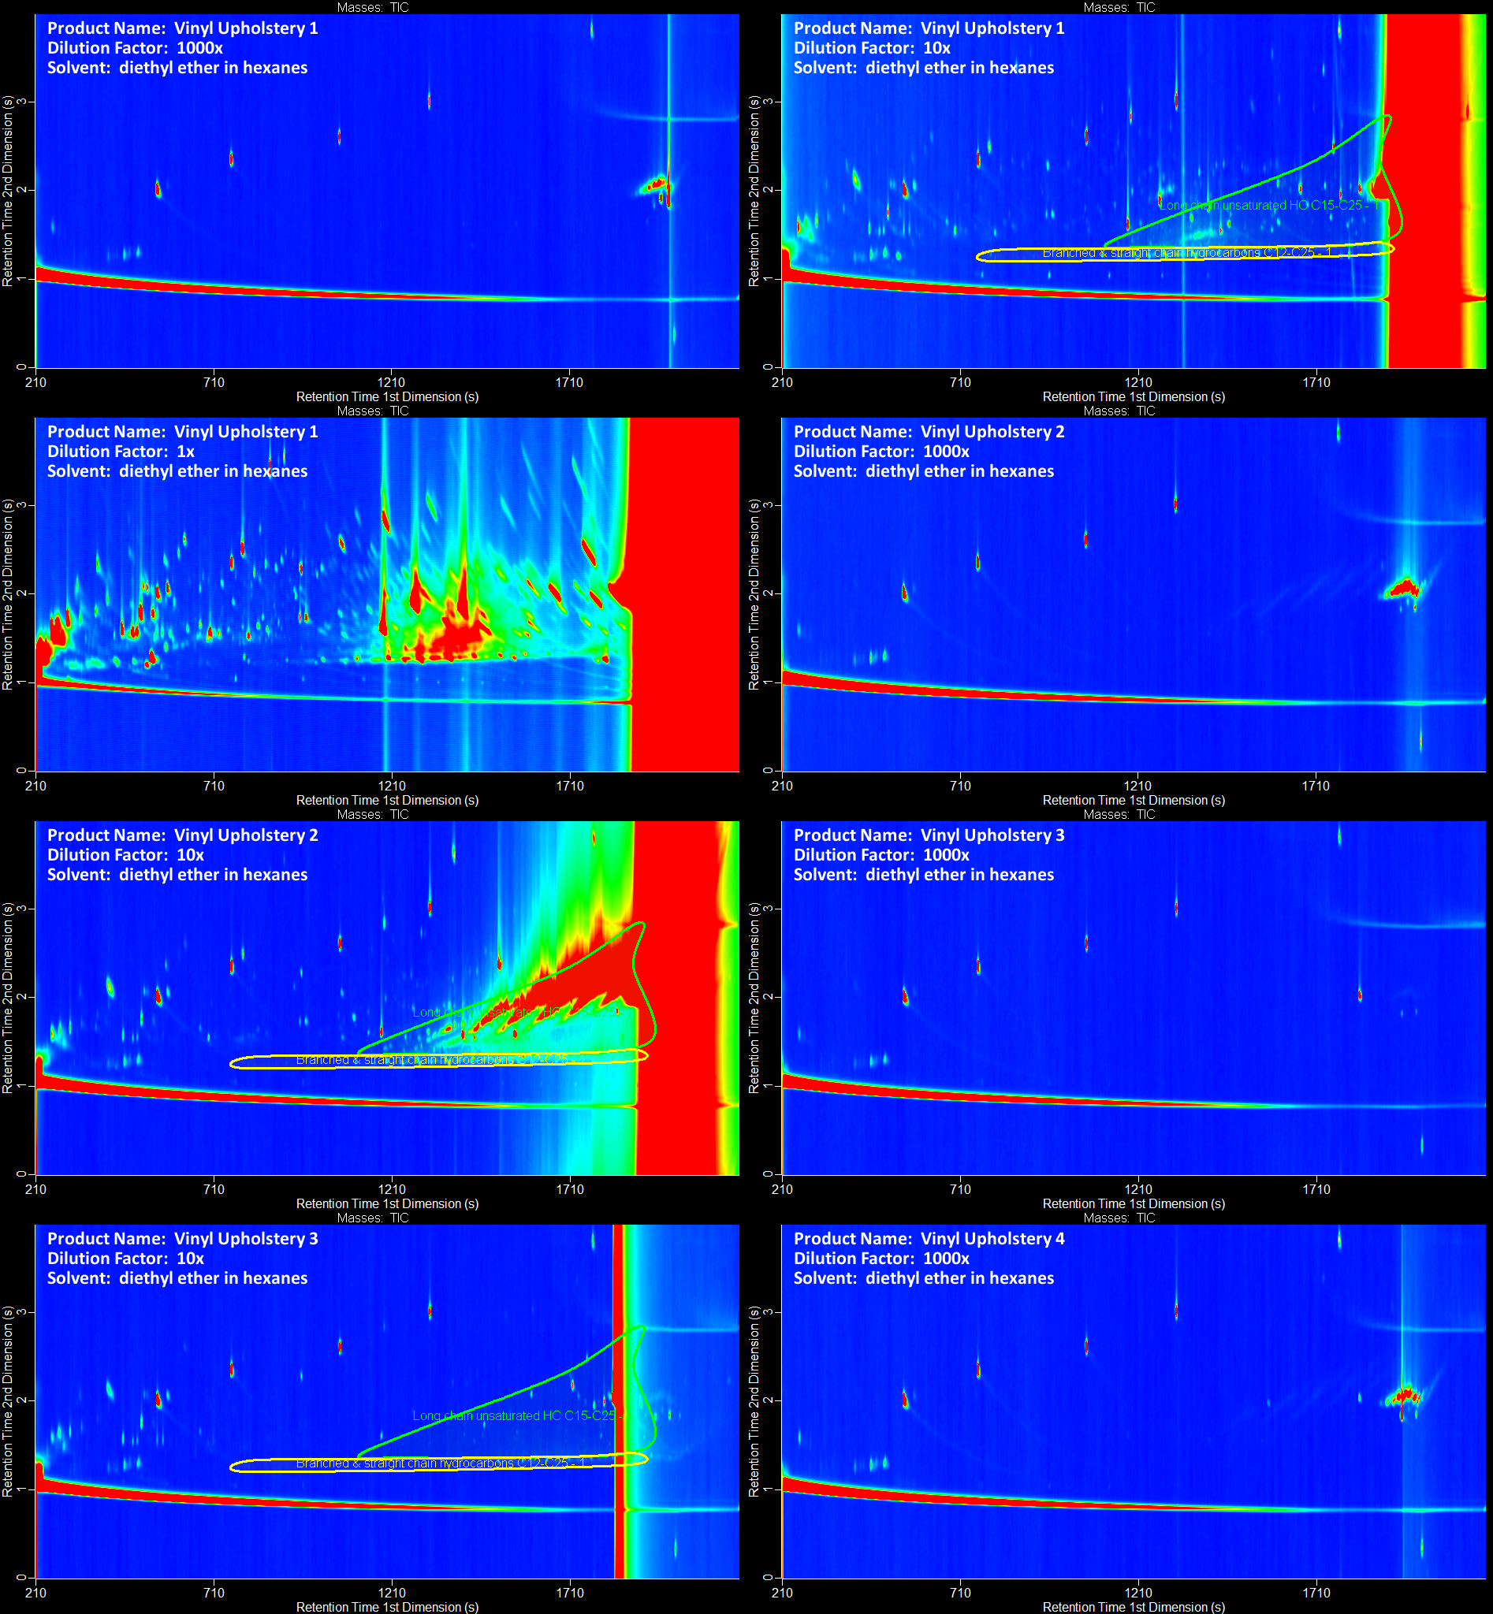
Figure S35. Gas chromatograms of vinyl upholstery.

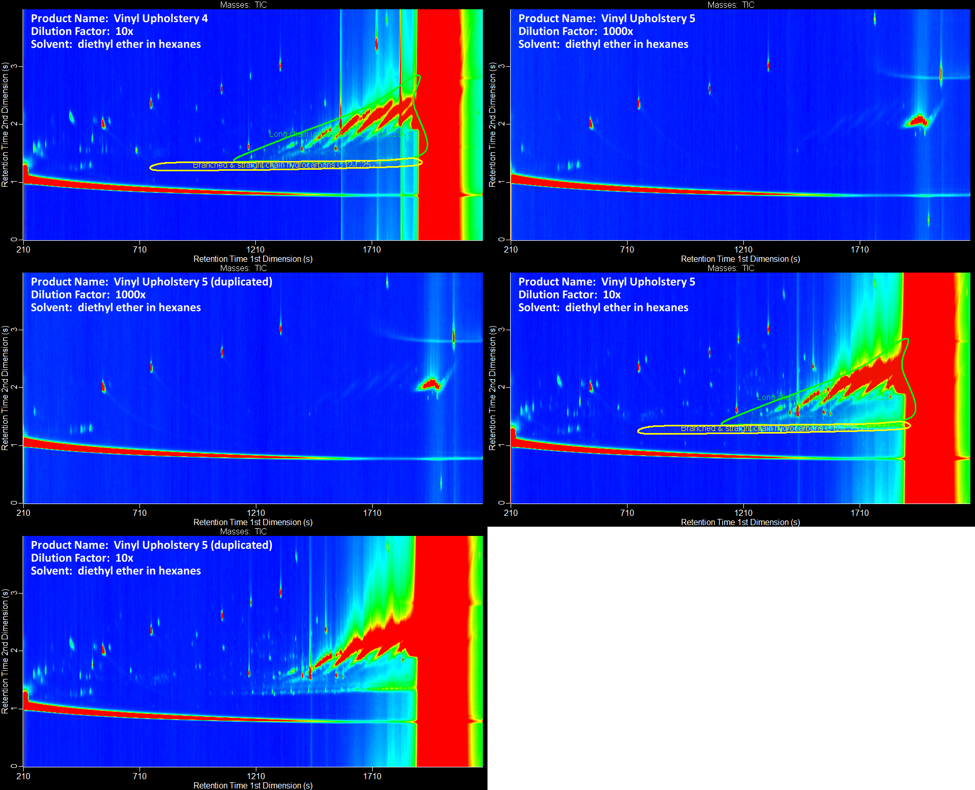
Figure S36. Gas chromatograms of vinyl upholstery (continued).

SI Tables
In order to make data more clear and accessible to readers, Tables S1 – S4 are included in a separate MS Excel file: suspect_screening_of_chemicals_in_consumer_products_SI_tables.xlsx. Table S1 provides all information used in the analysis of the identified spectral matches for all 100 consumer products. Table S2 provides information on the 200 reference standards that were used to confirm the presence of chemicals in the 100 consumer products. Table S3 lists chemicals that were either confirmed or tentatively identified in 25 or more products. Table S4 provided retention time modulation periods used to calculate the retention time windows in the SI Methods section.

SI References
1. Krowech, G. Brominated and chlorinated organic chemical compounds used as flame retardants (BFRs and CFRs). http://www.biomonitoring.ca.gov/sites/default/files/downloads/120408flame_pres.pdf),
2. Sjödin, A.; Patterson, D. G.; Bergman, Å., A review on human exposure to brominated flame retardants—particularly polybrominated diphenyl ethers. Environ. Int. 2003, 29 (6), 829-839.
3. Judson, R. S.; Magpantay, F. M.; Chickarmane, V.; Haskell, C.; Tania, N.; Taylor, J.; Xia, M.; Huang, R.; Rotroff, D. M.; Filer, D. L.; Houck, K. A.; Martin, M. T.; Sipes, N.; Richard, A. M.; Mansouri, K.; Setzer, R. W.; Knudsen, T. B.; Crofton, K. M.; Thomas, R. S., Integrated model of chemical perturbations of a biological pathway using 18 in vitro high-throughput screening assays for the estrogen receptor. Toxicol. Sci. 2015, 148 (1), 137-154.
4. Isaacs, K. K.; Goldsmith, M.-R.; Egeghy, P.; Phillips, K.; Brooks, R.; Hong, T.; Wambaugh, J. F., Characterization and prediction of chemical functions and weight fractions in consumer products. Toxicol. Rep. 2016, 3, 723-732.
5. Phillips, K. A.; Wambaugh, J. F.; Grulke, C. M.; Dionisio, K. L.; Isaacs, K. K., High-throughput screening of chemicals as functional substitutes using structure-based classification models. Green Chem. 2017, 19, 1063-1074.
6. U. S. Environmental Protection Agency Estimation Program Interface Suite for Microsoft Windows v4.11. https://www.epa.gov/tsca-screening-tools/epi-suitetm-estimation-program-interface),
7. Altamira LLC ToxPrint. https://toxprint.org/ (accessed April 2015),
8. Goldsmith, M. R.; Grulke, C. M.; Brooks, R. D.; Transue, T. R.; Tan, Y. M.; Frame, A.; Egeghy, P. P.; Edwards, R.; Chang, D. T.; Tornero-Velez, R.; Isaacs, K.; Wang, A.; Johnson, J.; Holm, K.; Reich, M.; Mitchell, J.; Vallero, D. A.; Phillips, L.; Phillips, M.; Wambaugh, J. F.; Judson, R. S.; Buckley, T. J.; Dary, C. C., Development of a consumer product ingredient database for chemical exposure screening and prioritization. Food Chem. Toxicol. 2014, 65, 269-279.
9. Isaacs, K. K.; Glen, W. G.; Egeghy, P.; Goldsmith, M.-R.; Smith, L.; Vallero, D.; Brooks, R.; Grulke, C. M.; Özkaynak, H., SHEDS-HT: an integrated probabilistic exposure model for prioritizing exposures to chemicals with near-field and dietary sources. Environ. Sci. Technol. 2014, 48 (21), 12750-12759.
10. State of Washington Department of Ecology Chemicals in Consumer Product. https://fortress.wa.gov/ecy/publications/publications/1404042.pdf (accessed November 2016),
11. State of Washington Department of Ecology Product Testing Data. https://fortress.wa.gov/ecy/ptdbpublicreporting/Default.aspx (accessed November 2016),

