Supplemental Data Set: An approach to measure parameter sensitivity
Table 1 HSPF parameter descriptions
 | Parameter | Units | Function of | Possible  Values¹ |  | Model Parameter Values
 |  |  |  | Min | Max | LMR | LVW
PWATER | LZSN - Lower Zone Nominal Soil Moisture Storage | mm | Soils, climate | 50.8 | 381 | 162.56 | 127
 | INFILT - Index to Infiltration Capacity | mm/hr | Soils, land use | 0.028 | 12.7 | 12.7 | 31.75²
 | AGWRC - Base groundwater recession | None | Base flow recession | 0.85 | 0.999 | 0.85 | 0.92
 | DEEPFR - Fraction of GW inflow to deep recharge | None | Geology, Groundwater recharge | 0 | 0.5 | 0.45 | 0.7²
 | UZSN - Upper zone nominal soil moisture storage | mm | Surface soil conditions, land use | 1.27 | 50.8 | 20.32 | 12.7
 | IRC - Interflow recession parameter | None | Soils, topography, land use | 0.3 | 0.85 | 0.75 | 0.45
IWATER | LSUR - Length of overland flow | meters | Topography | 15.24 | 76.2 | 76.2 | 91.44²
 | NSUR - Manning’s n (roughness) for overland flow | None | Surface conditions, residue, etc. | 0.01 | 0.3 | 0.05 | 0.08
 | RETSC - Retention (Interception) Storage capacity | mm | Retention potential of impervious surfaces | 2.54 | 12.7 | 2.54 | 2.54
¹ Range of possible values for each model parameter (USEPA 2000)
² Due to the local hydrologic characteristics, some parameters may have values beyond the recommended range (USEPA 2000).

Table 2 Flow rates for each regime in the LMR and LVW watersheds
 | Flow rates (m³/s)
 | Low (>60%) | Medium (10%-60%) | High (<10%)
LMR | <19 | 19-129 | >129
LVW | <5 | 5-6 | >6

Table 3 The ranking of the parameters in the LMR and LVW watersheds according to their sensitivities

Parameter Sensitivity | Watershed Parameters
 | LMR | LVW
High | DEEPFR | INFILT
 | INFILT | DEEPFR
 | AGWRC | LZSN
 | UZSN | AGWRC
 | IRC | RETSC
 | LZSN | I-LSUR
 | RETSC | I-NSUR
 | I-LSUR | UZSN
Low | I-NSUR | IRC

List of Figures
Figure 1 Maps of the study areas: the LMR and LVW watersheds
Figure 2 Conceptual model of HSPF hydrologic simulation
Figure 3 Major soil types of the LMR watershed
Figure 4 Major soil types of the LVW watershed
Figure 5 Flow regimes of a Flow Duration Curve (FDC)
Figure 6 Flow duration curves for the (a) LMR watershed; (b) LVW watershed
Figure 7 Comparison of parameter sensitivity for the entire flow ranges of LMR and LVW watersheds
Figure 8 Average slope of the SI curves for the entire flow range
Figure 9 LMR model parameter sensitivity in three flow regimes
Figure 10 Average slope of the SI curves of three flow regimes in LMR watershed
Figure 11 LVW model parameter sensitivity in three flow regimes
Figure 12 Average slope of the SI curves of three flow regimes in LVW watershed

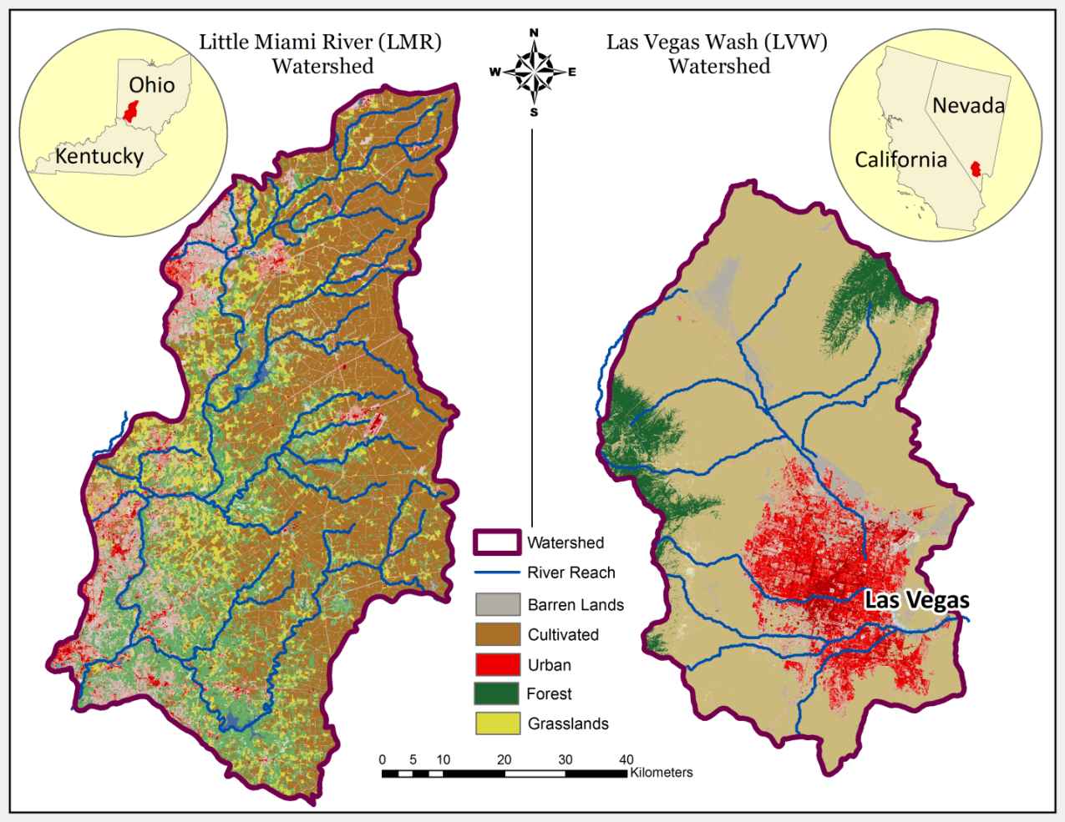
Fig. 1 Maps of the study areas: the LMR and LVW watersheds

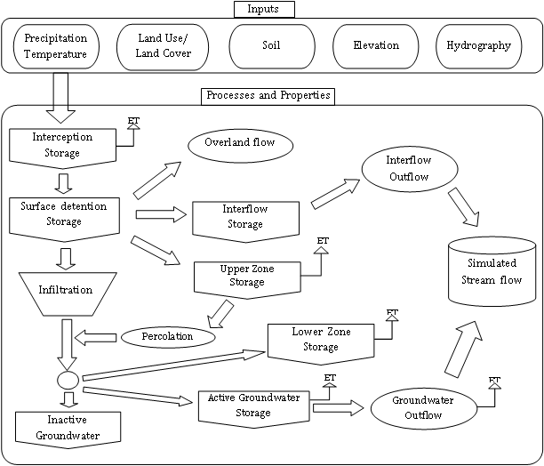
Fig. 2 Conceptual model of HSPF hydrologic simulation

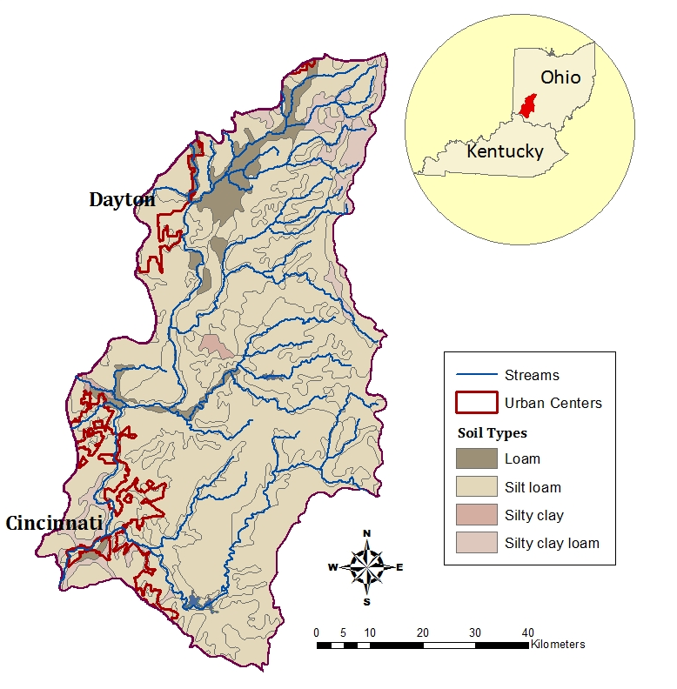
Fig. 3 Major soil types of the LMR watershed

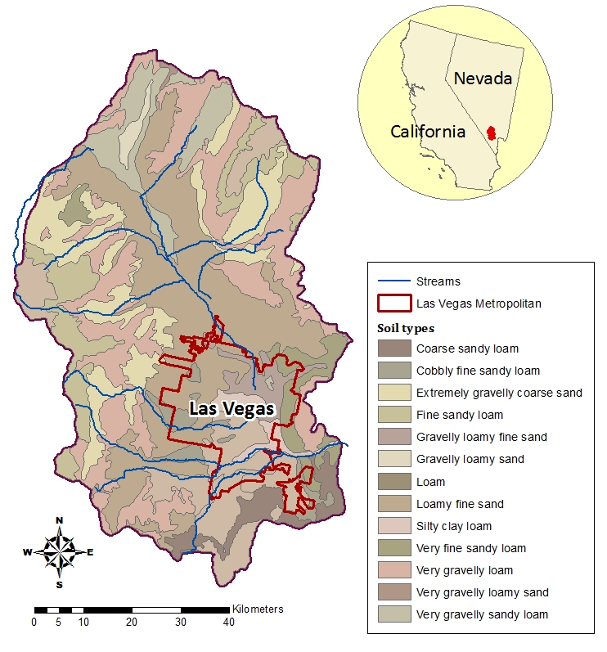
Fig. 4 Major soil types of the LVW watershed

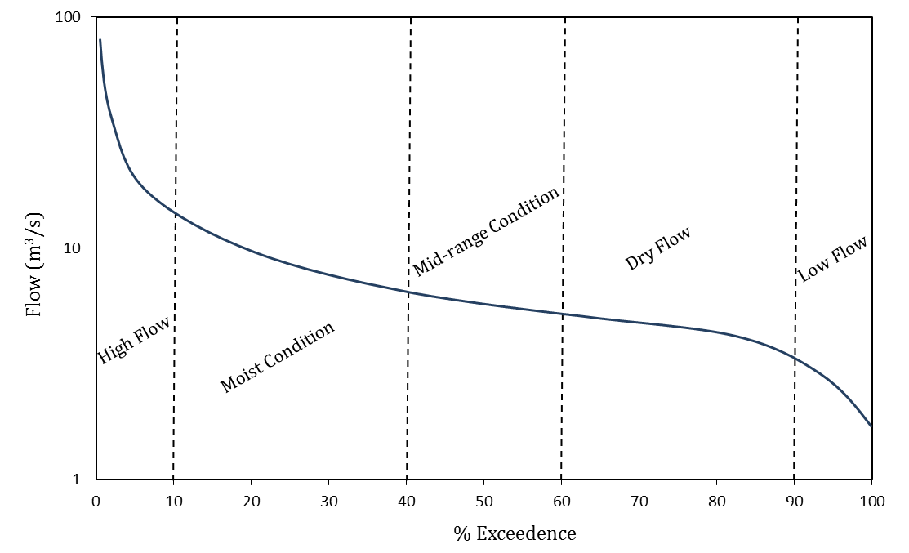
Fig. 5 Flow regimes of a Flow Duration Curve (FDC)

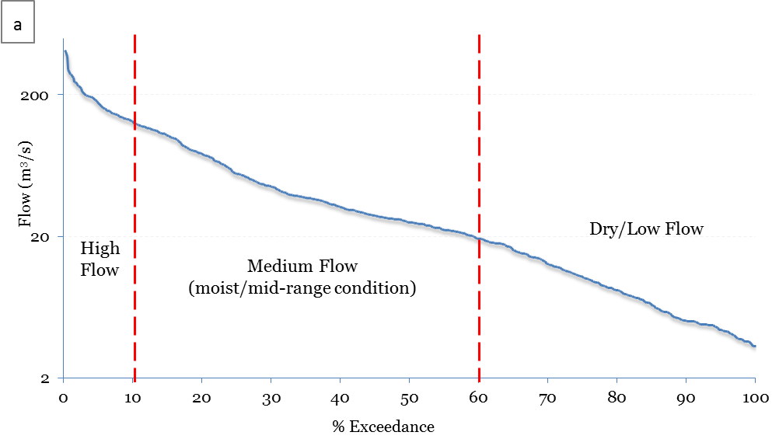
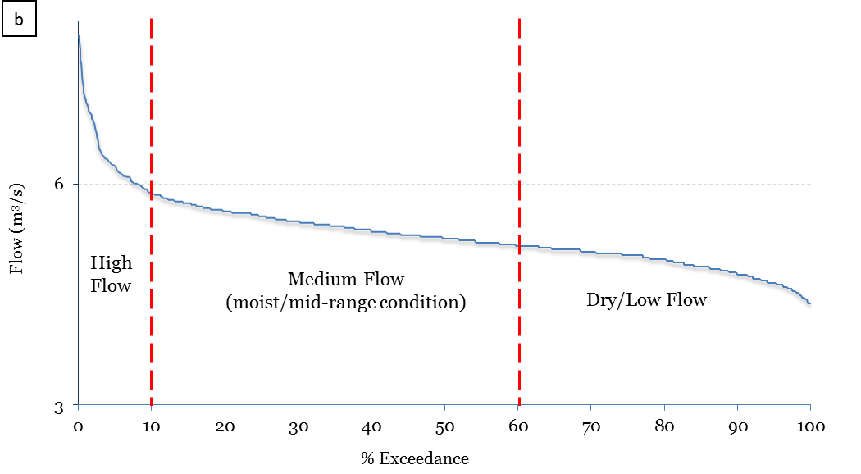
Fig. 6 Flow duration curves for the (a) LMR watershed; (b) LVW watershed

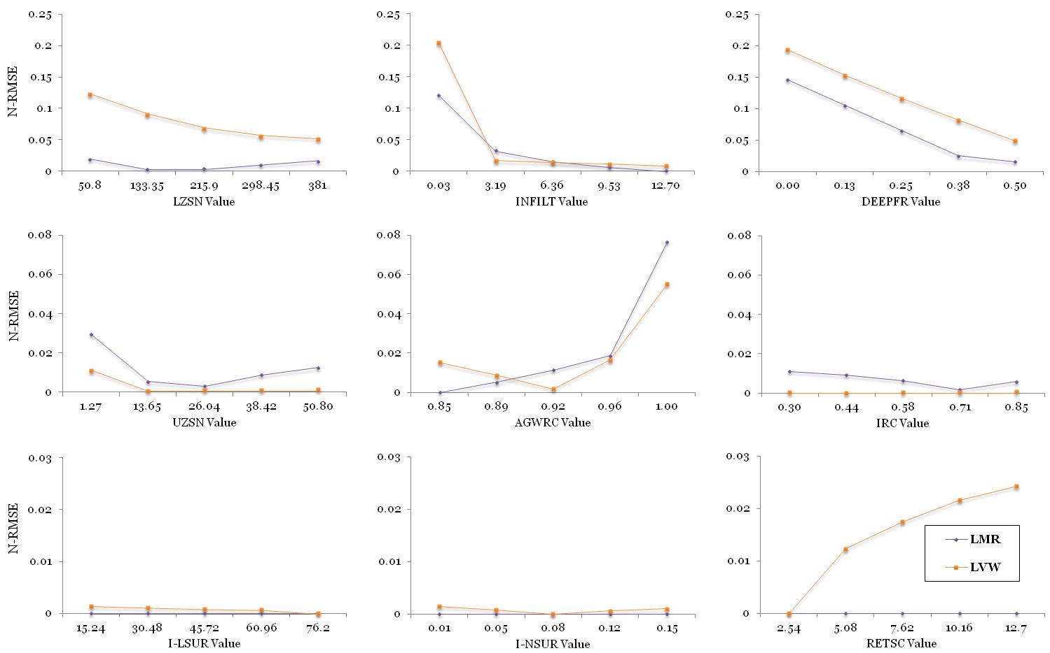
Fig. 7 Comparison of parameter sensitivity for the entire flow ranges of the LMR and LVW watersheds

Fig 8 Average slope of the SI curves for the entire flow range
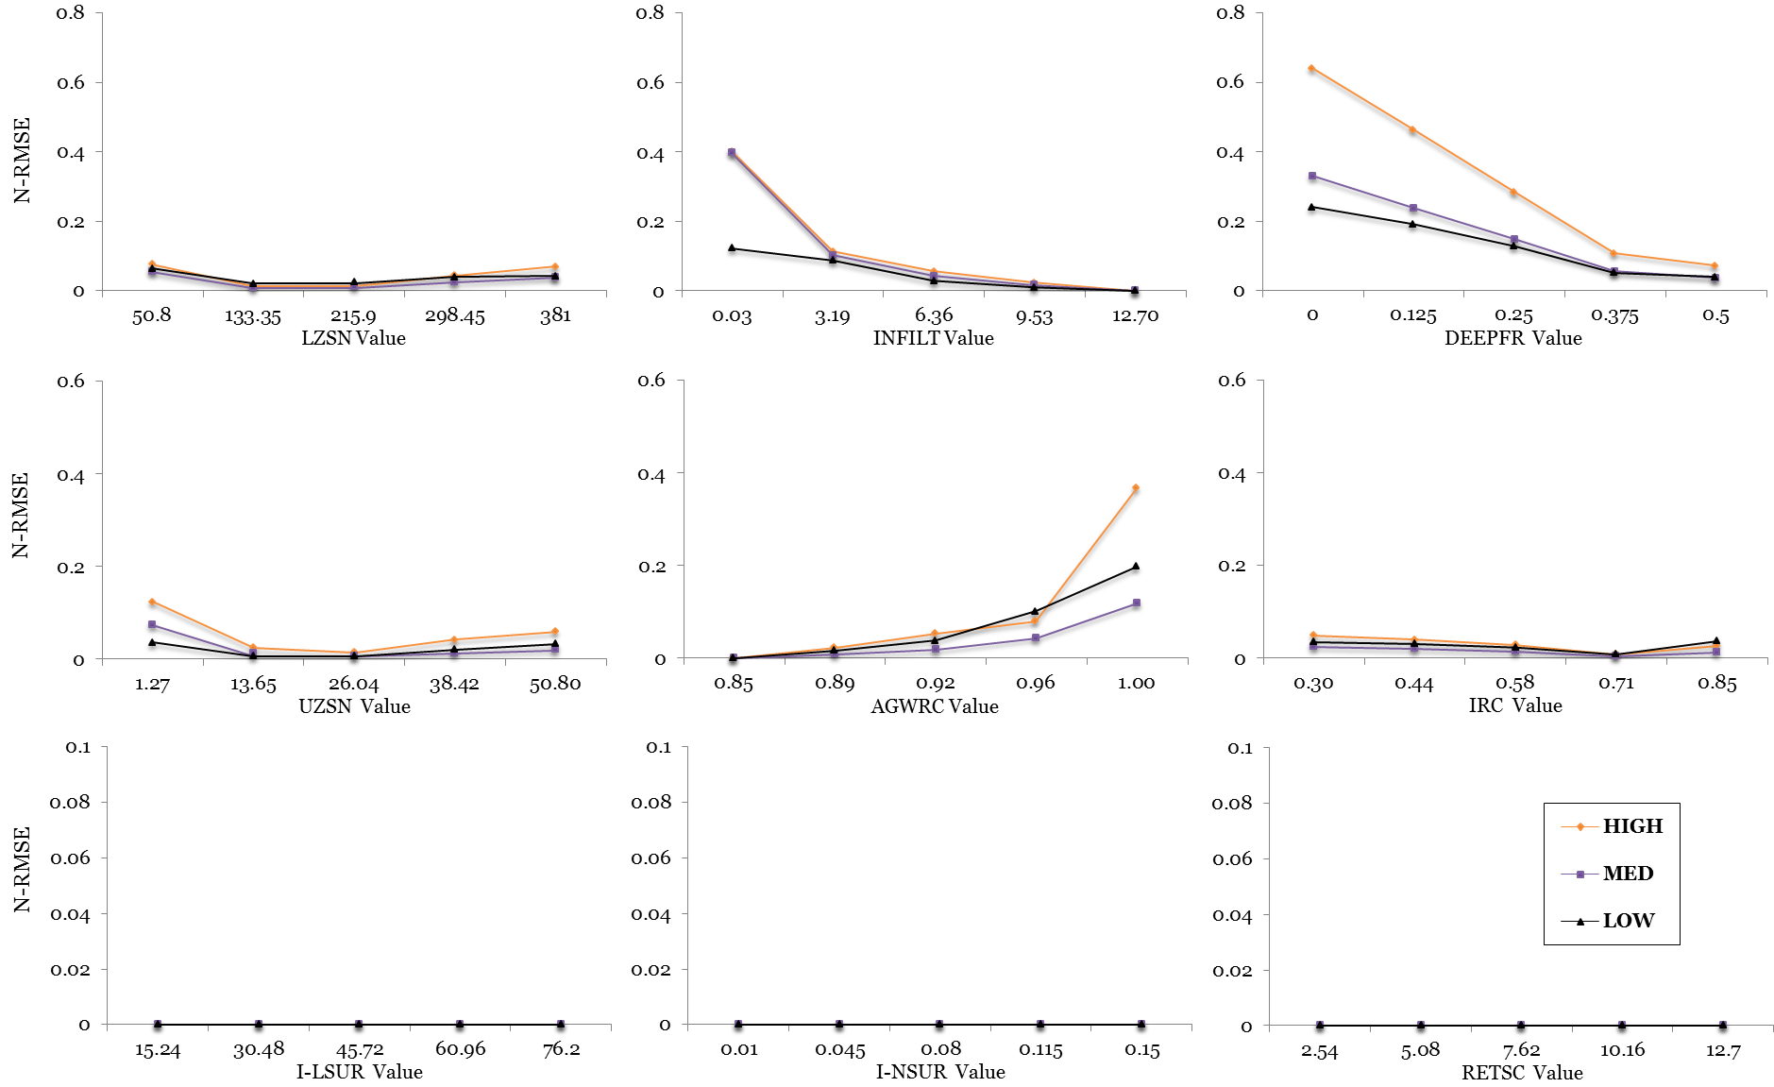
Fig. 9 LMR model parameter sensitivity in three flow regimes

Fig. 10 Average slope of the SI curves of three flow regimes in the LMR watershed
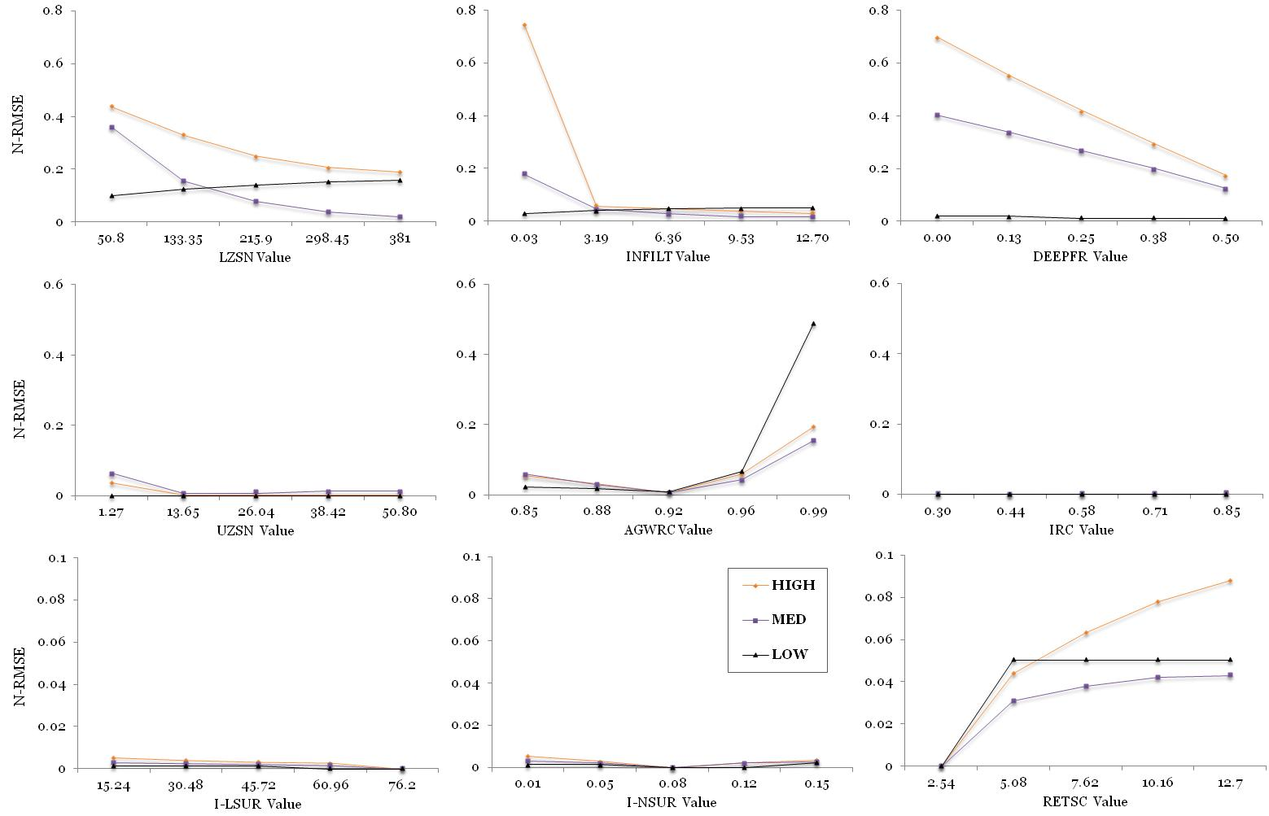
Fig. 11 LVW model parameter sensitivity in three flow regimes

Fig. 12 Average slope of the SI curves of three flow regimes in the LVW watershed

