Supplementary Information

Oxidative C-H activation of amines using protuberant lychee-like goethite

Sanny Vermaa†, R. B. Nasir Baiga†, Mallikarjuna N. Nadagoudab, Rajender S. Varmaa*

**Contents**

General procedure for the synthesis of protuberant lychee ferrites

General procedure for the α-cyanation of amines *via* C-H activation

Catalyst characterization

Figure S1: XRD analysis of protuberant lychee ferrites

Figure S2: XPS analysis of protuberant lychee ferrites

Figure S3: XPS analysis of Fe+n in protuberant lychee ferrites

1H and 13C NMR spectra of products

**General procedure for the synthesis of protuberant lychee ferrites**

Ferric sulfate (1 mmol), proline (2 mmol) and water (40 ml) were charged in a pressure reactor. The mixture was heated in 110 °C in an oven for 24 hours. After 24 hours the reaction temperature was brought down to room temperature. The ferrites with protuberant lychee morphology was isolated using centrifugation, washed with water followed by methanol and dried under vacuum at 50 °C. Catalyst characterization was performed using scanning electron microscopy (SEM), X-ray diffraction (XRD) and X-ray photoelectron spectroscopy (XPS).

**General procedure for the α-cyanation of amines *via* C-H activation**

A 25 mL side-armed round bottomed flask equipped with a magnetic stirring was charged with amine (1mmol), NaCN (1.2 mmol) and catalyst (10 mol %). 5 mL of water was added in the reaction mixture. The reaction mixture was heated at 50 °C by keeping vessel open. The progress of the reaction was monitored by checking TLC at regular interval of time. After completion of the reaction the product was isolated using ethyl acetate extraction, dried over sodium sulfate and purified using column chromatography and characterized.

**Catalyst characterization**

The Catalyst **protuberant lychee ferrites** characterized by X-ray diffraction (XRD; Figure S1) confirmed the formation of ferrites. The XRD pattern shows the mixture of iron oxides (FeO, Fe2O3 and Fe3O4). This was confirmed by X-ray photoelectron analysis (XPS; Figure S2 and Figure S3) of sample. The binding energy of Fe 2p3/2 is about 711 eV and Fe 2p1/2 is about 726 eV suggesting that the catalyst is a mixture of ferrites.

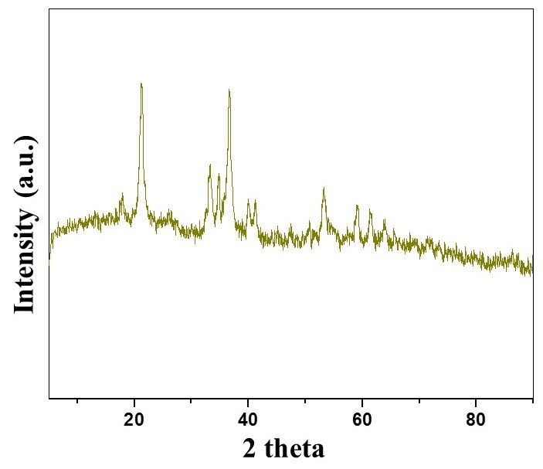

**Figure S1.** XRD pattern of protuberance lychee ferrites

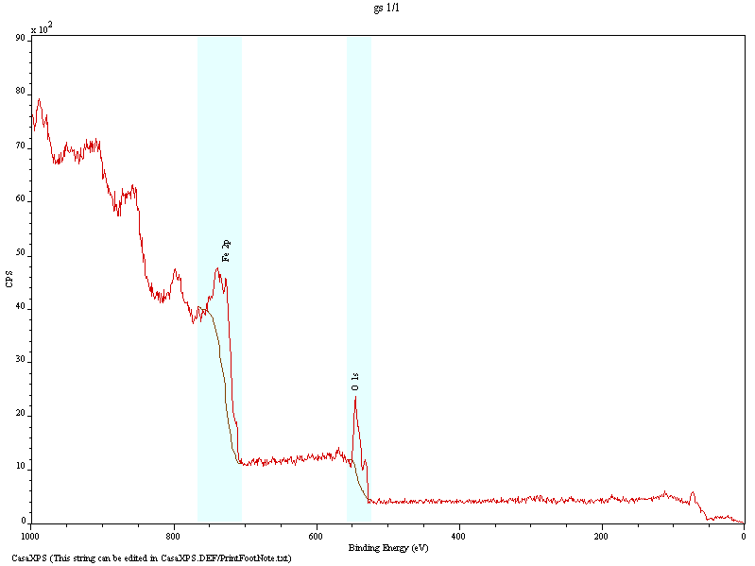

**Figure S2.** XPS analysis of protuberant lychee ferrites

**Figure S3.** XPS analysis of Fe+n in protuberant lychee ferrites

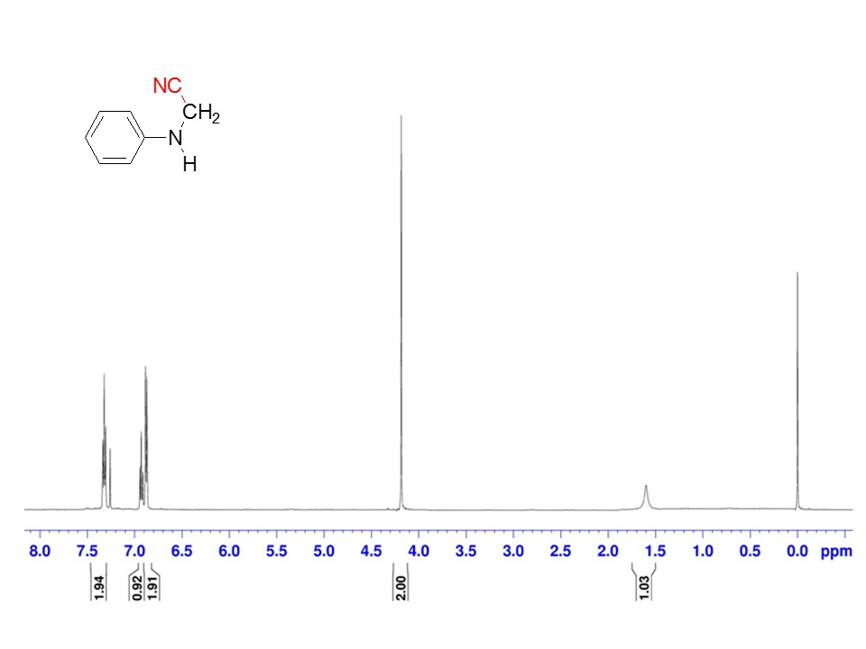**1HNMR and 13CNMR of the products**

