Supporting Information

Photocatalytic C-H Activation and Oxidative Esterification Using Pd@g-C₃N₄
Sanny Verma^{a†}, R. B. Nasir Baig^{a†}, Mallikarjuna N. Nadagouda^{b} and Rajender S. Varma^{c}*

ªOak Ridge Institute for Science and Education, P. O. Box 117, Oak Ridge TN, 37831, USA.
^{b}WQMB, WSWRD, National Risk Management Research Laboratory, U. S. Environmental Protection Agency, 26 West Martin Luther King Drive, Cincinnati, Ohio 45268, USA.
^{c}Sustainable Technology Division, National Risk Management Research Laboratory, U. S. Environmental Protection Agency, 26 West Martin Luther King Drive, MS 443, Cincinnati, Ohio 45268, USA.
* Corresponding Author: varma.rajender@epa.gov (R. S. Varma)
Tel: 513-487-2701; Fax: 513- 569-7677
† Equal contribution

The number of pages: 10
The number of figures: 2 (Fig. S1; Fig. S2)

XPS of Pd in Pd@g-C₃N₄ catalyst (S1)
XRD of recycled Pd@g-C₃N₄ catalyst (S2)
¹H NMR of the representative compounds

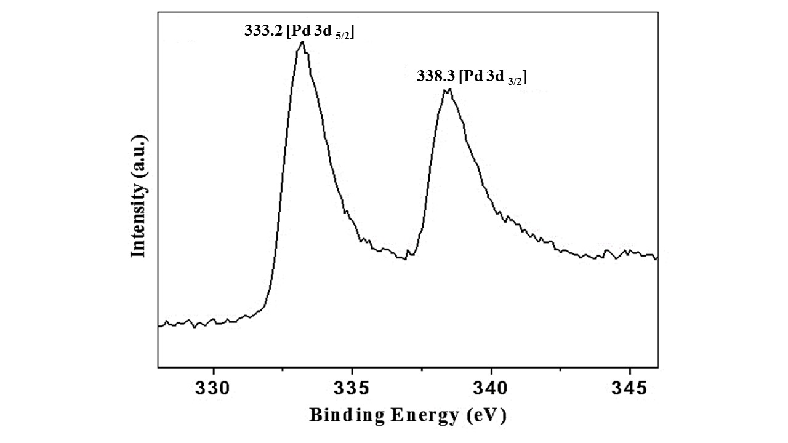
- XPS of Pd in Pd@g-C₃N₄ catalyst
Fig. S1. XPS of Pd in Pd@g-C₃N₄

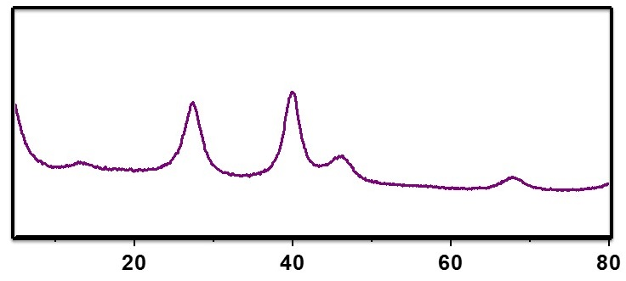
2. XRD of the recycled catalyst
Fig. S2. XRD analysis of recycled Pd@g-C₃N₄

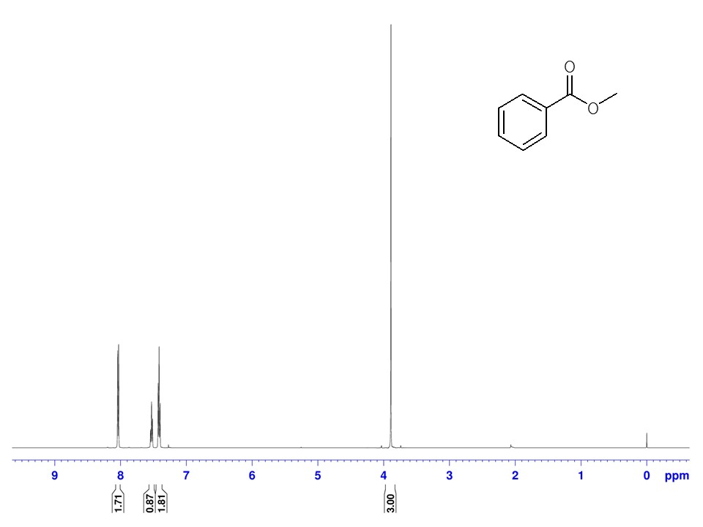
3. ¹H NMR of the product

