Supporting Information

**Photocatalytic C-H activation of Hydrocarbons over VO@g-C3N4**

Sanny Vermaa†, R. B. Nasir Baiga†, Mallikarjuna N. Nadagoudab and Rajender S. Varmaa*

aSustainable Technology Division, National Risk Management Research Laboratory, U. S. Environmental Protection Agency, 26 West Martin Luther King Drive, MS 443, Cincinnati, Ohio 45268, USA. Fax: 513- 569-7677; Tel: 513-487-2701. E-mail: varma.rajender@epa.gov

bWQMB, WSWRD, National Risk Management Research Laboratory, U. S. Environmental Protection Agency, 26 West Martin Luther King Drive, Cincinnati, Ohio 45268, USA

The number of pages: 24

The number of figures: 20 (Figure S1; Figure S2; Figure S3; Figure S4; Figure S5; Figure S6; Figure S7; Figure S8; Figure S9; Figure S10; Figure S11; Figure S12; Figure S13; Figure S14; Figure S15; Figure S16; Figure S17; Figure S18; Figure S19; Figure S20)

**General Methods**

**Synthesis of the materials**

**Synthesis of g-C3N4**

**Synthesis of VO@g-C3N4 catalyst**

**General procedure for the oxidation of methyl arenes and its derivatives (S1)**

**General procedure for the oxygen insertion in C-H aryl compound**

**TEM image of VO@g-C3N4 catalyst (S2)**

**SEM image of VO@C3N4 catalyst (S3)**

**XRD spectra of VO@g-C3N4 catalyst and g-C3N4 support**

**1H and 13C NMR of the representative compounds**

**General Methods.**

All the reactions were performed in an oven-dried apparatus in a closed box using domestic bulb (40 watt), with wave length in the range of 400-700 nm and were stirred magnetically. 1H and 13C spectra were recorded at 300MHz and 75MHz NMR instruments, respectively. Chemical shifts are reported in parts per million downfield from the internal reference, tetramethylsilane (TMS).

**Synthesis of materials**

**Synthesis of g-C3N4:**

The 100g urea was taken in ceramic crucible and calcinate at 500 °C for 2 hours in furnace at ambient atmosphere. The temperature was brought down to room temperature and graphitic carbon nitride (g-C3N4) was isolated as pale yellow solid.

**Synthesis of VO@g-C3N4 catalyst:**

The graphitic carbon nitride g-C3N4 (1.0 g) was dispersed in 200 ml aqueous methanol (50 %) under sonication; to this dispersion the methanolic solution of vanadyl acetylacetonate [VO(acac)2; 2 mmol] was added and stirred for 3h at room temperature. The reaction mixture was centrifuged, washed with acetone and dried under vacuum at 60 oC to give the formation of VO@g-C3N4 catalyst as pale yellow solid. The VO@g-C3N4 was isolated and characterized using SEM, TEM, XRD and ICP-AES analysis.

**General procedure for the oxidation of methyl arenes and its derivatives**

In 10 mL round bottom flask methyl arenes (1mmol), catalyst VO@g-C3N4 (25 mg) and 2 mL of acetonitrile were placed. After mixing, solution of 30% of H2O2 (1.5 mmol) was added and exposed to visible light irradiation. The progress of reaction was monitored using TLC. After the completion of the reaction, the VO@g-C3N4 catalyst was separated using a centrifuge and the product was isolated by extracting with ethyl acetate, dried over sodium sulfate, concentrated and characterized by NMR.

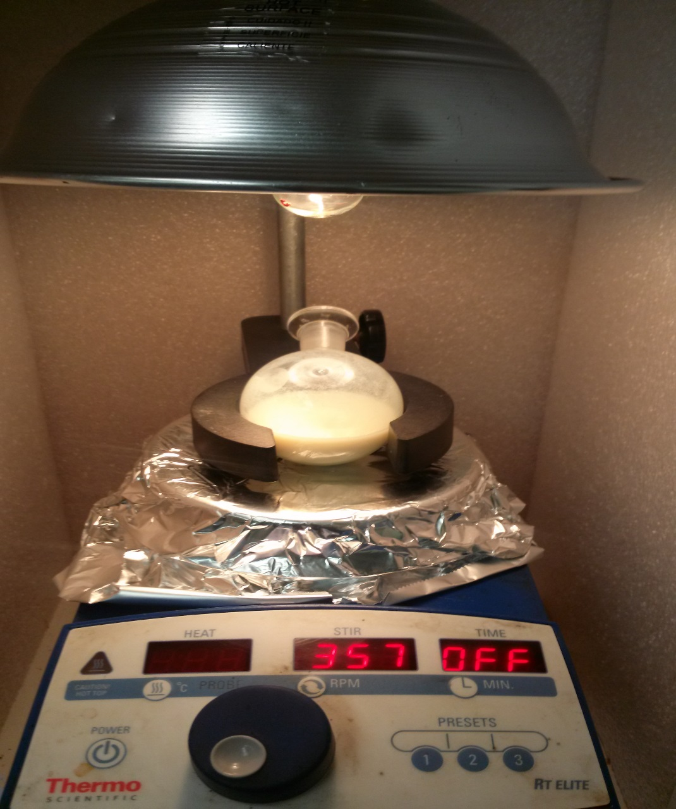

**Figure S1** Reaction setup

**General procedure for the oxygen insertion in C-H aryl compound**

Catalyst, VO@g-C3N4 (25 mg) and 2 mL of acetonitrile were placed in 10 mL round bottom flask benzene (1mmol). After mixing, solution of 30% of H2O2 (1.5 mmol) was added and exposed to visible light irradiation. The progress of reaction was monitored using TLC. After the completion of the reaction, the VO@g-C3N4 catalyst was separated using centrifuge and the product was isolated by extracting dichloromethane, dried over sodium sulfate, concentrated and characterized by GC-MS.

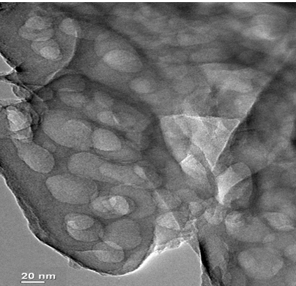

**Figure S2** TEM image of VO@g-C3N4 catalyst

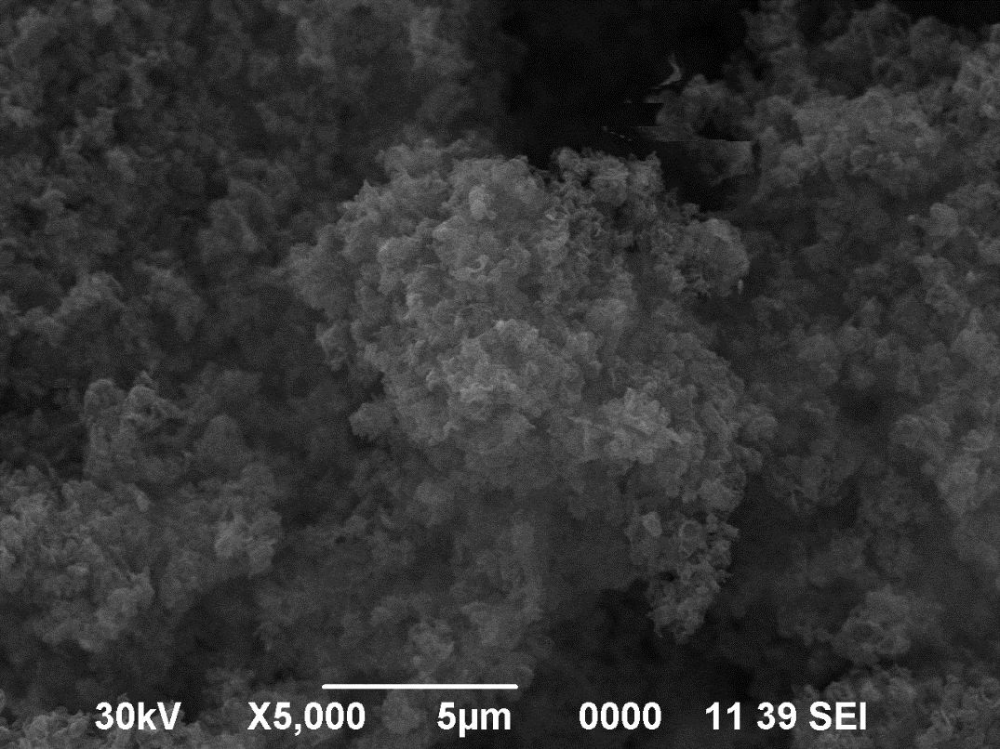

**Figure S3** SEM image of VO@C3N4 catalyst

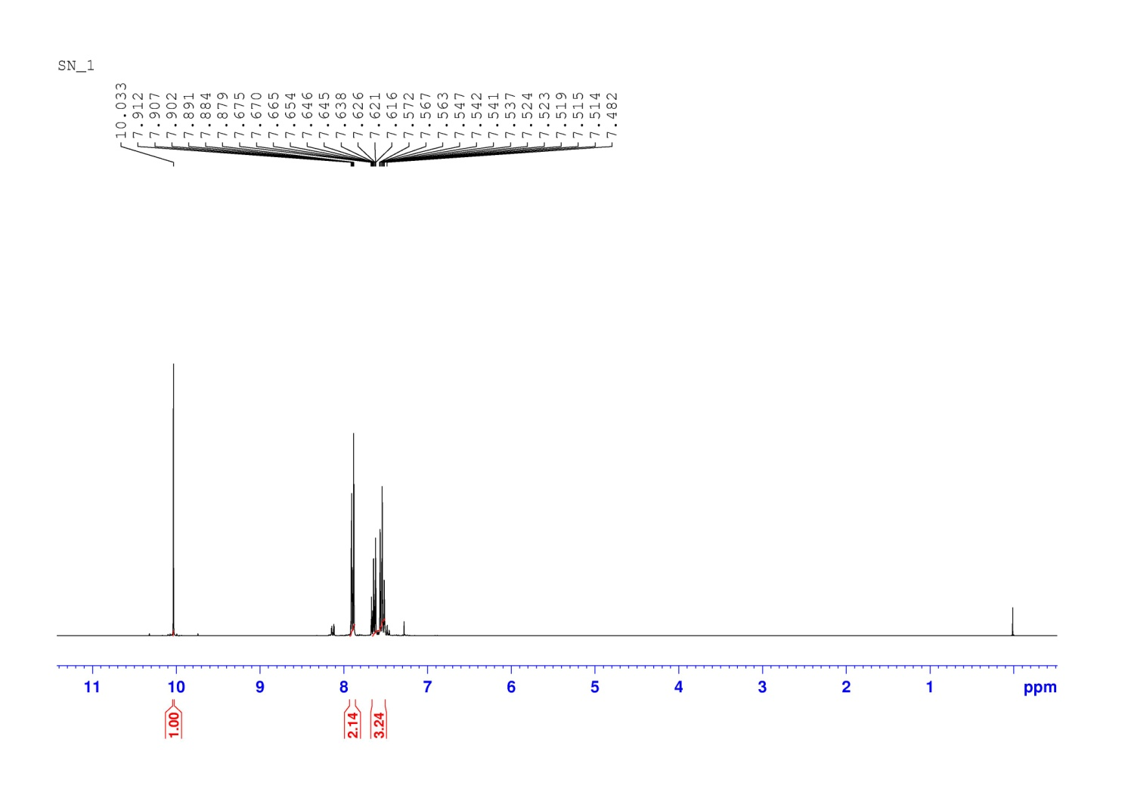

**Figure S4** 1H NMR spectra for the product of Table 2, Entry 1

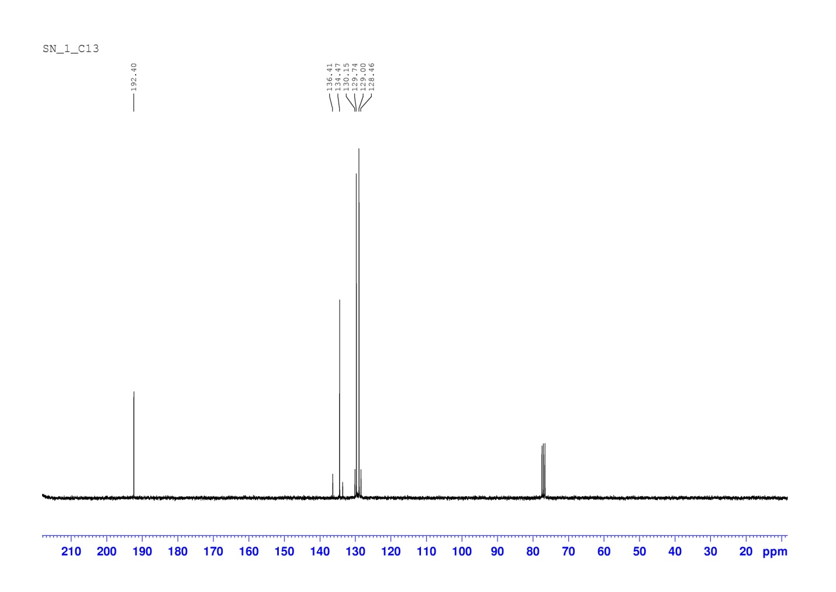

**Figure S5** 13C NMR spectra for the product of Table 2, Entry 1

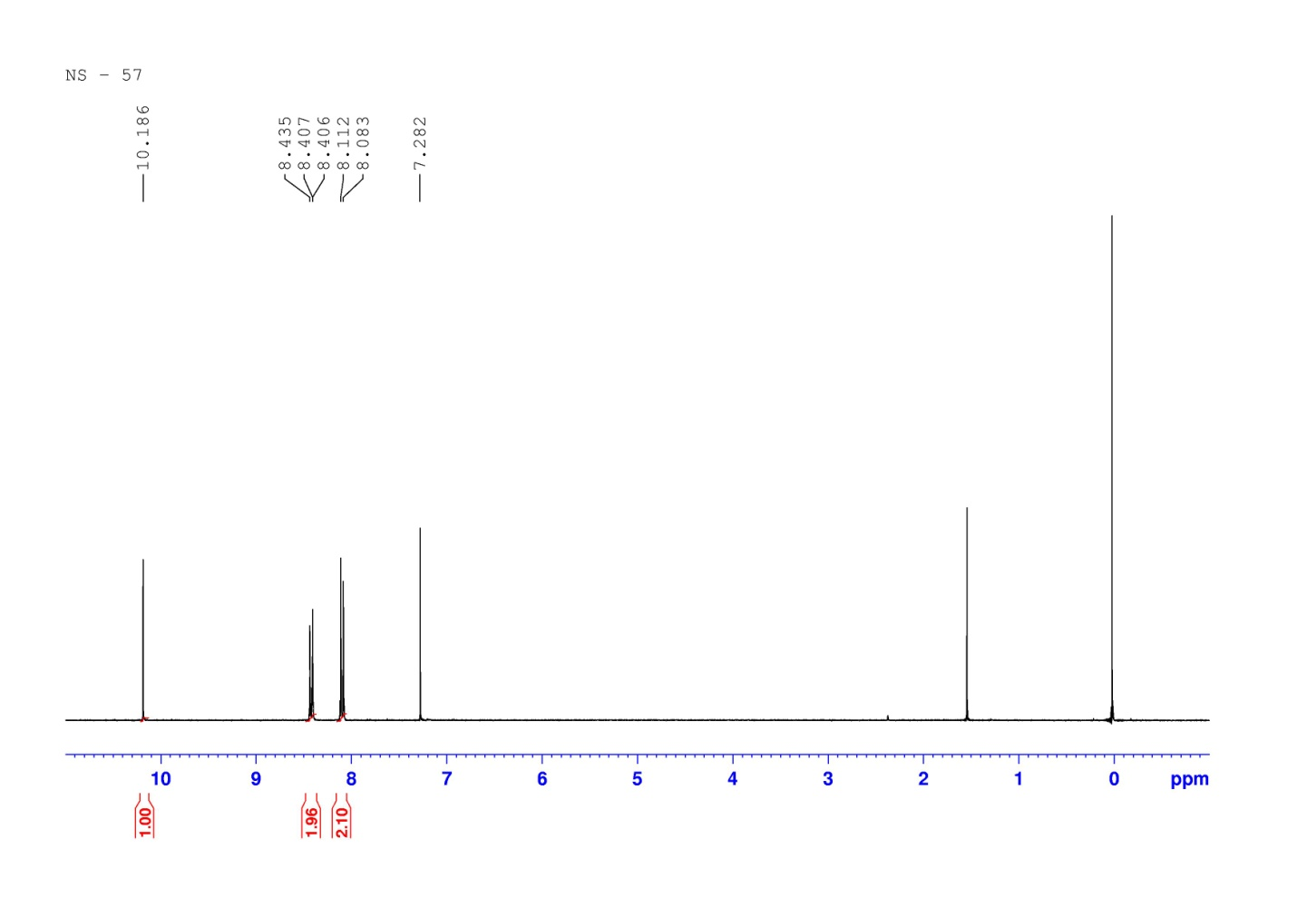

**Figure S6** 1H NMR spectra for the product of Table 2, Entry 2

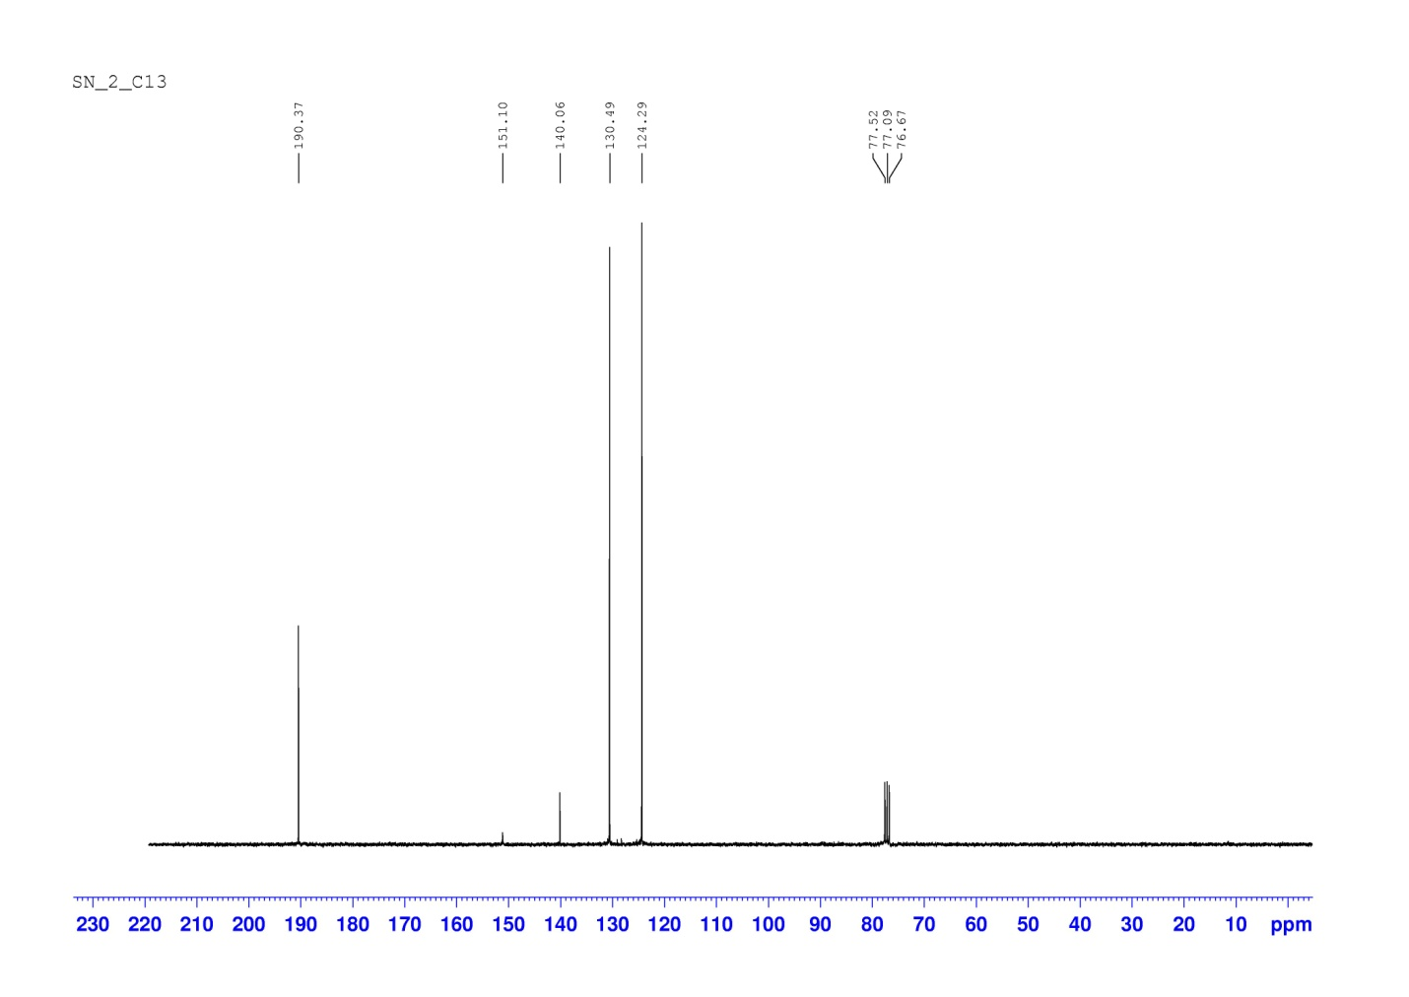

**Figure S7** 13C NMR spectra for the product of Table 2, Entry 2

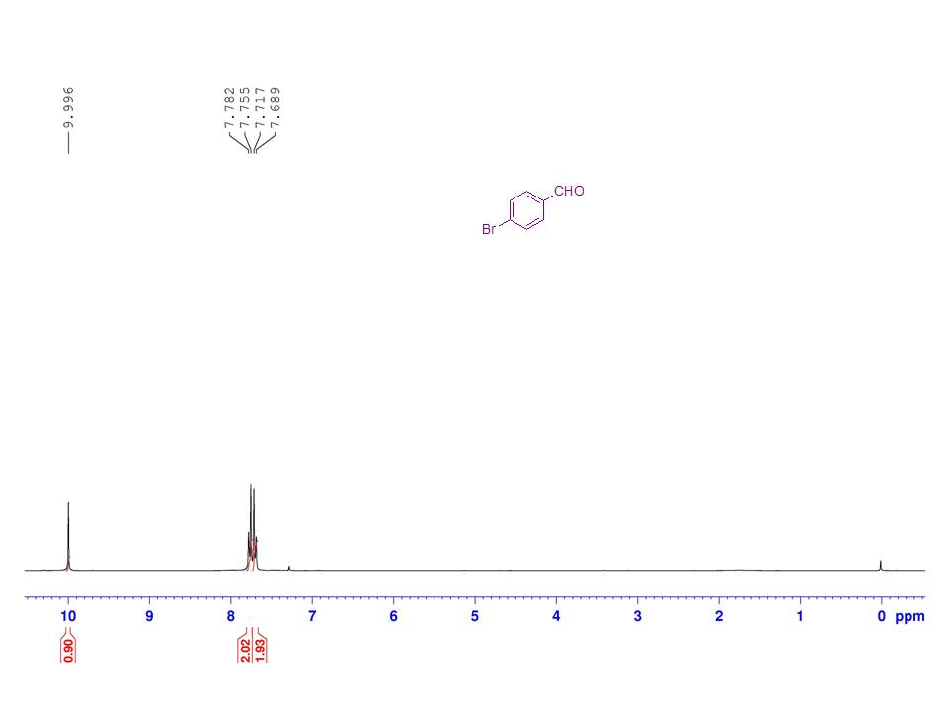

**Figure S8** 1H NMR spectra for the product of Table 2, Entry 3

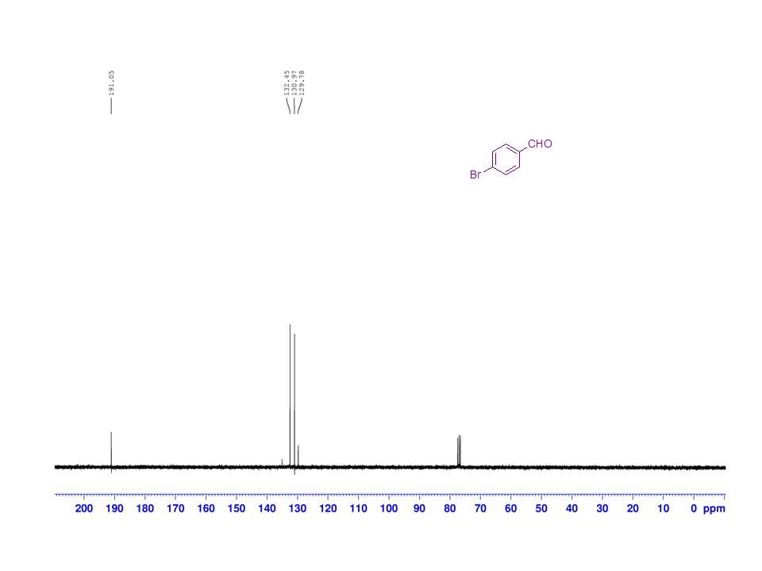

**Figure S9** 1H NMR spectra for the product of Table 2, Entry 3

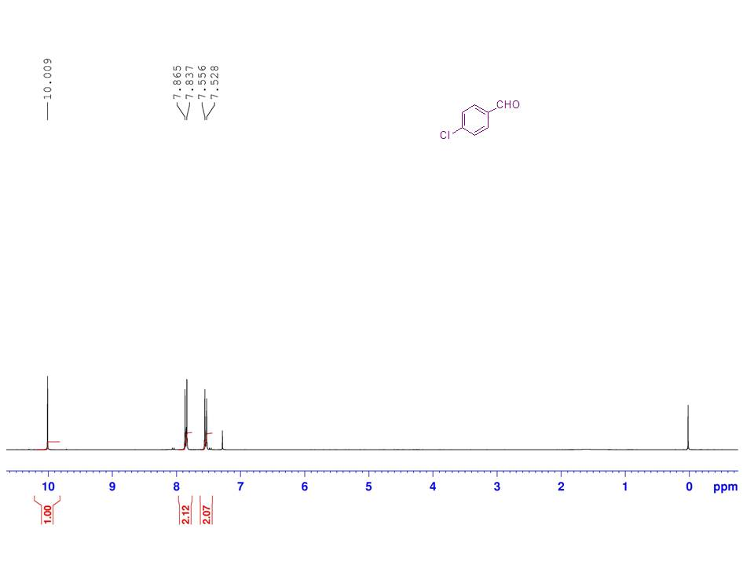

**Figure S10** 1H NMR spectra for the product of Table 2, Entry 4

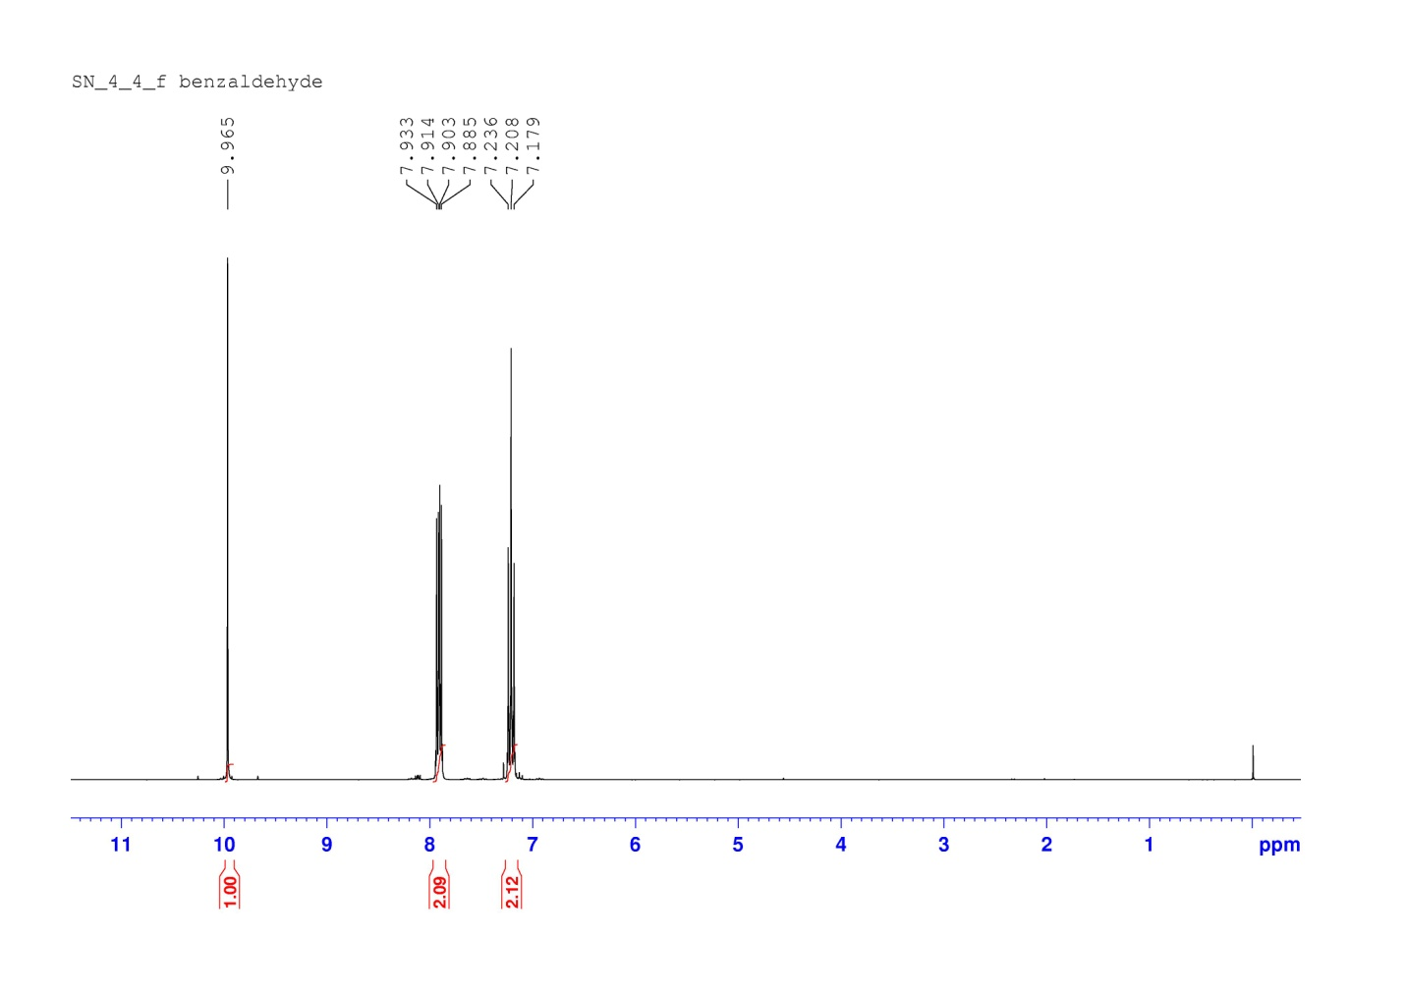

**Figure S11** 1H NMR spectra for the product of Table 2, Entry 5

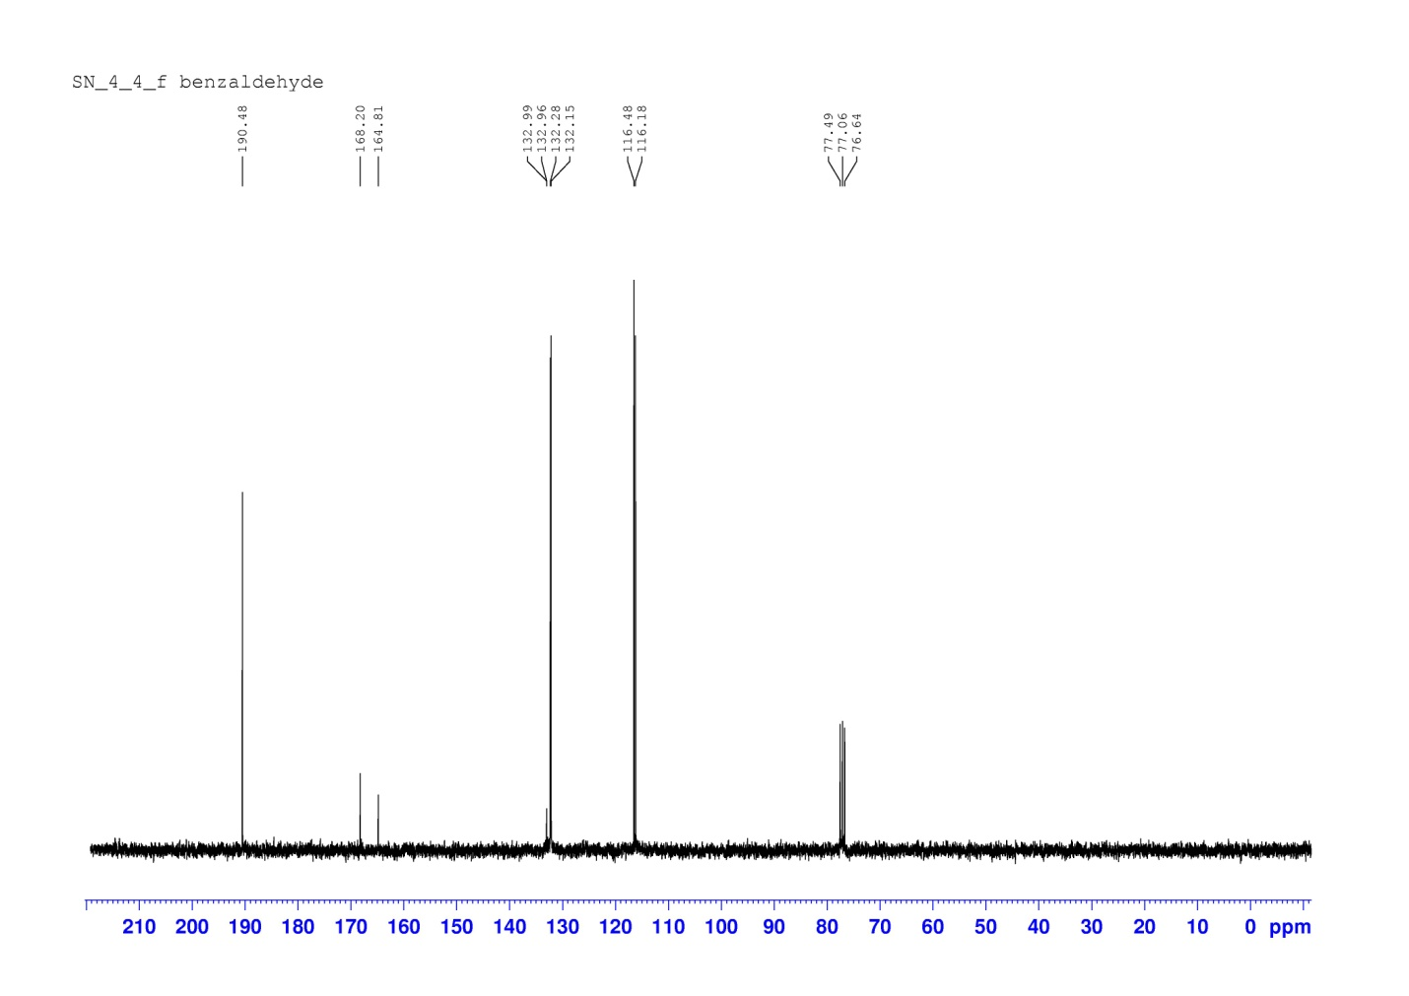

**Figure S12** 13C NMR spectra for the product of Table 2, Entry 5

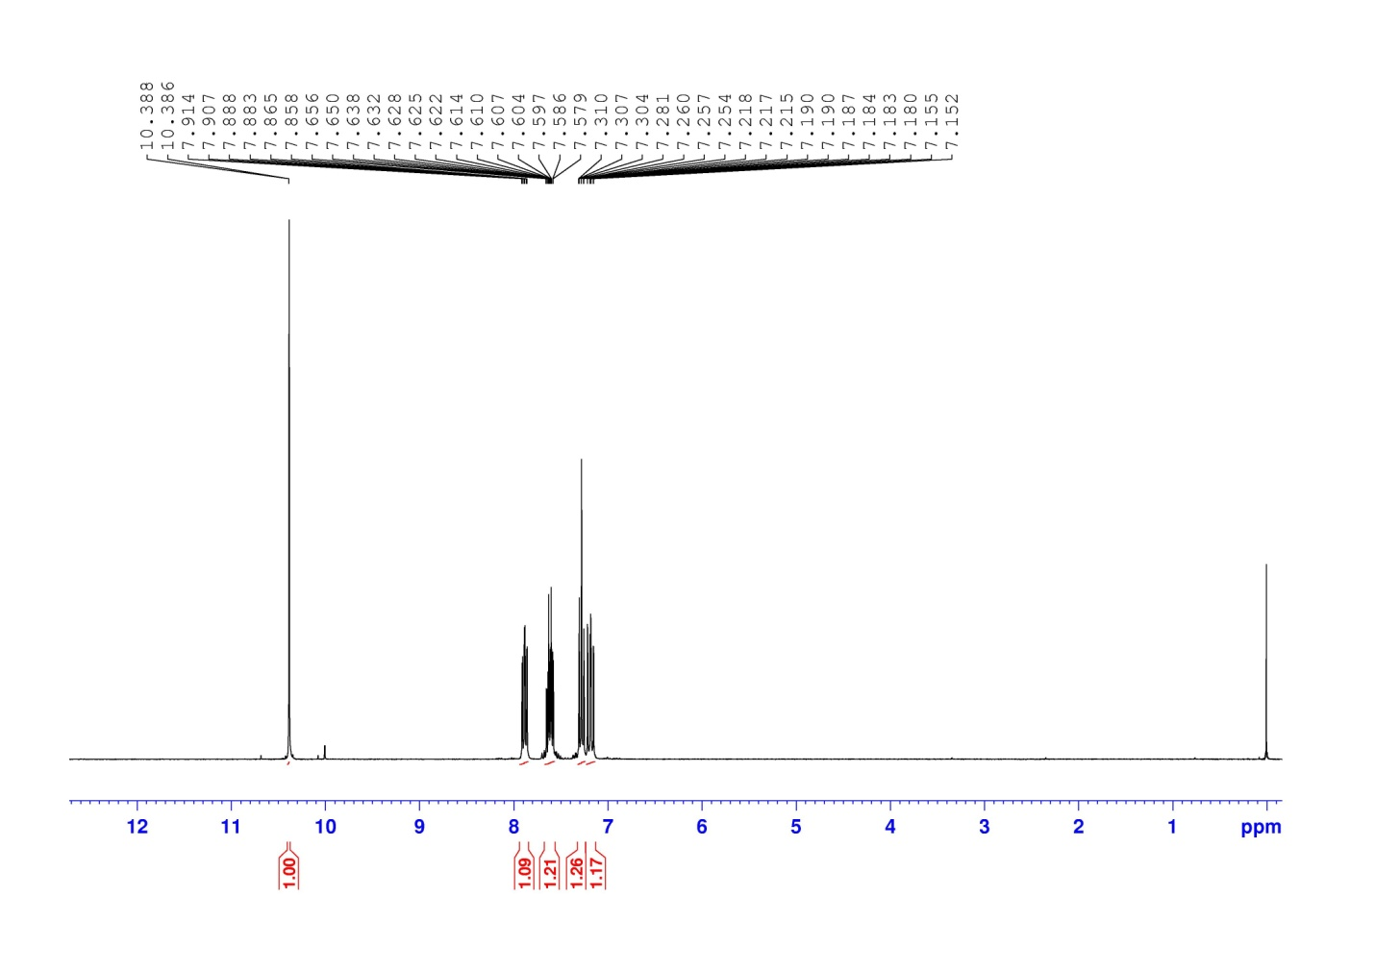**Figure S13** 1H NMR spectra for the product of Table 2, Entry 6



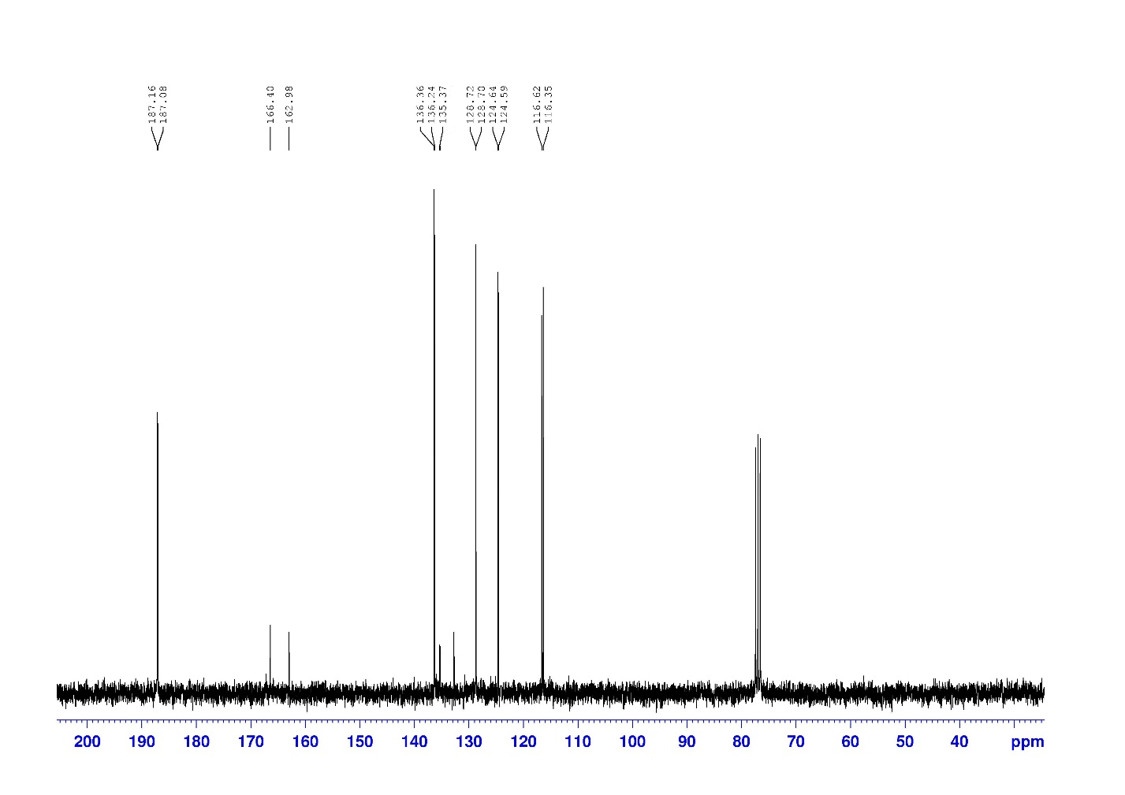

**Figure S14** 13C NMR spectra for the product of Table 2, Entry 6

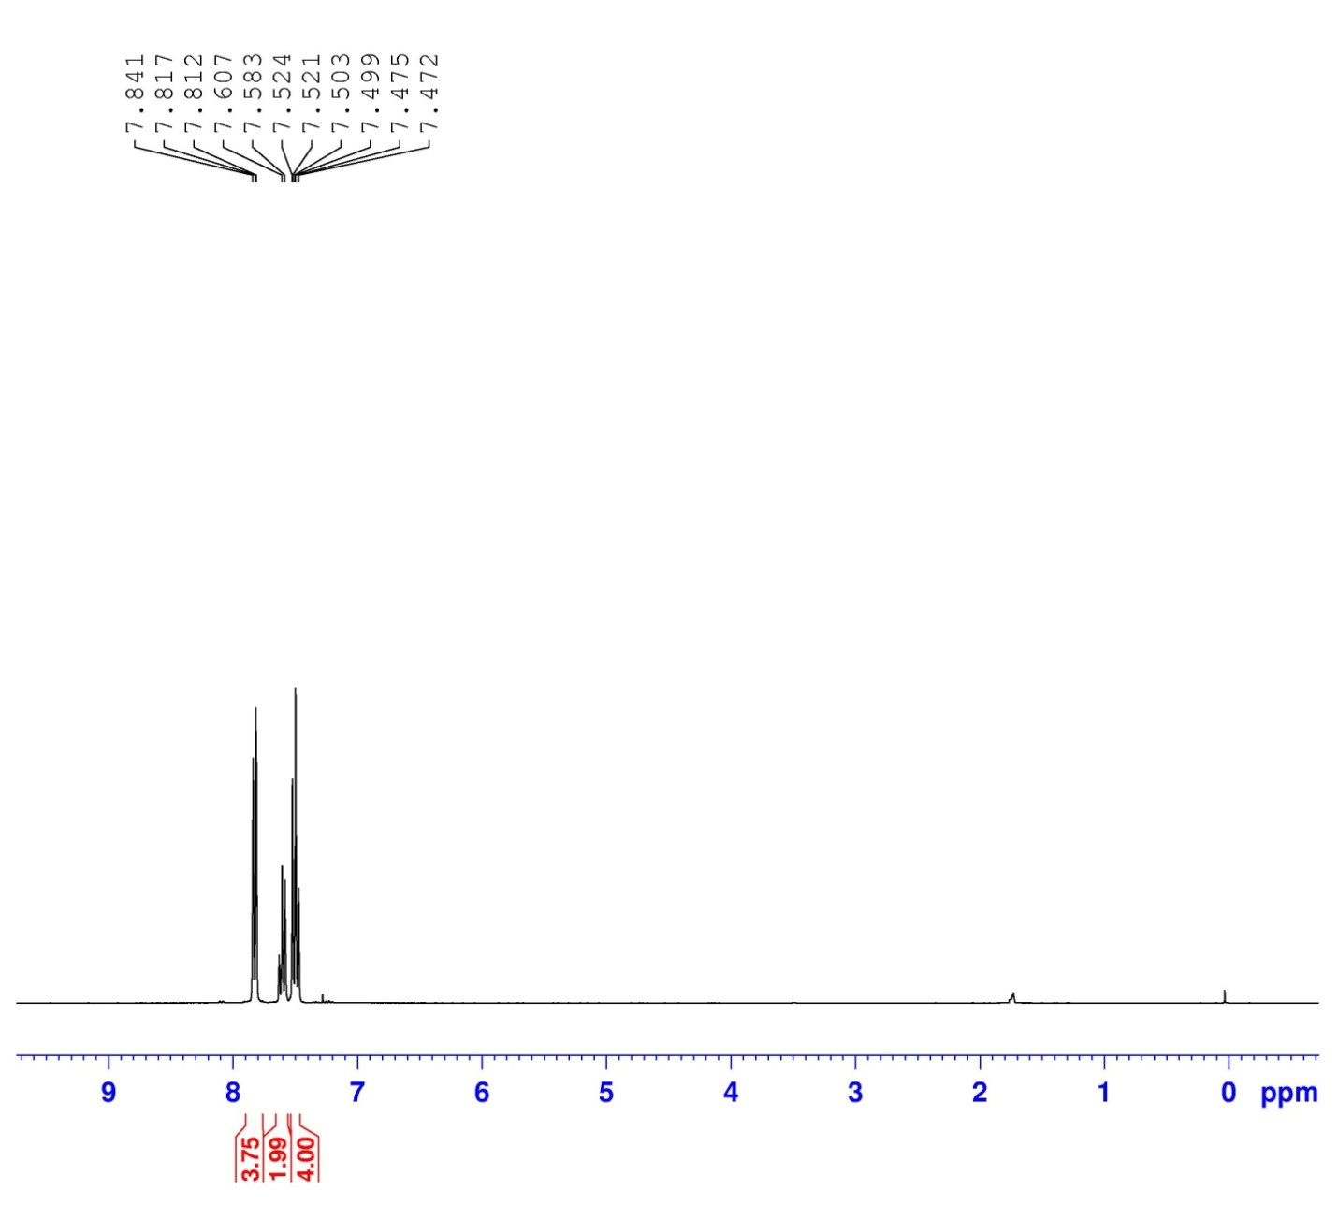

**Figure S15** 1H NMR spectra for the product of Table 2, Entry 10

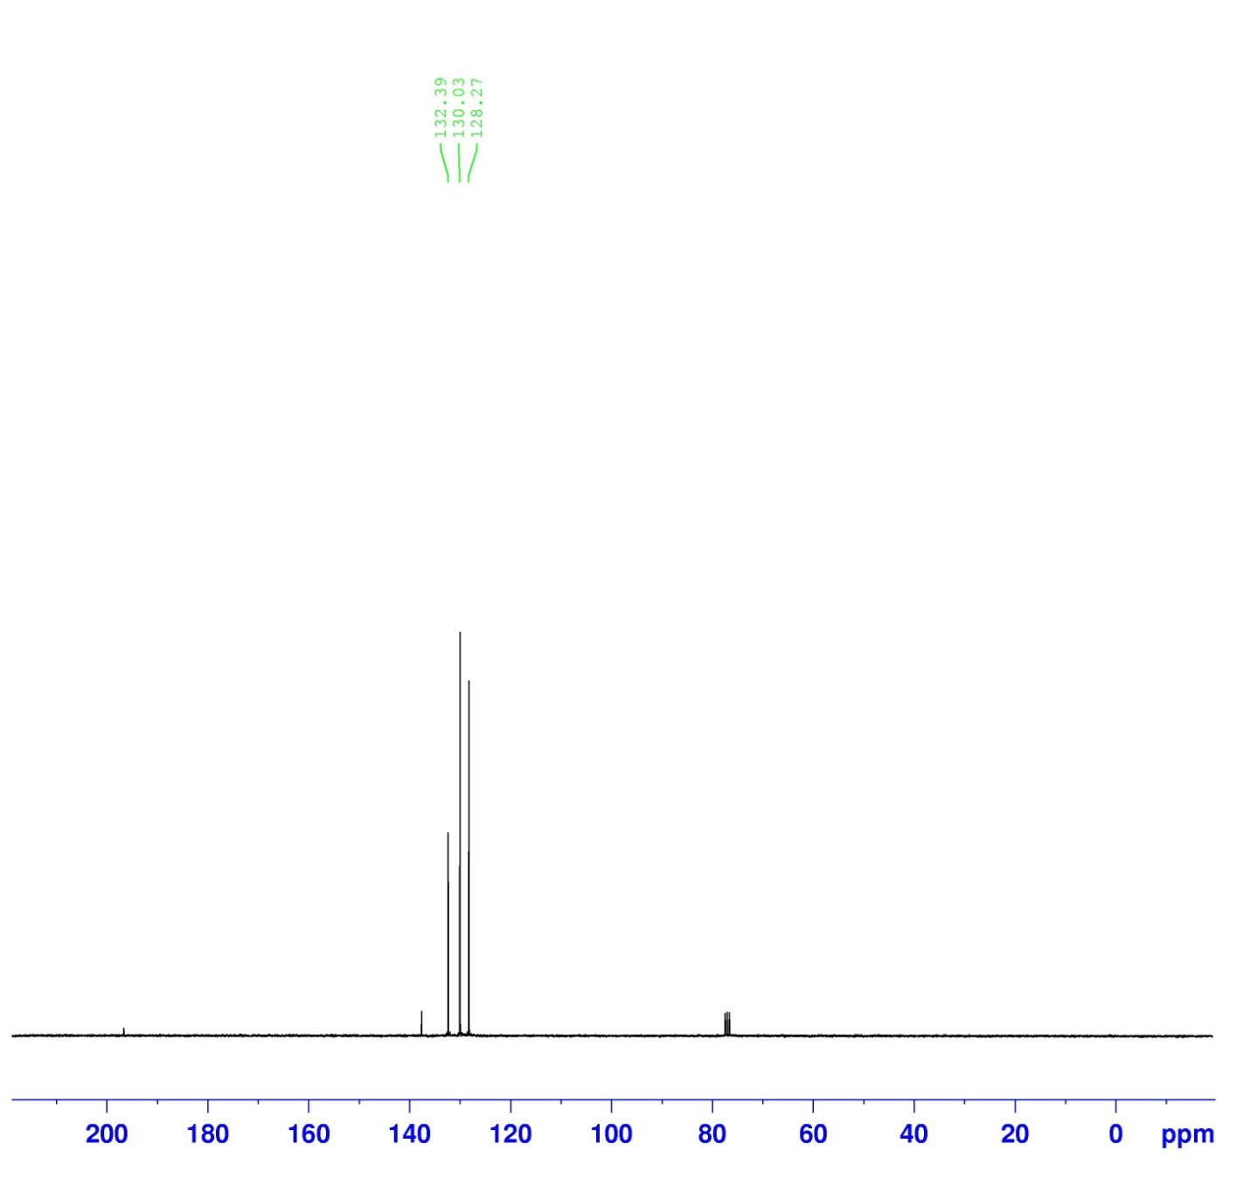

**Figure S16** 13C NMR spectra for the product of Table 2, Entry 10

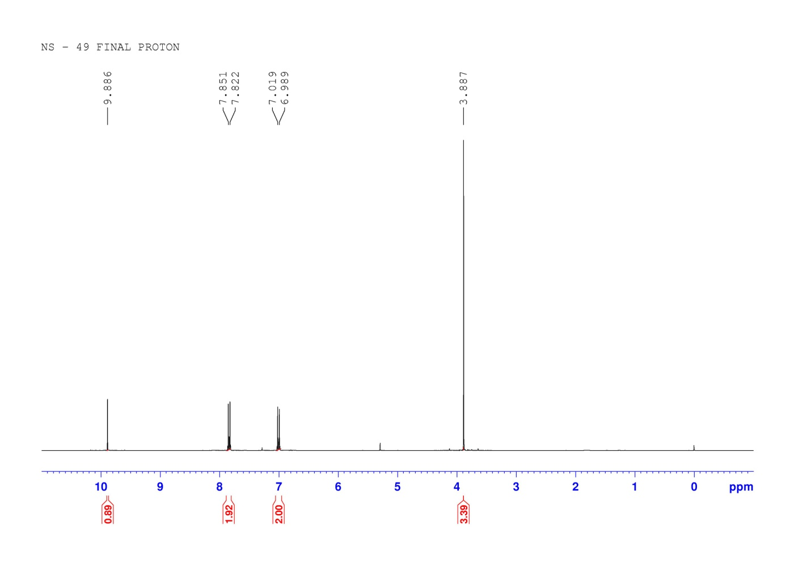

**Figure S17** 1H NMR spectra for the product of Table 2, Entry 7

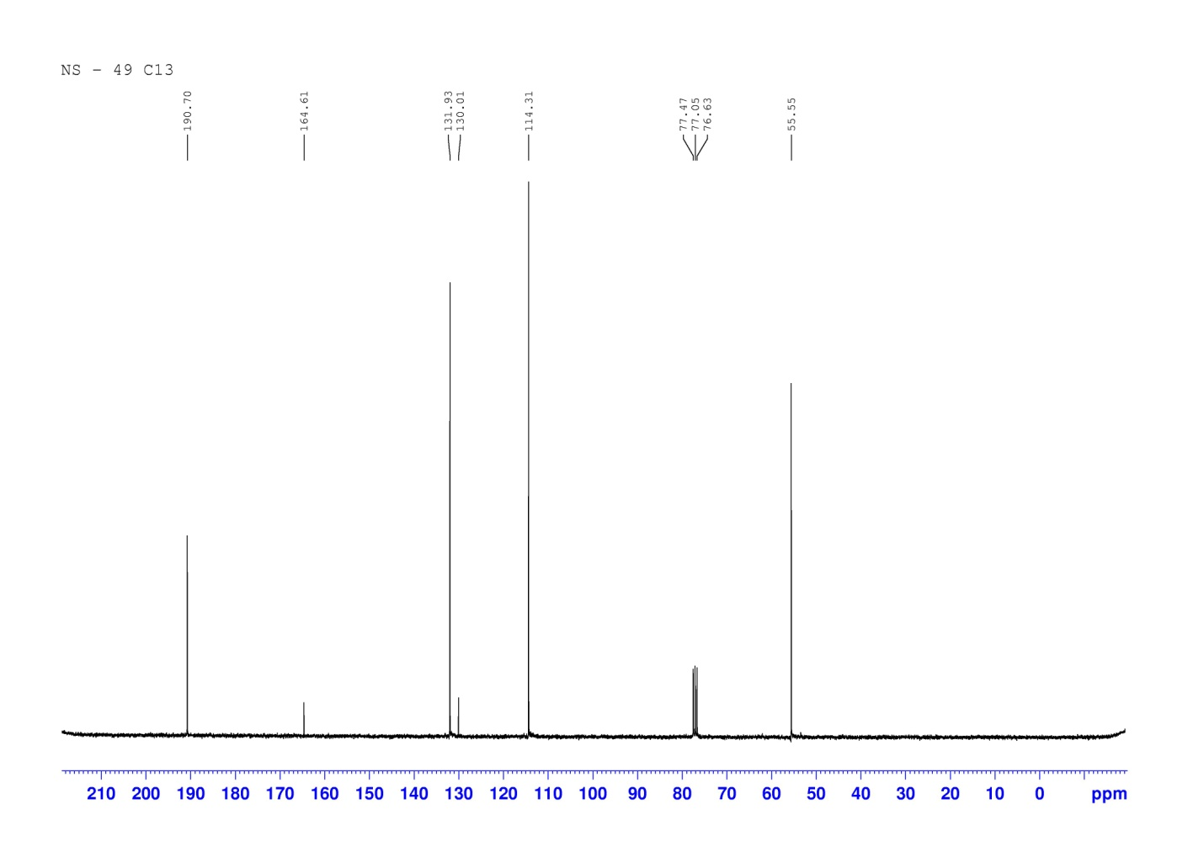

**Figure S18** 13C NMR spectra for the product of Table 2, Entry 7

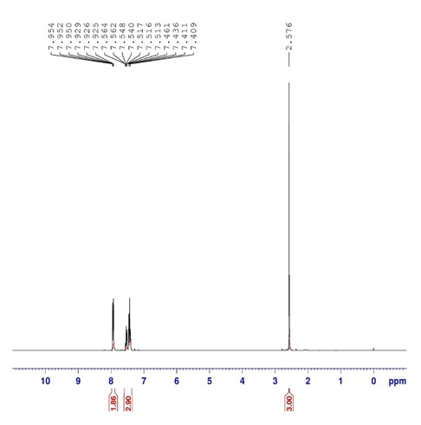

**Figure S19** 1H NMR spectra for the product of Table 2, Entry 9

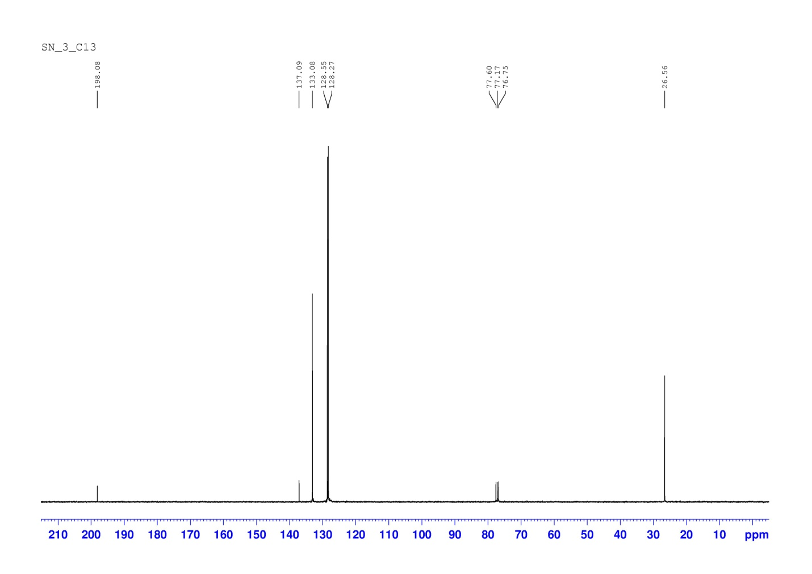

**Figure S20** 13C NMR spectra for the product of Table 2, Entry 9