Supporting Information

Photocatalytic oxidation of aromatic amines using MnO₂@g-C₃N₄
Sanny Verma and Rajender S. Varma*
Sustainable Technology Division, National Risk Management Research Laboratory, U. S. Environmental Protection Agency, MS 443, Cincinnati, Ohio 45268, USA. Fax: 513- 569-7677; Tel: 513-487-2701. E-mail: varma.rajender@epa.gov

- SEM of recycled MnO₂@g-C₃N₄ catalyst
- XRD of recycled MnO₂@g-C₃N₄ catalyst
- ¹H and ¹³C NMR of Azobenzene

- SEM of recycled MnO₂@g-C₃N₄ catalyst

S1. SEM of recycled MnO₂@g-C₃N₄ catalyst

2. XRD of recycled MnO₂@g-C₃N₄ catalyst
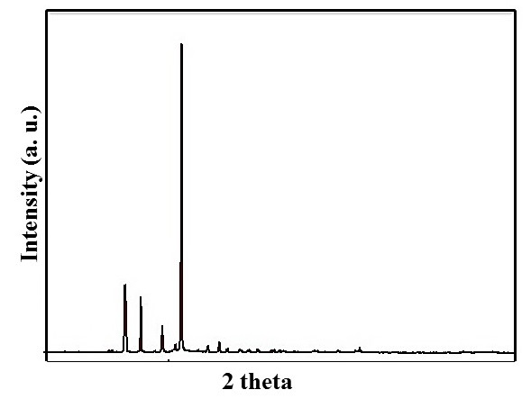

S2. XRD of recycled MnO₂@g-C₃N₄ catalyst

2. ¹H and ¹³C NMR of Azobenzene

