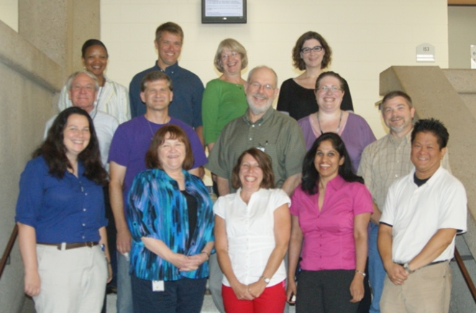

Fig. 1. The joint U.S. Environmental Protection Agency (USEPA) and U.S. Geological Survey (USGS) multidisciplinary team. Front row (from left to right): Maura Donohue (USEPA), Vicki Wilson (USEPA), Stacy Pfaller (USEPA), Eunice Varughese (USEPA), Eric Villegas (USEPA). Second row: Bob Benson (USEPA), Dana Kolpin (USGS), Ed Furlong (USGS), Susan Glassmeyer (USEPA), Scott Boone (USEPA). Third row: Octavia Conerly (USEPA), Heath Mash (USEPA), Kathleen Schenck (USEPA), Angela Batt (USEPA). Team members not shown: Dawn King (USEPA), Mitch Kostich (USEPA), Jane Ellen Simmons (USEPA), and Stephen Vesper (USEPA).

