**Supporting Information**

**Effects of Simulated Smog Atmospheres in Rodent Models**

**of Metabolic and Immunologic Dysfunction**

Marie McGee Hargrove1*, Samantha J. Snow2*, Robert W. Luebke2, Charles E. Wood2, Jonathan D. Krug2, Q. Todd Krantz2, Charly King2, Carey B. Copeland2, Shaun D. McCullough2, Kymberly M. Gowdy3, Urmila P. Kodavanti2, M. Ian Gilmour2, and Stephen H. Gavett2**

1Oak Ridge Institute for Science and Education, Research Triangle Park, NC; 2National Health and Environmental Effects Research Laboratory, Office of Research and Development, U.S. EPA, Research Triangle Park, NC; 3Department of Pharmacology and Toxicology, East Carolina University, Greenville, NC. *M.M.H. and S.J.S. contributed equally to this work. **Corresponding Author: Stephen H. Gavett: [gavett.stephen@epa.gov](mailto:gavett.stephen@epa.gov)

Number of Pages: 13

Number of Tables: 3

Number of Figures:7

**Methods**

**Glucose and Insulin Tolerance Testing**

Rats were fasted for approximately 6 hr prior to testing. Baseline blood glucose levels were obtained from fasted rats by pricking the distal surface of the tail with a sterile needle, collecting blood on a glucose test strip and measuring with a glucometer (Bayer Contour, Leverkusen, Germany). After an i.p. injection of glucose (5 mL/kg of a 20% D-glucose solution in saline; Sigma-Aldrich, St Louis, MO), blood glucose measurements were made every 30 min over 2 hr for a total of five readings. Insulin tolerance testing (ITT) was performed following the same protocol as GTT with the exception of an i.p. injection of insulin (HumulinR, Lilly USA, LLC, Indianapolis, IN; 1.0 IU diluted in 1 mL saline/kg) instead of glucose after the baseline glucose measurement.

**T-Independent Antibody Titers to HKSP**

High binding ELISA plates (Costar #3590, Corning, NY) were coated overnight at 4°C with 50 µg/well of phosphorylcholine (PC) coupled to Bovine Serum Albumin (BSA) (PC-l 011 H, PC-BSA, High loaded, Biosearch Technologies, Petaluma, CA), blocked for 1 hr at room temperature with 3% BSA (Sigma A-7030, ST. Louis, MO) in phosphate buffered saline (PBS) and washed X3 with PBS+ 0.05% Tween 20 (Fisher BP337-50). Two-fold serial dilutions of mouse serum samples were added, beginning at an initial dilution of 1:400. Pooled immunized and non-immunized mouse serum was included in separate wells as positive and negative controls. Plates were incubated for one hour at room temperature and, after washing X4 with PBS/Tween, 100 µL of detection antibody (1:10,000 dilution of horseradish peroxidase labeled goat anti-mouse IgM, Accurate (JGM035020)) was added and plates were incubated for one hour at room temperature. Following five washes, 100 µL of substrate (tetramethylbenzidine) Dako S1599, Carpinteria, CA) was added, the plates incubated for 40 minutes at room temperature and absorbance was read at 650 nm using a SpectraMax-350 plate reader. Data were processed using SoftMax Pro software version 5.2, revision C, (Molecular Devices, Sunnyvale, CA) and expressed as log2 titers.

**Influenza A Virus Burden and mRNA Cytokine Response**

Approximately 30 mg of preserved lung tissue was placed in a 2 mL FastPrep tube containing matrix D (MP Biomedicals, Solon, OH) containing 650 µL of Qiagen RLT buffer plus 2-mercaptoethanol. The tissue was disrupted using two 40 second runs at 6 M/S, and debris were pelleted by centrifuging the Fastprep tube at 14,000 RPM for 3 minutes in a microfuge. The clarified supernatant was transferred to an RNase-free microfuge tube, centrifuged for 3 minutes at 14,000 RPM, and 350 µL of supernatant was then transferred to an equal volume of 70% ethanol (step 2 of the Quiagen RNeasy Mini kit instructions) and the vendor’s instructions were followed to isolate RNA. The concentration and purity of isolated RNA was measured using a Nanodrop-1000 (Thermo Scientific, Wilmington, DE). 500 ng of total RNA was reverse transcribed into cDNA using an iScript cDNA synthesis kit (Bio-Rad, Hercules, CA). cDNA was diluted to 5 ng/µl and 5 µl was used in each qPCR reaction. qPCR was carried out using sequence-specific primers (F: 5’-AAACAACACCACGACCACTTAGAC-3’; R: 5’-AGGCATCCATCAGCAGGAAT-3’), a sequence-specific probe (5'- /56-FAM/TCCGAATGGGCCTCCCTGTTCTC/3BHQ_l/-3', (Integrated DNA Technologies, Coraville, IA) and iTaq Universal Probes Supermix (BioRad). Duplicate qPCR reactions had a final concentration of 150 nM primer and probe in a total volume of 20 µl and were amplified in an ABI 7900 HT (Thermofisher). Thermocycling conditions were 95°C for 10 minutes, then 40 cycles of 95°C for 15 seconds and 60°C for one minute. Data are expressed as copies/g of total RNA as determined from a standard curve prepared using the pUC57-InvA-PA plasmid, which was constructed by inserting a fragment (base pairs 1-1540, synthesized by Genewiz, Research Triangle Park, NC) of the Puerto Rico 8/34 (PR8) strain of the Influenza A (H1N1) virus genome (Genbank accession #CY083955.1) into the pUC57 vector by recombination at the BamHI and StuI restriction enzyme sites.

For cytokine and chemokine analysis, sequence-specific primers were synthesized for interferon-1 (*Ifnb1;* 5’-3’ GGAGATGACGGAGAAGATGC, 3’-5’ CCCAGTGCTGGAGAAATTGT), or obtained commercially (Applied Biosystems, Foster City, CA): tumor necrosis factor-alpha (*Tnfa*; catalogue number Mm00443258), interleukin-6 (*Il6*; Mm00446190), interleukin-1 (*Il1b*; Mm00434228), chemokine (C-X-C motif) ligand 2 (*Cxcl2*; Mm00436450), chemokine (C-X-C motif) ligand 1 (*Cxcl1*; Mm04207460), chemokine (C-C motif) ligand 3 (*Ccl3*; Mm00441259), and 18S ribosomal RNA (*Rn18s*; Mm03928990). Data are expressed relative to quantity of *Rn18s* mRNA.

**Table S1.** Complete blood counts following exposure to SA in non-obese Type II Diabetic GK model.Data show mean ± SEM (n=6/group). Abbreviations: SA-PM, particulate matter-enriched simulated atmosphere; SA-O3, ozone-enriched simulated atmosphere; WBC, white blood cells; RBC, red blood cells; Hgb, hemoglobin; HCT, hematocrit; MCV, mean corpuscular volume; MCH, mean corpuscular hemoglobin; MCHC, mean corpuscular hemoglobin concentration.

|  |  |  |  |  |  |  |  |  |  |  |
| --- | --- | --- | --- | --- | --- | --- | --- | --- | --- | --- |
| Exposure Type | Exposure Days | Allergic Status | Pigment, Alveolar Macrophages | Alveolar Histiocytosis | Mixed Cell Inflammation | Intrabronchiolar Mucus | Mucous Cell Metaplasia | Multinucleated Giant Cells1 | Lymphoid Hyperplasia | Intrapulmonary Foreign Material2 |
| Air | 1 | NA | 0/8 | 4/8 (0.5) | 4/8 (0.5) | 2/8 (0.3) | 0/8 (0.0) | 0/8 | 2/8 (0.3) | 0/8 |
| 1 | HDM | 0/7 | 5/7 (0.7) | 7/7 (1.7) | **7/7 (1.9)#** | **5/7 (1.1)#** | 2/7 | 2/7 (0.3) | 1/7 |
| SA-PM | 1 | NA | 1/8 | 3/8 (0.4) | 1/8 (0.1) | 2/8 (0.3) | 0/8 (0.0) | 0/8 | 0/8 (0.0) | 0/8 |
| 1 | HDM | 2/8 | 6/8 (0.9) | **8/8 (1.8)#** | **8/8 (1.9)#** | **7/8 (1.3)#** | 3/8 | **6/8 (0.8)#** | 0/8 |
| Air | 5 | NA | 1/8 | 2/8 (0.3) | 1/8 (0.1) | 1/8 (0.1) | 0/8 (0.0) | 2/8 | 3/8 (0.4) | 0/8 |
| 5 | HDM | 0/8 | 6/8 (0.8) | **8/8 (1.9)#** | **8/8 (1.6)#** | **5/8 (0.9)#** | 3/8 | 3/8 (0.4) | 4/8 |
| SA-PM | 5 | NA | 4/8 | 6/8 (0.8) | 3/8 (0.4) | 3/8 (0.4) | 0/8 (0.0) | 0/8 | 1/8 (0.1) | 3/8 |
| 5 | HDM | 2/8 | 4/8 (0.5) | **8/8 (1.9)#** | **8/8 (1.6)#** | **6/8 (0.8)#** | 2/8 | 2/8 (0.3) | 1/8 |
| Air | 1 | NA | 1/8 | 5/8 (0.6) | 2/8 (0.3) | 2/8 (0.3) | 0/8 (0.0) | 0/8 | 1/8 (0.0) | 0/8 |
| 1 | HDM | 0/8 | 5/8 (0.6) | **8/8 (1.6)#** | **8/8 (1.5)#** | **6/8 (1.0)#** | 1/8 | **6/8 (0.9)#** | 0/8 |
| SA-O3 | 1 | NA | 1/8 | 4/8 (0.5) | 0/8 (0.0) | 1/8 (0.1) | 0/8 (0.0) | 0/8 | 1/8 (0.0) | 0/8 |
| 1 | HDM | 2/8 | 7/8 (1.0) | **8/8 (1.5)#** | **8/8 (1.6)#** | **7/8 (1.4)#** | 4/8 | 4/8 (0.9) | 1/8 |
| Air | 5 | NA | 0/8 | 4/8 (0.5) | 1/8 (0.1) | 0/8 (0.0) | 0/8 (0.0) | 0/8 | 1/8 (0.0) | 0/8 |
| 5 | HDM | 0/8 | 7/8 (0.9) | **8/8 (1.5)#** | **8/8 (1.6)#** | **8/8 (1.5)#** | **6/8#** | **7/8 (1.3)#** | 0/8 |
| SA-O3 | 5 | NA | 0/8 | 3/8 (0.4) | **6/8 (0.9)*#** | 4/8 (0.5) | 1/8 (0.1) | 0/8 | 0/8 (0.0) | 0/8 |
| 5 | HDM | 2/8 | 6/8 (0.8) | 8/8 (2.0) | 8/8 (1.6) | **6/8 (1.0)#** | 3/8 | **7/8 (1.3)#** | 0/8 |

**Table S2.** Incidence summary table of histopathological changes in the lung after SA-PM or SA-O3 exposure in non-allergic (NA) and house dust mite (HDM)-allergic mice (n=8 mice/group). Values represent the incidence, with average severity score in parentheses for selected findings. Severity scores used a qualitative 0-4 scale (0=absent; 1=minimal; 2 mild; 3=moderate; 4=severe); scores shown were averaged across all animals in each group. #*P*<0.05 (bold font) for incidence compared to respective non-allergic groups for the same treatment. \**P*<0.05 (bold font) for incidence compared to respective air control group (same model). 1Considered a component of mixed cell inflammation. 2Consistent with aspiration of bedding or feed.

|  |  |  |  |  |
| --- | --- | --- | --- | --- |
| **HKSP Immunization** | | | | |
| Endpoint | D1/Air | D1/SA-PM | D7/Air | D7/SA-PM |
| IgM titer to HKSP (log2) | 8.4 ± 0.1 | 8.4 ± 0.2 | 8.4 ± 0.2 | 7.8 ± 0.3 |
| Body weight (g, at necropsy) | 17.3 ± 0.2 | 17.3 ± 0.5 | 17.8 ± 0.3 | 17.6 ± 0.3 |
| BALF LDH (U/mL) | 23.4 ± 1.8 | 20.7 ± 2.5 | 20.9 ± 2.4 | 19.5 ± 1.8 |
| BALF total protein (µg/mL) | 63.3 ± 4.5 | 65.5 ± 3.2 | 63.9 ± 4.3 | 63.3 ± 3.7 |
| BALF total cells (x10-4/mL) | 9.5 ± 0.8 | 8.7 ± 2.5 | 7.7 ± 1.4 | 7.4 ± 0.8 |
| BALF % macrophages | 99.2 ± 0.3 | 99.6 ± 0.2 | 96.0 ± 2.0 | 99.4 ± 0.3 |
| BALF % neutrophils* | 0.4 ± 0.2 | 0.4 ± 0.2 | 3.9 ± 2.1 | 0.6 ± 0.3 |
|  |  |  |  |  |
| **Influenza A (H1N1) Infection** | | | | |
| Endpoint | D1/Air | D1/SA-O3 | D7/Air | D7/SA-O3 |
| Body weight gain/loss (g)# | 0.7 ± 0.5 | 0.2 ± 0.4 | -2.8 ± 0.4 | -1.8 ± 0.6 |
| Left lung lobe weight (mg)# | 53.2 ± 3.4 | 52.8 ± 4.2 | 75.4 ± 6.0 | 60.4 ± 4.3 |
| BALF LDH (U/mL) | 75.0 ± 15.3 | 83.4 ± 10.7 | 106.2 ± 10.7 | 89.6 ± 16.8 |
| BALF total protein (µg/mL) | 305.1 ± 82.9 | 321.2 ± 56.8 | 487.1 ± 70.8 | 377.6 ± 94.2 |
| BALF total cells (x10-4/mL) | 87.9 ± 27.7 | 103.5 ± 21.1 | 108.5 ± 18.1 | 101.1 ± 23.8 |
| BALF % macrophages | 84.8 ± 3.2 | 88.8 ± 2.0 | 91.2 ± 1.7 | 92.5 ± 2.3 |
| BALF % neutrophils | 15.2 ± 3.2 | 11.3 ± 2.0 | 8.8 ± 1.7 | 7.5 ± 2.3 |

**Table S3.** Antibody responses (HKSP model), body weights, and parameters of lung injury in mice immunized with HKSP or infected with influenza A (H1N1). Mice were immunized with HKSP or infected with IA immediately before the first (D1) or last (D7) of 7 daily 4-hr exposures to air or SA-PM (for HKSP) or SA-O3 (for IA). All mice were necropsied 7 days after immunization or infection. Data show mean ± SEM (n=8-10/group). *Significant (*P*<0.05) interaction between immunization timing and exposure; no effect of smog exposure, significant (*P*<0.05) difference between D1 and D7 immunization air groups. #Significant (*P*<0.05) effect of infection timing (D1 *vs.* D7); pairwise T-tests (Holm-Sidak) detected no effect of smog exposure.

**Figure S1.** Pulmonary inflammation in GK rats was not increased following exposure to SA. GK rats were exposed to filtered air, SA-PM (left panels), or SA-O3 (right panels) for 1 day or 5 consecutive days. BALF samples were collected immediately post-exposure and analyzed for total cell count (A, E), macrophages (B, F), neutrophils (C, G), and eosinophils (D, H). Data show mean ± SEM (n=6/group). *Significantly different (*P*<0.05) *vs.* filtered air group.**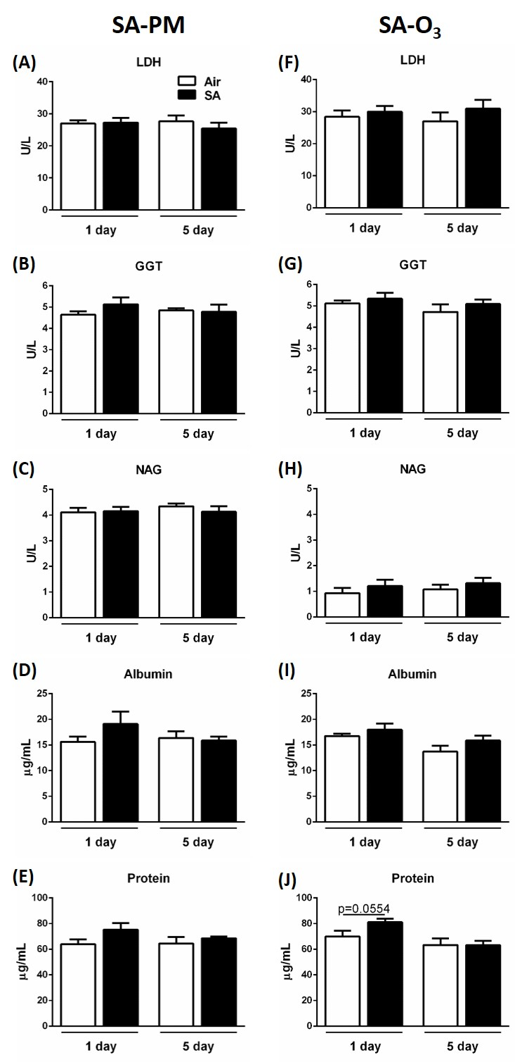Figure S2.** BALF biomarkers of pulmonary injury in GK rats were not changed following exposure to SA. GK rats were exposed to filtered air, SA-PM (left panels), or SA-O3 (right panels) for 1 day or 5 consecutive days. BALF samples were collected immediately post-exposure and analyzed for LDH activity (A, F), GGT activity (B, G), NAG activity (C, H), albumin (D, I), and protein (E, J). Data show mean ± SEM (n=6/group).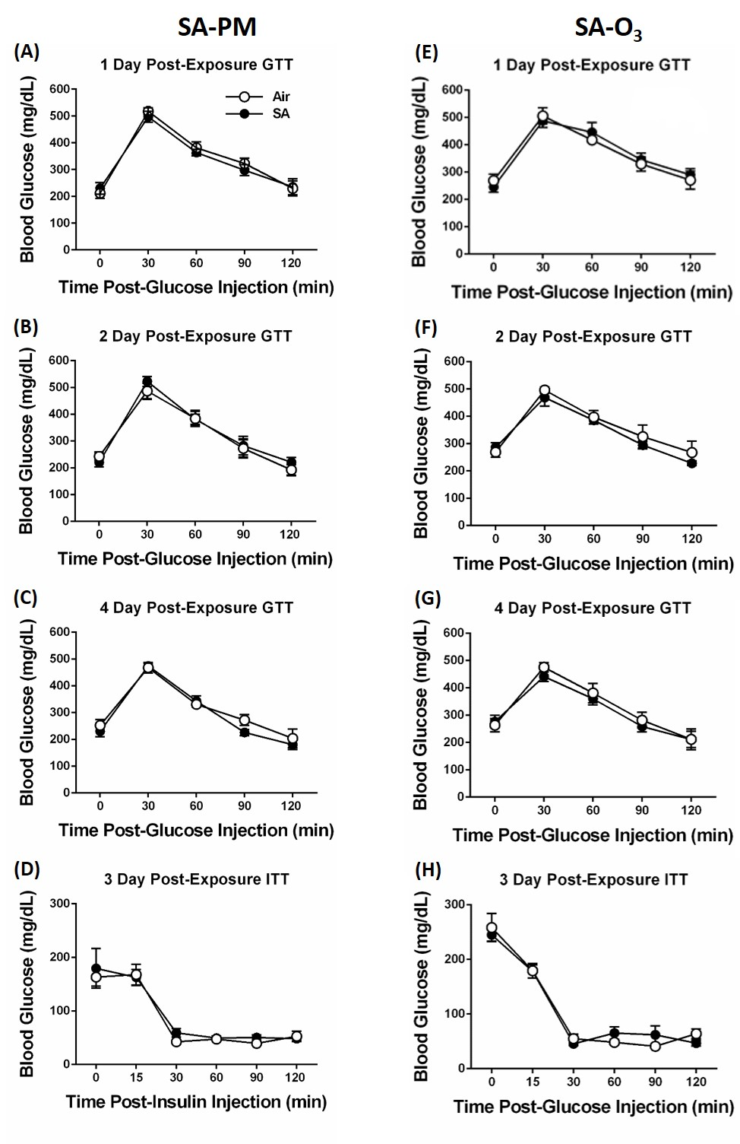**Figure S3.** No changes in hyperglycemia, glucose intolerance, and insulin intolerance following exposure of GK rats to SA.GTT was conducted after 1 day (A, E), 2 days (B, F), and 4 days (C, G) of exposure to filtered air, SA-PM (left panels), or SA-O3 (right panels). ITT was conducted after 3 days of exposure (D, H). Data show mean ± SEM (n=6/group).****

**Figure S4.** No effects of SA-PM (left panels) or SA-O3 (right panels) on BALF biomarkers of pulmonary injury following exposure of non-allergic or HDM-allergic mice for 1 or 5 days. Values shown are mean + SEM (n=7-8 per group). *Significantly different (*P*<0.05) *vs.* non-allergic group exposed to the same atmosphere.



**Figure S5.** No effects of SA-PM (left panels) or SA-O3 (right panels) on numbers of BALF alveolar macrophages, neutrophils, and eosinophils recovered from non-allergic and HDM-allergic mice exposed for 1 or 5 days. *Significantly different (*P*<0.05) *vs.* non-allergic group exposed to the same atmosphere.

**Figure S6.** Representative image of scant intracytoplasmic brown to black particles <2 µm in diameter within alveolar macrophages (arrow) following 5-day exposure to SA-PM. Objective magnification 60x.

**Figure S7.** Representative images of lung sections from non-allergic mice exposed for 5 days to filtered air (A) or SA-O3 (B). Minimal to mild perivascular mixed cell inflammation, including eosinophils, neutrophils, and lymphocytes, was evident following SA-O3 exposure. Objective magnification: 20x.

**(A)**

**(B)**